# Objective and Cost of Software Quality Measurement

**Cost of Software Quality -** is the financial assessment of software quality development and maintenance – is just another class of software quality metrics, where financial values are used as the measuring tool. Managerial control over the cost of software quality (CoSQ) is achieved by a comparison of actual performance figures with:

* Prevention and appraisal activities budget
* Previous year’s failure cost
* Previous project’s total quality
* Other department’s quality cost

# Cost of Software Quality Measurement Objectives

* Control organization-initiated costs to prevent and detect software errors.
* Evaluate financial damages of software failures as a basis for revising the SQA budget.
* Evaluate plans to increase/decrease SQA activities, or to invest in new/updated SQA infrastructure.

# The Classic Model of Cost of Software Quality

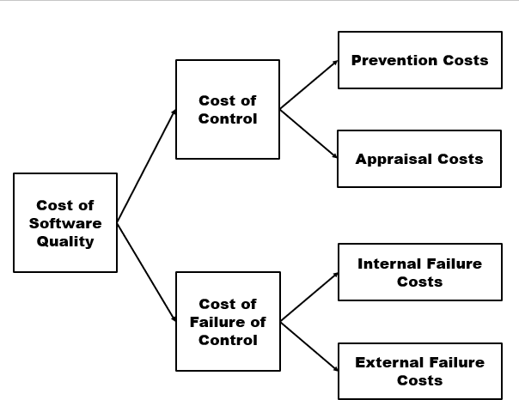

The classic quality cost model, developed in the early 1950s by Feigenbaum and others, provides a methodology for classifying the costs associated with product quality assurance from a financial point of view. The model was developed to suit quality settings in manufacturing organizations and has since been widely implemented. The model classifies quality costs into two general classes:

* **Costs of Control -** relate to costs controlled by the software developer and includes the following subclasses:
  + Prevention Costs
  + Appraisal Costs
* **Costs of Failure of Control -** relate to the costs of correcting failures that occurred due to unsuccessful prevention activities. The model further subdivides these costs into two subclasses:
  + Internal Failure Costs
  + External Failure Costs

# Prevention Costs

**Prevention Costs -** include investments in establishing, updating, and improving a software quality infrastructure, as well as for performing the regular activities required for its operation. Typical preventive costs include:

1. Investments in the development of new or improved SQA infrastructure components or regular updating of these components:
   * Procedures and work instructions
   * Support devices
   * Software configuration management system
   * Software quality metrics
2. Regular implementation of SQA preventive activities:
   * Instruction of new employees on SQA topics and procedures related to their positions
   * Instruction of employees in new and updated SQA topics and procedures
   * Certification of employees for specific positions
   * Analysis of errors and additional data and the subsequent performing of corrective and preventive actions
3. Control of the SQA system through the performance of:
   * Internal quality audits
   * External quality audits by customers and SQA system certification organizations
   * Management quality reviews

# A picture containing screenshot Description automatically generatedExtended Model for Cost of Software Quality

**Appraisal Costs** .

**Appraisal costs -** include the cost of activities performed for a specific project or software system to detect software errors that need to be corrected. Typical appraisal costs cover:

1. Reviews:
   * Formal reviews
   * Peer reviews
   * Expert reviews
2. Cost of software testing
   * Unit tests
   * Integration tests
   * Software system tests
   * Acceptance tests
3. External participants:
   * Subcontractors
   * Software system suppliers
   * Project participant

# Internal Failure Costs

**Internal failure costs -** are those incurred through correcting errors that were detected through design reviews, software tests, and acceptance tests performed before the software was installed at customer sites. In other words, internal failure costs represent the cost of error correction subsequent to formal examinations of the software during its development. Typical costs of internal failures:

1. Cost of rework
2. Cost of design corrections subsequent to design reviews and test findings
3. Cost of correcting programs following test findings
4. Regression tests
5. Domino effect damages

# External Failure Costs

**External failure costs** include all costs of correcting failures detected by customers or maintenance teams after the software system has been installed at customer sites. These costs may be further classified into overt external failure costs and hidden external failure costs.

It extends the classic model to include management’s “contribution” to the total cost of software quality. The management quality costs are classified into two general classes:

* 1. **Management Control Costs - r**elate to costs that are controlled by the management and include two subclasses as follows:
     + **Management Prevention Costs:** Management preventions costs are associated with activities performed to prevent managerial failures or reduce prospects of their occurrence. These activities are required to be performed before work commences on the project and are the responsibility of management. It includes pre-project activities designed to detect erroneous proposal parts and prepare appropriate plans for project performance.
     + **Management Appraisal Costs:** Management preparations and control costs are associated with activities performed to prevent managerial failures or reduce prospects of their occurrence. Typical management appraisal costs include the costs of activities to control the performance of a specific project.
  2. **Management Failure of Control Costs - r**elates to the costs of correcting failures that occurred due to unsuccessful prevention activities. Divides these costs into two subclasses:
     + **Management Internal Failure Costs:** Management internal failure costs may be incurred throughout the entire course of software development. They are most likely to materialize in connection with failed attempts to identify project risks, failed estimates regarding the appropriate project schedule and budget, as well as to detect in a timely fashion those deviations and problems that necessitate management intervention.
     + **Management External Failure Costs:** Naturally, most managerial external failure costs incurred after completion of software development and system installation. It includes additional error repairs at customer sites and damages paid to customers due to customer-detected product faults resulting from management commitments and failures.

# Application of Cost of Software Quality (CoSQ) System

In the first stage of applying a CoSQ model, the organization should choose its preferred type of cost model–classic or extended. Whichever model is selected, its effectiveness is determined to a great degree by the suitability for the organization of the cost items designed to be measured for the model. In other words, these model items, defined specifically for the organization, are considered relevant to the organization’s activities and budget expenditures. In order to apply a cost of software quality system in an organization, the following are required:

* Definition of a cost of software quality model and an array of cost items specifically for the organization, department, team, or project
* Definition of a method of data collection
* Application of a cost of software quality system, including thorough follow-up
* Actions to be taken in response to the findings produced
* Inaccurate and/or incomplete identification and classification of quality costs
* Negligent reporting by team members and others
* Biased reporting of software costs, especially of “censored” internal and external costs
* Biased recording of external failure costs, due to indirect compensation of customers for failures (e.g., discounted future services, delivery of free services), whose implications are not recorded as external failure costs

# Problems Arising when Collecting Data on Managerial Prevention and Appraisal Costs

* Contract review and progress control activities are performed in many cases in a “part-time mode” and in addition, they are subdivided into several disconnected activities of short duration. The reporting of time invested in these activities is usually inaccurate and often neglected.
* Many of the participants in these activities are senior staff members and are not required to report their time.
* The nature of follow-up activities requiring few hours, and in many cases, even less than an hour, makes them difficult to report accurately.

# Problems Encountered in Collection of Data on Managerial Failure Costs

* Determination of responsibility for schedule failures: Schedule failure costs are frequently deliberated for lengthy periods because their direct causes or the specific contributions of each participant to the initial failures are difficult to pinpoint.
* Late payment of customer’s overt compensation: At the time of these compensations, it is too late for the effective application of the lessons learned.

# Problems in Application of CoSQ Measurements

Application of a CoSQ model is generally accompanied by problems to be overcome, whatever the industry is. These impinge upon the accuracy and completeness of quality cost data caused by:

References:

Galin, D. (2018). *Software quality assurance: Concepts and practice*. IEEE Computer Society, Inc.

Laporte, C. and April, A. (2018). *Software quality assurance*. IEEE Computer Society, Inc.