# PROFESSIONALISM AT ITS BEST

***The Root of Professionalism***

# Professionalism

Professionalism is more than just about qualifications, knowledge, and skill; but is also about integrity, ethics, and trust.

Practicing and maintaining a high level of valued professionalism will create stronger relationships with clients, employers, the team, and the public who will use or benefit from the products and services.

The essence of professionalism is not just for the job but also for how the job is done. It possesses a set of values, behaviors, and broader responsibilities in how the professional’s knowledge and skills are applied.

## Origin of Professionalism

The idea of professionalism and the establishment of modern professions originated from trade guilds and the learned societies for the church, law, and medicine. These developed from the transaction of providing privileges and recognized status to specific people in return for the development and application of their unique knowledge and skills.

The concepts of professionalism, profession, and professionalization have met considerable and critical attention in sociology through various interpretations and analyses.

# First Interpretation

According to initial British and American analyses, professionalism was determined to be an occupational value for the stability and ordinance of social systems.

Professional relations (PR) were cooperative and mutually supportive in this interpretation. Relations of trust represented the employee- client, and employee-management interactions as competence were presumed as a guarantee through education, training, and licensing.

# Second Interpretation

During the 1970s-1980s, professionalism was dismissed as a successful principle and professionalization as a process of authority over occupation or a market.

According to this interpretation, professionalization promotes a professional’s occupational self-interest in salary and power. It was a process initiated and controlled by the employees through professional institutions and associations to promote and protect their self-interests.

# Third Interpretation

It involved the analysis of professionalism as a discourse of occupational change and control, especially in organizations wherein it was increasingly applied and utilized by managers.

There is an important difference between the discourse of professionalism as built “*from within*.” It can also be from the occupational group itself and as-built “*from above*” or by managers in work organizations.

When discourse is built *from within*, the benefits to the group can be significant. The occupational group uses the discourse to build its occupational identity, promote its image with clients and customers, and secure and promote the occupational control of work by employees.

Studies in the early 21st century demonstrated that professionalism presents advantages for both clients and employees.

These studies highlighted the importance of maintaining professionalism and trust, competence, and discretion as the main organizing principles for service work in modern societies.

## Characteristics of Professionalism

Here are the characteristics true professionals possess in the workplace:

1. **Appropriateness:** Professionalism is knowing what is appropriate in different situations as it avoids awkwardness or upset, boosts credibility and helps to feel job security.

Appropriateness relates to outward appearances, such as dress, hygiene, and body language. It also covers the way of speaking and writing in selecting a topic to discuss and behavior with others.

1. **Competence**: It is about a professional who gets the job done and done well. The ability must meet the role's requirements to produce results that exceed expectations.

Professionalism manages the expectations of others and identifies when it is necessary to ask for support.

1. **Confidence:** Reasonable confidence reassures and motivates other people by boosting the ability to influence and lead. It also encourages everyone to take on new challenges as the risk of damaging their professional reputation if things go wrong is non-existent.
2. **Conscientiousness:** Professionalism involves being reliable, setting high standards, and displaying care in every aspect of the job. It is about being diligent and organized and holding oneself accountable for thoughts, words, and actions, no matter the results.

Conscientiousness should not be confused with working longer hours than everyone else or obsessing about details. True professionals plan and prioritize their work to keep it under control while not letting perfectionism hold them back.

1. **Emotional Intelligence:** Staying professional under pressure is a sign of a true professional. It requires strategies for managing emotions and a clear awareness of other people’s feelings and thoughts. In short, emotional intelligence is essential.

Professionalism means keeping emotions in check. But at the same time, expressing feelings for meaningful and fruitful conversations is necessary.

1. **Integrity:** This keeps professional people true to their word. It also stops them from compromising their values, even if that means taking a bigger risk.

Integrity is committed to being honest – to oneself and others. When beliefs and behaviors are aligned, genuineness reflects.

1. **Knowledge:** Professionalism involves detailed and up-to- date knowledge which is highly specialized. Professionals can master a role and a specialization by learning new knowledge at every stage of their careers.

It is also vital to put knowledge into action. Being professional means being confident to show that knowledge is not for self- promotion but for helping others succeed.

1. **Respect:** Professionalism means being a role model for politeness and displaying good manners to everyone, not just to impress specific people.

To show proper respect, take others’ needs into account, and help uphold their rights.

## Principles of Professionals at Work

Professionalism is about having an informed, ethical and strategic approach to work for the greater good and the wider benefit.

Here are the main professionalism principles in the workplace.

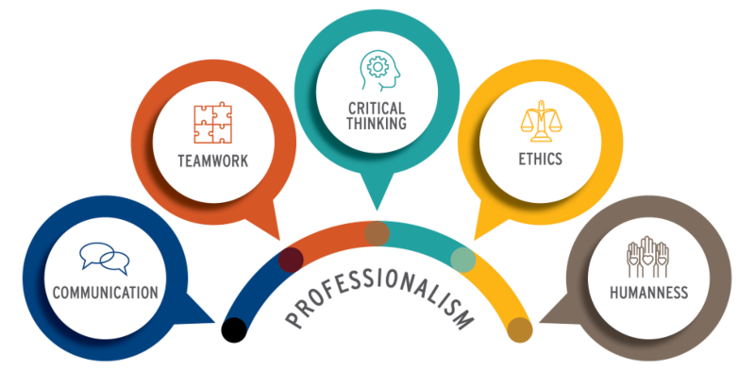

Source: https://memp.pratt.duke.edu/5-principles

***Figure 1****.* Five principles of professionals

1. **Communication:** From verbal and body language to e-Etiquette, employees must know the expectations in how they communicate. It is equally important that employees have the resources they need to develop their communication skills.

Quality communication can eliminate unnecessary problems and promote better productivity in the workplace. Communicating effectively creates a strong team connection increasing overall performance. If employees consult and consider the views of others, their interest in cooperation increases leading to finding the best possible solutions.

1. **Teamwork**: This builds a strong employee relationship as the more they work closely, the more they get to know and develop a liking for each other. Additionally, the more they work together, the more they learn and adapt to living with each other’s likes, dislikes, strengths, and weaknesses.

One of the benefits of teamwork is reduced toxic work culture. Toxic work culture is driven by drama, low morale at work, lack of communication, and the fear of a boss. Teamwork is enhanced by participating in team-building activities to practice relying on others’ strengths and consulting doubts and confusions as soon as they arise.

1. **Critical Thinking:** This allows a professional to analyze information, arrive at conclusions, and make sound decisions. Being a critical thinker is an essential skill everyone must improve.

Critical thinking skills are valuable in any role in an organization. It can be developed through communication and creative problem- solving as it allows the free-flowing connection of ideas to evaluate arguments, find errors, and solve complex issues.

Prioritize taking on high-risk problems that need immediate action to practice critical thinking skills while ensuring the correctness and quality of the output.

1. **Ethics**: Code of ethics aligns the behavior of employees to the company’s visions. It promotes openness, partnership, and trust. Additionally, when employees know supervisors’ expectations, they do better in their jobs.

Always mind the stakes involved in any aspect of the job to ensure actions are bounded by what is morally correct and acceptable.

Recognizing the importance of ethics helps employees feel secure as threats such as harassment and bullying are absent, and respect is thriving.

1. **Humanness**: This is expressed through natural human values and unique talents and perspectives that employees contribute. Humanity is dynamic as it incorporates the innate need for purpose, growth, and work-life balance simultaneously.

Practicing being kind, accepting, and emotionally available is a massive step towards achieving humanness in the workplace. It does not require additional skills but the natural values to do good around people. Professionals today want to be a part of something larger than themselves, something that in some way positively impacts the human experience.

# References:

Brindley, R. (2022). *Professionalism at work.* RIBA

Evetts, J. (2018). *Professionalism*. [Web Article]. Retrieved on July 7, 2022, from https[://www.brit](http://www.britannica.com/topic/professionalism)ann[ica.com/topic/professionalism](http://www.britannica.com/topic/professionalism)

Glass J. (2021). *Professionalism and the 5 principles.* [Web Article]. Retrieved on July 7, 2022, from https://memp.pratt.duke.edu/5- principles

MindTools (2018). *Professionalism: Meeting the standards that matter.* [Web Article]. Retrieved on July 7, 2022, from https[://www.m](http://www.mindtools.com/pages/article/professionalism.htm)ind[tools.com/pages/article/professionalism.htm#.](http://www.mindtools.com/pages/article/professionalism.htm) YepgoEg8mf0