# THE BUSINESS PLAN

**The Need for a Business Plan**

Technopreneurs regularly have many goals at the top of the priority list. They might include distributing

eco-friendly goods or integrating well-being into the workplace. As such, the business plan must include all the goals, regardless of which ones they are.

Technopreneurs are well aware of the dangers their companies face. Before they started the business, they considered these risks. Even if the business is already up and running, there may still be difficulties. It can be managed if the issues come up one at a time, but sometimes they come up simultaneously. A technopreneur must develop an effective business plan to avoid any mishaps during the business.

Planning might be viewed as an orderly way to accomplish specific goals, and it endeavors to dispose of blunders because of on-the-spot choices (Medina, 2014). The technopreneur has ample time to consider relevant factors and risks that will or may affect the business through business planning before making a decision.

# Key Differences Between Business Plan and Feasibility Study

According to Morato (2017), a business plan is a document entrepreneurs use to determine the resources required to achieve the company’s goals. It is made up of mostly tactics and strategies to be implemented to start, grow, and sustain the business. Additionally, business plans are created to ensure the company stays on course. There are five (5) primary purposes for writing a business plan:

1. It helps stay organized and goal-focused.
2. It helps make better decisions.
3. It is used as a tool for measurement.
4. It can help attract investors, partners, or lenders.
5. It is a legal requirement for most loans and grants.

On the other hand, a feasibility study is carried out to determine the workability and profitability of a business venture. Before investing in a new business venture, a feasibility study is carried out to know if the business venture is worth the time, effort, and resources. It is filled with calculations, analysis, and estimated projections of a business opportunity to reveal the profit potential of a business idea or opportunity to the entrepreneur. This means a feasibility study is prepared before a business plan is conducted.

**Business Types (CFI Team, 2022)**

# Sole Proprietorship

* + This type of business is owned and managed by one (1) person. It is the simplest type of business and typically has a few employees, and conducts relatively few business transactions. Financial records are not that hard to track for this kind of business. This kind of business falls under the category of small to medium enterprises, or SMEs, and it gets some legal and tax exemptions.

# Partnership

* + This is operated by two (2) or more people who are experts in the skill where their enterprise is categorized. There are two (2) types of partnership: general and limited.
    1. **General partnership** – The partners manage the enterprise and assume responsibility for the partnership’s liability, debt, and other obligations.
    2. **Limited partnership** – This includes a *general partner* who carries out the business and has unlimited personal liability for the debts and obligations of the partnership and a *limited partner* who has limited liability and cannot take part in managing the enterprise.

# Cooperative

* + A private business or organization known as a cooperative business, or a co-op, is owned and run by members who profit from the company’s products or services. It exists to meet a common need of its member-owners, such as more accessible supplies or improved services. Individuals, organizations, or other groups that join voluntarily and are willing to work toward a common objective are member-owners.

# Corporation

* + Forming a corporation is more difficult than the three (3) business types. The drafted articles of incorporation must include the number of shares to be issued, the business’s name, location, and purpose. Shareholders create corporations, which are their unique legal entity. Owners are protected from personal liability for the company’s debts and legal disputes by incorporation. (Zen 2021)

# Parts of the Business Plan

Business plans differ from one enterprise to another. Usually, they contain the following:

# Title Page

* 1. It must contain the following information: business name; business address; contact information of the business (telephone number/mobile number/e-mail address/website); name(s) of business proponent(s), and date of output submission.
  2. The required information must be presented based on the above order, vertically from the top to the bottom of the cover page.

# Table of Contents

* 1. It must present the list of section titles of the business plan together with their corresponding page numbers.

# Executive Summary

* 1. It summarizes the plan and states the objectives of the business.
  2. This part must also present the amount of initial capital investment and the sources of capital for the proposed business. If in case the technopreneur borrows money from a bank, another business, or a person, the manner of amortization payment with corresponding interests must be presented.

# Background of the Business Venture

* 1. It must include a brief description of the company, highlighting why the proponents choose to undertake the business venture.
  2. This section must also include the mission and vision statements of the proposed business.
  3. This part also describes the product or service the business offers and relays to the readers its edge over its competitors.
  4. It must highlight the following information: important features of the product or service, a detailed description of how to use the product or how the service will be given/delivered, and its uniqueness or competitive advantage.

# Marketing Strategies and Industry Analysis

* 1. This part must present a brief description of the industry to which the proposed business belongs. It must also explain the current size, growth potential, and existing distribution channels in the given industry.
  2. It must also present the industry analysis tool used to analyze the competition (SWOT, TOWS, and PESTEL analysis).
  3. It must also present in detail the following information: target market profile; pricing; market penetration; and advertising and promotion.

# Management and Organizational Plan

* 1. It must include in detail the following information: business location, start-up needs, and product development flow.
  2. This part must also present if the enterprise came from a new idea or an improvement of an existing idea. The ownership status of the enterprise should also be written, whether it is a sole proprietorship, partnership, corporation, or cooperative.
  3. This part must also include the management team of the proposed business. It must present in detail the managers, supervisors, and workers required to execute the activities of the proposed business. It must also provide a brief description of duties and responsibilities for each identified role.
  4. It must also present an organizational chart or a representation of the organizational structure, which identifies the relationships of the positions or jobs within it.

# Financial Plan

* 1. This section projects how the enterprise is expected to perform financially over the next couple of years. The financial projections must cover at least five (5) years from the proposed start of the business.
  2. It must include an *income statement* showing the business’s projected income, expenses, and profits. It must also include a *balance sheet* reflecting the financial status of the business entity. Competitors’ financial statements can be used as a benchmark for the projected financial statements.

# Auxiliary Documents

* 1. This section gives specific information that certain individuals (such as creditors and even investors) may want to review, such as technopreneurs’ resumes.

# Bibliography

* 1. This section must present all the references used in accomplishing the business plan. The entire paper must follow the official style of writing of the American Psychological Association (APA). Refer to this link for APA style guidelines:

*[https://owl.purdue.edu/owl/research_and_citation/apa_style/apa_formatting_and_styl](https://owl.purdue.edu/owl/research_and_citation/apa_style/apa_formatting_and_style_guide/general_format.html) [e_guide/general_format.html](https://owl.purdue.edu/owl/research_and_citation/apa_style/apa_formatting_and_style_guide/general_format.html)*

# Business Model Canvas

The business model canvas is a structured version of a business plan. Start-up businesses often use it like technopreneurial enterprises. It is a visual chart developed by Alexander Osterwalder, with areas describing a business entity’s *value proposition* or the belief of a client or customer about how value will be delivered, felt, and attained. It also describes the business’ infrastructure, customers, and finances. The following are the nine (9) building blocks of the business model canvas (Vermeulen, 2018).

1. **Key partners** – This area discusses the alliances or partnerships made by the enterprise. This is beneficial if the enterprise has competition.
2. **Key activities** – This section includes the prime activities of the enterprise, which are the basis of the value proposition.
3. **Key resources** – This area dictates what the company needs to operate. This can be categorized as physical, intellectual, money, or workforce.
4. **Value propositions** – This section is about the enterprise’s core and its promise to the customers. It includes how customers’ needs could be met. When the organization knows the added value for the customer, a great relationship may be developed with existing customers, which may be helpful in the scouting of new customers.
5. **Customer relationships** – This area details the enterprise’s relationship with its customers and clients. It also divides the customers into groups to address different customer needs.
6. **Channels** – This section is a way to introduce the products or services to partners and customers. It has five (5) stages: product awareness, purchase, delivery, evaluation and satisfaction, and after-sales.
7. **Customer segments** – This area details how customers are divided or grouped into segments. The purpose is to identify their specific needs and give them what they need to heighten customer satisfaction.
8. **Cost structure** – This includes the costs incurred by the business, such as product cost, labor cost, raw materials, etc.
9. **Revenue streams** – This section details how the enterprise will make profit from the customer segments. It gives the enterprise an insight into how much profit it could generate to break even. The Source of revenue can be through the sale of goods or the provision of services.

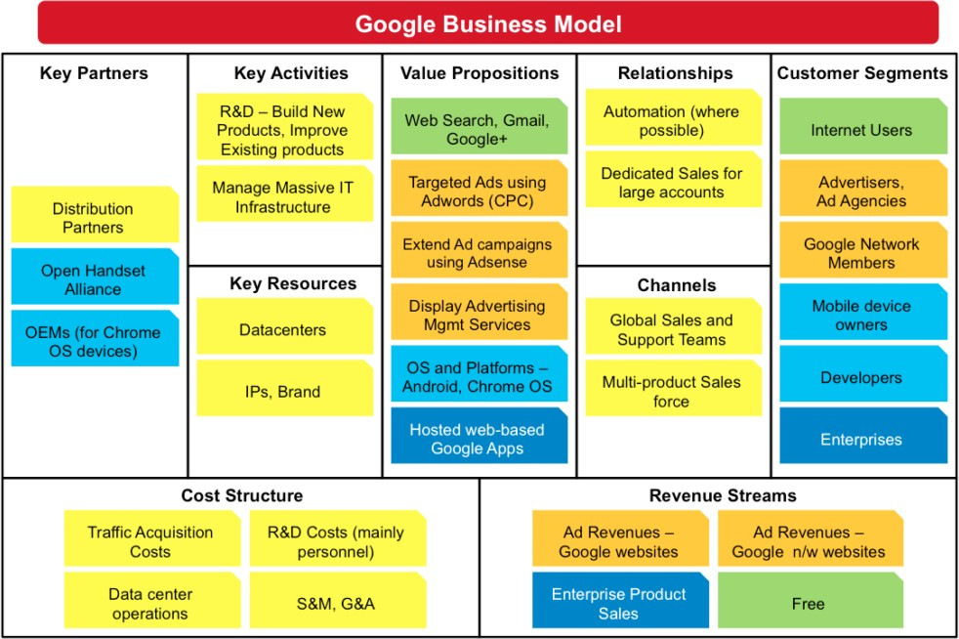Example Business Model Canvas of Google:

*Figure 1:* Samples Business Model Canvas of Google

*Source*: https://[www.businessmodelgeneration.com](http://www.businessmodelgeneration.com/)

# References

Balachandran, B. V. (2018). The next big thing in the start-up ecosystem - technopreneurship. https://[www.entrepreneur.com/article/312888](http://www.entrepreneur.com/article/312888)

Baumann, S. (2022*) Handbook on Digital Business Ecosystems: Strategies, Platforms, Technologies, Governance and Societal Challenges.* Massachusetts. Edward Elgar Publishing Inc.

Buckley, P., Nzembayie, K. (2022) *Digital Entrepreneurship Disruption and New Venture Creation.* Massachusetts. Edward Elgar Publishing Inc.

CFI Team (2022). *Types of Business.* https://corporatefinanceinstitute.com /resources/management/ types-of-businesses/ Guru Staff (2021) *What is a Cooperative*? https://[www.guru.com/blog/what-is-a-cooperative-business](http://www.guru.com/blog/what-is-a-cooperative-business)

Medina, R. (2014). *Entrepreneurship and small business management.* Quezon City: Rex Bookstore. Morato, E. A. (2017). *Entrepreneurship.* Quezon City, Philippines: Rex Printing Company.

Qayum, A. (2022) *The 7 best business plan examples*. https://[www.oberlo.com/blog/business-plan-examples](http://www.oberlo.com/blog/business-plan-examples) Simplilearn (2022). *Business Planning: It’s importance, types, and key elements.* https://[www.simplilearn.com/business-](http://www.simplilearn.com/business-)

planning-article

Vermeulen, F. (2018). *The first step of business model innovation: Focus.* https://[www.forbes.com/sites/freekvermeulen/2018/01/11/the-first-step-of-business-model-innovation-](http://www.forbes.com/sites/freekvermeulen/2018/01/11/the-first-step-of-business-model-innovation-) focus/#668bc8935022

Zen Business Plans (n.d.) Difference between feasility study and Business plan https://[www.zenbusinessplans.com/feasibility-study-business-plan/](http://www.zenbusinessplans.com/feasibility-study-business-plan/)