# Data Privacy

* **Personal data** refers to any information, whether recorded in a material form or not, from which the identity of an individual is apparent or can be directly ascertained by the entity holding the information.
* **Privacy** concerns the collection and use of data about individuals. There are three (3) primary privacy issues:
  + **Accuracy** relates to the responsibility of those who collect data to ensure that the data is correct.
  + **Property** relates to who owns the data.
  + **Access** relates to the responsibility of those who have data to control who can use that data.

# Data Privacy Versus Data Security

* Organizations commonly believe that keeping sensitive data secure from hackers means they’re automatically compliant with data privacy regulations
* Data privacy and data security are often used interchangeably, but there are distinct differences, although sometimes difficult to distinguish between. Whereas security controls can be met without also satisfying privacy considerations, privacy concerns are impossible to address without first employing effective security practices. In other words, security protects data, and privacy protects the identity
* Privacy and security come down to which data is being protected, how it’s being protected, from whom it’s being protected, and who is responsible for that protection. Security is about protecting data from malicious threats, whereas privacy is about using data responsibly.
* **Data privacy** is a part of the data protection area that deals with the proper handling of data, with the focus on compliance with data protection regulations.
* Data privacy focuses on the rights of individuals, the purpose of data collection and processing, privacy preferences, and the way organizations govern the personal data of data subjects. It focuses on how to collect, process, share, archive, and delete the data under the law.
* **Data security** includes a set of standards and different safeguards and measures that an organization is taking to prevent any third party from unauthorized access to digital data or any intentional or unintentional alteration, deletion, or data disclosure. It focuses on the protection of data from malicious attacks and prevents the exploitation of stolen data such as:
  + **Data breach –** an unauthorized or unintentional disclosure of confidential information.
  + **Cyberattack –** the stealing of data or confidential information by electronic means, including ransomware and hacking.
* To achieve this, organizations use tools and technology such as firewalls, user authentication, network limitations, and internal security practices to prevent such access.

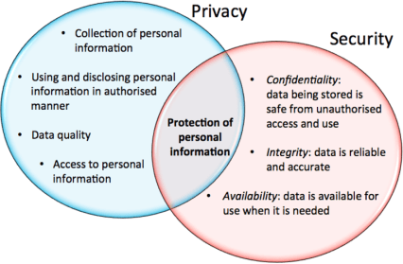

***Figure 1.*** Privacy and Security

* **CIA Triad** is a model designed to guide an organization’s policies on information security. The elements of the triad are considered the three most crucial components of security. The following are the three (3) elements of data security.
  + **Confidentiality** ensures that data is accessed only by authorized individuals.
  + **Integrity** ensures that information is reliable as well as accurate; and
  + 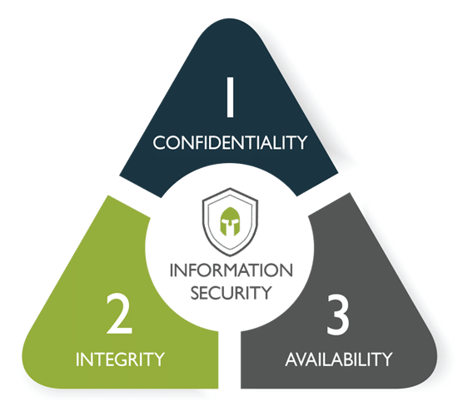**Availability** ensures that data is both available and

accessible to satisfy business needs.

***Figure 1.*** CIA Triad

# Elements of Data Privacy

* Data privacy encompasses three (3) key elements:
  + Right of an individual to be left alone and have control over their data
  + Procedures for proper handling, processing, collecting, and sharing of personal data
  + Compliance with data protection laws
* **Data management** – the process of ingesting, storing, organizing, and maintaining the data created and collected by an organization.
* Data management is at the heart of privacy. Data is a vague concept and can encompass such a wide range of information.

# Aspect of Privacy

* Information privacy is considered an important aspect of information sharing. With the advancement of the digital age, personal information vulnerabilities have increased
* Information privacy may be applied in numerous ways, including encryption, authentication, and data masking, each attempting to ensure that information is available only to those with authorized access.
* Information privacy includes the regulations required for companies to protect data. And as more data protection regulation grows worldwide, global privacy requirements and demands will also expand and change.
* Protective measures are geared toward preventing data mining and the unauthorized use of personal information, which are illegal in many parts of the world.
* Information privacy also relates to different data types, including:
  + **Internet privacy**: All personal data shared over the Internet is subject to privacy issues. Most websites publish a privacy policy that details the website's intended use of collected online and/or offline collected data.
  + **Financial privacy**: Financial information is particularly sensitive, as it may easily use to commit online and/or offline fraud.
  + **Medical privacy**: All medical records are subject to stringent laws that address user access privileges. By law, security and authentication systems are often required for individuals that process and store medical records.

**References**:

Kumar, G., Saini, DK., Huy Cuong, NH. (2020). *Cyber Defense Mechanisms: Security, Privacy, and Challenges.* CRC Press.

Stallings, W. (2019). *Information Privacy Engineering and Privacy by Design: Understanding privacy threats, technologies, and regulations.* Assison-Wesley Professional.

Petters, J. *Data Privacy Guide: Explanations and Legislation.* Retrieved from https://[www.varonis.com/blog/data-privacy/#tips](http://www.varonis.com/blog/data-privacy/#tips) on September 9, 2020