Procurement

Procurement Management entails the activity of handling request of required goods to the moment of arrival and payment of the goods. Online procurement plan are negated from the budget and the cash management system based on defined authorization levels. Raise requisitions for items that must be in the procurement plan. The requisitions are automatic conversed to order ready for processing after the defined approval process. The system also supports processing of purchase orders based on contractual agreements with a supplier, specifying payment terms, delivery dates, item identification and quantities. Management of goods receipt also including support of partial delivery and goods returns.

The system automatic links the received goods to the warehouse and storage bins supported with alerts on reorder levels. There is a seamless integration of purchase orders and goods receipt notes to the purchase invoice and an automatic audit of document flow from Requisition > Purchase order > Goods receipt note > Purchase Invoice and payment flow.

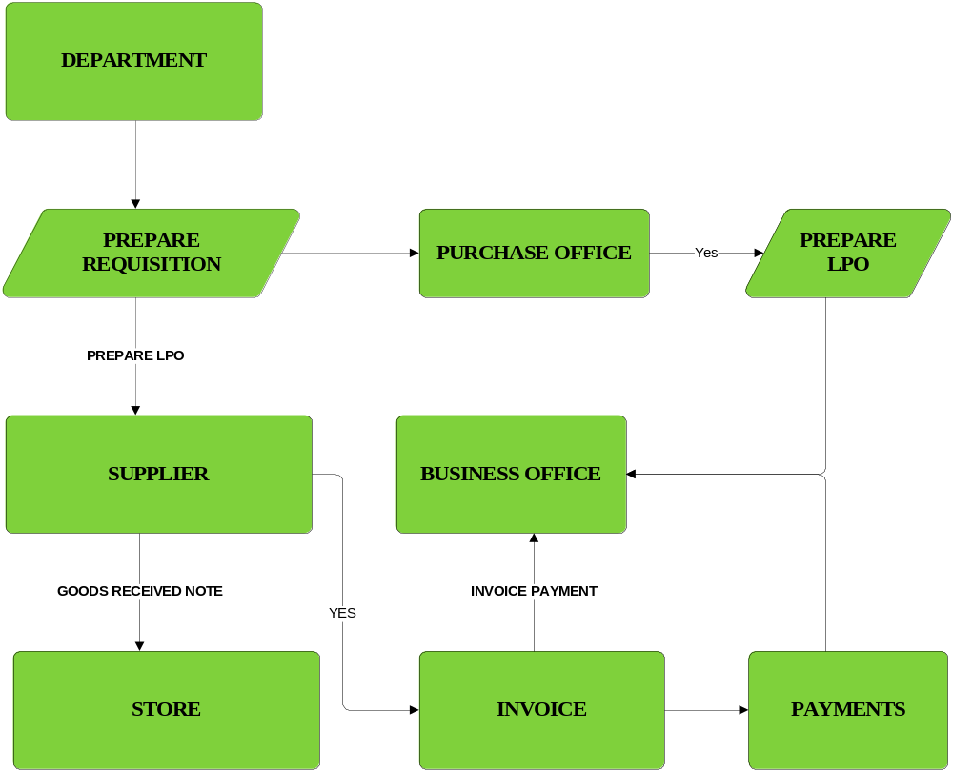

The procurement system involved the following automated process.
- Departments fill out a Purchase Requisition which is automatically matched against the budget.
- The Requisition undergoes all necessary approvals and check.
- The Purchasing Office approves all requisition received from departments then an LPO is prepared for each item in the requisition.
- All LPOs appear in the Business Office online window for further approval.
- Approved
- If approved, the LPO is then sent to the suppliers as an order form from the purchasing office.
- As agreed on the LPO, payment for the items delivered are paid and delivered.
- Support for automated contract creation, management, and reporting.

Primary Data

- Enter details all suppliers, including their banking details and product categories supplied.
- Track supplier deletion and data changes
- Create a customized items category
- Enter details of all items for purchase

Purchase Requisition
These forms are used by the various departments that constitute the college to make purchases from outside facilities or departments. Each PRF would need approval from the Department Head, School Dean.
Raise requests to quote online

The system generates online quotation in excel format that allow for suppliers to fill in costs and return the document for upload to the system. Support for Electronic purchasing via Electronic Data Interchange EDI standards, order and invoice transfer, invoice receipting and automatic invoice matching.

L.P.O.

The LPO is a detailed description of the terms of sale between the supplier and the organization clearly stating the payment details, authorization, item(s) to be delivered, who was spoken to, date and the quotation given; also if a fax was sent and where to. It should have various departments to which the report is sent to when the LPO is completed; the suppliers, Accounts Office, Procurement Office and the requesting department.

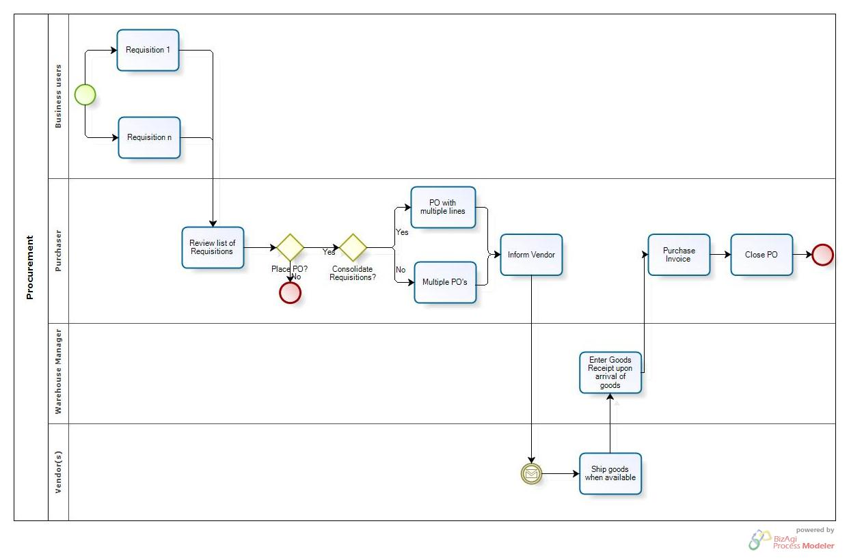

Order Processing

System involves tracking of the LPO forms and automatically generating reports which would include within the report anyone who has accessed or checked on the progress of the LPO. This is due to the high security that would have to be around the LPO. Only senior employees in the relevant departments of the college would be allowed to access the LPO. System will also keep the past purchasing records of the department which will help ensure that it stays within its budget and more accurately .This would also ensure that the various departments do not repeatedly order the same things over and over again.

Receive goods
- Receive stock either by LPO or by cash purchase.
- Enter of delivery notes and invoices.
- Generate a GRN for each procurement transaction.
- Record if goods were inspected, when and by whom.
- Make relevant ledger postings after formal acceptance of supplies.
- Handle partial deliveries and goods returned

Inventory management

The Inventory Management module keeps a detailed accounting of inventory quantities, and at the same time, provides in-depth information to help you make purchasing and pricing decisions.
The system which can be integrated with the procurement makes it easier to eliminate possible errors.

This helps in Comprehensive reports provide up-to-date information on stock status, reordering needs, inventory valuation, inventory turnover, and detailed item history and analysis.

The system helps supports Multiple Stores with an assigned code, description, address and general segment this achieved over the web.

- On receiving stock, the systems automatically increment the stock level. On issuing out stock, the system reduces the stock level.
- Generate material issue notes against an approved stores requisition.
- Record which employees were allocated with specific items.
- Track an item online
- Valuation of stock from an accounting perspective;
- Recognition of expiration dates where relevant;
- Barcode scanning support;
- Multiple stores and multiple locations within a store.

Reporting

The system is able to generate the following reports:

- Pending and approved requisition
- Produce a list of procurement requisitions made over a particular period.
- Issued, pending and canceled LPOs.
- Goods received against an LPO
- Invoices issued against a good received note and LPO
- Print drill-down report for goods, suppliers, department and other definable criteria

Asset management

Purchase of assets undergoes the normal procurement process and on goods receipt, assets are logged into the asset register. The asset can be transferred in different stores and departments. The system support the following asset features:

This will help in accurate accounting, acquisition, movement and disposition of property
- Asset coding;
- Depreciation / revaluation;
- Location tracking;
- Service schedules;
- Maintenance details (incidents and costs);
- Disposal records;
- Handling of intangible assets, e.g. computer software.

- Physical inventory process

- Maintain up to date property records and initiate all forms necessary to properly carry out its function with respect to property and equipment.

- Establish procedures and controls to protect property from loss, theft, abuse, or misuse.

