**Counseling management system**

**CHAPTER ONE**

**INTRODUCTION**

**1.0 Introduction**

This chapter presents the introduction to counseling management system. It covers the introduction, theoretical background, aim and objectives of the study, significance of the study, scope of the study, organization of the research and definition of terms.

**1.1 Theoretical Background**

Counseling is a form of education, which the students receive from their counselors. The essence of incorporating guidance and counseling into the school system was to eliminate overwhelming ignorance of many young people on their choices of career prospects and personality maladjustment among school children. The role of ICT in guidance can be seen in three ways: as a tool, as an alternative, or as an agent of change. The growth of websites and help lines as forms of technically mediated service delivery means that the potential of ICT as a change agent is now greater than ever before. The telephone, websites and e-mail, alongside face-to-face facilities, could be alternative services; or they could be portals into a wide, flexible and well-harmonized network of services. The essence of incorporating guidance and counseling into the school system was to eliminate overwhelming ignorance of many young people on their choices of career prospects and personality maladjustment among school children. Based on these and more, career officers and counselors were appointed to take the responsibilities in sensitizing students on the needs for effective career choice. However, it is important to develop a system that can be used in the absence of human experts and this has given rise to the adoption of artificial intelligence in guidance and counseling.

**1.2 Statement of the Problem**

The following problems were identified in the counseling system of Ritman College:

1. There is no automated system for guidance and counseling
2. It is time consuming and cumbersome to manage counseling records.
3. It is difficult to manually determine if a student is fit for a science or arts career.

**1.3 Aim and Objectives of the Study**

The aim of the study is to develop a counseling management system for secondary school. The following are the specific objectives of the study

1. To design and implement an automated career guidance and counseling.
2. To capture the O level courses grades of students in order to determine if they are fit for a science or arts career.
3. To design a system that will maintain a database of counseling records.

**1.4 Significance of the Study**

The significance of the study is that it will provide an automated system for guidance and counseling. It will help in determining of a student is fit for a science career or not. The research study will also be significant to other scholars seeking for information pertaining the subject.

**1.5 Scope of the Study**

This study covers Counseling management system for secondary school (A case study of Ritman College, Ikot Ekpene). It is limited to counseling based on choice of career (Science or Arts) using O level grades as a criteria for evaluation.

**1.6 Organization of the Research**

This research work is organized into five chapters. Chapter one is concerned with the introduction of the research study and it presents the preliminaries, theoretical background, statement of the problem, aim and objectives of the study, significance of the study, scope of the study, organization of the research and definition of terms.

Chapter two focuses on the literature review, the contributions of other scholars on the subject matter is discussed.

Chapter three is concerned with the system analysis and design. It analyzes the present system to identify the problems and provides information on the advantages and disadvantages of the proposed system. The system design is also presented in this chapter.

Chapter four presents the system implementation and documentation. The choice of programming language, analysis of modules, choice of programming language and system requirements for implementation.

Chapter five focuses on the summary, conclusion and recommendations are provided in this chapter based on the study carried out.

**1.7 Definition of Terms**

**Artificial Intelligence :** A branch of computer science that develops programs to allow machines to perform functions normally requiring human intelligence

**Career -** A job or occupation regarded as a long-term or lifelong activity. The general path or progress taken by somebody or something

**Counseling -** Help with personal or psychological matters usually given by a professional

**Expert System**- A computer program that applies artificial-intelligence methods to problem-solving

**Guidance -** Advice or counseling, especially counseling given to students on academic matters

**CHAPTER TWO**

**LITERATURE REVIEW**

**2.0 Introduction**

This chapter is concerned with the literature review. The contributions of other researchers on the subject of career guidance and counseling is examined in this chapter.

**2.1 The Concept of Career Guidance and Counseling**

Career counseling is very fundamental to students’ successful and meaningful living. Every student desire to be identified with a good profession, but this could only be achieved through effective counseling on the choices of career to maximize their potential. Career, though crucial to mankind, occupies almost all entire human life. This is due to the fact that career contribute enormously to all human activities, building individuals high self esteem, satisfaction and adjusting to healthy life. It equally assists students to discover their innate potentials and acquire the needed knowledge for building lifelong profession. The word ―career‖ refers to the activities and position involved in vocation, occupation, and jobs as well as to related activities associated with an individual’s life time of work. In view of this, adequate utilization of career counseling is required in public secondary schools in Nigeria if the nation’s goals are to be attained. According to BAC, the term counseling includes work with individuals and with relationships which may be developmental, crisis support, psychotherapeutic, guiding or problem solving.

A good number of adolescent and youths in many Nigerian secondary schools have incongruent patterns between their aspirations and subject combination for the school certificate examination. The implication is that most Nigerian youths today engage in occupations not on the basis of ―reasonable‖ choice but on the basis of fate. Case of maladaptive behaviors like violation of school rule and regulation, bullying, truancy, drug abuse, alcohol addition, sexual abuse, rape is on the increase among our school adolescents. Managing and modifying adolescent maladaptive behavior is still a big challenge facing teachers, student caregivers and the society at large. Students have variety of interest and abilities. This makes it difficult for them to choose a career. In vocational counseling, students should be provided with detailed up- to-date useful information about different careers. The information should be centered on careful planning for a career, getting and retaining the career and adjusting effectively to it. The reason for all these is to let the students consider the various areas in harmony with their potentials and consequently choose the best career.

**2.2 Artificial Intelligence Overview and its Role in Guidance and Counseling**

Artificial Intelligence (AI), the study and engineering of intelligent machines capable of performing the same kinds of functions that characterize human thought. The concept of AI dates from ancient times, but the advent of digital computers in the 20th century brought AI into the realm of possibility. AI was conceived as a field of computer science in the mid-1950s. The term AI has been applied to computer programs and systems capable of performing tasks more complex than straightforward programming. According to Shaw (2008), AI might be simplistically described as an attempt to use computers to mimic the functioning of human intelligence and may include knowledge acquisition, reasoning and adaptation to experience. However, the realization of such a concept lies in the future. Current experimental developments use large, fast and expensive computers. A branch of AI that is specifically systems that mimic human experts is expert system

Expert systems are computer programs which represent explicit human knowledge, are capable of explaining their reasoning and are easily modified. The justification for applying expert systems techniques to training can be stated very simply: they allow you to do some things which could not be done any other way, or could not be done as economically or as effectively. Implicit in this is the claim that expert systems, properly applied to training, can:

• Significantly enhance existing training;

• Produce cost savings;

• Alleviate or avoid the consequences of failure provide effective training.

Examples of computer-based training (CBT) were analyzed to see how they could be enhanced through the application of expert systems. All the examples tested were of well-acclaimed courseware which has been validated and is in wide use within the organization for which they were produced. The expert systems approach is therefore being measured against good-quality courseware. A comparison of a videotape and a CBT fault-finding exercise on an industrial plant illustrated one essential difference in the approach which expert systems make possible; they can be used for guidance and counseling far more effectively than the more usual CBT approaches. There is, however, a clear similarity of style between the fault-finding approach and many expert systems approaches and the question then arises as to which is superior. Part of the answer lies with the types of application for which expert systems are not suitable. They are not particularly good for simulation work and setting up ‘what happens if ...’ investigations. They are, however, very good where:

• Advice is required.

• Explanations or reasons for decisions are desirable.

• The ability for the trainee to identify the chain of reasoning is useful.

• The advice of, or consultation with, an expert or experienced person would improve effectiveness in use.

• Further enhancement is envisaged.

An analysis of an expert system application for the application of rules and regulations governing statutory sick pay illustrated that expert systems can provide these features more readily and more cheaply than many authoring languages for CBT. They also have an additional advantage. Most CBT, when written in a standard authoring or programming language, presents a fixed approach to a topic and once the training has taken place there may be little value in retaking the training course. With expert systems, however, the material can be designed to be part of the initial training and to then provide ongoing support after the training has finished by way of their expert consultant facilities.

A videotape presentation of an expert system used in the role of counselor and advisor demonstrated that expert systems can also be designed to provide, through their role of expert consultant, continuous on-the-job training and enhancement of performance. This can be tailored for use by the novice, the experienced and the expert employee alike. The value here lies not merely with the increase in efficiency deriving from the constant availability of the expert tutor, but also from the rapid (and almost incidental) acquisition by the trainee of the expert knowledge of the expert system. Once the tremendous potential of this aspect of expert systems is recognized it will be apparent that there is a very diverse range of applications where an expert system, taking on the role of the expert counselor, can be used to provide ongoing training in the work environment. This avoids the costs associated with removing personnel from their work and transporting them to central training locations, but does assume the availability of appropriate hardware, such as IBM PCs at the work locations. The expert counselor will also be available to provide advice in the future—to be used for refresher training, consolidation of knowledge and experience or for reference on specific issues. These are features which are very difficult to achieve by other CBT methods. A second example of CBT, this time in the realm of the selection and use of measurement devices in chemical engineering, illustrates these points. This approach is satisfactory for producing an awareness level of competence, but it cannot guarantee understanding or retention of information or the accurate and appropriate application of that knowledge. Replace, or better still add to, this piece of CBT with an expert system containing the new knowledge, but is structured to:

• Offer advice on either general or specific issues and circumstances.

• Explain the reasons for its advice.

• Prescribe the alternatives available and the circumstances in which they would be used.

• Offer the option to explore a range of features of the problem and their implications.

• Explain the consequences of wrong decisions

And you have a vastly superior, powerful and useful piece of training material. Furthermore, you have a knowledge based on expert information which can be amended relatively easily in circumstances such as when changes in legislation, engineering practice or technological innovation occur.

The expense, time and manpower resource required to achieve the same result by standard CBT techniques would be quite prohibitive. In addition the tasks of specifying, designing, implementing, debugging and maintaining such a CBT package would be immense, and later amendment or enhancement would be extremely difficult. Expert systems techniques, however, allow all of the previously mentioned possibilities to be achieved quickly and economically.

**2.3 The Roles of Principals and Teachers In The Guidance And Counseling Programme In Secondary Schools.**

Enumerated below is the role of principals in the provision of guidance and counseling services among which are:-

i. To encourage board participation.

ii. Arrange for guidance activities in the time table.

iii. Recommended competent individuals for in service training in guidance and counseling.

iv. Commend teachers and careers masters, and encourage them in their efforts

v. Establish the procedure for the student referrals.

vi. Provide dynamic stimulation and leadership.

vii. Provide for expenditure in the budget

Teachers can also help since they are in a better position to observe their students frequently in a variety of situations than the counselor. In the vote of the teachers, it is extensively noted that teachers are not meant to take over the guidance and counseling responsibilities of the counselor because they lack professional training. They further added that school administrators should recommend only graduates of education that offered the course in guidance and counseling and appoint them to serve as career masters.

**2.3.1 Responsibilities of Guidance Counselors In Secondary Schools**

In any school setting the roles of the guidance counselor include the following:-

* Taking charge of establishing school guidance programme.
* Coordinating the guidance programme in schools
* Define objectives of the school guidance programme for the benefit of the principals, teachers parents and the students.
* Helping to disseminate career information of the students
* Playing major role in the identification of the guidance needs of the students.
* Supervising the building and maintenance of students’ cumulative records in schools.
* Providing relevant data for the placement of students in the transition from junior to senior secondary schools.
* Assisting parents in relating student’s interest, attitudes and abilities to current future educational, occupational opportunities and requirement.
* Providing counseling service to the students regarding their educational, vocational and personal social concern.
* Assisting students and parents to understand procedures for applying to higher institutions and for financing student’ education.
* Functioning as a resource person to teach in exhibited classroom.

**2.4 The Relevance of Guidance and Counseling In Our Schools**

The importance of guidance and counseling programme include bringing to the students an increased understanding of the educational, vocational and social information needed to make wise choices. Guidance within the Nigeria culture complies a quesi-parental style of steering the child towards behaviors or decisions deemed to be his good. Guidance is a programme that provides service to individual students based upon their needs and understanding of their immediate environment factor have on the students and the unique features of each school. Guidance and counseling can also be as the process and techniques used by a counselor to assist individual to cope with the problems in the areas of his/her life, so that he/she can become useful and contribute to the society in which he lives. One can assert that guidance and counseling is a process developmental in natures by which an individual is assisted to understand, accept and utilize his/her abilities aptitudes interest and attitudinal patterns in relation to his/her aspiration.

Prior to 1937 very little attention was given by the government and education to formal guidance of young people in educational settings. Due to the rapid development the country is undergoing, it calls for technological advancement hence guidance and counseling needs to be adopted to the changes faced by the new system of education (6-3-3-4) system which is a two tier secondary schools system of six years duration and it is divided into two stages of Junior and Senior secondary each being a three (3) years duration. The Federal Ministry of Education initiated the establishment of guidance and counseling in all secondary schools as a result of the apparent prospects and in view of personality mal-adjustment among the school children.

**2.5 Other Applications of ICT in Guidance And Counseling**

The knowledge of ICT usage improves human capacity in every fields of human endeavor such as business transactions, industrial operations, educational programmes and activities in all aspects of life in general. ICT is a revolution that involves the use of computers, internet and other telecommunication technology in every aspects of human endeavor. ICT can also be seen as the handling and processing of information (texts, images, instructions, etc) for use, by means of electronic and communication devices such as computer, cameras, telephone. Counseling is an educational process used in solving problems of the learner. The array of information provided through counseling would help tremendously in production of professionally competent graduates.

The provision of ICT facilities in the resource centers presupposes that counselors and students can use them to improve awareness, adjustment and learning. Investment in ICT facility will help in counseling and other support services necessary for effective delivery of an ICT-based curriculum should be utmost in government priorities. Globalization and information revolution is increasingly changing the learning process in higher education in Europe and America. Globalization has challenged higher institutions in Nigeria and in particular South East Universities to face new type of learning involving the use of ICT facilities to improve counseling. It has been observed that there is a lack of ICT infrastructure in Nigerian Secondary Schools. It is recommended that attention must be given to the availability of ICT facilities in schools. The availability of Internet services at school will help the counselors and students.

One of the areas in the various services being provided by the school is guidance services or the school counseling services. Through the implementation of the school guidance program various goals and objectives of developing and honing young children to become good and productive citizens of the country could be attained. Through the efficient and effective use of ICT, school counselors are in a better position to provide administrators, teachers, parents, and students the appropriate timely information needed to help all students to set ambitious goals and to realize their goals. The benefits of using ICT in school counseling are so great that there is no need for more justification as to why there is an urgent need to undertake our study on integrating ICT in school counseling for the basic education. Martin describes the school counselor of the future as one who will be prepared in a pre-service program to possess pro-active, socially critical behavior and skills needed to strategically plan to challenge the status quo in systems where inequities impede students’ academic success.

***Roles of integrated websites***

Career centers’ websites can have at least five different purposes. One is as a funnel into their own existing off-line services, aiming to maximize take-up of these services. The second is to act as a diversion, seeking to take the pressure away from these off-line services by diverting users to other, usually web-based resources where their needs can be met. The third is an enhancement of such diversion, seeking to deliver on-line guidance within the site itself. The final two add further enhancements: providing a forum for putting users in contact with others facing similar issues to their own, or with people who may offer help in relation to these issues (e.g. potential career mentors); and providing a source of distance learning programmes in career management skills and related areas.

***Telephone help lines***

There has been growing interest in the use of telephone help lines in delivering career information and guidance services. A comparative analysis of these help lines indicates that some have been promoted essentially as information services; others as career counseling services. Some are focused primarily on learning or on work; others on career, embracing the two. Some are aimed at young people or adults; others are all-age. Some are separate services based on call centers; others are integrated in various ways into more broadly-based services .

**CHAPTER THREE**

**SYSTEM ANALYSIS AND DESIGN**

1. **Introduction**

This chapter presents the research methodology, system design, input file specification and program flow chart.

**3.1 Research Methodology**

The source of data methods of collection, the evaluation of the existing system and the organizational structure of the system are presented. The software development model used is waterfall model. The [Waterfall model](http://en.wikipedia.org/wiki/Waterfall_model) is a sequential development approach, in which development is seen as flowing steadily downwards (like a waterfall) through the phases of requirements analysis, design, implementation, testing (validation), integration, and maintenance.The data used for the development of the research was gotten from the internet, textbooks and articles. The contributions of other researchers on the subject were examined so as to gather relevant information. The case study also provided useful information for the development of the system. The necessary fields involve in recording court cases was retrieve from the case study.

**3.2 System Analysis**

System analysis entails examining a system in order to understand its step by step operations so as to identify its benefits and areas of limitation that require improvements.

**3.2.1 Analysis of the existing system**

The existing system at the case study is such that there is a counseling unit that students can go for counseling. A counselor is usually present to guide the student on the path of career chosen.

**3.2.2 Problems of the existing system**

A major problem of the existing system is that it is difficult to counsel all the students due to the high number of students that need counseling. The human counselors can only assist a low number of students due to limited time.

**3.2.3 Analysis of the proposed system**

The proposed system is such that the career of the students will be determined based on the O level result of the student that will be captured and the system will process the grades to determine if the student should go for arts career or science career. It does this by the application of artificial intelligence principles.

**3.2.3.1 Advantages of the proposed system**

The advantages of the proposed system includes the following; it will provide an easy way of counseling students independent of a human counselor, it is fast and can function for 24 hours unlike the human counselor that can only counsel for a limited time.

**3.2.3.2 Disadvantages of the proposed system**

The disadvantages of the proposed system are; it can only be used with electricity, only computer literate individuals can use the system, without a computer system the application cannot be used, a virus attack may corrupt the application.

**3.3 System Design**

The system design shows the layout of the proposed system and it consists of the input and output layout.

**3.3.1 Input Layout**

Registration NoNumber

Full Name

sex

Age

Marital status

What is your subject area?

**PLEASE INPUT YOUR O LEVEL DETAILS BELOW**

English

Physics

Maths

Agric science

Chemistry

Geography

Biology

Futher maths

Accounts

Economics

Literature in english

C.R.K

Commerce

Health Education

Government

Music

Food and nutrition

Fine arts

Technical drawing

Wood work

History

French

**Fig 3.1:** Input Format

**3.3.2 Output layout**

|  |  |  |  |  |  |  |  |  |
| --- | --- | --- | --- | --- | --- | --- | --- | --- |
| **Full name** | **Registration No.** | **Sex** | **Age** | **Marital status** | **Subject area** | **Maths** | **Chemistry** | **…..** |
|  |  |  |  |  |  |  |  |  |
|  |  |  |  |  |  |  |  |  |

**3.3.3 Algorithm**

Step 1 – Start

Step 2- Login

Step 3 – Display Main Menu

Step 4 – Input Choice

Step 5 – If choice is Counseling management goto step 6 else goto step 10

Step 6 – Input O level performance details

Step 7 – Process O level details

Step 8 - If English, maths, physics, chemistry, biology, Geography >=Credit then display “You are good in science, you can offer medical and engineering course” else goto step 9

Step 9 – If English, maths, literature, government, commerce, biology >=Credit then display “You are good in arts, you can offer law or any other arts”

Step 10 – If choice is counseling records goto step 11 else goto step 14

Step 11 – Display counseling records

Step 12 – Query by surname

Step 13 – Display matching records

Step 14 – If choice is quit goto step 15

Step 15 - Stop

**3.3.4 Program Flowchart**

Input Username and Password

Is username and password valid?

Display “Invalid Username/password”

No

Yes

**Fig 3.2: Login Flowchart**

Input choice

Is choice counseling Management?

Quit ?

Yes

No

Yes

No

Is choice counseling records?

Yes

No

**Fig 3.3:** Main Menu flowchart

Input O level details

**Is English, maths, physics, chemistry, biology, Geography >= Credit**

**Display “You are good in science, you can offer medical and engineering course”**

**Is English, maths, literature, government, commerce, biology >= Credit**

**Display “You are good in arts, you can offer law or any other arts course**”

**Display “Your subject combinations are mixed”**

Continue?

No

Yes

No

Yes

Yes

No

**Fig 3.4:** Counseling flowchart

Display database of counseling records

Query by surname

**Fig 3.4:** Counseling records flowchart

**CHAPTER FOUR**

**SYSTEM IMPLEMENTATION AND DOCUMENTATION**

1. **Introduction**

This chapter presents the system flow chart, analysis of modules, choice of programming language and programming environment.

**4.1 System Design Diagram**

MAIN MENU

COUNSELLING MANAGEMENT

QUIT

OK

SAVE

CLOSE

COUNSELLING RECORDS

QUIT

**Fig 4.1:** System Design Diagram

**4.2 Choice of Programming Language**

The programming language chosen for the development of the system is Visual Basic.Net. The language was chosen because it enables the creation of applications with a graphical user interface, containing controls such as text fields, combo box, labels, command buttons etc.

**4.3 Analysis of Modules**

The system comprises of two main modules namely:

**Counseling management module:** This module enables guidance and counseling to be done by assessing O level details of students. It provides an interface to enter grades for different subjects and when the user clicks get counsel, it processes the grades to see if the inputs match for a science career or arts career. It also enables saving of the guidance and counseling record to the database.

**Counseling records**: This module provides access to registered counseling records.

**Quit:** This module terminates the program.

**4.4 Programming Environment**

The programming environment used for the development of the application is windows 7 operating system. The hardware requirements are;

* Pentium iv computer system
* Super video graphic array monitor
* 512 MB RAM
* Keyboard
* Mouse
* Uninterruptible power supply (UPS)

The software requirements are:

* Microsoft Visual Basic 6.0
* Microsoft Access 2003

**4.5 Implementation**

Implementation is the process of replacing the old system with the new system. There are four different ways of replacing the old system with the new system. The reasons for choosing one implementation type over another depend upon; how quickly must the changeover happen? How important is it to prevent data loss? What will the cost of the changeover be?

**Phased implementation:** Takes longer to complete the implementation but the risks to the business are less than for direct changeover. The new system can be split into separate working parts e.g sales, marketing, payroll etc. part of the old system is replaced with the new one until the replaced part is working properly. Continue the process until the entire old system has been replaced by the new system.

**Direct changeover**: In this system the old system is no longer available and everything must run on the new system. Problems with the new system can cause major problems for the business, only suitable for non-critical systems.

**Parallel Running**: Highly fault tolerant, new system and the old system are used with extra staffs recruited to run the new system but it is very expensive. Both systems continue to run until the new system is working properly then the old one is discarded.

**Pilot Running:** If the business has many different offices or sites then this is an option. One single site is chosen and the old system is replaced with the new system in the same way as direct changeover but only on one site, the rest of the business continue to use the old system. Once the new system is shown to work well in that one ‘pilot’ site then the new system can replace the old one in the rest of the company.

For the scope of this work, the system implementation method recommended and chosen by the system developer is the parallel running so as to prevent data loss.

**CHAPTER FIVE**

**SUMMARY, CONCLUSION AND RECOMMENDATIONS**

**5.0 Introduction**

This chapter presents the, constraints of the study summary, conclusion and useful recommendations.

**5.1 Constraints of the study**

In carrying out the research work, some challenges were faced that limited the study such as:

**Time:** The time given for the completion of the research work was too short hence the researcher had speed up the research work to meet up and this has an impact on the study.

**Limited Materials**: few materials were found pertaining to the research area and this limited the bulk of the literature review.

**Finance**: The high cost of textbooks, internet browsing and transportation to different libraries to gather materials stood as a constraint to the research work.

**5.2 Summary**

The essence of incorporating guidance and counseling into the school system was to eliminate overwhelming ignorance of many young people on their choices of career prospects and personality maladjustment among school children. The role of artificial intelligence in guidance can be seen in three ways: as a tool, as an alternative, or as an agent of change. In the absence of a human expert, the system can be used. The importance of guidance and counseling programme in secondary schools, include bringing to the students an increased understanding of the educational, vocational and social information needed to make wise choices.

**5.3 Conclusion**

An artificial intelligence based system for guidance and counseling is a very important system. This is true because a human counselor may not always be around but with a software system that is programmed to have the artificial intelligence of what a counselor would do, the problem of limited counselors will be solved as the system only needs to be used with a functional computer system and all the specifications of the hardware and software.

**5.4 Recommendation**

The following recommendations are offered based on the findings of the study: given the benefits of an artificial intelligence system for guidance and counseling, secondary schools should acquire such software to aid counseling, computer programmers should be employed as staff in institutions of learning, research in the area of artificial intelligence system for guidance and counseling should be encouraged, staff of secondary schools should be trained to be computer literate.

**REFERENCES**

Afia, N. J. (2005). *The Influence of Counselling Services on Educational Development of Secondary School Students in Awka-Ibom State.* Journal of Counselling and Communication, 1 (2) (94-100).

Akinboye, J. O. (1987). *Guidance and Counselling Strategies for Handling Adolescent and Youth Problems*. Ibadan: University press.

British Association for Counseling BAC, (1984). *Code of Ethics and practice for Counsellors*. Rugby: BAC

Egbochukwu, E. O (2008). *Guidance and Counseling; A Comprehensive Text*. Benin City. University of Benin Press.

Ifelunni, C. S. I (1997). *Psychometric and Ethical Consideration in Counseling*. Enugu: Auto-Century Publishing Company Limited.

Nwaokolo, C. (2006). *Appraisal of the Implementation off Guidance and Counseling Services at the Post-Primary level*. Paper presented at the 2006 Annual Conference of Education.

Olowu, A. A. (1991). *Special Students in Normal Secondary Schools: Implication for Organisation for Economic Co-operation and Development*, *Learning to Bridge the Digital Divide*, OECD, Paris.

Uwaifo, V. O. & Uddin, P. S. O. (2009). *Transition from the 6-3-3-4 to the 9-3-4 System of Education in Nigeria: An Assessment of Its Implementation on Technology Subjects*. Stud Home Comm Sci, 3(2): 81-86.

Zunker, V. G. (2002). *Career Counseling: Applied Concepts of Life Planning* 6th ed. U.S.A: Brooks/Cole.

**APPENDIX A**

**SOURCE CODE**

Private Sub Command1_Click()

If Text1.Text = "CHRISTIAN" And Text2.Text = "CHRISTIAN" Then

Form3.Show

Unload Me

Else

MsgBox "Invalid username/password"

End If

End Sub

Private Sub Command2_Click()

End

End Sub

Private Sub MNUDBAS_Click(Index As Integer)

On Error Resume Next

Form2.Show

End Sub

Private Sub MNUGC_Click(Index As Integer)

On Error Resume Next

Form1.Show

End Sub

Private Sub MNUQ_Click(Index As Integer)

End

End Sub

Private Sub Command1_Click()

'CHECK IF STUDENT CAN OFFER SCIENCE COURSES

If (Comboenglish.Text = "A." Or Comboenglish.Text = "AB." Or Comboenglish.Text = "B." Or Comboenglish.Text = "BC." Or Comboenglish.Text = "C.") _

And (Combomaths.Text = "A." Or Combomaths.Text = "AB." Or Combomaths.Text = "B." Or Combomaths.Text = "BC." Or Combomaths.Text = "C.") _

And (Combophysics.Text = "A." Or Combophysics.Text = "AB." Or Combophysics.Text = "B." Or Combophysics.Text = "BC." Or Combophysics.Text = "C.") _

And (Combobiology.Text = "A." Or Combobiology.Text = "AB." Or Combobiology.Text = "B." Or Combobiology.Text = "BC." Or Combobiology.Text = "C.") _

And (Combochemistry.Text = "A." Or Combochemistry.Text = "AB." Or Combochemistry.Text = "B." Or Combochemistry.Text = "BC." Or Combochemistry.Text = "C.") _

And (Combogeography.Text = "A." Or Combogeography.Text = "AB." Or Combogeography.Text = "B." Or Combogeography.Text = "BC." Or Combogeography.Text = "C.") Then

Text3.Text = "You are good in science, you can offer medical and engineering course"

Exit Sub

Else

Text3.Text = ""

GoTo bc

End If

bc:

'CHECK IF STUDENT CAN OFFER ARTS COURSES

If (Comboenglish.Text = "A." Or Comboenglish.Text = "AB." Or Comboenglish.Text = "B." Or Comboenglish.Text = "BC." Or Comboenglish.Text = "C.") _

And (Combomaths.Text = "A." Or Combomaths.Text = "AB." Or Combomaths.Text = "B." Or Combomaths.Text = "BC." Or Combomaths.Text = "C.") _

And (Combogovernment.Text = "A." Or Combogovernment.Text = "AB." Or Combogovernment.Text = "B." Or Combogovernment.Text = "BC." Or Combogovernment.Text = "C.") _

And (Comboliterature.Text = "A." Or Comboliterature.Text = "AB." Or Comboliterature.Text = "B." Or Comboliterature.Text = "BC." Or Comboliterature.Text = "C.") _

And (Combobiology.Text = "A." Or Combobiology.Text = "AB." Or Combobiology.Text = "B." Or Combobiology.Text = "BC." Or Combobiology.Text = "C.") _

And (Combocommerce.Text = "A." Or Combocommerce.Text = "AB." Or Combocommerce.Text = "B." Or Combocommerce.Text = "BC." Or Combocommerce.Text = "C.") Then

Text3.Text = "You are good in arts, you can offer law and any other course"

Else

MsgBox "Your subjects selection are mixed"

Text3.Text = ""

End If

End Sub

Private Sub Command2_Click()

Adodc1.Recordset.Update

MsgBox "Saved"

End Sub

Private Sub Command4_Click()

Unload Me

End Sub

Private Sub Form_Load()

Adodc1.Recordset.AddNew

End Sub

**APPENDIX B**

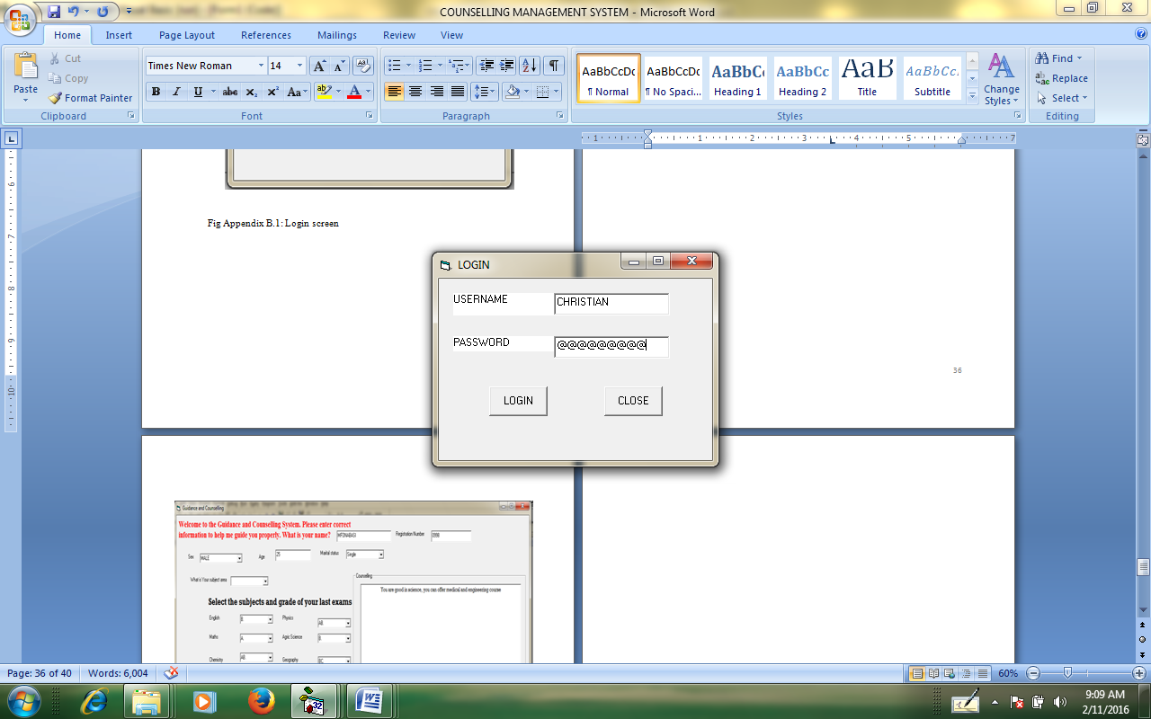**OUTPUT**

Fig Appendix B.1: Login screen

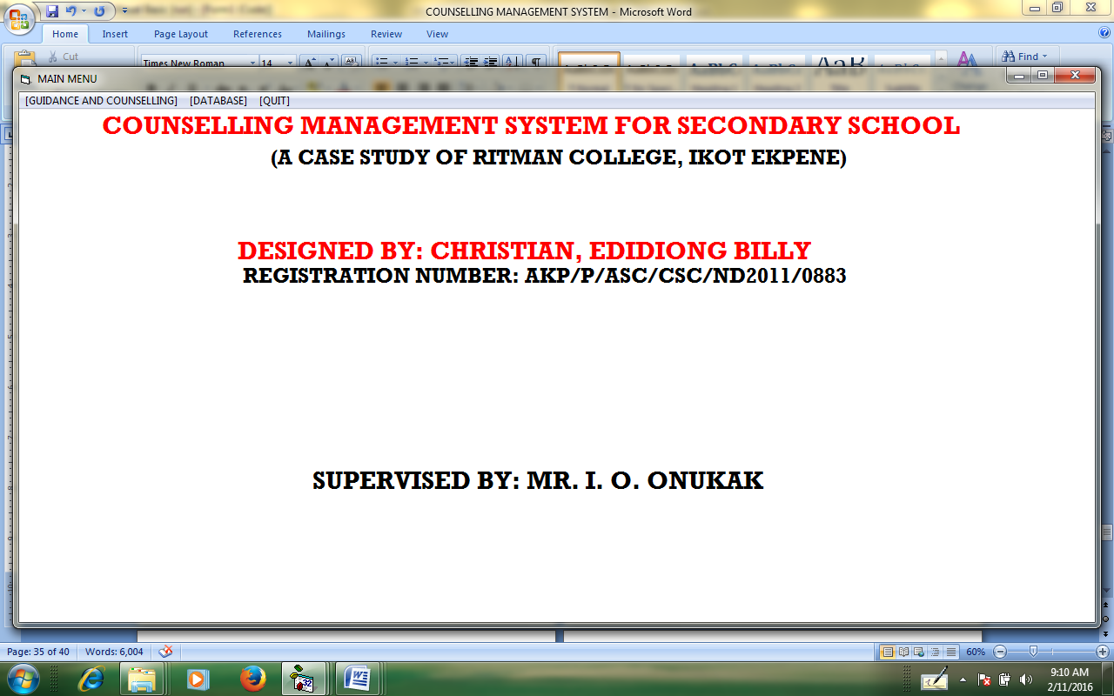Appendix B.3: Main Menu screen

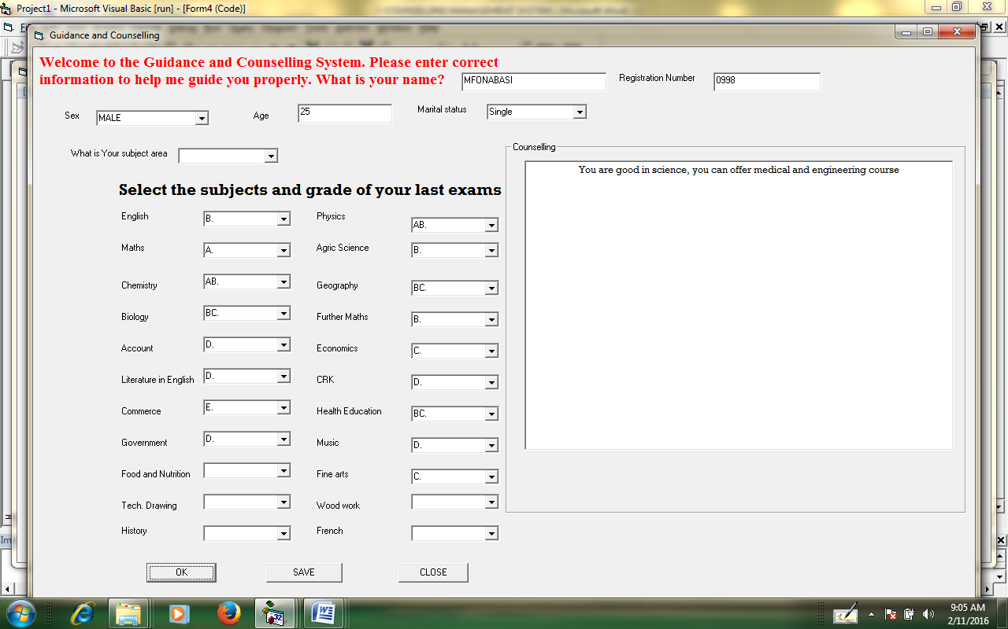

Fig Appendix B.4: Counseling screen

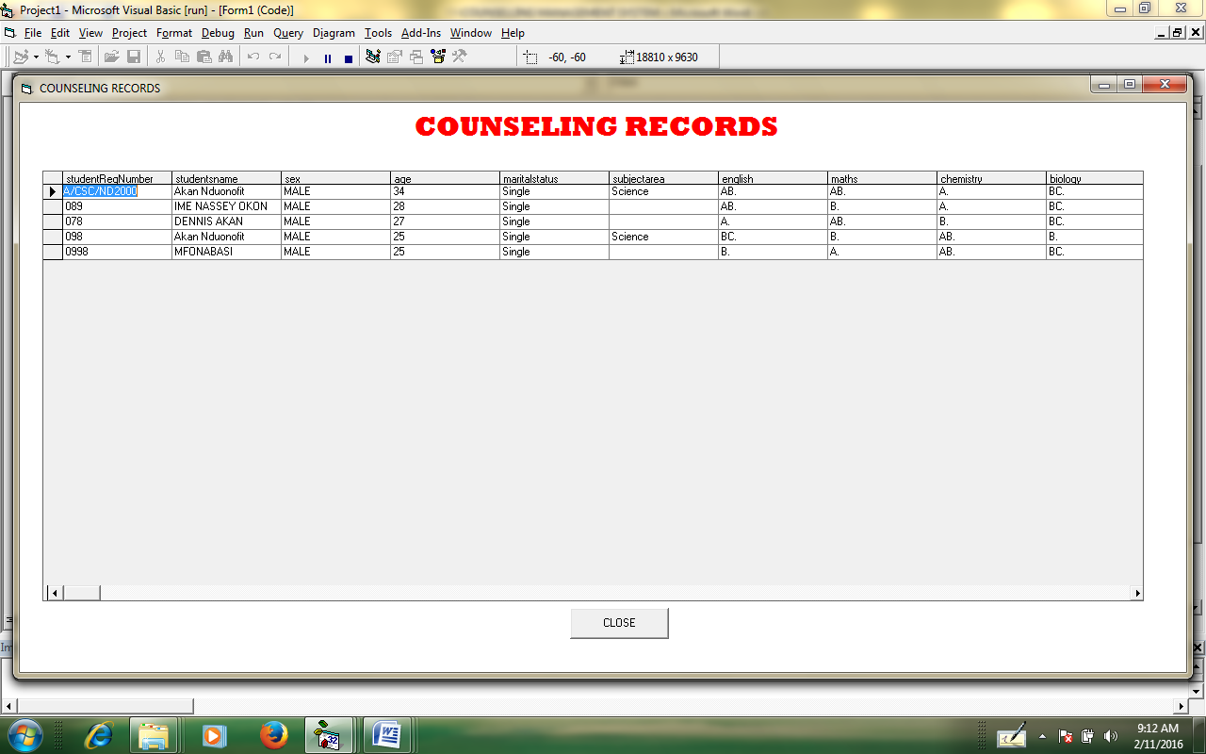Fig Appendix B.5: Counseling records screen

**Abstract**

*This study focused on the design and implementation of an artificial intelligence system for guidance and counseling. Guidance and counseling is a professional activity that is targeted at helping students choose a path of progress in life that is best suited for them based on their present academic abilities. An artificial intelligence system for career guidance and counseling interacts with its user by asking basic questions and accepting input such as the O’ level grades of its user and then the result will be processed to determine if the student can become an art student or science student. The importance of the system is that it can be used without a human expert and it will help in solving the problem of wrong career choice since individual student can make use of the system. The software development methodology that will be adapted to develop the system is the spiral model and the programming language used is visual basic 6.0 and the database used is Microsoft Access. In conclusion, an artificial intelligence system for guidance and counseling is very important as it is an alternative to supplement and aid human effort especially in a situation where human counselors are limited in number.*