

Developing a Conceptual Model and Delivering an Interactive Pitch on Gen AI

Faith Osakpolor Usie
@008215

Module Title: Managing Innovation and Creativity
NIOO-M0145 Level: M (63563)

Faith Osakpolor Usie
@00821597

August 2025

Table of contents

Table of contents ii
List of Figures iv
1. Introduction 1
2. Defining the Problem Situation 2
3. Literature Review on the Digital Divide and Gen AI 4
3.1 The Multidimensional Digital Divide 4
3.2 Determinants of Digital Exclusion 4
3.3 Emerging Solutions and the Promise of Gen AI 5
3.4 Risks and Ethical Challenges 5
3.5 Summary of Literature Gaps 6
4. Panel Data Analysis 7
4.1 Access to Broadband 7
3.2 Access to Digital Devices 7
3.3 Digital Skills Gap 8
3.4 Intersectional and Regional Trends 11
4. Conceptual Model – Gen AI Solution 11
4.1 Defining the Conceptual Model 11
4.2 Problem Situation 12
4.3 AI-Driven Interventions 13
4.4 Projected Inclusion Outcomes 13
5. Barriers to Implementation 14
5.1 Technological Barriers 14
5.2 Ethical and Algorithmic Risks 15
5.3 Social and Cultural Resistance 16
5.4 Organisational and Policy Constraints 16
6. Mitigation Strategies 17
6.1 Infrastructure and Access: Designing for Low-Bandwidth and Device-Constrained Settings 18
6.2 Ethical AI Design: Transparency, Inclusion, and Co-Creation 18
6.3 Building Trust and Confidence Through Human–AI Collaboration 18
6.4 Localisation and Accessibility 19
6.5 Organisational Capacity and Policy Alignment 19
7. Conclusion 20
References 21

List of Figures

Figure 1: Device Ownership by Income Quintile 6
Figure 2: Digital Literacy by Age Group in the UK 7
Figure 3: Conceptual Model of Bridging the Digital Divide Using Gen AI 9

Introduction
As the world is becoming more digitised, digital connectivity is becoming a necessity in order to engage in economic, educational, and social life. Nevertheless, a digital divide, which is a gap between those people and communities who are allowed to use digital technologies and those who are not, remains a significant challenge, especially in developed countries such as the United Kingdom (Van Dijk, 2020). The digital divide is at several levels: (1) access to such elements as broadband and digital devices, (2) skills needed to operate these technologies efficiently, and (3) results gained as a result of engagement in digital activities, like education, job, and health (Scheerder et al., 2017).
In the UK, the gap exists even with the great progress in the digital infrastructure. The Office for National Statistics (UK Parliament, 2023) notes that 6% of households do not have access to the broadband, and the most imbalanced are rural areas. Also, about 11 million adult UK citizens do not have basic digital abilities, and older adults, citizens with disabilities, and the low-income population, are the most likely to be left behind (BCS, 2023). Such disparities were even more flagrant with the COVID-19 pandemic that revealed a systemic dependency on the digital access to remote education, work, and healthcare (Lythreatis et al., 2022).
The purpose of this assessment is to examine how Generative Artificial Intelligence (Gen AI) may become an innovative tool to diminish the UK digital divide. Gen AI (i.e., algorithms that produce text, images, and other content, e.g., ChatGPT, Bard, Claude) could democratise how people seek information, since it provides adaptive, localised and user-friendly content (Lutz, 2019; Yu, 2020). Gen AI, when carefully applied, has the potential to reduce cognitive and technical-related barriers to digital engagement and enable the underserved groups to gain digital confidence.
This report aims at creating a conceptual model to define the problem of the digital divide in the UK and describe the solution to it using Gen AI. The model relies on the latest panel data, literatures that pass peer reviews, and policy reports, to:
- Analyse the digital exclusion landscape that is presently in place.
- Suggest customised Gen AIs therapy.
- Identify the barriers to the implementation and provide feasible mitigation measures

Defining the Problem Situation
Over the past decade, the United Kingdom has invested heavily in expanding its digital infrastructure. Yet, despite these improvements, a persistent digital divide continues to keep millions of people from participating fully in today’s online economy and society. This divide is more than just a matter of technology; it involves whether people have access to the internet and devices, whether they know how to use them confidently, and whether they can turn that use into tangible benefits in their daily lives (Van Dijk, 2020; Scheerder et al., 2017).
At the most basic level, the challenge begins with access to broadband and devices. National figures show that around 94% of households have broadband, but this headline figure hides sharp regional gaps. Rural parts of Scotland and Northern Ireland still fall below 85% coverage (UK Parliament, 2023). The problem is not just connectivity. Roughly 1.5 million households do not own a laptop, desktop computer, or tablet, an issue that hits low-income families particularly hard (Good Things Foundation, 2024).
A second layer of the divide is the gap in digital skills. Estimates suggest that 11 million UK adults cannot perform basic online tasks such as managing passwords, filling out digital forms, or finding information effectively (BCS, 2023). These gaps are not evenly spread—older adults, people with disabilities, and the unemployed in deprived areas are most affected. Age is a major factor: over 60% of those aged 65 and above are unable to carry out even simple tasks online (Ofcom, 2021).
Even when people have both access and basic skills, there is a third barrier, deriving meaningful benefits from being online. Many marginalised groups lack the confidence, cultural relevance, or personalised support needed to make digital tools work for them. Without this, technology remains underused, leaving opportunities in education, employment, healthcare, and civic participation untapped.
These three layers, access, skills, and outcomes, often overlap in complex ways. Factors such as age, income, geography, and disability can combine to create deep, long-term disadvantage. For example, an elderly person in a rural, low-income community might have unreliable internet, little confidence in using digital services, and few tangible benefits from going online.
Governments and charities have tried to address these issues through device donation schemes, public Wi-Fi projects, and classroom-style training. While valuable, these approaches are often short-lived, generic, and difficult to scale. They also tend to overlook the need for personalised and culturally relevant content that can truly engage people.
With the rapid growth of digital technologies, and the arrival of Generative AI (Gen AI), there is an opportunity to rethink how the UK tackles digital exclusion. If new strategies are not inclusive, targeted, and ethical, the country risks widening the gap even further, leaving the most vulnerable permanently disconnected from the benefits of the digital world.

Literature Review on the Digital Divide and Gen AI
To develop a well-rounded picture of the digital divide, it is important to evaluate academic views concerning the definition of the digital divide, its causes, and changing aspects of it, particularly as related to new technologies like Generative Artificial Intelligence (Gen AI). In this section, the synthesis of the major literature is conducted in five thematic areas.

3.1 The Multidimensional Digital Divide
The digital divide is originally thought of as a physical access gap to ICTs (Norris, 2003), but has since come to embrace a multidimensional and dynamic nature (Van Dijk & Hacker, 2003). It is currently divided into three levels that are widely categorised:
- First-level: Inequalities in access to infrastructure (e.g. broadband, devices).
- Second-level: Differences in digital skills and usage practices (Hargittai, 2001).
- Third-level: Differences in the online results and social capital benefits (Scheerder et al., 2017).
According to Van Deursen and Van Dijk (2019), access to material has gained more importance than connectivity because the devices are not equally good and functional. Therefore, one of the ways of dealing with this divide is not only to be able to provide access, but also to increase effective and meaningful use.

3.2 Determinants of Digital Exclusion
Digital inequality does not occur at random, whereby it overrepresents older adults, low-income families, rural citizens, and individuals with disabilities (Lythreatis et al., 2022). Van Dijk (2020) points out that the following are the key determinants:
- Structural factors: Income, education, age, and gender.
- Cultural capital: Familiarity with tech and learning habits.
- Technological design: Interface complexity, language, and accessibility features.
These disparities were worsened by the COVID-19 pandemic particularly in education. According to Aissaoui (2022), disadvantaged households had children disengaged in the digital world longer during lockdowns, which increased educational inequality.

3.3 Emerging Solutions and the Promise of Gen AI
The conventional digital inclusion initiatives involve donation of devices, digital skill learning, and community Wi-Fi access points. Nevertheless, these do not tend to offer scalable and personalised support.
A new opportunity is generative AI, epitomized by such tools as ChatGPT, Jasper, and Scribe. These models are in a position to:
- Develop context sensitive education content.
- Act as virtual digital literacy tutors.
- Create multi language/ localised material that appeals to the culture and language of the users.
According to Lutz (2019) and Yu (2020), Gen AI would make it easier to gather crowd participation due to the minimization of advanced digital literacy requirements. They both do warn, however, that Gen AI created without inclusivity would be prone to biases or widen the gap further, what Yu (2020) refers to as the algorithmic divide.

3.4 Risks and Ethical Challenges
There are dangers in the application of Gen AI. According to the research by Shakina et al. (2021) and Lythreatis et al. (2022), there is a warning of:
    - Training data bias, which means omitting the underrepresented voices.
    - Privacy and surveillance concerns, especially with AI tracking user behaviour.
    - Low digital assurance, which may restrict usage among the marginalised groups.
The best way to reduce such risks is by having a governance framework that incorporates the communities affected in developing and implementing Gen AI systems (Hepburn, 2018; Van Dijk, 2020).

3.5 Summary of Literature Gaps
Although literature acknowledges the potential of Gen AI, very little empirical literature dwells on the practical use of Gen AI in digital inclusion projects- particularly in the rural settings in the UK. In the following project, I will attempt to close that gap by approaching the use of Gen AI with underserved communities in a context-sensitive manner.

Panel Data Analysis
The most important step to take in this effort of comprehending the digital divide in the UK is to examine the current information on access to broadband connection, digital device and digital skills. Based on data available in the Office for National Statistics (ONS), British Computer Society (BCS), and Kaggle databases, as well as in government reports, this section will determine the main tendencies of the digital exclusion issue, especially among rural communities, older citizens, lower-income households, and disabled people.
Community Affected | Key Statistic / Insight | Source | Possible Impact / Implication
Rural Communities (esp. Scotland & Northern Ireland) | Only ~85% of rural households have broadband vs. 99% in urban areas | UK Parliament (2023); GOV.UK (2024) | Limited access to online education, telehealth, and job markets; risk of long-term economic exclusion
Low-Income Households | 1.5 million households lack laptops/desktops/tablets; bottom income quintile 3x more likely to lack devices | Good Things Foundation (2024); Kaggle (2021) | Children forced to share devices → reduced educational outcomes; persistent cycle of poverty
Children in Low-Income Families | 14% had to share a single device during COVID-19 lockdowns | GOV.UK (2024) | Disadvantage in remote learning → widening education gap
Older Adults (65+) | 60% unable to carry out basic online tasks | Ofcom (2021) | Exclusion from online banking, healthcare, and civic participation; increased social isolation
People with Disabilities | Many face inaccessible digital interfaces | Ipsos (2024); Lythreatis et al. (2022) | Limited access to digital services → exacerbates inequality, reduces independence
Unemployed in Deprived Areas | Higher likelihood of lacking both digital skills and confidence | Ipsos (2024); BCS (2023) | Difficulty in job applications and skills training; risk of long-term unemployment

4.1 Access to Broadband
There were 94% of households with broadband access in the UK as of 2023. Nevertheless, stable internet connection is experienced among just 85 per cent of households in rural areas as opposed to 99 per cent in urban centres (UK Parliament, 2023). Some areas such as Northern Ireland and rural Scotland have a lower-than-average connectivity because of insufficient investment in digital infrastructure (GOV.UK, 2024).
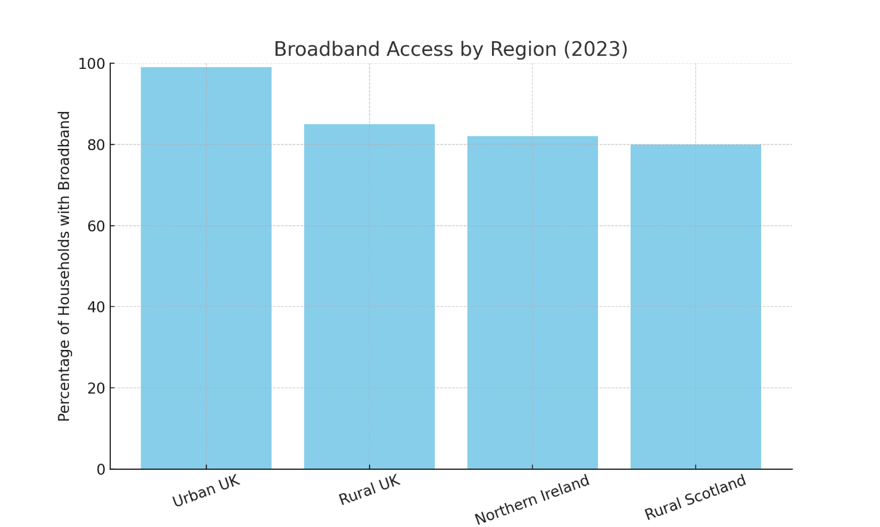

Geographic disparity continues to exist due to the lack of available infrastructure, especially in the case of distant learners and job seekers as well as vulnerable groups who are becoming more dependent on online services.

4.2 Access to Digital Devices
The digital device divide is also another factor in exclusion. A Good Things Foundation (2024) states that approx. 1.5m households in the UK do not own a laptop, desktop or tablet. Furthermore, 14% of children in low-income families had to share one device during COVID-19 lockdowns (GOV.UK, 2024), disallowing them to receive remote learning.
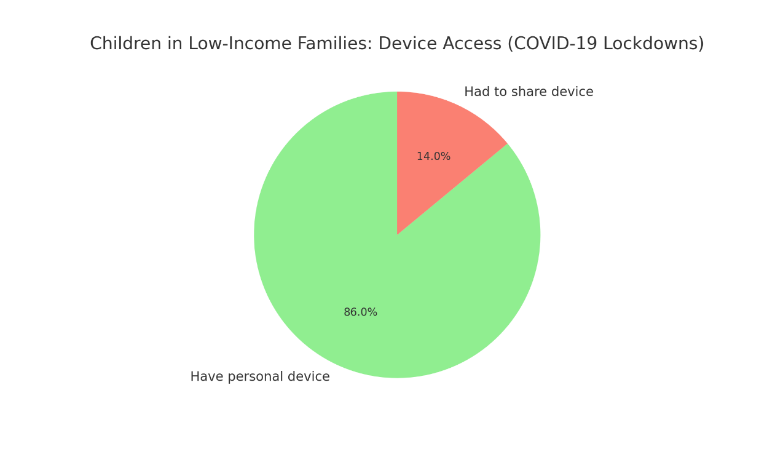
The negative relationship between the household income and the ownership of the digital device is further shown in a Kaggle dataset on Internet Access & Poverty Rate. The bottom quintile of households had almost three times higher chances of not having a connected device compared to the top quintile (Kaggle, 2021). Statista Research Department (2019) shows the Percentage of households with a mobile phone in the United Kingdom (UK) in 2018, by gross income group in Figure 1;
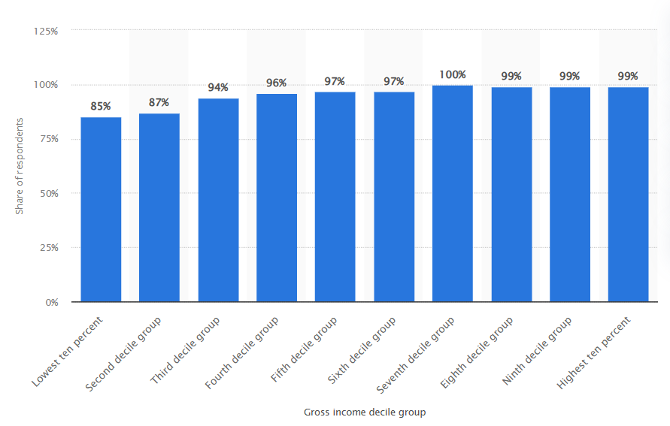
Figure 1: Device Ownership by Income Quintile

4.3 Digital Skills Gap
The main issue is digital literacy. According to The Lloyds Consumer Digital Index (2024), approximately 26 per cent of UK grown-ups are deficient in underpinning digital skills, or those that relate to the power to regulate passwords, search engines, or fill in forms online (Ipsos, 2024). This disparity is unequally impacted by:
    - The aged (65+) with 60% being unable to carry out simple tasks (Ofcom, 2021).
    - Individuals who have disabilities, a large number of whom are faced with inaccessible interfaces.
    - The unemployed particularly in the deprived areas.
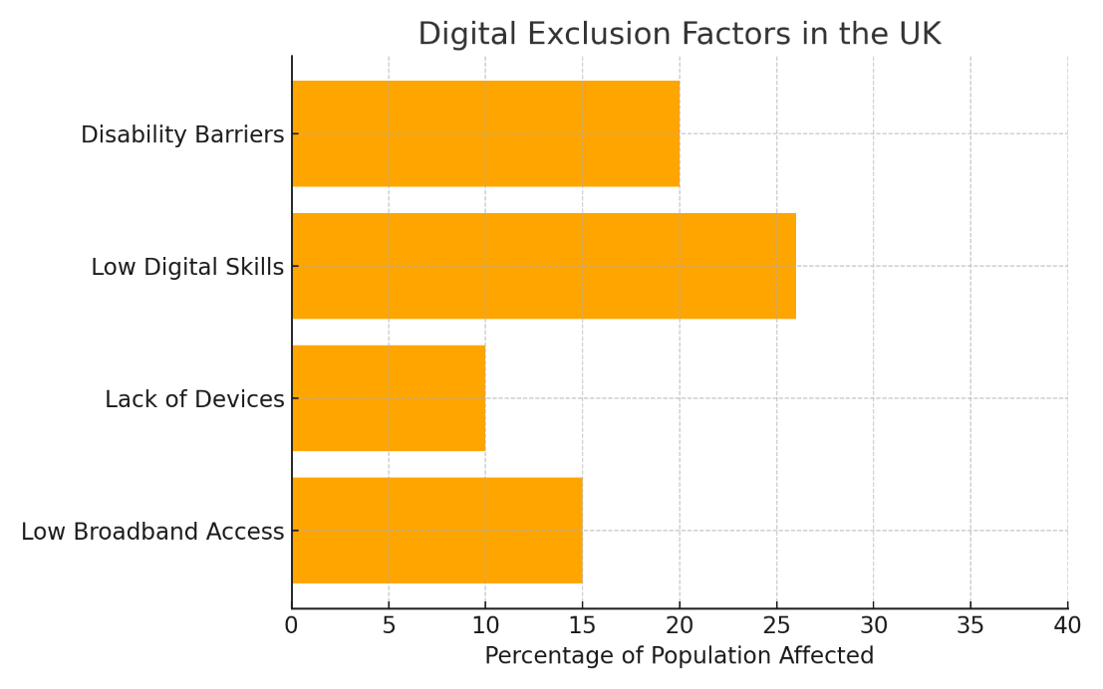

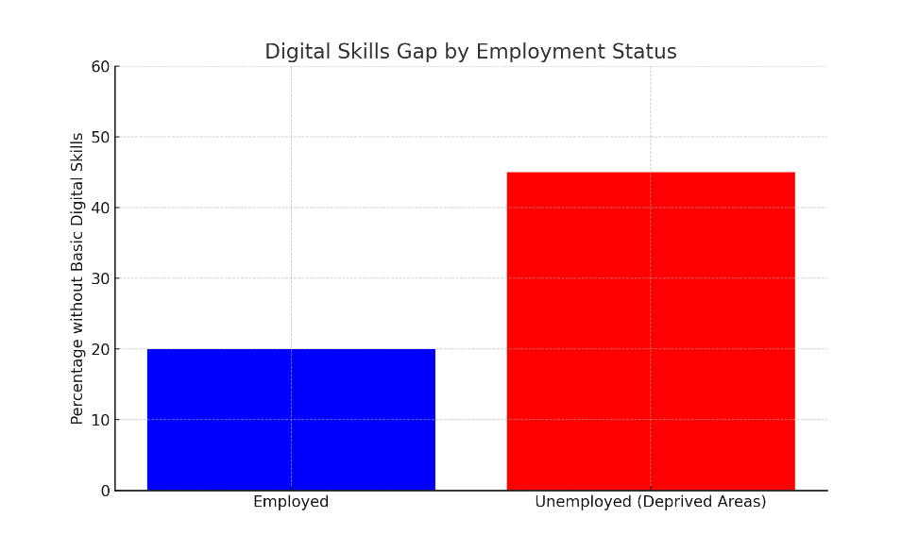

It is also worth mentioning that digital divide exists on the second level: not everyone who has the internet knows how to use it efficiently and with confidence (Hargittai, 2001; Van Deursen & Van Dijk, 2019). According to figure 2, the number of internet users is high in younger generations but the number decreases significantly in the age bracket of 65 and above;
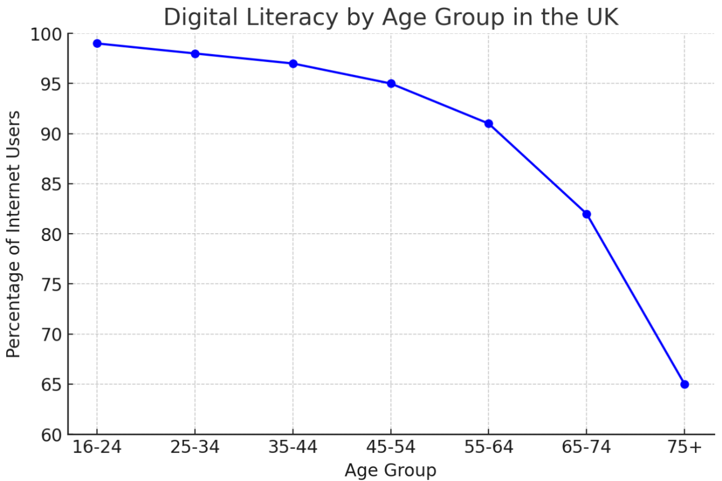
Figure 2: Digital Literacy by Age Group in the UK
Source: Cumberland Council (2025)

4.4 Intersectional and Regional Trends
Digital exclusion increases when there are compounding factors like age, income, geography and more so disability. As such, elderly residents in rural Northern Ireland would be disadvantaged threefold: low broadband, low digital confidence and low income.
Furthermore, the case study of elderly digital inclusion points out that the design of digital policies tends to ignore the experiences of marginalised users, which leads to poor intervention (Hepburn, 2018).

5. Conceptual Model – Gen AI Solution

4.1 Defining the Conceptual Model
A conceptual model involves a structured expression of a complex issue and its suggested response by manifesting connections between diverse elements, actors, and processes. In that regard, the model locates the multidimensional issue of digital exclusion in the UK and describes how the Generative Artificial Intelligence (Gen AI) can be used to decrease digital inequalities. The model is guided by panel data, conceptual approaches to digital inequality and newly arisen scholarly discussion of the transformative potential of AI in the education and delivery of public services.
The conceptual model will have three domains that should be interconnected with each other, including the problem situation, the AI-powered intervention mechanisms, and the intended inclusion outcomes. The structural barriers to the problem domain include poor broadband coverage, the lack of devices, and poor digital literacy. Intervention domain emphasises the contribution made by Gen AI in terms of developing accessible, scalable and localised digital experiences. Lastly, the outcome domain foresees a digitally inclusive society where everyone can contribute to the digital economy and the life of a community regardless of their backgrounds.
Figure 3 gives a graphical representation of this model. This visualization is used to track that certain forms of the digital divide can be addressed with specific Gen AI solutions to produce measurable results in digital confidence, access, and inclusion.

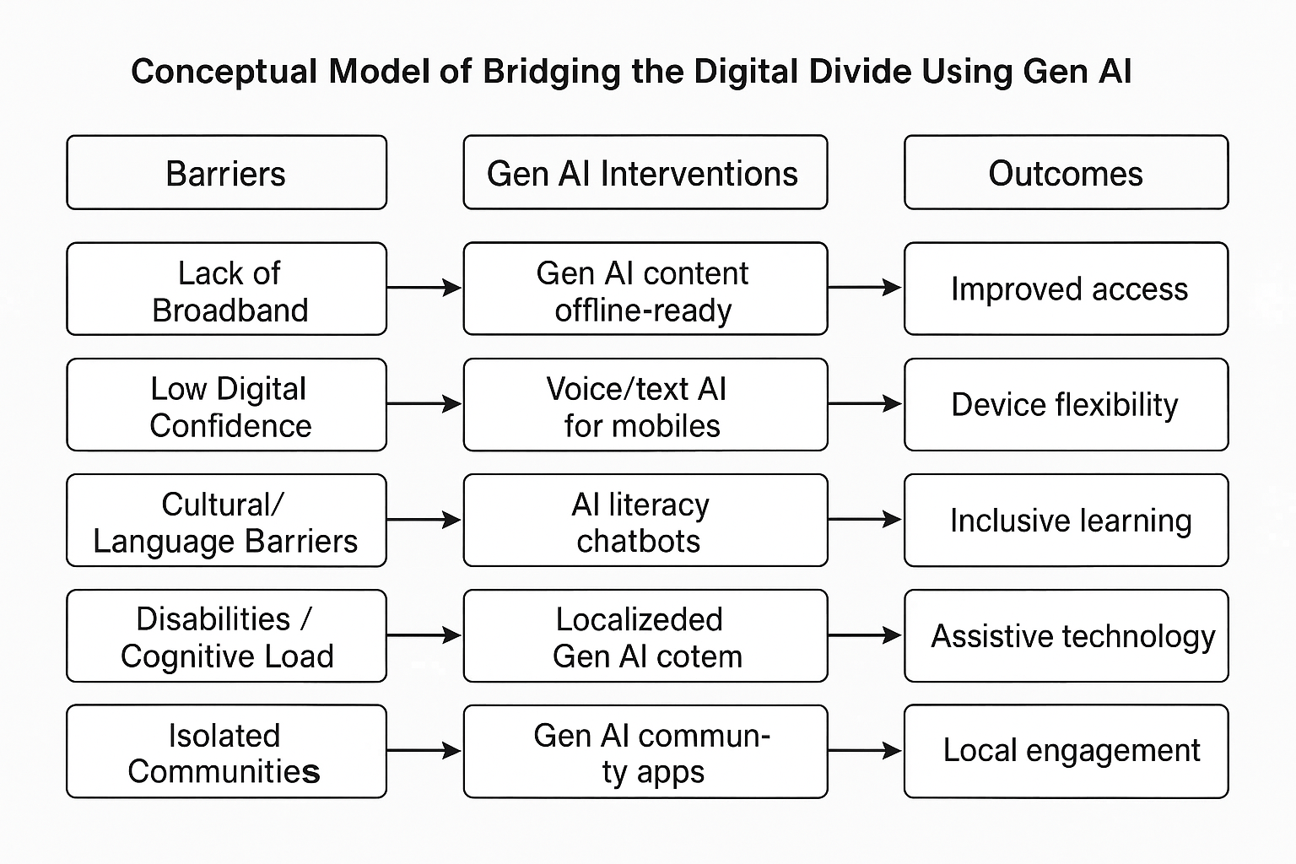
Figure 3: Conceptual Model of Bridging the Digital Divide Using Gen AI

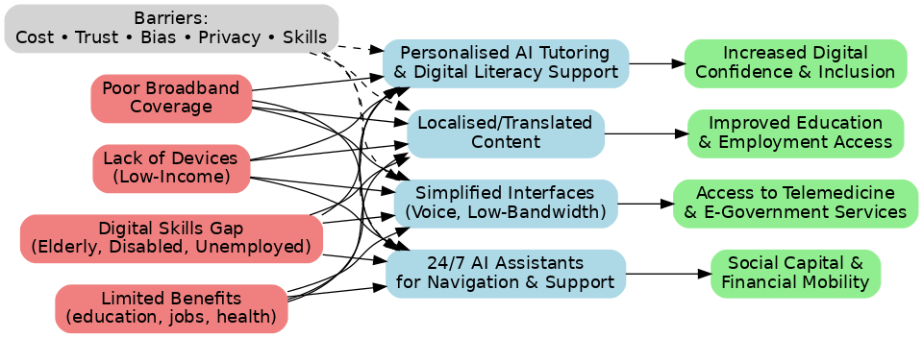

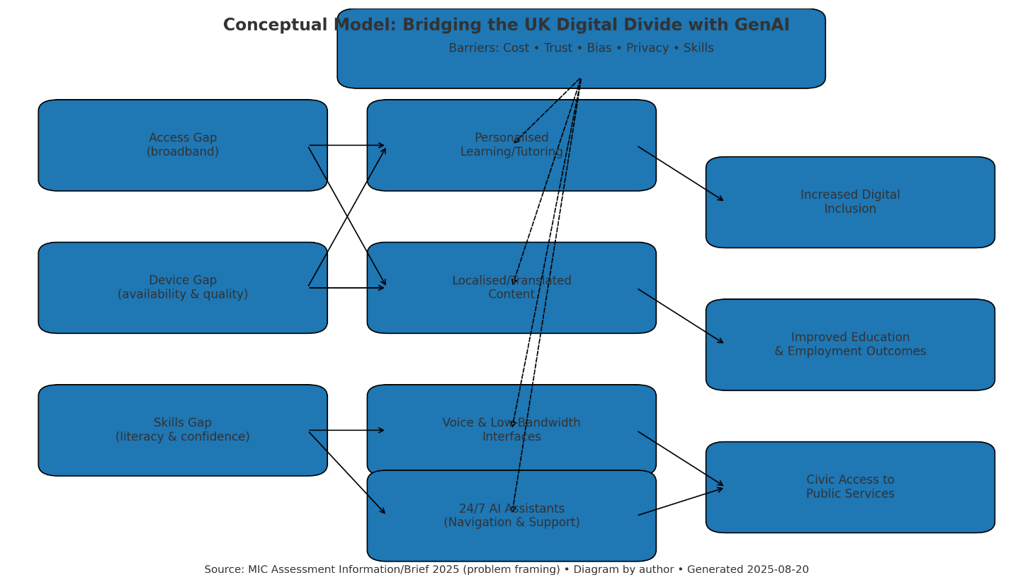

4.2 Problem Situation
The conceptual model is built on the basis of the noted inequalities in digital access, skills, and outcomes. The underserved population and rural area have an infrastructural gap in that they have no access to fast broadband or devices. Even households in the bottom quintile of the income distribution are the least likely to have a functioning laptop or a smartphone. Meanwhile, the old age and disabled users have a problem when traversing digital interfaces, even when the physical access is provided. Such cumulative adversities are not technological alone, but they are also socio-economic and cognitive, and generic solutions will simply not work (Van Dijk, 2020; Hepburn, 2018).
Notably, the second and third levels of stratification, i.e., the differences in digital literacy and the capacity to extract value out of the online interactions, are still poorly addressed at the policy and industry levels. Although infrastructure investment is still needed to expand the coverage, the ability and self-efficacy to participate in the digital systems meaningfully is a more deep-rooted problem, especially among the marginalised populations (Scheerder et al., 2017; Aissaoui, 2022).

4.3 AI-Driven Interventions
Gen AI will provide a scalable and adaptable way of managing these deeply rooted disparities. In contrast to conventional digital training programs, usually demanding a specific environment and well-trained facilitators, Gen AI applications can learn to accommodate a user, his or her setting, language, and speed. As an example, by using large language models like ChatGPT, one can have an interactive digital tutor that can teach how to use a computer or complete forms online or even how to be safe online. Not only do these tools exist in mobile devices, which are more prevalent in low-income populations, but they can also answer questions in natural language, the kind of language used in conversation, thus lessening the mental load typically found in digital interactions (Lutz, 2019; Yu, 2020).
The other opportunity is in the content localisation. Being generated, text, audio, or video content may be in various dialects, reading levels, or cultural frames so that users can work with material that seems familiar to them. Such a feature is especially useful in multicultural areas or with persons whose native language is not English. This form of personalisation leads to greater engagement as well as knowledge retention, not only addressing the skill gap but also the trust gap many digitally excluded people experience when using generic or overly technical websites (Shakina et al., 2021).
Moreover, user interface made with Gen AI can be developed to make the navigation easier by avoiding extra steps, using voice commands or visual feedback. Such interface optimizations have the potential to improve the usability of people with disabilities, the elderly, or people with low literacy levels, who are commonly disadvantaged by the design of the current digital services (Hargittai, 2001; Lythreatis et al., 2022).

4.4 Projected Inclusion Outcomes
The model projects a number of positive effects by incorporating Gen AI in the delivery of public services and community training. Some of them are enhanced digital confidence, expanded online learning and job-seeking, and enhanced access to telemedicine and e-government services. In the long term, this interaction will produce social capital, decrease isolation and enhance financial mobility, especially in underserved populations.
It is worthwhile to mention that the model does not describe Gen AI as a self-sufficient solution. Instead, it offers Gen AI as an enabler, a soft, adaptive layer that enhances the current strategies of digital inclusion through personalisation, accessibility, and their cultural responsiveness. Gen AI is one of the technologies which, when used responsibly and with community co-creation, can help foster the creation of an inclusive digital ecosystem and not a technical solution.

5. Barriers to Implementation

Although the possible future impact of Generative AI (Gen AI) in closing the digital divide in the UK is promising, the process of deploying the said technologies in underserved communities is not without great obstacles. These obstacles are technological, ethical, social and organisational. This part critically analyses these barriers and establishes the basis of the next section on mitigation measures.

5.1 Technological Barriers
Among the most direct obstacles to the implementation of the Gen AI solutions is the dependency on the infrastructure. Even though Gen AI tools may be lightweight and adaptable, most of them still depend on stable internet connections and sufficient computational power, which is scarce in either rural or low-income regions (UK Parliament, 2023). In case of connectivity, the limitation of devices, including old smartphones or shared laptops in a household, can also impede the complete interaction with AI-enabled platforms.
In addition, a wide variety of Gen AI tools are constructed on the basis of large language models (LLMs) which need constant updates and connection to cloud services. This adds the risk of incompatibility or latency in very low-bandwidth settings (Lythreatis et al., 2022). Moreover, integration into the inclusion strategies may be complicated by the absence of interoperability between AI tools and current solutions used in providing public services (e.g., NHS Digital, GOV.UK).

5.2 Ethical and Algorithmic Risks
Another significant challenge is the ethical issue with bias and fairness in AI models. When trained on large amounts of data that tend to mirror existing societal inequities, gen AI systems can perform tasks that further the stereotyping of others, rule out minorities in terms of dialect, or fail to comprehend marginalised experiences (Yu, 2020). This is especially disturbing in those applications that address the vulnerable groups that are already underrepresented in training data (Lutz, 2019).
Another risk is the risk of algorithmic opacity where the users and even implementers may not have any idea of how the AI system makes decisions. This has the ability to destroy trust and reduce adoption. To use an illustration, an AI system that recommends learning modules based on wrong assumptions about the origin or the capability of a particular user might prove alienating instead of assisting the user.
Additionally, there are questions around data privacy and consent when using AI in community contexts. This means that most users, particularly the older users and the digitally reluctant users might not be aware of the collection and use of their data thus failing to comply with GDPR and lose their ethical participation (Shakina et al., 2021).

5.3 Social and Cultural Resistance
Digital exclusion does not only mean material shortages, as it is also influenced by perception, trust, and motivation of the users. Most of those who are digitally excluded, older people, in particular, are likely to regard new technologies with distrust or fear of failure, which prevents them to experiment or stay engaged (Van Dijk, 2020).
Moreover, barriers to language and cultural inappropriateness of Gen AI-generated contents to the local realities may also cause rejection and/or misinterpretation. As an example, the instructions or lessons created by AI might be unreachable to the users with lower literacy levels or those who study English as a second language because of using unfamiliar idioms or formal academic language (Aissaoui, 2022).
The stigma of being the former group, that is, digitally left behind, is also broader, and it might not allow people to seek help or acknowledge their weaknesses (Hepburn, 2018). The asking to get a digital tool may be seen as a symbol of weakness even in some communities particularly with older men or some ethnic groups, which further increases the gap in participation.

5.4 Organisational and Policy Constraints
Implementation-wise, inefficient coordination of policy framework and a scattered funding system restrain the scope and sustainability of Gen AI solutions within the public or third sector context. Although the UK has several programs on digital inclusion (including the Digital Inclusion Strategy, Good Things Foundation programs, and BCS-led partnerships), most of them exist in silos and fail to incorporate AI innovation in full (GOV.UK, 2024; BCS, 2023).
Skill shortages between local authority employees and workers in the third sector who might lack technical confidence to use or manage AI tools successfully are also an issue. It indicates that community training is not only necessary but so is capacity building in the implementing organisations (Shakina et al., 2021).
Moreover, in the UK, AI technology advances can easily outpace regulatory certainty and there is confusion on AI ethics codes, procurement policies and public-private partnerships. This makes the adoption slow and discourages risk averse stakeholders.

6. Mitigation Strategies
The challenges to overcome to introduce Gen AI to the UK communities that are excluded in the digital world are high but not beyond reach. In this section, I have described practical and situation-specific means of resolving the technological, ethical, social, and organisational issues that were presented above. The proposed recommendations are based on the existing models of inclusions, case studies, and research on the digital innovations to promote the more comprehensive and sustainable approach.

6.1 Infrastructure and Access: Designing for Low-Bandwidth and Device-Constrained Settings
Gen AI systems are to be optimised to be mobile-first and offline to overcome infrastructural deficits. According to the research, low-income and rural users are much more likely to own smartphones than laptops (Kaggle, 2021; UK Parliament, 2023). So, Gen AI interface must:
    - Reduce data usage (e.g. low-weight apps, use of voice only).
    - Integrate offline capability with pre-trained models in devices (Lutz, 2019).
    - Be able to be deployed on the public access points (e.g. libraries, community Wi-Fi hubs).
Local level and government must encourage public-private partnerships to deliver low-cost or donated devices and internet connectivity to vulnerable households- this could be based on the current models such as the DeviceDotNow project and the Good Things Foundation National Databank.

6.2 Ethical AI Design: Transparency, Inclusion, and Co-Creation
To reduce bias, surveillance issues and black box algorithms, developers should integrate ethical AI principles in the heart of Gen AI solutions. This includes:
    - Training on a wide range and representative of training data, including regional accents in the UK, cultures and languages.
    - An engagement of community co-design workshops, during which end-users test and design AI features prior to its deployment (Van Dijk, 2020).
    - Applying the explainability features, which will enable the users to see the process of the creation of AI suggestions (Yu, 2020).
Organisations like the Alan Turing Institute and AI Now Institute have published ethical AI toolkits that can guide inclusive design practices.

6.3 Building Trust and Confidence Through Human–AI Collaboration
It is important to build trust in order to reach digitally hesitant users. Another feasible approach is to make Gen AI an extension of the human support rather than an alternative to it and thus a part of the hybrid learning framework. For example:
- AI tools can be presented during the sessions in the community by digital mentors or volunteers (e.g. Digital Unite).
- AI can work on repetitive matters (e.g. resetting passwords, filling out form tutorials) and people can offer a sense of security, background guidance, and social interaction.
Such hybrid approaches have proven successful in adult literacy and digital health programmes, especially when deployed in culturally familiar settings (Hepburn, 2018; Aissaoui, 2022).

6.4 Localisation and Accessibility
The element of culture is important in maintaining common ground and being accessible. Strategies include:
    - Training Gen AI models to produce local slangs or content that is local specific.
    - Provision of multilingual assistance especially in places with intensive migration or ethnicity.
    - Embedding universal design principles, such as large font options, screen reader compatibility, and voice-only navigation for people with visual or cognitive impairments (Lythreatis et al., 2022).
The AI developers can work with local government digital inclusion officers and charities (e.g. AbilityNet) to make sure that these adaptations are properly put into practice.

6.5 Organisational Capacity and Policy Alignment
Most third-sector organisations and local government do not have the skills or resources to carry out AI-led projects. Hence, the national capacity-building programmes must be developed. Recommendations include:
    - Ethics, deployment and troubleshooting AI upskilling workshops to the staff.
    - Developing a central Gen AI inclusion toolkit to be used by councils and NGOs, like the Local Digital already available toolkits.
At the policy level, the policy and practice of aligning the deployment of AI with the UK Digital Strategy (2022), Levelling Up White Paper (2022), and the priorities expressed by the Digital Skills Council will guarantee funding and accountability. A broad usage will also be promoted by the presence of clear procurement standards and ethical approval procedures.

7. Conclusion
The digital divide in the United Kingdom has remained one of the significant social and economic challenges, where the rural communities, low-income families, elderly, and those with disabilities are disproportionately represented. Like this report has demonstrated, the gap is not only about the availability of broadband or devices, but also about the fact that there are considerable differences in terms of digital skills, confidence and the capability to deliver meaningful things through digital involvement.
In this report, a theoretical framework has been established to reflect Generative Artificial Intelligence (Gen AI) as an empowering digital inclusion tool. Based on panel data and relevant literature, the model translates digital exclusion barriers to tailored Gen AI solutions, such as tailored digital literacy support, local content creation and voice assisted navigation. It also includes the ethical and structural impediment like algorithmic prejudice, data confidentiality and user distrust.
The application of Gen AI can help to achieve the digital inclusion agendas of the UK and make sure that the vulnerable groups are not left behind in the digital era through inclusive design principles, public-private cooperation, community engagement, and the use of ethical AI governance. The presented model supports the notion that co-designed and contextualised technology can be identified as a potent equaliser.

References
Aissaoui, N. (2022). The digital divide: A literature review and some directions for future research in light of COVID-19. Global Knowledge, Memory and Communication, 71(8/9), 686–708.
BCS. (2023). Digital poverty and digital capital. British Computer Society. https://www.bcs.org/articles-opinion-and-research/digital-poverty-and-digital-capital/
Cumberland Council. (2025). Chapter 4: Digital health and literacy. Cumberland Public Health Annual Report 2025. https://www.cumberland.gov.uk/cumberland-public-health-annual-report-2025/chapter-4-digital-health-and-literacy
Good Things Foundation. (2024). How deep is the UK’s digital divide? https://www.goodthingsfoundation.org/discover/digital-inclusion-insights/digital-inclusion-insights-2024/how-deep-is-the-uks-digital-divide
GOV.UK. (2024). Beyond the digital divide: Realising wellbeing through a digital needs hierarchy. https://www.gov.uk/government/publications/beyond-the-digital-divide/beyond-the-digital-divide-realising-wellbeing-through-a-digital-needs-hierarchy
Hargittai, E. (2001). Second-level digital divide: Mapping differences in people's online skills. arXiv preprint cs/0109068.
Hepburn, P. A. (2018). A new governance model for delivering digital policy agendas: A case study of digital inclusion amongst elderly people in the UK. International Journal of E-Planning Research (IJEPR), 7(3), 36-49.
Ipsos. (2024). Essential digital skills for work 2024. Ipsos. https://www.ipsos.com/en-uk/essential-digital-skills-work-2024
Kaggle. (2021). Digital Divide ~ Internet Access & Poverty Rate. https://www.kaggle.com/code/sasakitetsuya/digital-divide-internet-access-poverty-rate
Lloyds Bank. (2024). UK Consumer Digital Index 2024. https://www.lloydsbank.com/consumer-digital-index.html
Lutz, C. (2019). Digital inequalities in the age of artificial intelligence and big data. Human Behavior and Emerging Technologies, 1(2), 141-148.
Lythreatis, S., Singh, S. K., & El-Kassar, A. N. (2022). The digital divide: A review and future research agenda. Technological Forecasting and Social Change, 175, 121359.
Norris, P. (2003). Digital divide: Civic engagement, information poverty, and the Internet worldwide.
Ofcom. (2021, March). Digital divide narrowed by pandemic, but around 1.5 million homes remain offline. https://www.ofcom.org.uk/media-use-and-attitudes/online-habits/digital-divide-narrowed-but-around-1.5m-homes-offline
Scheerder, A., Van Deursen, A., & Van Dijk, J. (2017). Determinants of Internet skills, uses and outcomes. A systematic review of the second-and third-level digital divide. Telematics and informatics, 34(8), 1607-1624.
Shakina, E., Parshakov, P., & Alsufiev, A. (2021). Rethinking the corporate digital divide: The complementarity of technologies and the demand for digital skills. Technological Forecasting and Social Change, 162, 120405.
Statista Research Department. (2019, January). UK households with a mobile phone, by income group 2018. Statista. https://www.statista.com/statistics/289305/distribution-of-mobile-phones-in-the-uk-by-income-group/
UK Parliament. (2023). Digital exclusion (3rd Report of Session 2022–23, HL Paper 219). House of Lords Communications and Digital Committee. https://committees.parliament.uk/publications/40662/documents/198365/default/
Van Deursen, A. J., & Van Dijk, J. A. (2019). The first-level digital divide shifts from inequalities in physical access to inequalities in material access. New media & society, 21(2), 354-375.
Van Dijk, J. (2020). The digital divide. John Wiley & Sons. https://www.scirp.org/reference/referencespapers?referenceid=3990274
Van Dijk, J., & Hacker, K. (2003). The digital divide as a complex and dynamic phenomenon. The information society, 19(4), 315-326.
Yu, P. K. (2020). The algorithmic divide and equality in the age of artificial intelligence. Fla. L. Rev., 72, 331.

