Assignment
Please do implement the BM25 search index in your mongo db and update the env file with you respective mongo details.
Please complete the above assignment on creating the BM25 search index.
Additionally, explore and test the following functionalities:
* Vector Search
* BM25 Search - test cases
* Hybrid Search
* Prompt Schema
* Summarization
* De-duplication
BM25 Index Created
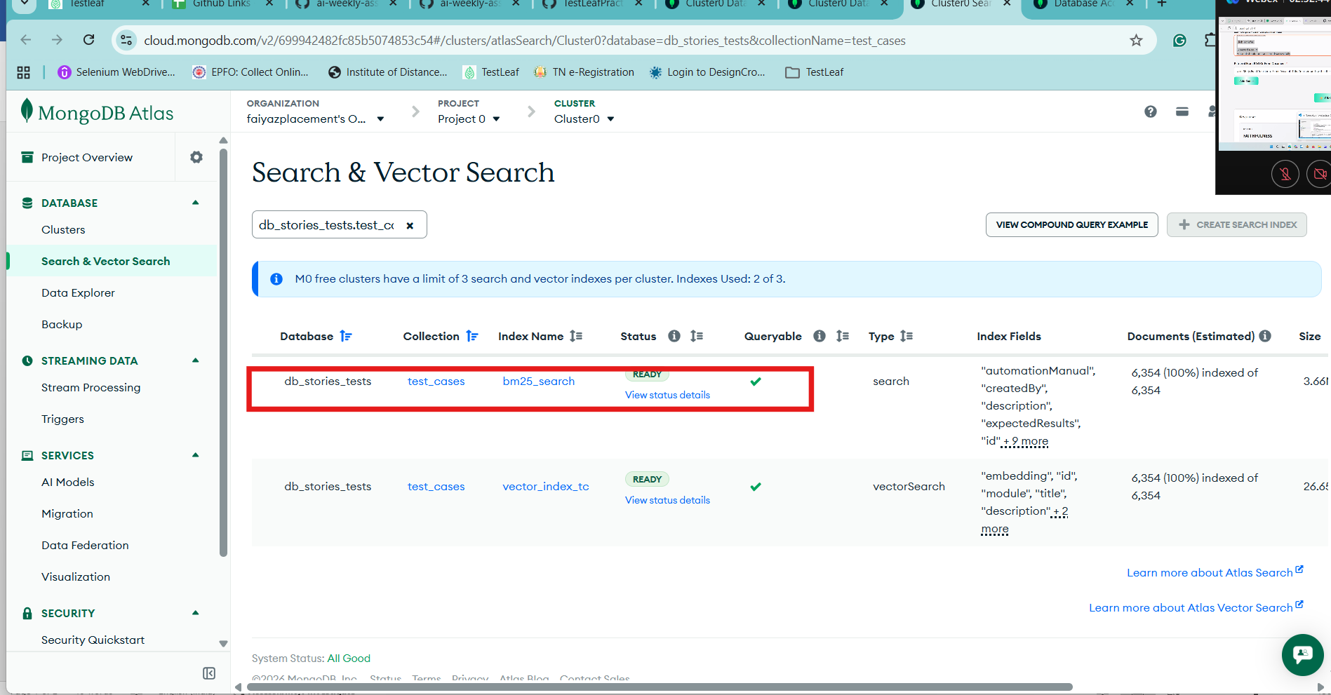
Embeddings created for Test cases and User Stories
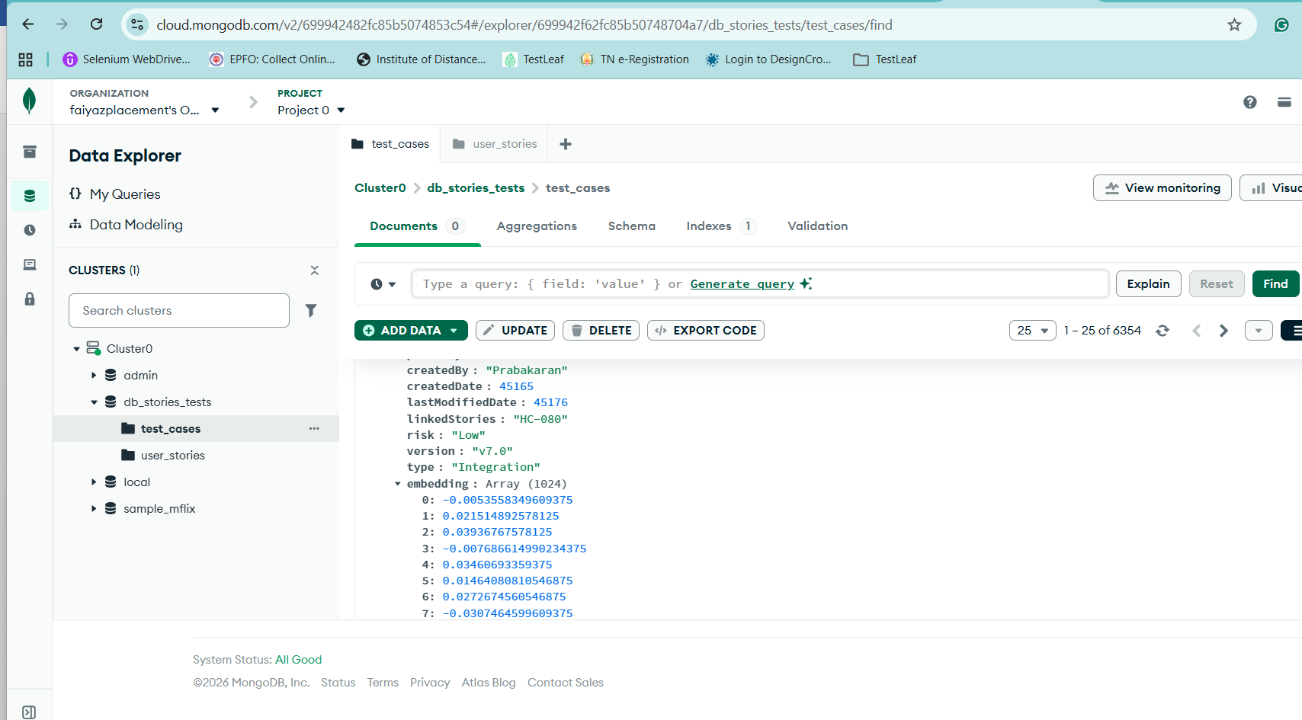

User stories
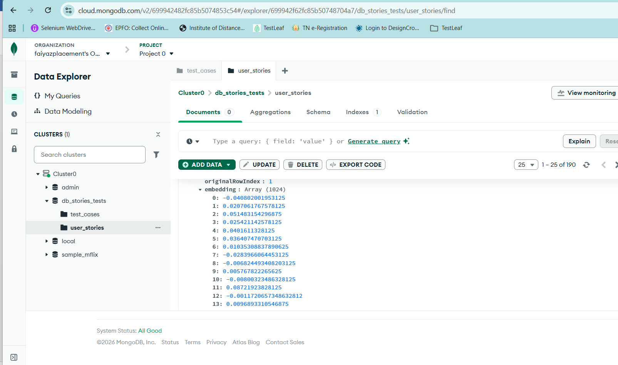

BM25 Search
1.Network tab result
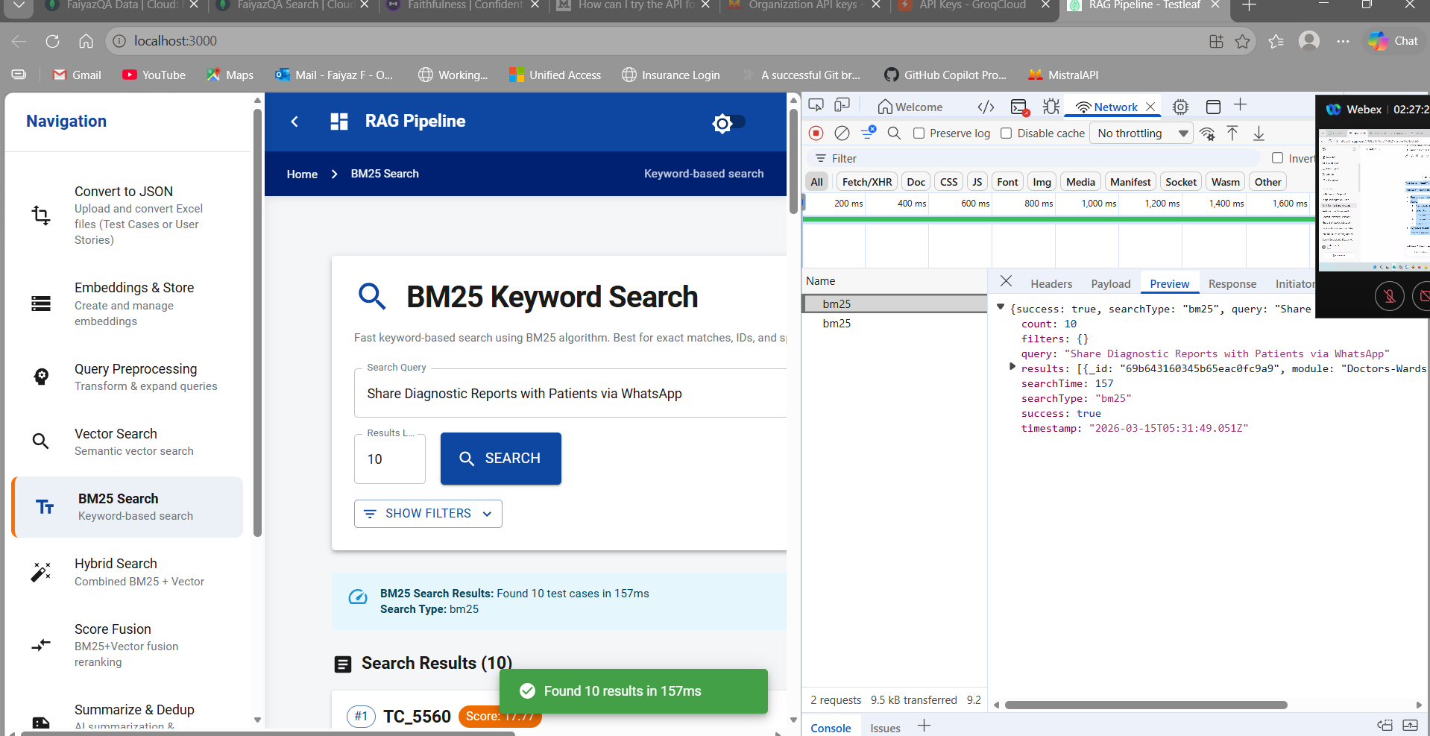

2.UIResult
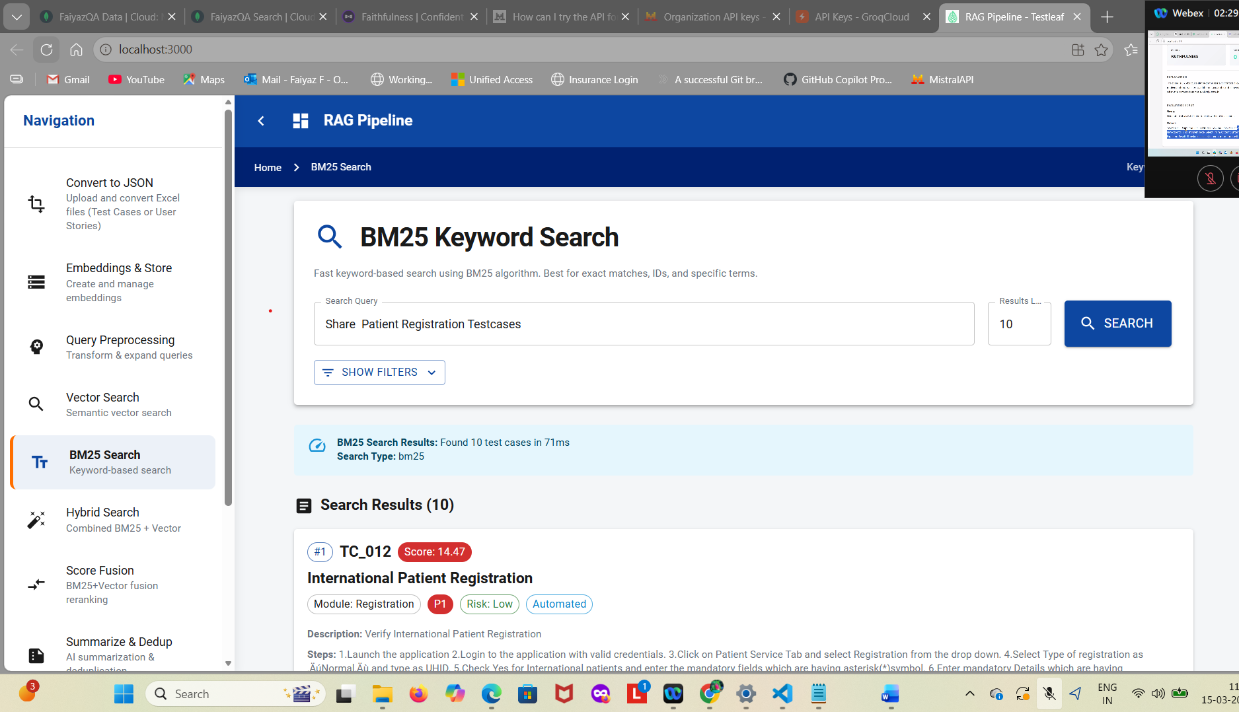

2. * Vector Search
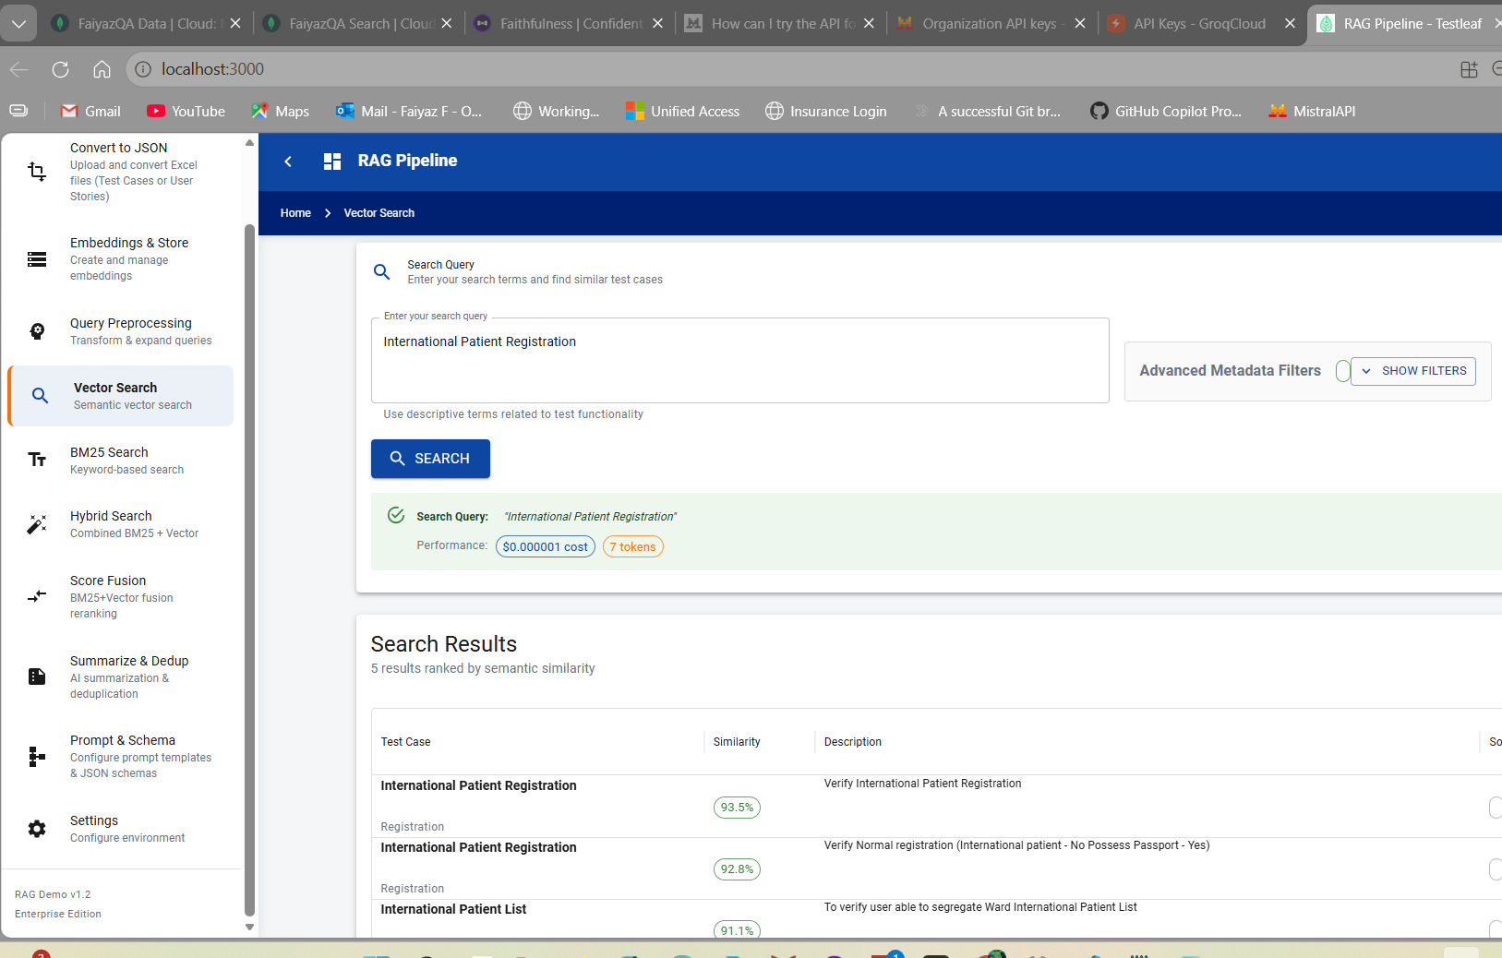
3. * Hybrid Search
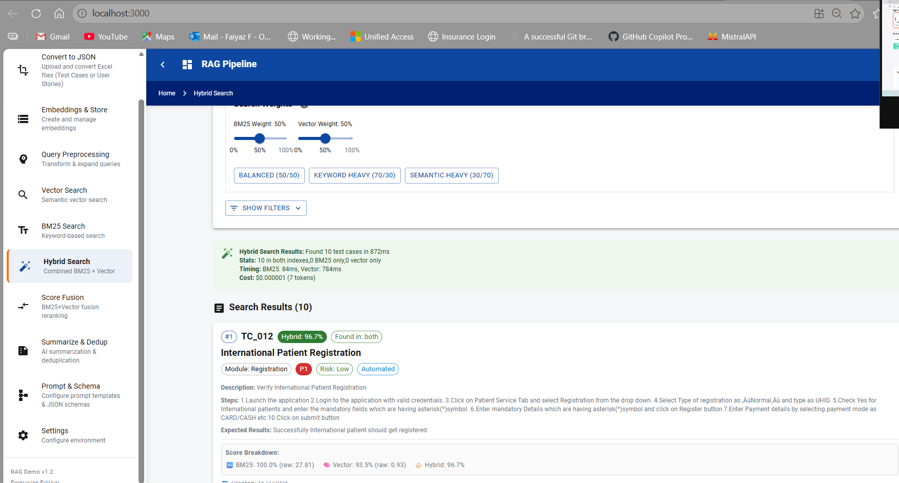
4. * Prompt Schema -Complete RAG Pipeline
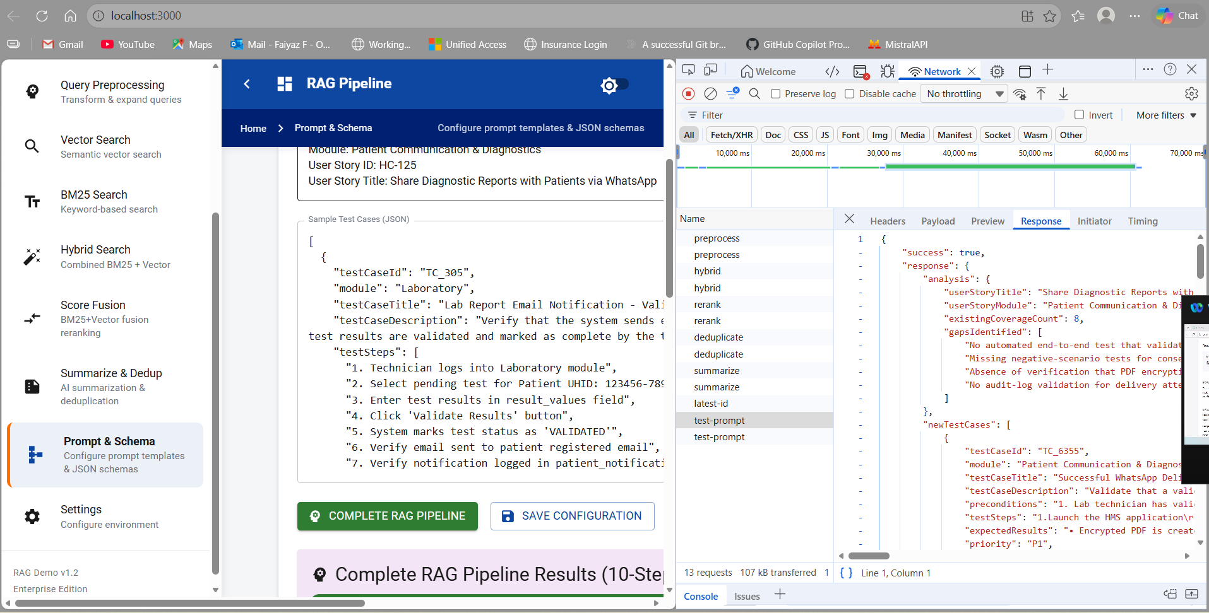
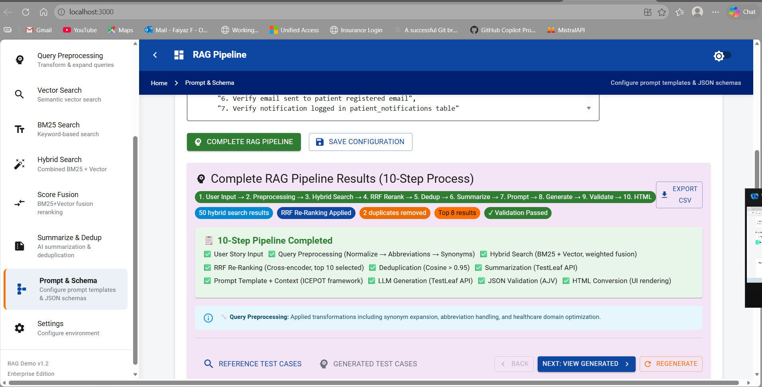
5. * Summarization & * De-duplication
