User Stories Scenario
- Created the collection named user_stories and vector index as userstory_vector_index
- {
- "fields": [
- {
- "type": "vector",
- "path": "embedding",
- "numDimensions": 1024,
- "similarity": "cosine"
- },
- {
- "type": "filter",
- "path": "jiraMetadata.projectKey"
- },
- {
- "type": "filter",
- "path": "status.name"
- },
- {
- "type": "filter",
- "path": "priority.name"
- },
- {
- "type": "filter",
- "path": "assignee.displayName"
- },
- {
- "type": "filter",
- "path": "components"
- },
- {
- "type": "filter",
- "path": "labels"
- },
- {
- "type": "filter",
- "path": "fixVersions"
- }
- ]
- }

Initially collection is empty
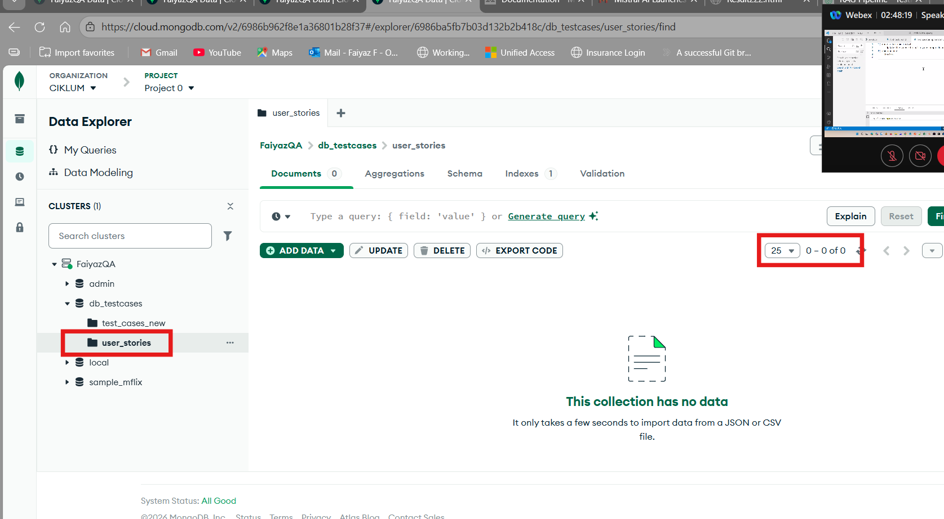
User Stories Excel to Json converted successfully
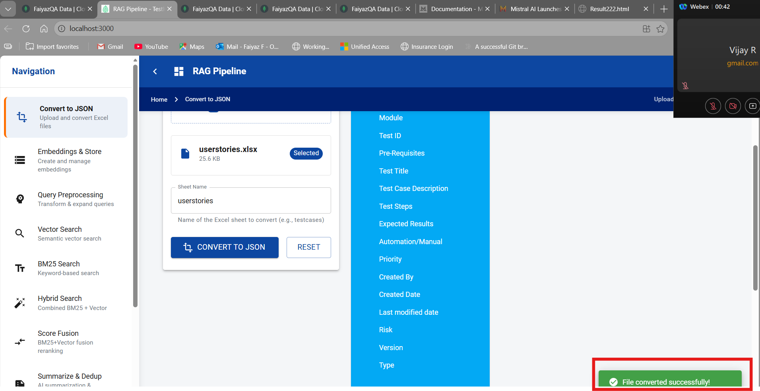

Embeddings is in progress
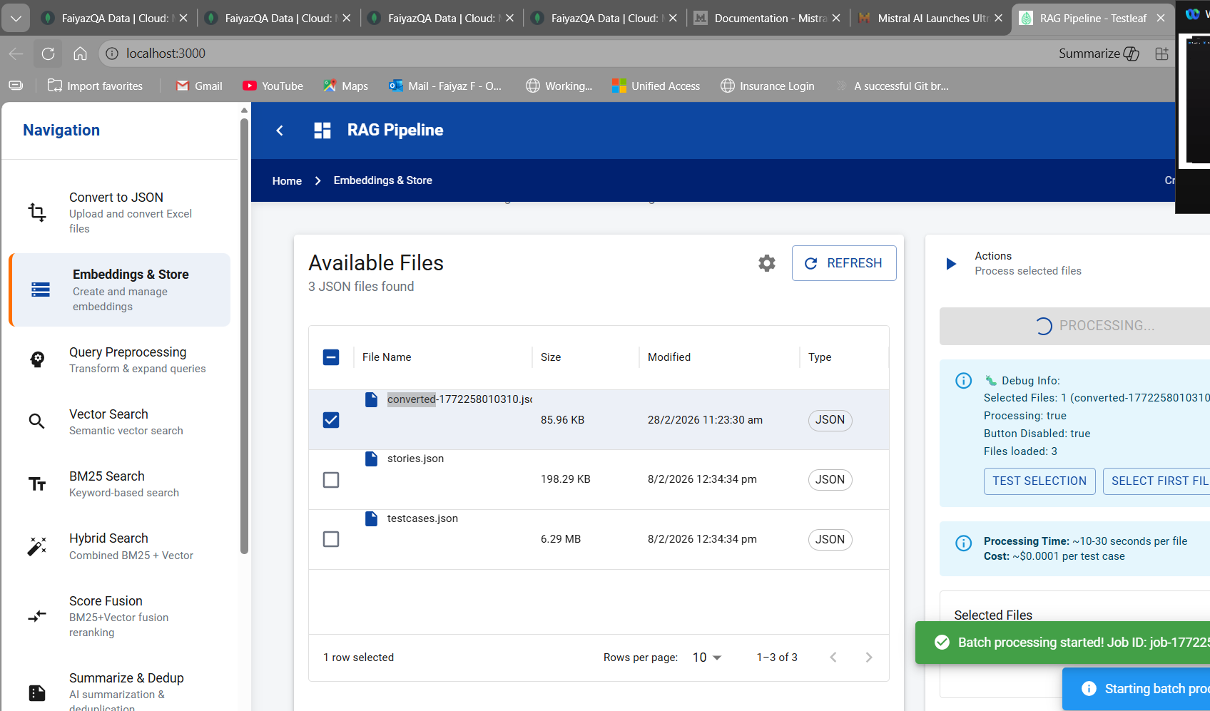

Embedding processed successfully
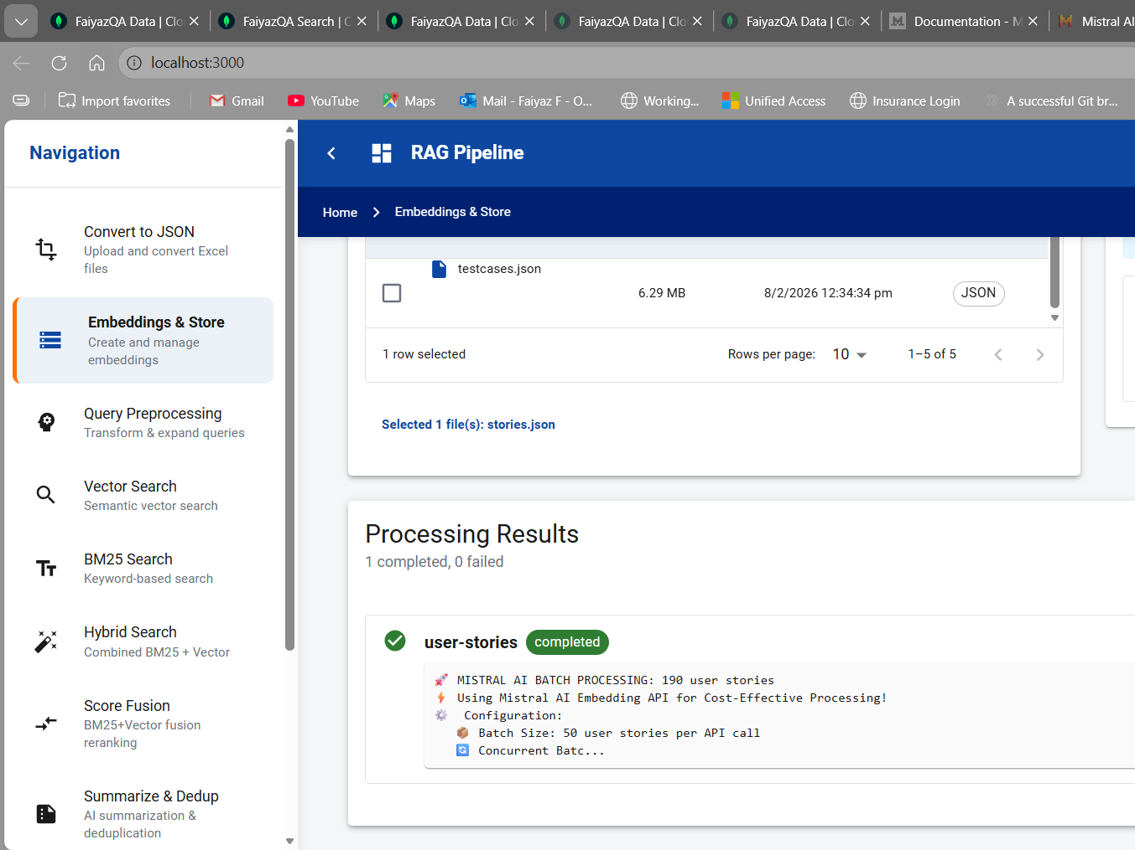
In DB embeddings created

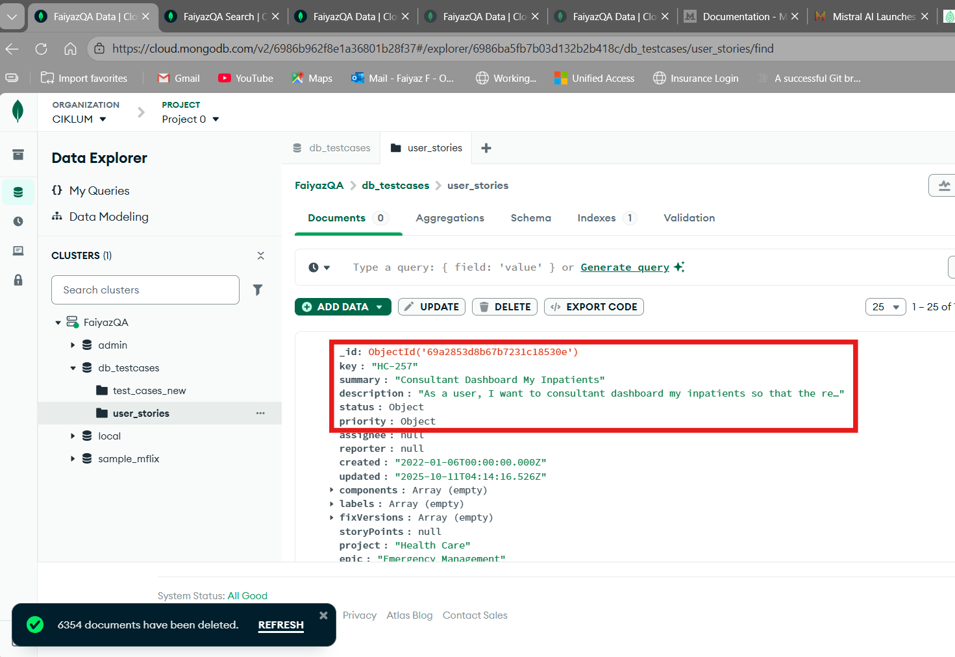

6000+ Testcases Scenario
1. Created the collection named test_cases and vector index as testcase_vector_index
{
"fields": [
{
"type": "vector",
"path": "embedding",
"numDimensions": 1024,
"similarity": "cosine"
},
{
"type": "filter",
"path": "id"
},
{
"type": "filter",
"path": "module"
},
{
"type": "filter",
"path": "title"
},
{
"type": "filter",
"path": "description"
},
{
"type": "filter",
"path": "steps"
},
{
"type": "filter",
"path": "expectedResults"
}
]
}

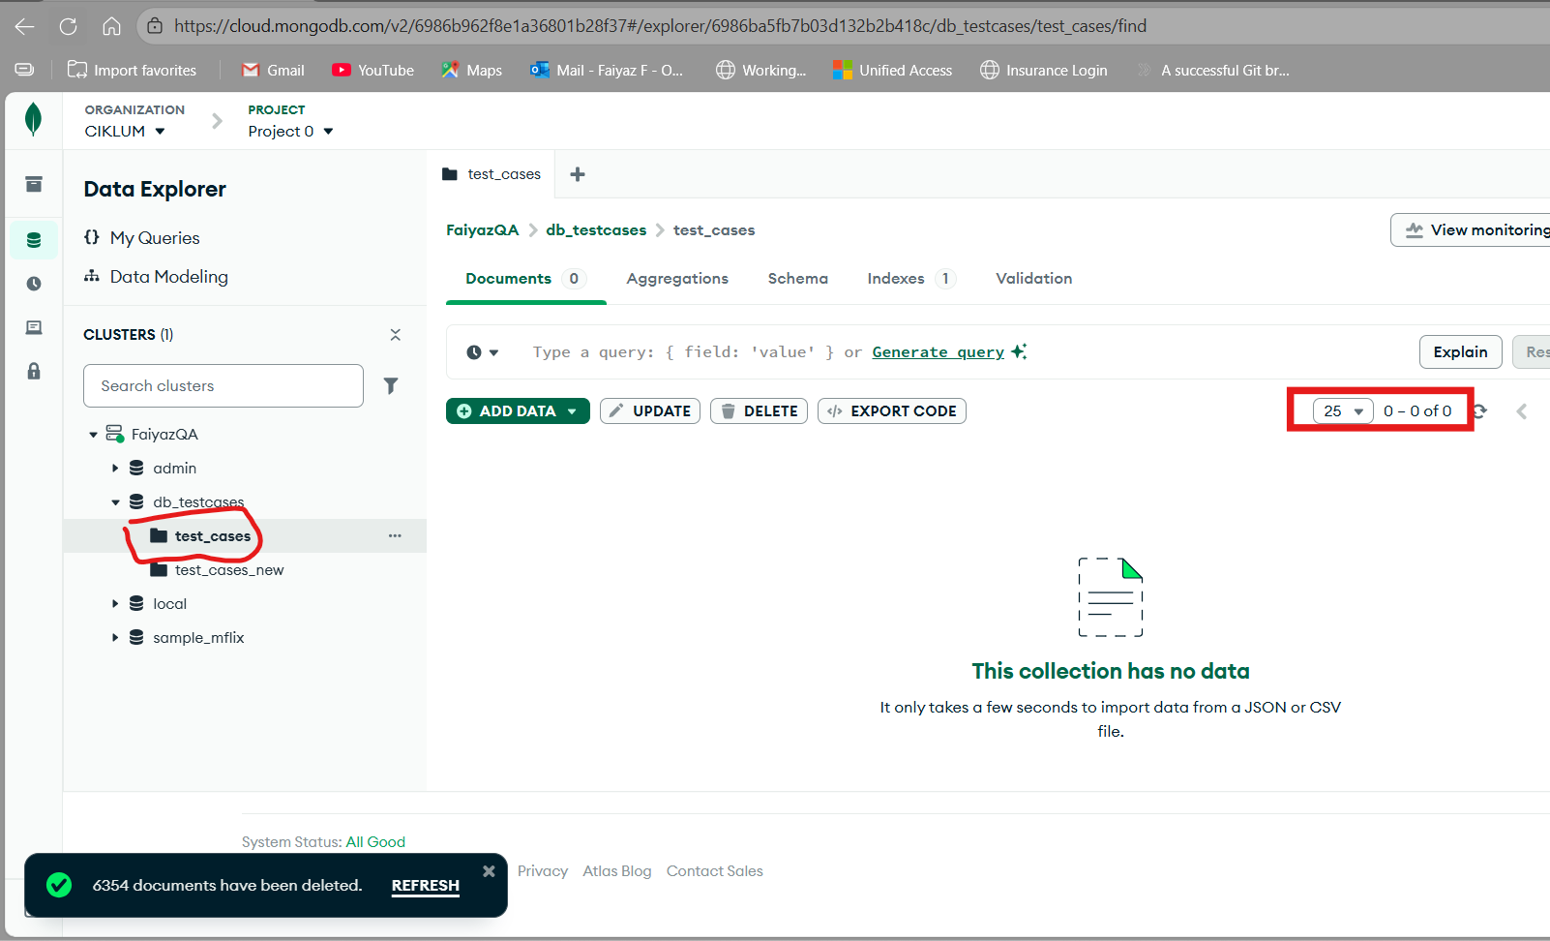
- Launched RAG application and converted the test cases Excel to JSON
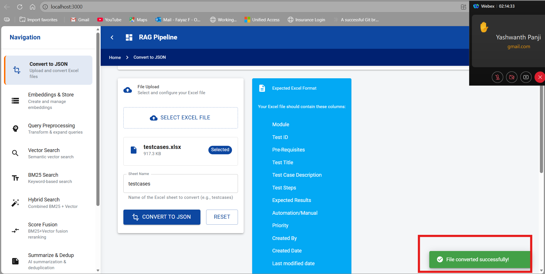

3.Creating embeddings- Inprogress
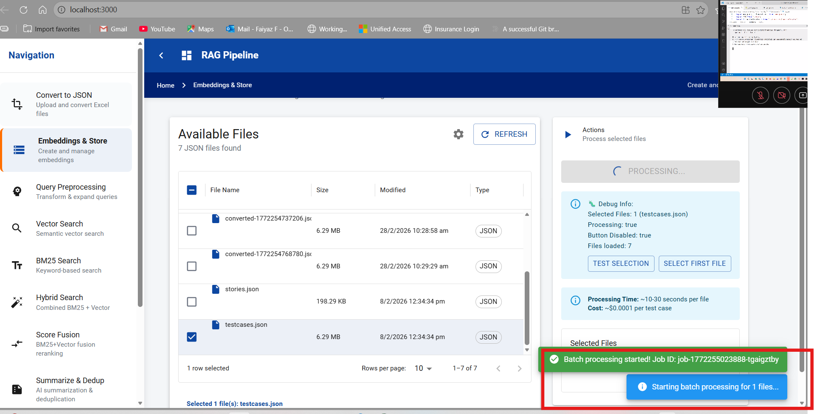

4.Processing completed
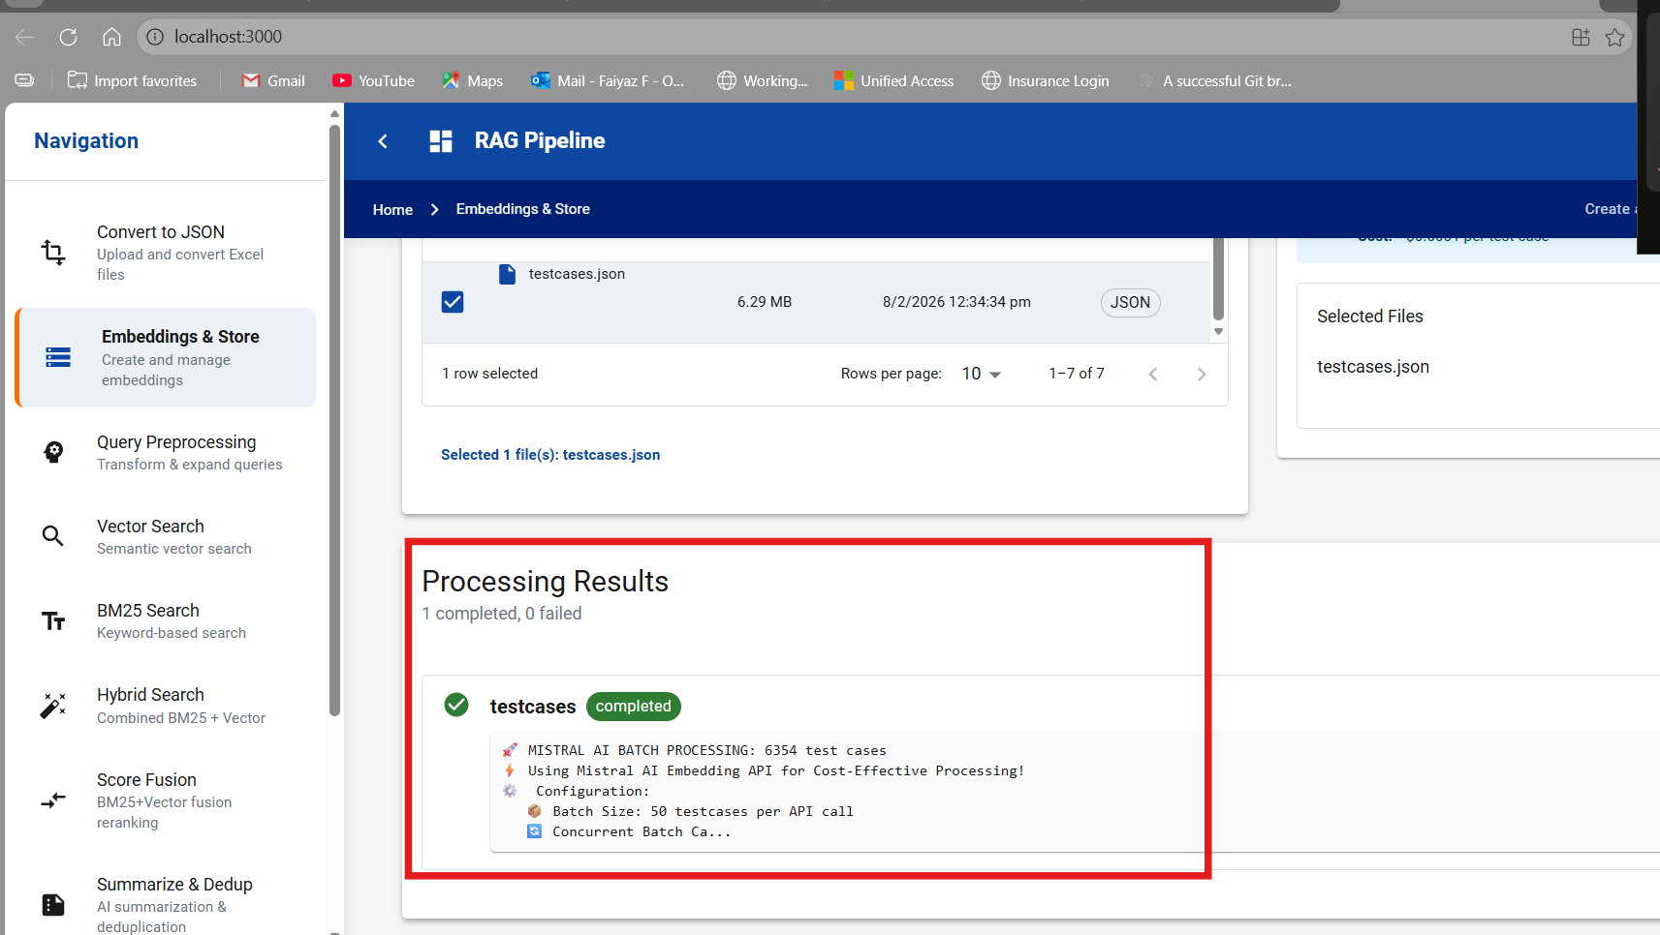

5.Inserted al the testcases
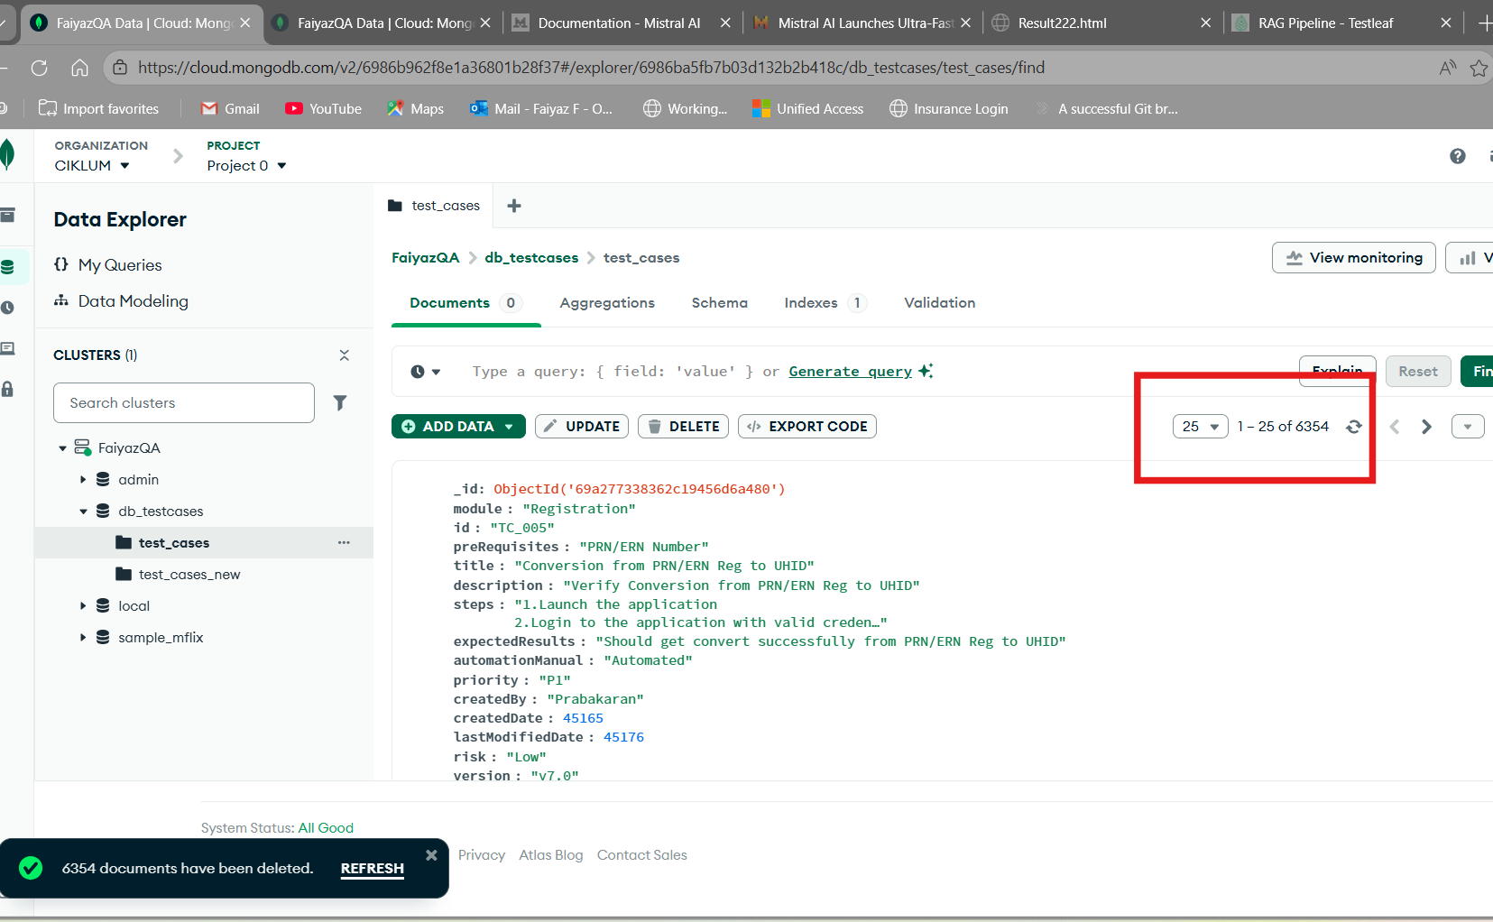
Embeddings
