AI AMBULANCE DISPATCH SYSTEM

A PROJECT REPORT
Submitted by
FAIZ RAHAMAN (CH.SC.U4AIE23014)
HARINDERAN T (CH.SC.U4AIE23019)
K KOUSHIK (CH.SC.U4AIE23024)
in partial fulfillment for the award of the degree of
BACHELOR OF TECHNOLOGY IN COMPUTER SCIENCE AND ENGINEERING
Under the guidance of
Dr. DEV KUNWAR SINGH CHOUHAN
Submitted to
DEPARTMENT OF COMPUTER SCIENCE & ENGINEERING
AMRITA SCHOOL OF COMPUTING
AMRITA VISHWA VIDYAPEETHAM
CHENNAI - 601103
OCTOBER 2025

BONAFIDE CERTIFICATE
This is to certify that this project report entitled "AI Ambulance Dispatch System" is the bonafide work of "Mr. Faiz Rahaman (Reg. No. CH.SC.U4AIE23014), Mr. Harinderan T (Reg. No. CH.SC.U4AIE23019), Mr. K Koushik (Reg. No. CH.SC.U4AIE23024)" who carried out the project work under my supervision as a part of Capstone project.
SIGNATURE
Dr. Dev Kunwar Singh Chouhan
Assistant Professor (Sr.Gr.)
Department of Computer Science & Engineering
Amrita School of Computing,
Amrita Vishwa Vidyapeetham,
Chennai Campus

DECLARATION BY THE CANDIDATE
I declare that the report entitled "AI Ambulance Dispatch System" submitted by me for the degree of Bachelor of Technology is the record of the project work carried out by me as a part of Capstone project under the guidance of "Dr. Dev Kunwar Singh Chouhan" and this work has not formed the basis for the award of any course project, degree, diploma, associateship, fellowship, titled in this or any other University or other similar institution of higher learning. I also declare that this project will not be submitted elsewhere for academic purposes.
S.No | Register Number | Name | Contribution %
1 | CH.SC.U4AIE23014 | Faiz Rahaman | 33.3%
2 | CH.SC.U4AIE23019 | Harinderan T | 33.3%
3 | CH.SC.U4AIE23024 | K Koushik | 33.3%
SIGNATURE
FAIZ RAHAMAN HARINDERAN T K KOUSHIK
(CH.SC.U4AIE23014) (CH.SC.U4AIE23019) (CH.SC.U4AIE23024)

ACKNOWLEDGEMENT
This project work would not have been possible without the contribution of many people. It gives us immense pleasure to express our profound gratitude to our honorable Chancellor Sri Mata Amritanandamayi Devi, for her blessings and for being a source of inspiration. We are indebted to extend our gratitude to our Director, Mr. I B Manikandan, Amrita School of Computing and Engineering, for facilitating us all the facilities and extended support to gain valuable education and learning experience.
We register our special thanks to Dr. V. Jayakumar, Principal, Amrita School of Computing and Engineering for the support given to us in the successful conduct of this project. We would like to express our sincere gratitude to Dr. Dev Kunwar Singh Chouhan, Assistant Professor (Sr.Gr.), Department of Computer Science and Engineering for his support and co-operation.

ABSTRACT
Emergency medical services (EMS) rely heavily on rapid response times to save lives. Traditional ambulance dispatch systems often face challenges related to inefficient routing, miscommunication during emergencies, and manual triage bottlenecks. This project introduces an AI-powered Ambulance Dispatch System that integrates proximity-based routing using the Haversine formula and the Google Maps API, ensuring the nearest and most optimal ambulance is dispatched in real-time. The system features a comprehensive web portal tailored for users, hospitals, and administrators, allowing seamless coordination.
To enhance accessibility and emergency response, we integrated the VAPI voice AI hotline (+1 608-901-3032), which acts as an autonomous triage agent capable of receiving SOS calls, evaluating patient severity, and dynamically dispatching ambulances without human intervention. The backend is built using FastAPI and MySQL, ensuring high concurrency and reliable state management for live ambulance tracking. The results indicate a significant reduction in dispatch latency and optimized routing even in high-traffic urban settings like Chennai, effectively addressing the limitations of conventional systems.
Keywords: Ambulance Dispatch, Artificial Intelligence, Proximity Routing, FastAPI, VAPI Voice Agent, Real-time Tracking.

CHAPTER 1: INTRODUCTION

1.1 MOTIVATION
The motivation behind this project originates from the critical need to reduce ambulance response times in urban and semi-urban areas. Delays in emergency medical response often lead to severe consequences, including loss of life. By leveraging modern AI and full-stack web technologies, we can automate and optimize the dispatch process, making it more robust, transparent, and scalable.

1.2 PROBLEM DEFINITION
Current EMS infrastructure heavily relies on manual operators who process emergency calls, determine severity, and manually assign ambulances based on perceived proximity. This introduces human error, latency, and inefficiencies. The primary objective of this project is to develop an automated system that captures patient location, calculates the most efficient route utilizing the Haversine formula and live map APIs, and uses an AI voice assistant for triage and continuous monitoring.

1.3 SYSTEM ARCHITECTURE OVERVIEW
The architecture comprises:
- Frontend: React-based dashboards for Users, Admins, and Hospitals.
- Backend: FastAPI services for routing, state management, and real-time WebSocket communication.
- Voice AI: VAPI integration for automated emergency call handling.
- Database: MySQL for storing user data, hospital metrics, and ambulance statuses.

1.4 SCOPE AND OBJECTIVES
1. Implement a location-aware dispatch algorithm.
2. Develop role-based interfaces for different stakeholders.
3. Integrate an AI voice assistant for hands-free SOS handling.
4. Provide live ambulance tracking with real-time ETA updates.

CHAPTER 2: METHODOLOGY

2.1 SYSTEM ARCHITECTURE
The system employs a microservices-inspired architecture where the frontend interacts with RESTful APIs provided by the FastAPI backend. The dispatch logic utilizes spatial queries to identify nearby hospitals and filters available ambulances based on fuel levels and operational status.

2.2 PROXIMITY DISPATCH LOGIC
When an SOS is triggered, the system fetches the patient's coordinates. It then iterates through all registered hospitals, calculating the straight-line distance using the Haversine formula. For the closest candidates, it invokes the Google Maps Directions API to obtain actual driving distances and ETAs, selecting the optimal ambulance that meets fuel requirements (>50%).

CHAPTER 3: IMPLEMENTATION DETAILS

3.1 FRONTEND IMPLEMENTATION
The user portal includes an Emergency SOS page with one-click dispatch capabilities and location presets for rapid testing (e.g., Pallavaram, Vengal). The Track Ambulance page provides a live satellite map view of the dispatched vehicle's route.

3.2 BACKEND & AI INTEGRATION
The FastAPI backend exposes endpoints for incident creation (`/api/users/incident`) and handles database transactions via SQLAlchemy. The VAPI AI voice agent is integrated via webhooks (`/vapi/status` and `/vapi/function-call`), enabling the agent to autonomously fetch ambulance tracking details and communicate them to the caller.
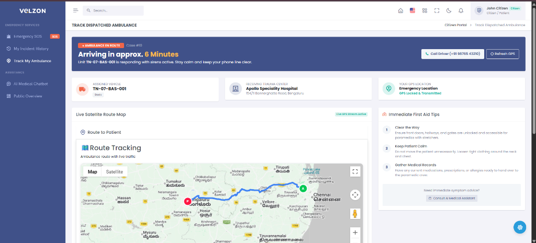
Figure 3.1: Live Satellite Route Tracking Interface

CHAPTER 4: RESULTS AND ANALYSIS
The implemented system was rigorously tested across various simulated emergency scenarios in Chennai, such as dispatching from Vengal College and Pallavaram. The proximity algorithm successfully identified the nearest hospitals and bypassed distant ones (e.g., avoiding Bengaluru dispatches). The VAPI voice agent demonstrated high accuracy in parsing natural language requests and returning correct ETA updates.

CHAPTER 5: CONCLUSION
This project successfully demonstrates the feasibility of an AI-driven, automated ambulance dispatch system. By combining full-stack web development, real-time geolocation APIs, and voice AI, the system significantly streamlines the emergency response workflow, proving superior to traditional manual dispatch methods.

BIBLIOGRAPHY
[1] FastAPI Documentation, Available: https://fastapi.tiangolo.com/
[2] VAPI AI Voice Agent, Available: https://vapi.ai/
[3] Google Maps Directions API, Available: https://developers.google.com/maps/documentation/directions

