Name: Faiz Ul Hassan
Roll-No: 22i-0818
Section: CS-C

Assignment-2(Secure-Chat Application)

Flow of My Chat Application:

Certificates:
I generated two valid certificates (one for server and other for the client), signed by(issuer) the root CA. The certificated for CA and its private key were created beforehand. When the server starts, it loads the CA’s cert and its own cert along private key to sign the messages, and so does the client in parallel.
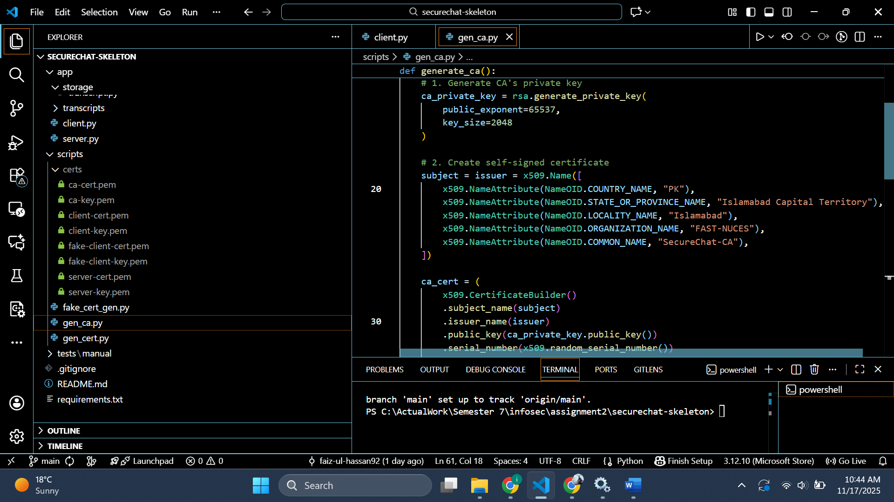
Initializing Communication:
When a client wants to connect to server, it sends its certificate to the server. The server verifies the validity of the certificate(the issuer, not-valid-after parameter) and sends its own certificate along its public key for the temporary deffi-Hellman for encrypted credential exchange.
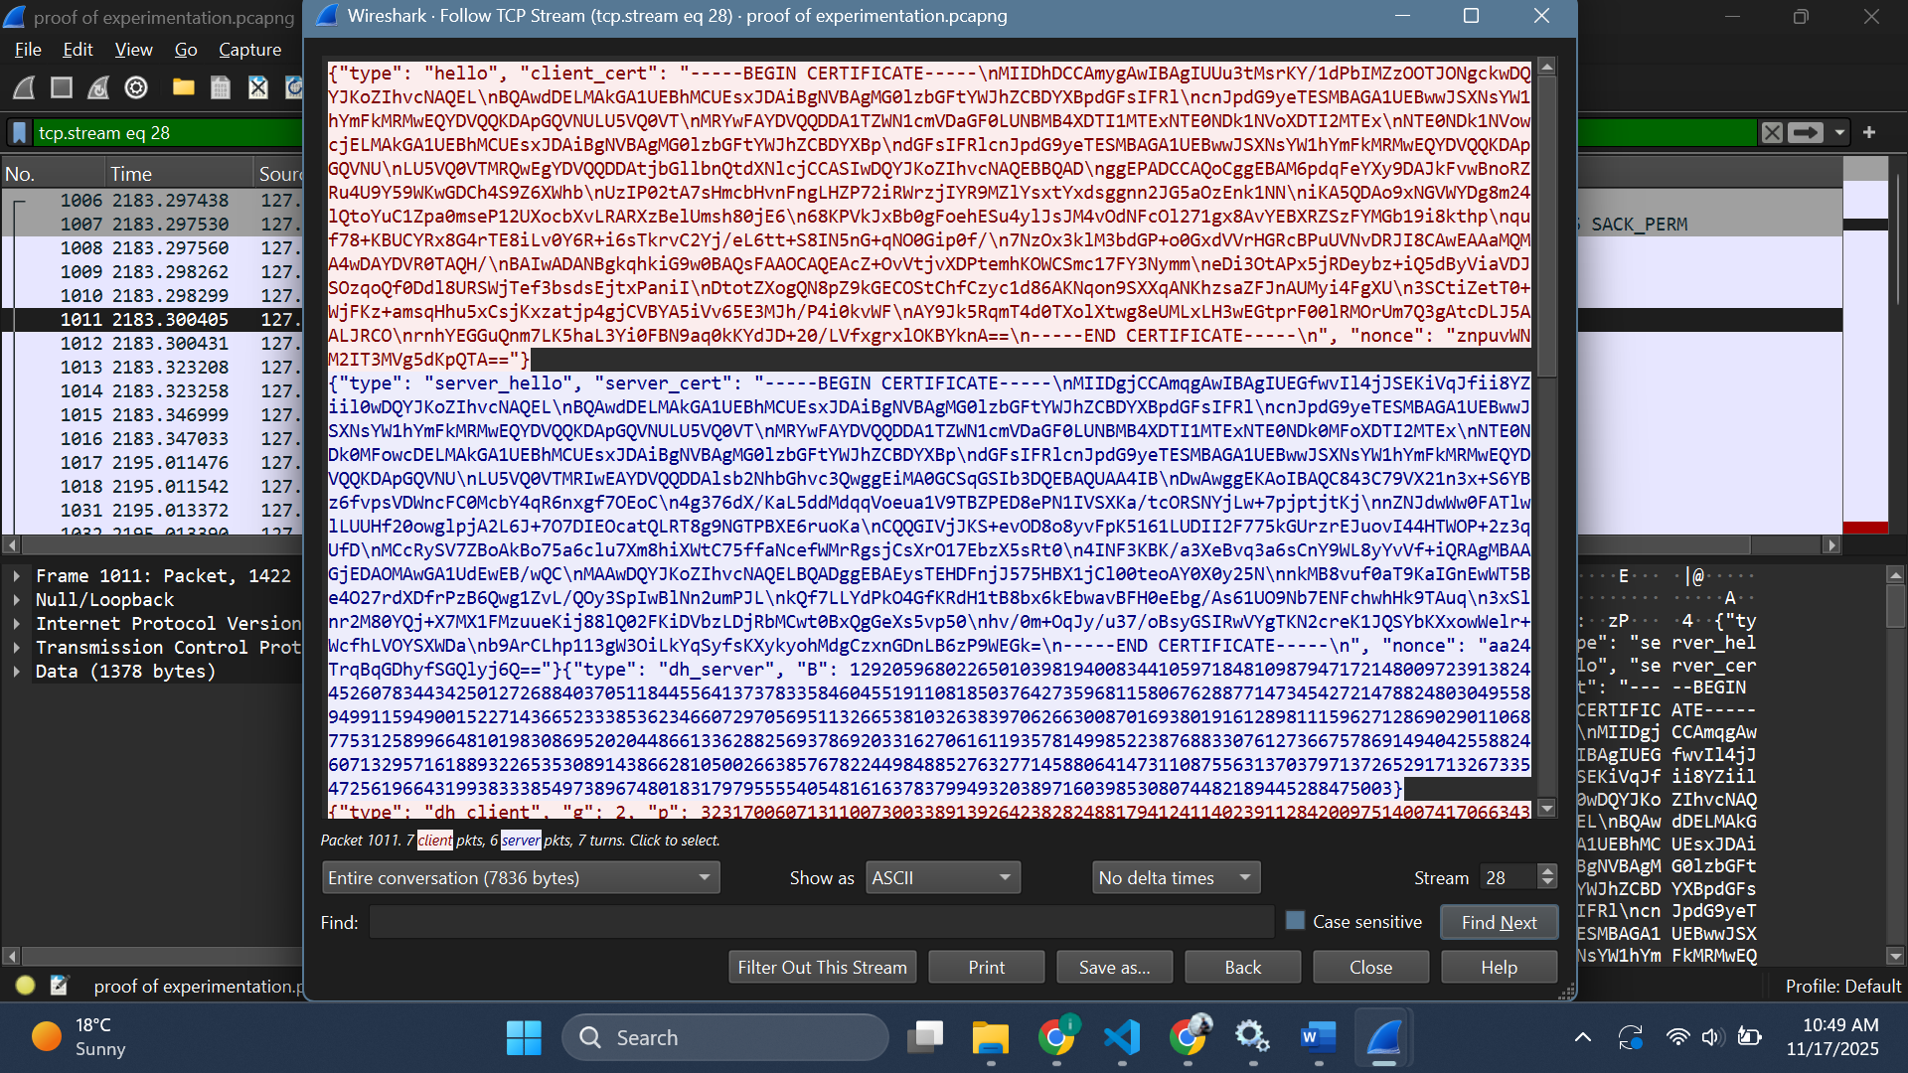
The client sends its own public DH key back (with g and p, which don’t matter because I have hard coded the values for both server and client deffi-hellman keys as they are on the same machine already).

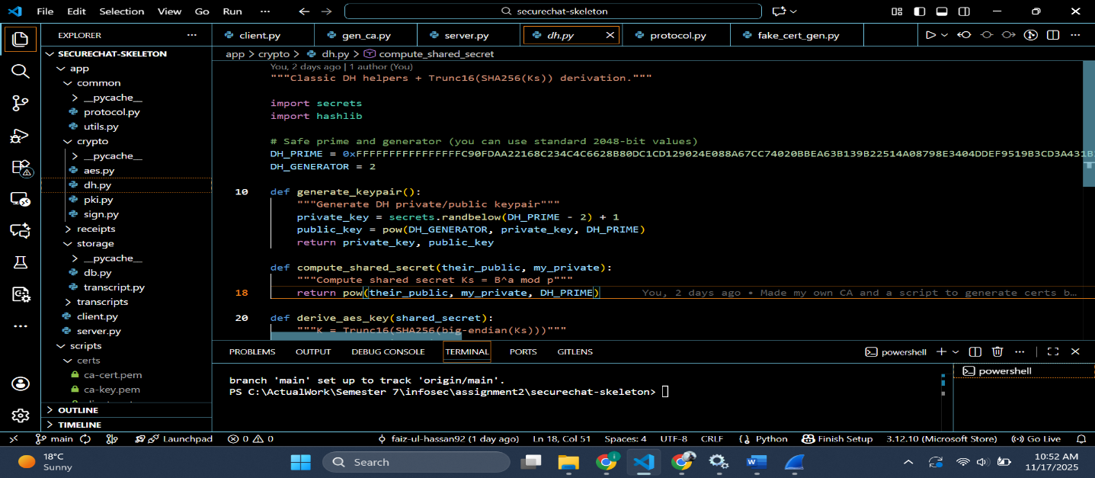
Login/Register:
If client chooses to login, it sends the email and requests the password salt (the one it had sent while registration) else it sends the resgitration info(email, username, passwd hashed, along the salt)

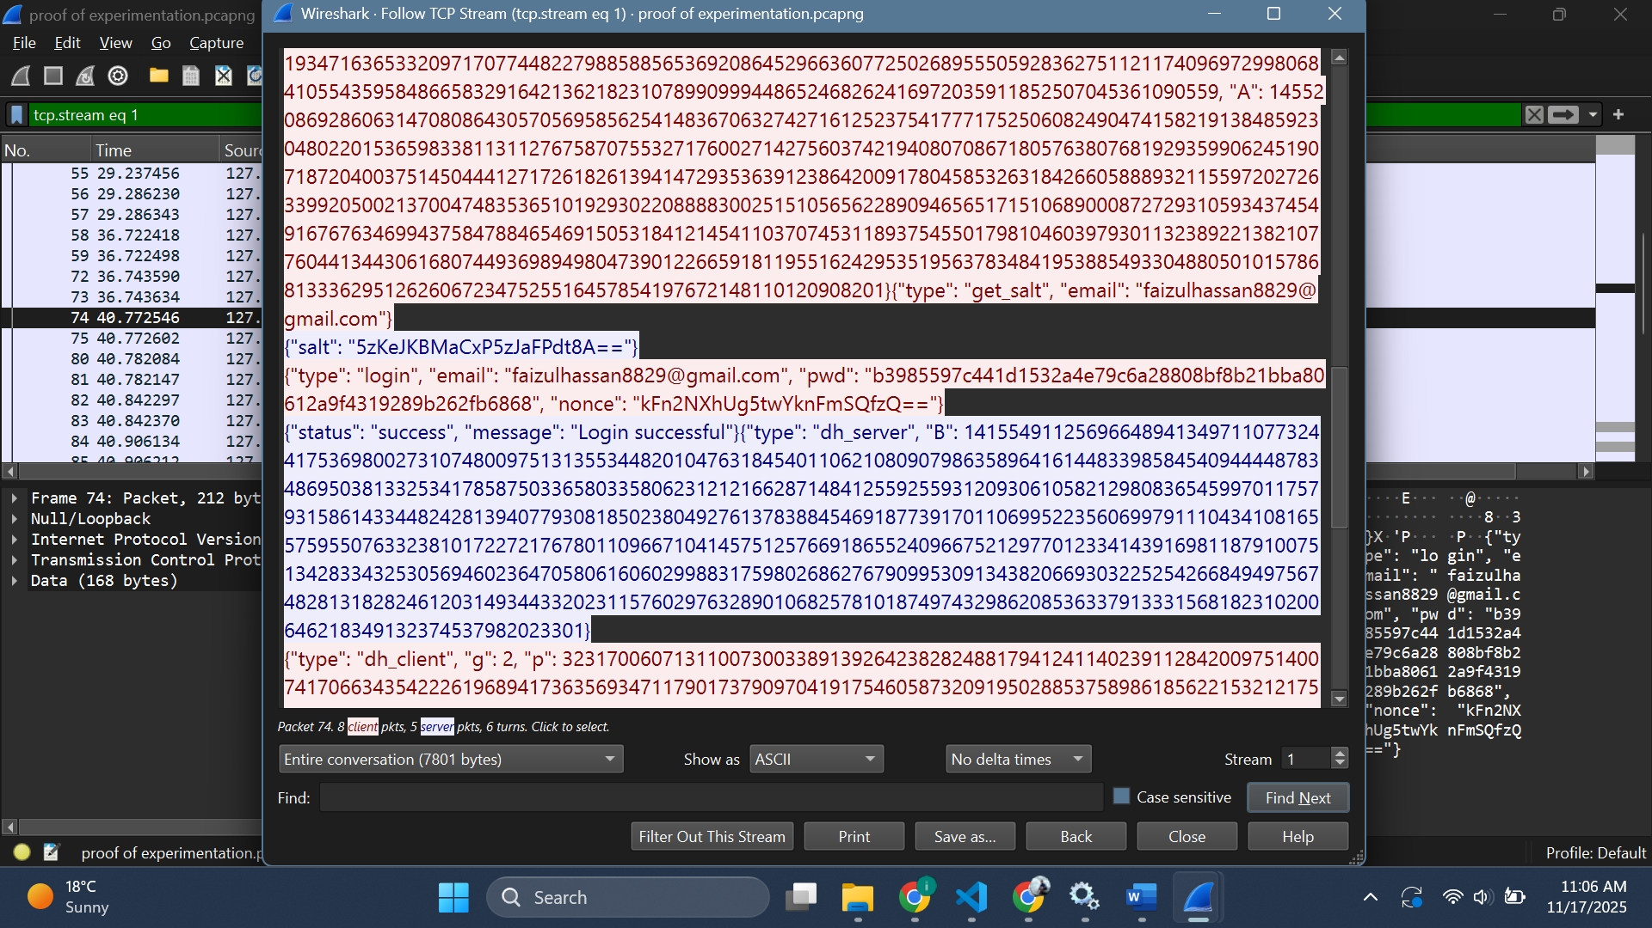

Re-DH:
As visible in above screenshots, after login/registeration is successful another deffi-hellman key exchange happens to generate a key for AES, which is then used for data plane encryption.

Sign and Verification:
For every message, encryption is done on the text, fields are prepared(seq_no, timestamp) and then all of them are hashed and signed with clients private key. This signature is sent to the server that decrypts the signature, recomputes and matches the hash to make sure the message isn’t altered in its path.

Seq-No:
The server maintains a seq_no with itself and increments it with the messages to deter replay attacks through MiTM.

Transcript and Receipt:
Every message the server receives it appends it in the transcript of the session along a fingerprint (hash of certificate) to make the transcript a proof of this session. At the end both the entities make a receipt by concatenating all transcript rows, hashing and signing themselves. This works for non-repudiation of sent messages.

The github repo is available here: https://github.com/Faiz-Ul-Hassan92/SecureChatApplication

The tests are available in the test report.

