Email Marketing Application

# List of Features

1. How to build free professional email template
2. Grammarly browser extension
3. Email list upload
4. Auto Fill Delivery Server data
5. Warm up buttons
6. List of added delivery servers and Buttons
7. Server table columns information

## How to build free professional email template

There are many websites which provide facilities to build HTML templates to send to email marketing campaigns. In this application we provided references of two websites as follows.

* [BeeFree](https://beefree.io/editor/?template=empty)
  + You can build an email template as per the requirements using Text, image, HTML code and many more features. After building a template, click on **EXPORT -> Download** button from the upper right corner as mentioned in the image and download the zip file. Extract the zip file and upload the HTML file to Mailwizz template which will be used in mailwizz campaign.
* [Mosaico](https://mosaico.io/editor-0.17.5-nr.html#3ov0ud4)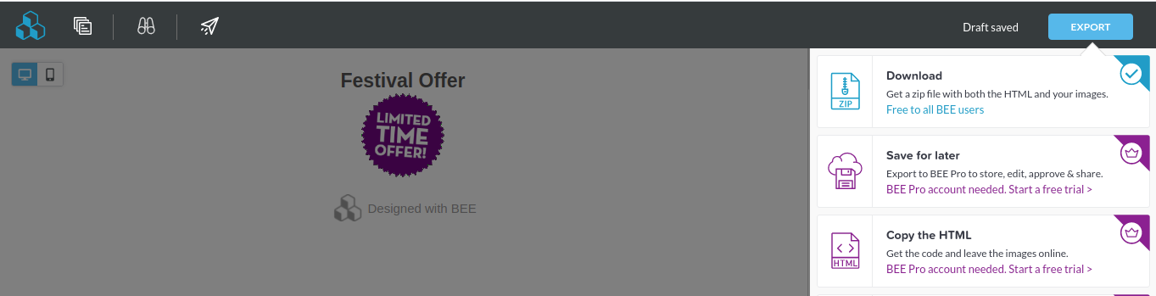
  + Similar to BeeFree, Mosaico is also an email template builder. It has predefined sections which can be easily modified as per the requirements. Download the template from the **Download** button located at the upper right corner as mentioned in the image. Template html file will be downloaded which you can directly upload to mailwizz to use in email campaigns as displayed in the below image.

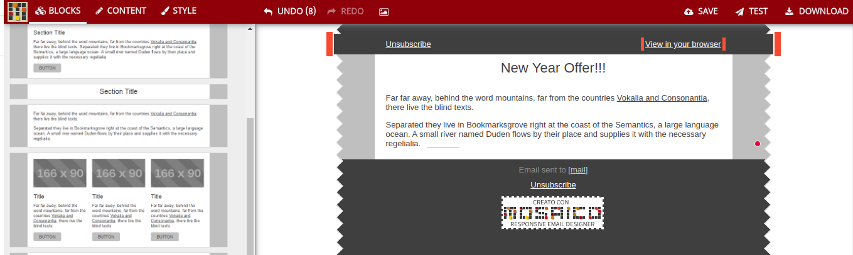

Above downloaded template files can be uploaded to mailwizz customer portal as displayed in the screenshot.

Link of the below displayed page: <https://apps.houzzu.com/mailwizz/latest/customer/index.php/templates/index>

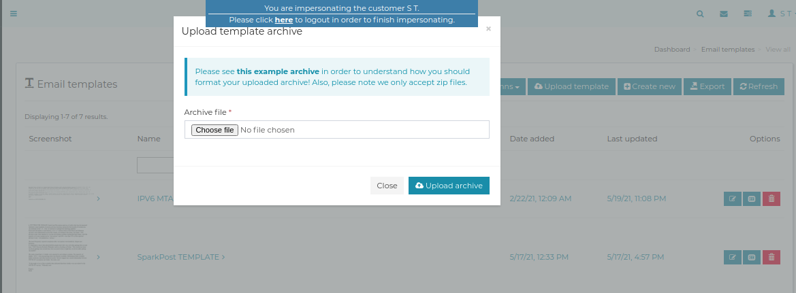

**NOTE**: BeeFree provides a zip file which can be directly uploaded to mailwizz.However, Mosaico provides html file which needs to be archived to zip file to upload it mailwizz. In addition to that, make sure the name of the template name is matching with the name of your delivery server.

## 

## Grammarly browser extension

To avoid grammar, punctuations and spelling errors, you can add grammarly browser extension in your browser using this link [Grammarly](https://www.grammarly.com/). It is free to use and can be very helpful while building email template or for better communication.

## Email list upload

We can upload customer emails list to mailwizz automatically by uploading a text file and unique mailwizz list ids to the Application. Below are the steps which should be followed to upload a list of customer emails.

1. Prepare a text file containing a list of customer emails. Place each email in the new line without comma
2. Fetch two unique list uids from mailwizz. It can be found at Mailwizz Customer Portal. <https://apps.houzzu.com/mailwizz/latest/customer/index.php/lists/index>. If there is not list present in the below page then you need to create two lists in which add one gmail address and one yahoo address respectively by clicking on the Create **New** button. Save a list and copy those two unique ids and paste them in UI application.

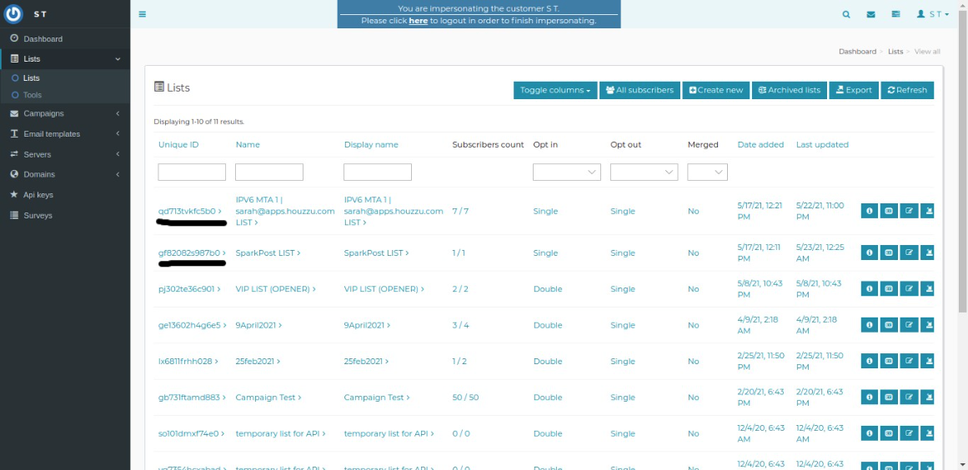

Go to this link <http://apps.houzzu.com:5000/> and paste gmail list uid in **Gmail List UID** text box and non gmail list uid in **Non-Gmail list UID** text box.

1. Upload the prepared text file and click on **Add Customers List** button, Wait for a few seconds and all customers list will be uploaded to mailwizz into respective mentioned lists.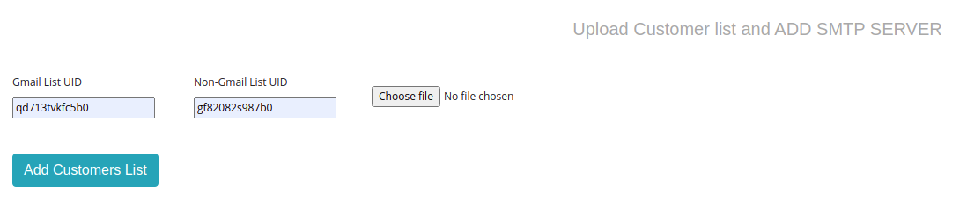
2. Once the customer list gets uploaded to mailwizz, **Customer List Uploaded to mailwizz message** will be displayed on the page.

## Following is the process of the uploading customer list to mailwizz: 1. Create two list into mailwizz. One for gmail and other for non gmail 2. Copy two list ids from mailwizz after creating two customer lists (which doesnt have customer emails) 3. Paste those two list ids into UI. Gmail list id into first text box and non-Gmail list uid into second text box 4. Upload a mixed list of emails by clicking on "Choose File" 5. Click on "Add Customer List" button 6. Wait for the success message 7. Check those two created list into mailwzz which should have added customers emails by parsing them into Gmail and Non-Gmail from the uploaded text file into mailwizz customer lists.

## Auto Fill Delivery Server data

Now, a delivery server should be added to create a mailwizz campaign. Add name of the Server taken from Mailwizz like “IPV6 MTA 1 | [sarah@apps.houzzu.com](mailto:sarah@apps.houzzu.com)”, “IPV6 MTA 2 | [suzan@apps.houzzu.com](mailto:suzan@apps.houzzu.com)”, “Mailgun API Server” etc. Copy any of the active delivery server name and paste it in the “Name” text box in the UI.

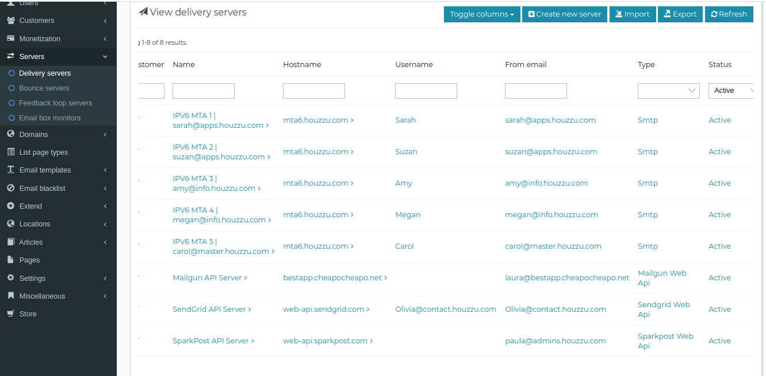

As per the below image, “IPV6 MTA 1 | [sarah@apps.houzzu.com](mailto:sarah@apps.houzzu.com)” is added in the “Name” text box. After adding it, click on “Auto Fill Data” button and wait for few seconds. Rest of the data such as “Host Name, Port, From Name and Email” boxes will be filled automatically. Check them once and add “Email Subject” and “Days”.

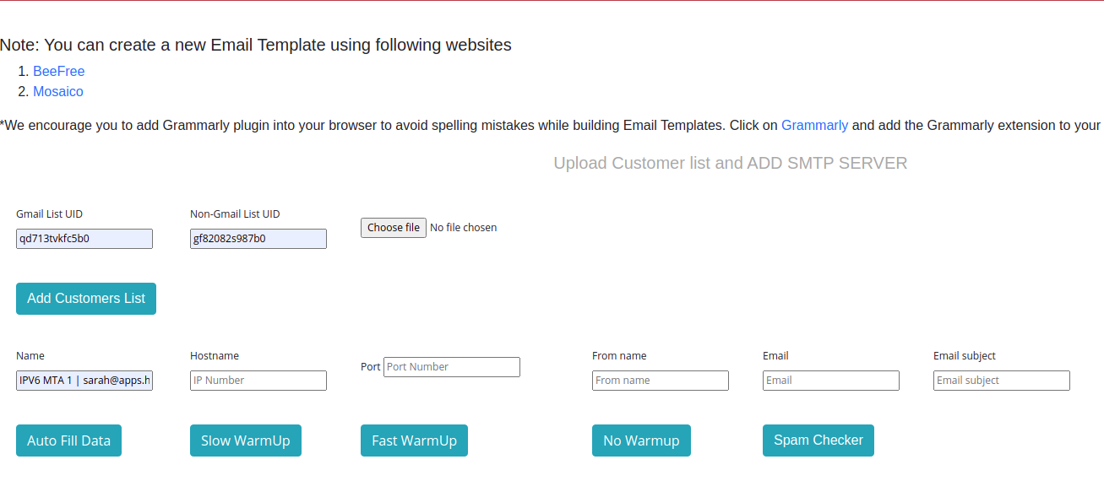

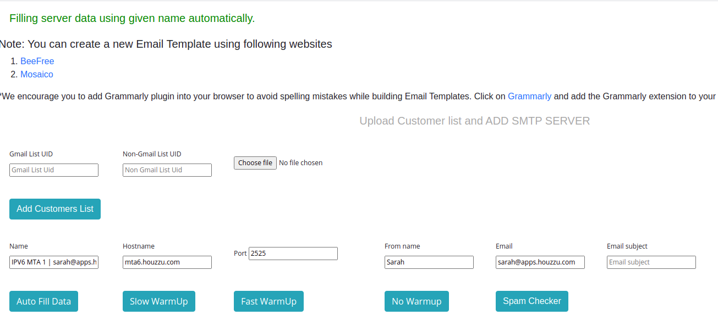

While adding Email Subject, notice the rating of the subject which is **87 out of 100** in this case. You can play around it by adding emoji or special characters to the email subject.

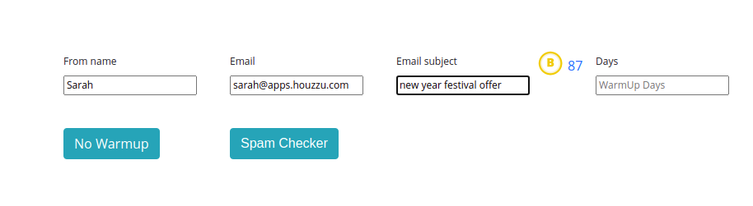

By clicking on the 87 number, you will be redirected to the external link <https://sendcheckit.com/email-subject-line-tester/?subject=new%20year%20festival%20offer> in which you can see the bifurcation of each subject and their impact on subject ratings. This is a really cool feature and you can play around with this to make a better email subject.

**Days:** In this text box, you need to enter the number of days you want to warm up the IP. e.g. you want to warm up the IP for 30 days, then enter 30 in the “Days” text box.

**No warmup email count:** This is an optional field. you need to enter number of emails you want to send for a campaign without warming up the IP. e.g. you want send 100 emails daily by specific delivery server without warming up the IP, then enter 100 in the “No warmup email count” and click on “No Warmup” button to add a delivery server.

## Warmup Buttons

* These buttons are used to add a delivery server with the warmup behaviour for an email campaign. There are three features of warmup. Slow Warm Up, Fast Warmup and No Warmup which are described below.
* **Slow Warmup:**
  + This button is used to create a campaign for warming up a delivery server slowly with less number of email counts. E.g. number of emails to be sent on daily basis will be as follows
  + For 10 days of slow warm up, warmup email count will be as displayed in the table.
* **Fast Warmup**:
  + This button is used to create a campaign for warming up a delivery server with more email counts. E.g. number of emails to be sent on daily basis will be as follows
  + For 10 days of fast warm up, warmup email count will be as displayed in the table.

|  |  |  |  |
| --- | --- | --- | --- |
| **Slow Warmup** | | **Fast Warmup** | |
| Day | Count | Day | Count |
| 1 | 50 | 1 | 20 |
| 2 | 50 | 2 | 50 |
| 3 | 100 | 3 | 100 |
| 4 | 100 | 4 | 300 |
| 5 | 100 | 5 | 800 |
| 6 | 200 | 6 | 1200 |
| 7 | 200 | 7 | 1800 |
| 8 | 200 | 8 | 2200 |
| 9 | 300 | 9 | 3500 |
| 10 | 300 | 10 | 5000 |

* **No Warmup**: This feature is useful when there is no need to warmup the IP and mailwizz can send regular emails on a daily basis. NOTE: **No warmup email count** valuemust be given in order to run the campaign without warmup.

## 

## 

## List of added delivery servers and Buttons

This table displays Current Day of the Campaign, Today’s email limit, Server Status and Play/Pause/Resume/Delete buttons as displayed in the image.

**Running Server Image**

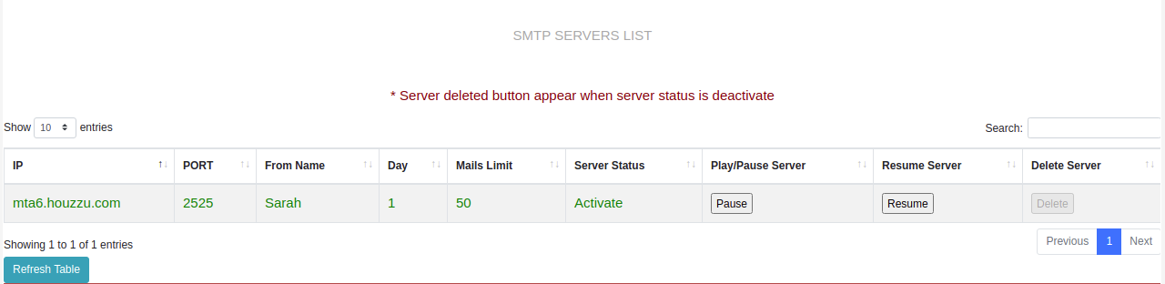

**Paused Server Image**

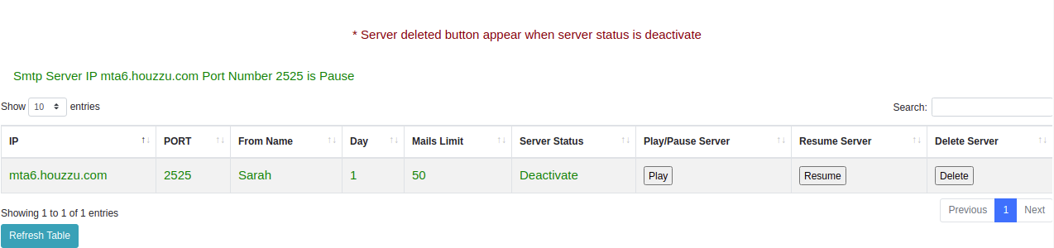

## Server table columns information

|  |  |
| --- | --- |
| Column Name | Description |
| IP | Hostname/IP of the delivery server |
| PORT | Port of the delivery server on which delivery server is running |
| From Name | Name of the email sender which can be displayed to the customer who receive email |
| Day | Today’s day count since campaign started |
| Mails Limit | Today’s email sending limit of mailwizz campaign |
| Server Status | Status of the server whether it is currently active or deactive |
| Play/Pause Server | It is used to start or pause the currently running campaign. If campaign is running then **Pause** button will be displayed and if campaign is not running and paused at the moment then **Play** button will be displayed. |
| Resume Server | If you want to continue the IP warmup till 99 days then this Resume button is useful. **NOTE**: if the delivery server is added by 99 days of warmup itself, then the Resume button will be disabled. |
| Delete Server | If you don't want to run the campaign again then by clicking on the Delete server button, the campaign will be deleted.  **NOTE**: This button will be disbaled until you stop the user's findings. |