Q1

(AND True) False
True = (λx·(λy·x)
AND = (λp·(λq·(p q) p)

((λp·(λq·(p q) p) True) False
((λq·(p q) p)[p := True]) False →β
(λq·(True q) True) False
(λq·((λx·(λy·x) q) True) False →α
(λq·((λx·(λy·x) q) True) False
(λq·((λy·x)[x := q]) True) False →β
(λq·((λy·q) True) False
(λq·((q)[y := True]) False →β
(λq·q) False
q[q := False] →β
False

Q2

(OR True)
True = (λx·(λy·x)
OR = (λp·(λq·(p p) q)

((λp·(λq·(p p) q) True)
((λq·(p p) q)[p := True]) →β
((λq·(True True) q)
((λq·((λx·(λy·x) True) q) →α
((λq·((λx·(λy·x) True) q)
((λq·((λy·x)[x := True]) q) →β
((λq·(λy·True) q)
((λq·(True)[y := q]) →β
(λq·True)
–
A function waiting for a parameter only to return True, ignoring the parameter.

Q3

XOR
a | b | xor
0 | 0 | 0
0 | 1 | 1
1 | 0 | 1
1 | 1 | 0
In-fix – ( a || b ) & ! ( a & b )
Post-fix – ( ( & ) ( ( || ) a b ) ( (!) ( ( & ) a b ) ) )
Deriving NOT;
1)
NOT TRUE →β FALSE
TRUE FALSE TRUE→β FALSE
2)
NOT FALSE →β TRUE
FALSE FALSE TRUE →β TRUE

By 1) and 2) we can conclude,
NOT := λp·(p FALSE TRUE)

Now try to implement the post-fix in lambda calculus,

(λx·(λy·(AND (OR x y) (NOT (AND x y)))))

Q4
Summary
board (Fig 2) can be covered by just V3 pieces (Fig 1) with a corner removed where, .
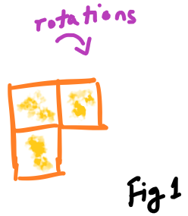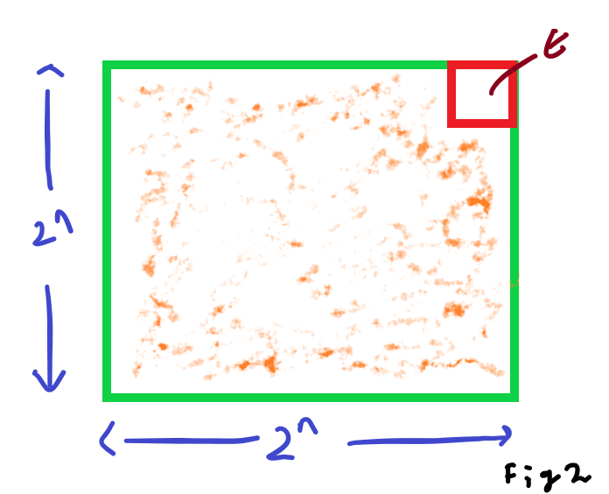
Proof
Base
We have, . With 1 V3 piece shown in orange.
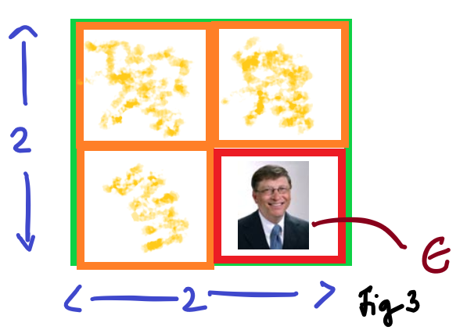
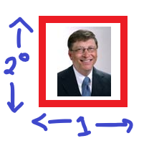
Where , is covered naturally.
Hypothesis
We have, assumed to be true.
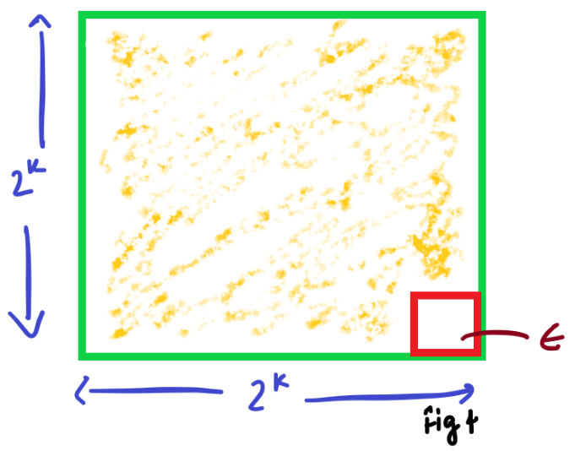
Inductive Step
By Hypothesis we have,

Shown true, by inserting 1, V3 piece in the center of 4 blocks of the k case.
