- Explain regression
Act as a data analytics instructor and explain regression analysis in beginner-friendly terms, focusing on what regression is, how variables relate to each other, and how regression can be used to make predictions. My goal is to apply regression to real data analytics projects, so limit the response to material that can be learned in one lesson and organize it into a concise summary table with key concepts, definitions, a simple real-world example, and steps for applying regression to a dataset.

Explanation: The prompt I had drafted is much better because of how vivid it is. I first ask the AI to take a role. Throughout the prompt I provide restrictions for the AI in terms of what I want and how I want it.

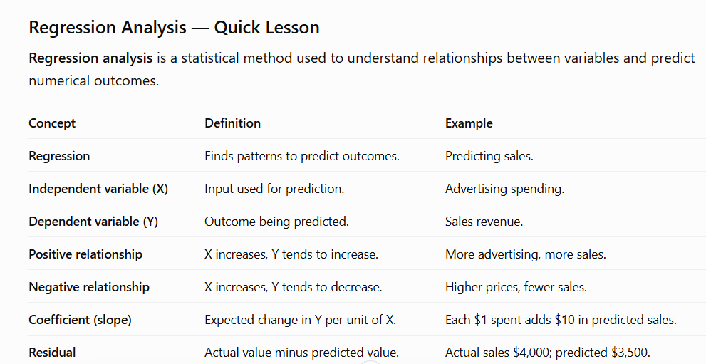

- Help me understand SQL
Act as an SQL tutor for a beginner data analyst and teach me how SQL is used to retrieve, filter, sort, and analyze data in relational databases. My goal is to practice SQL hands-on, so limit the lesson to a manageable set of beginner commands such as SELECT, FROM, WHERE, and ORDER BY, and organize the response into sections with a summary table, example queries, explanations of each query, and a short practice exercise.

Explanation: I followed the same template for each improved prompt I had drafted. I first ask the AI to take a role. Throughout the prompt I provide restrictions for the AI in terms of what I want and how I want it.

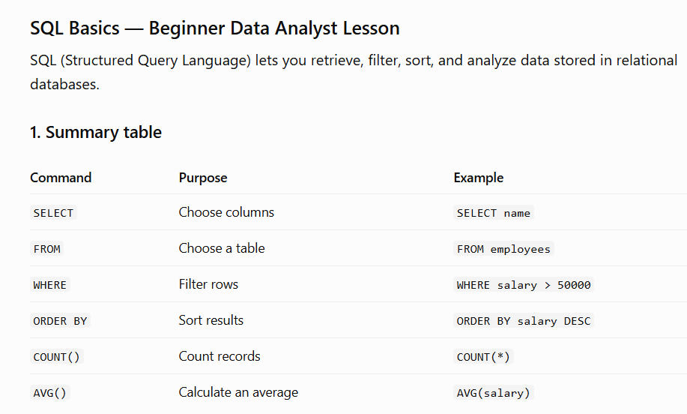

- Create a dataset
Act as a data analyst creating practice material for a beginner and generate a realistic dataset containing customer ID, product, category, quantity purchased, price, and purchase date. My goal is to practice basic data analysis, so keep the dataset and activities small enough for one lesson and organize the response as a clean data table followed by a structured summary of 3–5 exercises involving sorting, filtering, calculations, and identifying trends.

Explanation: I followed the same template for each improved prompt I had drafted. I first ask the AI to take a role. Throughout the prompt I provide restrictions for the AI in terms of what I want and how I want it.

