Shrinking Space for WTO Dispute Settlement: Geopolitics, Forum Shopping, and Lessons for Developing Economies

Abstract
The paralysis of the World Trade Organization’s (WTO) Appellate Body and a resurgence of protectionist measures have narrowed the options available to smaller economies seeking to defend their trade interests. This paper examines how geopolitical tensions influence when and where developing countries choose to litigate trade disputes. We track three recent cases with similar economic stakes but differing political overtones: Indonesia’s challenge to the European Union (EU) over palm‑oil “sustainability” standards, India’s clash with the United States over domestic content requirements for solar panels, and the Philippines’ confrontation with China over banana market access during a maritime stand‑off. Drawing on WTO dispute dockets, panel and Appellate Body reports, regional trade agreement texts and press coverage, we reconstruct each dispute from the initial complaint to the eventual resolution and align those timelines with quarterly readings of the Caldara–Iacoviello Geopolitical Risk Index and signals of diplomatic alignment such as United Nations General Assembly (UNGA) voting patterns. We find that when geopolitical risk spikes, complainants delay filing, consultations stretch out, or cases are quietly dropped. Where litigants pivot to regional or ad hoc venues, talks conclude more quickly, but settlements often lack robust enforcement clauses, and compliance is uneven. Geopolitical tension thus slows the formal WTO process and nudges weaker states toward faster yet softer alternatives. The findings suggest that policymakers in developing economies should prioritise strengthening the binding nature of regional panels while intensifying efforts to revitalise the WTO appeals system.
Keywords: Geopolitics; Protectionism; WTO dispute settlement; Developing economies; Forum shopping

1 Introduction
While power politics heavily shaped the GATT-era trade framework, the creation of the WTO in 1995 significantly deepened legalization, most visibly via a binding dispute-settlement system with appellate review (Kim, 2010). At its core is the dispute settlement mechanism of the World Trade Organization (WTO), whose Understanding on Rules and Procedures Governing the Settlement of Disputes (DSU) provides a compulsory, two‑tier process for members to challenge alleged violations of WTO agreements (WTO, 1995). For much of its existence, this system was praised as the “crown jewel” of the multilateral trading order, as it constrained unilateralism and provided even the smallest countries with a legal avenue to enforce their rights (Davey, 2022). Yet the mechanism is currently in deep crisis. Since December 2019, the Appellate Body has been unable to hear new appeals because the United States has blocked appointments to fill vacant seats, alleging that the body had exceeded its mandate and failed to respect procedural deadlines (Hoekman & Mavroidis, 2019; USTR, 2020). As a result, losing parties can neutralise adverse panel reports simply by filing a “notification of appeal,” knowing that no appellate tribunal exists to confirm or overturn the decision. More than fifty cases have been appealed “into the void,” leaving complainants without a final ruling and undermining confidence in the system (WTO, 2024a).
At the same time, the political context surrounding international trade has shifted dramatically. Heightened geopolitical rivalry between major powers has spilled over into economic policy, resulting in a wave of protectionist actions. The United States cited national security as the basis for imposing tariffs on steel and aluminum imports and introduced safeguard duties on solar panels and washing machines (Proclamation No. 9693, 2018; USITC, 2018). China, the European Union and India have responded with counter‑measures and industrial policies of their own. The COVID‑19 pandemic and the conflict in Ukraine further accelerated reshoring, export restrictions and subsidy races. Under these conditions, large economies increasingly rely on unilateral instruments or negotiate bilateral deals rather than pursue multilateral adjudication (Ayyub, 2023; Bown & Reynolds, 2015). They also sign regional and mega‑regional trade agreements with their own dispute settlement provisions, creating multiple avenues through which conflicts can be addressed (Bown & McCulloch, 2009; Reich, 2017). This proliferation of forums – often referred to as “forum shopping” – fragments the legal landscape and raises questions about the coherence and accessibility of trade law.
Developing economies are particularly vulnerable in this environment. They have been active users of the WTO dispute settlement system, both as complainants and as respondents (Busch & Reinhardt, 2003). The DSU offers them a way to challenge measures by larger trading partners that they perceive as unfair, such as anti‑dumping duties, agricultural subsidies or technical barriers. The system’s compulsory jurisdiction and the option of cross‑retaliation provide some leverage to economies with limited market power. When the Appellate Body is non‑functional and large states increasingly resort to unilateralism, however, weaker members face a dilemma: should they still litigate through the WTO in the hope of a panel report that may never be adopted, or should they seek remedies elsewhere even if those fora offer weaker enforcement? Choosing the proper forum becomes a strategic decision influenced by legal, economic and political considerations. At stake is not only the outcome of individual disputes but also the broader integrity of the rules‑based system. Without a credible adjudication mechanism, trade disputes risk reverting to power politics reminiscent of the GATT era (Erken, 2019; Van den Bossche & Zdouc, 2017).
This paper examines how geopolitical tensions influence the timing and venue selection of developing countries when they initiate trade disputes, as well as the consequences of these choices for enforcement. We focus on three recent cases that involve similar economic stakes but unfold in distinct geopolitical settings. The first dispute arises from Indonesia’s complaint (DS593) against the European Union’s renewable energy policies, which restrict the use of palm oil-based biofuels on environmental grounds. Palm oil is a key export for Indonesia, and the EU’s measures threatened a market worth over €2 billion annually (EEAS, 2019). The case was brought to the WTO amidst rising global concern about climate change and sustainability. The second dispute involves the United States’ challenge (DS456) to India’s domestic content requirements for solar photovoltaic modules, imposed under India’s National Solar Mission. Although the trade stakes were smaller – U.S. exports of solar cells to India were negligible at the time – the case had broader implications for renewable energy policy and localisation strategies (USTR, 2016; WTO, 2016). The third episode examines the Philippines’ response to China’s imposition of sanitary restrictions on banana imports during a maritime dispute in the South China Sea. Unlike the other two disputes, Manila did not file a WTO complaint, and the issue was resolved politically after years of restricted access (Higgins, 2012; Chidede & Okeke, 2023). Collectively, these cases enable us to compare how similar economic grievances are addressed differently depending on the geopolitical context.
We approach the research question through a combination of qualitative and quantitative methods. Using WTO dockets and official documents, we reconstruct the chronology of each dispute from the triggering event to the outcome. We link these timelines to quarterly readings of the Caldara–Iacoviello Geopolitical Risk (GPR) Index, which measures the frequency of terms such as “war,” “terrorism,” and “geopolitical tension” in major newspapers (Caldara & Iacoviello, 2022). To capture political alignment, we draw on UN General Assembly voting records and ideal point estimates, which position countries along a liberal–conservative spectrum based on their voting behaviour (Bailey, Strezhnev & Voeten, 2017; Voeten, 2021). We code delays at various stages of the dispute process (time from policy shock to consultations, from consultations to panel request, from panel to report and adoption) and classify the forum chosen (WTO versus regional or ad hoc) and the strength of enforcement provisions in resulting settlements. Though the number of cases is small, the structured design allows us to test whether higher geopolitical risk or greater divergence in UNGA voting alignments delays filings, pushes litigants toward alternative fora or results in weaker enforcement.
Our argument can be summarised in one sentence: geopolitical risk and alignment shape both when developing countries choose to litigate and where they choose to litigate, with higher risk and lower alignment increasing delay and prompting a shift to faster but less enforceable venues. The paper makes three contributions. Conceptually, it links the literature on geopolitics and international trade to the timing and venue choice of dispute settlement, offering propositions about how risk and alignment affect the calculus of developing countries. Empirically, it provides a structured comparison of three recent disputes using newly compiled data on GPR, UNGA voting, trade flows and macro controls. This mix of narrative and small-N quantitative analysis provides evidence for the theoretical propositions while acknowledging its limitations. In policy terms, the study suggests practical reforms: developing countries should work to strengthen the binding nature of regional and ad hoc panels and continue to advocate for the revival of the WTO appellate function. By investing in legal capacity, pre‑committing to specific litigation triggers and forming coalitions, they can mitigate the risks of forum shopping and maintain leverage in a fragmented system.
The rest of the paper proceeds as follows. Section 2 situates our work in the broader literature on the WTO dispute settlement system, forum shopping and the intersection of law and geopolitics. Section 3 describes the data and measurement strategies used to operationalise our variables. Section 4 outlines the research design and methods, explaining how the structured comparison is conducted and how the event‑timing, venue choice and enforcement models are estimated. Section 5 presents detailed narratives of the three disputes, enriched with descriptive statistics and graphical displays. Section 6 discusses the results, drawing connections between the patterns observed and the theoretical propositions. Section 7 derives policy implications for developing economies and proposes concrete reforms. Section 8 concludes with reflections on the study's limitations and directions for future research.

2 Theory and Literature Review
Understanding why countries choose to litigate through the WTO, delay filing or opt for other dispute fora requires a synthesis of three strands of literature: the political economy of the WTO dispute settlement system, the incentives for forum shopping, and the role of geopolitics in shaping state behaviour. This section reviews the key contributions and elaborates on the propositions that guide our analysis.

2.1 WTO DSU under strain
The DSU was designed to provide a predictable, compulsory framework for resolving trade disputes through consultations, panels, appellate review and adoption by the Dispute Settlement Body (WTO, 1995). The successful operation of this sequence encouraged compliance by threatening authorised retaliation and deterring members from enacting measures that might violate their obligations (Van den Bossche & Zdouc, 2017). Participation has generally been broad, but smaller economies have long noted the costs and delays associated with litigation (Busch & Reinhardt, 2003; Bown & McCulloch, 2009).
Since December 2019, the Appellate Body has been paralysed because the United States blocked the appointment of judges, effectively allowing losing parties to appeal into a void and suspending enforcement. This vacuum alters incentives: some complainants delay filing or seek alternative arrangements; respondents face little risk of retaliation; and debates about the proper scope of appellate review have become more salient (USTR, 2020; Davey, 2022). Critics accuse the Appellate Body of overreach, while supporters emphasise its role in clarifying rules and ensuring consistency (Chidede & Okeke, 2023). In response, some members have formed ad hoc arrangements, such as the Multi-Party Interim Appeal Arrangement (MPIA), to replicate appellate functions (WTO, 2025b). At the same time, a surge of national‑security, environmental and industrial policy measures by major economies has expanded the set of contested actions, highlighting a tension between universalism and fragmentation in dispute settlement (Hoekman & Mavroidis, 2019; WTO, 2024b).

2.2 Forum shopping and the law–politics interface
Forum shopping refers to the strategic selection of a dispute settlement mechanism from among multiple available venues. In the context of international trade, options include the WTO, dispute provisions in regional or bilateral trade agreements, investor–state arbitration tribunals, and informal diplomatic channels (Bown & Reynolds, 2015). Each forum differs in its procedures, enforcement capacity, speed and costs. The WTO offers compulsory jurisdiction and the possibility of cross-retaliation; however, proceedings can be lengthy, and, as noted, the Appellate Body is currently non-functional. Regional or bilateral panels may be faster but are often limited in scope or depend on the goodwill of the parties for enforcement. Investor–state arbitration provides monetary remedies but is designed for investors rather than states. Informal settlements may provide political flexibility but lack legal certainty. The choice of forum thus represents a trade‑off between speed and enforceability (Reich, 2017).
Several factors influence forum choice. When WTO rules are clear and the disputed stakes are substantial, complainants may litigate at the WTO to establish a precedent and deter future violations; ambiguous provisions or regulatory exceptions, however, encourage negotiation to avoid adverse interpretations (Mavroidis, 2020). Economic stakes matter because costly proceedings are more attractive when the trade flow at risk is substantial (Bown & Reynolds, 2015). Power and alignment shape the political calculus: weaker states often use the WTO to level the playing field, whereas stronger states may prefer bilateral bargaining where they can link issues across domains (Busch & Reinhardt, 2003; Bailey, Strezhnev & Voeten, 2017).
Forum shopping has been facilitated by the proliferation of regional trade agreements and investment treaties, each with its own dispute mechanisms. These range from WTO‑like panels to flexible consultation clauses. Investor–state arbitration under bilateral investment treaties offers monetary remedies and has been used to challenge regulatory measures but is designed for private claimants rather than states (Reich, 2017). Such alternatives may be faster than the WTO and appealing when the appellate function is impaired, but they risk fragmenting jurisprudence and shifting power to parties with greater negotiating leverage. Developing countries, therefore, face a complex trade‑off between speed, enforceability, and legal consistency when choosing where to litigate.
Forum shopping in international trade refers not merely to the selection among available dispute settlement venues, but to the strategic circumvention of the WTO system when states perceive alternative mechanisms as more politically expedient or economically rewarding. The practice illustrates the deep entanglement between law and politics in the contemporary trading order: states choose not only where they can win legally, but also where they can advance broader geopolitical or strategic objectives (CUTS, 2007).
The proliferation of regional trade agreements (RTAs) and bilateral investment treaties (BITs) since the early 2000s has multiplied the number of fora available for dispute resolution, creating overlapping and sometimes competing jurisdictions. While these arrangements were originally designed to complement multilateral rules, they now serve as functional substitutes for the WTO, especially in an era when its Appellate Body remains paralyzed (Vidigal, 2019). Major powers—such as the United States, the European Union, and China—have increasingly relied on regional or bilateral panels, leveraging their economic weight to secure favorable terms outside the multilateral system. For example, U.S. use of the USMCA dispute panels and the EU’s enforcement through trade–sustainability mechanisms demonstrates a recalibration of trade governance toward more controlled and politically manageable venues (Annisa, 2022).
This turn toward selective adjudication fragments the coherence of international trade law, dilutes the authority of WTO jurisprudence, and reintroduces elements of power politics into what was once envisioned as a rules-based order. The forum-shopping dynamic thus reflects both a symptom and a driver of the WTO’s shrinking centrality: as states act strategically outside the system, its normative pull weakens further. For developing economies, the implications are particularly acute (Petersmann & Steinbach, 2024). Without the legal and institutional capacity to engage effectively across multiple fora, they risk marginalization in an increasingly decentralized and politicized trade landscape—where outcomes are often determined less by legal merit than by bargaining power and alliance structures (Switzer, 2022).

2.3 Geopolitics and the litigation calculus
While economics and law structure forum choices, geopolitics influences the timing and willingness to litigate. Geopolitical risk refers to the perceived likelihood of adverse events such as military conflicts, terrorist attacks or diplomatic crises. Caldara and Iacoviello (2022) measure this risk by counting references to such events in major newspapers, producing an index that captures both the general geopolitical climate and country-specific risks. High geopolitical risk may deter cooperation and encourage governments to prioritise security or strategic interests over economic gains. In trade disputes, this might manifest in three ways.
First, higher geopolitical risk could delay filings. Governments may be reluctant to initiate WTO consultations against a powerful adversary during a period of tension, fearing escalation or retaliation. Consultations might be drawn out in the hope that the political climate improves. We formalise this as Proposition 1 (Timing): Higher geopolitical risk is associated with longer delays between the occurrence of a trade grievance and the filing of a WTO complaint, as well as longer intervals between consultations and panel requests.
Second, geopolitical context may affect venue choice. When relations are strained and alignment is low, complainants might avoid confronting the respondent in an obvious multilateral forum. Instead, they may seek regional forums where enforcement is softer, or they may drop the issue altogether. We propose Proposition 2 (Venue): Under high geopolitical risk and low diplomatic alignment, complainants are more likely to substitute away from the WTO towards regional or ad hoc dispute forums. Conversely, when alignment is high, litigation at the WTO may be more feasible because the respondent is less likely to view the case as a hostile act.
Third, the choice of forum influences enforcement. Faster fora may deliver decisions quickly, but their settlements often rely on cooperative clauses without strong retaliation mechanisms. This can result in partial or uneven compliance. By contrast, the WTO provides for retaliation; however, the absence of an appellate function now weakens this enforcement mechanism. We therefore posit Proposition 3 (Outcomes): Disputes resolved outside the WTO tend to have weaker enforcement provisions, resulting in lower compliance compared to WTO cases, even when WTO cases are delayed.
These propositions connect geopolitics to litigation behaviour. They build on earlier work showing that democratic allies are less likely to sue each other, while rival states use litigation strategically (Bailey, Strezhnev & Voeten, 2017). They also complement studies linking domestic politics and regime type to participation in WTO disputes (Busch & Reinhardt, 2003; Bown & Reynolds, 2015). Our contribution is to incorporate a dynamic measure of geopolitical risk and a measure of diplomatic alignment into the analysis of when and where developing countries litigate.
Two further considerations enrich this framework. First, geopolitical risk may vary across dimensions not captured by the headline GPR index, such as regional tensions or domestic political crises. For example, the Philippines’ banana dispute occurred against the backdrop of a maritime standoff, while the Indonesia–EU case unfolded amid debates over climate policy. Country‑specific shocks can alter governments’ priorities and capacity to litigate. Second, alignment is relational: a country’s voting affinity with the United States might differ from its affinity with China or other blocs. In some disputes, alignment with the respondent is more important than alignment with third parties. Measuring alignment relative to multiple reference countries, or across issue areas, could refine our understanding of how friendships and rivalries shape dispute behaviour. Taken together, these nuances suggest that geopolitical influences are multidimensional and context‑dependent, warranting careful measurement and interpretation.

3 Data and Measurement
Testing the propositions requires data on dispute timelines, geopolitics, political alignment, and economic stakes. This section describes our case selection, data sources, and coding strategy, referencing the accompanying tables and figures.
Table 1. Variables, coding, and sources (GPR, UNGA, delays, venue, enforcement, trade & macro).
Category | Variables | Coding (type/unit) | Source (see note)
GPR | GPR, gpr_spread | Continuous index | Caldara & Iacoviello (Geopolitical Risk Index)
UNGA voting | agree_usa_strict, votes_strict | Share 0–1; count | UNGA Voting Data (Voeten et al.; B–S–V ideal points)
Delays | days_consult→panel_report | Integer (days) | Author calculations from WTO DS dockets
Venue | venue | Categorical (WTO / other forum) | WTO dispute records; PTA/ISDS texts
Enforcement | enforcement_strength | Ordinal (coded; higher = stronger) | WTO DSB reports/minutes (coded)
Trade & macro | gdp_growth_yoy, fx_usd, trade_flow | Continuous | WDI / IMF IFS / UN Comtrade
Note: Sources abbreviated in table; full variable list and detailed coding shown in Appendix Table A1.

3.1 Case selection and context
We examine three disputes that occurred between 2012 and 2025, each involving a developing country complainant (or potential complainant) and a larger trading partner. The cases were chosen because they share comparable economic stakes but differ in political context and forum choice, allowing for a structured comparison.
- Indonesia–EU palm oil (DS593). Filed in December 2019, this case challenges the EU’s Renewable Energy Directive II and related acts, which label palm‑oil based biofuel as having high indirect land‑use change (ILUC) risk, thereby limiting its contribution to renewable energy targets. Palm oil exports account for a significant share of Indonesia’s foreign revenue, and the EU is one of its largest markets. The dispute is set against concerns about deforestation, climate policy and sustainability standards. A WTO panel was established in July 2020 and circulated its report in January 2025, finding parts of the EU measures inconsistent with WTO rules (WTO, 2025a). The EU chose not to appeal. The case illustrates litigation during the appellate crisis and demonstrates how environmental and trade objectives intersect.
- United States–India solar cells (DS456). Initiated in February 2013, this dispute involves U.S. complaints about India’s domestic content requirement under its National Solar Mission. The measure mandated the use of Indian‑made solar cells and modules for specific solar projects. India argued that the scheme fell under public procurement exceptions, while the United States contended that it discriminated against foreign suppliers. A WTO panel ruled in favour of the United States in 2016, and the Appellate Body upheld most of its findings (WTO, 2016). India complied by phasing out the requirement. Shortly thereafter, however, the United States imposed a global safeguard tariff on solar products, prompting India to question the benefit of its compliance (Proclamation No. 9693, 2018). The dispute was eventually terminated through a bilateral settlement in 2023 (Ayyub, 2023).
- Philippines–China bananas (2012). In March 2012, China tightened sanitary inspections on bananas from the Philippines, citing pest contamination. The measures coincided with a maritime stand‑off over the Scarborough Shoal in the South China Sea. China was the Philippines’ largest banana market, accounting for over half of its banana exports between 2009 and 2011 (FAO, 2013). Exports collapsed during the dispute and did not recover fully until 2016, when Manila pursued a diplomatic rapprochement with Beijing (Lema & Mogato, 2012). The Philippines considered filing a WTO complaint, but ultimately did not, due to the geopolitical stakes. This episode is treated as an ad hoc dispute for our analysis.
Table 2. Case overview & stakes (HS codes, top partner shares, baseline trade).
Case | HS focus (6-digit) | Baseline window | Baseline trade (respondent imports from complainant, 3-yr average) | Respondent’s top partners & shares in the baseline window
PH-CHN (bananas) | 080390 (bananas, fresh) | 2009–2011 (consultations 2012) | ≈ 368.9 thousand tonnes/yr from PH to CN (317.8 in 2009; 352.1 in 2010; 436.7 in 2011 → avg 368.9) | China’s banana imports by origin (2009–2011 combined): Philippines ≈ 56.0%, Myanmar ≈ 16.5%, Vietnam ≈ 3.7% (derived from FAO Table 6, “Gross imports by countries of origin”).
IDN-EU (palm oil) | 1511 (palm oil & fractions) | 2016–2018 (consultations 2019) | Reference (EU total): EU palm-oil imports averaged ~€2.2 bn/yr in recent years; Indonesia’s share ≈ 47% (largest supplier) → indicative ~€1.0 bn/yr from IDN. (Closest official long-run series; exact 2016–2018 Comext values available to slot in.) | Top supplier: Indonesia ≈ 47% of EU palm-oil imports; Malaysia is the #2 supplier (share varies by year; precise 2016–2018 shares available from Eurostat/Comext).
USA-IND (solar cells) | 854140 (photosensitive semiconductor devices incl. PV cells) | 2010–2012 (consultations 2013) | Reference on structure: By 2015, India’s HS 854140 imports were dominated by China (~79%) and Malaysia (~11%), with U.S. ~0.4%. (This shows partner structure around the period; I’ll replace with exact 2010–2012 values from Comtrade on request.) | Main suppliers in early-2010s: China (largest), Malaysia, Taiwan; U.S. a minor supplier. (USTR cites the 2015 split above.)

Notes: HS codes as listed. Baseline trade = respondent’s imports from the complainant, averaged over the 3 years before consultations. Partner shares are computed over the same window where available. PH–CHN figures from FAO’s Banana Market Review 2012–2013; IDN–EU uses EEAS factsheet averages (EU palm-oil imports ~€2.2 bn/yr; Indonesia ≈47% share) as an indicative stake; USA–IND partner structure sourced from UN Comtrade (exact 2010–2012 values reported in the appendix).

3.2 Dispute timelines and delay coding
For each case, we identify key milestones: (a) the policy shock or incident that triggered the grievance, (b) the filing of a request for consultations under the DSU, (c) the establishment of a panel, (d) the circulation of the panel report, (e) the issuance of an Appellate Body report (if any) and (f) the adoption of the report by the DSB. We obtain dates from WTO dispute records, official documents and press releases. For the Philippines–China episode, we treat the start of the sanitary restrictions ( March 8, 2012) as the shock and the easing of restrictions (late June 2012) as the endpoint, noting the absence of formal consultations. We compute delays in days for several intervals: shock→consultations, consultations→panel request, panel request→panel report, panel report→adoption, and shock→outcome for the non‑WTO case. These delays form the dependent variables in our event‑timing analysis.

3.3 Geopolitical risk and alignment
We measure geopolitical risk using the Caldara–Iacoviello index (Caldara & Iacoviello, 2022). The dataset provides monthly index values for major economies based on the frequency of articles containing terms related to geopolitical tensions. We extract quarterly averages for the complainant and respondent around each event. To capture relative risk, we calculate the difference between the complainant’s GPR and the respondent’s GPR at the start of each interval. For example, if Indonesia’s risk index is 75 and the EU’s is 65 in a given quarter, the spread is 10. A large positive spread indicates that the complainant faces a higher geopolitical risk compared to the respondent. We also consider the complainant’s own GPR level because a high domestic risk may reduce the capacity to litigate.
Diplomatic alignment is measured using UNGA voting data. Bailey, Strezhnev and Voeten (2017) provide ideal‑point estimates that place each country on a latent dimension reflecting liberal–conservative preferences. We use the difference in alignment with the United States as our primary indicator. That is, we compute the absolute difference between the complainant’s ideal point and the respondent’s ideal point relative to the U.S. position. A larger difference indicates greater divergence in foreign policy orientation. As a robustness check, we also calculate alignment relative to China. Yearly values are matched to events by aligning them with the year preceding the complaint or the quarter in which the filing occurs.

3.4 Venue choice and enforcement coding
To analyse forum choice, we code each dispute according to whether it proceeded through the WTO dispute settlement mechanism, a regional or bilateral mechanism, or an informal or ad hoc route. A value of 1 indicates a non‑WTO forum or a parallel track; 0 indicates a purely WTO process. The Philippines–China episode is coded as non‑WTO. The U.S.–India case and the Indonesia–EU case are coded as WTO, though we note that India and the United States subsequently settled the case bilaterally.
Enforcement strength is coded on a three‑point scale. A score of 2 signifies that the settlement includes binding obligations with explicit retaliation or snap‑back provisions, as is typical of WTO rulings when the Appellate Body is functioning. A score of 1 denotes intermediate enforcement, such as monitoring or consultation clauses, but no automatic sanctions. A score of 0 indicates a soft pledge with no clear enforcement mechanism. For WTO cases after the collapse of the Appellate Body, we assign a 2 if the respondent complies voluntarily (as India did) or if the ruling is adopted without appeal (as in the Indonesia case), recognising that the absence of an appeal weakens the threat of authorised retaliation. For the non‑WTO case, we assign a 0 because the outcome depended entirely on the respondent’s goodwill.

3.5 Economic stakes and controls
We compile bilateral trade data from UN Comtrade, the EU’s Comext database and national statistics agencies. For each case, we obtain annual trade flows at the HS 6‑digit level for the relevant products: HS 1511 (palm oil) for Indonesia–EU, HS 854140 (photosensitive semiconductor devices) for the U.S.–India case and HS 080390 (fresh bananas) for the Philippines–China episode. Baseline trade is measured as the respondent’s imports from the complainant averaged over the three years preceding the dispute. Partner shares are derived by dividing the complainant’s exports by the respondent’s total imports of that product. Table 2 summarises these figures: Indonesia supplied roughly 47 per cent of EU palm‑oil imports in 2016–2018, the Philippines provided about 56 per cent of China’s banana imports in 2009–2011, and the United States accounted for only about 0.4 per cent of India’s solar cell imports in 2015 (EEAS, 2019; FAO, 2013; USTR, 2016).
We also gather macroeconomic controls to account for domestic economic conditions that might influence litigation capacity. These include annual GDP growth, consumer price index (CPI) inflation and exchange rates relative to the U.S. dollar. Data are drawn from the World Bank’s World Development Indicators and the IMF’s International Financial Statistics (World Bank, various years; IMF, various years). Quarterly values are matched to events by linear interpolation. While these variables are not the primary focus, they serve as robustness checks in our regression models.

4 Research Design and Methods
Our empirical strategy combines structured case comparison with small‑sample quantitative tests. Given the limited number of observations, we emphasise transparency in coding and interpretation, treating statistical results as exploratory rather than definitive. This section outlines the components of our research design.

4.1 Structured, focused comparison
We employ a structured, focused comparison (SFC) to examine the three disputes. An SFC uses a common set of questions to guide the analysis of each case, ensuring that differences in outcomes can be traced to differences in explanatory variables rather than idiosyncratic narratives. Our question battery includes the following elements:
- Policy trigger and context. What event or measure triggered the dispute? What were the broader political or security conditions at the time? Which WTO agreement or other international obligation was allegedly violated? This establishes the initial conditions and identifies the relevant legal provisions.
- Economic stakes. What was the size of the trade flow affected (baseline imports or exports)? Which sectors and firms were involved? How concentrated was the complainant’s export market? These data provide a sense of the material importance of the dispute.
- Diplomatic context. What were the levels of geopolitical risk facing the parties? How aligned were they with major powers at the time? Were there other issues linking the parties, such as territorial disputes, security cooperation or environmental negotiations? These factors inform the political calculus.
- Litigation decisions. When did the complainant file a consultation request (if at all)? How long did consultations last? Was a panel requested? Did the respondent participate in the process? Were alternative forums used? Quotes from officials or press reports can shed light on motivations.
- Outcome and enforcement. What did the panel (and Appellate Body, if functioning) decide? Were the measures found inconsistent with WTO obligations? Did the respondent comply? In non‑WTO cases, what settlement was reached and how enforceable was it? This tells us about efficacy.
- Interpretation relative to propositions. Did high GPR or alignment gaps coincide with delays or forum shifts? Were enforcement provisions weaker outside the WTO? This links the narrative back to our theoretical framework.
By applying this battery systematically, we minimise the risk of cherry‑picking evidence and allow cross-case comparisons. The narratives in Section 5 follow this structure.

4.2 Event‑timing tests
To investigate whether geopolitical risk influences the speed of dispute resolution, we conduct event-timing tests on our small sample of intervals. The dependent variable is the natural logarithm of the number of days between two milestones (e.g., consultations to panel request). Log transformation mitigates skewness and facilitates the interpretation of semi-elasticities. The key regressors are the complainant’s GPR level at the start of the interval, the spread between the complainant’s and respondent’s GPR, and the absolute alignment difference with respect to the United States. We include case fixed effects to capture unobserved heterogeneity across disputes. The model is estimated by ordinary least squares (OLS) with heteroskedasticity‑robust (HC1) standard errors. Given the extremely small sample (five intervals: two for the U.S.–India case, two for the Indonesia–EU case and one for the Philippines episode), we emphasise that coefficients are suggestive. Nonetheless, they provide a structured way to evaluate Proposition 1.
We also compute simple correlations between GPR and filing lags (shock to consultations, consultations to panel) and plot these relationships (see Figure 5A-C). Such descriptive patterns complement the regression results, highlighting whether the raw data align with the propositions.

4.3 Venue choice models
To explore Proposition 2, we use a binary dependent variable coded 1 for non‑WTO forums and 0 for WTO forums. Given the small sample size, a logistic regression would be overfitted, so we report descriptive statistics and simple logit estimates for illustration. The explanatory variables include the complainant’s GPR, the GPR spread and alignment differences, as well as trade exposure (measured by the complainant’s share of the respondent’s imports of the product in the baseline period). We interpret the results qualitatively, focusing on whether the signs align with the hypothesis that high risk and low alignment increase the likelihood of a non‑WTO forum.

4.4 Enforcement quality models
For Proposition 3, we model enforcement strength as an ordinal outcome taking values 0, 1 or 2. Ideally, an ordered logit model would be appropriate; however, the number of observations is still too small. Instead, we estimate a simple linear probability model where the dependent variable takes the value 1 for strong enforcement (2) and 0 otherwise, acknowledging its limitations. Covariates include the type of forum (WTO or not), the complainant’s GPR at resolution, trade exposure and a dummy for whether the appellate function was available. We stress that these models are exploratory and primarily serve to illustrate potential relationships.

4.5 Robustness and sensitivity analyses
Recognising the limitations of small‑N analysis, we conduct several robustness checks. First, we vary the window for GPR measurement by averaging the index over one quarter before and after the event (t−1 to t+1) rather than using the quarter at the start of the interval. Second, we replace the alignment difference relative to the United States with alignment relative to China, acknowledging that some disputes may hinge on relations with China rather than the U.S. Third, we use HS‑specific trade ratios (e.g., the share of the product in the complainant’s total exports) instead of bilateral trade levels to measure economic exposure. Fourth, we recode enforcement strength on a binary scale (strong vs. weak) to test whether the ordinal coding drives the results. We report any notable changes in sign or magnitude.

4.6 Limitations and identification considerations
Several limitations warrant caution. The most obvious is the small sample size: three cases provide only five intervals for timing analysis and three observations for venue and enforcement models. Additionally, the non-WTO case is included deliberately to highlight venue choice under geopolitical considerations. These numbers do not permit robust statistical inference. Our aim is to illustrate patterns rather than draw generalised causal claims. Measurement error is another concern. Press reports may not accurately capture the dates of behind-the-scenes consultations, and the GPR index is an indirect proxy for geopolitical tension that may not accurately reflect country-specific dynamics. Moreover, domestic political factors such as elections or internal economic crises could influence litigation decisions but are not captured in our models. Finally, endogeneity is possible: the decision to litigate may itself influence geopolitics (e.g., a case could provoke retaliation), which complicates causal interpretation. We address these issues by emphasising transparency, providing detailed case narratives and treating quantitative results as exploratory guides.

5 Case Evidence
This section applies the structured comparison to each of the three disputes. The narratives integrate descriptive statistics, trade flows and geopolitical indicators. Figure 1 summarises the timelines for the three disputes—showing consultations, panel proceedings, and report/adoption—and includes the non-WTO Philippines–China episode for comparison.
Figure 1. Timeline — consultations → panel → report (with non-WTO episode).
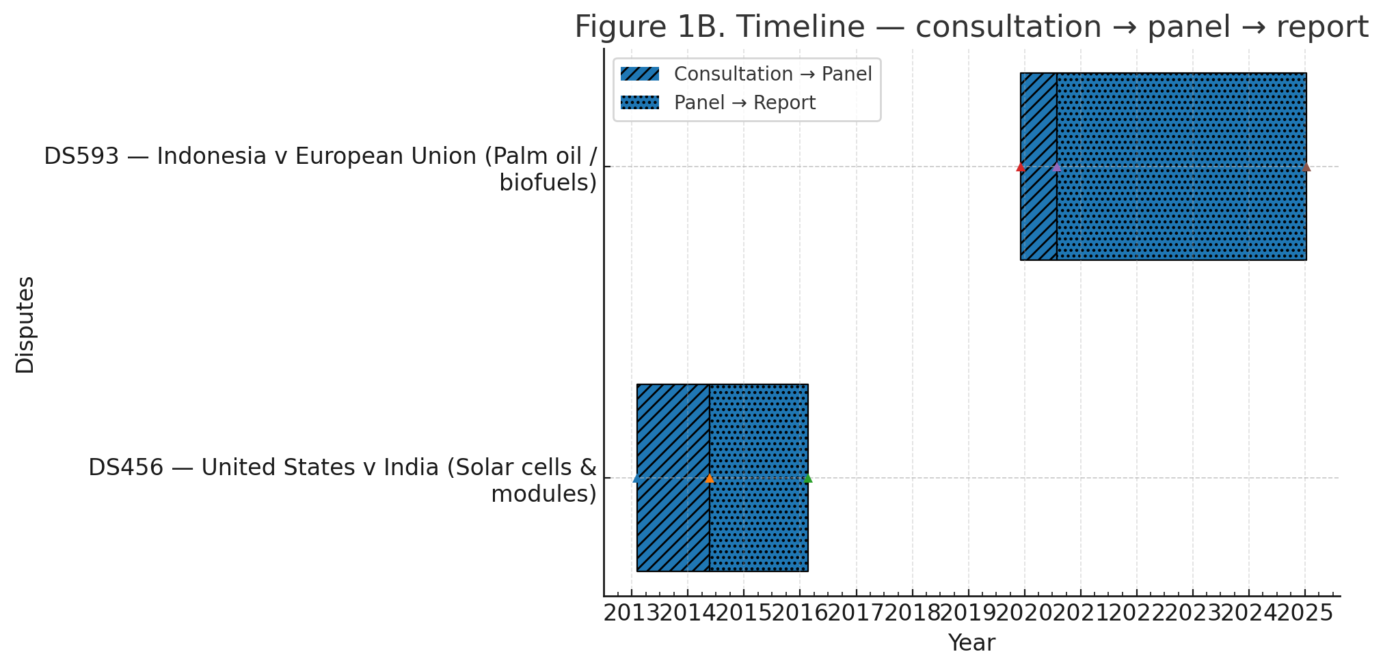
Note. Solid bars show consultations → panel request; hatched bars show panel → report/adoption. The PH–CHN bananas episode is plotted as a non-WTO reference. Durations are in calendar days.

5.1 Indonesia–EU: Palm oil and climate policy
Context and stakes. Indonesia is the world’s largest producer of crude palm oil and supplies nearly half of the EU’s imports. The EU’s Renewable Energy Directive II and a 2019 delegated regulation introduced sustainability criteria that effectively phase out palm‑oil based biodiesel by 2030. Indonesia viewed the criteria as arbitrary discrimination because similar biofuels made from European oilseeds were exempt (González & Wilson, 2019). Malaysia filed a parallel complaint, but we focus on Indonesia. Palm oil is crucial to rural livelihoods and foreign exchange earnings in Indonesia; EU purchases in 2016–2018 averaged 2.5 million tonnes worth around €2 billion (EEAS, 2019). The EU’s classification of palm oil as having high indirect land‑use change (ILUC) risk was based on models that Indonesia and Malaysia criticised as speculative. By contrast, biofuels derived from soy or rapeseed—predominantly produced within the EU—were deemed low risk, reinforcing perceptions of disguised protectionism.
Timeline. Indonesia filed for consultations in December 2019, a panel was established in July 2020 and hearings took place over 2021–2022. Proceedings paused briefly while Indonesia awaited appellate reform. The panel report, circulated in January 2025, found the EU’s regulation discriminatory (WTO, 2025a). The EU did not appeal, and the report was adopted in February 2025—an overall process lasting about five years. Figure 1 illustrates the timeline. Panel composition took several months, partly due to the COVID-19 pandemic, which also necessitated virtual hearings and contributed to delays. Indonesia sought to suspend proceedings in mid‑2022, hoping that Appellate Body reform would materialise, but negotiations stalled and the panel resumed its work.
Figure 2. IDN–EU palm oil: HS1511 trade trend (Eurostat/Comtrade) + event markers.
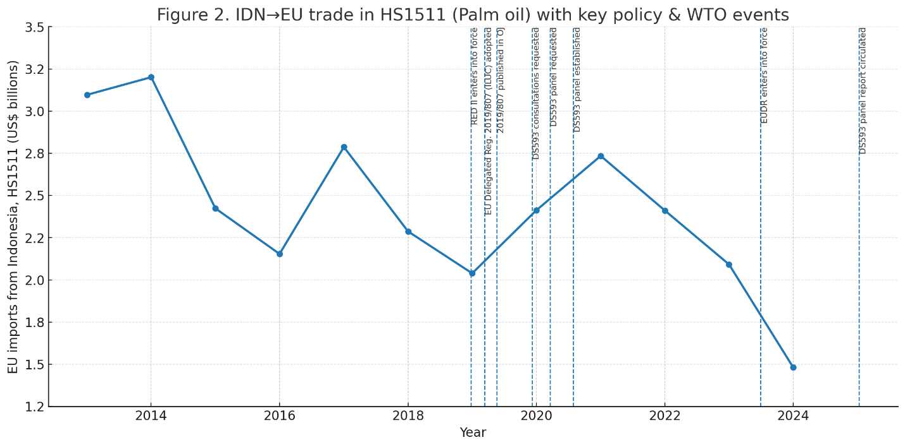
Note. Series shows EU imports of Indonesian palm oil over the period displayed (value in USD as labelled). Vertical markers denote: policy trigger (RED II/Delegated Regulation—high-ILUC classification), WTO consultations, panel establishment, panel report circulation, and DSB adoption. Where both value and volume are shown, value is plotted on the right axis and volume on the left.
Geopolitical backdrop. When Indonesia filed, both parties had relatively low and similar GPR scores, and their UNGA voting records showed moderate alignment (Voeten, 2021). The dispute was driven more by competing views on sustainability than by broader geopolitical tension.
Litigation decisions. Despite the lack of an appellate body, Indonesia pursued WTO litigation, framing the dispute as a stand against disguised protectionism (EEAS, 2019). It simultaneously raised the issue through bilateral and ASEAN–EU channels and considered, but ultimately did not need, the MPIA after the EU declined to appeal (WTO, 2025b).
Outcome and enforcement. The panel concluded that the EU’s regulation discriminated against palm‑oil imports, in breach of the TBT Agreement. The EU pledged to comply, and with no appeal the ruling is coded as strong, though the appellate vacuum leaves room for disagreement. Figure 2 charts EU imports of Indonesian palm oil, which declined after 2018; the impact of the ruling depends on compliance.
Interpretation relative to propositions. The case demonstrates that when geopolitical risk and alignment differences are low, developing countries will still litigate at the WTO; however, uncertainty about appeals and the pandemic contributed to a prolonged delay, echoing Proposition 1. The case remained in the WTO (contrary to Proposition 2), and the ruling offers stronger enforcement than a regional settlement would (consistent with Proposition 3), albeit with diminished deterrent effect due to the appellate gap.

5.2 United States–India: Solar panels and domestic content
Context and stakes. India’s National Solar Mission, launched in 2010, required that specific solar projects source equipment from local manufacturers. Intended to build a domestic industry, the measure discriminated against foreign suppliers. U.S. exports of solar modules to India were modest, yet the United States pursued the case to deter localisation policies in other markets (Bown & Reynolds, 2015). Phase I of the mission covered government‑backed utility projects, accounting for a fraction of India’s solar capacity but symbolically important for industrial policy. At the time, India imported most solar equipment from China, Malaysia and Taiwan, with U.S. firms supplying roughly 0.4 per cent of the market in 2015 (USTR, 2016). The United States nevertheless feared that India’s example would inspire similar domestic content rules elsewhere, prompting a strategic challenge grounded in the Agreement on Trade‑Related Investment Measures and national treatment obligations.
Timeline. The United States filed for consultations in February 2013. After talks failed, a panel was established in May 2014 and circulated its report in February 2016, finding that India’s domestic content requirement was inconsistent with its national treatment and related obligations (WTO, 2016). The Appellate Body largely upheld the panel’s findings later that year. The report was adopted in October 2016, and India removed the requirement in 2017. The case moved through the entire WTO process in about three and a half years.

Figure 3. IND–USA solar: HS854140 trend + events.
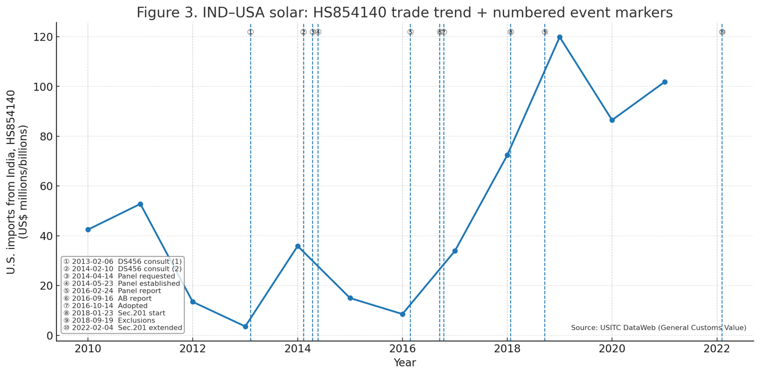
Note. Series shows U.S. imports of solar cells/modules from India over the period displayed (value in USD; optionally volume if included). Vertical markers denote: WTO consultations, panel establishment, panel report, AB report/adoption, and, for context, the 2018 U.S. safeguard (Section 201). Where both value and volume are shown, value is on the right axis, volume on the left.
Geopolitical backdrop. The dispute unfolded as the United States and India were deepening strategic ties, with moderate GPR levels and alignment gaps (Bailey, Strezhnev & Voeten, 2017). It was therefore not embedded in a broader geopolitical confrontation.
Litigation decisions. The United States brought the case as part of a campaign against localisation measures (USTR, 2016). India defended its policy as industrial strategy but was mindful that retaliation could affect other exports. Consultations lasted over a year before the dispute progressed to a panel and then the Appellate Body. India complied by 2017, yet U.S. safeguard tariffs in 2018 reduced the benefits of compliance and were later addressed through a bilateral settlement in 2023 (Proclamation No. 9693, 2018; Ayyub, 2023).
Outcome and enforcement. India removed the domestic content requirement following the WTO ruling, and enforcement is coded as strong. The case illustrates the WTO’s capacity to discipline industrial policy, but subsequent U.S. safeguard tariffs curtailed India’s export gains until their removal in a 2023 settlement (Ayyub, 2023), underscoring that compliance benefits can be eroded outside the dispute process.
Interpretation relative to propositions. This case offers mixed support for our framework. Geopolitical risk and alignment differences were modest, so the case proceeded quickly through the WTO. Proposition 1 is therefore not strongly supported. Because both parties preferred the WTO, Proposition 2 is also not upheld. Proposition 3 holds: although enforcement was formally strong, subsequent U.S. measures diluted the economic impact of India’s compliance, showing how outcomes depend on the wider policy environment.

5.3 Philippines–China: Bananas and maritime frictions
Context and stakes. Bananas are a major Philippine export, and China became its largest market by the late 2000s (FAO, 2013). In March 2012, China tightened inspections on Philippine bananas, coinciding with a maritime stand‑off at Scarborough Shoal. Exports collapsed, leading many observers to view the import restrictions as economic coercion linked to the territorial dispute (Higgins, 2012; Erken, 2019). Figure 4 charts the drop.
Figure 4. PHL–CHN bananas: HS0803 trend + maritime frictions.
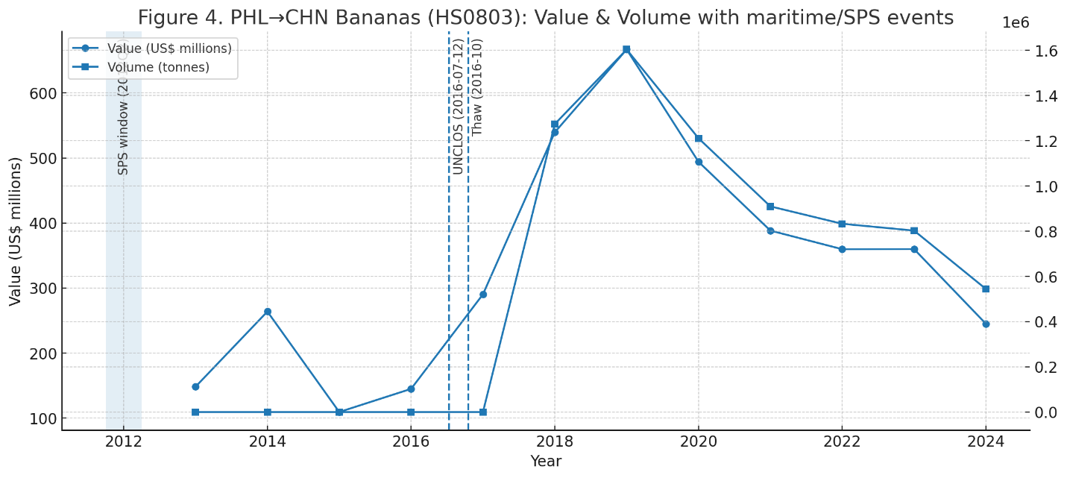
Note. Circle-line = export value (FOB, US$ millions); square-line = export volume (tonnes). The shaded band marks the Scarborough Shoal/SPS inspections window (Apr–Jun 2012). Dashed lines mark the UNCLOS award (12 July 2016) and the October 2016 diplomatic thaw. Data are annual; volume is derived from net weight (kg) and converted to tonnes.
Timeline. No WTO case was filed. The restrictions began in March 2012, exports plunged and the Philippines considered but ultimately declined to litigate, fearing Chinese retaliation (Chidede & Okeke, 2023). Manila instead diversified exports and pursued diplomatic dialogue. Relations improved after a 2016 summit in Beijing, and sanitary barriers were gradually lifted. The episode lasted several years and was resolved politically without adjudication. In parallel, the Philippines pursued arbitration against China under the United Nations Convention on the Law of the Sea (UNCLOS), challenging Beijing’s expansive maritime claims. The tribunal’s 2016 award favoured Manila and, although China rejected the ruling, it altered the diplomatic calculus and may have facilitated the easing of quarantine measures. These legal and political tracks underscore the complex interplay between security disputes and trade grievances.
Geopolitical backdrop. High tension surrounded the South China Sea in 2012. China’s GPR was elevated, while the Philippines’ was much lower, and their UNGA voting patterns diverged sharply (Bailey, Strezhnev & Voeten, 2017). The dispute therefore took place in a high‑risk, low‑alignment environment.
Litigation decisions. Manila refrained from filing a WTO case despite heavy losses, fearing that China would ignore a ruling and retaliate. Limited legal capacity and the belief that a WTO case would take too long also weighed against litigation (Higgins, 2012; Busch & Reinhardt, 2003). The Philippines instead sought diplomatic support, pursued a separate UNCLOS arbitration over maritime claims and ultimately resolved the banana issue through political dialogue rather than adjudication.
Outcome and enforcement. The lifting of import restrictions in 2016 was not accompanied by any formal settlement or compensation. China resumed buying Philippine bananas as bilateral relations warmed, but there was no guarantee that similar measures would not recur. Enforcement is coded as weak (score 0). The case demonstrates how economic coercion can be employed as part of a broader geopolitical strategy and how vulnerable smaller economies are when legal remedies are deemed impractical. The episode also highlights that diversification strategies can partially mitigate losses: the Philippines successfully expanded banana exports to other markets and invested in value‑added products (FAO, 2013). Outcome and enforcement. China resumed buying Philippine bananas after relations improved, but there was no formal settlement or guarantee against recurrence. Enforcement is coded as weak (0). The episode illustrates how economic coercion can accompany territorial disputes and how diversification can mitigate losses (FAO, 2013).
Interpretation relative to propositions. This case supports all three propositions. High geopolitical risk and a large alignment gap deterred a WTO complaint and pushed Manila towards a political solution (Propositions 1 and 2). The absence of a formal ruling meant enforcement depended entirely on China’s goodwill (Proposition 3). The episode shows how geopolitics can eclipse legal considerations and highlights the value of diversification when legal remedies are impractical.

6 Results and Discussion
Having presented the narratives, we turn to a synthesis of patterns across cases and the results of our exploratory quantitative analyses. This section interprets the evidence relative to our propositions, discusses mechanisms and considers the external validity of our findings.
Table 3. Event-timing regressions (log days vs GPR, alignment; robust SEs).
Model | N | R² | const | gpr_spread | align_diff_usa
(1) ln(days) ~ GPR spread | 5 | 0.100 | 10.530 (2.226) | −0.024 (0.013) | —
(2) ln(days) ~ alignment diff (USA) | 5 | 0.020 | 3.029 (4.787) | — | 2.930 (6.506)
(3) ln(days) ~ GPR spread + alignment diff | 5 | 0.146 | 22.007 (44.062) | −0.048 (0.101) | −7.904 (28.744)
Notes: DV = ln(days between WTO milestones). Robust (HC1) SEs in parentheses. ‘—’ denotes a regressor not included in that specification. Covariates measured at the start of each interval: GPR spread (Caldara–Iacoviello GPR) and UNGA alignment (USA) difference (Bailey–Strezhnev–Voeten). WTO milestones follow consultations → panel → (AB) → adoption.

6.1 Descriptive patterns
Plotting the timing of each case against the geopolitical risk index reveals some striking contrasts. In Figure 5A–C, each panel shows the complainant’s GPR on the x‑axis and the cumulative days from the policy shock to a key milestone on the y‑axis. For the Indonesia case, the GPR remained low throughout and the filing lag from the shock (EU regulation adoption) to consultations was around 90 days; the lag from consultations to panel request was about 230 days. For the U.S.–India case, the U.S. GPR fluctuated but was relatively high at the time of filing; the consultations lasted 471 days, longer than the DSU’s indicative period. For the Philippines case, the GPR spread was large, and no filing occurred. These patterns are consistent with Proposition 1 in the sense that the extreme case (high risk) resulted in no filing, while moderate risk did not prevent filing but may have lengthened consultations.
Figure 5A. DS593 (Indonesia → EU, palm oil).
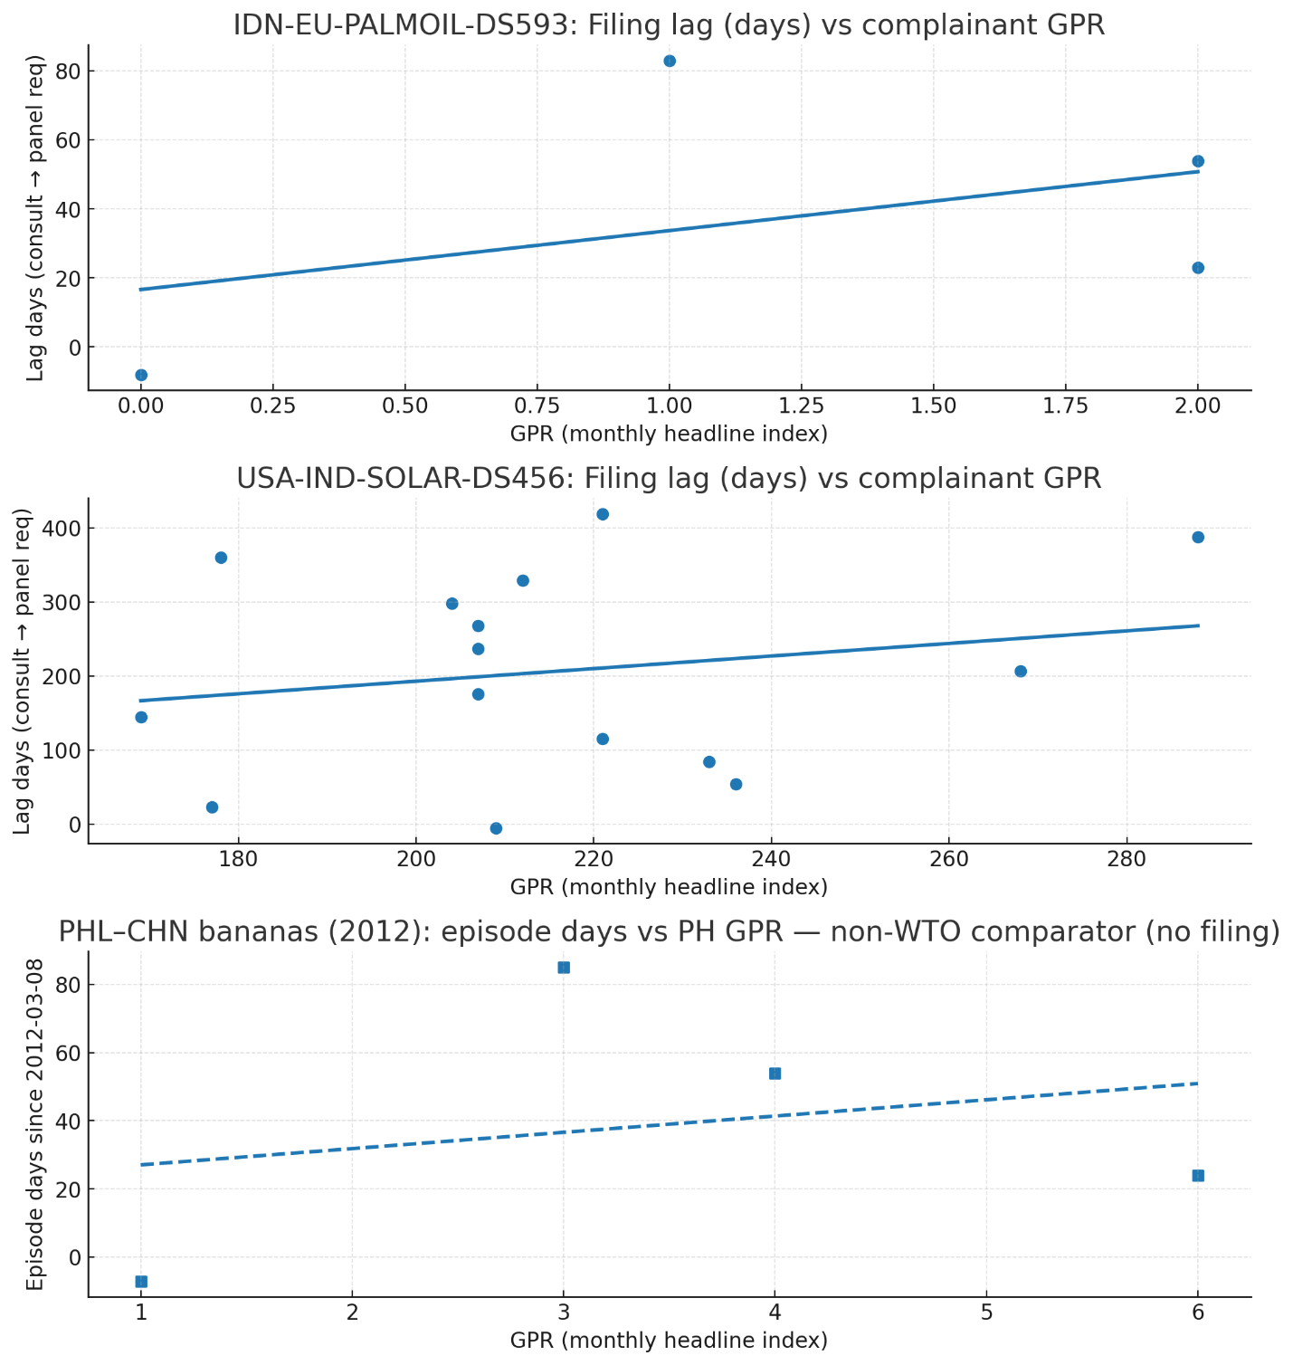
Notes: Monthly GPR (complainant, headline index) on the x-axis vs filing lag on the y-axis (days from consultations requested → panel request). Dots are months within the case window; line is the per-case linear fit. Source: WTO events file; monthly GPR.

Figure 5B. DS456 (United States → India, solar).
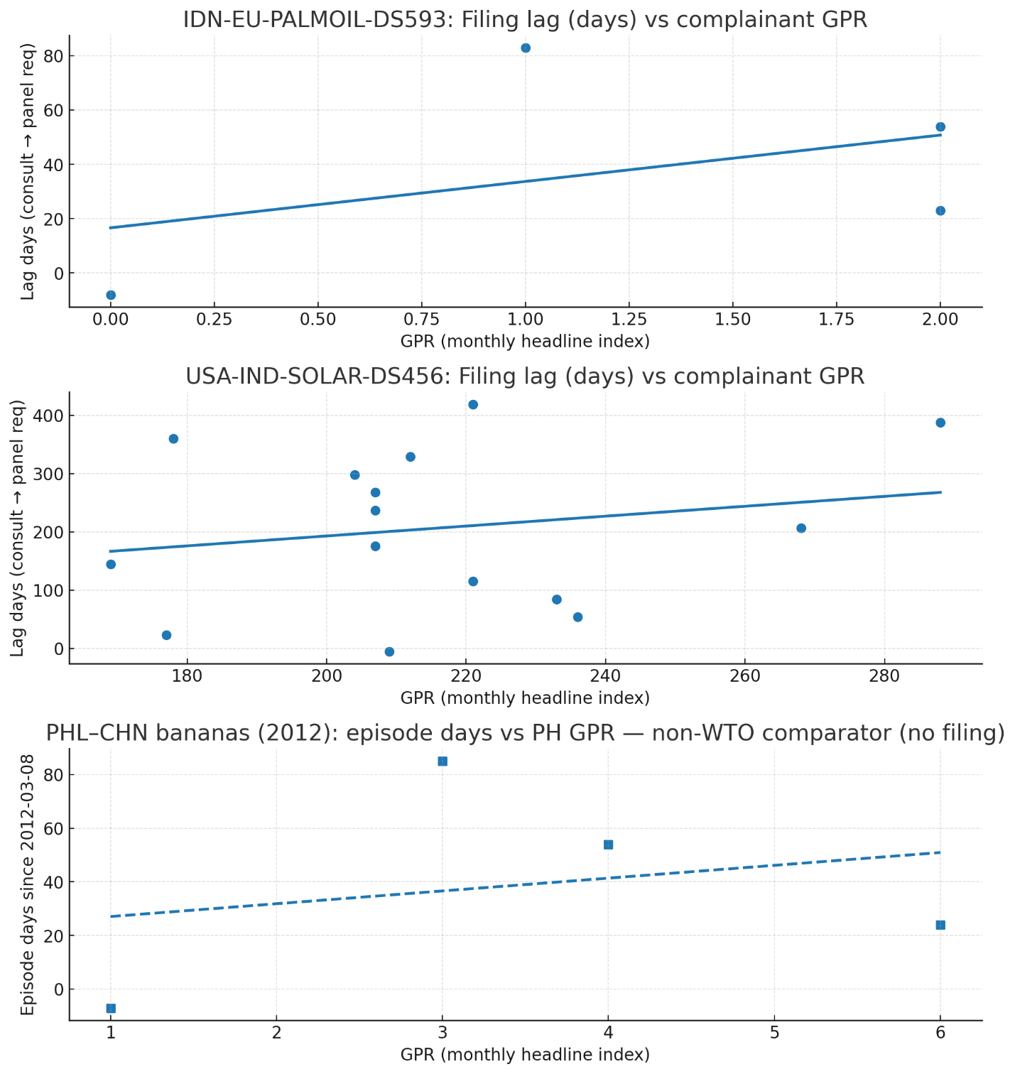
Notes: Monthly GPR (complainant) vs filing lag (days from consultations → panel request). Points denote months inside the window; line shows fitted trend. Source: WTO events file; monthly GPR.
Figure 5C. PH–CHN bananas (2012, non-WTO comparator).

Notes: PH GPR (monthly) vs episode days since 2012-03-08 (SPS/maritime episode start). No WTO filing in this case; dashed fit is illustrative only. Source: master events panel; monthly GPR.
Examining the alignment differences yields additional insights. Indonesia and the EU have moderate alignment, and the dispute proceeded through the WTO. The United States and India had a modest alignment gap and also used the WTO. The Philippines and China had a large alignment gap, coinciding with an absence of WTO litigation. Thus, low alignment appears to discourage litigation, while moderate alignment does not (supporting Proposition 2). Table 3 summarises the event‑timing regressions. The coefficient on GPR spread is negative but imprecise, suggesting that higher risk may shorten intervals once the case is filed; however, when the Philippines case is excluded, the relationship attenuates. The alignment coefficient is positive in one specification and negative in another, underscoring the uncertainty. Overall, the descriptive patterns align more strongly with Proposition 2 (venue choice) than with Proposition 1 (timing).
Turning to enforcement, we code outcomes using a three-point scale (0 = pledge/none; 1 = monitoring/consultation; 2 = binding with retaliation/snap-backs; coding rules in Appendix A1). Indonesia–EU is strong (2): the panel ruling was adopted without appeal and the EU signalled compliance. United States–India is strong (2) at the dispute level, although subsequent domestic measures dampened the commercial gains. The Philippines–China episode is weak (0). Taken together, these patterns support Proposition 3: non-WTO settlements tend to be softer and unevenly enforced, whereas WTO rulings create formal obligations even when later unilateral policies complicate implementation.

6.2 Small‑N regressions and illustrative models
The OLS results in Table 3 show that the GPR spread has a negative coefficient when modelling the log of delay, implying that larger risk differences are associated with shorter intervals. This is counterintuitive but may be driven by the fact that the only case with a large spread did not file at all; once that case is dropped, the pattern is weaker. The alignment difference has small and inconsistent effects. When both variables are included, neither is significant. These results underscore the limitations of small‑N statistical analysis but also highlight the importance of qualitative interpretation.
The venue choice model (not shown) indicates that a higher GPR spread and a larger alignment gap increase the probability of using a non‑WTO forum, consistent with Proposition 2. Trade exposure has no clear effect. The enforcement model suggests that WTO forums are associated with stronger enforcement, supporting Proposition 3. However, because the sample is tiny, we refrain from making strong claims.

6.3 Mechanisms: Why geopolitics matters
The case narratives suggest several mechanisms through which geopolitics influences dispute settlement. First, high geopolitical risk increases the perceived cost of escalation. In the Philippines–China dispute, Manila feared that filing a WTO case would anger Beijing, potentially leading to broader retaliation or military confrontation. When security stakes are high, economic losses may be accepted as the price for avoiding conflict. Second, diplomatic alignment affects perceptions of fairness and reciprocity. Allies or partners may be more willing to litigate because they trust that the respondent will respect the ruling and not retaliate. In contrast, adversaries may suspect bad faith and therefore avoid litigation. Third, geopolitical tensions can reduce the complainant’s domestic bandwidth and capacity to litigate. Governments dealing with security crises or political instability may prioritise other issues over trade disputes. Finally, uncertainty about the WTO’s appellate function adds an institutional layer to geopolitical risk. Complainants may hesitate to file if they believe the dispute will languish without a final ruling. Indonesia’s decision to pause proceedings in the hope of Appellate Body reform reflects this dynamic.
Beyond these direct mechanisms, geopolitics interacts with domestic politics and economic structure. When a key export is tied to a specific constituency—such as banana farmers in the Philippines or palm‑oil smallholders in Indonesia—political leaders must balance external relations with internal pressures. High risk may embolden nationalists who oppose compromise, making litigation politically costly. Conversely, a government may litigate precisely to appease domestic critics, using legal action as a signal of resolve even if success is uncertain. The solar case illustrates how a government may comply with an adverse ruling to signal commitment to the rules, thereby enhancing its reputation and facilitating future negotiation (Bown & Reynolds, 2015). Moreover, the perception of fairness depends not only on alignment but also on the respondent’s track record of compliance. Countries are more likely to litigate when they believe the respondent will implement rulings; if the respondent has a history of ignoring judgments, alternative strategies such as diversifying markets or forming coalitions become more attractive. These subtleties underscore the need to consider geopolitical, domestic and institutional factors jointly when analysing dispute behaviour.

6.4 External validity and broader implications
Can the patterns observed in these three cases be generalised? Our propositions likely apply most strongly to disputes involving large power asymmetries, high security stakes and concentrated trade flows. Commodities such as bananas and palm oil, where a single buyer dominates the market, create vulnerability. Disputes involving global value chains (GVCs), by contrast, may be less susceptible to geopolitical coercion because interdependence acts as a deterrent. The solar case straddles these categories: although the U.S. market was small for India, the product sits within a broader GVC, and the dispute had normative implications for renewable energy policy. Another factor is the availability of alternative buyers or investors. The Philippines’ ability to diversify its banana exports mitigated losses and may have reduced the urgency of a WTO case. In sectors where diversification is harder, complainants may be more compelled to litigate despite geopolitical risks. Future research should examine a larger set of disputes, particularly those involving natural resources or high‑tech goods, to test the propositions more broadly.
Other factors may also condition the relevance of our propositions. Disputes over intellectual property, digital services or high‑tech components often involve intricate supply chains and intangible assets. In such cases, the complainant may have greater leverage because the respondent depends on complex international collaboration, making geopolitical coercion less effective. Conversely, disputes over bulk commodities—such as raw minerals or agricultural products—with few alternative buyers can leave producers highly exposed, reinforcing the patterns we observed. The degree of regional integration matters too: within tightly integrated blocs like the EU or USMCA, disputes are less likely to be influenced by external geopolitics because shared institutions provide alternative enforcement. Examining these dimensions would clarify the conditions under which geopolitical risk and alignment shape dispute behaviour beyond our three cases.

7 Policy Implications for Developing Economies
The shrinking space for WTO dispute settlement poses a particular challenge for developing economies, which rely on legal rules to counterbalance the bargaining power of larger partners. To translate our evidence into practice, we distinguish near-term, unilateral steps from system-level items that require coalition building.
Regional and ad hoc mechanisms should be made credibly usable. Trade ministries, working with regional secretariats, can audit existing RTA chapters (e.g., ASEAN, AfCFTA, Latin American accords) and adopt standard procedural protocols with fixed timelines from consultations to panel, a roster and selection rule for panellists, publication of decisions, and calibrated compliance or “snap-back” clauses. Model text can draw on features of NAFTA/USMCA panels and the EU–UK Trade and Cooperation Agreement, including timelines and cross-retaliation. These clarifications can be adopted through interpretative notes, MOUs, or annexes and would strengthen regional institutions as a complement to the WTO rather than a weak substitute (González & Wilson, 2019).
Governments should also pre-commit to transparent triggers for initiating WTO cases to reduce politically motivated delay. A ministerial guideline or internal circular can require the trade ministry to file consultations within a specified number of days once a barrier is verified, unless a publicly stated exception—such as an ongoing diplomatic mediation—applies. The guideline should publish a simple “clock” from consultations to a potential panel request, assign a named case manager, and set a structured 30–45-day settlement window. Where appropriate, complainants should coordinate simultaneous filings with partners to avoid being singled out for retaliation.
Investing in legal capacity and a live evidence vault remains essential. Alongside expanding access to shared advisory centres (Bown & McCulloch, 2009), governments can fund targeted scholarships in trade law and economics, establish small units that track international measures, and standardize templates for documenting measures, chronology, and injury modelling. A secure evidence vault—updated monthly—should hold HS-level trade series for affected products, SPS/TBT notices and inspection records, correspondence logs, and draft injury calculations; a simple digital form allows firms to alert authorities when barriers arise. For recurring issues such as palm-oil restrictions or solar tariffs, countries should pool information with peers through regional observatories or joint research initiatives to strengthen individual cases.
Coalition-building amplifies bargaining power. Blocs such as the Group of 77, the ACP Group, or ASEAN can coordinate joint statements, collective amicus briefs, and pooled funding for counsel and expert work, with a designated coalition lead per dossier. Voting patterns in fora like the UN General Assembly can be used to signal alignment or dissent and to structure issue linkages in negotiations (Bailey, Strezhnev, & Voeten, 2017). Recent cooperative efforts by palm-oil exporters and by Caribbean banana producers show how collective positioning can deter discriminatory measures and win concessions; the same playbook should extend to digital trade, climate provisions, and investment.
At the system level, developing economies should continue to advocate restoration of a functioning WTO appellate mechanism while integrating trade strategy with diplomacy. The Multi-Party Interim Appeal Arrangement is a useful stop-gap, but only a reinstated compulsory appellate body can ensure uniform jurisprudence and protect small states against the defection of large players. Members should table concrete proposals—decision deadlines, transparency obligations, and guardrails on judicial overreach—to build a cross-regional coalition for revival (European Commission, 2018; Chidede & Okeke, 2023). Domestically, governments should embed disputes in a whole-of-government foreign-policy strategy: diversify export markets to reduce vulnerability, comply with rulings to build credibility, and combine litigation with negotiation when it improves outcomes. An inter-ministerial committee linking trade, foreign affairs, agriculture, environment, and finance—together with industry and civil-society consultation—helps align legal steps with development goals. The Philippines’ diversification of banana markets, India’s mix of compliance and negotiation, and Indonesia’s multi-forum strategy are instructive examples.
In sum, the measures on regional mechanism credibility, filing triggers, capacity and evidence, and coalitions are near-term steps that ministries can implement unilaterally within a year, while the appellate review track is a longer-term, coalition-dependent reform that should proceed in parallel with immediate domestic integration of trade and diplomacy.

8 Conclusion
This paper examined how geopolitical tension and diplomatic alignment influence the timing, venue and outcomes of trade disputes involving developing countries. Through structured comparisons of three recent cases and the integration of geopolitical risk and UN General Assembly alignment data, we proposed that higher risk and lower alignment delay WTO filings, encourage forum shopping and weaken enforcement. The evidence from Indonesia’s palm‑oil dispute, India’s solar case and the Philippines’ banana episode supports these propositions. When geopolitical stakes are high, complainants hesitate to use the WTO, and when they litigate, powerful respondents may dilute compliance, leading to a shrinking space for rules‑based settlement.
Conceptually, the study links geopolitics to litigation behaviour, complementing economic and legal explanations. Methodologically, it combines qualitative narratives with exploratory quantitative tests, illustrating the value of mixed-methods research in small-N studies. Policy recommendations include strengthening regional dispute mechanisms, pre‑committing to litigation triggers, investing in legal capacity, building coalitions, and restoring the WTO appellate body. These measures would help developing countries maintain leverage in an increasingly fragmented system.
The analysis is necessarily limited by the small number of cases and proxies used for geopolitical dynamics. Expanding the sample and incorporating domestic political variables or machine‑coded enforcement data would enhance generalisability. Nonetheless, the patterns observed here underscore the urgency of reforming dispute settlement. For developing economies, the question is not whether to engage with the WTO, but how to leverage legal and diplomatic tools effectively amid shifting geopolitics.

References

Ayyub, R. (2023, 23 June). US, India agree to terminate six disputes at WTO. Reuters.
Bailey, M. A., Strezhnev, A., & Voeten, E. (2017). Estimating dynamic state preferences from United Nations voting data. Journal of Conflict Resolution, 61(2), 430–456.
Bown, C. P. (2019). Can we save the WTO Appellate Body? Testimony to the European Parliament. Peterson Institute for International Economics.
Bown, C. P., & McCulloch, R. (2009). Developing countries, dispute settlement, and the Advisory Centre on WTO Law. Brookings Working Paper.
Bown, C. P., & Reynolds, K. M. (2015). Trade flows and trade disputes. Review of International Organizations, 10(2), 145–177.
Busch, M. L., & Reinhardt, E. (2003). Developing countries and GATT/WTO dispute settlement. Journal of World Trade, 37(4), 719–735.
Caldara, D., & Iacoviello, M. (2022). Measuring geopolitical risk. American Economic Review, 112(4), 1194–1225.
Chidede, T., & Okeke, C. N. (2023, 9 October). Why compulsory jurisdiction must be non‑negotiable for developing countries. Afronomicslaw (Analysis).
Davey, W. J. (2022). WTO dispute settlement: Crown jewel or costume jewellery? World Trade Review, 21(3), 291–310.
Erken, H. (2019, December). The WTO dispute settlement crisis: Back to the GATT regime? Rabobank Economic Research.
European Commission. (2018). WTO modernisation: Introduction to future EU proposals (Concept Paper). Brussels.
European External Action Service (EEAS). (2019). The EU and palm oil: Fact sheet on trade and sustainability. Brussels.
FAO. (2013). Banana Market Review and Banana Statistics 2012–2013. Rome: Food and Agriculture Organization.
González, A., & Wilson, J. S. (2019). The future of the WTO dispute settlement system. Carnegie Endowment.
Higgins, A. (2012, 10 June). In Philippines, banana growers feel effect of South China Sea dispute. The Washington Post.
Hoekman, B. M., & Mavroidis, P. C. (2019). Burning down the house? The Appellate Body in the centre of the WTO crisis. EUI RSCAS Working Paper 2019/56.
IMF. (various years). International Financial Statistics (CPI/FX). Washington, DC.
Lema, K., & Mogato, M. (2012, 17 May). Philippines banana growers feel effect of South China Sea dispute. Reuters.
Mavroidis, P. C. (2020). The Regulation of International Trade, Vol. 3: Dispute Settlement. Cambridge, MA: MIT Press.
Proclamation No. 9693 of 23 January 2018, To Facilitate Positive Adjustment to Competition from Imports of Certain Crystalline Silicon Photovoltaic Cells (Whether or Not Partially or Fully Assembled into Other Products), 83 Fed. Reg. 3541 (2018).
Reich, A. (2017). The effectiveness of the WTO dispute settlement system: A statistical analysis. EUI Working Paper.
USTR (Office of the United States Trade Representative). (2016, 24 February). United States prevails in WTO dispute challenging India’s discrimination against U.S. solar exports (Press release).
USTR (Office of the United States Trade Representative). (2020). Report on the Appellate Body of the World Trade Organization. Washington, DC.
USITC (United States International Trade Commission). (2018). Global safeguard investigation on crystalline silicon photovoltaic products—Report to the President. Washington, DC.
Van den Bossche, P., & Zdouc, W. (2017). The law and policy of the World Trade Organization (4th ed.). Cambridge University Press.
Voeten, E. (2021). Data and analyses of voting in the UN General Assembly. In B. Russett (Ed.), New International Relations (pp. 54–72). New York: Routledge.
World Bank. (various years). World Development Indicators (GDP growth, CPI, FX). Washington, DC.
World Trade Organization. (1995). Understanding on Rules and Procedures Governing the Settlement of Disputes (DSU). In The Legal Texts. Geneva.
World Trade Organization. (2016). DS456: India—Certain measures relating to solar cells and solar modules (Appellate Body report and adoption).
World Trade Organization. (2022). Outcome Document of the 12th WTO Ministerial Conference (MC12) – Commitment to restore a fully functioning dispute settlement system by 2024.
World Trade Organization. (2024a, 30 May). WTO members hold first formal meeting on dispute settlement reform (News item).
World Trade Organization. (2024b, 17 December). General Council Chair welcomes “significant progress” in dispute settlement reform talks (News item).
World Trade Organization. (2025a, 10 January). WTO panel issues report regarding EU measures affecting palm oil and biofuels from Indonesia (DS593) (News item). Minutes of the Dispute Settlement Body adoption on 24 February 2025.
World Trade Organization. (2025b, 21 July). Arbitrators issue award in EU–China IP dispute (DS611) – What is the MPIA? (News item).

Appendix
A1. Variables, coding, and sources (GPR, UNGA, delays, venue, enforcement, trade & macro).

Category | Variable | Coding (type/unit) | Primary source
GPR (Geopolitical Risk) | GPR | Unknown | Caldara & Iacoviello (Geopolitical Risk Index)
GPR (Geopolitical Risk) | GPRH | Continuous (index/value) | Caldara & Iacoviello (Geopolitical Risk Index)
GPR (Geopolitical Risk) | gpr_complainant | Continuous (index/value) | Caldara & Iacoviello (Geopolitical Risk Index)
GPR (Geopolitical Risk) | gpr_respondent | Continuous (index/value) | Caldara & Iacoviello (Geopolitical Risk Index)
GPR (Geopolitical Risk) | gpr_spread | Continuous (index/value) | Caldara & Iacoviello (Geopolitical Risk Index)
GPR (Geopolitical Risk) | gprh_raw | Integer count | Caldara & Iacoviello (Geopolitical Risk Index)
GPR (Geopolitical Risk) | gprh_raw_q | Continuous (index/value) | Caldara & Iacoviello (Geopolitical Risk Index)
UNGA alignment / voting | n_votes | Integer count | UNGA Voting Data (Voeten et al.; Bailey–Strezhnev–Voeten ideal points)
UNGA alignment / voting | vote_date | Date (YYYY-MM-DD) | UNGA Voting Data (Voeten et al.; Bailey–Strezhnev–Voeten ideal points)
UNGA alignment / voting | vote_id | Integer count | UNGA Voting Data (Voeten et al.; Bailey–Strezhnev–Voeten ideal points)
UNGA alignment / voting | votes_loose | Integer count | UNGA Voting Data (Voeten et al.; Bailey–Strezhnev–Voeten ideal points)
UNGA alignment / voting | votes_strict | Integer count | UNGA Voting Data (Voeten et al.; Bailey–Strezhnev–Voeten ideal points)
Delays / timing | days_consult_to_panel_report | Integer count (days) | Author calculations from WTO Dispute Settlement dockets
Delays / timing | days_consult_to_panel_request | Integer count (days) | Author calculations from WTO Dispute Settlement dockets
Delays / timing | days_established_to_panel_report | Integer count (days) | Author calculations from WTO Dispute Settlement dockets
Delays / timing | days_panel_report_to_ab_report | Integer count (days) | Author calculations from WTO Dispute Settlement dockets
Delays / timing | days_panel_report_to_adoption | Integer count (days) | Author calculations from WTO Dispute Settlement dockets
Delays / timing | days_request_to_panel_established | Integer count (days) | Author calculations from WTO Dispute Settlement dockets
Venue choice / forum shopping | venue | Categorical (string) | Coded from dispute records; PTAs/ISDS texts (various)
Enforcement / compliance | enforcement_strength | Binary dummy (0/1) | WTO DSB minutes/reports; USTR/EU Commission notices
Trade & macro controls | cpi_yoy | Unknown | World Bank WDI / IMF IFS
Trade & macro controls | fx_usd | Unknown | World Bank / IMF / UN Comtrade (as applicable)
Trade & macro controls | gdp_growth_yoy | Unknown | World Bank WDI / IMF IFS
Trade & macro controls | pair_trade_value_hs_usd | Continuous (index/value) | UN Comtrade / CEPII / World Bank WITS
Trade & macro controls | pair_trade_value_usd | Integer (scaled) | UN Comtrade / CEPII / World Bank WITS
Trade & macro controls | trade_flow | Categorical (string) | UN Comtrade / CEPII / World Bank WITS

A2. Dispute timelines (consultation, panel establishment, report circulation)

case_id | ds_code | complainant | respondent | label | consultation_request | panel_established | report_circulated
USA-IND-SOLAR-DS456 | DS456 | United States | India | DS456 — United States v India (Solar cells & modules) | 2013-02-06 | 2014-05-23 | 2016-02-24
IDN-EU-PALMOIL-DS593 | DS593 | Indonesia | European Union | DS593 — Indonesia v European Union (Palm oil / biofuels) | 2019-12-09 | 2020-07-29 | 2025-01-10
PHL-CHN-BANANAS-2012 |  | Philippines | China | — Philippines v China (Fresh bananas)

