**WEEK-3**

(Implemented in Eclipse )

**1)Spring Core Maven Exercises**

Exercise 1: Configuring a Basic Spring Application:

1. Set Up a Spring Project:

* + Created a Maven project named **LibraryManagement**.

Added Spring Core dependencies to `pom.xml` file:

pom.xml

<project xmlns="http://maven.apache.org/POM/4.0.0">

<modelVersion>4.0.0</modelVersion>

<groupId>com.library</groupId>

<artifactId>LibraryManagement</artifactId>

<version>1.0-SNAPSHOT</version>

<dependencies>

<!-- Spring Core -->

<dependency>

<groupId>org.springframework</groupId>

<artifactId>spring-context</artifactId>

<version>5.3.34</version>

</dependency>

</dependencies>

</project>

2.Configure the Application Context:

applicationContext.xml

<?xml version="1.0" encoding="UTF-8"?>

<beans xmlns="http://www.springframework.org/schema/beans"

xmlns:xsi="http://www.w3.org/2001/XMLSchema-instance"

xsi:schemaLocation="http://www.springframework.org/schema/beans

http://www.springframework.org/schema/beans/spring-beans.xsd">

<!-- Define BookRepository Bean -->

<bean id="bookRepository" class="com.library.repository.BookRepository" />

<!-- Define BookService Bean and inject BookRepository -->

<bean id="bookService" class="com.library.service.BookService">

<property name="bookRepository" ref="bookRepository"/>

</bean>

</beans>

3.Define Service and Repository Classses:

BookRepository.java

**package** com.library.repository;

**public** **class** BookRepository {

**public** **void** saveBook(String bookName) {

System.***out***.println("Book '" + bookName + "' saved to repository.");

}

}

BookService.java

**package** com.library.service;

**import** com.library.repository.BookRepository;

**public** **class** BookService {

**private** BookRepository bookRepository;

// Setter for DI

**public** **void** setBookRepository(BookRepository bookRepository) {

**this**.bookRepository = bookRepository;

}

**public** **void** addBook(String bookName) {

bookRepository.saveBook(bookName);

}

}

LibraryApplicationManagement.java

**package** com.library;

**import** com.library.service.BookService;

**import** org.springframework.context.ApplicationContext;

**import** org.springframework.context.support.ClassPathXmlApplicationContext;

**public** **class** LibraryApplicationManagement {

**public** **static** **void** main(String[] args) {

ApplicationContext context = **new** ClassPathXmlApplicationContext("applicationContext.xml");

BookService bookService = context.getBean("bookService", BookService.**class**);

bookService.addBook("The Great Gatsby");

((ClassPathXmlApplicationContext) context).close(); // optional

}

}

**Output:**

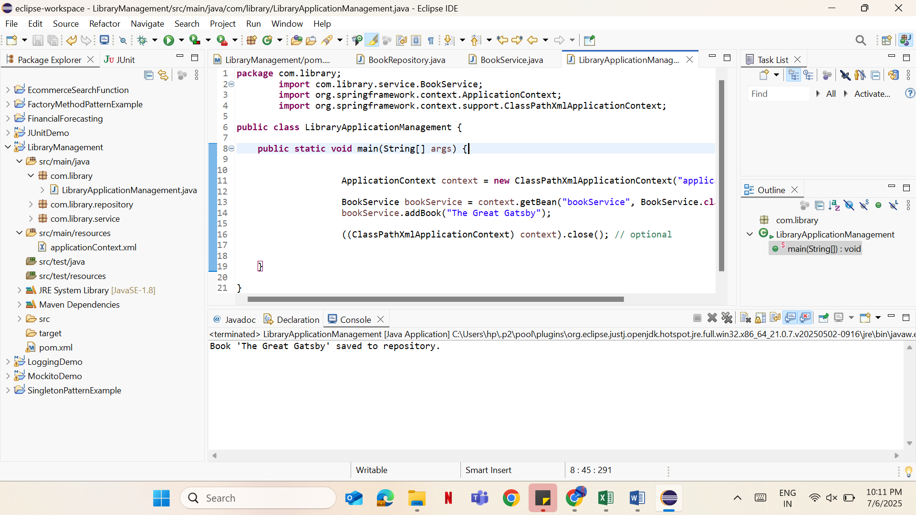

Exercise 2: Implementing Dependeny Injection:

1. Modify the XML Configuration:

applicationContext.xml

<?xml version="1.0" encoding="UTF-8"?>

<beans xmlns="http://www.springframework.org/schema/beans"

xmlns:xsi="http://www.w3.org/2001/XMLSchema-instance"

xsi:schemaLocation="http://www.springframework.org/schema/beans

http://www.springframework.org/schema/beans/spring-beans.xsd">

<!-- Define BookRepository Bean -->

<bean id="bookRepository" class="com.library.repository.BookRepository" />

<!-- Define BookService Bean and inject BookRepository -->

<bean id="bookService" class="com.library.service.BookService">

<property name="bookRepository" ref="bookRepository"/>

</bean>

</beans>

BookService.java

**package** com.library.service;

**import** com.library.repository.BookRepository;

**public** **class** BookService {

**private** BookRepository bookRepository;

// Setter for Dependency Injection

**public** **void** setBookRepository(BookRepository bookRepository) {

**this**.bookRepository = bookRepository;

}

**public** **void** addBook(String bookName) {

bookRepository.saveBook(bookName);

}

}

BookRepository.java

**package** com.library.repository;

**public** **class** BookRepository {

**public** **void** saveBook(String bookName) {

System.***out***.println("Book '" + bookName + "' saved to repository.");

}

}

LibraryApplication.java

**package** com.library;

**import** com.library.service.BookService;

**import** org.springframework.context.ApplicationContext;

**import** org.springframework.context.support.ClassPathXmlApplicationContext;

**public** **class** LibraryApplication {

**public** **static** **void** main(String[] args) {

// Load Spring context

ApplicationContext context = **new** ClassPathXmlApplicationContext("applicationContext.xml");

// Get the BookService bean

BookService bookService = context.getBean("bookService", BookService.**class**);

// Use the service (which has BookRepository injected)

bookService.addBook("1984 by George Orwell");

((ClassPathXmlApplicationContext) context).close(); // optional

}

}

**Output:**

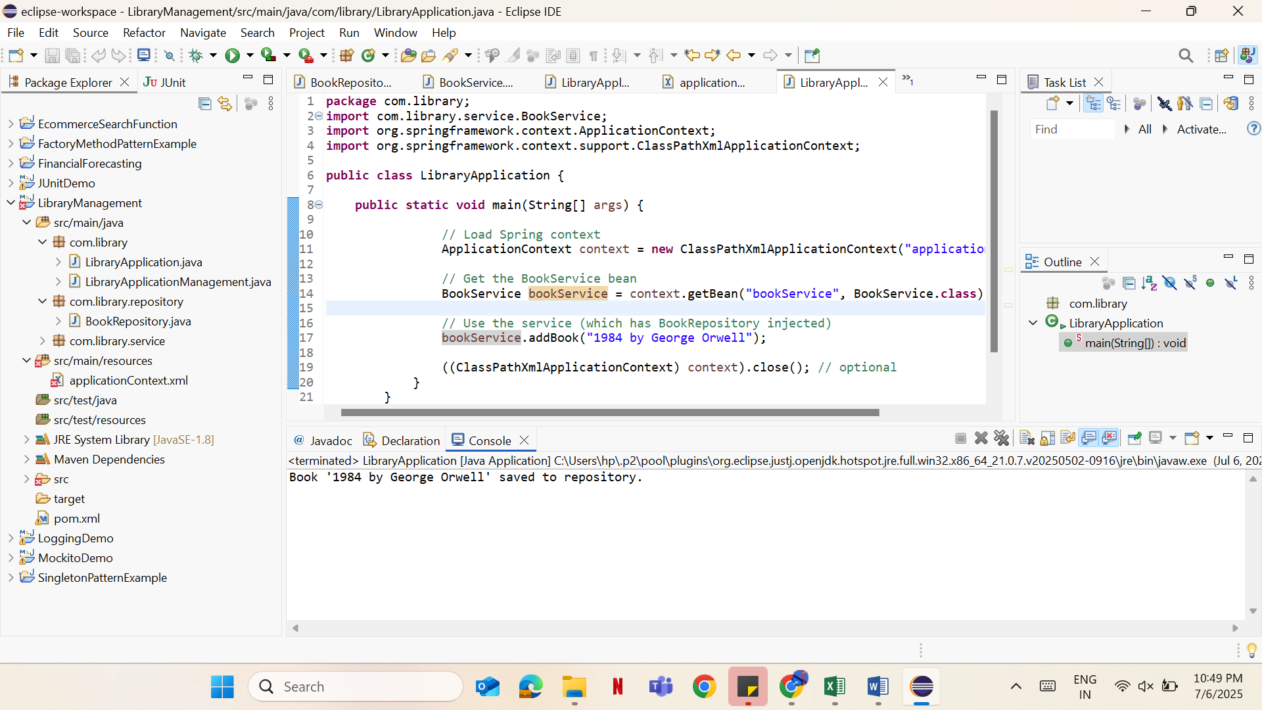

Exercise 4: Create and Configuring a Maven Project

pom.xml

<project xmlns="http://maven.apache.org/POM/4.0.0"

xmlns:xsi="http://www.w3.org/2001/XMLSchema-instance"

xsi:schemaLocation="http://maven.apache.org/POM/4.0.0

http://maven.apache.org/xsd/maven-4.0.0.xsd">

<modelVersion>4.0.0</modelVersion>

<groupId>com.library</groupId>

<artifactId>LibraryM</artifactId>

<version>1.0-SNAPSHOT</version>

<dependencies>

<!-- Spring Context -->

<dependency>

<groupId>org.springframework</groupId>

<artifactId>spring-context</artifactId>

<version>5.3.34</version>

</dependency>

<!-- Spring AOP -->

<dependency>

<groupId>org.springframework</groupId>

<artifactId>spring-aop</artifactId>

<version>5.3.34</version>

</dependency>

<!-- Spring Web MVC -->

<dependency>

<groupId>org.springframework</groupId>

<artifactId>spring-webmvc</artifactId>

<version>5.3.34</version>

</dependency>

<!-- Commons Logging (required for Spring logging) -->

<dependency>

<groupId>commons-logging</groupId>

<artifactId>commons-logging</artifactId>

<version>1.2</version>

</dependency>

</dependencies>

<build>

<plugins>

<!-- Maven Compiler Plugin -->

<plugin>

<groupId>org.apache.maven.plugins</groupId>

<artifactId>maven-compiler-plugin</artifactId>

<version>3.10.1</version>

<configuration>

<source>1.8</source>

<target>1.8</target>

</configuration>

</plugin>

</plugins>

</build>

</project>

LibraryApplication.java

**package** com.library;

**import** com.library.service.BookService;

**import** org.springframework.context.ApplicationContext;

**import** org.springframework.context.support.ClassPathXmlApplicationContext;

**public** **class** LibraryApplication {

**public** **static** **void** main(String[] args) {

// Load Spring context

ApplicationContext context = **new** ClassPathXmlApplicationContext("applicationContext.xml");

// Get the BookService bean

BookService bookService = context.getBean("bookService", BookService.**class**);

// Use the service (which has BookRepository injected)

bookService.addBook("Wings of Fire");

((ClassPathXmlApplicationContext) context).close(); // optional

}

}

