**WEEK-4**

(Implemented in Eclipse)

**Spring REST using Spring Boot 3**

**1) 1. Hands on 1 Spring Web Project using maven**

SpringLearnApplication.java

**package** com.cognizant.spring_learn;

**import** org.springframework.boot.SpringApplication;

**import** org.springframework.boot.autoconfigure.SpringBootApplication;

**import** org.slf4j.Logger;

**import** org.slf4j.LoggerFactory;

@SpringBootApplication

**public** **class** SpringLearnApplication {

**private** **static** **final** Logger ***LOGGER*** = LoggerFactory.*getLogger*(SpringLearnApplication.**class**);

**public** **static** **void** main(String[] args) {

SpringApplication.*run*(SpringLearnApplication.**class**, args);

***LOGGER***.info("Inside main method...");

}

}

pom.xml

<?xml version="1.0" encoding="UTF-8"?>

<project xmlns="http://maven.apache.org/POM/4.0.0"

xmlns:xsi="http://www.w3.org/2001/XMLSchema-instance"

xsi:schemaLocation="http://maven.apache.org/POM/4.0.0 https://maven.apache.org/xsd/maven-4.0.0.xsd">

<modelVersion>4.0.0</modelVersion>

<parent>

<groupId>org.springframework.boot</groupId>

<artifactId>spring-boot-starter-parent</artifactId>

<version>3.1.5</version>

<relativePath/>

</parent>

<groupId>com.cognizant</groupId>

<artifactId>spring-learn</artifactId>

<version>0.0.1-SNAPSHOT</version>

<name>spring-learn</name>

<description>Demo project for Spring Boot</description>

<properties>

<java.version>17</java.version>

</properties>

<dependencies>

<dependency>

<groupId>org.springframework.boot</groupId>

<artifactId>spring-boot-starter-web</artifactId>

</dependency>

<dependency>

<groupId>org.springframework.boot</groupId>

<artifactId>spring-boot-devtools</artifactId>

<scope>runtime</scope>

<optional>true</optional>

</dependency>

<dependency>

<groupId>org.springframework.boot</groupId>

<artifactId>spring-boot-starter-test</artifactId>

<scope>test</scope>

</dependency>

</dependencies>

<build>

<plugins>

<plugin>

<groupId>org.springframework.boot</groupId>

<artifactId>spring-boot-maven-plugin</artifactId>

</plugin>

</plugins>

</build>

</project>

**Output:**

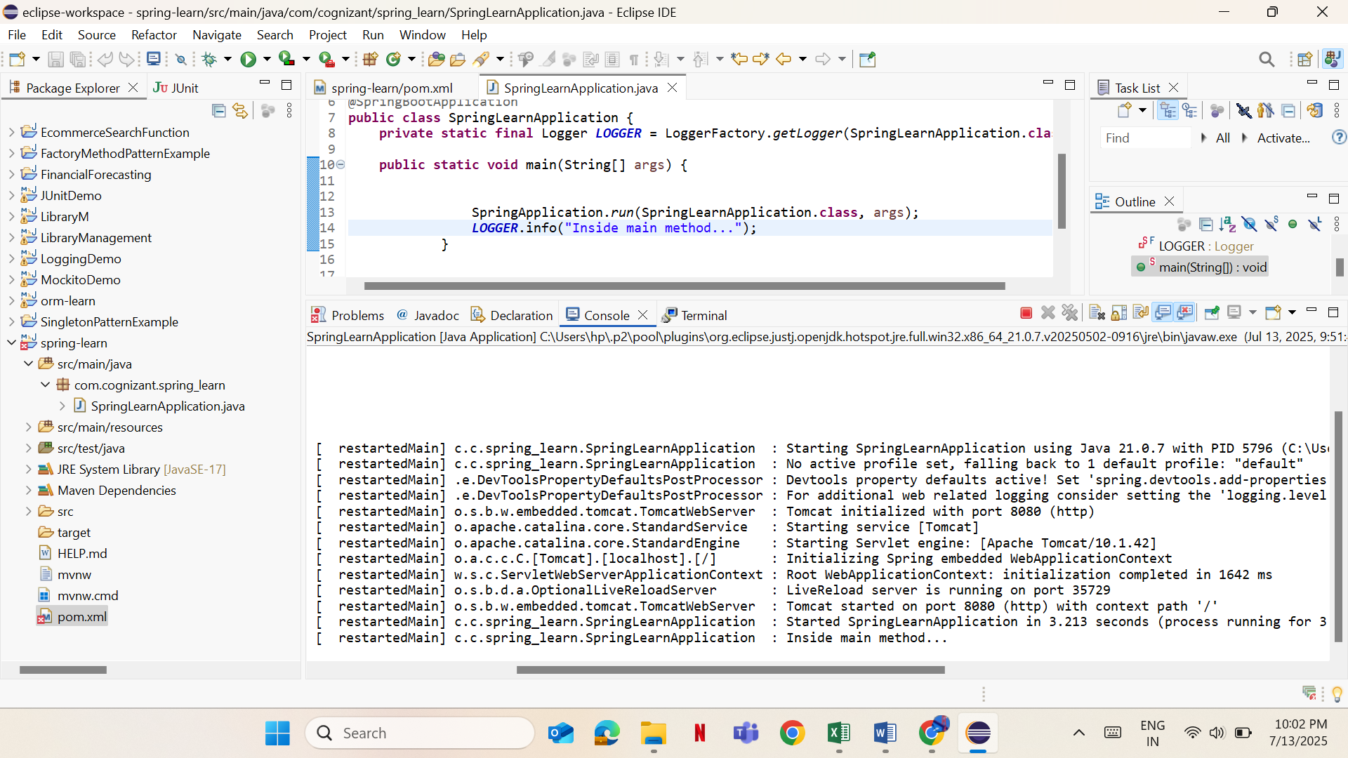

**2) 1. Hands on 4 Spring Core:Load Country from Spring Configuration XML**

Country.java

**package** com.cognizant.spring_learn;

**import** org.slf4j.Logger;

**import** org.slf4j.LoggerFactory;

**public** **class** Country {

**private** **static** **final** Logger ***LOGGER*** = LoggerFactory.*getLogger*(Country.**class**);

**private** String code;

**private** String name;

**public** Country() {

***LOGGER***.debug("Inside Country Constructor.");

}

**public** String getCode() {

***LOGGER***.debug("Inside getCode");

**return** code;

}

**public** **void** setCode(String code) {

***LOGGER***.debug("Inside setCode");

**this**.code = code;

}

**public** String getName() {

***LOGGER***.debug("Inside getName");

**return** name;

}

**public** **void** setName(String name) {

***LOGGER***.debug("Inside setName");

**this**.name = name;

}

@Override

**public** String toString() {

**return** "Country [code=" + code + ", name=" + name + "]";

}

}

country.xml

<?xml version="1.0" encoding="UTF-8"?>

<beans xmlns="http://www.springframework.org/schema/beans"

xmlns:xsi="http://www.w3.org/2001/XMLSchema-instance"

xsi:schemaLocation="http://www.springframework.org/schema/beans

http://www.springframework.org/schema/beans/spring-beans.xsd">

<bean id="country" class="com.cognizant.springlearn.Country">

<property name="code" value="IN" />

<property name="name" value="India" />

</bean>

</beans>

SpringLearnApplication.java

**package** com.cognizant.spring_learn;

**import** org.slf4j.Logger;

**import** org.slf4j.LoggerFactory;

**import** org.springframework.context.ApplicationContext;

**import** org.springframework.context.support.ClassPathXmlApplicationContext;

**public** **class** SpringLearnApplication {

**private** **static** **final** Logger ***LOGGER*** = LoggerFactory.*getLogger*(SpringLearnApplication.**class**);

**public** **static** **void** main(String[] args) {

***LOGGER***.debug("START main");

*displayCountry*();

***LOGGER***.debug("END main");

}

**public** **static** **void** displayCountry() {

ApplicationContext context = **new** ClassPathXmlApplicationContext("country.xml");

Country country = context.getBean("country", Country.**class**);

***LOGGER***.debug("Country : {}", country.toString());

}

}

Output:

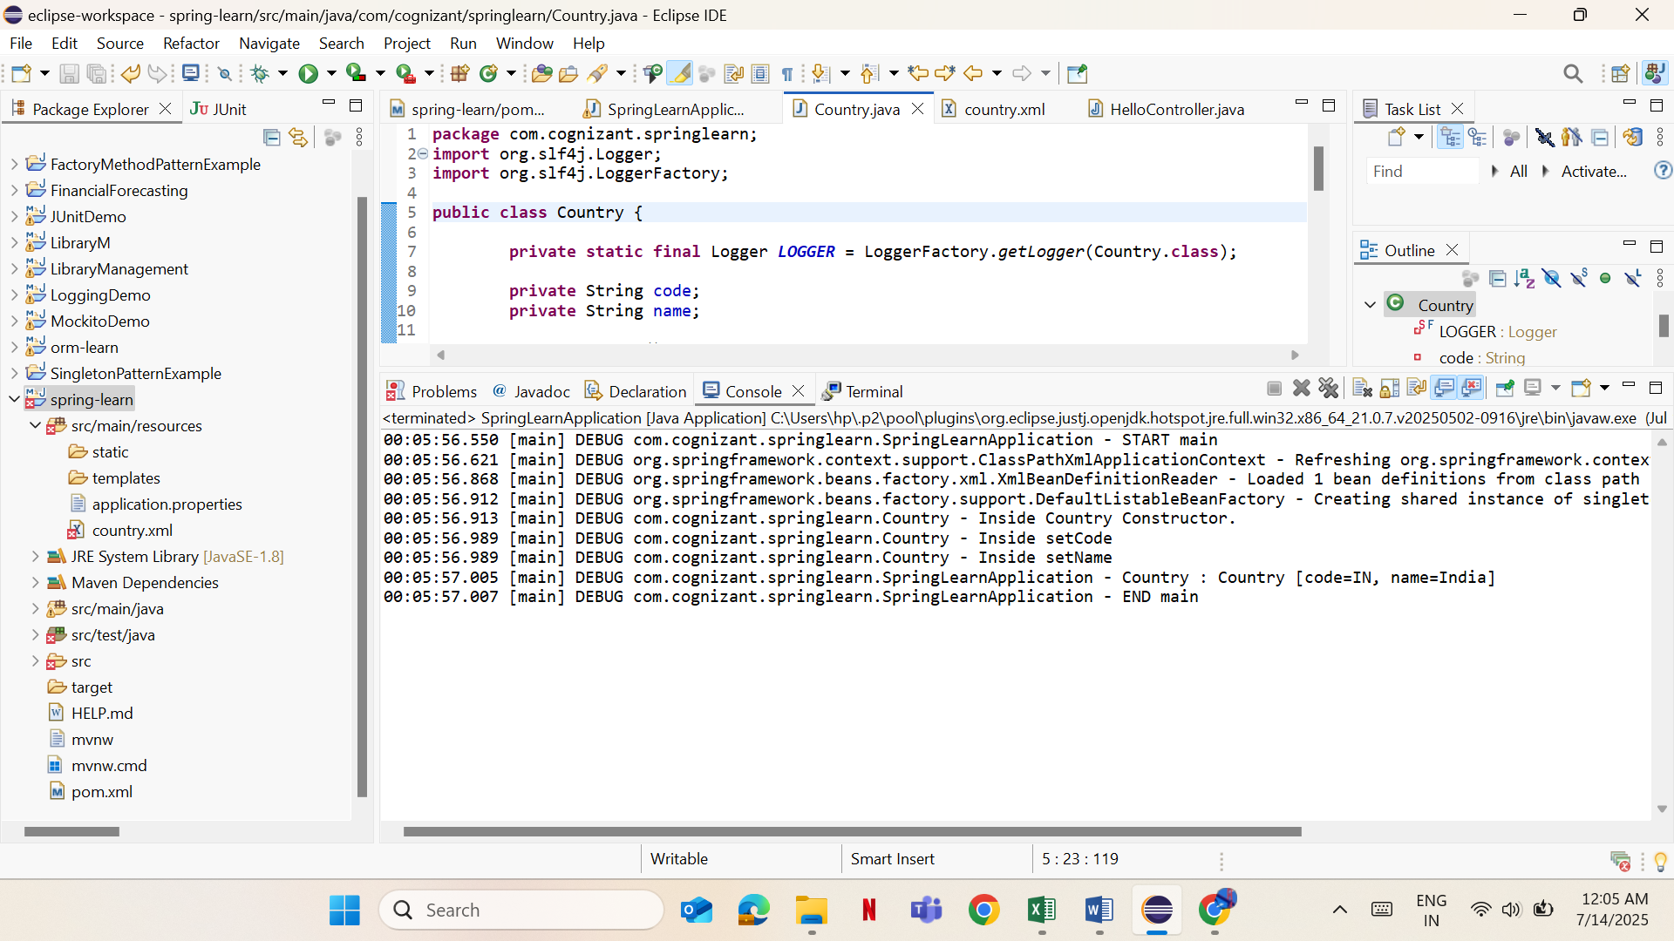

**3) 2.Hands on 1 Hello World Restful Web Service**

Application.properties

spring.application.name=spring-learn

server.port=8085

SpringLearnApplication.java

**package** com.cognizant.springlearn;

**import** org.slf4j.Logger;

**import** org.slf4j.LoggerFactory;

**import** org.springframework.boot.SpringApplication;

**import** org.springframework.boot.autoconfigure.SpringBootApplication;

@SpringBootApplication

**public** **class** SpringLearnApplication {

**private** **static** **final** Logger ***LOGGER*** = LoggerFactory.*getLogger*(SpringLearnApplication.**class**);

**public** **static** **void** main(String[] args) {

***LOGGER***.info("START main");

SpringApplication.*run*(SpringLearnApplication.**class**, args);

***LOGGER***.info("END main");

}

}

HelloController.java

**package** com.cognizant.springlearn.controller;

**import** org.slf4j.Logger;

**import** org.slf4j.LoggerFactory;

**import** org.springframework.web.bind.annotation.GetMapping;

**import** org.springframework.web.bind.annotation.RestController;

@RestController

**public** **class** HelloController {

**private** **static** **final** Logger ***LOGGER*** = LoggerFactory.*getLogger*(HelloController.**class**);

@GetMapping("/hello")

**public** String sayHello() {

***LOGGER***.info("START sayHello()");

String message = "Hello World!!";

***LOGGER***.info("END sayHello()");

**return** message;

}

}

pom.xml

<?xml version="1.0" encoding="UTF-8"?>

<project xmlns="http://maven.apache.org/POM/4.0.0"

xmlns:xsi="http://www.w3.org/2001/XMLSchema-instance"

xsi:schemaLocation="http://maven.apache.org/POM/4.0.0 https://maven.apache.org/xsd/maven-4.0.0.xsd">

<modelVersion>4.0.0</modelVersion>

<parent>

<groupId>org.springframework.boot</groupId>

<artifactId>spring-boot-starter-parent</artifactId>

<version>3.1.5</version>

<relativePath/>

</parent>

<groupId>com.cognizant</groupId>

<artifactId>spring-learn</artifactId>

<version>0.0.1-SNAPSHOT</version>

<name>spring-learn</name>

<description>Demo project for Spring Boot</description>

<properties>

<java.version>17</java.version>

</properties>

<dependencies>

<dependency>

<groupId>org.springframework.boot</groupId>

<artifactId>spring-boot-starter-web</artifactId>

</dependency>

<dependency>

<groupId>org.springframework.boot</groupId>

<artifactId>spring-boot-devtools</artifactId>

<scope>runtime</scope>

<optional>true</optional>

</dependency>

<dependency>

<groupId>org.springframework.boot</groupId>

<artifactId>spring-boot-starter-test</artifactId>

<scope>test</scope>

</dependency>

</dependencies>

<build>

<plugins>

<plugin>

<groupId>org.springframework.boot</groupId>

<artifactId>spring-boot-maven-plugin</artifactId>

</plugin>

</plugins>

</build>

</project>

**Output:**

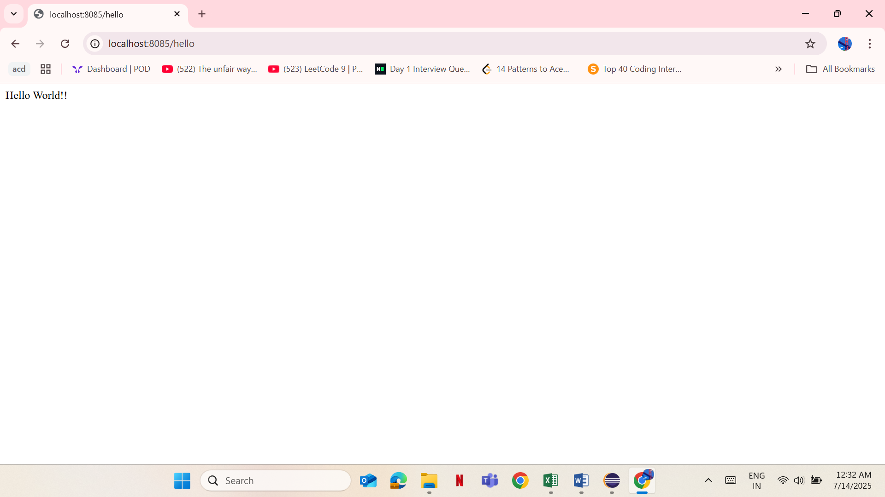

**4) 2.Hands on 2 REST Country Web Service**

Application.properties

spring.application.name=spring-learn

server.port=8085

country.xml

<?xml version="1.0" encoding="UTF-8"?>

<beans xmlns="http://www.springframework.org/schema/beans"

xmlns:xsi="http://www.w3.org/2001/XMLSchema-instance"

xsi:schemaLocation="

http://www.springframework.org/schema/beans

http://www.springframework.org/schema/beans/spring-beans.xsd">

<bean id="in" class="com.cognizant.springlearn.model.Country1">

<property name="code" value="IN"/>

<property name="name" value="India"/>

</bean>

</beans>

SpringLearnApplication.java

**package** com.cognizant.springlearn;

**import** org.slf4j.Logger;

**import** org.slf4j.LoggerFactory;

**import** org.springframework.boot.SpringApplication;

**import** org.springframework.boot.autoconfigure.SpringBootApplication;

@SpringBootApplication

**public** **class** SpringLearnApplication {

**private** **static** **final** Logger ***LOGGER*** = LoggerFactory.*getLogger*(SpringLearnApplication.**class**);

**public** **static** **void** main(String[] args) {

***LOGGER***.info("START main");

SpringApplication.*run*(SpringLearnApplication.**class**, args);

***LOGGER***.info("END main");

}

}

CountryController.java

**package** com.cognizant.springlearn.controller;

**import** com.cognizant.springlearn.model.Country1;

**import** org.slf4j.Logger;

**import** org.slf4j.LoggerFactory;

**import** org.springframework.context.ApplicationContext;

**import** org.springframework.context.support.ClassPathXmlApplicationContext;

**import** org.springframework.web.bind.annotation.RequestMapping;

**import** org.springframework.web.bind.annotation.RestController;

@RestController

**public** **class** CountryController {

**private** **static** **final** Logger ***LOGGER*** = LoggerFactory.*getLogger*(CountryController.**class**);

@RequestMapping("/country")

**public** Country1 getCountryIndia() {

***LOGGER***.info("START - getCountryIndia()");

ApplicationContext context = **new** ClassPathXmlApplicationContext("country.xml");

Country1 country = (Country1) context.getBean("in");

***LOGGER***.info("END - getCountryIndia()");

**return** country;

}

}

Country1.java

**package** com.cognizant.springlearn.model;

**public** **class** Country1 {

**private** String code;

**private** String name;

// Constructors

**public** Country1() {}

**public** Country1(String code, String name) {

**this**.code = code;

**this**.name = name;

}

// Getters & Setters

**public** String getCode() {

**return** code;

}

**public** **void** setCode(String code) {

**this**.code = code;

}

**public** String getName() {

**return** name;

}

**public** **void** setName(String name) {

**this**.name = name;

}

// toString()

@Override

**public** String toString() {

**return** "Country [code=" + code + ", name=" + name + "]";

}

}

pom.xml

<?xml version="1.0" encoding="UTF-8"?>

<project xmlns="http://maven.apache.org/POM/4.0.0"

xmlns:xsi="http://www.w3.org/2001/XMLSchema-instance"

xsi:schemaLocation="http://maven.apache.org/POM/4.0.0 https://maven.apache.org/xsd/maven-4.0.0.xsd">

<modelVersion>4.0.0</modelVersion>

<parent>

<groupId>org.springframework.boot</groupId>

<artifactId>spring-boot-starter-parent</artifactId>

<version>3.1.5</version>

<relativePath/>

</parent>

<groupId>com.cognizant</groupId>

<artifactId>spring-learn</artifactId>

<version>0.0.1-SNAPSHOT</version>

<name>spring-learn</name>

<description>Demo project for Spring Boot</description>

<properties>

<java.version>17</java.version>

</properties>

<dependencies>

<dependency>

<groupId>org.springframework.boot</groupId>

<artifactId>spring-boot-starter-web</artifactId>

</dependency>

<dependency>

<groupId>org.springframework.boot</groupId>

<artifactId>spring-boot-devtools</artifactId>

<scope>runtime</scope>

<optional>true</optional>

</dependency>

<dependency>

<groupId>org.springframework.boot</groupId>

<artifactId>spring-boot-starter-test</artifactId>

<scope>test</scope>

</dependency>

</dependencies>

<build>

<plugins>

<plugin>

<groupId>org.springframework.boot</groupId>

<artifactId>spring-boot-maven-plugin</artifactId>

</plugin>

</plugins>

</build>

</project>

**Output:**

