**WEEK-6**

(Implemented in VSCODE)

**REACT**

**1. REACT JS-HOL**

App.js

function App() {

  return (

    <h1>Welcome to the first session of React by Faiza Hameed</h1>

  );

}

export default App;

**Output:**

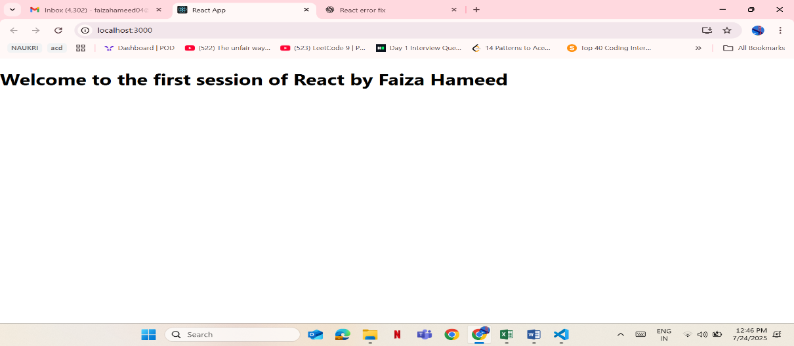

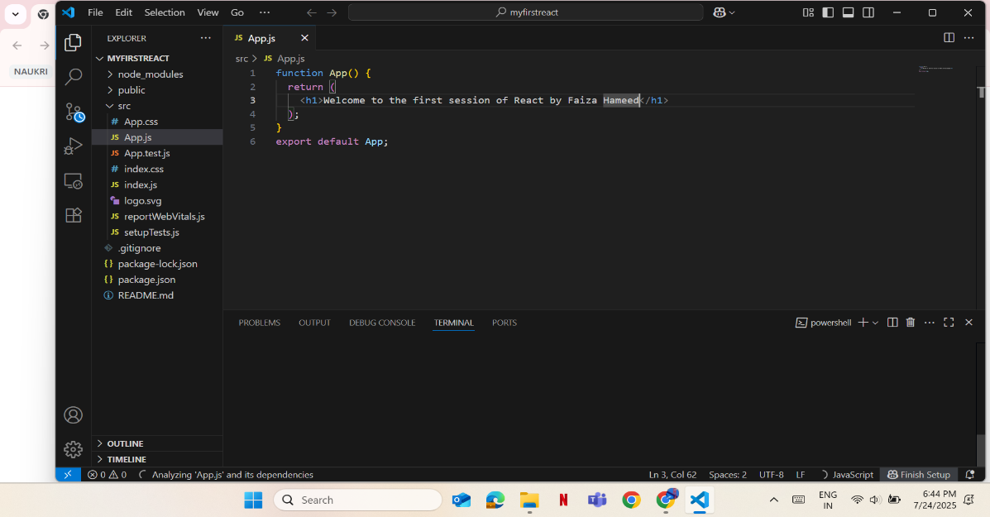

**2. REACT JS-HOL**

App.js

import logo from './logo.svg';

import './App.css';

import Home from './Components/Home';

import Aboutus from './Components/Aboutus';

import Contact from './Components/Contact';

function App() {

  return (

    <div className="container">

      <Home/>

      <Aboutus/>

      <Contact/>

      </div>

  );

}

export default App;

Home.js

import React,{Component} from 'react';

class Home extends Component{

    render(){

        return(

        <div>

        <h3>Welcome to HomePage of Student Management Portal by Faiza Hameed</h3>

        </div>

        );

    }

}

export default Home;

Contact.js

import React,{Component} from 'react';

class Contact extends Component{

    render(){

        return(

        <div>

        <h3>Welcome to ContactPage of Student Management Portal by Faiza Hameed-8712799934</h3>

        </div>

        );

    }

}

export default Contact;

Aboutus.js

import React,{Component} from 'react';

class Aboutus extends Component{

    render(){

        return(

        <div>

        <h3>Welcome to AboutUs of Student Management Portal by Faiza Hameed.Faiza Hameed is an amzing coder.</h3>

        </div>

        );

    }

}

export default Aboutus;

Output:

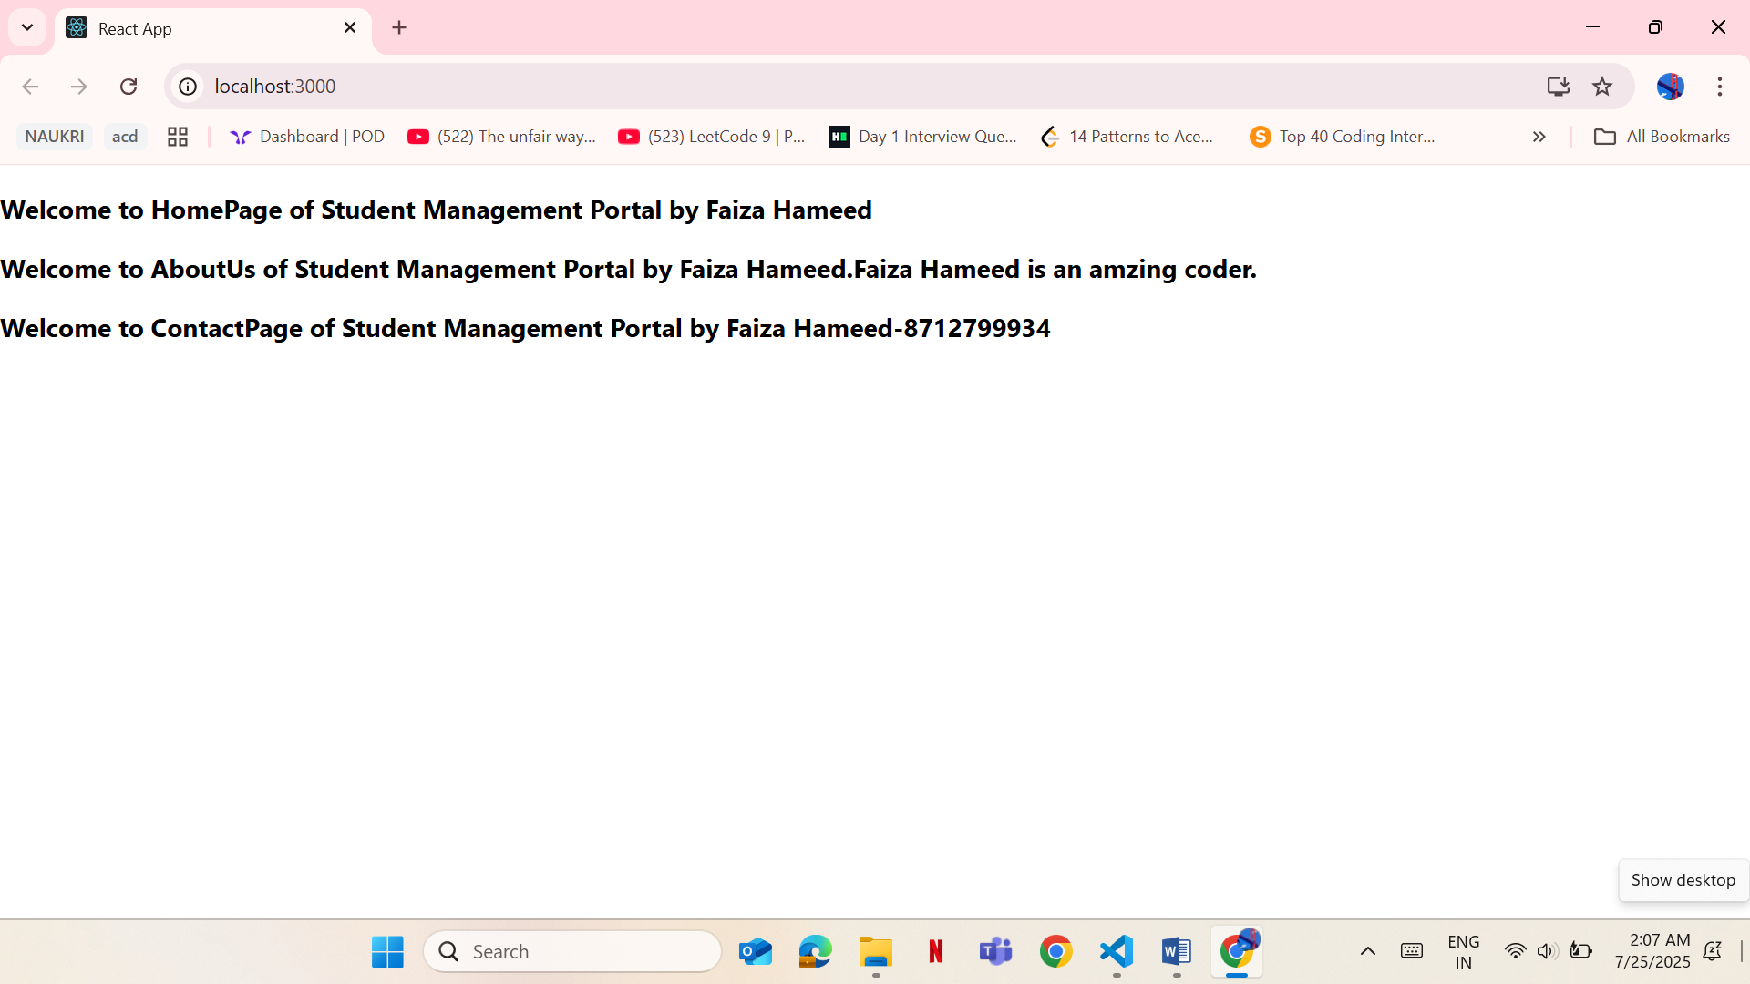

**3. REACT JS-HOL**

Calculatescore.js

import './mystyle.css';

const percentToDecimal = (decimal) => {

  return decimal.toFixed(2) + '%';

};

const calcScore = (total, goal) => {

  return percentToDecimal(total / goal);

};

export const CalculateScore = ({ Name, School, total, goal }) => (

  <div className="formatstyle">

    <h1><font color="Brown">Student Details:</font></h1>

    <div className="Name">

      <b><span> Name: </span></b>

      <span>{Name}</span>

    </div>

    <div className="School">

      <b><span> School: </span></b>

      <span>{School}</span>

    </div>

    <div className="Total">

      <b><span>Total:</span></b>

      <span>{total} Marks</span>

    </div>

    <div className="Score">

      <b>Score:</b>

      <span>{calcScore(total, goal)}</span>

    </div>

  </div>

);

App.js

import logo from './logo.svg';

import './App.css';

import { CalculateScore } from './Components/calculatescore'; // ✅ Adjust path if needed

 // Adjust the path as needed

function App() {

  return (

    <div>

      <CalculateScore Name={"Faiza Hameed"}

    School={"International School"}

    total={280}

    goal={3}

    />

    </div>

  );

}

export default App;

mystyle.css

.Name

{

    font-weight:300;

    color:blue;

}

.School

{

    color:crimson;

}

.Total

{

    color:darkmagenta;

}

.formatstyle

{

    text-align:center;

    font-size:large;

}

.Score

{

    color:forestgreen;

}

**Output:**

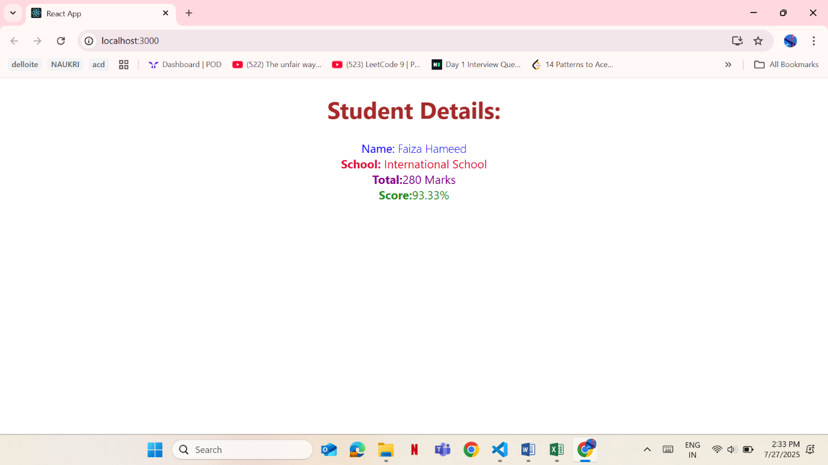

**4. REACT JS-HOL**

Post.js

// src/Posts.js

import React from "react";

import Post from "./Post";

class Posts extends React.Component {

  constructor(props) {

    super(props);

    this.state = {

      posts: [],

      error: null

    };

  }

  // Fetch posts from the API

  loadPosts = async () => {

    try {

      const response = await fetch("https://jsonplaceholder.typicode.com/posts");

      const data = await response.json();

      // Convert raw data to Post instances

      const postList = data.map(post => new Post(post.id, post.title, post.body));

      // Update state

      this.setState({ posts: postList });

    } catch (error) {

      this.setState({ error });

    }

  };

  // Lifecycle hook: called once after component is mounted

  componentDidMount() {

    this.loadPosts();

  }

  // Lifecycle hook: handles rendering errors

  componentDidCatch(error, info) {

    alert("An error occurred in Posts component.");

    console.error("Caught by componentDidCatch:", error, info);

  }

  // Render UI

  render() {

    const { posts, error } = this.state;

    if (error) {

      return <h2>Failed to load posts.</h2>;

    }

    return (

      <div>

        <h1>Blog Posts by Faiza Hameed</h1>

        {posts.map(post => (

          <div key={post.id} style={{ marginBottom: "20px" }}>

            <h3>{post.title}</h3>

            <p>{post.body}</p>

          </div>

        ))}

      </div>

    );

  }

}

export default Posts;

App.js

import React from "react";

import Post from "./Post";

function App() {

  return (

    <div className="App">

      <Post />

    </div>

  );

}

export default App;

**Output:**

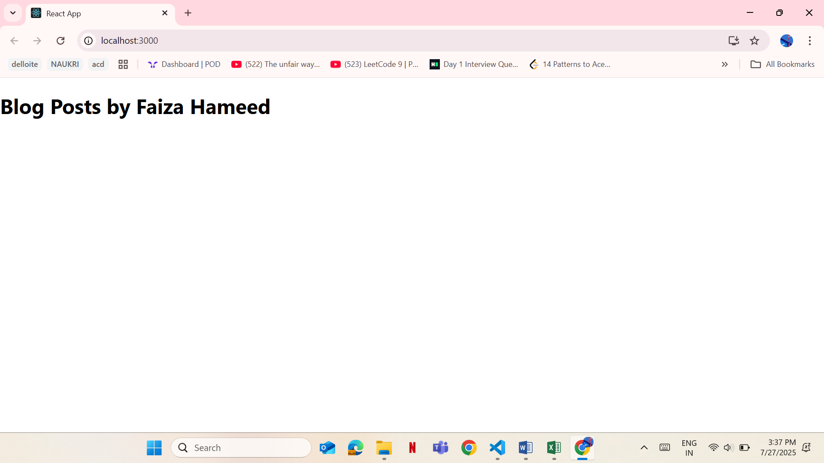

**5. REACT JS-HOL**

**App.js**

// src/App.js

import React from "react";

import CohortDetails from "./CohortDetails";

function App() {

  const cohort1 = {

    cohortCode: "CB101",

    technology: "React Basics",

    startDate: "01-Jul-2025",

    currentStatus: "ongoing",

    coachName: "John Doe",

    trainerName: "Jane Smith",

  };

  const cohort2 = {

    cohortCode: "CB102",

    technology: "Advanced Java",

    startDate: "01-Jun-2025",

    currentStatus: "completed",

    coachName: "Emily Brown",

    trainerName: "Robert Black",

  };

  return (

    <div>

      <h1>My Academy Dashboard</h1>

      <CohortDetails cohort={cohort1} />

      <CohortDetails cohort={cohort2} />

    </div>

  );

}

export default App;

**Cohort.js**

import React from "react";

import styles from "./CohortDetails.module.css"; // adjust path if needed

function CohortDetails({ name, status, startDate, endDate }) {

  const headingStyle = {

    color: status.toLowerCase() === "ongoing" ? "green" : "blue",

  };

  return (

    <div className={styles.box}>

      <h3 style={headingStyle}>{name}</h3>

      <dl>

        <dt>Status:</dt>

        <dd>{status}</dd>

        <dt>Start Date:</dt>

        <dd>{startDate}</dd>

        <dt>End Date:</dt>

        <dd>{endDate}</dd>

      </dl>

    </div>

  );

}

export default CohortDetails;

**CohortDetails.js**

function CohortDetails(props) {

    return (

        <div>

            <h3>

                {props.cohort.cohortCode} -

                <span>{props.cohort.technology}</span>

            </h3>

            <dl>

                <dt>Started On</dt>

                <dd>{props.cohort.startDate}</dd>

                <dt>Current Status</dt>

                <dd>{props.cohort.currentStatus}</dd>

                <dt>Coach</dt>

                <dd>{props.cohort.coachName}</dd>

                <dt>Trainer</dt>

                <dd>{props.cohort.trainerName}</dd>

            </dl>

        </div>

    );

}

export default CohortDetails;

**CohortDetails.module.css**

/* CohortDetails.module.css */

.box {

  width: 300px;

  display: inline-block;

  margin: 10px;

  padding: 10px 20px;

  border: 1px solid black;

  border-radius: 10px;

}

/* Styling the <dt> tag globally inside the module */

dt {

  font-weight: 500;

}

**Output:**

