**WEEK-7**

(Implemented in VSCODE)

**REACT**

**9. REACT JS-HOL**

App.js

import React, { useState } from 'react';

import ListofPlayers from './components/ListofPlayers';

import IndianPlayers from './components/indianplayers';

function App() {

  const [flag, setFlag] = useState(true);

  const toggleView = () => {

    setFlag(prev => !prev);

  };

  return (

    <div className="App">

      <h1>🏏 Cricket App</h1>

      <button onClick={toggleView}>

        {flag ? "Switch to Indian Players" : "Switch to List of Players"}

      </button>

      <hr />

      {flag ? <ListofPlayers /> : <IndianPlayers />}

    </div>

  );

}

export default App;

indianplayers.js

// src/components/IndianPlayers.js

import React from 'react';

const IndianPlayers = () => {

  const allPlayers = ["Virat", "Rohit", "Rahul", "Dhawan", "Hardik", "Jadeja", "Dhoni", "Pant", "Bumrah", "Chahal", "Bhuvi"];

  // Odd and Even indexed players

  const oddTeam = allPlayers.filter((_, i) => i % 2 === 0);

  const evenTeam = allPlayers.filter((_, i) => i % 2 !== 0);

  // Destructuring top 2

  const [odd1, odd2, ...restOdd] = oddTeam;

  const [even1, even2, ...restEven] = evenTeam;

  // Merge arrays

  const T20players = ["Virat", "Rohit", "Pant"];

  const RanjiTrophy = ["Pujara", "Karun", "Pandey"];

  const mergedPlayers = [...T20players, ...RanjiTrophy];

  return (

    <div>

      <h2>Odd Team</h2>

      <p>Top 2: {odd1}, {odd2}</p>

      <p>Rest: {restOdd.join(", ")}</p>

      <h2>Even Team</h2>

      <p>Top 2: {even1}, {even2}</p>

      <p>Rest: {restEven.join(", ")}</p>

      <h2>Merged Players (T20 + Ranji)</h2>

      <ul>

        {mergedPlayers.map((p, i) => <li key={i}>{p}</li>)}

      </ul>

    </div>

  );

};

export default IndianPlayers;

ListofPlayers.js

// src/components/ListofPlayers.js

import React from 'react';

const ListofPlayers = () => {

  const players = [

    { name: "Virat", score: 85 },

    { name: "Rohit", score: 92 },

    { name: "Rahul", score: 65 },

    { name: "Dhawan", score: 70 },

    { name: "Hardik", score: 55 },

    { name: "Jadeja", score: 78 },

    { name: "Dhoni", score: 90 },

    { name: "Pant", score: 62 },

    { name: "Bumrah", score: 80 },

    { name: "Chahal", score: 50 },

    { name: "Bhuvi", score: 75 }

  ];

  // Use arrow function and filter

  const below70 = players.filter(player => player.score < 70);

  return (

    <div>

      <h2>All Players:</h2>

      <ul>

        {players.map((p, index) => (

          <li key={index}>{p.name} - {p.score}</li>

        ))}

      </ul>

      <h3>Players with score below 70:</h3>

      <ul>

        {below70.map((p, index) => (

          <li key={index}>{p.name} - {p.score}</li>

        ))}

      </ul>

    </div>

  );

};

export default ListofPlayers;

**Output:**

**Flag=true**

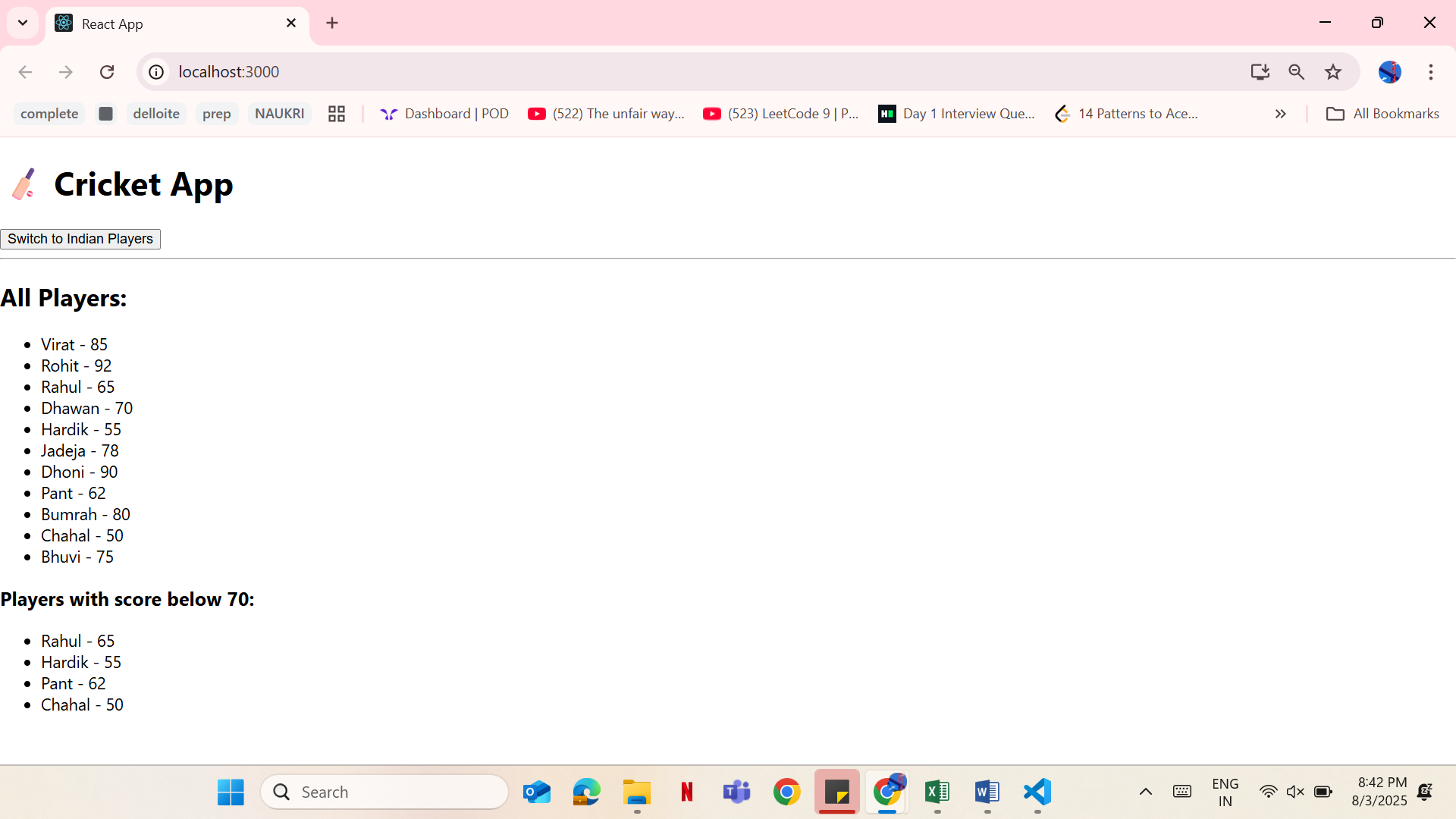

**Flag=false**

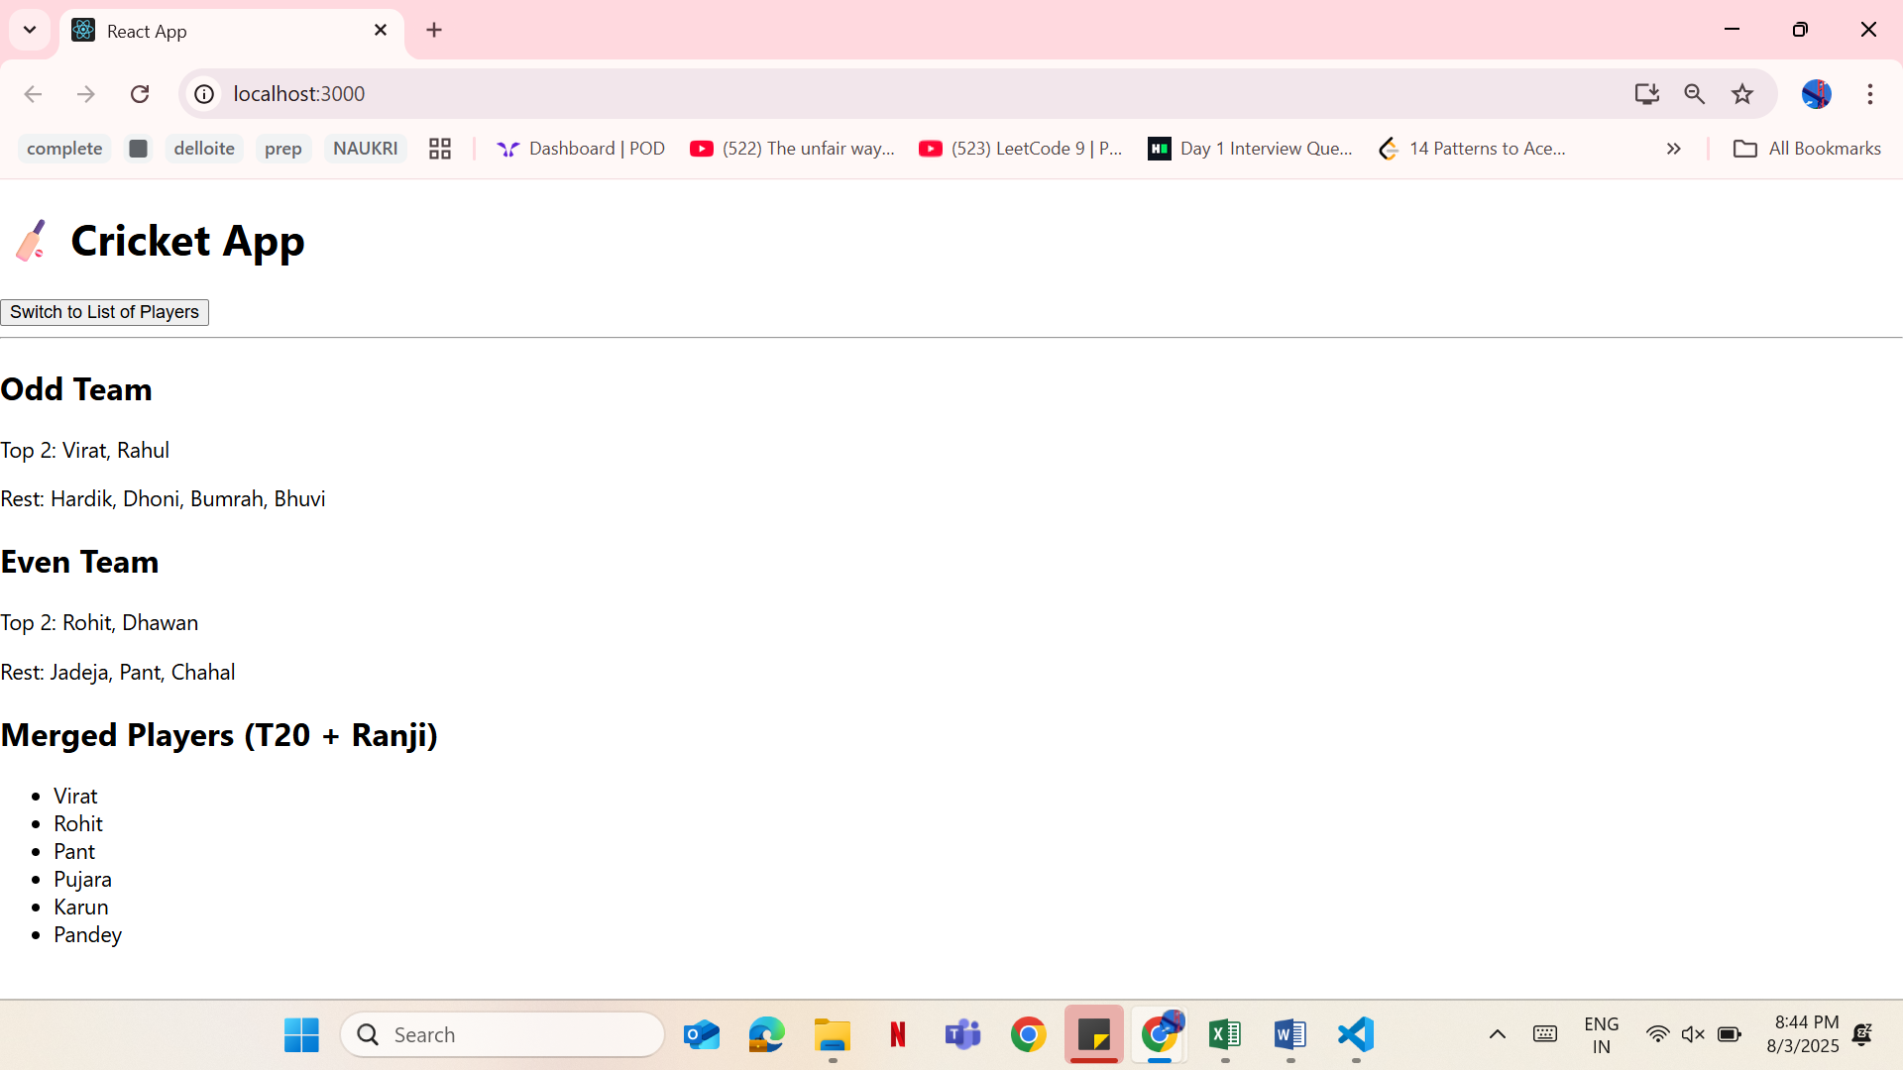

**10. REACT JS-HOL**

App.js

import React from 'react';

import './App.css';

function App() {

  const office1 = {

    name: "Corporate Heights",

    rent: 55000,

    address: "MG Road, Bengaluru"

  };

  const officeList = [

    { name: "Tech Park Hub", rent: 45000, address: "Whitefield" },

    { name: "Innovation Tower", rent: 60000, address: "Electronic City" },

    { name: "Startup Bay", rent: 75000, address: "Indiranagar" }

  ];

  const getRentStyle = (rent) => ({

    color: rent > 60000 ? "green" : "red",

    fontWeight: "bold"

  });

  return (

    <div className="App">

      <h1>🏢 Office Space Rental App</h1>

      {/* Picture from CSS */}

      <div className="office-image"></div>

      <h2>Featured Office</h2>

      <p>Name: {office1.name}</p>

      <p style={getRentStyle(office1.rent)}>Rent: ₹{office1.rent}</p>

      <p>Address: {office1.address}</p>

      <hr />

      <h2>Other Office Listings</h2>

      <ul>

        {officeList.map((office, index) => (

          <li key={index} style={{ marginBottom: "15px" }}>

            <p>Name: {office.name}</p>

            <p style={getRentStyle(office.rent)}>Rent: ₹{office.rent}</p>

            <p>Address: {office.address}</p>

          </li>

        ))}

      </ul>

    </div>

  );

}

export default App;

App.css

.App {

  font-family: Arial, sans-serif;

  padding: 20px;

}

.office-image {

  width: 400px;

  height: 250px;

  background-image: url("https://images.unsplash.com/photo-1600585154340-be6161a56a0c");

  background-size: cover;

  background-position: center;

  border-radius: 10px;

  margin-bottom: 20px;

}

Output:

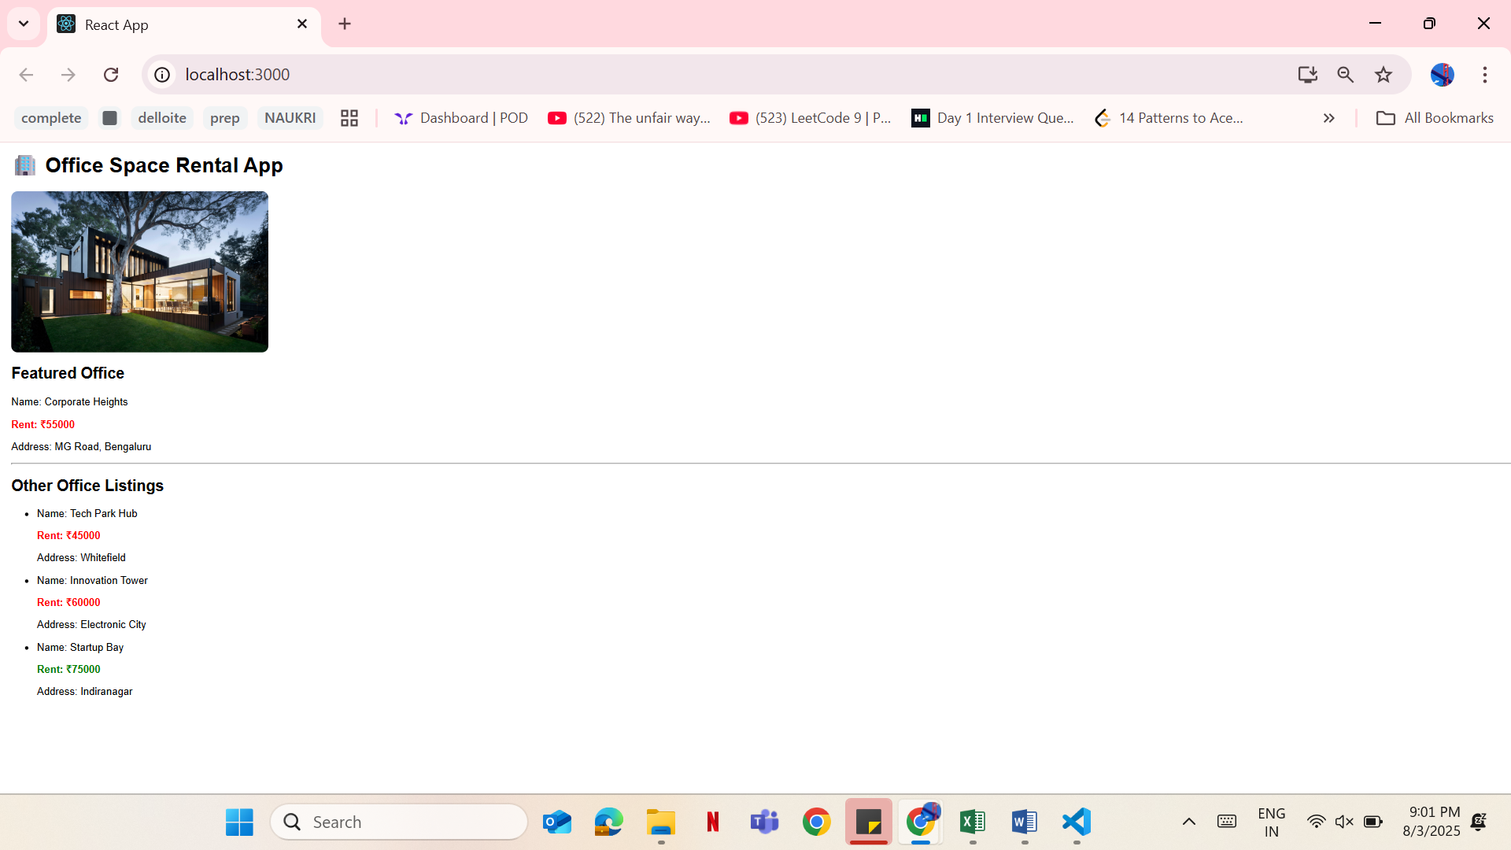

**11. REACT JS-HOL**

App.js

// src/App.js

import React, { Component } from 'react';

import CurrencyConvertor from './components/CurrencyConvertor';

class App extends Component {

  constructor() {

    super();

    this.state = {

      count: 0

    };

  }

  increment = () => {

    this.setState(prev => ({ count: prev.count + 1 }));

    this.sayHello();

  };

  sayHello = () => {

    console.log("Hello from React!");

    alert("Hello! The counter was incremented.");

  };

  decrement = () => {

    this.setState(prev => ({ count: prev.count - 1 }));

  };

  sayWelcome = (msg) => {

    alert(msg);

  };

  handlePress = (e) => {

    alert("I was clicked"); // Synthetic Event

    console.log("Synthetic event triggered:", e);

  };

  render() {

    return (

      <div className="App" style={{ padding: "20px" }}>

        <h1>🎯 React Event Handling Demo</h1>

        <h2>Counter: {this.state.count}</h2>

        <button onClick={this.increment}>Increment</button>

        <button onClick={this.decrement}>Decrement</button>

        <br /><br />

        <button onClick={() => this.sayWelcome("Welcome to React!")}>

          Say Welcome

        </button>

        <br /><br />

        <button onClick={this.handlePress}>Click on me</button>

        <hr />

        <CurrencyConvertor />

      </div>

    );

  }

}

export default App;

App.css

button {

  margin: 5px;

  padding: 10px 15px;

  background-color: #007bff;

  color: white;

  border: none;

  border-radius: 6px;

  cursor: pointer;

}

button:hover {

  background-color: #0056b3;

}

input {

  padding: 8px;

  margin-right: 10px;

}

ConcurrencyConverter.js

// src/components/CurrencyConvertor.js

import React, { useState } from 'react';

const CurrencyConvertor = () => {

  const [amount, setAmount] = useState("");

  const [currencyType, setCurrencyType] = useState("INR to EUR");

  const [converted, setConverted] = useState("");

  const handleSubmit = () => {

    const amt = parseFloat(amount);

    if (isNaN(amt)) {

      alert("Please enter a valid amount");

      return;

    }

    let result = 0;

    if (currencyType === "INR to EUR") {

      result = amt * 0.011; // 1 INR ≈ 0.011 EUR

      setConverted(`€${result.toFixed(2)}`);

    } else {

      result = amt * 91; // 1 EUR ≈ 91 INR

      setConverted(`₹${result.toFixed(2)}`);

    }

  };

  return (

    <div>

      <h2>💱 Currency Convertor</h2>

      {/* Currency Type Dropdown */}

      <select

        value={currencyType}

        onChange={(e) => setCurrencyType(e.target.value)}

      >

        <option value="INR to EUR">INR to EUR</option>

        <option value="EUR to INR">EUR to INR</option>

      </select>

      {/* Amount Input */}

      <input

        type="number"

        placeholder="Enter amount"

        value={amount}

        onChange={(e) => setAmount(e.target.value)}

      />

      {/* Convert Button */}

      <button onClick={handleSubmit}>Convert</button>

      {/* Converted Result */}

      {converted && (

        <p>Converted Amount: <strong>{converted}</strong></p>

      )}

    </div>

  );

};

export default CurrencyConvertor;

**Output:**

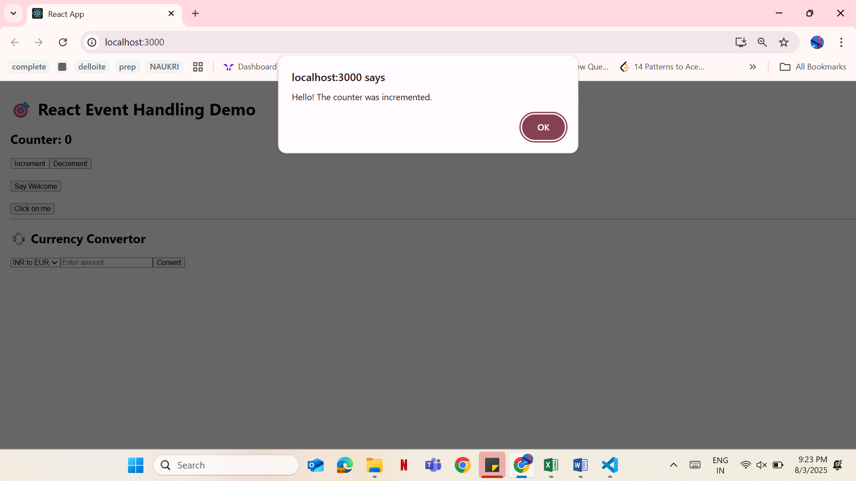

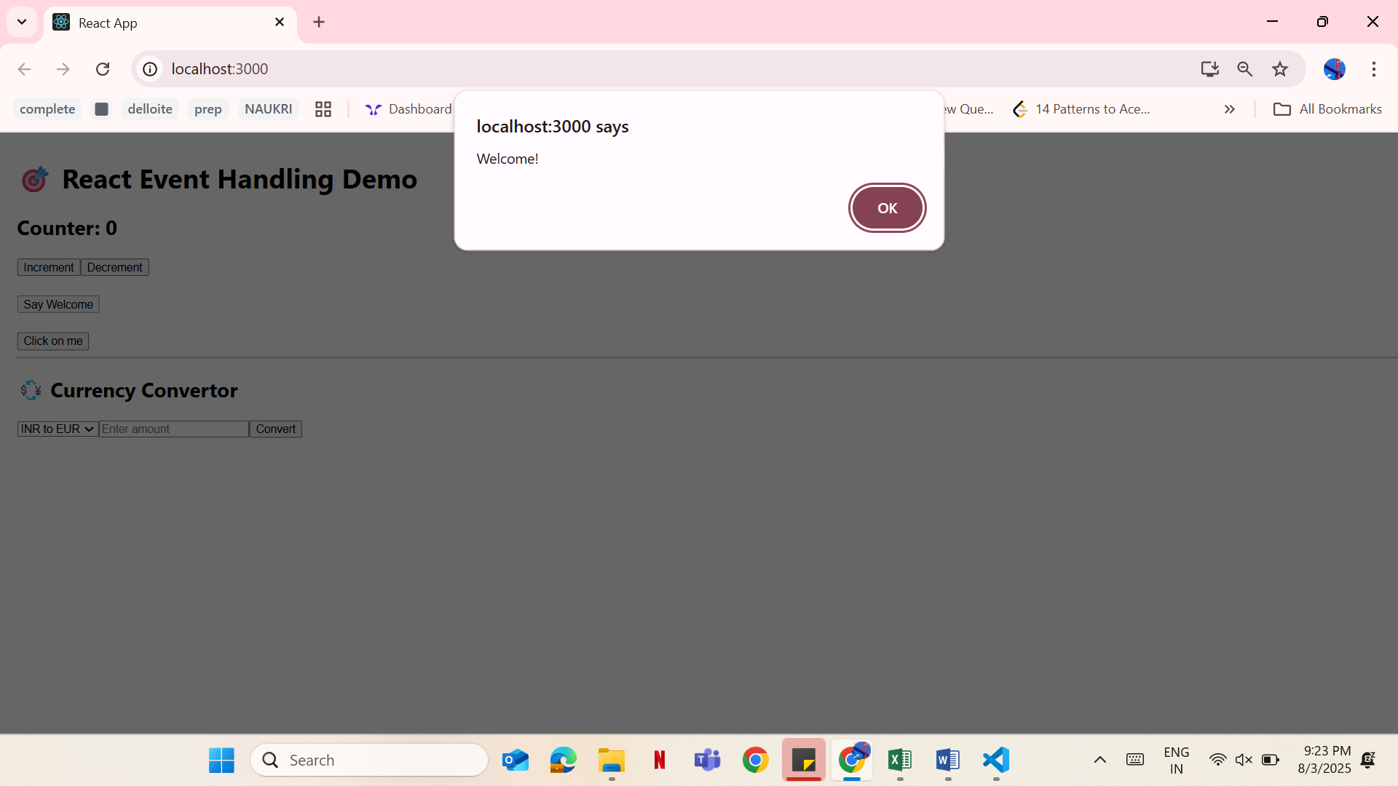

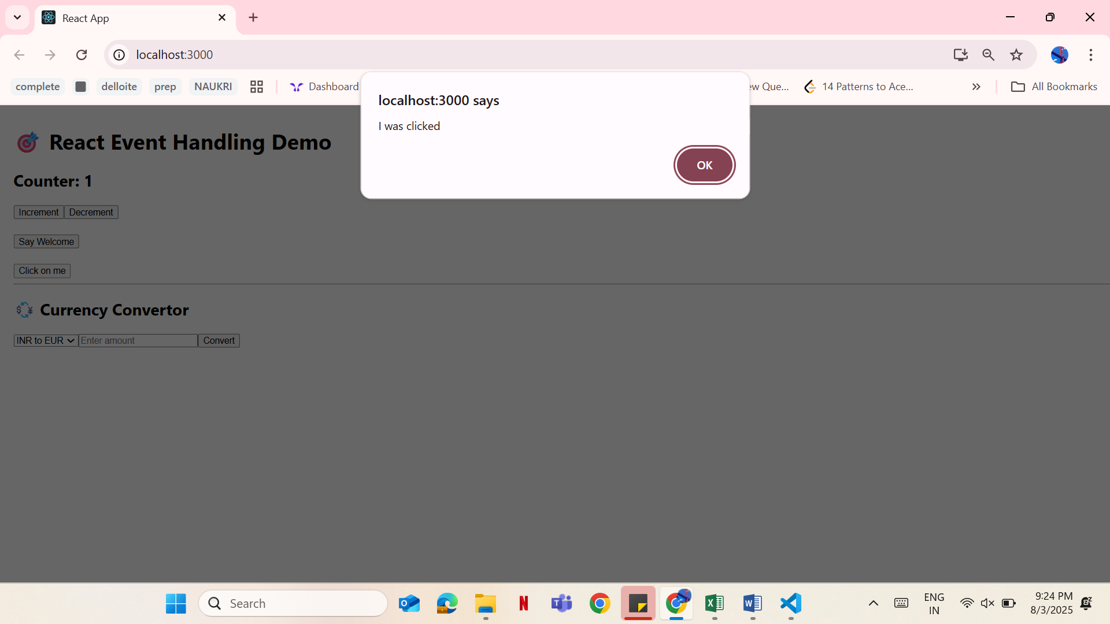

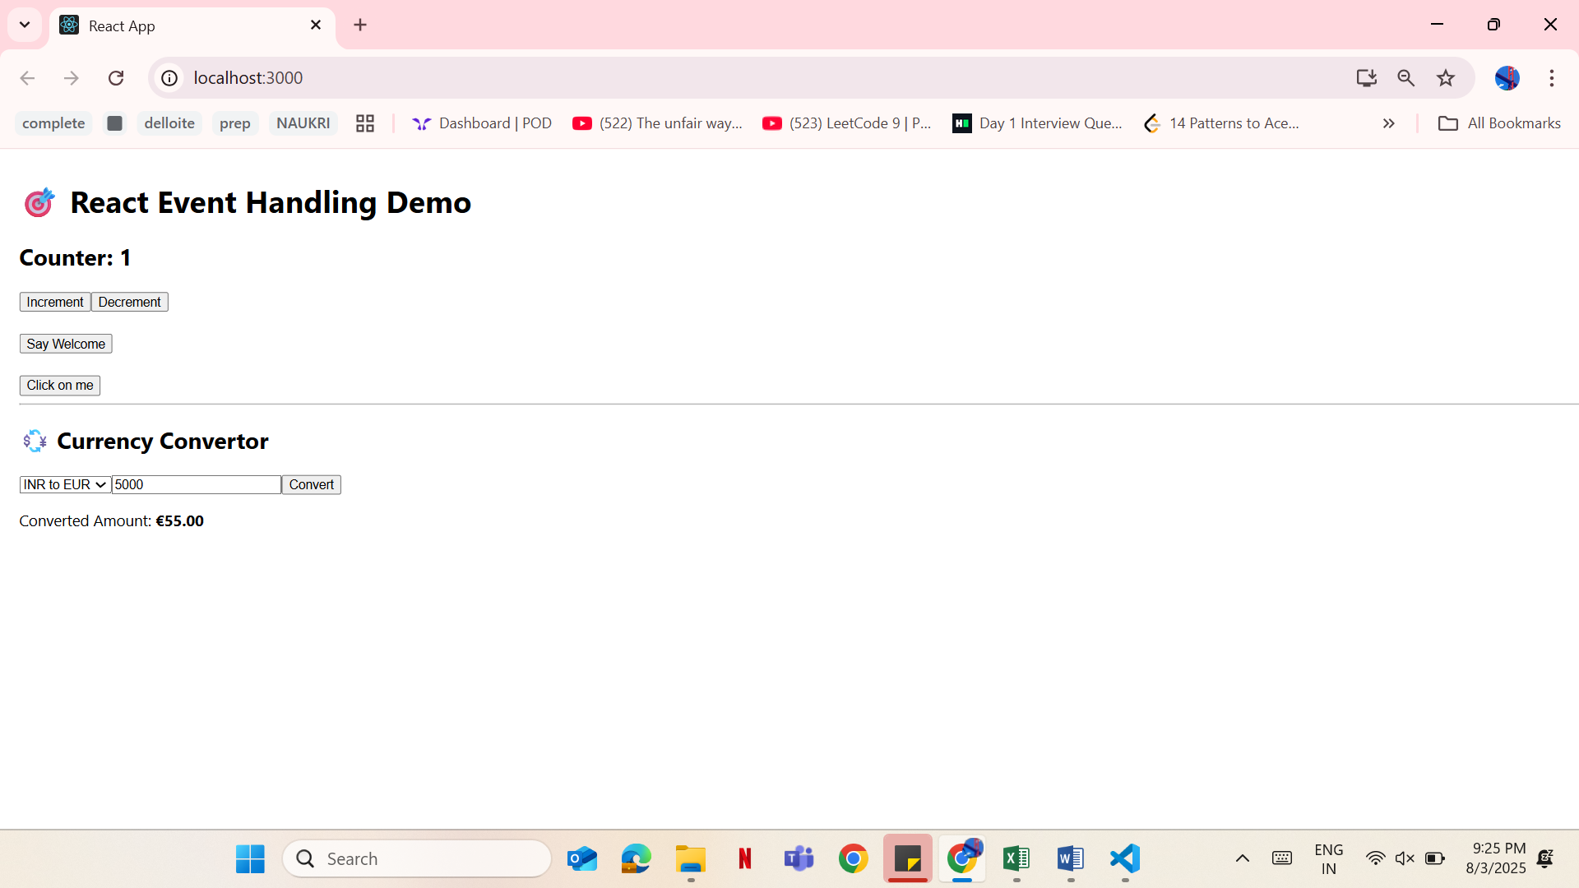

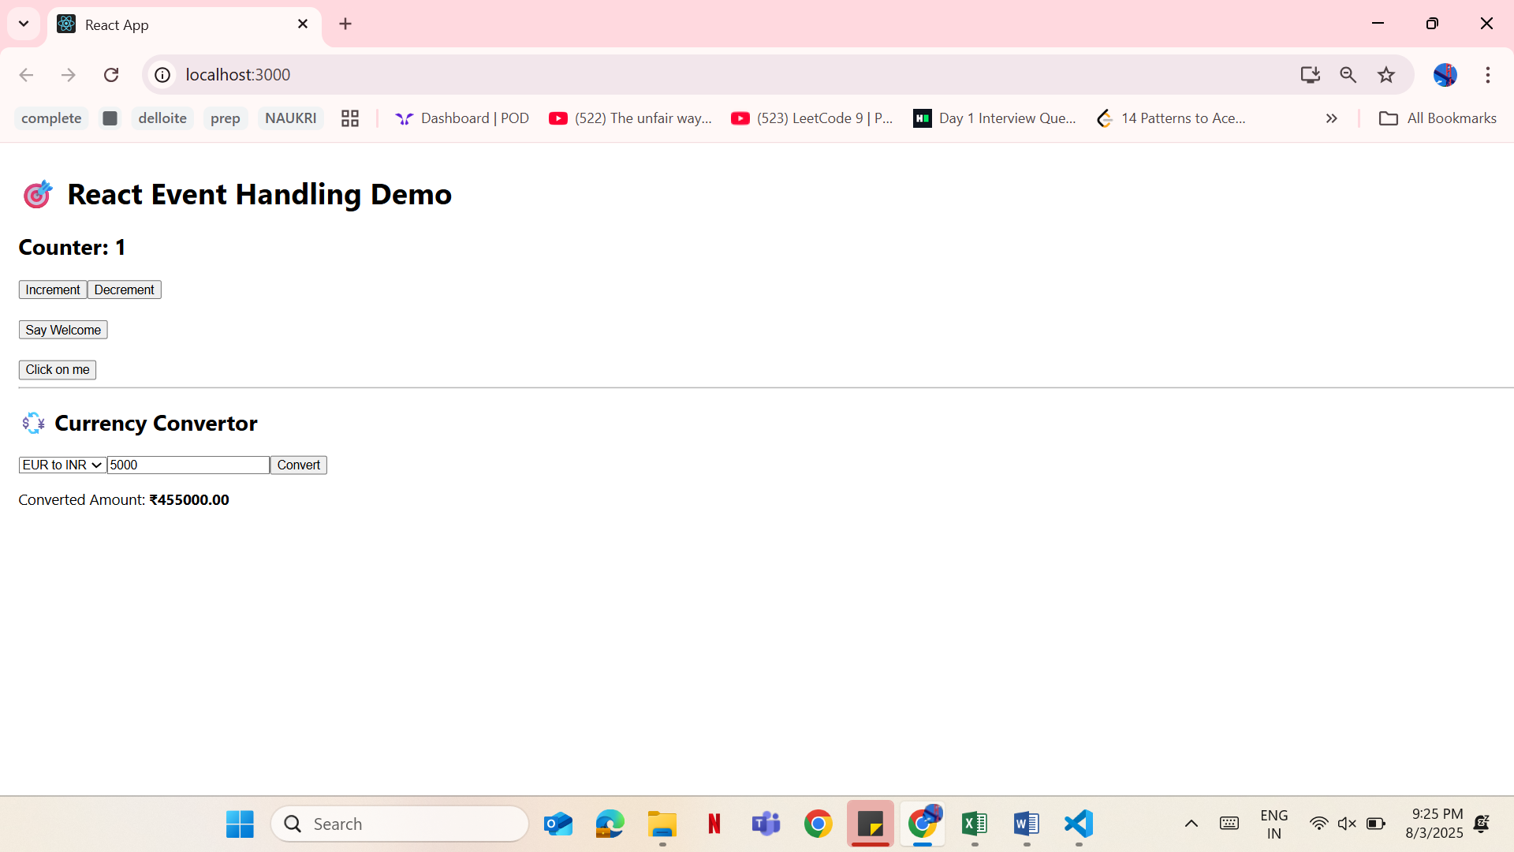

**12. REACT JS-HOL**

App.js

import React, { useState } from 'react';

import GuestPage from './components/GuestPage';

import UserPage from './components/UserPage';

import './App.css';

function App() {

  const [isLoggedIn, setIsLoggedIn] = useState(false);

  // Using element variables (required in doc)

  let pageToDisplay;

  if (isLoggedIn) {

    pageToDisplay = <UserPage />;

  } else {

    pageToDisplay = <GuestPage />;

  }

  return (

    <div className="App">

      <h1>🎫 Ticket Booking App</h1>

      {/* Login/Logout buttons */}

      {!isLoggedIn ? (

        <button onClick={() => setIsLoggedIn(true)}>🔐 Login</button>

      ) : (

        <button onClick={() => setIsLoggedIn(false)}>🚪 Logout</button>

      )}

      <hr />

      {/* Conditional Rendering of Page */}

      {pageToDisplay}

    </div>

  );

}

export default App;

App.css

.App {

  text-align: center;

  font-family: Arial;

  padding: 20px;

}

button {

  padding: 10px 20px;

  margin: 10px;

  font-size: 16px;

  cursor: pointer;

}

**UserPage.js**

// src/components/UserPage.js

import React from "react";

import FlightList from "./FlightList";

const UserPage = () => {

  const handleBooking = () => {

    alert("Ticket booked successfully!");

  };

  return (

    <div>

      <h2>✅ Welcome User</h2>

      <p>You can book your flight tickets below.</p>

      <FlightList />

      <button

        onClick={handleBooking}

        style={{ marginTop: "10px", padding: "10px 20px", fontSize: "16px" }}

      >

        🛫 Book Ticket

      </button>

    </div>

  );

};

export default UserPage;

**GuestPage.js**

import FlightList from "./FlightList";

const GuestPage = () => (

  <div>

    <h2>👤 Welcome Guest</h2>

    <p>You can browse flights but must log in to book.</p>

    <FlightList />

  </div>

);

export default GuestPage;

**FlightList.js**

const FlightList = () => {

  const flights = [

    { flight: "AI202", from: "Delhi", to: "Mumbai", time: "10:00 AM" },

    { flight: "AI203", from: "Chennai", to: "Bangalore", time: "1:30 PM" },

    { flight: "AI204", from: "Kolkata", to: "Hyderabad", time: "4:00 PM" }

  ];

  return (

    <div>

      <h3>✈️ Available Flights</h3>

      <ul>

        {flights.map((f, idx) => (

          <li key={idx}>

            {f.flight}: {f.from} ➡️ {f.to} @ {f.time}

          </li>

        ))}

      </ul>

    </div>

  );

};

export default FlightList;

**Output:**

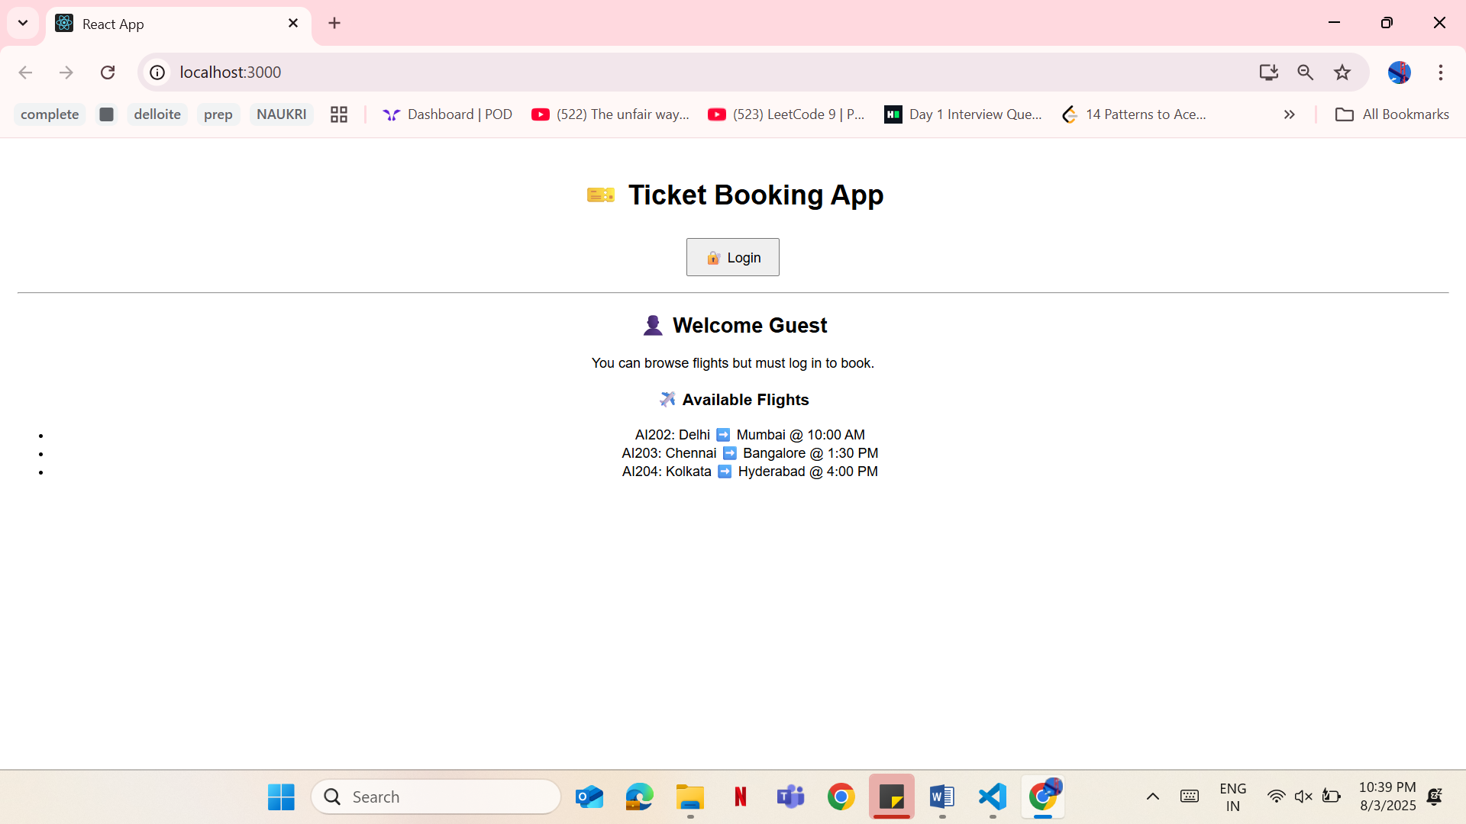

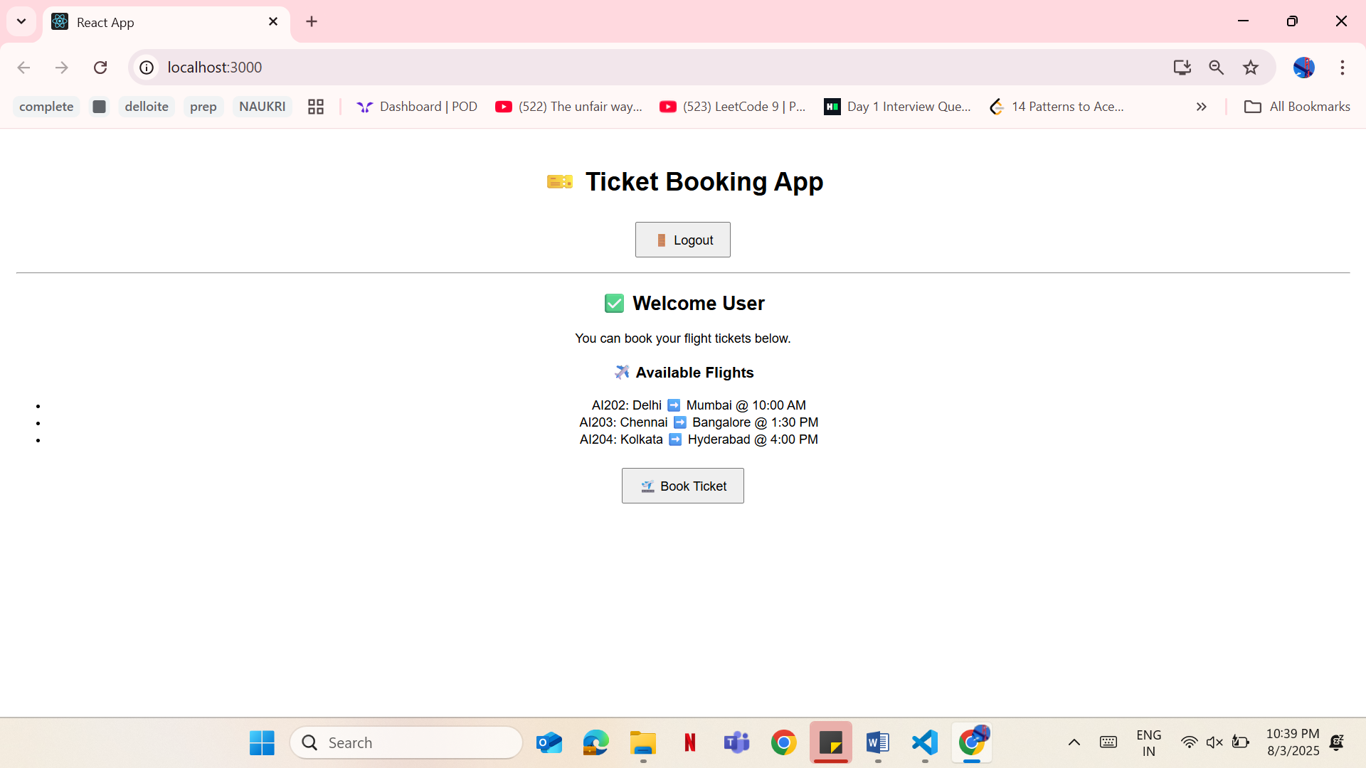

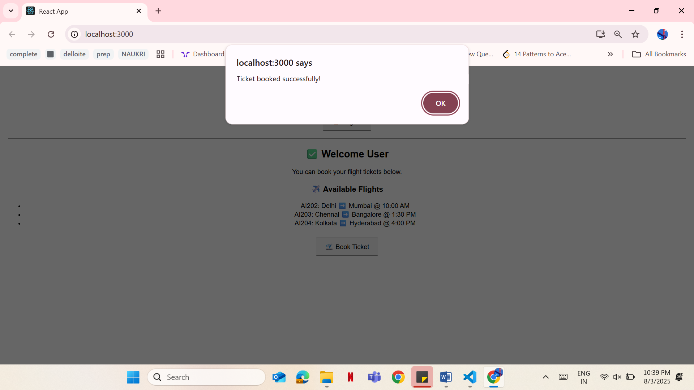

**13. REACT JS-HOL**

**App.js**

import React, { useState } from 'react';

import BookDetails from './components/bookdetails';

import BlogDetails from './components/blogdetails';

import CourseDetails from './components/coursedetails';

import './App.css';

function App() {

  const [selected, setSelected] = useState("book");

  return (

    <div className="App">

      <h1>📖 Blogger App</h1>

      <select value={selected} onChange={(e) => setSelected(e.target.value)}>

        <option value="book">Book Details</option>

        <option value="blog">Blog Details</option>

        <option value="course">Course Details</option>

      </select>

      <div className="container">

        <div className="card">

          {selected === "book" && <BookDetails />}

          {selected === "blog" && <BlogDetails />}

          {selected === "course" && <CourseDetails />}

        </div>

      </div>

    </div>

  );

}

export default App;

**App.css**

.App {

  text-align: center;

  padding: 20px;

  font-family: Arial, sans-serif;

}

select {

  padding: 10px;

  margin: 20px;

  font-size: 16px;

}

.container {

  display: flex;

  justify-content: center;

  margin-top: 20px;

}

.card {

  border: 2px solid #000;

  padding: 20px;

  width: 300px;

  text-align: left;

  background-color: #f9f9f9;

  border-radius: 8px;

}

**coursedetails.js**

const CourseDetails = () => {

  return <h3>🎓 Course: "Full Stack Development with React"</h3>;

};

export default CourseDetails;

**blogdetails.js**

const BlogDetails = () => {

  return <h3>📝 Blog Post: "Understanding JSX & Virtual DOM"</h3>;

};

export default BlogDetails;

**bookdetails.js**

const BookDetails = () => {

  return <h3>📚 Book Details: "React Essentials" by Dan Abramov</h3>;

};

export default BookDetails;

**Output:**



