✦ LAB REPORT ✦
web application development · fall 2026
STYLING WEB PAGES
an introduction to CSS
LAB-03 · Introduction to CSS, Styling Web Pages
“where my pages finally learned how to dress.”
SUBMITTED BY
Name FAZIA AROOJ
Roll No. UW-24-AI-BS-014
Section BS-AI-5TH
Submission Date 20/10/2026

1 | CSS Cascade Puzzle  making the cascade work for me, not against me

For my first task, I built one page that tells a small story about the cascade. I started with an internal <style> block, then linked an external task1_style.css, and finished with a few inline styles — so every single line ends up looking exactly the way its own sentence describes. It felt a bit like a puzzle: the rule that wins is never the one you first expect, and !important laughs at all of them.
WHAT I COVERED ✓
✔ Internal <style> block in the <head>, followed by a linked external task1_style.css
✔ Inline styles used where they must beat everything else
✔ Grey line styled by the internal p rule
✔ Yellow line from the external .note class
✔ Crimson line proving the external sheet loses the tie when it comes first
✔ Teal, bold line showing the id beating the class
✔ Light-blue class box with an inline-styled line inside it
✔ Every line's appearance matches the rule its sentence names

<!DOCTYPE html>
<html lang="en">
<head>

<title>Task 1 - CSS Cascade</title>
<style>
body {
font-family: Arial, sans-serif;
color: #555;
margin: 40px;
}

h2 {
color: #555;
}

p {
color: #555;
font-size: 20px;
}

.note {
background-color: #fff2cc;
padding: 12px;
}

.class-rule {
color: #1457d9;
}

</style>
<link rel="stylesheet" href="task1_style.css">
</head>
<body>
<h1>CSS Cascade Puzzle</h1>
<hr>

<h2>Purple: both sheets set h2, and the external sheet is linked later.</h2>
<p>Grey: the internal p rule.</p>
<p class="note">Yellow background from the internal .note, border from the external .note.</p>
<p style="color: crimson;">Crimson: an inline style beats both sheets.</p>
<p class="class-rule">Blue: a class beats the p element rule.</p>
<p id="id-rule" class="class-rule">Teal and bold: the id beats the class.</p>
<p class="important-rule" style="color: crimson;">Orange: !important in the external sheet beats even this inline style.</p>
<p class="box">Light blue box: p.box styles paragraphs with class box ...</p>
<div class="box">... but not this div, which also has class box.</div>
<p>Inside this grey paragraph, <span>this span inherits the grey colour</span> and <em>this em is blue</em>.</p>
</body>
</html>

CSS FILE:
h2 {
color: purple;
}

.note {
border: 2px solid #e0b94f;
}

#id-rule {
color: #008b8b;
font-weight: bold;
}

.important-rule {
color: darkorange !important;
}

p.box {
background-color: #e8f1ff;
border: 1px solid #3875bd;
padding: 10px;
}

em {
color: blue;
}

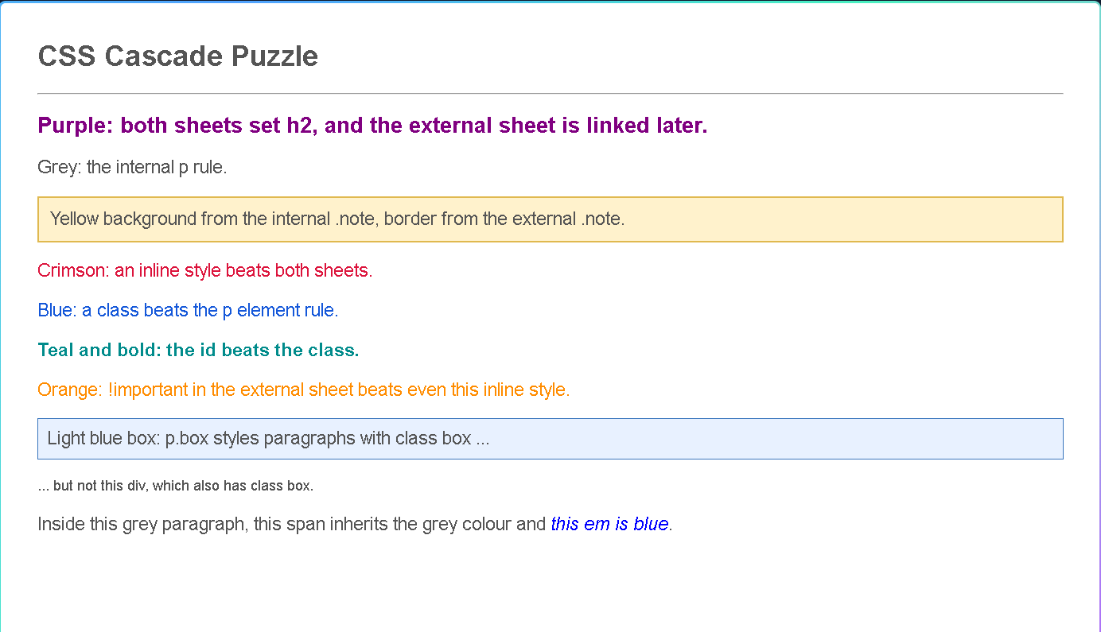

2 | Campus News Board  one stylesheet, every kind of selector

Next, I recreated the campus news board using only an external file, task2_news.css. The challenge was to touch the HTML as little as possible: element selectors for the headings, a class for each post, an id for the board itself, grouping, descendant selectors for the meta lines, and a pseudo-class so the link under my mouse ('Events') lights up. No inline styles, no <style> tag — just clean CSS doing all the work.
WHAT I COVERED ✓
✔ External stylesheet task2_news.css only — no inline styles, no <style> element
✔ Element selectors for h1, h2 and paragraph styling
✔ Class selectors for post titles and meta/date lines
✔ An id selector for the news board container
✔ Grouping selector to share styles between headings
✔ Descendant selectors for items inside the board and list
✔ Pseudo-class selector giving the hovered 'Events' link its hover state
✔ Layout matches the target: nav bar, board title, three posts and the sidebar

<!DOCTYPE html>
<html lang="en">
<head>
<meta charset="UTF-8">
<title>Task 2 - Campus News Board</title>
<link rel="stylesheet" href="task2_news.css">
</head>
<body>
<nav class="top-navigation" id="main-navigation">
<a href="#">Home</a>
<a href="#">Events</a>
<a href="#">Sports</a>
<a href="#">Contact</a>
</nav>

<div class="news-board" id="news-board">
<h1 class="page-title">Campus News Board</h1>

<div class="news-story lead-story">
<h2>Web Lab Moves to Lab 3</h2>
<p class="posted-date">Posted 12 October 2026</p>
<p>From next Monday all CS-371 lab sessions will be held in Lab 3, CS Block.</p>
</div>

<div class="news-story notice-story">
<h2>Fee Deadline Tomorrow</h2>
<p class="posted-date">Posted 14 October 2026</p>
<p>Semester fee must be paid by 5 pm tomorrow to avoid a late fine.</p>
</div>

<div class="news-story">
<h2>Coding Club Meeting</h2>
<p class="posted-date">Posted 15 October 2026</p>
<p>The coding club meets on Thursday after the last lecture. Beginners welcome.</p>
</div>

<h2 class="section-title">This Week</h2>
<ul class="weekly-list">
<li class="important-news">Mid-term date sheet published</li>
<li>Library open till 8 pm</li>
<li>Sports trials on Saturday</li>
</ul>
</div>

<footer class="page-footer">
Updated by the Student Affairs Office.
</footer>
</body>
</html>

CSS FILE:
body {
margin: 0;
color: #111;
font-family: Arial, sans-serif;
}

nav, footer {
border: 1px solid #ccc;
}

#main-navigation {
background-color: #214f78;
padding: 20px 32px;
}

nav a {
display: inline-block;
color: white;
font-size: 24px;
font-weight: bold;
padding: 0 10px;
text-decoration: none;
}

nav a:hover {
color: #ffda5c;
text-decoration: underline;
}

#news-board {
margin: 0 40px;
}

.page-title {
font-family: Georgia, serif;
font-size: 46px;
margin: 42px 0;
}

.news-story {
border-left: 8px solid #3875bd;
margin: 28px 0;
padding: 18px 24px;
}

.news-story h2, .section-title {
color: navy;
font-family: Georgia, serif;
font-size: 30px;
margin: 0 0 12px;
}

.lead-story {
border: 3px dashed #888;
}

.notice-story {
background-color: #fdebea;
}

.posted-date {
color: #888;
font-size: 18px;
font-style: italic;
margin: 10px 0;
}

.news-story p {
font-size: 22px;
margin: 10px 0;
}

.section-title {
margin-top: 32px;
}

.weekly-list {
font-size: 22px;
list-style-type: square;
margin-left: 36px;
}

.important-news {
color: #bd1010;
font-weight: bold;
}

.page-footer {
border-left: 0;
border-right: 0;
color: #888;
font-size: 18px;
font-style: italic;
margin-top: 30px;
padding: 16px;
text-align: center;
}

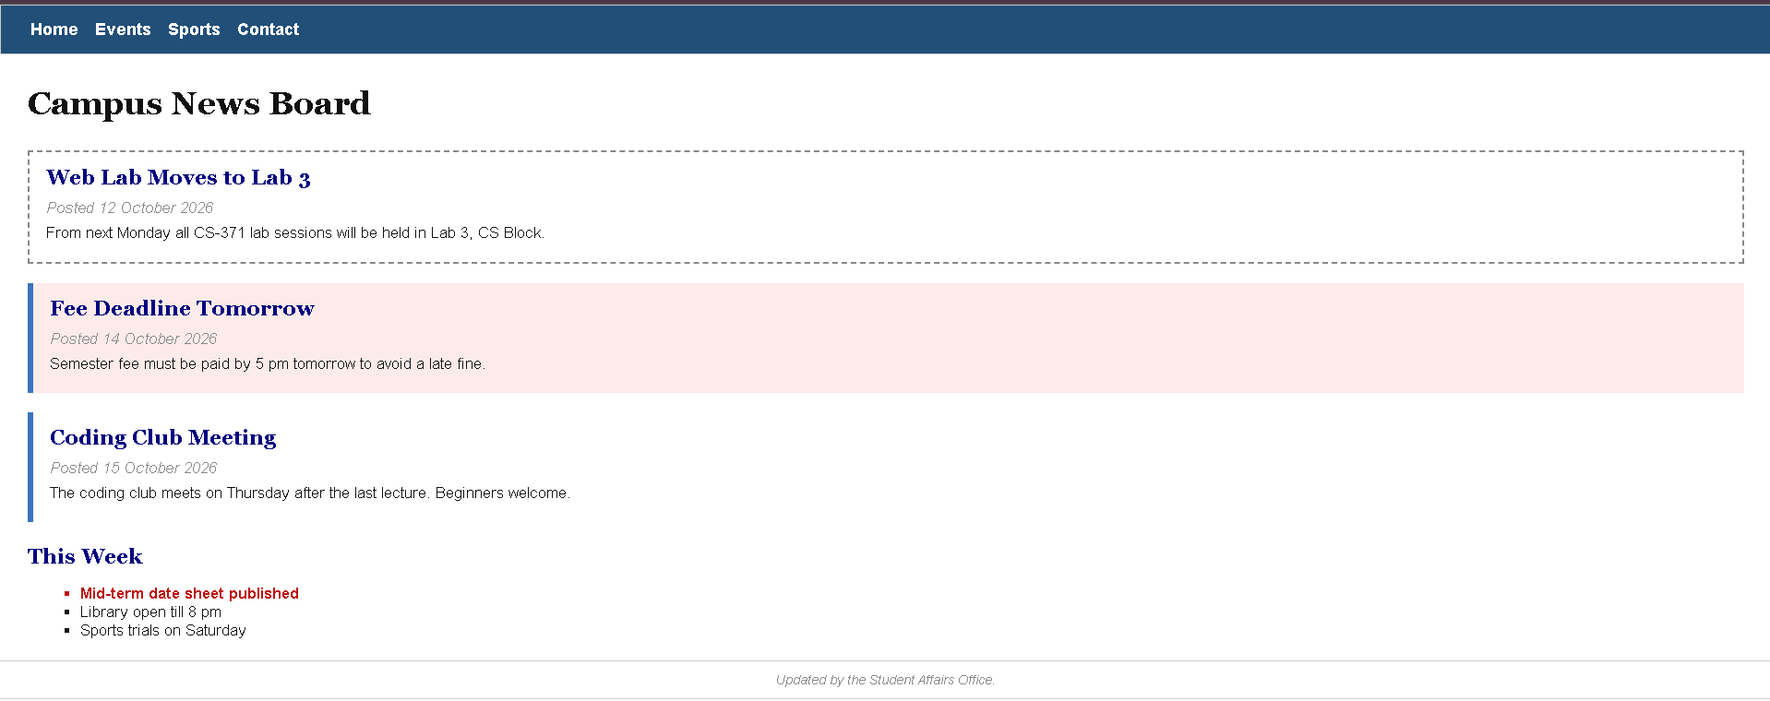

3 | Box Model by Hand  padding, borders and margins — computed the old way

This task made me slow down and actually think. I built the four boxes exactly as specified, then worked out all eight missing measurements by hand before opening the browser. Boxes B and D use box-sizing: border-box, which flips the whole calculation — the width suddenly includes padding and border. Box D also sits centred thanks to margin: 0 auto. Writing out the arithmetic on paper first made the browser's answer feel like a small victory.
WHAT I COVERED ✓
✔ All four boxes (A–D) built with correct widths, padding, borders and margins
✔ Boxes B and D set to box-sizing: border-box
✔ Box D centred horizontally with margin: 0 auto
✔ Box A total width (border to border) calculated by hand
✔ Box A total height and width-including-margins calculated by hand
✔ Box B total width and content width calculated by hand
✔ Box C total width (taller padding on the sides) calculated by hand
✔ Box D content width and content height calculated by hand
✔ A 'My Calculations' section listing all eight answers on the page

<!DOCTYPE html>
<html lang="en">
<head>
<meta charset="UTF-8">
<title>Task 3 - Box Model by Hand</title>
<link rel="stylesheet" href="task3_box.css">
</head>
<body>
<h1>Box Model by Hand</h1>

<div class="box box-a">Box A</div>
<div class="box box-b">Box B</div>
<div class="box box-c">Box C</div>
<div class="box box-d">Box D (centred)</div>

<h2>My Calculations</h2>
<p>Box A total width (border to border): 460 px (400 + 40 padding + 20 border)</p>
<p>Box A total height (border to border): 220 px (160 + 40 padding + 20 border)</p>
<p>Box A width including its margins: 490 px (460 + 15 left margin + 15 right margin)</p>
<p>Box B total width (border to border): 400 px (set width with border-box)</p>
<p>Box B content width: 340 px (400 - 40 padding - 20 border)</p>
<p>Box C total width (border to border): 632 px (600 + 24 padding + 8 border)</p>
<p>Box D content width: 540 px (600 - 50 padding - 10 border)</p>
<p>Box D content height: 180 px (240 - 50 padding - 10 border)</p>
</body>
</html>

CSS FILE:

body {
font-family: Arial, sans-serif;
margin: 40px;
}

.box {
background-color: #d9e3f3;
border: 10px solid #214f78;
color: #111;
font-size: 22px;
margin-bottom: 20px;
padding: 20px;
}

.box-a {
height: 160px;
margin-left: 15px;
margin-right: 15px;
width: 400px;
}

.box-b {
box-sizing: border-box;
height: 140px;
width: 400px;
}

.box-c {
border-width: 4px;
height: 40px;
padding: 12px;
width: 600px;
}

.box-d {
box-sizing: border-box;
height: 240px;
margin: 30px auto;
width: 600px;
}

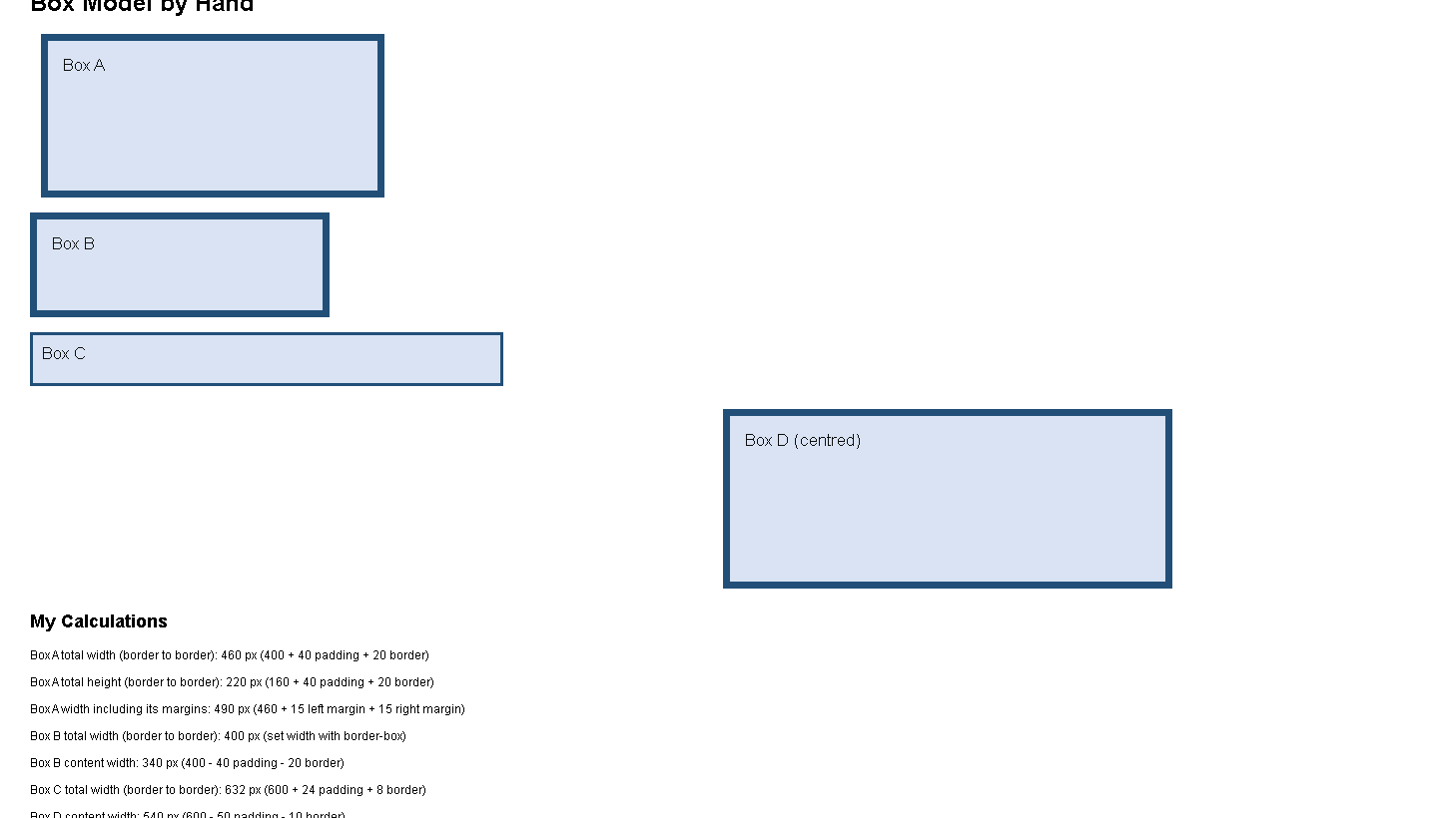

4 | Wah Cafe Menu  turning plain HTML into a place you'd actually eat at

Task four was my favourite so far. I took a completely plain menu and, using only an external style sheet, gave the Wah Cafe a proper identity: cream page, deep headings with a rule underneath, and every price locked into one neat column on the right. The trick was treating each dish row as a line where the price hugs the right edge — no tables, no spaces, just CSS. The little green veg badges were the finishing touch.
WHAT I COVERED ✓
✔ External stylesheet only — the HTML stayed plain and untouched
✔ Cream page background with warm, readable body text
✔ Section headings (Starters, Main Course, Drinks, Specials) in deep red-brown with a bottom rule
✔ Every price aligned in a single right-hand column
✔ Dish names styled in a serif, small-caps feel
✔ Green rounded 'veg' badges beside the vegetarian items
✔ Specials shown as a square-bulleted list
✔ A small italic footer line with the cafe's opening hours

<!DOCTYPE html>
<html lang="en">
<head>
<meta charset="UTF-8">
<title>Task 4 - Wah Cafe Menu</title>
<link rel="stylesheet" href="task4_menu.css">
</head>
<body>
<div class="menu-card">
<div class="menu-heading">
<h1>WAH CAFE</h1>
<p>Fresh food for hungry students since 1998</p>
</div>

<div class="menu-section" id="starters">
<h2>Starters</h2>
<div class="menu-list">
<div class="menu-row">
<span class="dish-name">Chicken Corn Soup</span>
<span class="price">Rs. 350</span>
</div>
<div class="menu-row">
<span class="dish-name">Samosa Platter <span class="badge">veg</span></span>
<span class="price">Rs. 250</span>
</div>
</div>
</div>

<div class="menu-section">
<h2>Main Course</h2>
<div class="menu-list">
<div class="menu-row">
<span class="dish-name">Chicken Karahi</span>
<span class="price">Rs. 1200</span>
</div>
<div class="menu-row">
<span class="dish-name">Daal Makhni <span class="badge">veg</span></span>
<span class="price">Rs. 650</span>
</div>
<div class="menu-row">
<span class="dish-name">Beef Pulao</span>
<span class="price">Rs. 900</span>
</div>
</div>
</div>

<div class="menu-section">
<h2>Drinks</h2>
<div class="menu-list">
<div class="menu-row">
<span class="dish-name">Mint Margarita <span class="badge">veg</span></span>
<span class="price">Rs. 300</span>
</div>
<div class="menu-row">
<span class="dish-name">Doodh Patti Chai <span class="badge">veg</span></span>
<span class="price">Rs. 120</span>
</div>
</div>
</div>

<div class="menu-section">
<h2>Today's Specials</h2>
<ul class="special-list">
<li>Free chai with any main course before 11 am</li>
<li>Student card: 10% off on Fridays</li>
<li>Family platter on weekends</li>
</ul>
</div>

<p class="opening-hours">Open 8 am to 8 pm, Monday to Saturday</p>
</div>
</body>
</html>

CSS FILE:
body {
background-color: #f3efe7;
color: #333;
font-family: Georgia, serif;
margin: 0;
}

.menu-card {
box-sizing: border-box;
background-color: white;
border: 1px solid #d5c7b2;
margin: 40px auto;
padding: 40px 60px;
width: 92%;
}

.menu-heading {
text-align: center;
}

.menu-heading h1 {
color: #963c1f;
font-size: 38px;
letter-spacing: 5px;
margin: 32px 0 8px;
}

.menu-heading p {
color: #888;
font-size: 22px;
font-style: italic;
margin: 8px 0 36px;
}

.menu-section {
margin-bottom: 30px;
}

.menu-section h2 {
border-bottom: 3px solid #963c1f;
color: #963c1f;
font-size: 28px;
margin: 0 0 20px;
padding-bottom: 8px;
}

.menu-row {
padding: 8px 12px;
}

#starters .menu-row:first-child {
background-color: #fbf3e5;
}

.dish-name, .price {
display: inline-block;
font-size: 21px;
vertical-align: top;
}

.dish-name {
width: 78%;
}

.price {
font-weight: bold;
text-align: right;
width: 20%;
}

.badge {
background-color: #287d38;
border-radius: 14px;
color: white;
display: inline-block;
font-family: Arial, sans-serif;
font-size: 15px;
margin-left: 10px;
padding: 3px 12px;
}

.special-list {
color: #555;
font-size: 20px;
line-height: 1.8;
list-style-type: square;
margin-left: 40px;
}

.opening-hours {
color: #999;
font-size: 18px;
margin: 36px 0 20px;
text-align: center;
}

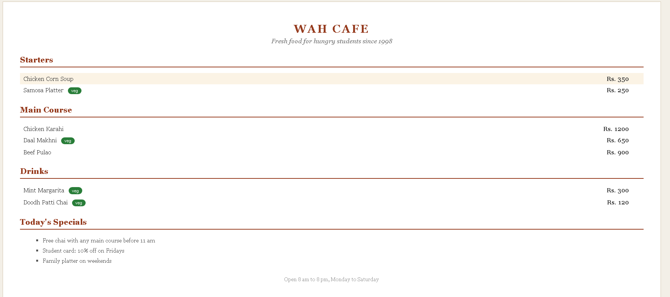

5 | Styling My CV  my lab-1 CV, finally wearing its good clothes

For the final task, I went back to the CV I made in Lab 1 and gave it a complete makeover with an external cv.css. The header became a deep banner with my name in white and a perfectly round photo positioned absolutely in the corner. Below, the page splits into two columns — contact, skills and languages on the left; about me, education and projects on the right. My skills became little pill badges, and when the mouse hovers over my email it gives a friendly underline. Same content as Lab 1, but now it actually looks like me.
WHAT I COVERED ✓
✔ Lab-1 CV restyled through an external cv.css file only
✔ Deep header banner with large white name and subtitle
✔ Round photo positioned absolutely in the header corner
✔ Two-column layout: narrow sidebar + wide main column
✔ Skill badges styled as inline-block pills with soft backgrounds
✔ Languages list and sidebar sections styled consistently
✔ Education years right-aligned; project titles bolded
✔ Hover state on the email link (underline on mouse-over)

<!DOCTYPE html>
<html lang="en">
<head>

<title>Task 5 - Faiza Arooj CV</title>
<link rel="stylesheet" href="cv.css">
</head>
<body>
<div class="resume">
<div class="resume-header">
<img class="profile-picture" src="../Lab01/profile.png" alt="Faiza Arooj">
<h1>Faiza Arooj</h1>
<p class="degree-line">BS Artificial Intelligence | University of Wah</p>
<p class="email-line"><a href="mailto:aroojfaiza7865@gmail.com">aroojfaiza7865@gmail.com</a></p>
</div>

<div class="resume-content">
<div class="sidebar resume-column">
<h2>Contact</h2>
<p>University of Wah</p>
<p>BS Artificial Intelligence, Semester 5</p>

<h2>Skills</h2>
<p class="skill-list">
<span class="skill-badge">HTML</span>
<span class="skill-badge">Basic Web Design</span>
<span class="skill-badge">Python</span>
<span class="skill-badge">Data Analytics</span>
<span class="skill-badge">Git</span>
<span class="skill-badge">VS Code</span>
<span class="skill-badge">AI and Machine Learning</span>
</p>
</div><div class="main-column resume-column">
<h2>About Me</h2>
<p>University student with a focus on data analytics, software development, programming, and exploring artificial intelligence concepts. I enjoy learning new technologies and building my skills.</p>

<h2>Education</h2>
<p class="education-entry">BS Artificial Intelligence, University of Wah <span class="education-detail">Semester 5 | CGPA 3.92</span></p>
<p class="education-entry">Intermediate, Pre-Medical <span class="education-detail">87%</span></p>
<p class="education-entry">Matriculation, F.G. Public School No. 6 <span class="education-detail">90%</span></p>

<h2>Academic Work</h2>
<ul class="work-list">
<li><strong>Course Outline:</strong> Organized semesters and course subjects with nested lists.</li>
<li><strong>Class Timetable:</strong> Created a weekly course schedule using HTML tables.</li>
<li><strong>Exam Feedback Form:</strong> Built a feedback page with a table and form controls.</li>
</ul>
</div>
</div>
</div>
</body>
</html>

CSS FILE:
body {
background-color: #eef1f4;
color: #333;
font-family: Arial, sans-serif;
margin: 20px auto;
width: 92%;
}

.resume {
background-color: white;
border: 1px solid #ccc;
}

.resume-header {
background-color: #214f78;
color: white;
padding: 36px 60px;
position: relative;
}

.resume-header h1 {
font-size: 42px;
letter-spacing: 1px;
margin: 8px 0;
width: 55%;
}

.degree-line {
color: #d8e4f1;
font-size: 18px;
margin: 8px 0 24px;
width: 55%;
}

.email-line {
margin: 0;
width: 55%;
}

.email-line a {
background-color: #ffda5c;
border-radius: 24px;
color: #214f78;
display: inline-block;
font-size: 18px;
font-weight: bold;
padding: 8px 18px;
text-decoration: none;
}

.profile-picture {
border: 6px solid white;
border-radius: 50%;
height: 170px;
position: absolute;
right: 42px;
top: 28px;
width: 170px;
}

.resume-content {
padding: 0 24px;
}

.resume-column {
box-sizing: border-box;
display: inline-block;
padding: 24px;
vertical-align: top;
}

.sidebar {
background-color: #f3f5f8;
width: 30%;
}

.main-column {
width: 69%;
}

.resume-column h2 {
border-bottom: 3px solid #214f78;
color: #214f78;
font-size: 24px;
letter-spacing: 1px;
margin: 8px 0 22px;
padding-bottom: 8px;
text-transform: uppercase;
}

.resume-column p, .work-list {
font-size: 18px;
line-height: 1.4;
}

.skill-list {
margin-bottom: 28px;
}

.skill-badge {
background-color: #d9e3f3;
border-radius: 18px;
color: #214f78;
display: inline-block;
margin: 0 5px 8px 0;
padding: 6px 12px;
}

.education-entry {
margin: 10px 0;
}

.education-detail {
color: #888;
display: inline-block;
text-align: right;
width: 100%;
}

.work-list {
list-style-type: square;
margin-left: 20px;
padding-left: 16px;
}

.work-list li {
margin-bottom: 10px;
}

