✦ LAB REPORT ✦
WEB APPLICATION
DEVELOPMENT
C S - 3 7 1

LAB-01 · PRE-DJANGO
Introduction to Web Development & Basic HTML Page Creation

Name: FAIZA AROOJ
Roll No: UW-24-AI-BS-014
Section: BS AI5th
Submitted on: 11/10/2026

✦ | OVERVIEW  what this lab is all about

This report walks through Lab-01 of Web Application Development (CS-371), where I built my very first HTML pages from scratch. The lab covered the anatomy of an HTML document — the <html>, <head>, <title> and <body> tags — along with headings, paragraphs, text formatting, hyperlinks and images. The three tasks that follow build on each other: first a single page mixing the core tags, then a small two-page site with a navigation bar, and finally a personal resume written entirely in HTML.

THE ROAD AHEAD
Task 1 | core tags, one page
Task 2 | two pages, one navbar
Task 3 | my resume, in HTML

01 | TASK 1 — CORE TAGS, ONE PAGE  headings · paragraphs · formatting · links · images

✎ WHAT I DID
For my first task, I brought together all the core tags from the lab in a single HTML page. I wrote a few paragraphs, emphasized parts of the text in bold, italics and underline, added a hyperlink to an external site, dropped in an image, and structured the page with heading levels 1, 3 and 5. This task made the basic document anatomy second nature.
✔ REQUIREMENTS COVERED
✔ | A complete HTML page with paragraphs of text
✔ | Bold, italic & underlined text using <b>, <i> and <u>
✔ | A hyperlink with <a href="…"> pointing to an external site
✔ | An image inserted with <img> and a valid src path
✔ | Heading levels 1, 3 and 5 structuring the page

🖥 CODE SCREENSHOT
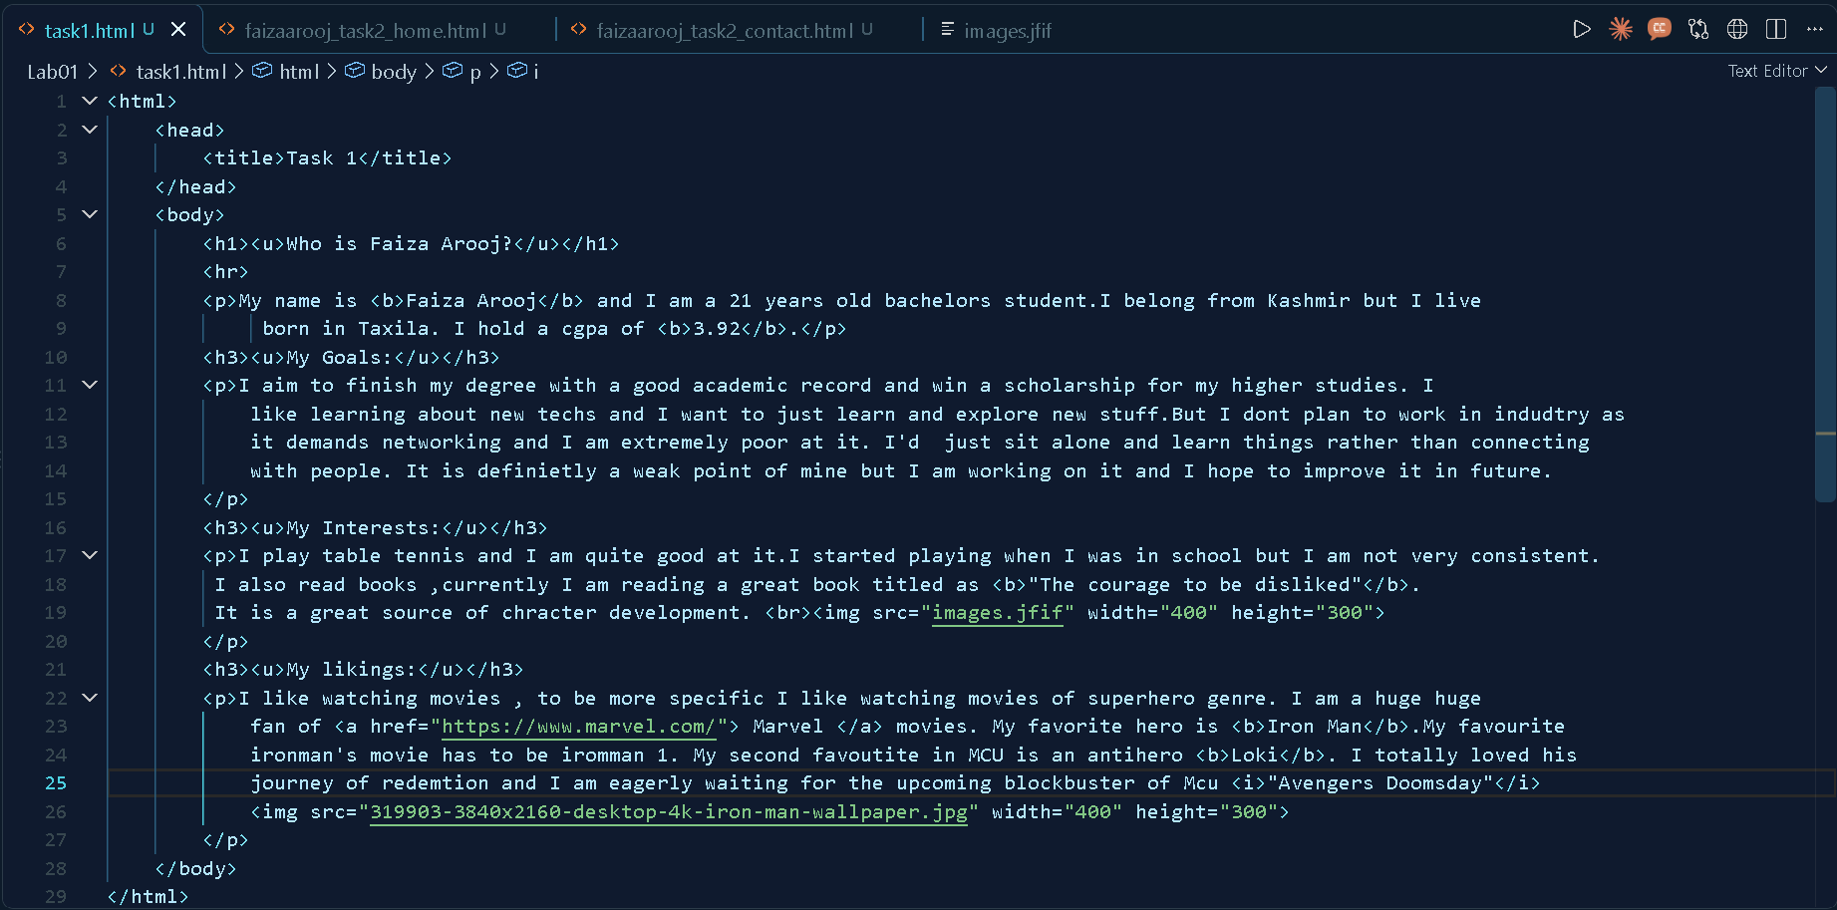

🌐 OUTPUT SCREENSHOT
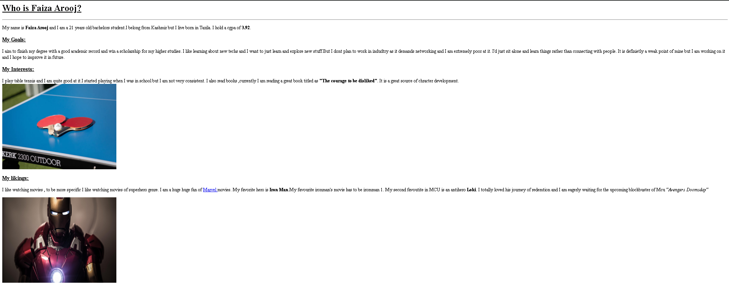

02 | TASK 2 — TWO PAGES, ONE NAVBAR  home · contact · local links · lists · <hr> · <br>

✎ WHAT I DID
Next, I grew the single page into a tiny two-page website — a Home page and a Contact page — linked together by a shared navigation bar made of anchor tags. I used local (relative) URLs to jump between the pages, and practised the remaining demo tags: lists, horizontal rules and line breaks. Seeing both pages share the same navbar really made the "site" feel real.
✔ REQUIREMENTS COVERED
✔ | Two pages — Home and Contact — built in VS Code
✔ | A navigation bar on both pages linking them together
✔ | Relative URLs used for page-to-page navigation
✔ | Demo tags: lists, links, images, <hr> and <br>
✔ | A consistent look across both pages

🖥 CODE SCREENSHOT
Home page: 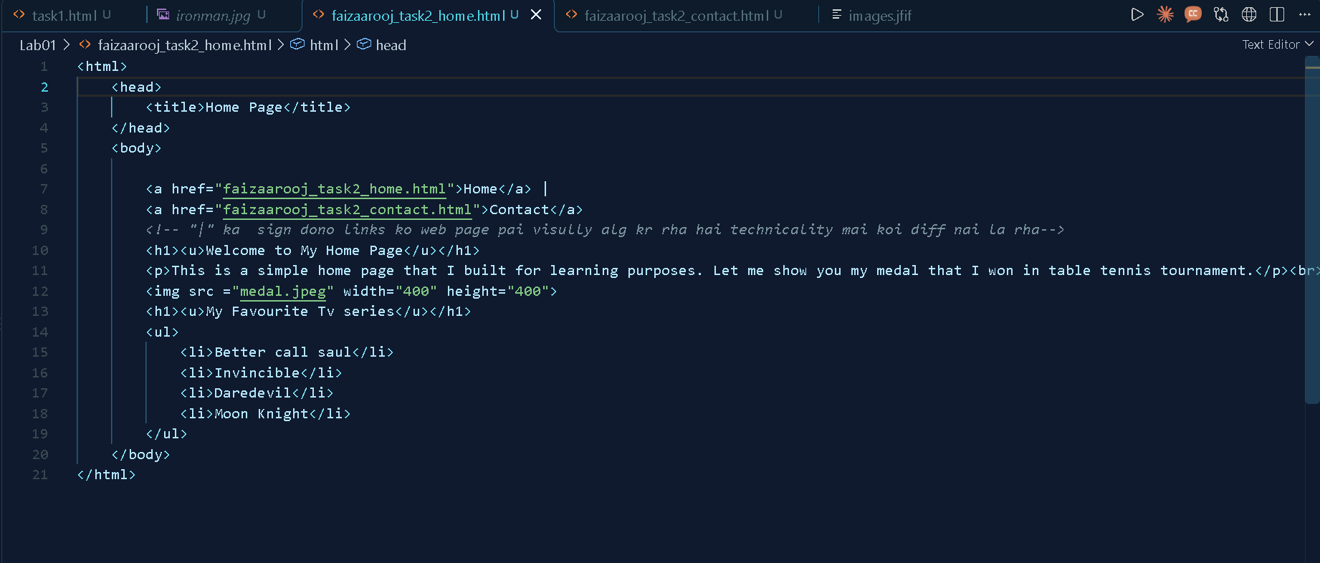
Contact page: 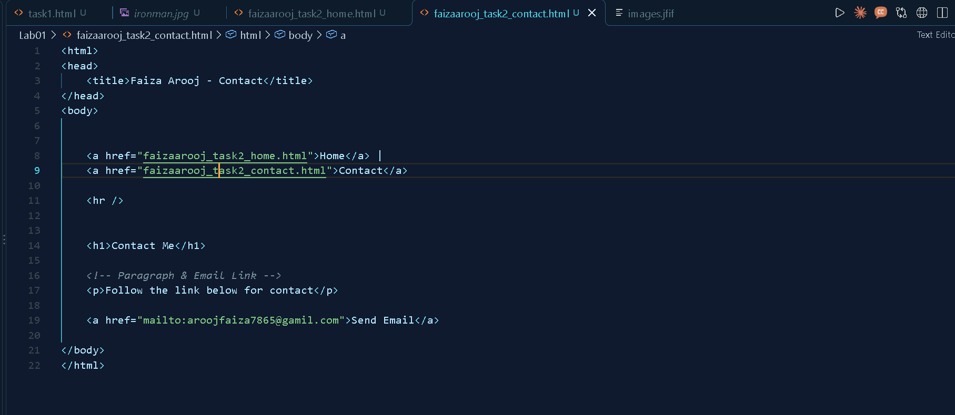

🌐 OUTPUT SCREENSHOT
Home page: 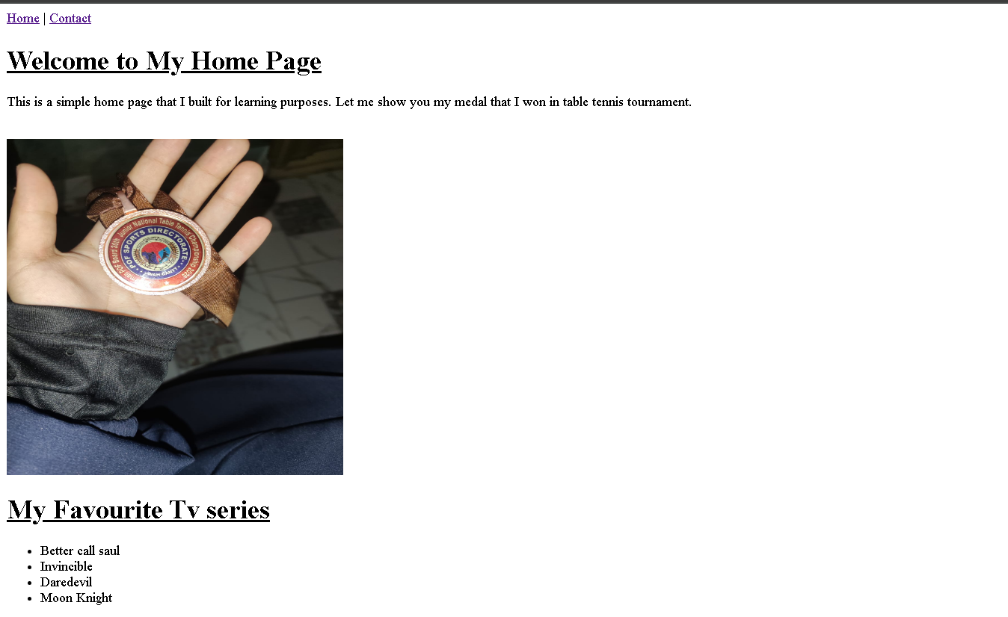
Contact page: 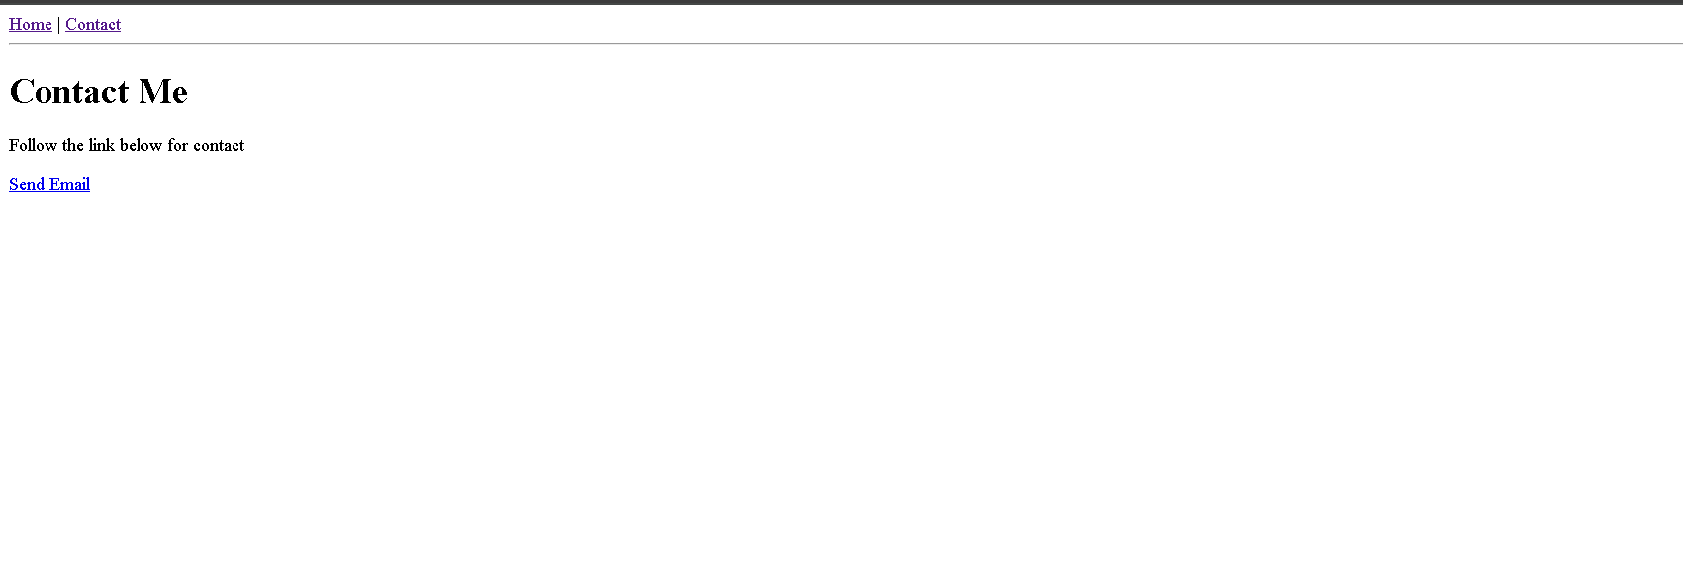

03 | TASK 3 — MY RESUME, IN HTML  headings · paragraphs · profile image · mailto link

✎ WHAT I DID
Finally, I turned the lab skills into something personal: my own resume, written entirely in HTML. Headings divide it into sections, paragraphs carry the descriptions, a photo sits at the top via an <img> tag, and a mailto: link lets anyone reach me straight from the page. It is simple, but it is mine — my first real web page.
✔ REQUIREMENTS COVERED
✔ | Headings (<h1>–<h6>) organising each resume section
✔ | Paragraphs for the summary and experience blocks
✔ | A profile photo placed with the <img> tag
✔ | An email link using href="mailto:you@example.com"

🖥 CODE SCREENSHOT
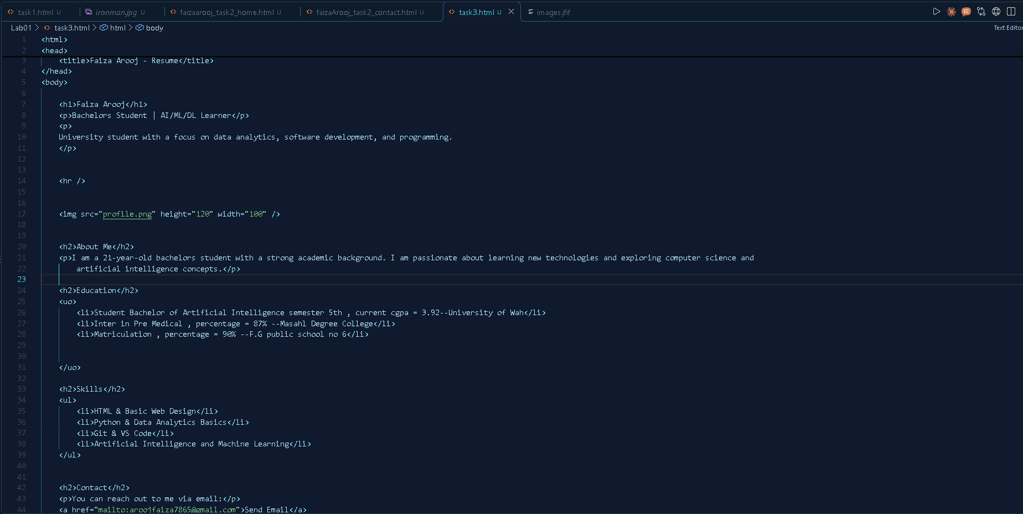

🌐 OUTPUT SCREENSHOT
