✦ LAB REPORT ✦
CS-371 · PRE-DJANGO SERIES
WEB APPLICATION
DEVELOPMENT
Structure first. Style later.
LAB-02 — HTML LISTS, TABLES AND FORMS
where every form I build today becomes a Django view tomorrow
STUDENT DETAILS
Name ··· FAZIA AROOJ
Roll No. ··· UW-24-AI-BS-014
Section ··· BS-5TH
Submission Date ··· 12/10/2026
University of Wah
Department of Computer Science

1 |  | NESTED LISTS · BSComp OUTLINE  shopping lists, recipes, dictionaries — one page, three personalities
For my first task I rebuilt the BSComp semester outline using nothing but lists — and I have to admit, the first draft fell apart the moment I nested. My sub-list kept escaping its parent item until I realised the rule from the manual: an inner list must live inside its <li>, before that <li> closes. After that fix, the whole outline clicked together — ordered semesters, a bulleted web stack, a counting-down rules list, and a tiny glossary to finish.
WHAT I COVERED
✔ <ol type="I"> for the three semesters — roman numerals, browser does the counting
✔ Nested <ul> inside Semester 3's <li> for HTML, CSS, JavaScript and Django
✔ reversed ordered list for Lab Rules counting down 5 → 1
✔ start="10" ordered list continuing the rules at 10, 11, 12
✔ <dl> glossary pairing each term (<dt>) with its explanation (<dd>)

<html>
<head>
<title>Task 4 - Patient Registration</title>
</head>
<body>
<h1>Patient Registration</h1>

<form>
<fieldset>
<legend>Personal Information</legend>

<label for="full-name">Full Name:</label>
<input type="text" id="full-name" name="full_name" placeholder="As on your ID">
<br><br>

<label for="date-of-birth">Date of Birth:</label>
<input type="date" id="date-of-birth" name="date_of_birth">
<br><br>

Gender:
<input type="radio" id="gender-male" name="gender" value="male" checked>
<label for="gender-male">Male</label>
<input type="radio" id="gender-female" name="gender" value="female">
<label for="gender-female">Female</label>
<input type="radio" id="gender-other" name="gender" value="other">
<label for="gender-other">Other</label>
<br><br>

<label for="email">Email:</label>
<input type="email" id="email" name="email">
<br><br>

<label for="password">Password:</label>
<input type="password" id="password" name="password">
<br><br>
</fieldset>

<fieldset>
<legend>Medical Details</legend>

<label for="blood-group">Blood Group:</label>
<select id="blood-group" name="blood_group">
<option value="">-- Select --</option>
<option value="A+">A+</option>
<option value="A-">A-</option>
<option value="B+">B+</option>
<option value="B-">B-</option>
<option value="AB+">AB+</option>
<option value="AB-">AB-</option>
<option value="O+">O+</option>
<option value="O-">O-</option>
</select>
<br><br>

<label for="weight">Weight (kg):</label>
<input type="number" id="weight" name="weight" min="1" max="300">
<br><br>

Known Allergies:
<input type="checkbox" id="allergy-dust" name="allergies" value="dust">
<label for="allergy-dust">Dust</label>
<input type="checkbox" id="allergy-pollen" name="allergies" value="pollen">
<label for="allergy-pollen">Pollen</label>
<input type="checkbox" id="allergy-penicillin" name="allergies" value="penicillin">
<label for="allergy-penicillin">Penicillin</label>
<br><br>

<label for="medicines">Current Medicines (hold Ctrl):</label>
<br>
<select id="medicines" name="medicines" multiple size="3">
<option value="paracetamol">Paracetamol</option>
<option value="insulin">Insulin</option>
<option value="aspirin">Aspirin</option>
</select>
<br><br>

<label for="registration-date">Registration Date:</label>
<input type="date" id="registration-date" name="registration_date" value="2026-10-10">
<br><br>

<label for="patient-id">Patient ID:</label>
<input type="text" id="patient-id" name="patient_id" value="Assigned by hospital" disabled>
</fieldset>

<fieldset>
<legend>Appointment</legend>

<label for="department">Department:</label>
<select id="department" name="department">
<option value="cardiology" selected>Cardiology</option>
<option value="neurology">Neurology</option>
<option value="orthopedics">Orthopedics</option>
<option value="dermatology">Dermatology</option>
</select>
<br><br>

<label for="urgency">Urgency (1-5):</label>
<input type="range" id="urgency" name="urgency" min="1" max="5" value="3">
<br><br>

<label for="symptoms">Symptoms:</label>
<br>
<textarea id="symptoms" name="symptoms" rows="5" cols="50" placeholder="Describe your symptoms"></textarea>
<br><br>

<input type="checkbox" id="confirm" name="confirm" value="yes">
<label for="confirm">I confirm the information above is correct</label>
<br><br>
</fieldset>

<input type="submit" value="Register Patient">
<input type="reset" value="Reset">
</form>
</body>
</html>

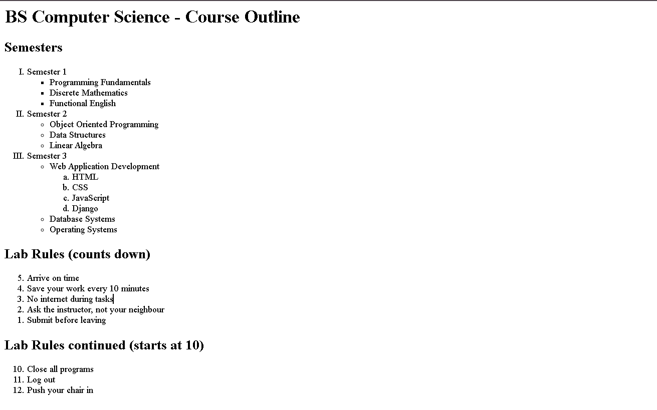

2 |  | CLASS TIMETABLE · SPANS & SECTIONS  six columns, four spans, zero ragged rows
Task two was a timetable, and it taught me the manual's golden rule the hard way: every row must add up to the same number of columns. I drew the grid on paper first and ticked off each slot, counting a rowspan="2" cell as a slot already reserved from the row above. Only then did I write the <thead>, <tbody> and <tfoot> — and the table came out perfectly even on the first render.
WHAT I COVERED
✔ Six-column grid planned on paper before a single <td> was typed
✔ <caption> naming the table: Class Timetable — Fall 2026
✔ <thead> with Time and Mon–Fri, <th scope="col"> on each header
✔ rowspan="2" merging Statistics and Sports across two rows
✔ colspan="5" on the Free Study row, plus a <tfoot> note row

<html>
<head>
<title>Task 2 - Class Timetable</title>
</head>
<body>
<table border="1" cellpadding="6" cellspacing="0" width="100%">
<caption>Class Timetable - Fall 2026</caption>
<thead>
<tr>
<th colspan="6" bgcolor="lightblue">Department of Computer Science</th>
</tr>
<tr bgcolor="lightblue">
<th scope="col">Time</th>
<th scope="col">Mon</th>
<th scope="col">Tue</th>
<th scope="col">Wed</th>
<th scope="col">Thu</th>
<th scope="col">Fri</th>
</tr>
</thead>
<tbody>
<tr>
<th scope="row">09-10</th>
<td>Web Lecture</td>
<td>Database</td>
<td>Web Lecture</td>
<td>Database</td>
<td>Seminar</td>
</tr>
<tr>
<th scope="row">10-11</th>
<td rowspan="2">web dev Lab</td>
<td>Statistics</td>
<td>Statistics</td>
<td rowspan="2">operating system</td>
<td rowspan="2">knowledge representstion/td>
</tr>
<tr>
<th scope="row">11-12</th>
<td>Database Lab</td>
<td>Web Lab</td>
</tr>
<tr>
<th scope="row">12-13</th>
<td colspan="5">Lunch Break</td>
</tr>
<tr>
<th scope="row">13-14</th>
<td colspan="3">Free Study</td>
<td>AI Lecture</td>
<td>AI Lecture</td>
</tr>
</tbody>
<tfoot>
<tr>
<td colspan="6">Room allocation is announced on the notice board.</td>
</tr>
</tfoot>
</table>
</body>
</html>

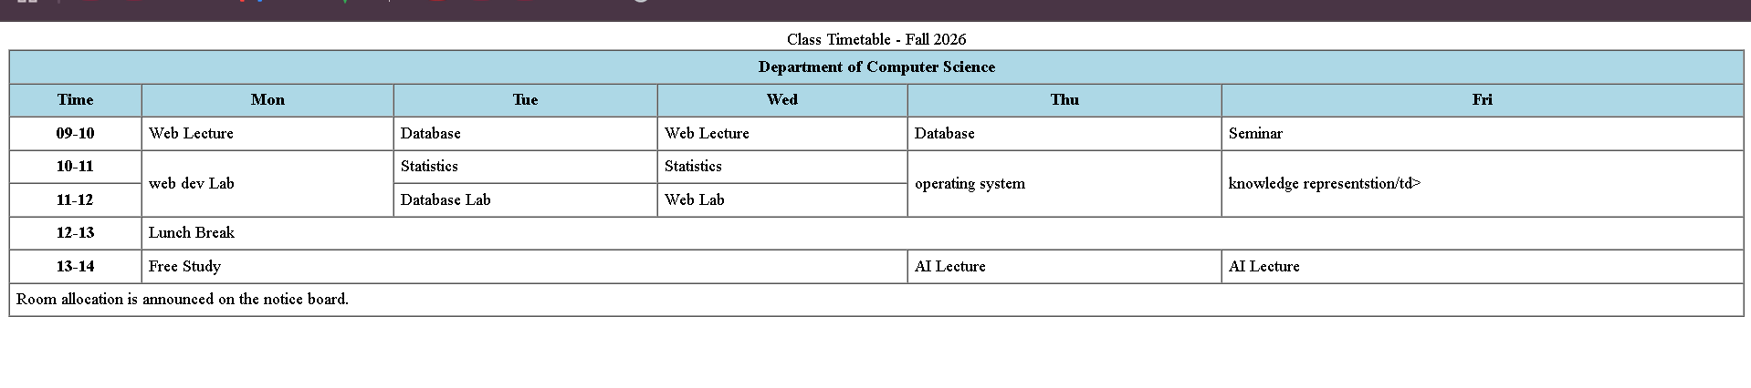

3 |  | MARKS SHEET · TWO-LEVEL HEADER  arithmetic as a markup exercise
This one felt half like maths homework: I worked out every total by hand — 32+48=80, 28+41=69, 35+52=87, 22+38=60 — then summed the columns (117, 179, 296) and the percentage, 82.9%. Building the two-level header with rowspan="2" on Subject and Grade took one careful count, and the summary footer made the table feel like a real transcript rather than a grid of numbers.
WHAT I COVERED
✔ Two-level header: Subject and Grade span both header rows
✔ <th scope="col"> on Mid, Final and Total; scope="row" on subject names
✔ Per-row Total computed by hand: 80, 69, 87 and 60 out of 100
✔ Summary <tfoot> row: column totals 117 / 179 / 296
✔ Percentage row stretching with colspan="4" — 82.9% overall

<html>
<head>
<title>Task 3 - Marks Sheet</title>
</head>
<body>
<table border="1" cellpadding="6" cellspacing="0">
<caption>Marks Sheet</caption>
<thead>
<tr bgcolor="lightblue">
<th colspan="5">Faiza Arooj UW-24-Ai-BS-014</th>
</tr>
<tr bgcolor="lightblue">
<th scope="col" rowspan="2">Subject</th>
<th colspan="3">Marks</th>
<th scope="col" rowspan="2">Grade</th>
</tr>
<tr bgcolor="lightblue">
<th scope="col">Mid (40)</th>
<th scope="col">Final (60)</th>
<th scope="col">Total (100)</th>
</tr>
</thead>
<tbody>
<tr>
<th scope="row">Web Development</th>
<td>32</td>
<td>48</td>
<td>80</td>
<td>A</td>
</tr>
<tr>
<th scope="row">operating systems</th>
<td>28</td>
<td>41</td>
<td>69</td>
<td>B</td>
</tr>
<tr>
<th scope="row">neural networks</th>
<td>35</td>
<td>52</td>
<td>87</td>
<td>A</td>
</tr>
<tr>
<th scope="row">web development</th>
<td>22</td>
<td>38</td>
<td>60</td>
<td>C</td>
</tr>
</tbody>
<tfoot>
<tr>
<th scope="row">Total</th>
<td>117</td>
<td>179</td>
<td>296</td>
<td>-</td>
</tr>
<tr>
<th scope="row">Percentage</th>
<td colspan="4">74%</td>
</tr>
</tfoot>
</table>
</body>
</html>

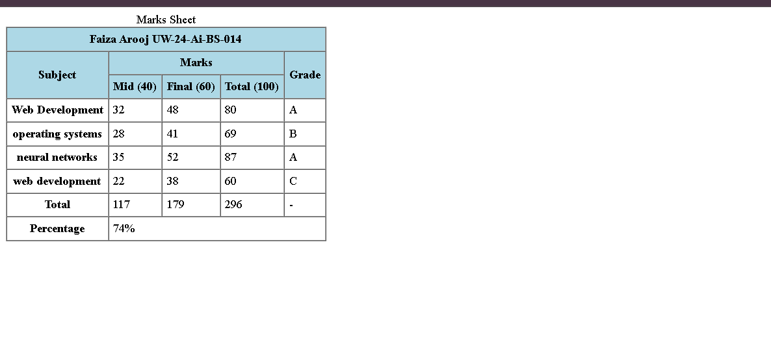

4 |  | PATIENT REGISTRATION · FULL FORM  the form I'll one day point at Django
The big one. I built a patient registration form with three fieldsets — Personal Information, Medical Details and Appointment — and I obsessed over the two identities of every control: id for the label's for, name for the data that actually travels. Clicking a label and watching the cursor jump into its input was the moment the label-for pairing really made sense. Then I submitted it empty and read the address bar like a receipt.
WHAT I COVERED
✔ Every control labelled — for matches id exactly, character for character
✔ name on every control; nothing silently lost on submit
✔ <fieldset> + <legend> grouping the three sections
✔ Right control per field: date, radio group, multi-select, range slider, textarea
✔ placeholder hint, readonly Patient ID; verified name=value pairs in the address bar

<html>
<head>
<title>Task 4 - Patient Registration</title>
</head>
<body>
<h1>Patient Registration</h1>

<form>
<fieldset>
<legend>Personal Information</legend>

<label for="full-name">Full Name:</label>
<input type="text" id="full-name" name="full_name" placeholder="As on your ID">
<br><br>

<label for="date-of-birth">Date of Birth:</label>
<input type="date" id="date-of-birth" name="date_of_birth">
<br><br>

Gender:
<input type="radio" id="gender-male" name="gender" value="male" checked>
<label for="gender-male">Male</label>
<input type="radio" id="gender-female" name="gender" value="female">
<label for="gender-female">Female</label>
<input type="radio" id="gender-other" name="gender" value="other">
<label for="gender-other">Other</label>
<br><br>

<label for="email">Email:</label>
<input type="email" id="email" name="email">
<br><br>

<label for="password">Password:</label>
<input type="password" id="password" name="password">
<br><br>
</fieldset>

<fieldset>
<legend>Medical Details</legend>

<label for="blood-group">Blood Group:</label>
<select id="blood-group" name="blood_group">
<option value="">-- Select --</option>
<option value="A+">A+</option>
<option value="A-">A-</option>
<option value="B+">B+</option>
<option value="B-">B-</option>
<option value="AB+">AB+</option>
<option value="AB-">AB-</option>
<option value="O+">O+</option>
<option value="O-">O-</option>
</select>
<br><br>

<label for="weight">Weight (kg):</label>
<input type="number" id="weight" name="weight" min="1" max="300">
<br><br>

Known Allergies:
<input type="checkbox" id="allergy-dust" name="allergies" value="dust">
<label for="allergy-dust">Dust</label>
<input type="checkbox" id="allergy-pollen" name="allergies" value="pollen">
<label for="allergy-pollen">Pollen</label>
<input type="checkbox" id="allergy-penicillin" name="allergies" value="penicillin">
<label for="allergy-penicillin">Penicillin</label>
<br><br>

<label for="medicines">Current Medicines (hold Ctrl):</label>
<br>
<select id="medicines" name="medicines" multiple size="3">
<option value="paracetamol">Paracetamol</option>
<option value="insulin">Insulin</option>
<option value="aspirin">Aspirin</option>
</select>
<br><br>

<label for="registration-date">Registration Date:</label>
<input type="date" id="registration-date" name="registration_date" value="2026-10-10">
<br><br>

<label for="patient-id">Patient ID:</label>
<input type="text" id="patient-id" name="patient_id" value="Assigned by hospital" disabled>
</fieldset>

<fieldset>
<legend>Appointment</legend>

<label for="department">Department:</label>
<select id="department" name="department">
<option value="cardiology" selected>Cardiology</option>
<option value="neurology">Neurology</option>
<option value="orthopedics">Orthopedics</option>
<option value="dermatology">Dermatology</option>
</select>
<br><br>

<label for="urgency">Urgency (1-5):</label>
<input type="range" id="urgency" name="urgency" min="1" max="5" value="3">
<br><br>

<label for="symptoms">Symptoms:</label>
<br>
<textarea id="symptoms" name="symptoms" rows="5" cols="50" placeholder="Describe your symptoms"></textarea>
<br><br>

<input type="checkbox" id="confirm" name="confirm" value="yes">
<label for="confirm">I confirm the information above is correct</label>
<br><br>
</fieldset>

<input type="submit" value="Register Patient">
<input type="reset" value="Reset">
</form>
</body>
</html>

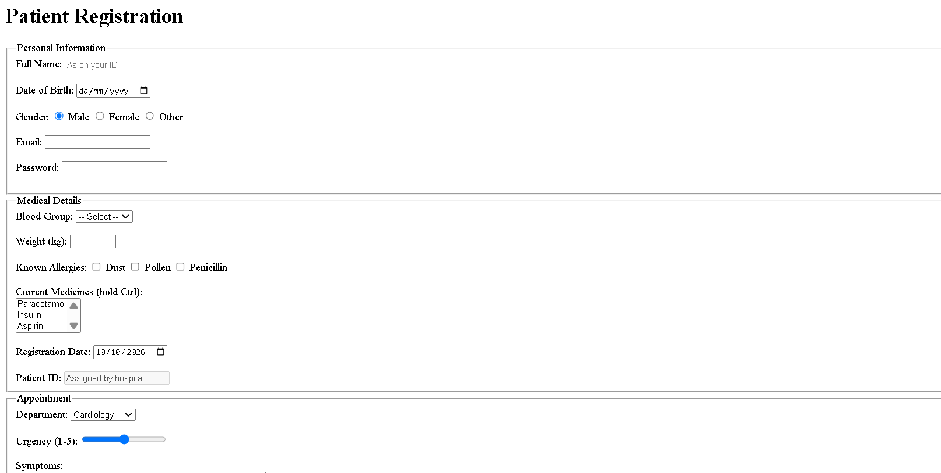

5 |  | EXAM PORTAL · LISTS + TABLE + FORM  everything from this lab, one page
For the final task I combined all three structures on a single exam portal page: an unordered list of allowed items, a nested ordered list for the instructions, an exam-details table, and a feedback table doing double duty as a grid of radio buttons. The trick was giving all four radios in each row the same name — that single shared name is what keeps a rating to one choice per row.
WHAT I COVERED
✔ <ul> for allowed items; nested <ol> for before / during the exam
✔ Exam details table with <th scope="row"> labels
✔ Feedback table laying out Poor → Excellent as a radio grid
✔ Shared name per radio row — exactly one rating selectable
✔ Send Feedback + Clear buttons; address bar confirms the pairs sent

<html>
<head>
<title>Task 5 - Online Exam Portal</title>
</head>
<body>
<h1>Online Exam Portal</h1>

<h2>Exam Details</h2>
<table border="1" cellpadding="6" cellspacing="0">
<tbody>
<tr>
<th scope="row">Course</th>
<td>Web Application Development</td>
</tr>
<tr>
<th scope="row">Date</th>
<td>20 December 2026</td>
</tr>
<tr>
<th scope="row">Allowed items</th>
<td>
<ul>
<li>Pen</li>
<li>Student card</li>
<li>Calculator</li>
</ul>
</td>
</tr>
</tbody>
</table>

<h2>Instructions</h2>
<ol>
<li>Before the exam
<ul type="circle">
<li>Arrive 30 minutes early</li>
<li>Bring your student card</li>
</ul>
</li>
<li>During the exam
<ul type="circle">
<li>Switch off your phone</li>
<li>Do not leave the hall in the first 30 minutes</li>
</ul>
</li>
</ol>

<h2>Feedback</h2>
<form method="get">
<label for="name">Name:</label>
<input type="text" id="name" name="name">
<br><br>

<table border="1" cellpadding="6" cellspacing="0">
<thead>
<tr>
<th></th>
<th scope="col">Poor</th>
<th scope="col">Fair</th>
<th scope="col">Good</th>
<th scope="col">Excellent</th>
</tr>
</thead>
<tbody>
<tr>
<th scope="row">Course content</th>
<td><input type="radio" name="course_content" value="poor"></td>
<td><input type="radio" name="course_content" value="fair"></td>
<td><input type="radio" name="course_content" value="good"></td>
<td><input type="radio" name="course_content" value="excellent"></td>
</tr>
<tr>
<th scope="row">Instructor</th>
<td><input type="radio" name="instructor" value="poor"></td>
<td><input type="radio" name="instructor" value="fair"></td>
<td><input type="radio" name="instructor" value="good"></td>
<td><input type="radio" name="instructor" value="excellent"></td>
</tr>
<tr>
<th scope="row">Lab sessions</th>
<td><input type="radio" name="lab_sessions" value="poor"></td>
<td><input type="radio" name="lab_sessions" value="fair"></td>
<td><input type="radio" name="lab_sessions" value="good"></td>
<td><input type="radio" name="lab_sessions" value="excellent"></td>
</tr>
</tbody>
</table>
<br>

<label for="comments">Comments:</label>
<br>
<textarea id="comments" name="comments" rows="5" cols="50"></textarea>
<br><br>

<input type="checkbox" id="contact" name="contact" value="yes">
<label for="contact">Contact me about my feedback</label>
<br><br>

<input type="submit" value="Send Feedback">
<input type="reset" value="Clear">
</form>
</body>
</html>



