✦ L A B R E P O R T ✦

WEB APPLICATION
DEVELOPMENT
CS-371 · PRE-DJANGO · UNIVERSITY OF WAH

LAB 05 — BOOTSTRAP: FORMS, NAVBAR & VALIDATION

menus, forms and friendly red-and-green feedback —
all wired up with data- attributes, no JavaScript ✎

S U B M I T T E D B Y
Name: FAIZA AROOJ

Roll No: UW-24-AI-BS-014

Section: BS AI 5TH

Submission Date:
03/11/2026

 | 1 | THE DARK RESPONSIVE NAVBAR  the menu every page will share
For my first task, I built the navbar that the whole site would share. On a wide screen the links sit in a tidy row; below the lg breakpoint they fold away behind a hamburger button. I used navbar-expand-lg with bg-dark and data-bs-theme="dark", and wired the toggler to the collapse div purely with data-* attributes — I wrote zero JavaScript. The one detail I had to be careful with was the link between the button's data-bs-target="#mainNav" and the div's id="mainNav": they must match exactly, hash included. I finished by resizing the browser from 1000px down to phone width and pressing the menu button to watch the links drop down.
R E Q U I R E M E N T S C O V E R E D
✔ Used navbar navbar-expand-lg with bg-dark + data-bs-theme="dark"
✔ Matched the toggler's data-bs-target="#mainNav" to the collapse div's id exactly
✔ Placed the links in ul.navbar-nav with ms-auto pushing them right
✔ Marked the current page with active and aria-current="page"
✔ Tested at wide width and at phone width with the menu open
✔ No dropdown menu — and no JavaScript written

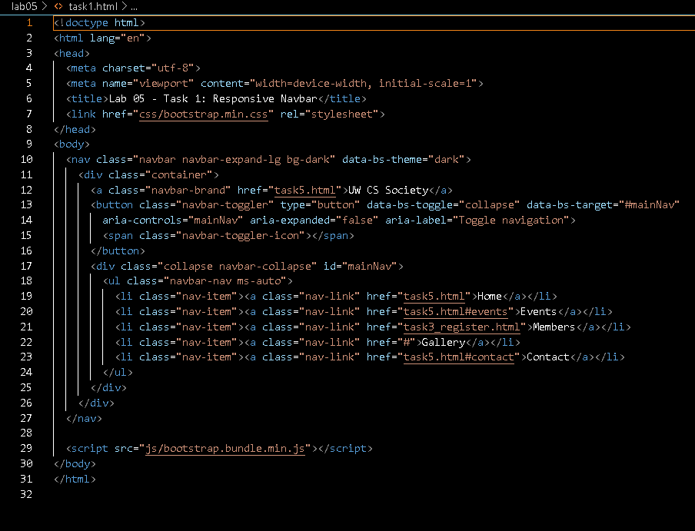

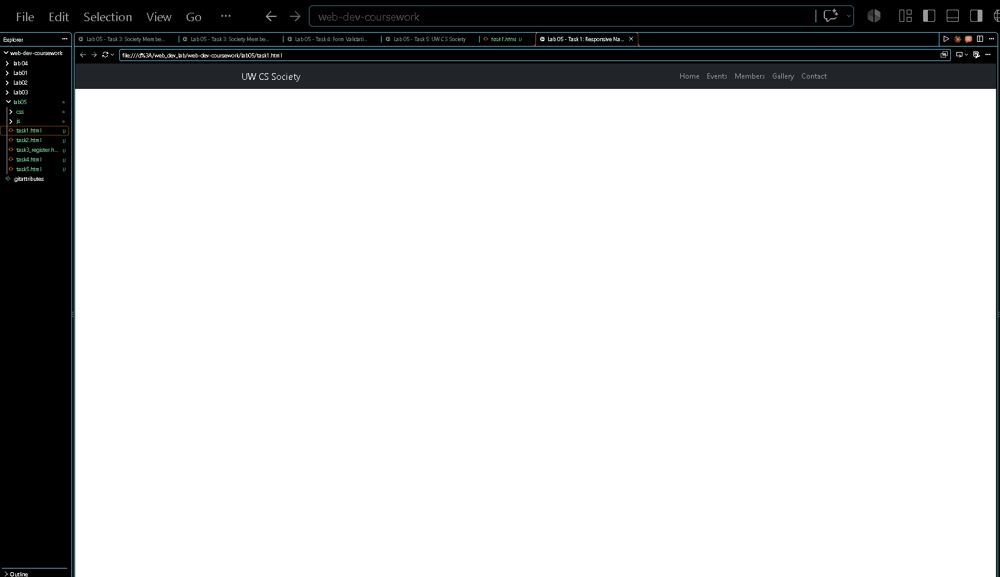

 | 2 | ENROLLMENT FORM ON THE GRID  two names, side by side
Task 2 was my first form built on the Bootstrap grid instead of stacked rows. The trick I had to internalize: the form itself is the row, so I wrote form class="row g-3" and gave each label-and-input pair its own col div — no extra row inside. First and last name sit side by side in two col-md-6 divs, email stretches across col-md-8 with the year select in col-md-4 beside it. The roll number input is readonly so it shows the value but can't be edited, the fee code uses form-control-sm, and the course field gets its suggestions from a datalist — I checked that the input's list attribute and the datalist id match exactly, since the manual warned they must.
R E Q U I R E M E N T S C O V E R E D
✔ Laid the form out with class="row g-3" (the form is the row)
✔ Put first and last name side by side in two col-md-6 divs
✔ Split email (col-md-8) and the year select (col-md-4)
✔ Added the course input with a matching datalist id / list pair
✔ Set the roll number input to readonly and shrank the fee code with form-control-sm
✔ Kept every for/id pair and name attribute from Lab 2

<!doctype html>
<html lang="en">
<head>
<meta charset="utf-8">
<meta name="viewport" content="width=device-width, initial-scale=1">
<title>Lab 05 - Task 2: Course Enrollment</title>
<link href="css/bootstrap.min.css" rel="stylesheet">
</head>
<body>
<nav class="navbar navbar-expand-lg bg-dark" data-bs-theme="dark">
<div class="container">
<a class="navbar-brand" href="task5.html">UW CS Society</a>
<button class="navbar-toggler" type="button" data-bs-toggle="collapse" data-bs-target="#mainNav"
aria-controls="mainNav" aria-expanded="false" aria-label="Toggle navigation">
<span class="navbar-toggler-icon"></span>
</button>
<div class="collapse navbar-collapse" id="mainNav">
<ul class="navbar-nav ms-auto">
<li class="nav-item"><a class="nav-link" href="task5.html">Home</a></li>
<li class="nav-item"><a class="nav-link" href="task5.html#events">Events</a></li>
<li class="nav-item"><a class="nav-link" href="task3_register.html">Members</a></li>
<li class="nav-item"><a class="nav-link" href="#">Gallery</a></li>
<li class="nav-item"><a class="nav-link" href="task5.html#contact">Contact</a></li>
</ul>
</div>
</div>
</nav>

<main class="container my-4">
<h1 class="h3 mb-4">Course Enrollment Form</h1>
<form class="row g-3">
<div class="col-md-6">
<label for="firstName" class="form-label">First Name</label>
<input type="text" class="form-control" id="firstName" name="firstName" required>
</div>
<div class="col-md-6">
<label for="lastName" class="form-label">Last Name</label>
<input type="text" class="form-control" id="lastName" name="lastName" required>
</div>
<div class="col-md-8">
<label for="email" class="form-label">Email</label>
<input type="email" class="form-control" id="email" name="email" required>
</div>
<div class="col-md-4">
<label for="year" class="form-label">Year</label>
<select class="form-select" id="year" name="year" required>
<option value="" selected disabled>Choose...</option>
<option value="1">Year 1</option>
<option value="2">Year 2</option>
<option value="3">Year 3</option>
<option value="4">Year 4</option>
</select>
</div>
<div class="col-12">
<label for="course" class="form-label">Course</label>
<input type="text" class="form-control" id="course" name="course"
list="courseList" placeholder="Start typing a course name..." required>
<datalist id="courseList">
<option value="Web Application Development"></option>
<option value="Database Systems"></option>
<option value="Artificial Intelligence"></option>
<option value="Computer Networks"></option>
</datalist>
</div>
<div class="col-md-6">
<label for="rollNumber" class="form-label">Roll Number (read-only)</label>
<input type="text" class="form-control" id="rollNumber" name="rollNumber"
value="FA24-BCS-????" readonly>
</div>
<div class="col-md-6">
<label for="feeCode" class="form-label">Fee Code (small input)</label>
<input type="text" class="form-control form-control-sm" id="feeCode" name="feeCode"
placeholder="e.g. F2026-A">
</div>
<div class="col-12">
<button type="submit" class="btn btn-primary">Submit</button>
<button type="reset" class="btn btn-outline-secondary">Clear</button>
</div>
</form>
</main>

<script src="js/bootstrap.bundle.min.js"></script>
</body>
</html>

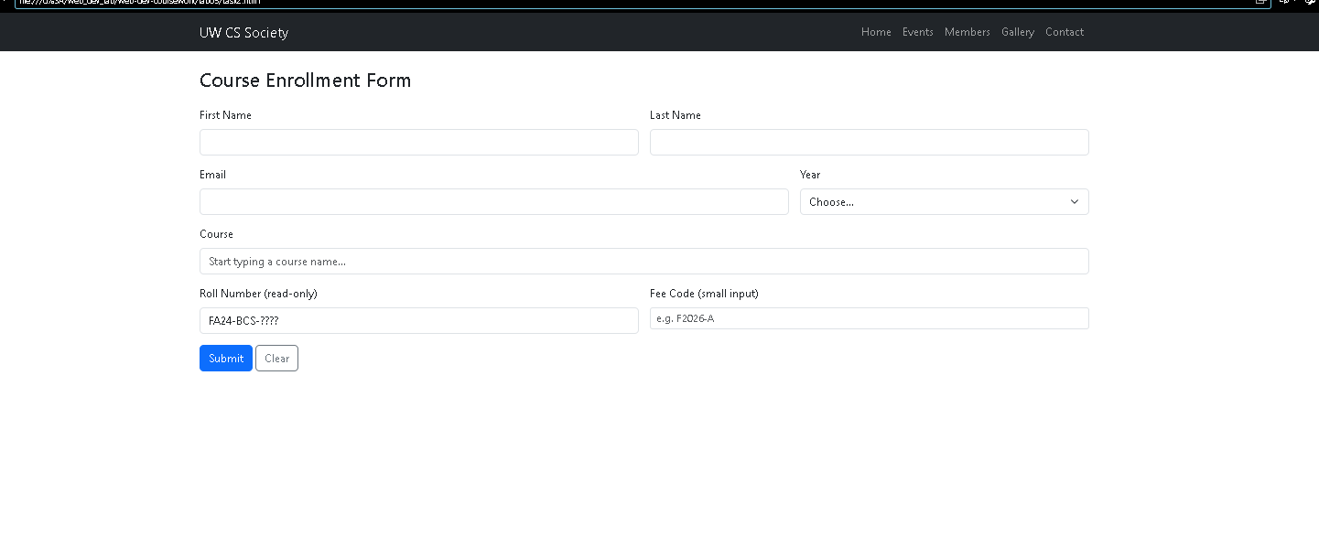

 | 3 | MEMBERSHIP REGISTRATION  checks, radios and a textarea
This registration form mixed several control types, and each had its own small rule. Checkboxes and radios never get form-control — instead each one is wrapped in a div.form-check, with form-check-input on the input and form-check-label on its label. The year radios share the name "yr" so only one can be chosen, and form-check-inline places them side by side, while the interest checkboxes stay stacked. I added a section select at the top and a textarea with rows for the message box. Following the manual, I kept the page honest: no modal, no input-group anywhere — just plain, well-labelled Bootstrap controls.
R E Q U I R E M E N T S C O V E R E D
✔ Wrapped every checkbox and radio in a div.form-check
✔ Put form-check-input on inputs and form-check-label on labels
✔ Made the year radios mutually exclusive with a shared name, placed inline
✔ Stacked the interest checkboxes one per line
✔ Added a section select and a textarea with rows for the message
✔ No modal and no input-group anywhere in the page

<!doctype html>
<html lang="en">
<head>
<meta charset="utf-8">
<meta name="viewport" content="width=device-width, initial-scale=1">
<title>Lab 05 - Task 3: Society Membership</title>
<link href="css/bootstrap.min.css" rel="stylesheet">
</head>
<body>
<nav class="navbar navbar-expand-lg bg-dark" data-bs-theme="dark">
<div class="container">
<a class="navbar-brand" href="task5.html">UW CS Society</a>
<button class="navbar-toggler" type="button" data-bs-toggle="collapse" data-bs-target="#mainNav"
aria-controls="mainNav" aria-expanded="false" aria-label="Toggle navigation">
<span class="navbar-toggler-icon"></span>
</button>
<div class="collapse navbar-collapse" id="mainNav">
<ul class="navbar-nav ms-auto">
<li class="nav-item"><a class="nav-link" href="task5.html">Home</a></li>
<li class="nav-item"><a class="nav-link" href="task5.html#events">Events</a></li>
<li class="nav-item"><a class="nav-link active" aria-current="page" href="task3_register.html">Members</a></li>
<li class="nav-item"><a class="nav-link" href="#">Gallery</a></li>
<li class="nav-item"><a class="nav-link" href="task5.html#contact">Contact</a></li>
</ul>
</div>
</div>
</nav>

<main class="container my-4">
<h1 class="h3 mb-4">Society Membership Form</h1>
<form class="row g-3">
<div class="col-md-6">
<label for="fullName" class="form-label">Full Name</label>
<input type="text" class="form-control" id="fullName" name="fullName" required>
</div>
<div class="col-md-6">
<label for="rollNumber" class="form-label">Roll Number</label>
<input type="text" class="form-control" id="rollNumber" name="rollNumber" required>
</div>
<div class="col-md-8">
<label for="email" class="form-label">Email</label>
<input type="email" class="form-control" id="email" name="email" required>
</div>
<div class="col-md-4">
<label for="section" class="form-label">Section</label>
<select class="form-select" id="section" name="section" required>
<option value="" selected disabled>Choose...</option>
<option value="A">Section A</option>
<option value="B">Section B</option>
<option value="C">Section C</option>
</select>
</div>
<fieldset class="col-12">
<legend class="form-label mb-1">Year of Study</legend>
<div class="form-check form-check-inline">
<input class="form-check-input" type="radio" name="year" id="year1" value="1" required>
<label class="form-check-label" for="year1">Year 1</label>
</div>
<div class="form-check form-check-inline">
<input class="form-check-input" type="radio" name="year" id="year2" value="2">
<label class="form-check-label" for="year2">Year 2</label>
</div>
<div class="form-check form-check-inline">
<input class="form-check-input" type="radio" name="year" id="year3" value="3">
<label class="form-check-label" for="year3">Year 3</label>
</div>
<div class="form-check form-check-inline">
<input class="form-check-input" type="radio" name="year" id="year4" value="4">
<label class="form-check-label" for="year4">Year 4</label>
</div>
</fieldset>
<fieldset class="col-12">
<legend class="form-label mb-1">Interests (choose any)</legend>
<div class="form-check">
<input class="form-check-input" type="checkbox" id="interestWeb" name="interests" value="web">
<label class="form-check-label" for="interestWeb">Web Development</label>
</div>
<div class="form-check">
<input class="form-check-input" type="checkbox" id="interestAI" name="interests" value="ai">
<label class="form-check-label" for="interestAI">Artificial Intelligence</label>
</div>
<div class="form-check">
<input class="form-check-input" type="checkbox" id="interestDatabases" name="interests" value="databases">
<label class="form-check-label" for="interestDatabases">Databases</label>
</div>
<div class="form-check">
<input class="form-check-input" type="checkbox" id="interestNetworking" name="interests" value="networking">
<label class="form-check-label" for="interestNetworking">Networking</label>
</div>
</fieldset>
<div class="col-12">
<label for="reason" class="form-label">Why do you want to join?</label>
<textarea class="form-control" id="reason" name="reason" rows="3"></textarea>
</div>
<div class="col-12">
<div class="form-check">
<input class="form-check-input" type="checkbox" id="rules" name="rules" value="yes" required>
<label class="form-check-label" for="rules">I have read and agree to the society rules.</label>
</div>
</div>
<div class="col-12">
<button type="submit" class="btn btn-success">Register</button>
<button type="reset" class="btn btn-outline-secondary">Clear</button>
</div>
</form>
</main>

<script src="js/bootstrap.bundle.min.js"></script>
</body>
</html>

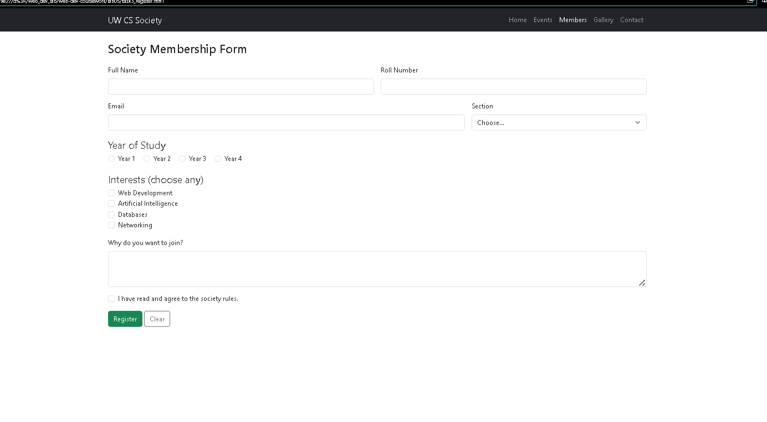

 | 4 | BOOTSTRAP FORM VALIDATION  green means go, red means fix me
The shortest task, but the one that made the forms feel finished. I added class="was-validated" together with novalidate directly on the form element — novalidate silences the browser's own error pop-up so Bootstrap's styling can take over. I pre-filled some required fields so they glow with a green border, and left others empty so they show red. Right after each input I placed a div.valid-feedback and a div.invalid-feedback as direct siblings; Bootstrap shows exactly the right one depending on whether the field passed. Watching 'Looks good!' appear on the filled fields while the empty ones demanded attention was oddly satisfying.
R E Q U I R E M E N T S C O V E R E D
✔ Added class="was-validated" and novalidate to the form element itself
✔ Pre-filled some required fields so they show green borders
✔ Left some required fields empty so they show red borders
✔ Placed valid-feedback and invalid-feedback directly after each input
✔ Confirmed the browser's own error bubble no longer appears

<!doctype html>
<html lang="en">
<head>
<meta charset="utf-8">
<meta name="viewport" content="width=device-width, initial-scale=1">
<title>Lab 05 - Task 4: Form Validation</title>
<link href="css/bootstrap.min.css" rel="stylesheet">
</head>
<body>
<nav class="navbar navbar-expand-lg bg-dark" data-bs-theme="dark">
<div class="container">
<a class="navbar-brand" href="task5.html">UW CS Society</a>
<button class="navbar-toggler" type="button" data-bs-toggle="collapse" data-bs-target="#mainNav"
aria-controls="mainNav" aria-expanded="false" aria-label="Toggle navigation">
<span class="navbar-toggler-icon"></span>
</button>
<div class="collapse navbar-collapse" id="mainNav">
<ul class="navbar-nav ms-auto">
<li class="nav-item"><a class="nav-link" href="task5.html">Home</a></li>
<li class="nav-item"><a class="nav-link" href="task5.html#events">Events</a></li>
<li class="nav-item"><a class="nav-link" href="task3_register.html">Members</a></li>
<li class="nav-item"><a class="nav-link" href="#">Gallery</a></li>
<li class="nav-item"><a class="nav-link" href="task5.html#contact">Contact</a></li>
</ul>
</div>
</div>
</nav>

<main class="container my-4">
<h1 class="h3 mb-3">Form Validation Demo</h1>
<p class="mb-4">The green fields are valid and the red fields need attention.</p>
<form class="row g-3 was-validated" novalidate>
<div class="col-12">
<label for="fullName" class="form-label">Full Name</label>
<input type="text" class="form-control" id="fullName" name="fullName" value="Ayesha Khan" required>
<div class="valid-feedback">Looks good!</div>
<div class="invalid-feedback">Please enter your name.</div>
</div>
<div class="col-12">
<label for="email" class="form-label">Email</label>
<input type="email" class="form-control" id="email" name="email" required>
<div class="valid-feedback">Email looks good!</div>
<div class="invalid-feedback">Enter a valid email address.</div>
</div>
<div class="col-12">
<label for="course" class="form-label">Course</label>
<select class="form-select" id="course" name="course" required>
<option value="web" selected>Web Application Development</option>
<option value="database">Database Systems</option>
<option value="ai">Artificial Intelligence</option>
</select>
<div class="valid-feedback">Great choice!</div>
<div class="invalid-feedback">Please choose a course.</div>
</div>
<div class="col-12">
<label for="rollNumber" class="form-label">Roll Number</label>
<input type="text" class="form-control" id="rollNumber" name="rollNumber" required>
<div class="valid-feedback">Looks good!</div>
<div class="invalid-feedback">Required.</div>
</div>
<div class="col-12">
<div class="form-check">
<input class="form-check-input" type="checkbox" id="terms" name="terms" value="yes" checked required>
<label class="form-check-label" for="terms">I agree to the terms.</label>
<div class="valid-feedback">Thank you!</div>
<div class="invalid-feedback">Please agree before submitting.</div>
</div>
</div>
<div class="col-12">
<button type="submit" class="btn btn-primary">Submit</button>
</div>
</form>
</main>

<script src="js/bootstrap.bundle.min.js"></script>
</body>
</html>

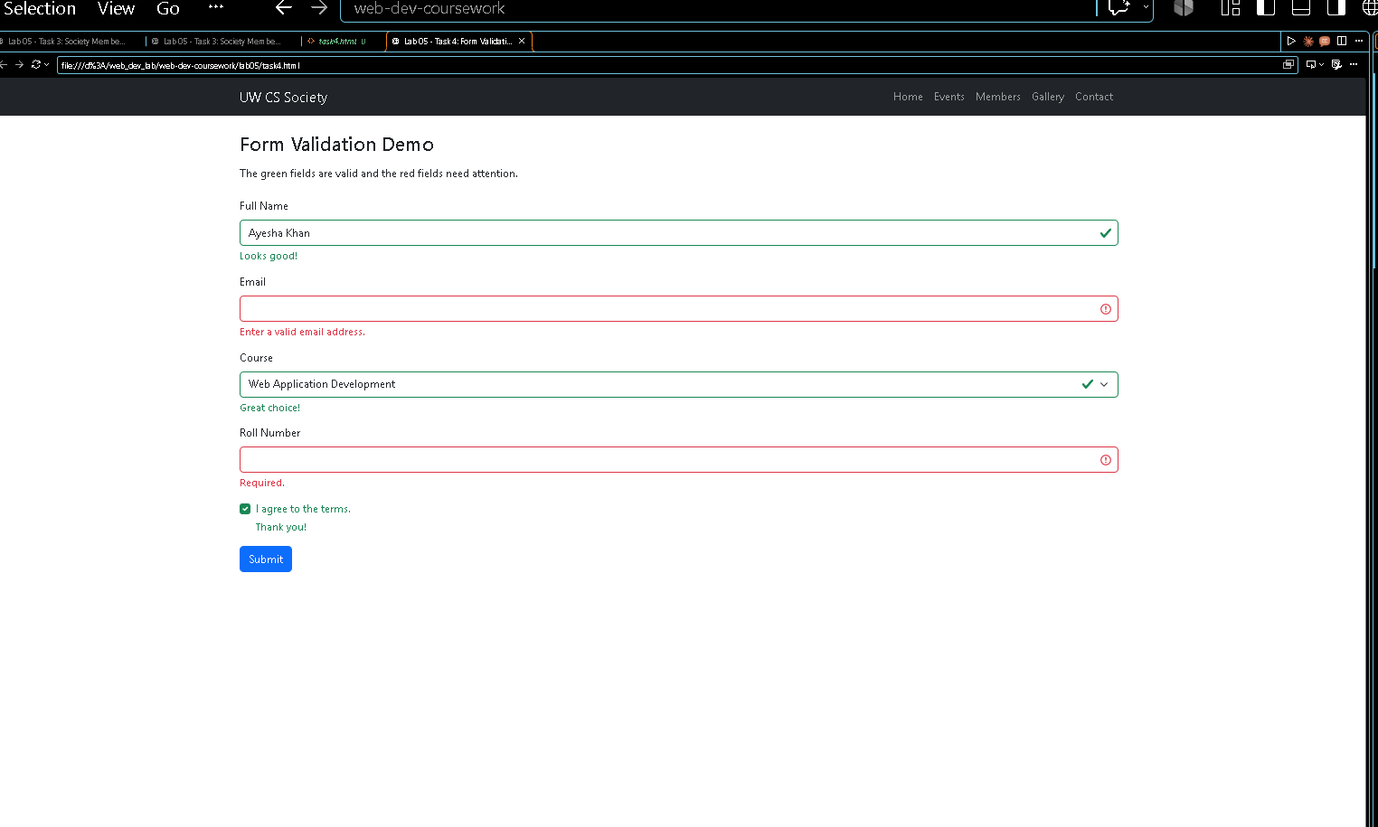

 | 5 | THE SOCIETY HOME PAGE  everything, assembled
The final task was assembly day. I copied the navbar from Task 1 to the top, then built the hero with p-5 bg-body-tertiary rounded-3, a display heading, a lead paragraph and a "Join the Society" button that links to task3_register.html. Under it I added an events table and a quick contact form, and closed the page with the dark footer: bg-dark text-white text-center py-3 mt-5. I kept exactly one h1 on the page, living in the hero, and resized the window from wide to narrow one last time to make sure the grid, navbar and table all behaved. Five tasks in, and the little society site finally felt like a real thing I had built.
R E Q U I R E M E N T S C O V E R E D
✔ Copied the same navbar from Task 1 to the top of the page
✔ Built the hero with p-5 bg-body-tertiary rounded-3 and a single h1
✔ Added an events table and a quick contact form
✔ Finished with the dark footer (bg-dark text-white text-center py-3 mt-5)
✔ Linked "Join the Society" to task3_register.html
✔ Tested the assembled page at wide and narrow window sizes

<!doctype html>
<html lang="en">
<head>
<meta charset="utf-8">
<meta name="viewport" content="width=device-width, initial-scale=1">
<title>Lab 05 - Task 5: UW CS Society</title>
<link href="css/bootstrap.min.css" rel="stylesheet">
</head>
<body>
<nav class="navbar navbar-expand-lg bg-dark" data-bs-theme="dark">
<div class="container">
<a class="navbar-brand" href="task5.html">UW CS Society</a>
<button class="navbar-toggler" type="button" data-bs-toggle="collapse" data-bs-target="#mainNav"
aria-controls="mainNav" aria-expanded="false" aria-label="Toggle navigation">
<span class="navbar-toggler-icon"></span>
</button>
<div class="collapse navbar-collapse" id="mainNav">
<ul class="navbar-nav ms-auto">
<li class="nav-item"><a class="nav-link active" aria-current="page" href="task5.html">Home</a></li>
<li class="nav-item"><a class="nav-link" href="#events">Events</a></li>
<li class="nav-item"><a class="nav-link" href="task3_register.html">Members</a></li>
<li class="nav-item"><a class="nav-link" href="#">Gallery</a></li>
<li class="nav-item"><a class="nav-link" href="#contact">Contact</a></li>
</ul>
</div>
</div>
</nav>

<main class="container my-4">
<section class="p-5 mb-4 bg-body-tertiary rounded-3">
<h1 class="display-5 fw-bold">Learn. Build. Share.</h1>
<p class="lead col-md-8">The Computer Science Society runs hands-on workshops, coding contests and mentoring circles for every student of the department.</p>
<a class="btn btn-primary" href="task3_register.html">Join the Society</a>
</section>

<section id="events" class="mb-4">
<h2 class="h4 mb-3">Upcoming Events</h2>
<div class="table-responsive">
<table class="table table-striped table-bordered table-hover align-middle">
<thead class="table-dark">
<tr>
<th scope="col">Date</th>
<th scope="col">Event</th>
<th scope="col">Venue</th>
</tr>
</thead>
<tbody>
<tr><td>22 Oct 2026</td><td>Git and GitHub Workshop</td><td>Lab 3</td></tr>
<tr class="table-warning"><td>5 Nov 2026</td><td>Web Design Contest</td><td>Seminar Hall</td></tr>
<tr><td>19 Nov 2026</td><td>Alumni Talk: Life as a Developer</td><td>Auditorium</td></tr>
<tr><td>3 Dec 2026</td><td>24-hour Hackathon</td><td>CS Block</td></tr>
</tbody>
</table>
</div>
</section>

<section id="contact" class="mb-4">
<h2 class="h4 mb-3">Quick Contact</h2>
<form class="row g-3">
<div class="col-md-6">
<label for="name" class="form-label">Name</label>
<input type="text" class="form-control" id="name" name="name" required>
</div>
<div class="col-md-6">
<label for="email" class="form-label">Email</label>
<input type="email" class="form-control" id="email" name="email" required>
</div>
<div class="col-12">
<label for="message" class="form-label">Message</label>
<textarea class="form-control" id="message" name="message" rows="3"></textarea>
</div>
<div class="col-12">
<button type="submit" class="btn btn-primary">Send</button>
</div>
</form>
</section>
</main>

<footer class="bg-dark text-white text-center py-3 mt-5">
&copy; 2026 UW CS Society
</footer>
<script src="js/bootstrap.bundle.min.js"></script>
</body>
</html>



