Git Workflow for Shopping Project (Multiple Developers)

Team Member 1: Faiza Aiman(23B81A05T2)
Team Member 2:Akkala Rithika Reddy(23B81A0V8)
Part A: Initial Setup:
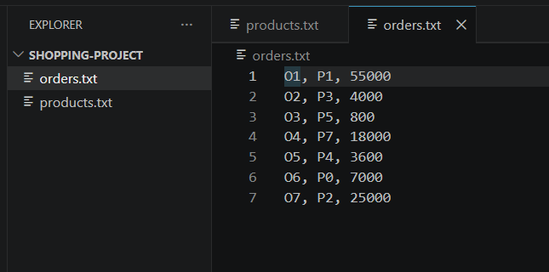
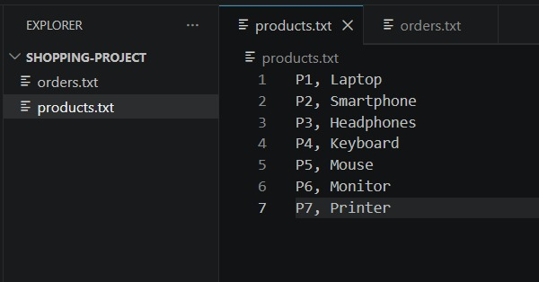
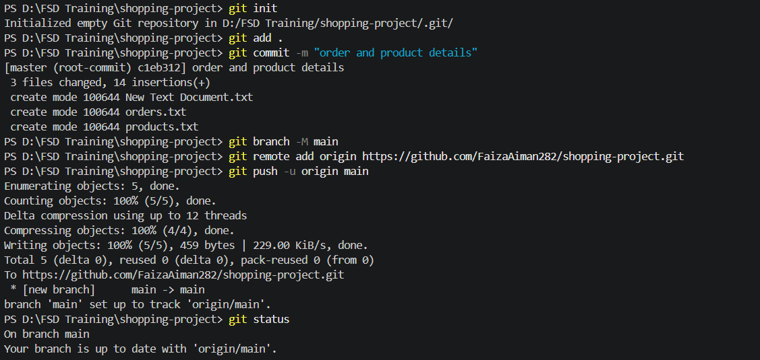
Part B: Feature Development (Parallel Work)
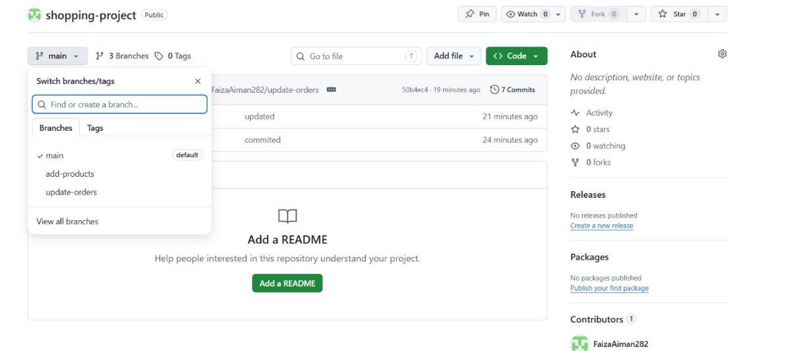
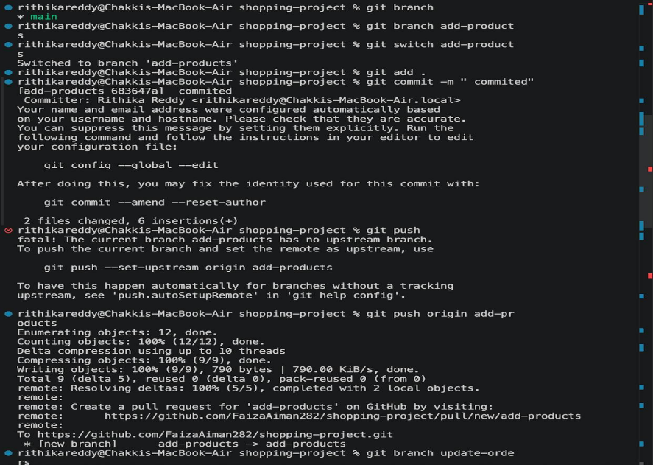

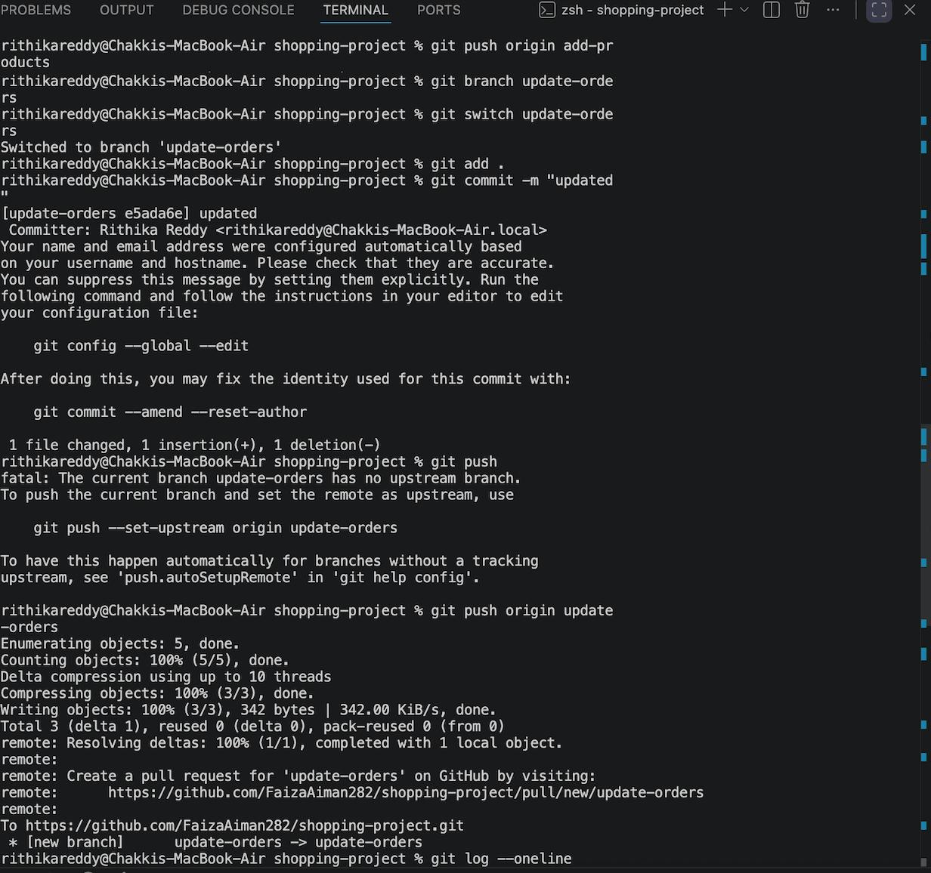
Part C: Merge & Conflict Handling
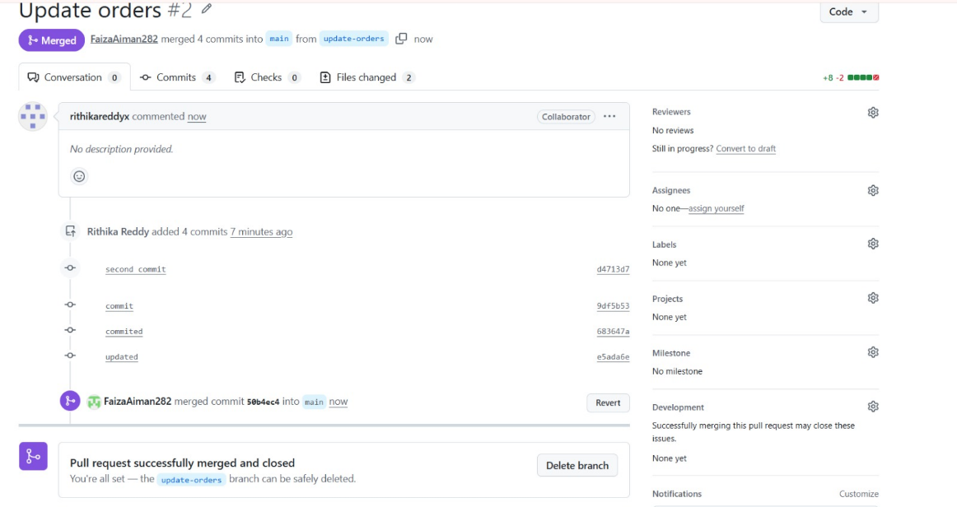
Part D: Reset & Revert
