

|  |
| --- |
| **Title: DATA STRUCTURE AND ALGORITHM** |

**Name:** Faiza Iftikhar

**Roll no:** 200901043

**Section**: A

**Date of Experiment:** 25 October, 2021

**Lab Performance**

**Task Code:**

import numpy as np

class queue:

  def __init__ (self):

    self.element = np.array([11, 19, 13, 14, 15, 11, 19, 21, 19, 20, 21]) #Making the array using the numpy

  def display(self):

    return self.element #Displaying all the elements of the array

  def enqueue(self,data):

    a=np.append(self.element,data) #adding the element

    return a

  def dequeue(self):

    index=[0]

    a=np.delete(self.element,index) #deleting element from the first index i-e the one which stored first in queue will be deleted first

    return a

  def front(self):

   return self.element[0] #Front is the 1st element

  def rear(self):

    return self.element[-1] #Rear is the last element

  def length(self):

    return len(self.element) #Checking the length

  def isempty(self):

    return (len(self.element)==0) #Checking the array is empty or not

**Task Output:**

**Created the object queue and displaying all the elements of the array**

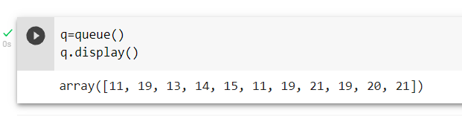

**Adding element in the array**

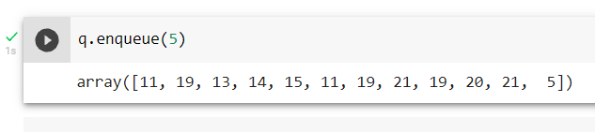

**Deleting 1st element from the array**

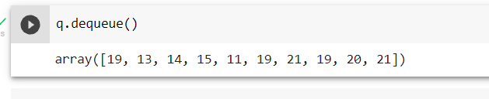

**Front from the array**

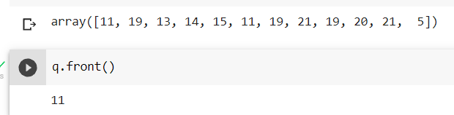

**Rear from the array**

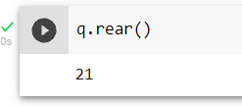

**Checking the length of the array**

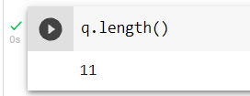

**Checking array is empty or not**

