

**Globsyn Skills**, Globsyn Crystals, 1st Floor, XI – 11 and 12, Block EP, Sector V, Salt Lake, Kolkata – 700091

**BUS TICKET RESERVATION SYSTEM**

**GROUP MEMBERS**

Ranjan Kumar,RCCIIT Kolkata,131170110057

Rudra Dev Pal , CEMK Kolaghat, 121070110041

Faizaan Ahmed Khan, RCCIIT Kolkata,131170110031

Subhashree Karmakar, CEMK Kolaghat, 121070110057

Shubham Kumar Karna, RCCIIT Kolkata,131170110072

**Table of Contents**

Acknowledgement...................................................................................................... 4

Project Objective ........................................................................................................ 5

Project Scope............................................................................................................... 6

Requirement Specification .......................................................................................... 7

Database Design .......................................................................................................... 8

Application Work Flow ................................................................................................ 9

Screenshots ................................................................................................................ 10

Future Scope of Improvements................................................................................... 11

Code............................................................................................................................ 12

Certificate ................................................................................................................... 13

**Acknowledgement**

I take this opportunity to express my profound gratitude and deep regards to my faculty (MR. ARNAB CHAKRABORTY) for his exemplary guidance, monitoring and constant encouragement throughout the course of this project. The blessing, help and guidance given by him time to time shall carry me a long way in the journey of life on which I am about to embark.

I am obliged to my project team members for the valuable information provided by them in their respective fields. I am grateful for their cooperation during the period of my assignment.

*Subhashree Karmakar*

*Faizaan Ahmed Khan*

*Rudra Dev Pal*

*Ranjan Kumar*

*Shubham Kumar Karna*

**Project Objective**

The main objective of this project is to cater the needs of the passenger who are traveling from one point to another. This project have contains essential modules like Customer and Administrator. User can book / reserved his ticket.

**Users of this application:**

• Customer

• Administrator

**Roles of Customer are:**

• Login his username and password

• Customer can book ticket by selecting Source and destination

• Customer can cancel ticket

**Role of Administrator are:**

• Login his username and password

• Provide details like Bus Name, Bus Route, Bus Type – AC/non-AC, seats,

departure time and arrival time

• Admin can view all transactions .

• Admin can perform operations on customer details except their password.

**Note:** Once the seat is booked, automatically the seat would be deducted.

**Project Scope**

*[The broad scope of the Bus Ticket Reservation System (BTRS) project includes:*

• *The system will be available on an online platform for 24x7 access to the students, the faculty and the administration*

• *The system will support online reservation for registered users and also provide*

*option for a quick registration.*

• *The system will support Administrator and User separately with different defined aspects of data manipulation .*

• *The system will support data manipulation of all types except customers personal details for the Administrator.*

• *The system will support new registrations , bus ticket booking , cancellation, editing profile, viewing transaction history for the customers*

**Requirement Specification**

• Problem Definition

Bus Ticket Reservation System

• Functional Requirements

Bus ticket reservation , cancellation, viewing history , editing profile , sign-up, sign-in ,

enquiry .

• Hardware /Software Requirements

o Hardware requirement

➢ Client side

Laptop , Desktop

➢ Server side

Laptop , Desktop

o Software Requirement

➢ Client side

Any updated Web Browser ( EX: Mozilla Firefox 3.0 +)

➢ Server side

Eclipse MARS , MySQL , Wildfly 8.2.0 , My Sql JDBC connector

**Database Design**

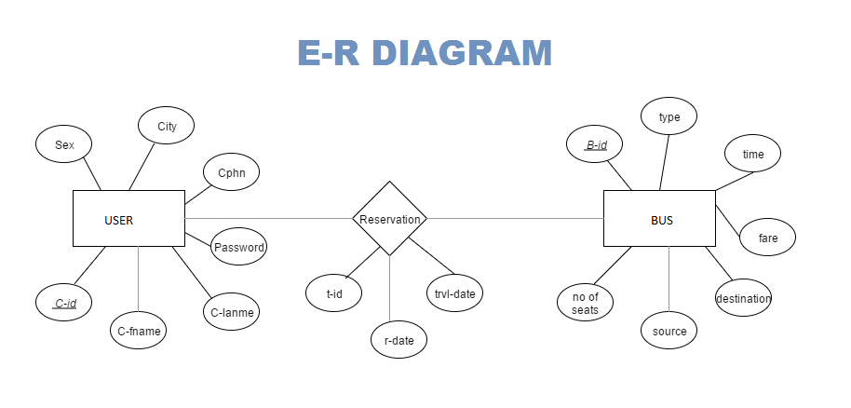

**Application Work Flow**

**Open the webpage**

Home page will be loaded

Click on enquiry to get the bus details for a particular route and date

Click on Check to get the bus details available for the above route and date

Select Bus Id radio button

Click on Book to book your ticket (Customer Should Login or can signup to Continue)

Click on Sign Up to create new account and enter your details

Click on “Submit “ to confirm your account details

Click on “Login” and enter your email and password and click on “Login” to access your account

(N.B. : To access admin account the user name should be “admin@firstbus.com” )

Logged In As Customer

Click on “Home” to go to the home page

Click on “profile” to see your registered details

Click on “Edit Details” to edit your profile details and click on update to confirm.

Click on “Enquiry/Book” to check for the details of buses available from source to destination on a particular date.

Select “Source” and “Destination” and “Date of journey “ from drop down menus and click on “Check” .

Select “Bus ID” radio button of your requirement and click on “Book” to book your ticket.

As confirmation it will show you a successful message.

Click on “History” to view your booking details of all time.

Select “Reservation ID” radio button and click on “Cancel Ticket” to cancel your ticket.

Click on “Logout” to sign out from your account.

Logged In As Admin

Click on “Home” to go to the home page

Click on “Profile” and then “Edit Details” to edit your profile details and click on update to confirm.

(N.B. : Username can’t be updated )

Click on “Bus”

Click on “Add Bus” to add a new bus details .

Enter the bus details and click on “Submit” to confirm and save bus details

Click on “Bus” then click on “Delete Bus” to delete any bus details

Enter the “BUS ID” and click on “Next” to check the details and click on “Delete” to confirm deletion

Click on “Bus” then click on “Edit Bus” to edit any bus details

Enter the “BUS ID” and click on “Next” to check the details and click on “Delete” to confirm deletion

Click on “Bus”

Click on “Add Bus” to add a new bus details .

Enter the bus details and click on “Submit” to confirm and save bus details

Click on “Bus” then click on “Delete Bus” to delete any bus details

Enter the “BUS ID” and click on “Next” to check the details and click on “Delete” to confirm deletion

**Screenshots**

*(This section contains the important screenshots of the application)*

**Future Scope of Improvements**

*(This section will list the future aspects of the application which can be incorporated to improve the functionality and user experience)*

**Code**

*(This section contains the source code of the application)*

**Certificate**

This is to certify that Mr/Ms [*fill in your name*] of [*fill in the name of the institution where you are studying*], registration number: [*fill in your university registration number*], has successfully completed a project on [*fill your project title*] using [*mention the technology on which your project was developed i.e., JEE/.Net/Java/Oracle Forms/ PHP/ Android/*

*Networking*] under the guidance of Mr/Ms/Mrs [*mention your faculty’s name*].

--- ---------------------------------------------------

-

[*Name of your faculty*]

**Globsyn Finishing School**

(*a division of Globsyn Skills*)