E-Commerce Profitability Analysis
What really drives margin, and why the reported numbers were misleading
Author: Faizah Azam Raisa Tools: MySQL 8.0, Tableau Public Date: October 2026
Dashboard: View on Tableau Public Code: [GitHub repository link]

1. Executive Summary
This project analyzes 138,116 orders from 24,911 customers to answer one question: which parts of the business generate strong revenue but weak profit, and what should management do about it? The analysis was done in MySQL and presented in a Tableau dashboard.
Key findings
- The reported regional profit gap is not real. The reported data shows North (46.1%) and West (45.0%) earning far higher margins than East (41.3%). After testing six explanations, the cause turned out to be a metric definition issue: the dataset counts sales tax as revenue and profit. North and West simply have higher tax rates. With tax removed, every region earns between 36.8% and 37.2%.
- Reported revenue and profit are overstated by $16.9M. Excluding sales tax, revenue is $160.2M (not $177.1M) and profit is $59.2M (not $76.2M). The true profit margin is 37.0%, not 43.0%.
- Product category is the real margin driver. Excluding tax, margins range from 27.3% (Electronics, the largest category) to 50.7% (Grocery). Discounts are identical across categories (~17%); the difference comes from product cost, which takes 72 cents of every Electronics sales dollar.
- Repeat customers are worth ~6x more, purely through frequency. 98.7% of customers buy more than once. They average 6.1 orders and $7,809 in lifetime value, versus $1,304 for one-time buyers, but they spend the same per order (~$1,280). The growth lever is order frequency, not basket size.
- Channel, segment, discounts, shipping, ratings and returns do not explain profit differences. All ten marketing channels earn 36.7% to 37.2% excluding tax, and every customer segment’s share of revenue matches its share of customers.
Recommendations: (1) correct the profit metric before making regional decisions; (2) improve Electronics margin through supplier and pricing review, and grow high-margin categories; (3) focus marketing on increasing order frequency among existing repeat customers. Details are in Section 9.

2. Business Problem and Questions
Revenue alone does not show how healthy a business is. A region, product or channel can sell a lot while keeping very little of each dollar as profit. Management needs to know where profit actually comes from before deciding where to invest.
Questions investigated
- Regions: Does the highest-revenue region also earn the highest margin? If not, why?
- Products: Which categories and brands drive profit, and is that driven by volume or by margin?
- Customers: Which segments are most valuable, and how much more are repeat customers worth?
- Marketing: Which channels deserve more budget?
- Returns: Are returns hurting profitability?

3. Data and Methodology

3.1 Dataset
E-Commerce Sales Dataset (Kaggle), loaded into MySQL as three related tables:
Table | Grain | Used for
ecommerce_sales_clean | One row per order (138,116 rows) | Regions, customers, channels, returns, KPIs
order_items | One row per product within an order | Product and category analysis
product_catalog | One row per product | Category, brand and supplier attributes
Table 1. Tables used in the analysis. All order items matched a product in the catalog.
The data covers 5 regions, 4 customer segments, 10 marketing channels and 15 product categories. It does not include an order date, so trends over time could not be analyzed.

3.2 Data quality
Check | Result
Total records | 138,116
Missing sales, profit, region or marketing channel | 0
Missing delivery days | 24,557 (17.8%)
Missing customer rating | 24,557 (17.8%)
Table 2. Missing values in key columns.
Every record missing delivery days was also missing a customer rating. This is consistent with orders that were never delivered (for example, cancelled or not yet shipped) and therefore could not be rated. These rows were kept for financial analysis and excluded only from rating analysis.

3.3 Cleaning steps
- Converted blank strings to NULL and cast text columns to proper numeric types (DECIMAL, UNSIGNED).
- Standardized return status: blank values were set to “Not Returned”.
- Verified the clean table has the same row count as the raw table, and that every order item matches a product.
- Checked that customer attributes (segment, repeat status, lifetime value) are constant across each customer’s orders: 0 conflicts found.

3.4 Metric definitions
Metric | Definition
Net sales (reported revenue) | List price − discount + sales tax + shipping charged. Verified on all 138,116 rows (0 mismatches).
Product cost | What the company paid for the goods sold (cost of goods sold). Excludes shipping and overheads.
Reported profit | Net sales − product cost − shipping cost. Because net sales includes tax, reported profit does too.
Revenue / profit (excl. tax) | Reported revenue or profit minus sales tax. Used as the corrected measure in this report.
Profit margin | Profit ÷ revenue, calculated from totals (revenue-weighted), not as an average of row-level margins.
Customer lifetime value (CLV) | Dataset column, repeated on every order. Averaged at customer level (one row per customer) to avoid over-weighting frequent buyers.
Table 3. Metric definitions.
Note: Profit in this dataset excludes marketing, salaries, rent and other overheads, so it is closer to gross profit than to net profit. Real e-commerce net margins are usually much lower.

4. Headline KPIs
KPI | As reported | Excluding sales tax
Revenue | $177.13M | $160.22M
Profit | $76.15M | $59.23M
Profit margin | 42.99% | 36.97%
Average order value | $1,283 | $1,160
Orders | 138,116 | 138,116
Customers | 24,911 | 24,911
Repeat customer rate | 98.7% | 98.7%
Return rate | 6.9% | 6.9%
Table 4. Company KPIs. Sales tax collected totals $16.91M, which overstates reported revenue by 10.6% and reported profit by 28.6%.
Figure 1. KPI row from the Tableau dashboard.

5. Regional Analysis: Investigating the Margin Gap

5.1 What the reported numbers show
Region | Revenue | Profit | Reported margin
North | $22.57M | $10.41M | 46.10%
West | $34.76M | $15.65M | 45.02%
South | $55.59M | $23.34M | 41.99%
Central | $37.17M | $15.57M | 41.90%
East | $27.05M | $11.18M | 41.32%
Table 5. Regional performance as reported.
South generates the most revenue and profit but keeps less of each dollar than North and West. On the reported numbers, the 4.8-point gap between North and East looks like a major efficiency difference worth replicating across regions. Before recommending that, the gap needed an explanation.

5.2 Testing possible explanations
Hypothesis | Evidence | Verdict
Higher shipping costs in low-margin regions | Shipping is 1.5–1.9% of sales everywhere; explains < 0.4 of the 4.8-point gap | Ruled out
Heavier discounting | Discount is ~17% of list price in every region ($235–$240 per order) | Ruled out
Product mix (more low-margin Electronics) | Electronics is 21.3–21.5% of sales in every region | Ruled out
Lower customer satisfaction | Average rating 3.67–3.68 in every region | Ruled out
More returns | Return rate 6.4–7.1%; North, with the highest reported margin, ties for the highest return rate | Ruled out
Paying more for products (sourcing) | Cost per unit is ~$126 in every region | Ruled out
Table 6. Six explanations were tested and ruled out.
On the reported basis, product cost takes a larger share of each sales dollar in South, Central and East (56–57%) than in North and West (52–53%). It first looked like a sourcing problem. But since unit costs are identical, the difference had to come from the other side of the ratio: revenue per unit.

5.3 Following the money: list price vs. net price
Region | Cost / unit | List price | Discount | Tax | Shipping | Net price
North | $126.63 | $245.31 | $42.34 | $34.05 | $3.69 | $240.70
West | $126.20 | $245.30 | $42.19 | $28.89 | $3.75 | $235.75
South | $126.33 | $245.08 | $42.51 | $18.36 | $4.05 | $224.98
Central | $125.73 | $243.93 | $41.81 | $17.61 | $4.03 | $223.75
East | $126.64 | $245.44 | $42.78 | $16.51 | $4.21 | $223.38
Table 7. Per-unit price bridge by region (net price = list price − discount + tax + shipping).
Cost, list price, discount and shipping are virtually the same in every region. The only component that differs is sales tax: North collects $34.05 per unit versus $16.51 in East. That $17.54 difference almost exactly matches North’s profit advantage per unit.
Root cause: Net sales, and therefore profit, include sales tax. Tax is collected on behalf of the government and is not revenue the business keeps. Regions with higher tax rates appear more profitable without being more efficient.

5.4 Regional margins with sales tax removed
Region | Tax rate | Reported margin | Margin excl. tax | Revenue excl. tax | Profit excl. tax
West | 14.5% | 45.02% | 37.17% | $30.41M | $11.30M
Central | 8.5% | 41.90% | 37.03% | $34.30M | $12.70M
North | 17.3% | 46.10% | 36.95% | $19.29M | $7.13M
South | 8.9% | 41.99% | 36.91% | $51.11M | $18.87M
East | 7.9% | 41.32% | 36.77% | $25.11M | $9.23M
Table 8. With tax removed, the 4.8-point gap shrinks to 0.4 points, and North falls from first to third.
Once tax is excluded, all five regions convert sales into profit at almost the same rate. South is the largest profit contributor ($18.9M) because it is the largest market, not because it is less efficient. Any plan to “replicate North’s strategy” would have been based on a tax artifact.
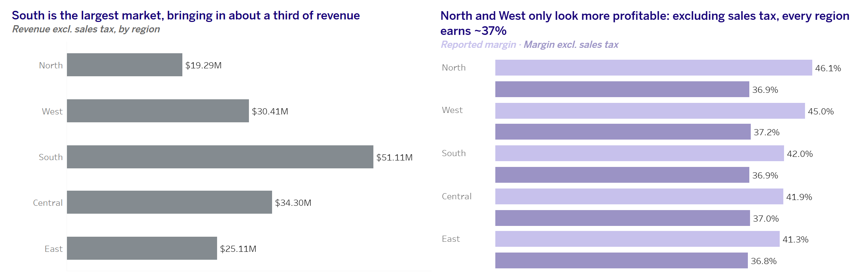
Figure 2. Revenue and margin by region.

6. Product Category Analysis
Unlike the regional gap, the category gap is real, and it widens once tax is removed.
Category | Revenue (reported) | Margin (reported) | Margin excl. tax | Product cost % excl. tax
Grocery | $2.99M | 55.14% | 50.70% | 41.11%
Beauty & Personal Care | $4.74M | 52.32% | 47.45% | 47.10%
Books & Media | $2.84M | 51.94% | 47.26% | 43.18%
Office Supplies | $8.88M | 51.61% | 46.56% | 50.60%
Toys & Games | $5.47M | 51.17% | 46.17% | 49.41%
Pet Supplies | $6.42M | 50.83% | 45.73% | 50.65%
Baby & Kids | $9.69M | 49.72% | 44.44% | 53.15%
Fashion | $7.43M | 49.36% | 44.07% | 53.03%
Home & Kitchen | $10.97M | 47.43% | 41.88% | 56.12%
Health & Wellness | $9.23M | 46.20% | 40.59% | 56.47%
Sports & Outdoors | $15.73M | 45.97% | 40.25% | 57.94%
Home Appliances | $24.84M | 41.42% | 35.18% | 63.83%
Jewelry | $25.56M | 40.65% | 34.33% | 64.82%
Automotive | $16.45M | 39.38% | 32.96% | 65.49%
Electronics | $41.15M | 34.28% | 27.25% | 72.16%
Table 9. Category performance, sorted by margin.
Scale vs. efficiency. The four largest categories (Electronics, Jewelry, Home Appliances, Automotive) all have the lowest margins. Electronics generates the most revenue ($41.2M) and the most reported profit ($14.1M) but keeps only 27 cents of each ex-tax dollar. Grocery keeps 51 cents but is one of the smallest categories.
What drives the difference? Discounts are flat at about 17% of list price in every category, so discounting does not explain the gap. Product cost does: Electronics pays 72 cents of every ex-tax sales dollar for the product, compared with 41–53 cents in the highest-margin categories.
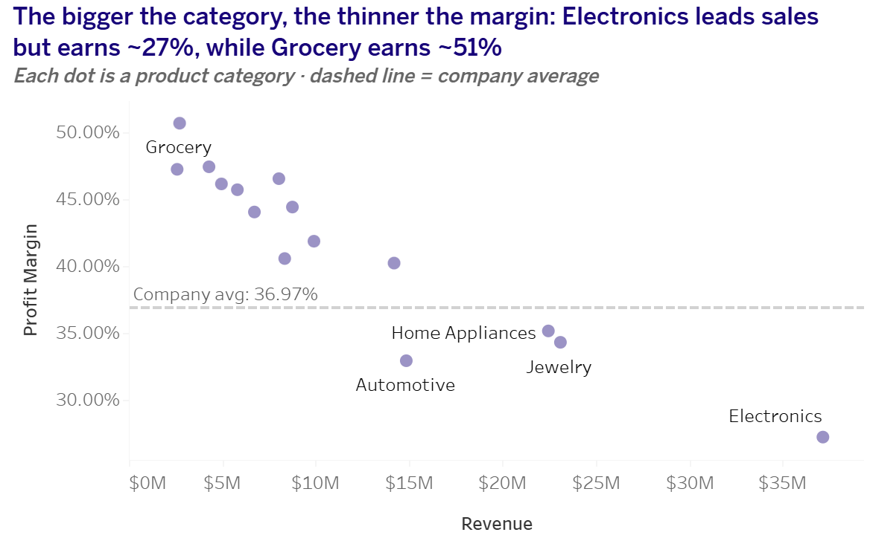
Figure 3. Category margin vs. revenue.

6.1 Brands
Brand | Category | Revenue | Profit | Margin (reported)
OnePlus | Electronics | $5.08M | $1.84M | 36.16%
David Yurman | Jewelry | $4.47M | $1.84M | 41.12%
Whirlpool | Home Appliances | $4.07M | $1.70M | 41.68%
HP | Electronics | $4.55M | $1.67M | 36.78%
Asus | Electronics | $4.83M | $1.62M | 33.43%
Pandora | Jewelry | $3.80M | $1.57M | 41.22%
Dyson | Home Appliances | $3.57M | $1.46M | 40.79%
Williams-Sonoma | Home & Kitchen | $2.71M | $1.35M | 49.97%
Table 10. Top brand-category combinations by profit. Brand margins are shown on the reported basis; tax is spread evenly across products, so rankings are unaffected.
Electronics brands dominate total profit through volume, but several of them (Samsung, LG, Sony, Xiaomi) have the lowest margins of any large brand, at 31.7–32.9% reported. Jewelry brands such as David Yurman and Pandora achieve similar profit with less revenue, showing stronger pricing power.

7. Customer Analysis

7.1 Customer segments
Segment | Customers | Share of customers | Revenue (reported) | Share of revenue
Consumer | 13,585 | 54.5% | $97.20M | 54.9%
Premium | 6,275 | 25.2% | $44.27M | 25.0%
VIP | 2,536 | 10.2% | $17.90M | 10.1%
Business | 2,515 | 10.1% | $17.76M | 10.0%
Table 11. Customer share vs. revenue share by segment.
Consumer is the largest segment by revenue and profit, but only because it has the most customers. Each segment’s share of revenue almost exactly matches its share of customers, and order frequency (6.9–7.0 orders) and order value (~$1,275–$1,290) are nearly identical across segments. Contrary to what the names suggest, Premium and VIP customers do not spend more.
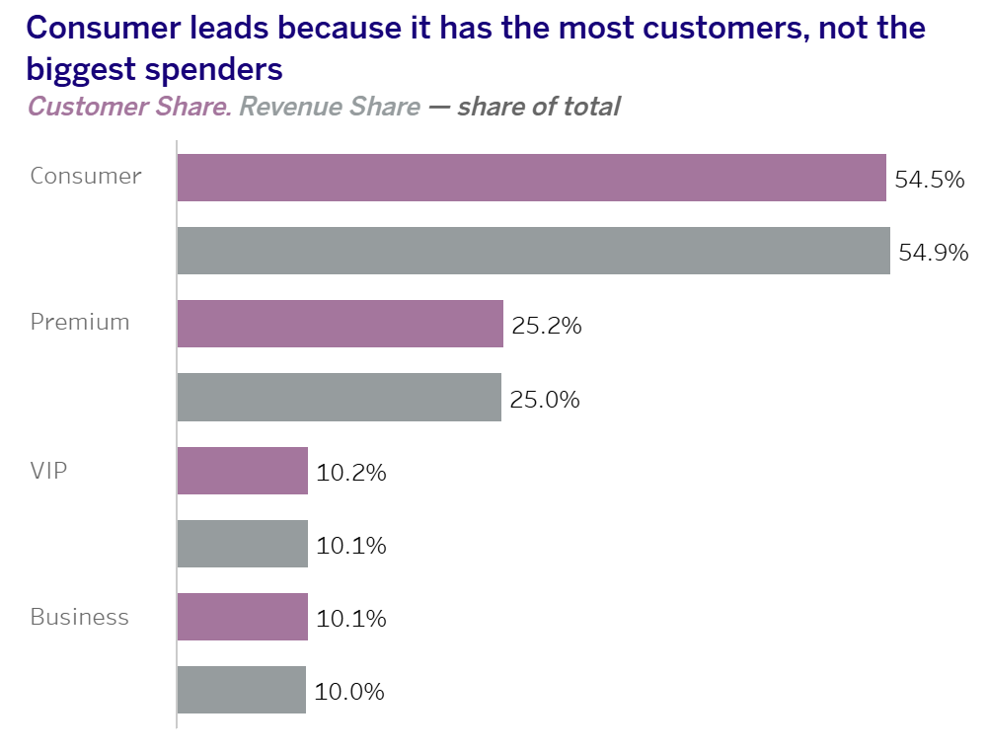
Figure 4. Customer share vs. revenue share by segment.

7.2 Repeat vs. one-time customers
Customer type | Customers | Share | Avg lifetime value | Avg orders | Value per order
Repeat | 24,577 | 98.7% | $7,809 | 6.09 | ~$1,282
One-time | 334 | 1.3% | $1,304 | 1.00 | $1,304
Table 12. Calculated at customer level (one row per customer).
Repeat customers are worth about six times more than one-time customers, but not because they spend more per order: value per order is almost identical. The entire gap comes from order frequency. With 98.7% of customers already returning, there is little room to improve retention itself; the opportunity is getting existing customers to order more often.
Methodology note: An earlier version of this analysis averaged lifetime value across orders, which counted frequent buyers several times and overstated repeat-customer value ($8,990). Averaging at customer level gives the correct figure of $7,809.
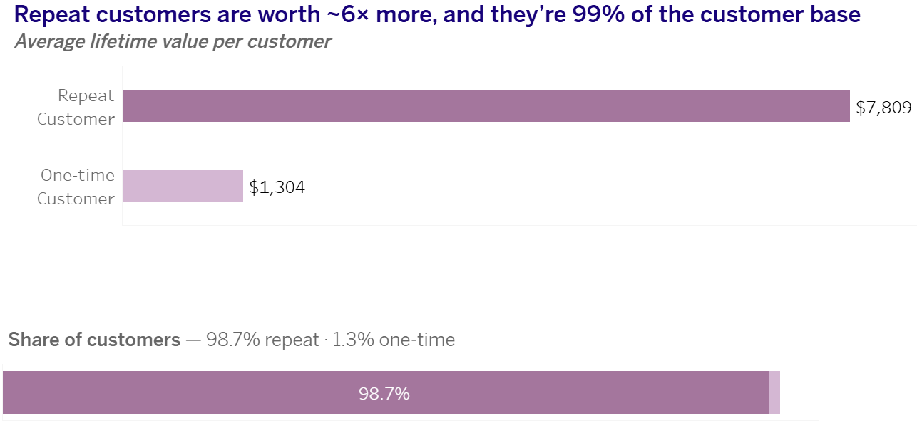

Figure 5. Repeat vs. one-time customers.

8. Marketing Channels and Returns

8.1 Marketing channels
Channel | Orders | Revenue (reported) | Reported margin | Margin excl. tax
Organic Search | 27,742 | $35.66M | 42.94% | 36.92%
Google Ads | 20,633 | $26.54M | 42.79% | 36.74%
Direct | 20,515 | $26.12M | 43.19% | 37.19%
Facebook Ads | 16,651 | $21.37M | 43.00% | 37.03%
Instagram | 13,801 | $17.68M | 42.91% | 36.88%
Email Marketing | 11,218 | $14.42M | 42.84% | 36.84%
Referral | 11,191 | $14.34M | 43.14% | 37.11%
Affiliate | 6,848 | $8.83M | 43.11% | 37.16%
TikTok | 5,437 | $6.98M | 43.15% | 36.99%
YouTube | 4,080 | $5.20M | 43.10% | 37.08%
Table 13. Channel performance, sorted by orders.
Every channel earns between 36.7% and 37.2% excluding tax, a spread of less than half a point. Channel choice does not drive profitability. Budget decisions should therefore be based on customer acquisition costs and volume, which this dataset does not include, rather than on margin.

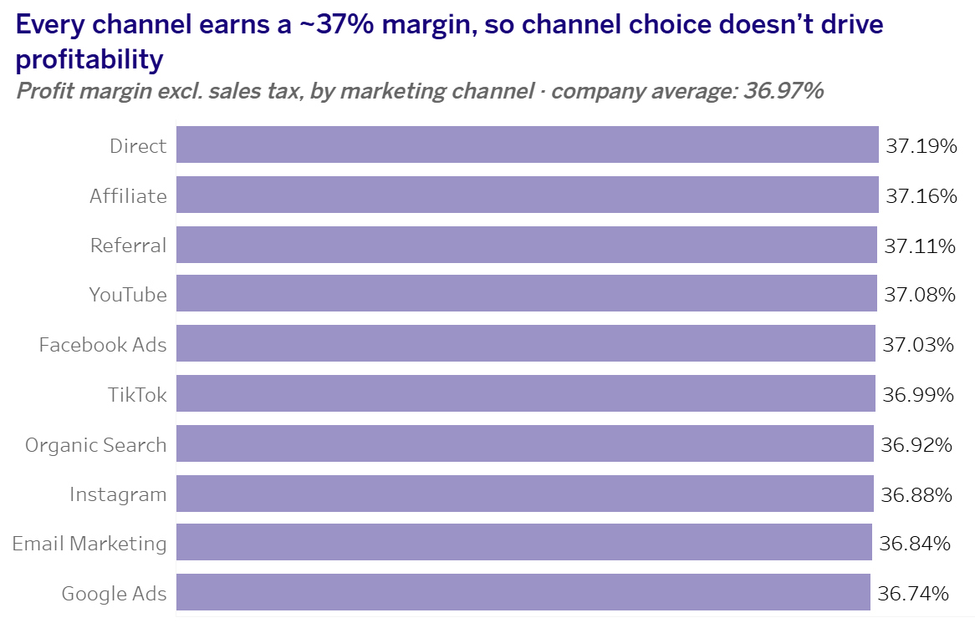
Figure 6. Profit margin excl. sales tax by marketing channel.

8.2 Returns
9,462 orders (6.9%) were returned. Return rates are consistent across regions (6.4–7.1%) and segments (6.7–7.1%), and return reasons are spread evenly, from Wrong Product (1,237) to Damaged Product (1,138). No single reason stands out as a fixable problem.
Returned orders still carry their full sales and profit in the data: $6.93M reported profit comes from returned orders, which also have a higher average value ($1,392 vs. $1,274). This suggests the dataset does not reverse revenue or profit for returns. If these orders were refunded, reported profit is overstated further.

9. Recommendations

1. Correct the profit metric before making regional decisions
Finding: Reported revenue and profit include $16.9M of sales tax, which creates a false 4.8-point regional margin gap. Returned orders also keep their full profit.
Action: Report revenue and profit excluding sales tax, and net out refunded returns. Do not shift resources between regions, or try to “replicate North’s model”, based on the reported margins.
Impact: Prevents decisions based on a 28.6% overstatement of profit and a regional ranking that reverses once tax is removed.

2. Improve Electronics margin and grow high-margin categories
Finding: Electronics is the largest category but earns only 27.3% excluding tax, because product cost takes 72% of each sales dollar. Discounts are not the cause.
Action: Review Electronics supplier costs and pricing, starting with the lowest-margin brands (Samsung, LG, Sony, Xiaomi). In parallel, increase visibility and marketing for categories earning 45%+ excluding tax, such as Grocery, Beauty & Personal Care and Office Supplies.
Impact: Each 1-point improvement in Electronics margin adds roughly $0.4M in profit.

3. Grow order frequency among existing repeat customers
Finding: 98.7% of customers already return and spend ~$1,280 per order. Lifetime value is driven by how often they order.
Action: Use loyalty programs, replenishment reminders and personalized offers to increase purchase frequency, rather than spending on retention of a base that is already loyal. Since all channels earn the same margin, choose channels by acquisition cost and volume.
Impact: A 10% increase in order frequency among repeat customers (6.1 to 6.7 orders) would add about $17M in revenue and $6M in profit, excluding tax.

10. Limitations and Next Steps
- No order date. Trends, seasonality and growth over time could not be analyzed.
- Profit excludes overheads. Marketing, salaries and fixed costs are not in the data, so margins are closer to gross margin than net margin.
- Returns may not be reversed. Returned orders keep their full profit, so even the ex-tax profit may be overstated.
- No acquisition cost data. Channel efficiency (cost per customer) could not be measured.
- Lifetime value is a dataset field. It could not be recalculated without tax, although the frequency finding holds either way.
- Possibly synthetic data. Discounts, unit costs and channel margins are unusually uniform, which suggests the dataset may be generated. The findings illustrate the analytical approach rather than a real company.
- Estimates are directional. Impact figures assume revenue and other costs stay constant.
Next steps: add order dates to analyze trends; obtain refund and acquisition cost data; run a pricing or supplier test on Electronics; and A/B test a frequency-focused campaign for repeat customers.

Appendix: SQL File Structure
All queries are in ecommerce_profitability_analysis.sql, organized as follows:
Section | Contents
1–2 | Data exploration and data quality checks
3–4 | Cleaning (type casting, NULL handling) and loading product / order-item tables
5 | Headline KPIs
6 | Regional analysis and hypothesis tests (shipping, discounts, mix, ratings, returns)
7 | Sales tax investigation: per-unit bridge, formula check, ex-tax margins
8 | Customer analysis at customer level (segments, repeat vs one-time)
9–10 | Marketing channels and returns
11 | Product, category and brand analysis
12 | Export for Tableau
Table 14. SQL file sections.

