

1. Please Remove the website PDF file that opens when you click “Whitepaper” and replace that with the following link when people click “Whitepaper” it goes to the following domain: [DiamondBack: - DiamondBack Whitepaper (gitbook.io)](https://diamondback.gitbook.io/diamondback-whitepaper/)   in a separate tab

_________________________________________________________________________

1. 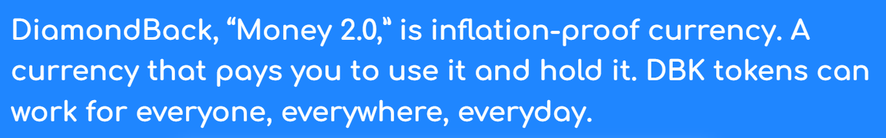  
     
   (replace with this please)

DiamondBack: A social experiment where currency is redefined. Designed to be inflation-proof, and pay you just for holding them, DBK digital tokens are “Sound Money 3.0”

______________________________________________________________________________________

2.5       (replace title with) The First of Its Kind, A Stableprice Coin For the Digital World 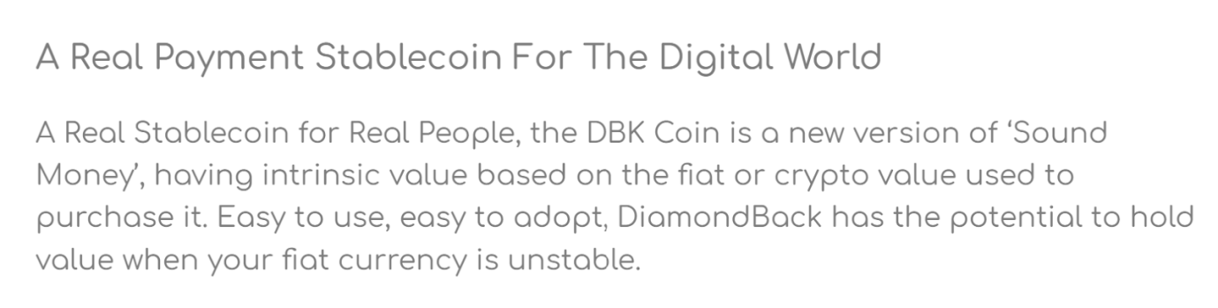

(replace paragraph with)

A DBK Stableprice coin is Real Money for Real People.  The DBK Coin is a new version… (keep the rest of the content how it is)

_________________________________________________________________________________

Why are Stablecoins so popular?  (this replaces the title) Stablecoins have a daily trading volume that exceeds that of Apple Stock... (this becomes the first sentence of the paragraph and leave the rest how it is)

1. 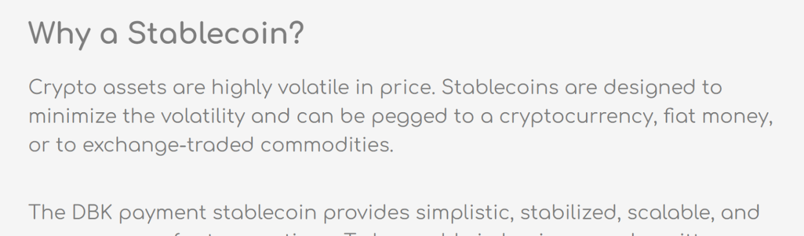

(second paragraph)  
By adding innovation to the existing concept of Stablecoins, The DBK Stableprice token provides simplistic, stabilised, scalable, and (leave the rest of the content how it is currently please)

_________________________________________________________________________

1. utilise the DBK Stableprice coin. (change of spelling and end of sentence)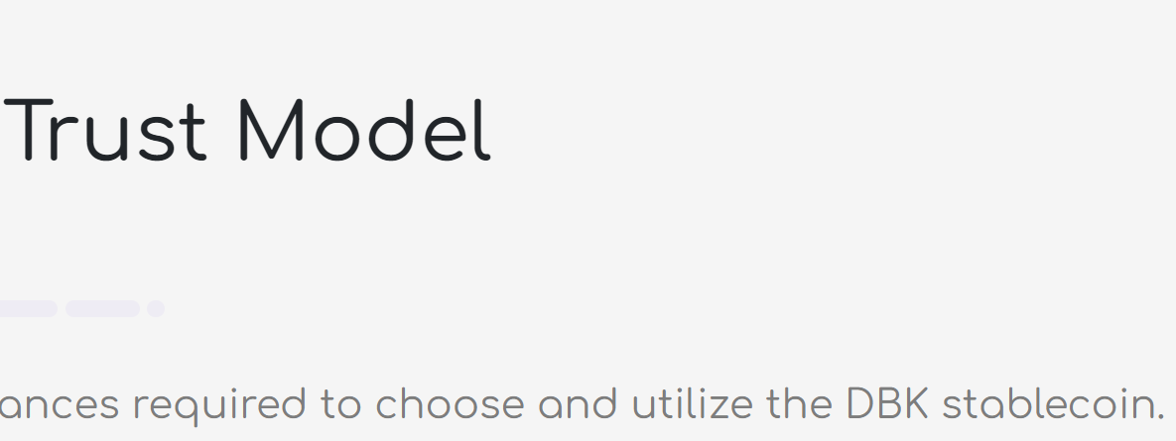

________________________________________________________________________

1. Please remove the following from Implementation Sheet   (the rest of the timeline is fine)

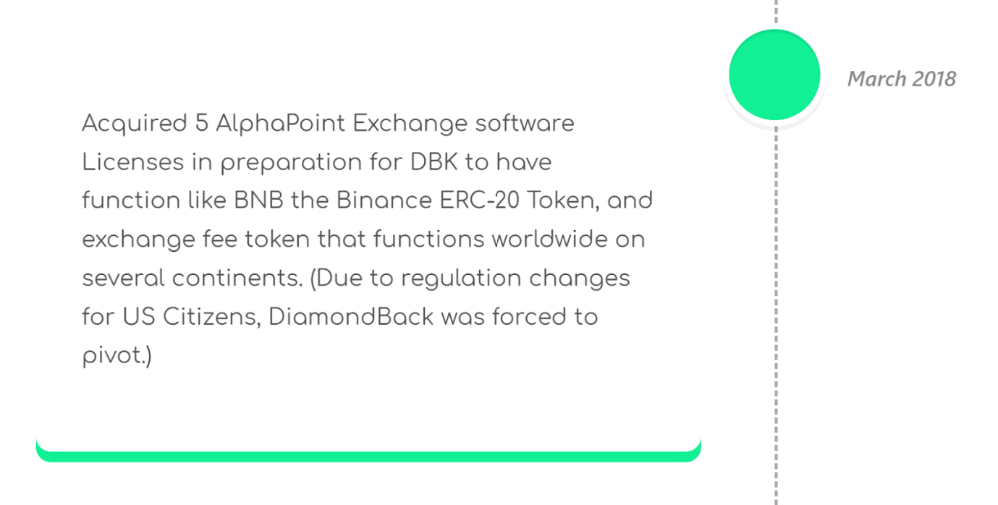

______________________________________________________________________________________

1. 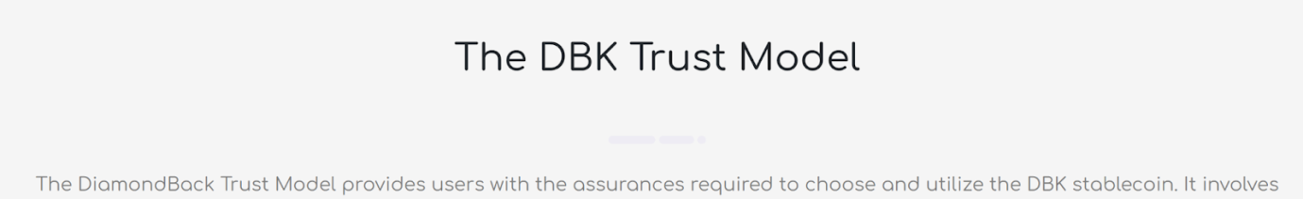

utilise the DBK Stableprice coin.  (spelling and end of 1st sentence change)

1. Please replace anywhere it says FAQ or frequently asked questions to go to this link in its own separate browser tab   
     
   https://diamondback.gitbook.io/faq/

____________________________________________________________________________________

7.25 

In this section and the boxes, anywhere it says StableCoin or stablecoin please change to Stableprice coin

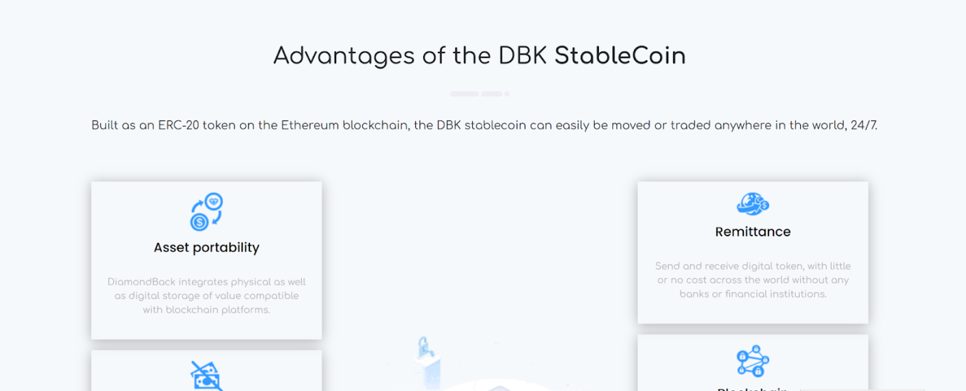

______________________________________________________________________________________

7.5

DBK is Scheduled to list worldwide on Exchanges with Millions of Users in 2022   (replace writing below please)

Where it says “learn more” please have they link go to [The Crypto Wallet with Unlimited Features | Home Page | Crypterium](https://crypterium.com/)  in a separate tab 