Functional Requirements Document

ATM And Cash Recycler Hits

**Process Name**: Internet Banking Registration

**Prepared by**: Novigo Solutions Pvt. Ltd.

**Version**: 1.0

TABLE OF CONTENTS

1 DOCUMENT HISTORY 3

2 DOCUMENT RESOURCES 3

3 DOCUMENT APPROVALS 3

4 GLOSSARY OF TERMS 3

5 PROJECT SUMMARY 4

5.1.1 Background 4

5.1.2 Current Process Flow 4

5.1.3 Objectives 4

5.1.4 Projected Solution 4

6 FUNCTIONAL REQUIREMENTS 6

7 EXCEPTIONS 14

8 APPLICATION ACCESS REQUIREMENTS 14

9 SYSTEM REQUIREMENTS 14

10 OUT OF SCOPE 15

13 ASSUMPTIONS 15

14 CLIENT ACCEPTANCE 15

# DOCUMENT HISTORY

|  |  |  |
| --- | --- | --- |
| **Version** | **Description** | **Author** |
| 1.0 | Initial Draft | Shreyas Shete |

# DOCUMENT RESOURCES

|  |  |
| --- | --- |
| **Name** | **Designation / Department** |
| Shenoy | Assets Management |

# DOCUMENT APPROVALS

|  |  |  |
| --- | --- | --- |
| **Approver Name** | **Designation / Department** | **Signature** |
| Shenoy | Assets Management |  |

# GLOSSARY OF TERMS

The following table includes definitions for any abbreviations or notation ns that are used in the document:

|  |  |
| --- | --- |
| **Term** | **Definition** |
| RPA | Robotic Process Automation |

# PROJECT SUMMARY

### Background

This process is to intimate nodal branches and the regional branches about the daily ATM and Cash recycler hits

### Current Process Flow

1. ATM

Login to <https://172.16.240.148/login> with the credentials and navigate to KBL/Reports. Select current year and click on current month and select yesterday’s date (Current date -1) and download the file starting with KBL_SUCCESS_TXN_Yesterday’s date.zip file. Extract the file with the password. This will open KBL successful transaction report excel file. Here you need to remove the header (first row) and delete the column TERMLOC and copy it from the Master excel sheet. Filter the column TERMLOC which has empty values. After filtering the empty values, Apply VLOOKUp on the excel sheet against the master excel sheet based on the TERMID. This will fill up the values based on the VLookUp condition. Delete all NA records. Add new column OPNG/LIVE DT on the same excel by mapping against the TERMID of the Master excel sheet. Now create 4 sheets on the same excel file

1. Date wise :- This will have all the information of existing excel file with OPNG/LIVE DT column sorted in Ascending wise
2. Alphabetical wise:- This will have all the information of existing excel file with TERM LOCATION column sorted in Ascending wise
3. Hits wise:- This will have all the information of existing excel file with TOTAL COUNT column sorted in Descending wise
4. Zero hits:- Take all the information from the existing file which has amount 0

Attach the excel file and send an email to below:

On first day of the month, segregate the records based on the total and average and send an email to branch and the regional office in the email body.

1. RECYCLER

Login to <https://172.16.240.148/login> with the credentials and navigate to KBL/Reports. Select current year and click on current month and select yesterday’s date (Current date -1) and download the file starting with KBL_RECYCLER_Yesterday’s date.zip file. Extract the file with the password. Filter the excel file with the column Total Count for zero. Delete all zero records from the excel and map against master excel sheet and send an email with the html table content in the email body. This should be a branch wise and regional office wise consolidated email.

### Objectives

The overall objective of this project is to implement RPA solution to BBDC department. This will completely automate the manual task currently processed by the bank staff. The purpose of the proposed new system increases the productivity and makes the process error-free.

This process will be developed on UiPath RPA Automation Tool. And the proposed system will only work on top of Microsoft.Net framework.

### Projected Solution

The following items are marked as “In-Scope” for RPA Implementation:

* Login to <https://172.16.240.148/login> with relevant credentials
* Download the excel file dynamically by navigating to KBL/Reports/Current Year/ Current Month / yesterday’s date and download the file starting with KBL_SUCCESS_TXN_Yesterday’s date.zip file
* Remove the first row and delete the column TERMLOC and Copy the values from ATM Master excel sheet and paste it to the excel sheet.
* Filter for NA or empty and delete the records
* Add new column OPNG/LIVE DT on the same excel by mapping against the TERMID of the Master excel sheet.
* Create 4 sheets on the same excel file Date wise/Alphabetical wise/Hits wise/Zero Hits
* Attach the excel sheet and send an email to the branch and regional office.
* On first day of the month, segregate the records total and average and send an email to respective branch and regional office.
* Login to <https://172.16.240.148/login> with relevant credentials
* Download the excel file dynamically by navigating to KBL/Reports/Current Year/ Current Month / yesterday’s date and download the file starting with KBL_RECYCLER_Yesterday’s date.zip file
* Filter records for zero and delete all the records with total count 0.
* Map against the nodal branch and send a segregated email in the email body.
* On first day of the month, segregate the records total and average and send an email to respective branch and regional office.

# FUNCTIONAL REQUIREMENTS

* Login to Finacle using URL “https://fin10.ktkbank.com:11000/SSO/ui/SSOLogin.jsp”
* Enter the **User ID and Password** in the login. Click on **Login**. Close the pop-up. The login screen is as shown in figure 6-1 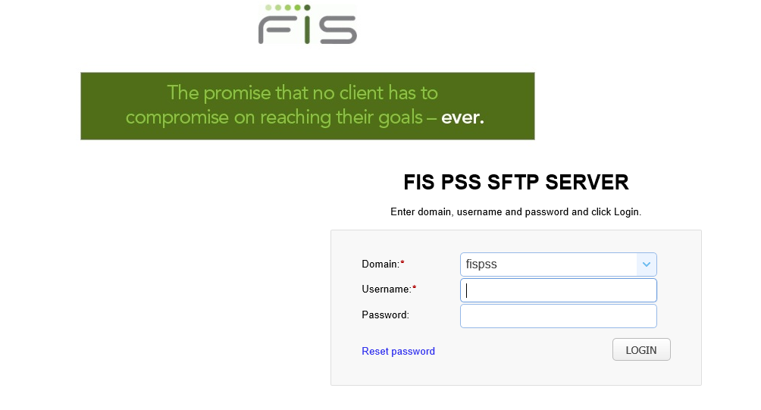

‑ Login to Finacle with relevant credentials

* Login to FEBA using URL “https://172.16.240.50/BankAwayRetail/AuthenticationController?FORMSGROUP_ID__=RMAuthenticationFG&__START_TRAN_FLAG__=Y&FG_BUTTONS__=LOAD&ACTION.LOAD=Y&RMAuthenticationFG.LOGIN_FLAG=2&BANK_ID=KBL”
* Enter the **User ID and Password** in the login page. Extract “captcha” and enter in the desired field Click on **Login** as shown in figure 6-2

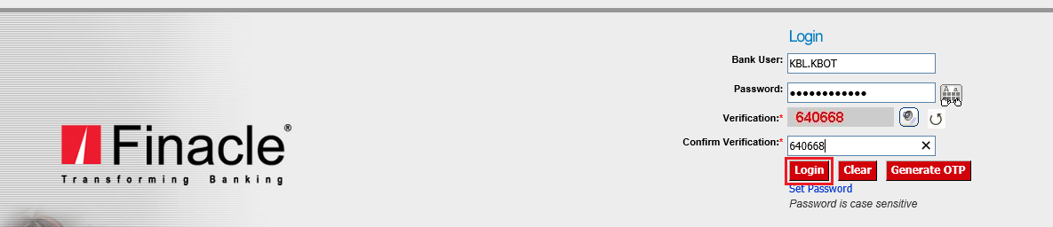

‑ Login to FEBA with relevant credentials

* Navigate to Request Maintenance screen as shown in figure 6-3

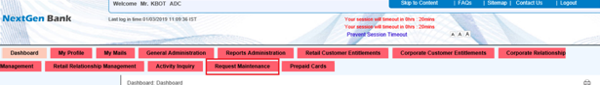

‑ Navigate to Request Maintenance Page

* Enter Request Status as “Pending”, Request Type as “Retail Online Registration” and relevant “From” and “To” dates and click on Search as shown in figure 6-4

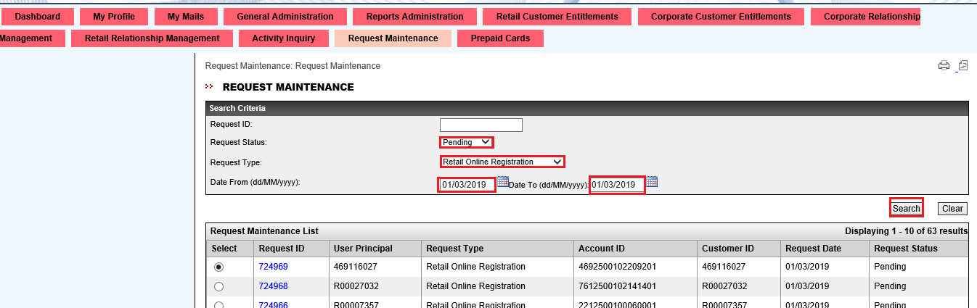

‑ Search for pending request

* Extract all the records for mentioned date on the screen present and add it to orchestrator queue
* Fetch pending requests one by one from queue and proceed the flow as given below
* Finale home page will be displayed. Type “HACLI” in the Finacle Menu Option and Click “Go” as shown in the figure 6-5. And click “GO”

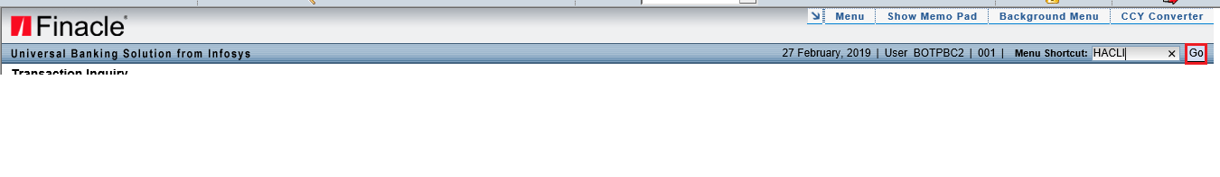

‑ Enter HACLI as Finacle Menu Option and click GO

* Type Account Number and From Date in the Menu Option as shown in the figure 6-6
* Click More-

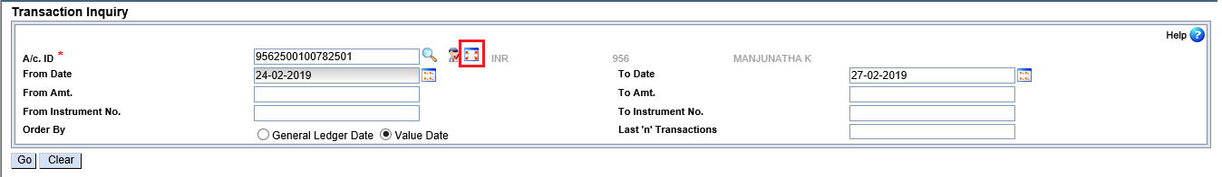

‑ Enter relevant details in HACLI screen and click More

* A screen is expected which will consist of Mode of Operation Code as shown in the figure 6-7. Extract Mode of Operation Code and check if it belongs to given set of pre-defined codes. If yes, proceed forward else log it as Rejected in Rejected Application log

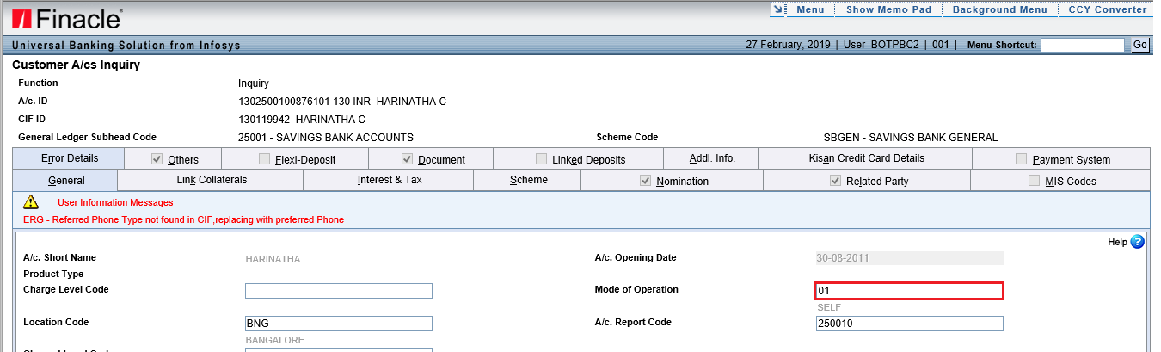

‑ Extract Mode of Operation Code

* Type “HACLI” in the Finacle Menu Option and Click “Go” as shown in the figure 6-8. And click “GO”



‑ Enter HCRV as Finacle Menu Option and click GO

* On new screen on Finacle, click on “General Details of Customer” as shown in the figure 6-9

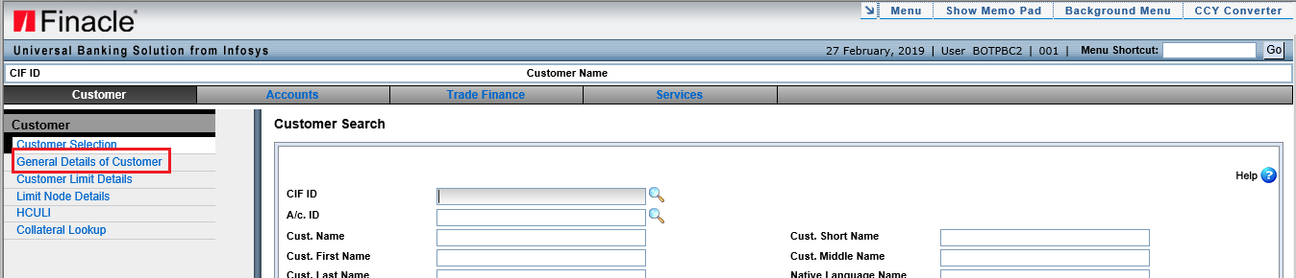

‑ Click on General Details of Customer

* On new screen on Finacle, type into CIF ID field and click “GO” as shown in the figure 6-10

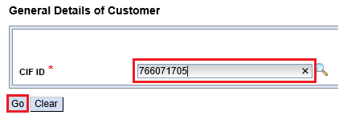

‑ Enter CIF ID and click GO

* A screen is expected which will consist of Date of Birth and Constitution as shown in the figure 6-11. Extract value for Date of Birth and Constitution and calculate the age and check if age is greater than or equal to 18 and constitution is “Individual”. If yes, proceed forward else log it as Rejected in Rejected Application log

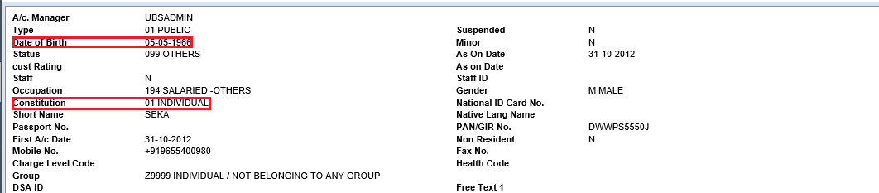

‑ Extract Date of Birth and Constitution field values

* Type “FVTM” in the Finacle Menu Option and Click “Go” as shown in the figure 6-12. And click “GO”

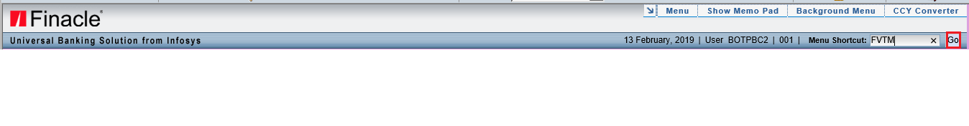

‑ FVTM as Finacle Menu Option and click GO

* Type “A – Add”, “1”, “WWW” and Customer ID in Function, Registration No., Major Facility and CIF ID fields in the FVTM screen and Click “Go” as shown in the figure 6-13

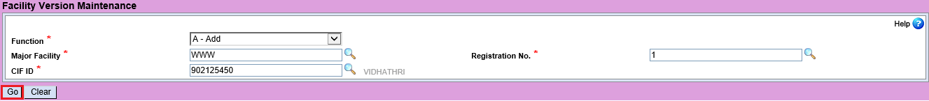

‑ Add operation in FVTM screen

* If “Record already present” error appears on screen as shown in the figure 6-14. Then Perform Modify operation in FVTM screen



‑ Record Already Present error

* Type “M - Modify”, “1”, “WWW” and Customer ID in Function, Registration No., Major Facility and CIF ID fields in the FVTM screen and Click “Go” as shown in the figure 6-15

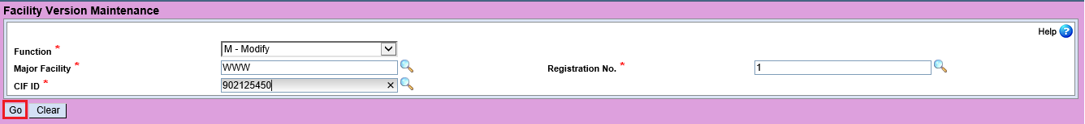

‑ Modify operation in FVTM screen

* Irrespective of “A – Add” or “M – Modify” operation Performed, a screen appears, type “444” and “1” in Version No. field and Install No. field and check if Address Line 1, Address Line 2, Address Line 3 are empty then, fill it with “.” Else, leave it as it is. If Phone No. field is empty or contains anything other than digits then fill it as “.” Else, leave it as it is. Enter Start Extraction From as “01/01/2019 and Click “Go” as shown in the figure 6-16

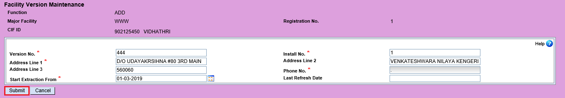

‑ Filling fields in FVTM screen

* On success screen on Finacle, click on “OK” as shown in the figure 6-17



‑ FVTM success message

* Type “CFTM” in the Finacle Menu Option and Click “Go” as shown in the figure 6-18. And click “GO”



‑ CFTM as Finacle Menu Option and click GO

* Type “C - Copy”, “WWW” and “351107023” in Function, Major Facility and CIF ID fields in the CVTM screen and Click “Go” as shown in the figure 6-19



‑ Copy operation in CFTM screen

* Type “WWW” and Customer ID in To Major Facility and To CIF ID fields in the CVTM screen and Click “Go” as shown in the figure 6-20

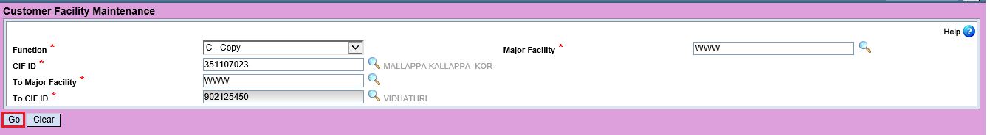

‑ Fill other fields in CFTM screen

* If “Record already present” error appears on screen as shown in the figure 6-21. Then Perform Modify operation in CFTM screen



‑ Record Already Present Error

* Type “M - Modify”, “WWW” and Customer ID in Function, Major Facility and CIF ID fields in the CFTM screen and Click “Go” as shown in the figure 6-22



‑ Modify operation in CFTM screen

* A screen is expected which will consist of Submit button, Click on it as shown if figure 6-23

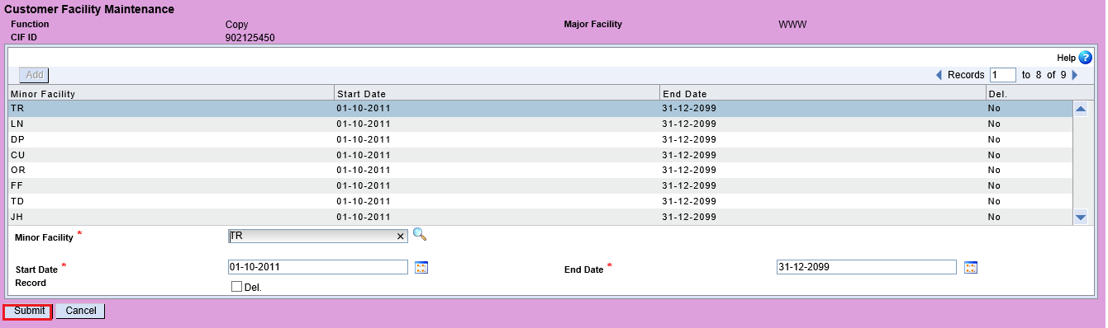

‑ Click submit in CFTM screen

* On success screen on Finacle, click on “OK” as shown in the figure 6-24



‑ Click OK on CFTM success screen

* On successfully processing all the steps mentioned above navigate to Request Maintenance screen on FEBA and enter the Request ID on the relevant field and click on Search as shown in the figure 6-25

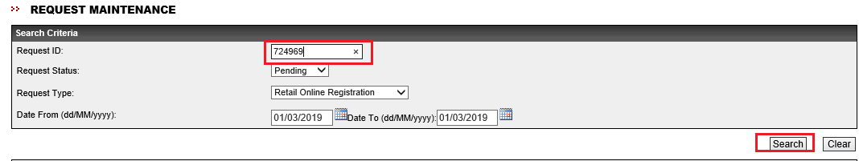

‑ Search for relevant Request ID in FEBA

* On Click on the request ID Present on FEBA screen as shown in the figure 6-26



‑ Click on relevant Request ID

* A screen is expected which will consist of “Approve” button, Enter Remarks as “A” click on “Approve” as shown if figure 6-27

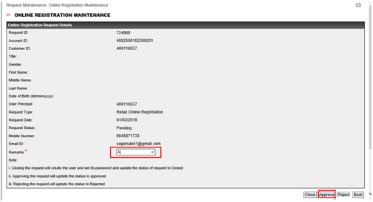

‑ Click Approve or Reject based on relevant condition

* On processing all the pending requests click on logout image on Finacle screen as shown in the figure 6-28



‑ Logout of Finacle

* Also, logout of FEBA as shown in the figure 6-29 & figure 6-30

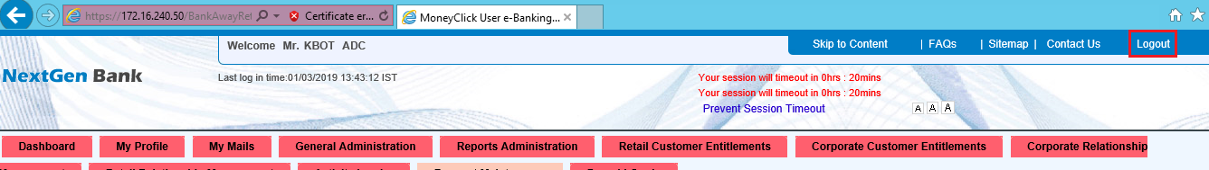

‑ Logout from FEBA

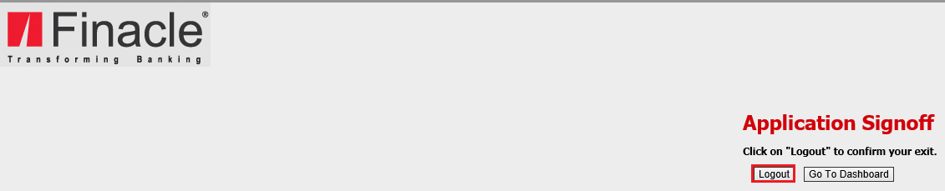

‑ Confirm Logout form FEBA

# EXCEPTIONS

|  |  |  |
| --- | --- | --- |
| **#** | **Findings** | **Suggestions** |
| 1 | Login to FEBA Production site Fails | Retry login for 3 times |
| 2 | Unexpected Error | Kill the process and retry the process for 3 times |

# APPLICATION ACCESS REQUIREMENTS

| **Req#** | **Application** | **Permissions** | **Reference/Comments** |
| --- | --- | --- | --- |
| 1 | Finacle | Read & Write | Required to get the information that need validate for internet banking registration |
| 2 | FEBA | Read & Write | Read: Extract the pending online registration requests from FEBA and upload to orchestrator queue  Write: Update the status as “Approve” or “Reject” based on pre-defined criteria |

# SYSTEM REQUIREMENTS

|  |  |  |
| --- | --- | --- |
| **Software Requirements** | **Operating System (Any one of these Operating System)** | * Windows 7 update [**KB 2533623**](https://goo.gl/x8hYZv) * Window 7 N update [**KB 968211**](https://goo.gl/Q7BfLX) * Windows 7 SP1 [**Update for Universal C Runtime**](https://goo.gl/YuVAP5) * Windows 8.1 * Windows 8.1 N Media Feature Pack [**KB 2835517**](https://goo.gl/Yu95L2) * Windows 10 * Windows 10 N Media Feature Pack [**KB4039813**](https://goo.gl/PWrVa7) * Windows Server 2008 R2 update [**KB 963697**](https://goo.gl/rGFVZ2) and the [**Desktop Experience**](https://goo.gl/L9MMYe) feature * Windows Server 2012 R2 Please note that **Windows Server 2012 R2 Standard and Datacenter** require the **Essential experience role**, [**Essentials Media Pack**](https://www.microsoft.com/en-us/download/details.aspx?id=40837), and lastly [**Update for Universal C Runtime**](https://goo.gl/YuVAP5) * Windows Server 2016 |
| **.NET Framework** | 4.5.2 |
| **Hardware Requirements**  **(Minimum Requirement)** | **CPU** | 1.4GHz 32-bit (x86) |
| **RAM** | 4 GB |

# OUT OF SCOPE

* Any error message not listed in section 7

# ASSUMPTIONS

* Details of all pending requests present in FEBA are relevant for performing the process
* The successful screen appears on successful completion of CFTM, FVTM and FEBA will be available as expected
* None of the screen (UI layout) or menu options changes in both Finacle and FEBA site
* Both Finacle and FEBA site are up and running during the execution of workflow

# CLIENT ACCEPTANCE

|  |  |
| --- | --- |
| Name of Document | Internet Banking Registration |
| Document | Functional Requirement Document |
| Revision Number | V1.0 |
| Number of Pages | 15 |

This document has been approved as the official Functional Requirements Document for RPA of Internet Banking Registration, and accurately reflects the current understanding of business requirements. Following approval of this document, requirement changes will be governed by the project’s change management process, including impact analysis, appropriate reviews and approvals

If you are in agreement with the above Business Requirements document for the mentioned business process automation, please sign below with date and return it back to Shamaprasad C. G(shamaprasadcg@novigosolutions.com) via email to confirm.

Karnataka Bank Pvt Ltd Novigo Solutions Pvt Ltd

|  |  |  |  |  |  |  |  |  |  |
| --- | --- | --- | --- | --- | --- | --- | --- | --- | --- |
| |  |  | | --- | --- | | Signature:______________________________ | Signature:_____________________________ | | Name: Shenoy | Name: Shamaprasad C. G | | Job Title: | Job Title: Project Manager | |  |  | |  |