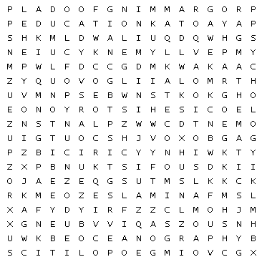

|  |  |  |
| --- | --- | --- |
| Animals | Astronomy | Design |
| Economics | Education | Engineering |
| Filmmaking | Food | Geography |
| Geopolitics | Health | History |
| Islam | Law | Mathematics |
| Music | Oceanography | Philosophy |
| Plants | Politics | Programming |
| Psychology | | |