$oftware ¢orp
Smart Parking Platform
Software Requirements Specification & Vision and Scope Document

Version 1.0 • September 8, 2026
Prepared by: Faiz Hajiani, Project Manager
Prepared for: Bayou City Parking Group (client) and project stakeholders

CIS 4374 – Information Systems Project Management
University of Houston • Fall 2026 • Instructor: Dr. Otto Dobretsberger
Repository: https://github.com/FaizaliHajiani964/smart-parking-platform

Table of Contents
1. Introduction 4
1.1 Purpose 4
1.2 Intended Audience 4
1.3 Definitions and Acronyms 4
2. Vision and Scope 4
2.1 Business Need and Background 5
2.2 How the Project Was Acquired 5
2.3 About $oftware ¢orp 5
2.4 Vision Statement 5
2.5 Scope 6
2.5.1 In Scope 6
2.5.2 Out of Scope 6
2.6 Assumptions and Dependencies 6
3. Market Research and Competitive Analysis 7
3.1 Existing Software Landscape 7
3.2 Competitor Profiles 8
3.3 How the Smart Parking Platform Is Different 9
4. Overall Description 10
4.1 Product Perspective 10
4.2 User Classes and Stakeholders 11
4.3 Operating Environment 11
4.4 Execution Constraints 11
5. Functional Requirements 12
5.1 Accounts & Authentication 12
5.2 Availability & Map 12
5.3 Reservations 12
5.4 Payments & Receipts 13
5.5 Operator Dashboard 13
5.6 Notifications 13
5.7 Integrations & Administration 14
6. Non-Functional Requirements 14
7. Use Cases 15
7.1 End-User (Driver) Use Cases 15
7.2 Operator, Finance, and Administrator Use Cases 19
7.3 Use-Case Coverage Summary 22
8. References 22

1. Introduction

1.1 Purpose
This document defines the vision, scope, and software requirements for the Smart Parking Platform, a real-time parking discovery, reservation, payment, and facility-management system to be delivered by $oftware ¢orp. It is the single source of truth for what the system must do (functional requirements), how well it must do it (non-functional requirements), and the limits of the engagement (scope). It will be updated weekly throughout the project and acts as the foundation for the work breakdown structure, schedule, budget, risk register, and later project artifacts.

1.2 Intended Audience
- Client executives and operations leads at Bayou City Parking Group – to confirm scope, priorities, and acceptance criteria.
- $oftware ¢orp development teams (mobile, web, backend/API, mapping, payments, QA) – to derive work items, designs, and test cases.
- Project sponsors and course stakeholders – to monitor progress against the agreed baseline.

1.3 Definitions and Acronyms
Term | Definition
PARCS | Parking Access and Revenue Control System – gates, ticket dispensers, pay stations, and the software that runs them.
LPR / ALPR | (Automated) License Plate Recognition – cameras that read plates to open gates and match vehicles to reservations.
Operator | A company or agency that runs one or more parking facilities (garages, surface lots).
Driver / End user | A member of the public who uses the mobile or web app to find, reserve, and pay for parking.
Occupancy | The number of spaces currently in use in a facility, expressed as a count and a percentage of capacity.
Dynamic pricing | Adjusting parking rates based on time of day, demand, or events, within operator-defined limits.
SRS | Software Requirements Specification (this document).
RFP | Request for Proposal – the client’s formal solicitation to which $oftware ¢orp responded.
MVP | Minimum Viable Product – the smallest release that delivers end-to-end value to drivers and operators.

2. Vision and Scope

2.1 Business Need and Background
Drivers in dense urban areas spend a significant amount of time circling for parking, which creates congestion, frustration, wasted fuel, and lost productivity. On the other side of the transaction, parking facility operators typically have limited real-time visibility into occupancy, depend on static pricing, and lack integrated tools to manage reservations, payments, and reporting across multiple facilities. The result is under-utilized parking assets and a poor experience for both groups.
The Smart Parking Platform tackles both problems with one system: drivers locate, reserve, and pay for garage parking in real time from a web or mobile app, while operators manage inventory, pricing, and occupancy analytics from an administrative dashboard.

2.2 How the Project Was Acquired
In mid-2026, Bayou City Parking Group, a fictional Houston-area operator managing 14 garages and surface lots in the Downtown, Midtown, Medical Center, and Galleria districts issued a Request for Proposal for a “Smart Parking Platform” to replace its patchwork of third-party reservation listings, legacy pay stations, and spreadsheet-based reporting. The RFP was published on the client’s procurement platform and distributed to pre-qualified vendors.
$oftware ¢orp responded with a proposal built around three commitments the client identified as decisive: (1) real-time availability rather than estimated inventory, (2) a single platform serving drivers and operators instead of two disconnected vendors, and (3) reservations that are honored at the gate because the platform itself controls the facility’s inventory. Following a technical presentation and reference checks, $oftware ¢orp was awarded the contract. Payment is milestone-based (30% at kickoff, 40% at MVP acceptance, 30% at final delivery), and any features requested beyond the scope defined in this document will be handled through a formal change request and a separate contract, protecting both parties from scope creep.

2.3 About $oftware ¢orp
$oftware ¢orp is a fictitious software development studio with unlimited resources and budget for the purposes of this project. The studio specializes in mobility and smart-city platforms and organizes work into six cross-functional development teams: Mobile Application, Web Application, Backend/API, Mapping & Location Services, Payment Integration, and Quality Assurance & Testing. The project is led by a dedicated Project Manager (the author of this document) who owns the schedule, budget, risk register, and stakeholder interaction. Although budget is not a constraint, the semester timeline is fixed, so the plan prioritizes disciplined scope control and early delivery of an end-to-end MVP.

2.4 Vision Statement
For drivers who waste time and fuel looking for parking, and parking operators who lack real-time control over their facilities, the Smart Parking Platform is a web and mobile parking system that lets drivers find, reserve, navigate to, and pay for a guaranteed space in real time, while giving operators live occupancy, pricing, and revenue tools across all of their facilities. Unlike driver-only marketplaces such as SpotHero or operator-only access-control systems such as FLASH, our platform owns the inventory end to end, so a reservation made in the app is the same record that opens the gate.

2.5 Scope

2.5.1 In Scope
- Driver-facing mobile applications (iOS and Android) and a responsive web application for account management, search, reservation, payment, receipts, and notifications.
- Real-time availability at the facility and space-count level, fed by gate/LPR events and, where installed, occupancy sensors.
- Interactive map with turn-by-turn hand-off to external navigation apps (Google Maps, Apple Maps, Waze).
- Reservation engine supporting hourly, daily, event, and monthly-permit bookings with modification and cancellation rules.
- Digital payment processing through a PCI-compliant third-party provider, including saved payment methods, receipts, and refunds.
- Operator administrative dashboard: facility and rate configuration, occupancy monitoring, reservation management, and reporting/analytics.
- System administration: role-based access control, audit logging, and configuration management.
- Integrations with gate controllers and LPR cameras at client facilities through documented APIs.
- Notifications (push, SMS, email) for reservation confirmations, reminders, expirations, and operator alerts.

2.5.2 Out of Scope
- On-street (metered) parking and municipal enforcement or citation management.
- Manufacture, installation, or maintenance of physical hardware (gates, cameras, sensors, pay stations); the platform integrates with hardware the client procures separately.
- Valet operations and vehicle key management.
- Electric-vehicle charging management and billing (a candidate for a future phase).
- A public marketplace listing facilities owned by operators who are not platform customers.
- Loyalty or rewards programs and third-party advertising within the apps.
- Custom integrations with individual city permit systems beyond publishing open occupancy data.
Explicitly listing exclusions protects the project from scope creep: any of these items may be added later through the change-request process and a separate agreement.

2.6 Assumptions and Dependencies
ID | Assumption / Dependency | If it fails…
A-1 | Client facilities have reliable wired or 4G/5G internet connectivity for gate controllers and LPR cameras. | Gate events are queued locally and synchronized when connectivity returns; availability shown to drivers is flagged as “last updated N minutes ago.”
A-2 | Gate and LPR hardware exposes a documented API or webhook interface. | A hardware adapter must be built or an integration middleware licensed; schedule impact assessed via change request.
A-3 | A third-party payment provider (e.g., Stripe) handles card storage and PCI-DSS scope. | Alternative provider selected; payment module abstracted behind an interface so the switch is isolated.
A-4 | Mapping and geocoding are provided by an external service (Google Maps Platform or Mapbox) under a commercial license. | Secondary provider configured; map features degrade to list view if both are unavailable.
A-5 | The client will provide facility data (capacity, hours, rates, addresses) before integration testing. | Onboarding milestone slips; the schedule includes a two-week buffer for data collection.
A-6 | Drivers have smartphones running iOS 16+ or Android 12+ with location services enabled. | Web application provides equivalent functionality; manual address entry replaces GPS.
A-7 | The platform must comply with Texas and City of Houston ordinances on parking, consumer payments, and data privacy. | Legal review triggers requirement changes handled through change control.

3. Market Research and Competitive Analysis

3.1 Existing Software Landscape
The parking-technology market is fragmented into three largely separate segments. Driver-facing marketplaces (SpotHero, ParkWhiz, ParkMobile, PayByPhone) let the public pay for or pre-book parking but do not control the facility. Operator-facing access-and-revenue-control systems (FLASH, T2 Systems, ParkHub) run gates, lanes, and reporting yet reach drivers only through partners. A third segment of sensing and analytics vendors (Nwave, ParkiFi, Smarking) supplies occupancy data and forecasting to operators. Few products span more than one segment, which is the gap the Smart Parking Platform is designed to fill.
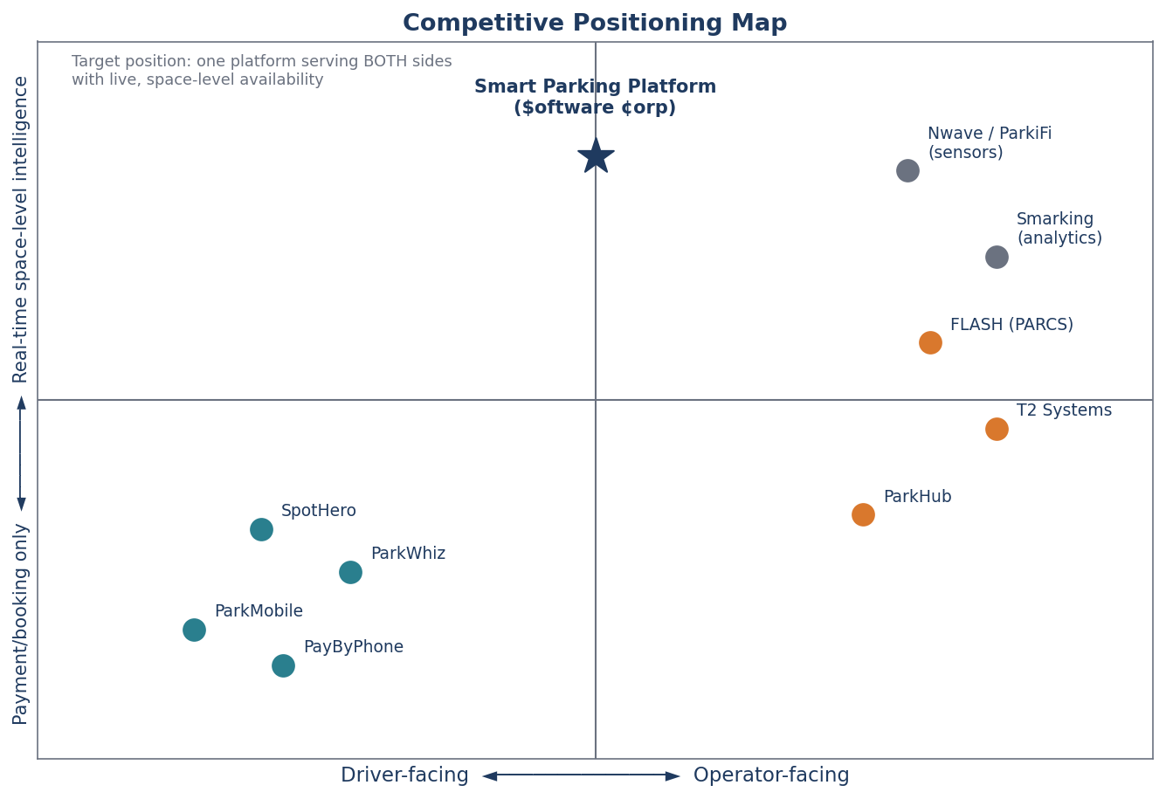
Figure 1. Competitive placement map: existing products cluster as either driver-facing booking tools or operator-facing control systems; the Smart Parking Platform targets the unoccupied center with real-time, space-level intelligence for both sides.

3.2 Competitor Profiles
Competitor | Segment / Focus | Strengths | Weaknesses and Limitations
SpotHero | Driver-facing garage and lot reservation marketplace across North America (7,000+ locations). | Largest garage marketplace; book-ahead pricing with average savings of about 30% versus drive-up rates; guaranteed-spot messaging. | Does not control facility inventory, so drivers report arriving to “Lot Full” signs or attendants refusing third-party reservations; access codes failing at gates; prices rising between search and checkout; support limited to chat.
ParkWhiz (Arrive) | Driver-facing reservations near venues and airports; event parking. | Simple, fast booking flow; strong event-day coverage; discounts up to 50%. | Garages fail to recognize reservations; surge pricing can double rates on event days; refunds take 10–15 business days; narrow check-in windows.
ParkMobile | Driver-facing mobile payment for on-street meters and municipal lots (1.5M+ spaces). | Largest zone footprint in U.S. cities; the default option for many municipalities; hourly session extension. | Street-focused with limited garage pre-booking; a $0.35 convenience fee on small meter payments; phantom sessions from GPS drift; failed stop commands that keep charging.
PayByPhone | Driver-facing meter payment; official partner in many U.S. and European cities. | Deep municipal integration; auto-extend sessions. | Expiration alerts fire only minutes before expiry; city-wide outages at peak hours; stale rate displays; account lockouts after card declines.
FLASH (FlashParking) | Operator-facing PARCS: kiosks, gates, LPR cameras, cloud management, business-intelligence dashboards. | Full-stack access and revenue control; camera-based “Flex Mode” entry; reports operators gain about 22% more daily revenue per spot; multi-facility portfolios. | Hardware-centric and capital-intensive; reaches drivers only by pushing inventory to partner apps; opaque pricing and long implementation timelines.
T2 Systems | Enterprise PARCS plus permits and enforcement for operators, municipalities, and universities. | Enterprise-grade multi-facility management; lane hardware integration; permit and citation workflows. | Primarily institutional; no consumer-grade driver experience; enforcement focus is outside garage-reservation use cases.
ParkHub | Operator-facing event and high-volume venue parking management. | Optimized for stadiums, arenas, and event surges; point-of-sale and pre-sold passes. | Narrow event focus; limited everyday commuter and monthly-permit functionality.
Nwave / ParkiFi / Smarking | Sensor and analytics vendors supplying occupancy data and demand forecasting. | Space-level occupancy sensing; utilization analytics and forecasting. | Data-only products that must be paired with separate booking and payment systems; no driver-facing app.

3.3 How the Smart Parking Platform Is Different
Differentiator | What it means for drivers | What it means for operators
One inventory, end to end | A reservation is the same record the gate reads; arrival is confirmed by LPR or QR code with no attendant intervention. | No double-booking between a marketplace and a pay station; one reconciliation report.
Live space-level availability | Search results show the number of free spaces and a “last updated” timestamp, not just open/closed. | Occupancy dashboards update within seconds of every entry and exit; alerts when a facility nears capacity.
All-in pricing up front | The price shown in search is the price charged, including taxes and fees. | Rates, surcharges, and dynamic-pricing rules are configured once and applied consistently across app, web, and on-site.
Built for both sides | One app for hourly, daily, event, and monthly parking across every facility on the platform. | Facility configuration, reservations, pricing, reporting, and staff roles in a single dashboard, with a role for finance/billing.
Open, adapter-based integrations | Navigation hand-off to the driver’s preferred maps app. | Works with existing gate and LPR hardware from multiple vendors; publishes open occupancy data to city transportation departments.

4. Overall Description

4.1 Product Perspective
The Smart Parking Platform is a new, cloud-hosted system composed of native mobile apps, a responsive web application, a backend/API layer, and an operator dashboard. It exchanges data with four classes of external systems: third-party payment providers, mapping and navigation services, garage hardware (gates, LPR cameras, occupancy sensors), and city transportation departments that consume open occupancy data.
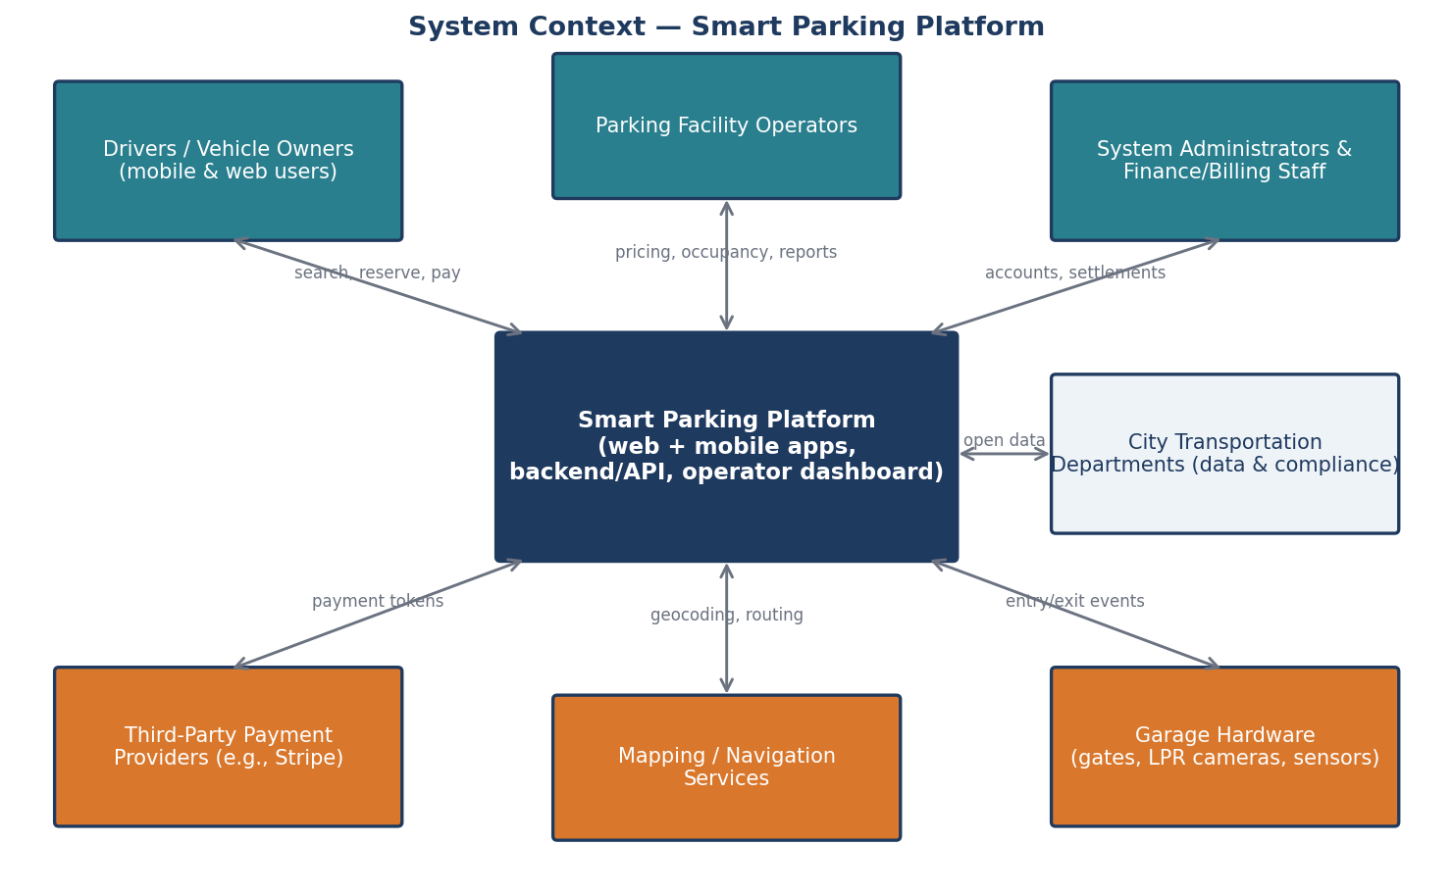
Figure 2. System context diagram showing the Smart Parking Platform, its user groups (teal), and the external systems it integrates with (orange).

4.2 User Classes and Stakeholders
Stakeholder / User Class | Role in the System | Primary Needs
Drivers and vehicle owners | End users of the mobile and web apps. | Find a guaranteed space quickly, know the total price up front, navigate to the entrance, enter without friction, get a receipt.
Mobile application users | Subset of drivers who rely on the iOS/Android app, often while in transit. | Fast, low-tap flows; reliable push notifications; offline access to an active reservation and QR code.
Parking facility operators | Primary paying customer; manage one or more facilities. | Configure rates and capacity, watch live occupancy, manage reservations and incidents, maximize utilization and revenue.
Finance and billing personnel | Operator staff who reconcile revenue and handle refunds. | Accurate daily settlement reports, refund tools, tax breakdowns, exports to accounting software.
System administrators | $oftware ¢orp and client IT staff who run the platform. | Role-based access control, audit logs, integration health monitoring, configuration management.
City transportation departments | External consumers of aggregated occupancy data; regulators. | Open data feeds for congestion planning; assurance of compliance with local ordinances.
Third-party payment providers | External system handling card processing and PCI scope. | Well-formed API calls, tokenized card data, webhook acknowledgements.

4.3 Operating Environment
- Mobile: native applications for iOS 16+ and Android 12+, distributed through the Apple App Store and Google Play.
- Web: responsive single-page application supporting the two most recent versions of Chrome, Safari, Edge, and Firefox.
- Backend: cloud-hosted (AWS or Azure) containerized services with a managed relational database and a message queue for hardware events.
- Facility edge: gate controllers and LPR cameras communicate with the backend over HTTPS/webhooks; a local edge service buffers events during connectivity loss.

4.4 Execution Constraints
- Budget: theoretically unlimited for this engagement, so technical decisions are optimized for quality and time rather than cost.
- Timeline: fixed to the academic semester; the final project document is due December 4, 2026, and interim milestones are delivered weekly.
- Third-party dependence: payment, mapping, and hardware integrations rely on external APIs whose availability and terms are outside the project’s control.
- Compliance: PCI-DSS (via the payment provider), Texas and City of Houston ordinances governing parking and consumer payments, ADA accessibility for the apps and web (WCAG 2.1 AA), and applicable data-privacy requirements for personal and vehicle data.

5. Functional Requirements
Functional requirements describe what the system shall do. They are grouped by the high-level requirement areas identified in the project brief; each will be traced to one or more use cases in Section 7 and to work items in the project tracker.

5.1 Accounts & Authentication
ID | Requirement
FR-1 | The system shall allow a driver to create an account using an email address and password, or through Apple or Google sign-in, in no more than 3 steps.
FR-2 | The system shall allow a driver to register up to 5 vehicles (license plate, state, make, model, color) and designate one as default.
FR-3 | The system shall provide role-based accounts for operator staff (Operator Admin, Facility Manager, Finance, Attendant) and platform administrators.
FR-4 | The system shall support multi-factor authentication for all operator and administrator roles.

5.2 Availability & Map
ID | Requirement
FR-5 | The system shall display facilities on an interactive map and in a list, filtered by distance, price, availability, vehicle-size restrictions, and amenities (covered, EV charging, 24/7).
FR-6 | The system shall show, for every facility, the number of available spaces and the time the count was last updated.
FR-7 | The system shall update facility availability from gate entry/exit events and, where installed, occupancy sensors.
FR-8 | The system shall hand off turn-by-turn navigation to the facility entrance to the driver’s preferred external maps application.

5.3 Reservations
ID | Requirement
FR-9 | The system shall allow a driver to reserve a space for an hourly, daily, event, or monthly-permit period and shall display the all-in price (rate, taxes, and fees) before confirmation.
FR-10 | The system shall hold inventory for a confirmed reservation so that the same space count cannot be sold twice.
FR-11 | The system shall allow a driver to modify or cancel a reservation subject to the facility’s cancellation policy and shall calculate any refund automatically.
FR-12 | The system shall allow a driver to extend an active session from the app when capacity permits.
FR-13 | The system shall generate a QR code and register the vehicle’s license plate for each reservation so entry can be validated by scanner or LPR camera.

5.4 Payments & Receipts
ID | Requirement
FR-14 | The system shall process payments through a PCI-compliant third-party provider supporting major credit/debit cards, Apple Pay, and Google Pay, and shall never store raw card numbers.
FR-15 | The system shall issue an itemized digital receipt by email and in-app for every completed transaction and shall keep reservation history for at least 24 months.
FR-16 | The system shall allow finance staff to issue full or partial refunds and shall record the reason and the staff member for each refund.

5.5 Operator Dashboard
ID | Requirement
FR-17 | The system shall allow an Operator Admin to create and configure facilities: address, capacity, hours, vehicle restrictions, amenities, and entrance coordinates.
FR-18 | The system shall allow operators to define rate schedules (hourly, daily, event, monthly) and optional dynamic-pricing rules with operator-set floor and ceiling prices.
FR-19 | The system shall display a live occupancy dashboard for each facility and for the operator’s portfolio, with configurable alerts when occupancy exceeds a threshold.
FR-20 | The system shall allow operators to view, search, and manually override reservations (e.g., honor a reservation when a scanner fails) with an audit trail.
FR-21 | The system shall generate occupancy, revenue, and utilization reports by facility, date range, and rate type, exportable to CSV and PDF, and shall automatically email a weekly summary to designated staff.

5.6 Notifications
ID | Requirement
FR-22 | The system shall send reservation confirmations, arrival reminders, expiration warnings (at 30 and 10 minutes), and receipts via push notification, SMS, or email according to the driver’s preferences.
FR-23 | The system shall alert operators when a gate or camera integration stops reporting events for more than 5 minutes.

5.7 Integrations & Administration
ID | Requirement
FR-24 | The system shall provide a documented API and webhook interface for gate controllers and LPR cameras to report entry/exit events and to request entry authorization.
FR-25 | The system shall publish an anonymized, aggregated occupancy data feed that city transportation departments can consume.
FR-26 | The system shall log all administrative and financial actions with user, timestamp, and before/after values, retained for at least 12 months.

6. Non-Functional Requirements
Non-functional requirements describe how the system shall be. Each is stated with a measurable target so that it can be verified by the QA team; none uses an absolute (0% or 100%) commitment.
ID | Category | Requirement
NFR-1 | Performance | Search results for a map viewport containing up to 200 facilities shall load within 2 seconds on a 4G connection at the 95th percentile.
NFR-2 | Performance | Facility availability shown to drivers shall reflect gate and sensor events within 5 seconds of the event reaching the backend.
NFR-3 | Performance | Gate entry authorization requests shall receive a response within 1 second at the 99th percentile so that vehicles are not delayed at the lane.
NFR-4 | Availability | The platform shall provide 99.9% monthly uptime for driver-facing services and 99.95% for the gate-authorization API, excluding announced maintenance windows.
NFR-5 | Reliability | Facility edge services shall buffer at least 24 hours of gate events locally and synchronize automatically when connectivity is restored.
NFR-6 | Scalability | The system shall support at least 10,000 concurrent app users and 500 facilities without degradation of NFR-1 through NFR-3, with horizontal scaling to 10× those figures.
NFR-7 | Security | All data in transit shall be encrypted with TLS 1.2 or higher and all personal and vehicle data at rest with AES-256; card data shall be tokenized by the payment provider so the platform remains out of PCI-DSS card-data scope.
NFR-8 | Security | Operator and administrator sessions shall expire after 30 minutes of inactivity and shall require multi-factor authentication.
NFR-9 | Usability | A returning driver shall be able to complete a reservation for a previously used facility in no more than 4 taps from the app home screen.
NFR-10 | Usability | A new driver shall be able to complete registration and a first reservation in under 3 minutes in usability testing with at least 8 of 10 participants succeeding without assistance.
NFR-11 | Accessibility | The mobile and web applications shall conform to WCAG 2.1 Level AA, including screen-reader labels and minimum 4.5:1 text contrast.
NFR-12 | Compatibility | The apps shall support iOS 16+ and Android 12+ and the web application the two most recent major versions of Chrome, Safari, Edge, and Firefox.
NFR-13 | Bandwidth | The mobile app shall function on connections as slow as 1 Mbps, and an active reservation with its QR code shall remain viewable with no connectivity.
NFR-14 | Maintainability | Facility hardware integrations shall be implemented as pluggable adapters so that a new gate or camera vendor can be supported without changes to core services; automated test coverage of core services shall be at least 80%.
NFR-15 | Compliance | The platform shall comply with applicable Texas and City of Houston ordinances for parking and consumer payments and shall provide data-export and deletion tools for driver personal data on request within 30 days.
NFR-16 | Data retention | Transaction records shall be retained for at least 7 years for financial audit; personal data no longer needed shall be anonymized after 24 months of account inactivity.

7. Use Cases
The following use cases were synthesized from stakeholder user stories gathered across the hierarchy – drivers, attendants, facility managers, finance staff, and administrators – rather than from management alone. Each use case states its actor, precondition, ordered steps, and postcondition. Eighteen use cases are defined in this version: ten for end users (drivers) and eight for operators, finance, and administrators. The list will grow in later versions.

7.1 End-User (Driver) Use Cases
UC-1 | Register account and add a vehicle
Actor | Driver
Precondition | Driver has installed the mobile app or opened the web app and has a valid email address.
Steps | 1. Driver selects “Create account” and enters email and password, or chooses Apple/Google sign-in.  2. System sends a verification code; driver enters it.  3. Driver enters license plate, state, and vehicle details and saves the vehicle as default.  4. System confirms the account is active and shows the map home screen.
Postcondition | A verified driver account exists with one default vehicle.
Alternate / Exceptions | If the plate is already registered to another account, the system asks the driver to confirm ownership via email before proceeding.

UC-2 | Search for available parking near a destination
Actor | Driver
Precondition | Driver is logged in and has granted location permission or entered a destination address.
Steps | 1. Driver enters a destination or uses current location and selects arrival date/time and duration.  2. System displays facilities on the map and in a list with available-space counts, all-in prices, distance, and “last updated” time.  3. Driver applies filters (price, covered, EV charging, vehicle height).  4. Driver taps a facility to view details, photos, hours, and entrance instructions.
Postcondition | Driver has identified a facility with confirmed availability for the requested time.
Alternate / Exceptions | If no facilities have availability, the system shows the nearest alternatives and offers a waitlist notification.

UC-3 | Reserve a parking space
Actor | Driver
Precondition | Driver has selected a facility with available spaces for the chosen time window and has a saved payment method (or will add one).
Steps | 1. Driver taps “Reserve” and confirms vehicle, arrival time, and duration.  2. System shows the itemized total (rate, taxes, fees) and the cancellation policy.  3. Driver confirms; system holds the inventory and charges the payment method.  4. System issues a confirmation with a QR code and registers the plate for LPR entry; confirmation is sent by push and email.
Postcondition | A confirmed reservation exists, inventory is decremented, payment is captured, and the driver holds a QR code.
Alternate / Exceptions | If payment fails, the hold is released after 5 minutes and the driver is prompted to try another method.

UC-4 | Navigate to the facility entrance
Actor | Driver
Precondition | Driver has an upcoming or active reservation.
Steps | 1. Driver opens the reservation and taps “Navigate.”  2. System opens the driver’s preferred maps app with the facility’s entrance coordinates (not the postal address).  3. Driver follows directions; system sends an arrival reminder 15 minutes before the reservation start.
Postcondition | Driver arrives at the correct entrance.
Alternate / Exceptions | If no maps app is installed, the system shows in-app directions and the entrance description.

UC-5 | Enter the facility with a reservation
Actor | Driver
Precondition | Driver has a confirmed reservation starting within the facility’s early-arrival window and is at the entry lane.
Steps | 1. LPR camera reads the plate and requests authorization from the platform.  2. System validates the reservation and instructs the gate to open within 1 second.  3. If LPR fails, driver scans the QR code at the reader.  4. System records the entry event, starts the session, and updates facility availability.
Postcondition | Vehicle is inside; the session is active; occupancy is updated.
Alternate / Exceptions | If neither LPR nor QR succeeds, the driver presses the intercom and the attendant validates the reservation from the dashboard (see UC-15).

UC-6 | Extend an active parking session
Actor | Driver
Precondition | Driver has an active session and the facility has capacity for the extension period.
Steps | 1. System notifies the driver 30 and 10 minutes before expiry.  2. Driver taps “Extend” and selects the additional time.  3. System checks capacity, shows the additional charge, and charges the saved payment method.  4. System updates the reservation end time and the LPR/QR authorization.
Postcondition | The session end time is extended and the additional payment is captured.
Alternate / Exceptions | If capacity is unavailable, the system explains the overstay rate that will apply and offers nearby alternatives.

UC-7 | Modify or cancel a reservation
Actor | Driver
Precondition | Driver has an upcoming reservation that has not started.
Steps | 1. Driver opens the reservation and chooses “Change time” or “Cancel.”  2. System displays the facility’s policy and the refund or price difference that applies.  3. Driver confirms.  4. System releases or re-holds inventory, processes the refund or charge, and sends an updated confirmation.
Postcondition | The reservation is updated or cancelled and inventory and payment are reconciled.
Alternate / Exceptions | Cancellations inside the non-refundable window are confirmed with a clear $0 refund message before completion.

UC-8 | View reservation history and download a receipt
Actor | Driver
Precondition | Driver is logged in and has at least one completed transaction.
Steps | 1. Driver opens “History.”  2. System lists past reservations with facility, date, duration, and amount.  3. Driver selects a transaction and taps “Receipt.”  4. System displays the itemized receipt and offers PDF download or email.
Postcondition | Driver has an itemized receipt suitable for expense reporting.

UC-9 | Purchase a monthly permit
Actor | Driver (commuter)
Precondition | Driver is logged in and the facility offers monthly permits with capacity available.
Steps | 1. Driver selects a facility and chooses “Monthly permit.”  2. System shows price, access hours, and auto-renewal terms.  3. Driver confirms and payment is captured; plate is registered for the permit period.  4. System issues the permit and schedules renewal reminders 7 days before each term.
Postcondition | An active monthly permit is associated with the driver’s vehicle and renews per the chosen terms.
Alternate / Exceptions | If permit capacity is full, the driver can join a waitlist and is notified when a permit becomes available.

UC-10 | Manage notification preferences
Actor | Driver
Precondition | Driver is logged in.
Steps | 1. Driver opens “Settings → Notifications.”  2. Driver toggles push, SMS, and email for each event type (confirmations, reminders, expirations, receipts, promotions).  3. System saves the preferences and confirms.
Postcondition | Notifications are delivered only through the channels the driver selected.

7.2 Operator, Finance, and Administrator Use Cases
UC-11 | Configure a new facility
Actor | Operator Admin
Precondition | Operator Admin is logged in with MFA and has facility data (address, capacity, hours, restrictions).
Steps | 1. Admin selects “Add facility” in the dashboard.  2. Admin enters name, address, entrance coordinates, total capacity, hours, vehicle restrictions, and amenities.  3. Admin uploads photos and entrance instructions.  4. Admin links the facility’s gate/LPR integration credentials and runs the connection test.  5. Admin publishes the facility.
Postcondition | The facility is live in the driver apps with the configured capacity and is receiving hardware events.
Alternate / Exceptions | If the connection test fails, the facility can be saved as a draft while the integration is resolved.

UC-12 | Set rates and dynamic-pricing rules
Actor | Facility Manager
Precondition | Facility exists and the manager has the Facility Manager role.
Steps | 1. Manager opens the facility’s “Pricing” tab.  2. Manager defines hourly, daily, event, and monthly rate schedules, including taxes and fees.  3. Manager optionally enables dynamic pricing with a floor, a ceiling, and occupancy or event triggers.  4. Manager previews the price a driver would see for sample times and saves.  5. System applies the new rates to new reservations from the effective date.
Postcondition | Rates are active and every driver-facing price reflects them, all-in.
Alternate / Exceptions | Changes do not affect already-confirmed reservations; the system flags the number of future reservations at old rates.

UC-13 | Monitor live occupancy and receive capacity alerts
Actor | Facility Manager
Precondition | Facility is publishing gate/sensor events.
Steps | 1. Manager opens the occupancy dashboard for one facility or the whole portfolio.  2. System displays current occupancy, available spaces, reservations arriving in the next hour, and a 24-hour trend.  3. Manager sets an alert threshold (e.g., 90%).  4. When the threshold is crossed, the system sends a push/email alert and, if enabled, pauses new same-day reservations.
Postcondition | Manager has real-time visibility and is alerted before the facility fills.
Alternate / Exceptions | If events stop arriving for 5 minutes, the dashboard flags the facility as “stale” and an integration alert is sent (FR-23).

UC-14 | Generate occupancy and revenue reports
Actor | Facility Manager / Finance
Precondition | At least one day of transaction and event data exists.
Steps | 1. User opens “Reports” and selects report type, facilities, date range, and grouping (day, rate type).  2. System renders charts and tables of occupancy, revenue, average duration, and reservation counts.  3. User exports to CSV or PDF, or schedules the report to be emailed weekly.
Postcondition | The report is available on screen, exported, or scheduled.

UC-15 | Resolve an entry problem at the gate
Actor | Attendant
Precondition | A driver at the entry lane has pressed the intercom because LPR and QR validation failed.
Steps | 1. Attendant opens the “Lane assist” view and searches by plate, name, or confirmation number.  2. System shows the reservation status and the reason validation failed (e.g., plate mismatch, early arrival).  3. Attendant corrects the plate or overrides and opens the gate; the override reason is recorded.  4. System starts the session normally.
Postcondition | The driver is admitted, the session is active, and an audit entry records the override.
Alternate / Exceptions | If no reservation exists, the attendant can sell a drive-up session at the posted rate from the same screen.

UC-16 | Issue a refund
Actor | Finance
Precondition | A completed or cancelled transaction exists and a refund request has been received.
Steps | 1. Finance user searches for the transaction.  2. System displays the amount paid, the applicable policy, and any partial refunds already issued.  3. Finance user enters the refund amount and reason and confirms.  4. System instructs the payment provider to refund, updates the receipt, and notifies the driver.
Postcondition | The refund is processed within the provider’s settlement window and is visible in the daily settlement report.
Alternate / Exceptions | Refunds above a configurable limit require a second approval from an Operator Admin.

UC-17 | Reconcile daily settlement
Actor | Finance
Precondition | The day’s transactions have been captured by the payment provider.
Steps | 1. Finance user opens the daily settlement report.  2. System lists gross revenue, taxes, fees, refunds, and net payout per facility, matched against the payment provider’s settlement file.  3. Finance user reviews discrepancies flagged by the system and marks the day as reconciled or opens a dispute.  4. User exports the report to the accounting system.
Postcondition | The day is reconciled and exported; discrepancies are tracked to resolution.

UC-18 | Manage staff roles and review the audit log
Actor | System Administrator / Operator Admin
Precondition | Administrator is logged in with MFA.
Steps | 1. Admin opens “Users & roles,” invites a staff member by email, and assigns a role (Operator Admin, Facility Manager, Finance, Attendant) and facilities.  2. Invitee accepts and sets up MFA.  3. Admin later opens the audit log, filters by user, action, or date, and reviews before/after values for configuration or financial changes.
Postcondition | Staff access is limited to their role and facilities, and all sensitive actions are traceable.
Alternate / Exceptions | Removing a user immediately revokes sessions and API tokens.

7.3 Use-Case Coverage Summary
Actor group | Use cases | Count
Drivers / end users (including mobile users and commuters) | UC-1 – UC-10 | 10
Operators (Operator Admin, Facility Manager, Attendant) | UC-11, UC-12, UC-13, UC-14, UC-15, UC-18 | 6
Finance and billing personnel | UC-14, UC-16, UC-17 | 3
System administrators | UC-18 | 1
Total distinct use cases |  | 18

8. References
- Project brief: “Semester Project: Smart Parking Platform,” CIS 4374, University of Houston, Fall 2026.
- Lecture 2 slides: “Kickoff, Requirements Gathering, and Documentation,” Dr. Otto Dobretsberger, September 4, 2026.
- Parksy, “SpotHero vs ParkWhiz vs ParkMobile: Which Wins in 2026?” https://www.parksy.com/blog/parking-apps-compared-spothero-vs-parkmobile-vs-parkwhiz
- Unstar, “ParkMobile vs SpotHero: 5 Parking Apps Ranked (2026),” https://unstar.app/blog/parkmobile-spothero-paybyphone-parkwhiz-passport-parking-apps-ranked-2026
- The Traveler, “The Hidden Cost of Using SpotHero for Parking Reservations,” https://www.thetraveler.org/the-hidden-cost-of-using-spothero-for-parking-reservations/
- FlashParking, “Parking Technology,” https://www.flashparking.com/parking-technology/
- FitGap, “Best parking management software,” https://us.fitgap.com/search/parking-management-software
- Wiegers, K. & Beatty, J., Software Requirements, 3rd ed. (Vision and Scope template structure).

