$oftware ¢orp
Smart Parking Platform
Project Management Document: Software Requirements Specification, Vision & Scope, Work Breakdown Structure, Project Schedule and Sprint Backlog

Version 3.0 • September 24, 2026
Prepared by: Faiz Hajiani, Project Manager
Prepared for: Bayou City Parking Group (client) and project stakeholders

CIS 4374: Information Systems Project Management
University of Houston • Fall 2026 • Instructor: Dr. Otto Dobretsberger
Repository: https://github.com/FaizaliHajiani964/smart-parking-platform

Document Revision History
Version | Date | Author | Summary of changes
1.0 | Sep 8, 2026 | Faiz Hajiani | HW1: Project kickoff: vision and scope, market research and competitive analysis, overall description, functional and non-functional requirements, 18 use cases.
2.0 | Sep 17, 2026 | Faiz Hajiani | HW2: Added Section 8 (three-level Work Breakdown Structure with story-point estimates) and Section 9 (estimation approach, milestones, dependencies, draft schedule and Gantt chart); references updated. Existing sections unchanged.

Table of Contents
1. Introduction 5
1.1 Purpose 5
1.2 Intended Audience 5
1.3 Definitions and Acronyms 5
2. Vision and Scope 5
2.1 Business Need and Background 6
2.2 How the Project Was Acquired 6
2.3 About $oftware ¢orp 6
2.4 Vision Statement 6
2.5 Scope 7
2.5.1 In Scope 7
2.5.2 Out of Scope 7
2.6 Assumptions and Dependencies 7
3. Market Research and Competitive Analysis 8
3.1 Existing Software Landscape 8
3.2 Competitor Profiles 9
3.3 How the Smart Parking Platform Is Different 10
4. Overall Description 11
4.1 Product Perspective 11
4.2 User Classes and Stakeholders 12
4.3 Operating Environment 12
4.4 Execution Constraints 12
5. Functional Requirements 13
5.1 Accounts & Authentication 13
5.2 Availability & Map 13
5.3 Reservations 13
5.4 Payments & Receipts 14
5.5 Operator Dashboard 14
5.6 Notifications 14
5.7 Integrations & Administration 15
6. Non-Functional Requirements 15
7. Use Cases 16
7.1 End-User (Driver) Use Cases 16
7.2 Operator, Finance, and Administrator Use Cases 20
7.3 Use-Case Coverage Summary 23
8. Work Breakdown Structure 23
8.1 Conventions 23
8.2 WBS Overview (Levels 1 to 2) 24
8.3 Full Work Breakdown Structure (Levels 1 to 3) 25
8.4 Story-Point Summary by Module 29
9. Estimation and Project Timeline 30
9.1 Estimation Approach 30
9.2 Milestones 31
9.3 Schedule and Dependencies 32
9.4 Gantt Chart 35
9.5 Schedule Risks and Planned Refinements 37
10. Sprint Backlog and Board Management 37
10.1 Purpose and Tool Selection 37
10.2 Relationship Between the WBS and the Backlog 37
10.3 Board Conventions 38
10.4 Sprint 1 Backlog 39
10.5 Board Maintenance 40
11. References 41

1. Introduction

1.1 Purpose
This document defines the vision, scope, and software requirements for the Smart Parking Platform, a real-time parking discovery, reservation, payment, and facility-management system to be delivered by $oftware ¢orp. It is the single source of truth for what the system must do (functional requirements), how well it must do it (non-functional requirements), and the limits of the engagement (scope). It will be updated weekly throughout the project and acts as the foundation for the work breakdown structure, schedule, budget, risk register, and later project artifacts.

1.2 Intended Audience
- Client executives and operations leads at Bayou City Parking Group , to confirm scope, priorities, and acceptance criteria.
- $oftware ¢orp development teams (mobile, web, backend/API, mapping, payments, QA) , to derive work items, designs, and test cases.
- Project sponsors and course stakeholders , to monitor progress against the agreed baseline.

1.3 Definitions and Acronyms
Term | Definition
PARCS | Parking Access and Revenue Control System: gates, ticket dispensers, pay stations, and the software that runs them.
LPR / ALPR | (Automated) License Plate Recognition: cameras that read plates to open gates and match vehicles to reservations.
Operator | A company or agency that runs one or more parking facilities (garages, surface lots).
Driver / End user | A member of the public who uses the mobile or web app to find, reserve, and pay for parking.
Occupancy | The number of spaces currently in use in a facility, expressed as a count and a percentage of capacity.
Dynamic pricing | Adjusting parking rates based on time of day, demand, or events, within operator-defined limits.
SRS | Software Requirements Specification (this document).
RFP | Request for Proposal: the client’s formal solicitation to which $oftware ¢orp responded.
MVP | Minimum Viable Product: the smallest release that delivers end-to-end value to drivers and operators.

2. Vision and Scope

2.1 Business Need and Background
Drivers in dense urban areas spend a significant amount of time circling for parking, which creates congestion, frustration, wasted fuel, and lost productivity. On the other side of the transaction, parking facility operators typically have limited real-time visibility into occupancy, depend on static pricing, and lack integrated tools to manage reservations, payments, and reporting across multiple facilities. The result is under-utilized parking assets and a poor experience for both groups.
The Smart Parking Platform tackles both problems with one system: drivers locate, reserve, and pay for garage parking in real time from a web or mobile app, while operators manage inventory, pricing, and occupancy analytics from an administrative dashboard.

2.2 How the Project Was Acquired
In mid-2026, Bayou City Parking Group, a fictional Houston-area operator managing 14 garages and surface lots in the Downtown, Midtown, Medical Center, and Galleria districts issued a Request for Proposal for a “Smart Parking Platform” to replace its patchwork of third-party reservation listings, legacy pay stations, and spreadsheet-based reporting. The RFP was published on the client’s procurement platform and distributed to pre-qualified vendors.
$oftware ¢orp responded with a proposal built around three commitments the client identified as decisive: (1) real-time availability rather than estimated inventory, (2) a single platform serving drivers and operators instead of two disconnected vendors, and (3) reservations that are honored at the gate because the platform itself controls the facility’s inventory. Following a technical presentation and reference checks, $oftware ¢orp was awarded the contract. Payment is milestone-based (30% at kickoff, 40% at MVP acceptance, 30% at final delivery), and any features requested beyond the scope defined in this document will be handled through a formal change request and a separate contract, protecting both parties from scope creep.

2.3 About $oftware ¢orp
$oftware ¢orp is a fictitious software development studio with unlimited resources and budget for the purposes of this project. The studio specializes in mobility and smart-city platforms and organizes work into six cross-functional development teams: Mobile Application, Web Application, Backend/API, Mapping & Location Services, Payment Integration, and Quality Assurance & Testing. The project is led by a dedicated Project Manager (the author of this document) who owns the schedule, budget, risk register, and stakeholder interaction. Although budget is not a constraint, the semester timeline is fixed, so the plan prioritizes disciplined scope control and early delivery of an end-to-end MVP.

2.4 Vision Statement
For drivers who waste time and fuel looking for parking, and parking operators who lack real-time control over their facilities, the Smart Parking Platform is a web and mobile parking system that lets drivers find, reserve, navigate to, and pay for a guaranteed space in real time, while giving operators live occupancy, pricing, and revenue tools across all of their facilities. Unlike driver-only marketplaces such as SpotHero or operator-only access-control systems such as FLASH, our platform owns the inventory end to end, so a reservation made in the app is the same record that opens the gate.

2.5 Scope

2.5.1 In Scope
- Driver-facing mobile applications (iOS and Android) and a responsive web application for account management, search, reservation, payment, receipts, and notifications.
- Real-time availability at the facility and space-count level, fed by gate/LPR events and, where installed, occupancy sensors.
- Interactive map with turn-by-turn hand-off to external navigation apps (Google Maps, Apple Maps, Waze).
- Reservation engine supporting hourly, daily, event, and monthly-permit bookings with modification and cancellation rules.
- Digital payment processing through a PCI-compliant third-party provider, including saved payment methods, receipts, and refunds.
- Operator administrative dashboard: facility and rate configuration, occupancy monitoring, reservation management, and reporting/analytics.
- System administration: role-based access control, audit logging, and configuration management.
- Integrations with gate controllers and LPR cameras at client facilities through documented APIs.
- Notifications (push, SMS, email) for reservation confirmations, reminders, expirations, and operator alerts.

2.5.2 Out of Scope
- On-street (metered) parking and municipal enforcement or citation management.
- Manufacture, installation, or maintenance of physical hardware (gates, cameras, sensors, pay stations); the platform integrates with hardware the client procures separately.
- Valet operations and vehicle key management.
- Electric-vehicle charging management and billing (a candidate for a future phase).
- A public marketplace listing facilities owned by operators who are not platform customers.
- Loyalty or rewards programs and third-party advertising within the apps.
- Custom integrations with individual city permit systems beyond publishing open occupancy data.
Explicitly listing exclusions protects the project from scope creep: any of these items may be added later through the change-request process and a separate agreement.

2.6 Assumptions and Dependencies
ID | Assumption / Dependency | If it fails…
A-1 | Client facilities have reliable wired or 4G/5G internet connectivity for gate controllers and LPR cameras. | Gate events are queued locally and synchronized when connectivity returns; availability shown to drivers is flagged as “last updated N minutes ago.”
A-2 | Gate and LPR hardware exposes a documented API or webhook interface. | A hardware adapter must be built or an integration middleware licensed; schedule impact assessed via change request.
A-3 | A third-party payment provider (e.g., Stripe) handles card storage and PCI-DSS scope. | Alternative provider selected; payment module abstracted behind an interface so the switch is isolated.
A-4 | Mapping and geocoding are provided by an external service (Google Maps Platform or Mapbox) under a commercial license. | Secondary provider configured; map features degrade to list view if both are unavailable.
A-5 | The client will provide facility data (capacity, hours, rates, addresses) before integration testing. | Onboarding milestone slips; the schedule includes a two-week buffer for data collection.
A-6 | Drivers have smartphones running iOS 16+ or Android 12+ with location services enabled. | Web application provides equivalent functionality; manual address entry replaces GPS.
A-7 | The platform must comply with Texas and City of Houston ordinances on parking, consumer payments, and data privacy. | Legal review triggers requirement changes handled through change control.

3. Market Research and Competitive Analysis

3.1 Existing Software Landscape
The parking-technology market is fragmented into three largely separate segments. Driver-facing marketplaces (SpotHero, ParkWhiz, ParkMobile, PayByPhone) let the public pay for or pre-book parking but do not control the facility. Operator-facing access-and-revenue-control systems (FLASH, T2 Systems, ParkHub) run gates, lanes, and reporting yet reach drivers only through partners. A third segment of sensing and analytics vendors (Nwave, ParkiFi, Smarking) supplies occupancy data and forecasting to operators. Few products span more than one segment, which is the gap the Smart Parking Platform is designed to fill.
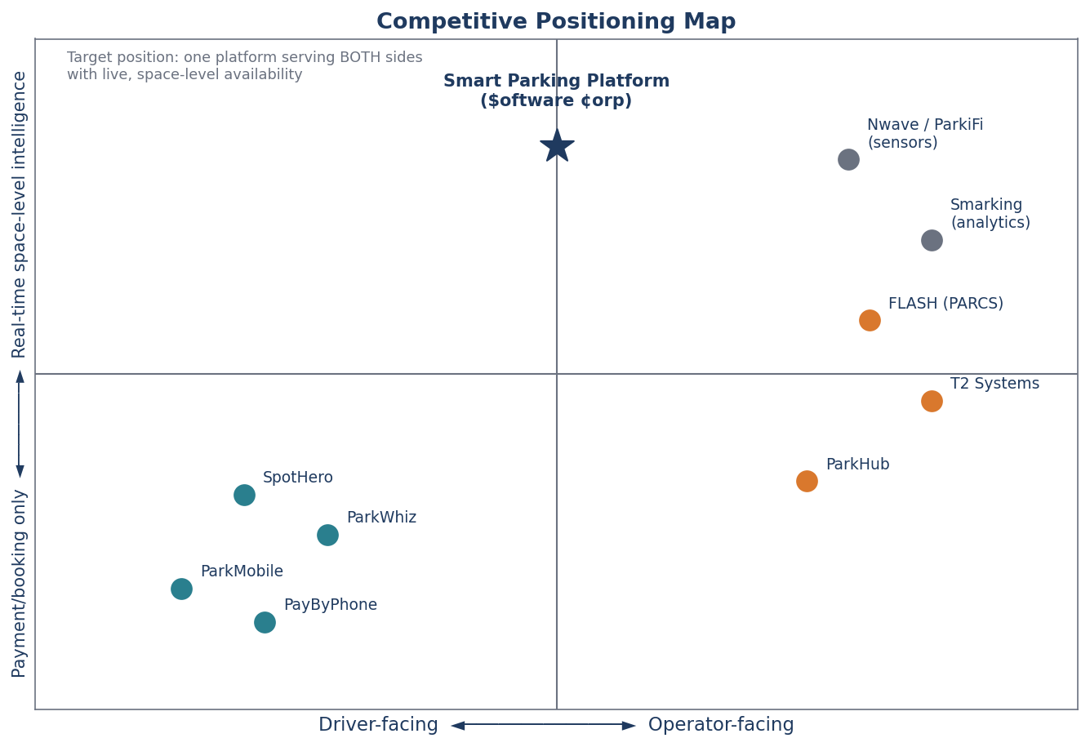
Figure 1. Competitive placement map: existing products cluster as either driver-facing booking tools or operator-facing control systems; the Smart Parking Platform targets the unoccupied center with real-time, space-level intelligence for both sides.

3.2 Competitor Profiles
Competitor | Segment / Focus | Strengths | Weaknesses and Limitations
SpotHero | Driver-facing garage and lot reservation marketplace across North America (7,000+ locations). | Largest garage marketplace; book-ahead pricing with average savings of about 30% versus drive-up rates; guaranteed-spot messaging. | Does not control facility inventory, so drivers report arriving to “Lot Full” signs or attendants refusing third-party reservations; access codes failing at gates; prices rising between search and checkout; support limited to chat.
ParkWhiz (Arrive) | Driver-facing reservations near venues and airports; event parking. | Simple, fast booking flow; strong event-day coverage; discounts up to 50%. | Garages fail to recognize reservations; surge pricing can double rates on event days; refunds take 10 to 15 business days; narrow check-in windows.
ParkMobile | Driver-facing mobile payment for on-street meters and municipal lots (1.5M+ spaces). | Largest zone footprint in U.S. cities; the default option for many municipalities; hourly session extension. | Street-focused with limited garage pre-booking; a $0.35 convenience fee on small meter payments; phantom sessions from GPS drift; failed stop commands that keep charging.
PayByPhone | Driver-facing meter payment; official partner in many U.S. and European cities. | Deep municipal integration; auto-extend sessions. | Expiration alerts fire only minutes before expiry; city-wide outages at peak hours; stale rate displays; account lockouts after card declines.
FLASH (FlashParking) | Operator-facing PARCS: kiosks, gates, LPR cameras, cloud management, business-intelligence dashboards. | Full-stack access and revenue control; camera-based “Flex Mode” entry; reports operators gain about 22% more daily revenue per spot; multi-facility portfolios. | Hardware-centric and capital-intensive; reaches drivers only by pushing inventory to partner apps; opaque pricing and long implementation timelines.
T2 Systems | Enterprise PARCS plus permits and enforcement for operators, municipalities, and universities. | Enterprise-grade multi-facility management; lane hardware integration; permit and citation workflows. | Primarily institutional; no consumer-grade driver experience; enforcement focus is outside garage-reservation use cases.
ParkHub | Operator-facing event and high-volume venue parking management. | Optimized for stadiums, arenas, and event surges; point-of-sale and pre-sold passes. | Narrow event focus; limited everyday commuter and monthly-permit functionality.
Nwave / ParkiFi / Smarking | Sensor and analytics vendors supplying occupancy data and demand forecasting. | Space-level occupancy sensing; utilization analytics and forecasting. | Data-only products that must be paired with separate booking and payment systems; no driver-facing app.

3.3 How the Smart Parking Platform Is Different
Differentiator | What it means for drivers | What it means for operators
One inventory, end to end | A reservation is the same record the gate reads; arrival is confirmed by LPR or QR code with no attendant intervention. | No double-booking between a marketplace and a pay station; one reconciliation report.
Live space-level availability | Search results show the number of free spaces and a “last updated” timestamp, not just open/closed. | Occupancy dashboards update within seconds of every entry and exit; alerts when a facility nears capacity.
All-in pricing up front | The price shown in search is the price charged, including taxes and fees. | Rates, surcharges, and dynamic-pricing rules are configured once and applied consistently across app, web, and on-site.
Built for both sides | One app for hourly, daily, event, and monthly parking across every facility on the platform. | Facility configuration, reservations, pricing, reporting, and staff roles in a single dashboard, with a role for finance/billing.
Open, adapter-based integrations | Navigation hand-off to the driver’s preferred maps app. | Works with existing gate and LPR hardware from multiple vendors; publishes open occupancy data to city transportation departments.

4. Overall Description

4.1 Product Perspective
The Smart Parking Platform is a new, cloud-hosted system composed of native mobile apps, a responsive web application, a backend/API layer, and an operator dashboard. It exchanges data with four classes of external systems: third-party payment providers, mapping and navigation services, garage hardware (gates, LPR cameras, occupancy sensors), and city transportation departments that consume open occupancy data.
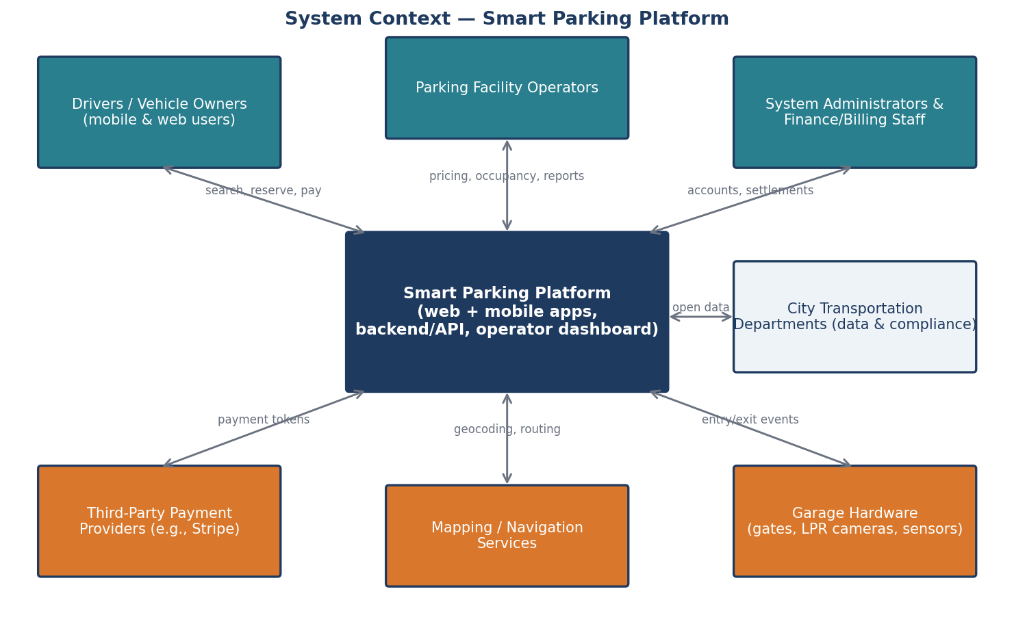
Figure 2. System context diagram showing the Smart Parking Platform, its user groups (teal), and the external systems it integrates with (orange).

4.2 User Classes and Stakeholders
Stakeholder / User Class | Role in the System | Primary Needs
Drivers and vehicle owners | End users of the mobile and web apps. | Find a guaranteed space quickly, know the total price up front, navigate to the entrance, enter without friction, get a receipt.
Mobile application users | Subset of drivers who rely on the iOS/Android app, often while in transit. | Fast, low-tap flows; reliable push notifications; offline access to an active reservation and QR code.
Parking facility operators | Primary paying customer; manage one or more facilities. | Configure rates and capacity, watch live occupancy, manage reservations and incidents, maximize utilization and revenue.
Finance and billing personnel | Operator staff who reconcile revenue and handle refunds. | Accurate daily settlement reports, refund tools, tax breakdowns, exports to accounting software.
System administrators | $oftware ¢orp and client IT staff who run the platform. | Role-based access control, audit logs, integration health monitoring, configuration management.
City transportation departments | External consumers of aggregated occupancy data; regulators. | Open data feeds for congestion planning; assurance of compliance with local ordinances.
Third-party payment providers | External system handling card processing and PCI scope. | Well-formed API calls, tokenized card data, webhook acknowledgements.

4.3 Operating Environment
- Mobile: native applications for iOS 16+ and Android 12+, distributed through the Apple App Store and Google Play.
- Web: responsive single-page application supporting the two most recent versions of Chrome, Safari, Edge, and Firefox.
- Backend: cloud-hosted (AWS or Azure) containerized services with a managed relational database and a message queue for hardware events.
- Facility edge: gate controllers and LPR cameras communicate with the backend over HTTPS/webhooks; a local edge service buffers events during connectivity loss.

4.4 Execution Constraints
- Budget: theoretically unlimited for this engagement, so technical decisions are optimized for quality and time rather than cost.
- Timeline: fixed to the academic semester; the final project document is due December 4, 2026, and interim milestones are delivered weekly.
- Third-party dependence: payment, mapping, and hardware integrations rely on external APIs whose availability and terms are outside the project’s control.
- Compliance: PCI-DSS (via the payment provider), Texas and City of Houston ordinances governing parking and consumer payments, ADA accessibility for the apps and web (WCAG 2.1 AA), and applicable data-privacy requirements for personal and vehicle data.

5. Functional Requirements
Functional requirements describe what the system shall do. They are grouped by the high-level requirement areas identified in the project brief; each will be traced to one or more use cases in Section 7 and to work items in the project tracker.

5.1 Accounts & Authentication
ID | Requirement
FR-1 | The system shall allow a driver to create an account using an email address and password, or through Apple or Google sign-in, in no more than 3 steps.
FR-2 | The system shall allow a driver to register up to 5 vehicles (license plate, state, make, model, color) and designate one as default.
FR-3 | The system shall provide role-based accounts for operator staff (Operator Admin, Facility Manager, Finance, Attendant) and platform administrators.
FR-4 | The system shall support multi-factor authentication for all operator and administrator roles.

5.2 Availability & Map
ID | Requirement
FR-5 | The system shall display facilities on an interactive map and in a list, filtered by distance, price, availability, vehicle-size restrictions, and amenities (covered, EV charging, 24/7).
FR-6 | The system shall show, for every facility, the number of available spaces and the time the count was last updated.
FR-7 | The system shall update facility availability from gate entry/exit events and, where installed, occupancy sensors.
FR-8 | The system shall hand off turn-by-turn navigation to the facility entrance to the driver’s preferred external maps application.

5.3 Reservations
ID | Requirement
FR-9 | The system shall allow a driver to reserve a space for an hourly, daily, event, or monthly-permit period and shall display the all-in price (rate, taxes, and fees) before confirmation.
FR-10 | The system shall hold inventory for a confirmed reservation so that the same space count cannot be sold twice.
FR-11 | The system shall allow a driver to modify or cancel a reservation subject to the facility’s cancellation policy and shall calculate any refund automatically.
FR-12 | The system shall allow a driver to extend an active session from the app when capacity permits.
FR-13 | The system shall generate a QR code and register the vehicle’s license plate for each reservation so entry can be validated by scanner or LPR camera.

5.4 Payments & Receipts
ID | Requirement
FR-14 | The system shall process payments through a PCI-compliant third-party provider supporting major credit/debit cards, Apple Pay, and Google Pay, and shall never store raw card numbers.
FR-15 | The system shall issue an itemized digital receipt by email and in-app for every completed transaction and shall keep reservation history for at least 24 months.
FR-16 | The system shall allow finance staff to issue full or partial refunds and shall record the reason and the staff member for each refund.

5.5 Operator Dashboard
ID | Requirement
FR-17 | The system shall allow an Operator Admin to create and configure facilities: address, capacity, hours, vehicle restrictions, amenities, and entrance coordinates.
FR-18 | The system shall allow operators to define rate schedules (hourly, daily, event, monthly) and optional dynamic-pricing rules with operator-set floor and ceiling prices.
FR-19 | The system shall display a live occupancy dashboard for each facility and for the operator’s portfolio, with configurable alerts when occupancy exceeds a threshold.
FR-20 | The system shall allow operators to view, search, and manually override reservations (e.g., honor a reservation when a scanner fails) with an audit trail.
FR-21 | The system shall generate occupancy, revenue, and utilization reports by facility, date range, and rate type, exportable to CSV and PDF, and shall automatically email a weekly summary to designated staff.

5.6 Notifications
ID | Requirement
FR-22 | The system shall send reservation confirmations, arrival reminders, expiration warnings (at 30 and 10 minutes), and receipts via push notification, SMS, or email according to the driver’s preferences.
FR-23 | The system shall alert operators when a gate or camera integration stops reporting events for more than 5 minutes.

5.7 Integrations & Administration
ID | Requirement
FR-24 | The system shall provide a documented API and webhook interface for gate controllers and LPR cameras to report entry/exit events and to request entry authorization.
FR-25 | The system shall publish an anonymized, aggregated occupancy data feed that city transportation departments can consume.
FR-26 | The system shall log all administrative and financial actions with user, timestamp, and before/after values, retained for at least 12 months.

6. Non-Functional Requirements
Non-functional requirements describe how the system shall be. Each is stated with a measurable target so that it can be verified by the QA team; none uses an absolute (0% or 100%) commitment.
ID | Category | Requirement
NFR-1 | Performance | Search results for a map viewport containing up to 200 facilities shall load within 2 seconds on a 4G connection at the 95th percentile.
NFR-2 | Performance | Facility availability shown to drivers shall reflect gate and sensor events within 5 seconds of the event reaching the backend.
NFR-3 | Performance | Gate entry authorization requests shall receive a response within 1 second at the 99th percentile so that vehicles are not delayed at the lane.
NFR-4 | Availability | The platform shall provide 99.9% monthly uptime for driver-facing services and 99.95% for the gate-authorization API, excluding announced maintenance windows.
NFR-5 | Reliability | Facility edge services shall buffer at least 24 hours of gate events locally and synchronize automatically when connectivity is restored.
NFR-6 | Scalability | The system shall support at least 10,000 concurrent app users and 500 facilities without degradation of NFR-1 through NFR-3, with horizontal scaling to 10× those figures.
NFR-7 | Security | All data in transit shall be encrypted with TLS 1.2 or higher and all personal and vehicle data at rest with AES-256; card data shall be tokenized by the payment provider so the platform remains out of PCI-DSS card-data scope.
NFR-8 | Security | Operator and administrator sessions shall expire after 30 minutes of inactivity and shall require multi-factor authentication.
NFR-9 | Usability | A returning driver shall be able to complete a reservation for a previously used facility in no more than 4 taps from the app home screen.
NFR-10 | Usability | A new driver shall be able to complete registration and a first reservation in under 3 minutes in usability testing with at least 8 of 10 participants succeeding without assistance.
NFR-11 | Accessibility | The mobile and web applications shall conform to WCAG 2.1 Level AA, including screen-reader labels and minimum 4.5:1 text contrast.
NFR-12 | Compatibility | The apps shall support iOS 16+ and Android 12+ and the web application the two most recent major versions of Chrome, Safari, Edge, and Firefox.
NFR-13 | Bandwidth | The mobile app shall function on connections as slow as 1 Mbps, and an active reservation with its QR code shall remain viewable with no connectivity.
NFR-14 | Maintainability | Facility hardware integrations shall be implemented as pluggable adapters so that a new gate or camera vendor can be supported without changes to core services; automated test coverage of core services shall be at least 80%.
NFR-15 | Compliance | The platform shall comply with applicable Texas and City of Houston ordinances for parking and consumer payments and shall provide data-export and deletion tools for driver personal data on request within 30 days.
NFR-16 | Data retention | Transaction records shall be retained for at least 7 years for financial audit; personal data no longer needed shall be anonymized after 24 months of account inactivity.

7. Use Cases
The following use cases were synthesized from stakeholder user stories gathered across the hierarchy (drivers, attendants, facility managers, finance staff, and administrators) rather than from management alone. Each use case states its actor, precondition, ordered steps, and postcondition. Eighteen use cases are defined in this version: ten for end users (drivers) and eight for operators, finance, and administrators. The list will grow in later versions.

7.1 End-User (Driver) Use Cases
UC-1 | Register account and add a vehicle
Actor | Driver
Precondition | Driver has installed the mobile app or opened the web app and has a valid email address.
Steps | 1. Driver selects “Create account” and enters email and password, or chooses Apple/Google sign-in.  2. System sends a verification code; driver enters it.  3. Driver enters license plate, state, and vehicle details and saves the vehicle as default.  4. System confirms the account is active and shows the map home screen.
Postcondition | A verified driver account exists with one default vehicle.
Alternate / Exceptions | If the plate is already registered to another account, the system asks the driver to confirm ownership via email before proceeding.

UC-2 | Search for available parking near a destination
Actor | Driver
Precondition | Driver is logged in and has granted location permission or entered a destination address.
Steps | 1. Driver enters a destination or uses current location and selects arrival date/time and duration.  2. System displays facilities on the map and in a list with available-space counts, all-in prices, distance, and “last updated” time.  3. Driver applies filters (price, covered, EV charging, vehicle height).  4. Driver taps a facility to view details, photos, hours, and entrance instructions.
Postcondition | Driver has identified a facility with confirmed availability for the requested time.
Alternate / Exceptions | If no facilities have availability, the system shows the nearest alternatives and offers a waitlist notification.

UC-3 | Reserve a parking space
Actor | Driver
Precondition | Driver has selected a facility with available spaces for the chosen time window and has a saved payment method (or will add one).
Steps | 1. Driver taps “Reserve” and confirms vehicle, arrival time, and duration.  2. System shows the itemized total (rate, taxes, fees) and the cancellation policy.  3. Driver confirms; system holds the inventory and charges the payment method.  4. System issues a confirmation with a QR code and registers the plate for LPR entry; confirmation is sent by push and email.
Postcondition | A confirmed reservation exists, inventory is decremented, payment is captured, and the driver holds a QR code.
Alternate / Exceptions | If payment fails, the hold is released after 5 minutes and the driver is prompted to try another method.

UC-4 | Navigate to the facility entrance
Actor | Driver
Precondition | Driver has an upcoming or active reservation.
Steps | 1. Driver opens the reservation and taps “Navigate.”  2. System opens the driver’s preferred maps app with the facility’s entrance coordinates (not the postal address).  3. Driver follows directions; system sends an arrival reminder 15 minutes before the reservation start.
Postcondition | Driver arrives at the correct entrance.
Alternate / Exceptions | If no maps app is installed, the system shows in-app directions and the entrance description.

UC-5 | Enter the facility with a reservation
Actor | Driver
Precondition | Driver has a confirmed reservation starting within the facility’s early-arrival window and is at the entry lane.
Steps | 1. LPR camera reads the plate and requests authorization from the platform.  2. System validates the reservation and instructs the gate to open within 1 second.  3. If LPR fails, driver scans the QR code at the reader.  4. System records the entry event, starts the session, and updates facility availability.
Postcondition | Vehicle is inside; the session is active; occupancy is updated.
Alternate / Exceptions | If neither LPR nor QR succeeds, the driver presses the intercom and the attendant validates the reservation from the dashboard (see UC-15).

UC-6 | Extend an active parking session
Actor | Driver
Precondition | Driver has an active session and the facility has capacity for the extension period.
Steps | 1. System notifies the driver 30 and 10 minutes before expiry.  2. Driver taps “Extend” and selects the additional time.  3. System checks capacity, shows the additional charge, and charges the saved payment method.  4. System updates the reservation end time and the LPR/QR authorization.
Postcondition | The session end time is extended and the additional payment is captured.
Alternate / Exceptions | If capacity is unavailable, the system explains the overstay rate that will apply and offers nearby alternatives.

UC-7 | Modify or cancel a reservation
Actor | Driver
Precondition | Driver has an upcoming reservation that has not started.
Steps | 1. Driver opens the reservation and chooses “Change time” or “Cancel.”  2. System displays the facility’s policy and the refund or price difference that applies.  3. Driver confirms.  4. System releases or re-holds inventory, processes the refund or charge, and sends an updated confirmation.
Postcondition | The reservation is updated or cancelled and inventory and payment are reconciled.
Alternate / Exceptions | Cancellations inside the non-refundable window are confirmed with a clear $0 refund message before completion.

UC-8 | View reservation history and download a receipt
Actor | Driver
Precondition | Driver is logged in and has at least one completed transaction.
Steps | 1. Driver opens “History.”  2. System lists past reservations with facility, date, duration, and amount.  3. Driver selects a transaction and taps “Receipt.”  4. System displays the itemized receipt and offers PDF download or email.
Postcondition | Driver has an itemized receipt suitable for expense reporting.

UC-9 | Purchase a monthly permit
Actor | Driver (commuter)
Precondition | Driver is logged in and the facility offers monthly permits with capacity available.
Steps | 1. Driver selects a facility and chooses “Monthly permit.”  2. System shows price, access hours, and auto-renewal terms.  3. Driver confirms and payment is captured; plate is registered for the permit period.  4. System issues the permit and schedules renewal reminders 7 days before each term.
Postcondition | An active monthly permit is associated with the driver’s vehicle and renews per the chosen terms.
Alternate / Exceptions | If permit capacity is full, the driver can join a waitlist and is notified when a permit becomes available.

UC-10 | Manage notification preferences
Actor | Driver
Precondition | Driver is logged in.
Steps | 1. Driver opens “Settings → Notifications.”  2. Driver toggles push, SMS, and email for each event type (confirmations, reminders, expirations, receipts, promotions).  3. System saves the preferences and confirms.
Postcondition | Notifications are delivered only through the channels the driver selected.

7.2 Operator, Finance, and Administrator Use Cases
UC-11 | Configure a new facility
Actor | Operator Admin
Precondition | Operator Admin is logged in with MFA and has facility data (address, capacity, hours, restrictions).
Steps | 1. Admin selects “Add facility” in the dashboard.  2. Admin enters name, address, entrance coordinates, total capacity, hours, vehicle restrictions, and amenities.  3. Admin uploads photos and entrance instructions.  4. Admin links the facility’s gate/LPR integration credentials and runs the connection test.  5. Admin publishes the facility.
Postcondition | The facility is live in the driver apps with the configured capacity and is receiving hardware events.
Alternate / Exceptions | If the connection test fails, the facility can be saved as a draft while the integration is resolved.

UC-12 | Set rates and dynamic-pricing rules
Actor | Facility Manager
Precondition | Facility exists and the manager has the Facility Manager role.
Steps | 1. Manager opens the facility’s “Pricing” tab.  2. Manager defines hourly, daily, event, and monthly rate schedules, including taxes and fees.  3. Manager optionally enables dynamic pricing with a floor, a ceiling, and occupancy or event triggers.  4. Manager previews the price a driver would see for sample times and saves.  5. System applies the new rates to new reservations from the effective date.
Postcondition | Rates are active and every driver-facing price reflects them, all-in.
Alternate / Exceptions | Changes do not affect already-confirmed reservations; the system flags the number of future reservations at old rates.

UC-13 | Monitor live occupancy and receive capacity alerts
Actor | Facility Manager
Precondition | Facility is publishing gate/sensor events.
Steps | 1. Manager opens the occupancy dashboard for one facility or the whole portfolio.  2. System displays current occupancy, available spaces, reservations arriving in the next hour, and a 24-hour trend.  3. Manager sets an alert threshold (e.g., 90%).  4. When the threshold is crossed, the system sends a push/email alert and, if enabled, pauses new same-day reservations.
Postcondition | Manager has real-time visibility and is alerted before the facility fills.
Alternate / Exceptions | If events stop arriving for 5 minutes, the dashboard flags the facility as “stale” and an integration alert is sent (FR-23).

UC-14 | Generate occupancy and revenue reports
Actor | Facility Manager / Finance
Precondition | At least one day of transaction and event data exists.
Steps | 1. User opens “Reports” and selects report type, facilities, date range, and grouping (day, rate type).  2. System renders charts and tables of occupancy, revenue, average duration, and reservation counts.  3. User exports to CSV or PDF, or schedules the report to be emailed weekly.
Postcondition | The report is available on screen, exported, or scheduled.

UC-15 | Resolve an entry problem at the gate
Actor | Attendant
Precondition | A driver at the entry lane has pressed the intercom because LPR and QR validation failed.
Steps | 1. Attendant opens the “Lane assist” view and searches by plate, name, or confirmation number.  2. System shows the reservation status and the reason validation failed (e.g., plate mismatch, early arrival).  3. Attendant corrects the plate or overrides and opens the gate; the override reason is recorded.  4. System starts the session normally.
Postcondition | The driver is admitted, the session is active, and an audit entry records the override.
Alternate / Exceptions | If no reservation exists, the attendant can sell a drive-up session at the posted rate from the same screen.

UC-16 | Issue a refund
Actor | Finance
Precondition | A completed or cancelled transaction exists and a refund request has been received.
Steps | 1. Finance user searches for the transaction.  2. System displays the amount paid, the applicable policy, and any partial refunds already issued.  3. Finance user enters the refund amount and reason and confirms.  4. System instructs the payment provider to refund, updates the receipt, and notifies the driver.
Postcondition | The refund is processed within the provider’s settlement window and is visible in the daily settlement report.
Alternate / Exceptions | Refunds above a configurable limit require a second approval from an Operator Admin.

UC-17 | Reconcile daily settlement
Actor | Finance
Precondition | The day’s transactions have been captured by the payment provider.
Steps | 1. Finance user opens the daily settlement report.  2. System lists gross revenue, taxes, fees, refunds, and net payout per facility, matched against the payment provider’s settlement file.  3. Finance user reviews discrepancies flagged by the system and marks the day as reconciled or opens a dispute.  4. User exports the report to the accounting system.
Postcondition | The day is reconciled and exported; discrepancies are tracked to resolution.

UC-18 | Manage staff roles and review the audit log
Actor | System Administrator / Operator Admin
Precondition | Administrator is logged in with MFA.
Steps | 1. Admin opens “Users & roles,” invites a staff member by email, and assigns a role (Operator Admin, Facility Manager, Finance, Attendant) and facilities.  2. Invitee accepts and sets up MFA.  3. Admin later opens the audit log, filters by user, action, or date, and reviews before/after values for configuration or financial changes.
Postcondition | Staff access is limited to their role and facilities, and all sensitive actions are traceable.
Alternate / Exceptions | Removing a user immediately revokes sessions and API tokens.

7.3 Use-Case Coverage Summary
Actor group | Use cases | Count
Drivers / end users (including mobile users and commuters) | UC-1 to UC-10 | 10
Operators (Operator Admin, Facility Manager, Attendant) | UC-11, UC-12, UC-13, UC-14, UC-15, UC-18 | 6
Finance and billing personnel | UC-14, UC-16, UC-17 | 3
System administrators | UC-18 | 1
Total distinct use cases |  | 18

8. Work Breakdown Structure
This section decomposes the Smart Parking Platform into a three-level Work Breakdown Structure (WBS). The WBS was derived top-down from the use cases and requirements in Sections 5 and 7: Level 1 groups the system into nine major modules, Level 2 breaks each module into deliverables (functional entities that can be built and tested as a unit), and Level 3 lists the work items required to complete each deliverable. Following the guidance from Lecture 3, Levels 1 and 2 are organized around deliverables rather than activities, and the structure stops at three levels because a fourth level would describe individual tasks that belong in the sprint backlog, where the management overhead of tracking them in the WBS would outweigh the benefit.

8.1 Conventions
Convention | Rule applied in this document
Numbering | Hierarchical decimal numbering (1, 1.1, 1.1.1). New scope discovered later is inserted under the relevant Level-2 deliverable (for example a new item 5.2.4) so that change requests keep a logical home.
Depth | Exactly three levels for every branch. Level 3 is the lowest level and is the level at which effort is estimated.
Deliverable orientation | Level-1 and Level-2 entries are nouns (modules and deliverables). Only Level-3 work items are phrased as work to be performed.
Estimation unit | Story points on the Fibonacci scale (1, 2, 3, 5, 8, 13), assigned only at Level 3 and rolled up to Levels 2 and 1. Points express relative complexity, risk and effort, not hours.
Baseline item | Item 7.2.1, the notification preference screen, is the simplest item in the project and defines 1 story point. Every other item was sized by comparison to it and to its neighbours.
Traceability | Each Level-1 module lists the functional requirements (FR), non-functional requirements (NFR), assumptions (A) and use cases (UC) it implements; each Level-3 item names its source requirement or lecture rationale.
Status | Draft v2.0. Points and structure will be refined weekly as estimates are validated in later assignments.

8.2 WBS Overview (Levels 1 to 2)
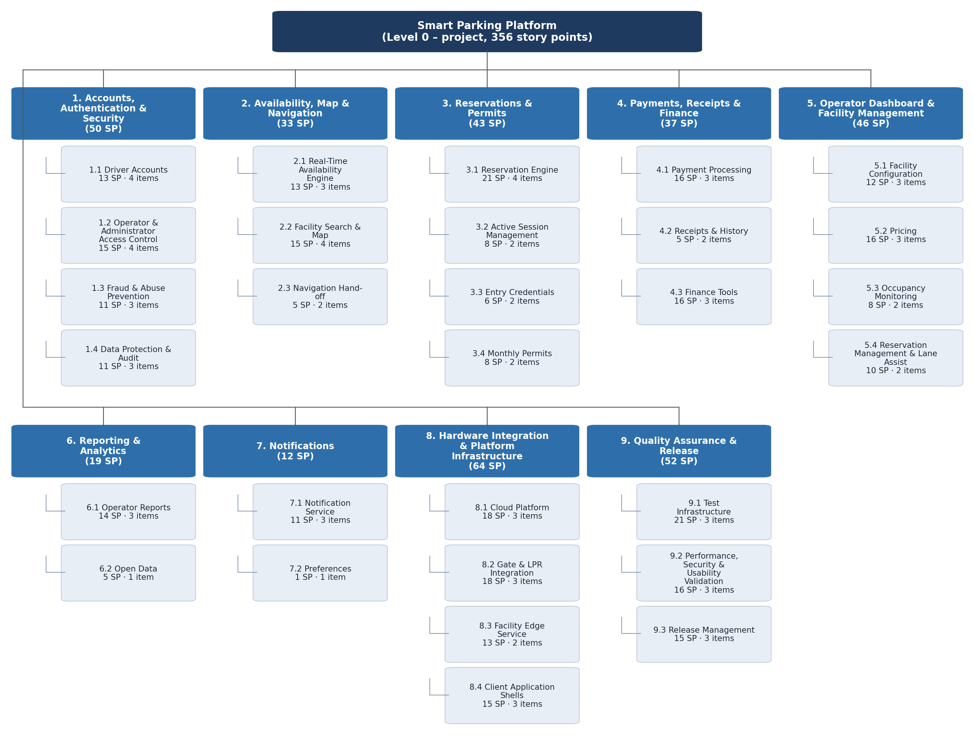
Figure 3. Work Breakdown Structure, Levels 0 to 2. Each Level-2 box shows its rolled-up story points and the number of Level-3 work items listed in Table 8-1.

8.3 Full Work Breakdown Structure (Levels 1 to 3)
Table 8-1 is the complete WBS. Shaded rows are Level-1 modules (dark) and Level-2 deliverables (light); unshaded rows are Level-3 work items with their story-point estimate and the requirement, use case or lecture rationale that justifies them.
Table 8-1. Work Breakdown Structure with story-point estimates.
ID | Module / Deliverable / Work item | SP | Trace / rationale
1 | Accounts, Authentication & Security | 50 | FR-1 to FR-4, FR-26, NFR-7/8/15; UC-1, UC-18
1.1 | Driver Accounts | 13 | 4 work items
1.1.1 | Email/password registration with verification code | 3 | UC-1 steps 1 to 2; standard but touches email service
1.1.2 | Apple and Google sign-in (OAuth) | 5 | Two third-party identity providers, app-store review rules
1.1.3 | Vehicle profiles (up to 5, default vehicle, plate-ownership check) | 3 | FR-2; CRUD plus duplicate-plate exception
1.1.4 | Password reset and account recovery | 2 | Well-understood pattern
1.2 | Operator & Administrator Access Control | 15 | 4 work items
1.2.1 | Role and permission model (Operator Admin, Facility Manager, Finance, Attendant, Platform Admin) | 5 | FR-3; permissions scoped per facility
1.2.2 | Staff invitation and facility assignment | 3 | UC-18 steps 1 to 2
1.2.3 | Multi-factor authentication and 30-minute session expiry | 5 | FR-4, NFR-8; MFA provider integration
1.2.4 | Immediate session and API-token revocation on user removal | 2 | UC-18 exception
1.3 | Fraud & Abuse Prevention | 11 | 3 work items
1.3.1 | Bot and duplicate-account defenses (rate limiting, CAPTCHA, device checks) | 5 | Lecture 3 'bot army' risk; unknowns in tuning
1.3.2 | Verified payment method with name match required before first reservation | 3 | Depends on 4.1; policy logic
1.3.3 | Per-account reservation limits and no-show rules | 3 | Business rules plus enforcement
1.4 | Data Protection & Audit | 11 | 3 work items
1.4.1 | Encryption in transit (TLS 1.2+) and at rest (AES-256), key management | 3 | NFR-7; mostly configuration
1.4.2 | Personal-data export and deletion tools | 3 | NFR-15; touches every data store
1.4.3 | Audit log service with before/after values (12-month retention) | 5 | FR-26; cross-cutting hook into all admin actions
2 | Availability, Map & Navigation | 33 | FR-5 to FR-8, NFR-1/2; UC-2, UC-4
2.1 | Real-Time Availability Engine | 13 | 3 work items
2.1.1 | Occupancy counter service consuming gate and sensor events | 8 | NFR-2 5-second freshness; concurrency and event ordering risk
2.1.2 | 'Last updated' staleness tracking and degraded-mode flag | 2 | A-1 fallback
2.1.3 | Waitlist notification when no availability | 3 | UC-2 exception
2.2 | Facility Search & Map | 15 | 4 work items
2.2.1 | Map provider integration (Google Maps Platform / Mapbox) and geocoding | 5 | A-4; secondary provider fallback
2.2.2 | Search by destination or current location with arrival time and duration | 5 | UC-2 steps 1 to 2; NFR-1 2-second target
2.2.3 | Filters (price, distance, covered, EV, height, 24/7) and list view | 3 | FR-5
2.2.4 | Facility detail page (photos, hours, entrance instructions) | 2 | UC-2 step 4
2.3 | Navigation Hand-off | 5 | 2 work items
2.3.1 | Deep link to Google Maps, Apple Maps and Waze with entrance coordinates | 3 | FR-8; three platforms
2.3.2 | In-app fallback directions and entrance description | 2 | UC-4 exception
3 | Reservations & Permits | 43 | FR-9 to FR-13, NFR-9/13; UC-3, UC-6, UC-7, UC-9
3.1 | Reservation Engine | 21 | 4 work items
3.1.1 | Inventory hold and double-sell prevention | 8 | FR-10; core transactional logic, highest business risk
3.1.2 | Hourly, daily and event booking flow with all-in price display | 5 | UC-3; NFR-9 4-tap flow
3.1.3 | Cancellation-policy engine and automatic refund calculation | 5 | FR-11; per-facility policies
3.1.4 | Modify or cancel reservation flow | 3 | UC-7
3.2 | Active Session Management | 8 | 2 work items
3.2.1 | Session extension with capacity check and additional charge | 5 | UC-6, FR-12
3.2.2 | Overstay rate handling and nearby alternatives | 3 | UC-6 exception
3.3 | Entry Credentials | 6 | 2 work items
3.3.1 | QR code generation with offline caching | 3 | FR-13, NFR-13
3.3.2 | License-plate registration for LPR authorization | 3 | FR-13; links to 8.2
3.4 | Monthly Permits | 8 | 2 work items
3.4.1 | Permit purchase with auto-renewal terms | 5 | UC-9; recurring billing
3.4.2 | Permit waitlist and 7-day renewal reminders | 3 | UC-9 exception
4 | Payments, Receipts & Finance | 37 | FR-14 to FR-16, NFR-16; UC-8, UC-16, UC-17
4.1 | Payment Processing | 16 | 3 work items
4.1.1 | Payment-provider integration (card tokenization, PCI scope kept at provider) | 8 | A-3, FR-14; third-party API, webhooks, failure modes
4.1.2 | Apple Pay and Google Pay | 5 | Two wallet integrations with platform certification
4.1.3 | Saved payment methods and failed-payment retry (5-minute hold release) | 3 | UC-3 exception
4.2 | Receipts & History | 5 | 2 work items
4.2.1 | Itemized receipt generation (in-app, email, PDF) | 3 | FR-15, UC-8
4.2.2 | Reservation history with 24-month retention | 2 | FR-15
4.3 | Finance Tools | 16 | 3 work items
4.3.1 | Refund workflow with reason, actor and second approval above limit | 5 | UC-16, FR-16
4.3.2 | Daily settlement reconciliation against provider settlement file | 8 | UC-17; file matching, discrepancy handling
4.3.3 | Export to accounting system | 3 | UC-17 step 4
5 | Operator Dashboard & Facility Management | 46 | FR-17 to FR-20; UC-11, UC-12, UC-13, UC-15
5.1 | Facility Configuration | 12 | 3 work items
5.1.1 | Add, edit and remove facility (address, capacity, hours, restrictions, amenities, entrance coordinates) | 5 | FR-17, UC-11
5.1.2 | Photo and entrance-instruction upload | 2 | UC-11 step 3
5.1.3 | Hardware credential linking, connection test and draft state | 5 | UC-11 steps 4 to 5 and exception
5.2 | Pricing | 16 | 3 work items
5.2.1 | Rate schedules (hourly, daily, event, monthly) including taxes and fees | 5 | FR-18, UC-12
5.2.2 | Dynamic-pricing rules with floor, ceiling and occupancy/event triggers | 8 | FR-18; rules engine, high risk of edge cases
5.2.3 | Price preview and effective-date handling for existing reservations | 3 | UC-12 steps 4 to 5 and exception
5.3 | Occupancy Monitoring | 8 | 2 work items
5.3.1 | Live facility and portfolio occupancy dashboard with 24-hour trend | 5 | FR-19, UC-13
5.3.2 | Threshold alerts and optional pause of same-day reservations | 3 | UC-13 steps 3 to 4
5.4 | Reservation Management & Lane Assist | 10 | 2 work items
5.4.1 | Reservation search and manual override with audit trail | 5 | FR-20
5.4.2 | Lane-assist view for attendants including drive-up sale | 5 | UC-15
6 | Reporting & Analytics | 19 | FR-21, FR-25; UC-14
6.1 | Operator Reports | 14 | 3 work items
6.1.1 | Occupancy, revenue and utilization reports by facility, date range and rate type | 8 | FR-21, UC-14; aggregation queries over large data
6.1.2 | CSV and PDF export | 3 | FR-21
6.1.3 | Scheduled weekly email summary | 3 | FR-21
6.2 | Open Data | 5 | 1 work items
6.2.1 | Anonymized, aggregated occupancy feed for city transportation departments | 5 | FR-25; anonymization rules
7 | Notifications | 12 | FR-22, FR-23; UC-10
7.1 | Notification Service | 11 | 3 work items
7.1.1 | Multi-channel delivery service (push, SMS, email) | 5 | Three providers, retry logic
7.1.2 | Driver event templates (confirmation, arrival reminder, 30/10-minute expiry, receipt) | 3 | FR-22
7.1.3 | Operator integration-health alerts after 5 minutes of silence | 3 | FR-23
7.2 | Preferences | 1 | 1 work items
7.2.1 | Notification preference screen (per-channel, per-event toggles) | 1 | UC-10 — BASELINE: simplest item in the WBS
8 | Hardware Integration & Platform Infrastructure | 64 | FR-24, NFR-3/4/5/6/12/14; A-1, A-2; UC-5
8.1 | Cloud Platform | 18 | 3 work items
8.1.1 | Cloud environment, containers, managed relational database and message queue | 8 | Foundation for everything; NFR-6 scaling design
8.1.2 | CI/CD pipeline and dev/stage/prod environments | 5 | Enables interleaved testing
8.1.3 | Monitoring, logging and uptime alerting | 5 | NFR-4 99.9%/99.95% targets
8.2 | Gate & LPR Integration | 18 | 3 work items
8.2.1 | Public API and webhook specification for entry/exit events and entry authorization | 5 | FR-24; documentation deliverable
8.2.2 | Pluggable vendor adapters for gate controllers and LPR cameras | 8 | NFR-14, A-2; unknown vendor behaviour
8.2.3 | Sub-1-second entry authorization path | 5 | NFR-3, UC-5 gate entry; performance-critical
8.3 | Facility Edge Service | 13 | 2 work items
8.3.1 | Local event buffering (24 hours) and synchronization on reconnect | 8 | NFR-5, A-1; distributed-systems risk
8.3.2 | Occupancy sensor ingestion | 5 | FR-7
8.4 | Client Application Shells | 15 | 3 work items
8.4.1 | iOS application shell and App Store setup | 5 | NFR-12
8.4.2 | Android application shell and Google Play setup | 5 | NFR-12
8.4.3 | Responsive web SPA shell with accessibility baseline (WCAG 2.1 AA) | 5 | NFR-11/12
9 | Quality Assurance & Release | 52 | NFR-6/10/11/14; A-5
9.1 | Test Infrastructure | 21 | 3 work items
9.1.1 | Unit-test framework with 80% coverage gate in CI | 5 | NFR-14; runs from sprint 1 (lecture: unit tests as safety net)
9.1.2 | Integration test suite (payments, hardware adapters, notifications) | 8 | Third-party sandboxes, hardware simulators
9.1.3 | End-to-end device test suite (iOS, Android, web) | 8 | Device farm, three platforms
9.2 | Performance, Security & Usability Validation | 16 | 3 work items
9.2.1 | Stress-test harness (10,000 concurrent users, 500 facilities) | 8 | NFR-6; lecture: 'stress test harness' before launch
9.2.2 | Security review, PCI-scope confirmation and penetration test | 5 | NFR-7; external firm
9.2.3 | Accessibility and usability testing (8 of 10 first-time users) | 3 | NFR-10/11
9.3 | Release Management | 15 | 3 work items
9.3.1 | Pilot at two client facilities with beta feedback loop | 5 | Lecture: iterate on real feedback before big-bang launch
9.3.2 | Client facility data onboarding (14 facilities) and staff training | 5 | A-5 two-week data buffer
9.3.3 | Production launch, app-store publication and handover documentation | 5 | Final delivery milestone
 | Total project | 356 | 9 modules · 29 deliverables · 79 work items

8.4 Story-Point Summary by Module
Level-1 module | L2 | L3 | Story points | Share | Largest single work item (SP)
1. Accounts, Authentication & Security | 4 | 14 | 50 | 14% | Role and permission model (Operator Admin, Facility Manager, Finance, Attendant, Platform Admin) (5)
2. Availability, Map & Navigation | 3 | 9 | 33 | 9% | Occupancy counter service consuming gate and sensor events (8)
3. Reservations & Permits | 4 | 10 | 43 | 12% | Inventory hold and double-sell prevention (8)
4. Payments, Receipts & Finance | 3 | 8 | 37 | 10% | Payment-provider integration (card tokenization, PCI scope kept at provider) (8)
5. Operator Dashboard & Facility Management | 4 | 10 | 46 | 13% | Dynamic-pricing rules with floor, ceiling and occupancy/event triggers (8)
6. Reporting & Analytics | 2 | 4 | 19 | 5% | Occupancy, revenue and utilization reports by facility, date range and rate type (8)
7. Notifications | 2 | 4 | 12 | 3% | Multi-channel delivery service (push, SMS, email) (5)
8. Hardware Integration & Platform Infrastructure | 4 | 11 | 64 | 18% | Pluggable vendor adapters for gate controllers and LPR cameras (8)
9. Quality Assurance & Release | 3 | 9 | 52 | 15% | Stress-test harness (10,000 concurrent users, 500 facilities) (8)
Total | 29 | 79 | 356 | 100%

Two observations shape the schedule in Section 9. First, Module 8 (platform infrastructure and hardware integration) carries the most points and has no predecessors, so it starts first and everything else depends on it. Second, the items rated 8 points (inventory hold, occupancy engine, payment-provider integration, dynamic pricing, edge buffering, vendor adapters, settlement reconciliation, reporting queries, and the stress-test harness) are the project’s principal technical risks; each involves third-party systems, concurrency or unknown vendor behaviour, and each is deliberately scheduled with slack after it.

9. Estimation and Project Timeline
This section converts the WBS into a draft schedule. It states the estimation method and assumptions, defines the project milestones, derives task durations and dependencies from the Level-2 deliverables, and presents the resulting Gantt chart. The schedule is a first draft: it will be refined weekly as estimates are validated, resources are levelled and risks are analysed in later assignments.

9.1 Estimation Approach
Story points were chosen over function points and COCOMO for three reasons. The Smart Parking Platform is greenfield development on a modern three-tier architecture, so lines of code do not track complexity and COCOMO is not appropriate. Function-point analysis requires trained certified counters and is normally supplied by a client for fixed-price Waterfall bids, whereas $oftware ¢orp works in two-week sprints with milestone-based payments. Story points let the team size a new domain (smart parking) relative to itself, which is the method recommended in Lecture 3 when no comparable past project exists. Points were converted to calendar time using the assumptions in Table 9-1; the assumptions are inputs to the accompanying spreadsheet, so changing any of them re-times the entire plan.
Table 9-1. Scheduling assumptions.
Assumption | Value | Basis
Effort per story point | 2 blended developer-days | Includes design, coding, code review, unit tests and sprint ceremonies for a mixed-seniority team; Lecture 3’s example of 1 point = 2 hours applies to a senior developer on a trivial item and was scaled up accordingly.
Team size | 19 engineers + 1 project manager | Backend/API 6, Mobile 3, Web 3, Mapping & Location 2, Payment Integration 2, QA & Testing 3 (the six teams named in Section 2.3). In COCOMO terms a semi-detached project: mixed experience, 20 to 30 people.
Duration of a deliverable | ⌈ story points × 2 ÷ people assigned ⌉ working days | People assigned per deliverable are listed in Table 9-3; a deliverable never has more people than can work on it without coordination overhead (Mythical Man-Month).
Working calendar | Monday to Friday; U.S. holidays Nov 26 and 27, Dec 24 and 25, Dec 31 and Jan 1, Jan 18, Feb 15 excluded
Cushion | 18 working days (18% of the 100-day build), split 5 days before MVP and 13 days before final delivery | Lecture 3 recommends 15 to 20% for a team new to the domain; shown as explicit grey bars so stakeholders can see the buffer being consumed.
Testing | Unit-test framework built in the first sprint (9.1); a 10-day integration and end-to-end window before each of the MVP and Beta milestones | Testing is interleaved with development rather than deferred to a final phase, the main red flag in the Lecture 3 ‘Facebook in six weeks’ case.
Build start | October 19, 2026 | First working day after milestone M1 (requirements and design approved).

9.2 Milestones
The project has five milestones, consistent with the Lecture 3 guidance that milestones are few, large and meaningful and are distinct from sprints. The two payment milestones from the contract (Section 2.2) map directly onto MVP acceptance and final delivery.
Table 9-2. Project milestones.
ID | Milestone | Target date | Definition of done
M0 | Project kickoff / contract award | Sep 8, 2026 | SRS v1.0 issued; 30% kickoff payment.
M1 | Requirements and design approved | Oct 16, 2026 | SRS v3.0 baselined; architecture, data model and UX designs accepted by Bayou City Parking Group. Gate for the build phase.
M2 | MVP acceptance | Feb 17, 2027 | Accounts, search, reservation, payment, gate entry and operator facility setup working end to end at two pilot facilities; 40% payment.
M3 | Beta release | Mar 3, 2027 | All 14 facilities configured; finance tools, reporting, notifications, fraud controls live for invited drivers; stress test and security review signed off.
M4 | Final delivery and handover | Apr 5, 2027 | Public launch on App Store, Google Play and web; documentation and training delivered; 30% final payment.

9.3 Schedule and Dependencies
Table 9-3 lists every Level-2 deliverable with its team, effort, duration, start and end dates and predecessors. Dependencies use the two types recommended for most work: finish-to-start (FS), where a deliverable cannot begin until its predecessor is complete (for example the reservation engine needs rates from the pricing deliverable), and start-to-start (SS), where work can run in parallel from the same start (for example the mobile and web shells begin alongside the cloud platform). No finish-to-finish dependencies are used. Requirements and design (Phase 0) precede the build and are shown on the Gantt chart but are project-management work rather than WBS product deliverables.
Table 9-3. Draft schedule by Level-2 deliverable (working days; dates from the dependency network).
ID | Deliverable | Team | SP | Days | Start | End | Predecessors | Scope
1 | Accounts, Authentication & Security |  |  |  | Nov 4, 2026 | Dec 14, 2026
1.1 | Driver Accounts | Backend + Web | 13 | 9 | Nov 4, 2026 | Nov 16, 2026 | 8.1 FS | MVP
1.2 | Operator & Administrator Access Control | Backend + Web | 15 | 10 | Nov 17, 2026 | Dec 2, 2026 | 1.1 FS | MVP
1.3 | Fraud & Abuse Prevention | Backend | 11 | 11 | Nov 30, 2026 | Dec 14, 2026 | 4.1 FS, 1.1 FS | Beta
1.4 | Data Protection & Audit | Backend | 11 | 11 | Nov 17, 2026 | Dec 3, 2026 | 1.2 SS | Beta
2 | Availability, Map & Navigation |  |  |  | Nov 20, 2026 | Dec 10, 2026
2.1 | Real-Time Availability Engine | Backend + Mapping | 13 | 9 | Nov 20, 2026 | Dec 4, 2026 | 8.2 FS | MVP
2.2 | Facility Search & Map | Mapping + Mobile | 15 | 8 | Nov 20, 2026 | Dec 3, 2026 | 8.4 FS, 2.1 SS | MVP
2.3 | Navigation Hand-off | Mobile | 5 | 5 | Dec 4, 2026 | Dec 10, 2026 | 2.2 FS | MVP
3 | Reservations & Permits |  |  |  | Jan 5, 2027 | Feb 3, 2027
3.1 | Reservation Engine | Backend + Mobile | 21 | 11 | Jan 5, 2027 | Jan 20, 2027 | 5.2 FS, 2.2 FS, 4.1 FS | MVP
3.2 | Active Session Management | Backend + Mobile | 8 | 6 | Jan 27, 2027 | Feb 3, 2027 | 3.3 FS | Beta
3.3 | Entry Credentials | Backend + Mobile | 6 | 4 | Jan 21, 2027 | Jan 26, 2027 | 3.1 FS, 8.2 FS | MVP
3.4 | Monthly Permits | Backend + Mobile | 8 | 6 | Jan 21, 2027 | Jan 28, 2027 | 3.1 FS | Beta
4 | Payments, Receipts & Finance |  |  |  | Nov 4, 2026 | Feb 10, 2027
4.1 | Payment Processing | Payments | 16 | 16 | Nov 4, 2026 | Nov 25, 2026 | 8.1 FS | MVP
4.2 | Receipts & History | Payments + Mobile | 5 | 4 | Jan 21, 2027 | Jan 26, 2027 | 3.1 FS | Beta
4.3 | Finance Tools | Payments + Web | 16 | 11 | Jan 27, 2027 | Feb 10, 2027 | 4.2 FS | Beta
5 | Operator Dashboard & Facility Management |  |  |  | Dec 3, 2026 | Feb 4, 2027
5.1 | Facility Configuration | Web + Backend | 12 | 8 | Dec 3, 2026 | Dec 14, 2026 | 1.2 FS | MVP
5.2 | Pricing | Web + Backend | 16 | 11 | Dec 15, 2026 | Jan 4, 2027 | 5.1 FS | MVP
5.3 | Occupancy Monitoring | Web + Backend | 8 | 6 | Dec 15, 2026 | Dec 22, 2026 | 2.1 FS, 5.1 FS | Beta
5.4 | Reservation Management & Lane Assist | Web + Backend | 10 | 7 | Jan 27, 2027 | Feb 4, 2027 | 3.3 FS | Beta
6 | Reporting & Analytics |  |  |  | Dec 7, 2026 | Feb 9, 2027
6.1 | Operator Reports | Backend + Web | 14 | 10 | Jan 27, 2027 | Feb 9, 2027 | 4.2 FS, 5.3 FS | Beta
6.2 | Open Data | Backend | 5 | 5 | Dec 7, 2026 | Dec 11, 2026 | 2.1 FS | Beta
7 | Notifications |  |  |  | Nov 4, 2026 | Nov 20, 2026
7.1 | Notification Service | Backend | 11 | 11 | Nov 4, 2026 | Nov 18, 2026 | 8.1 FS | MVP
7.2 | Preferences | Mobile | 1 | 2 | Nov 19, 2026 | Nov 20, 2026 | 7.1 FS | MVP
8 | Hardware Integration & Platform Infrastructure |  |  |  | Oct 19, 2026 | Dec 10, 2026
8.1 | Cloud Platform | Backend/API | 18 | 12 | Oct 19, 2026 | Nov 3, 2026 | M1 FS | MVP
8.2 | Gate & LPR Integration | Backend/API | 18 | 12 | Nov 4, 2026 | Nov 19, 2026 | 8.1 FS | MVP
8.3 | Facility Edge Service | Backend/API | 13 | 13 | Nov 20, 2026 | Dec 10, 2026 | 8.2 FS | MVP
8.4 | Client Application Shells | Mobile + Web | 15 | 8 | Oct 19, 2026 | Oct 28, 2026 | 8.1 SS | MVP
9 | Quality Assurance & Release |  |  |  | Oct 19, 2026 | Mar 17, 2027
9.1 | Test Infrastructure | QA | 21 | 21 | Oct 19, 2026 | Nov 16, 2026 | 8.1 SS | MVP
9.2 | Performance, Security & Usability Validation | QA | 16 | 11 | Jan 27, 2027 | Feb 10, 2027 | 3.3 FS, 8.3 FS | Beta
9.3 | Release Management | QA + PM | 15 | 10 | Mar 4, 2027 | Mar 17, 2027 | M3 FS | Release
T1 | MVP integration & end-to-end testing (2 pilot facilities, gate/LPR, payments) | QA + all teams |  | 10 | Jan 27, 2027 | Feb 9, 2027 | 3.3 FS, 2.3 FS, 8.3 FS | MVP
C1 | Schedule cushion: MVP (5 working days) | — |  | 5 | Feb 10, 2027 | Feb 17, 2027 | T1 FS | MVP
T2 | Beta regression, stress-test run and security sign-off | QA + Backend |  | 10 | Feb 18, 2027 | Mar 3, 2027 | 9.2 FS, 6.1 FS, 4.3 FS | Beta
C2 | Schedule cushion: Final (13 working days) | — |  | 13 | Mar 18, 2027 | Apr 5, 2027 | 9.3 FS | Release

The critical path runs through the platform foundation and the reservation chain: 8.1 Cloud Platform → 1.1 Driver Accounts → 1.2 Operator Access Control → 5.1 Facility Configuration → 5.2 Pricing → 3.1 Reservation Engine → 3.3 Entry Credentials → MVP integration testing → M2. Any slip on these deliverables moves the MVP date one-for-one, which is why the first cushion sits immediately after them. Beta-scope deliverables (green in the Gantt chart) are scheduled as soon as their own predecessors finish, so several of them complete before the MVP milestone; they are excluded from MVP acceptance to keep that milestone small and testable.

9.4 Gantt Chart
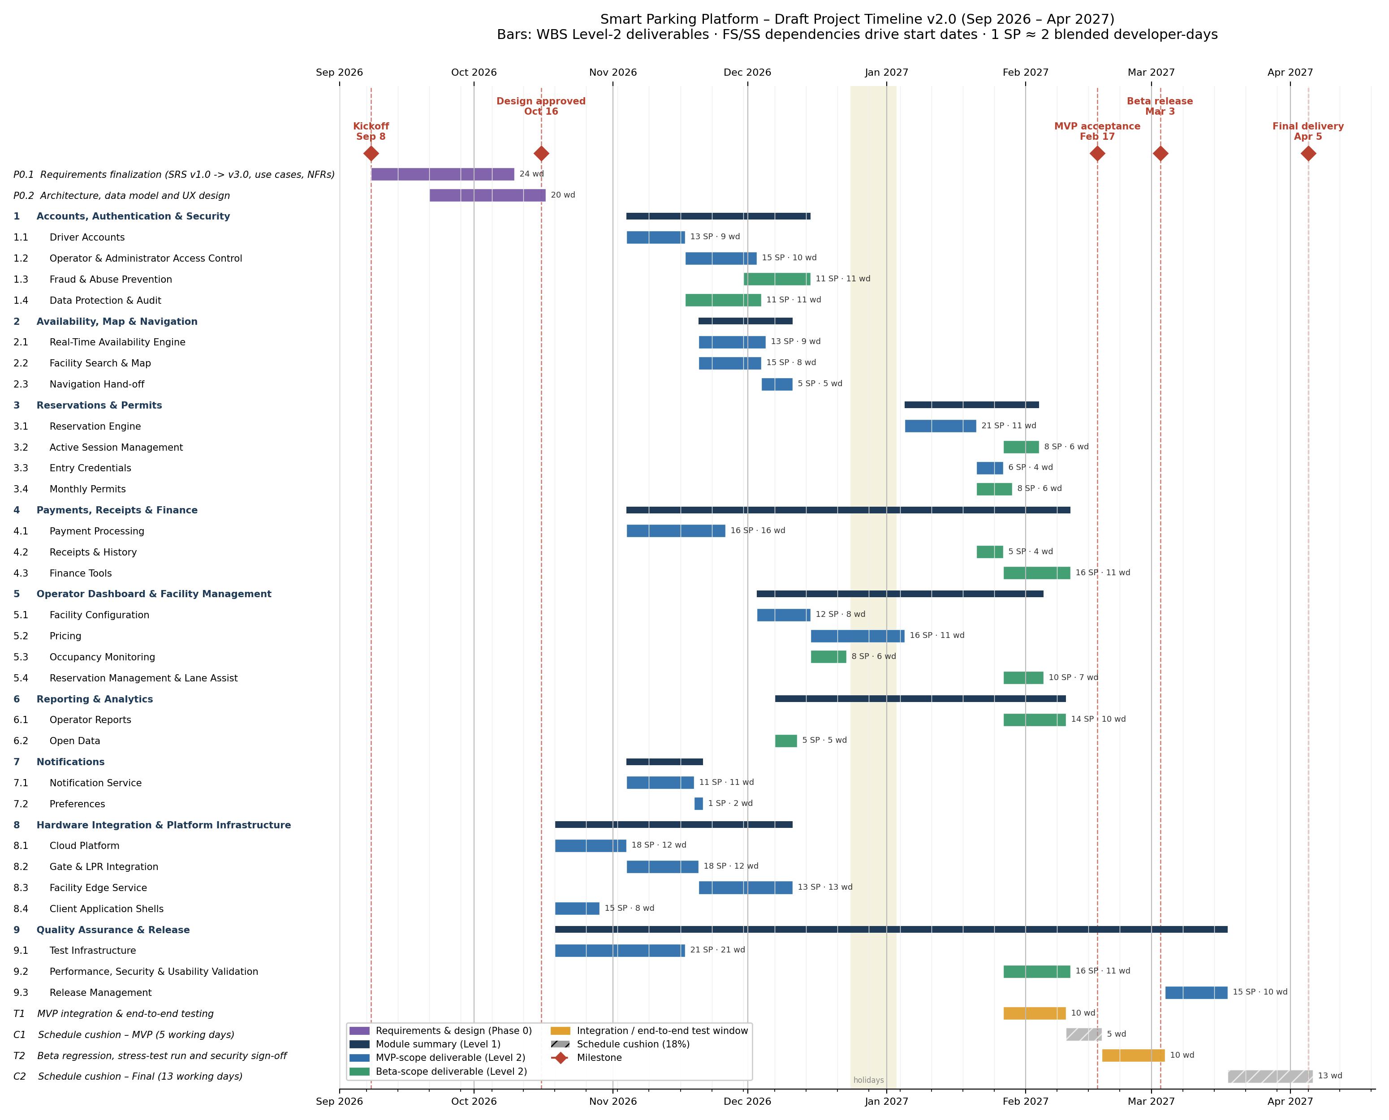
Figure 4. Draft Gantt chart, September 2026 to April 2027. Blue bars are MVP-scope deliverables, green bars Beta-scope, amber bars integration and end-to-end test windows, grey hatched bars schedule cushion, and red diamonds milestones. The editable source (SmartParking_Gantt_v2.0.xlsx, with formulas for durations, dependencies and dates) is kept in the repository so the chart can be re-timed by changing a duration or the days-per-point assumption.

9.5 Schedule Risks and Planned Refinements
Risk or open item | Effect on the schedule | Planned handling
Vendor gate/LPR APIs (A-2) behave differently from their documentation | 8.2 and 8.3 are 8-point items on the MVP path; a slip delays M2 directly | Request vendor sandboxes during Phase 0; hardware simulators built under 9.1.2 so integration testing does not wait for physical gates
Client facility data (A-5) arrives late | 9.3.2 onboarding compresses into the final cushion | Two-week data-collection buffer already in the plan; onboarding of the two pilot facilities happens at MVP, not at final delivery
Resource contention: Backend/API is assigned to 17 of 29 deliverables | Parallel bars in November assume six backend engineers are fully available | Resource-levelling pass planned for the next revision; durations may lengthen where the team is over-allocated
Story-point calibration | Durations scale linearly with the 2-day-per-point assumption | Re-estimate after the first two sprints using measured velocity; update Assumptions!B4 in the spreadsheet and re-issue the chart
Holiday period Dec 24 to Jan 3 | 5.2 Pricing spans the break | Already excluded from working days; no MVP-critical item is scheduled to finish inside the break

Planned refinements for the next versions of this document: resource levelling and a staffing plan per sprint, cost estimates derived from the duration table, a risk register with mitigation owners, and conversion of the Level-3 items into a sprint backlog. As instructed, all sections remain in this single document and the version number is incremented with every change.

10. Sprint Backlog and Board Management

10.1 Purpose and Tool Selection
Section 8 defined what the Smart Parking Platform must deliver and Section 9 defined when. This section converts that plan into the working artefact the development team uses day to day: a prioritised product backlog held on a Scrum board, and a committed backlog for the first sprint.
The board is maintained in Jira. Jira was selected over Trello because this project sits at the scale Jira is built for, with nine modules, twenty-nine deliverables and 356 story points across a seven-month schedule, and because it carries the three fields this backlog depends on natively: story-point estimates, a multi-label taxonomy for category, actor and module, and a sprint container that separates committed work from the product backlog. Trello would hold the same cards, but the metadata would live in the card titles rather than in queryable fields, which makes filtering and reporting manual. Both are Atlassian products and either is defensible at a smaller scale; the deciding criterion was the one applied to schedule tooling in Section 9, ease of change, since this backlog will be revised at every sprint boundary for the remainder of the project.

10.2 Relationship Between the WBS and the Backlog
The Work Breakdown Structure in Section 8 stops at Level 3, which is the industry-standard depth: below Level 3, deliverables decompose into individual work items that are managed as discrete entities inside a project-management tool rather than inside the WBS document itself. Carrying that decomposition further inside the WBS would increase management overhead without improving the estimate.
The board is therefore the Level-4 view of the same structure. Every card on the board names its Level-3 parent, so each item of work can be traced upward to a deliverable, a module, and ultimately to the functional requirements and use cases in Sections 5 and 7. No card exists on the board that does not originate in the WBS, and the WBS remains the authoritative statement of scope.
Table 10.1 — Backlog composition
Category | Cards | Driver-facing | Operator-facing | Requirement
Login and access control | 10 | 5 | 5 | 5 minimum
User interface (operator and driver) | 21 | 14 | 7 | 15 minimum
Backend processes (operator and driver) | 40 | 14 | 13 | 15 minimum
Reporting (operator and driver) | 13 | 2 | 10 | 10 minimum
Total | 84 |  |  | 45 minimum
Counts of driver- and operator-facing cards overlap where a card serves both actors or is platform-internal, so the category columns do not sum to the card total.
The backlog covers 71 of the 79 Level-3 work items and carries 309 of the 356 story points. The eight not yet represented are the later quality-assurance and release items (WBS 9.1.2, 9.1.3, 9.2.1 to 9.2.3 and 9.3.1 to 9.3.3), accounting for the remaining 47 points, which enter the board as the project approaches the Beta Release milestone on 3 March 2027. The unit-test framework (9.1.1) is the exception and is committed to Sprint 1, because a coverage gate that arrives late provides no protection for the code written before it.

10.3 Board Conventions
Columns. The board uses four columns: To Do, In Progress, In Review and Done. The In Review column is retained deliberately, because review is itself a unit of work that must complete before a card can move to Done, and collapsing it into In Progress hides the review queue.
Card identifiers. Cards carry a prefix indicating their category, L for login, U for user interface, B for backend and R for reporting, followed by a sequence number. This identifier is stable and is used in stand-ups and in this document.
Labels. Each card carries four labels: its category, its actor (actor-driver, actor-operator, actor-both or actor-system), its WBS module (wbs-1 through wbs-9), and its sprint assignment. The actor label makes it possible to filter the board to the operator-side work that the first delivery phase depends on.
Estimates. Every card carries the story-point value assigned to its parent work item in Section 8, distributed across the cards that decompose it. Story points follow the Fibonacci scale and measure complexity, risk and effort rather than duration, as described in Section 9.1. Where a single Level-3 work item decomposes into both an interface card and a backend card, its points are divided between them rather than duplicated, so the board reconciles exactly to the WBS: 309 points on the board plus 47 points deferred equals the 356-point project total in Section 8.4.
Definition of Done. A card reaches Done when its functionality is implemented, its unit tests pass the coverage gate, it has been reviewed by a second engineer, and it has been demonstrated against its originating use case. A deliverable in Section 8 is complete only when every card decomposing it is Done.

10.4 Sprint 1 Backlog
Sprint 1 runs for two weeks immediately following the Design Approved milestone of 16 October 2026, from Monday 19 October to Friday 30 October, consistent with the schedule in Section 9.3.
Capacity. Six developers over ten working days gives 60 developer-days. At the conversion rate established in Section 9.1, one story point to two blended developer-days, sprint capacity is 30 story points. Sprint 1 commits 28 story points, a deliberate 93% load. The remaining headroom absorbs the first-sprint estimation error that a team new to this domain should expect, and the product backlog is populated so that no developer becomes idle if the committed work finishes early.
Table 10.2 — Sprint 1 committed backlog
Card | WBS | Deliverable | Story points
B-01 | 8.1.1 | Cloud environment, containers, managed relational database and message queue | 8
B-02 | 8.1.2 | CI/CD pipeline and dev/stage/prod environments | 5
B-03 | 8.1.3 | Monitoring, logging and uptime alerting | 5
B-40 | 9.1.1 | Unit-test framework with 80% coverage gate in CI | 5
L-10 | 1.2.1 | Role and permission model (Operator Admin, Facility Manager, Finance, Attendant, Platform Admin) | 5
 |  | Total committed | 28
Sprint Goal. Stand up the platform foundation and the operator access model, so that facility onboarding can begin in Sprint 2.
Rationale for this selection. Three constraints point to the same starting scope:
• Dependency order. Every subsequent card in the backlog runs on the cloud environment, the deployment pipeline and the permission model. These are finish-to-start predecessors for the rest of the project, and the Gantt chart in Section 9.4 places Module 8.1 at the head of the schedule for exactly this reason.
• Operator-before-driver sequencing. The platform has no service to sell until a garage has been onboarded, so the operator side of the product must precede the driver side. Sprint 1 delivers the access-control model that operator onboarding depends on; Sprint 2 delivers facility configuration itself.
• Testing is not a final phase. The unit-test framework and its coverage gate are commissioned in Sprint 1 rather than before release, so that every line of code written from Sprint 2 onward is covered as it is produced.
Sprint 1 does not include any driver-facing functionality. That is expected at this stage and is worth stating explicitly to stakeholders: the Sprint 1 review will demonstrate a deployed environment, a passing test pipeline and a working permission model rather than a user-visible screen. Visible driver functionality begins in Sprint 3 and is fully demonstrable by the MVP Acceptance milestone of 17 February 2027.
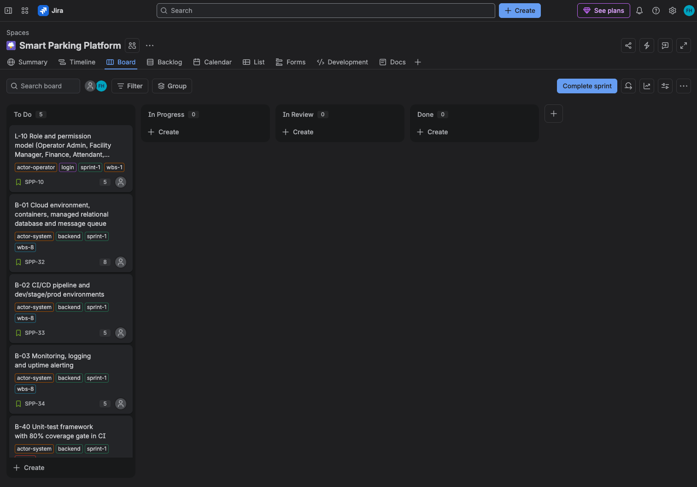
Figure 5. Sprint 1 board at the start of the sprint. All five committed cards sit in To Do; the In Review column is kept separate from In Progress so that the review queue stays visible. Each card shows its category, actor and WBS module labels and its story-point estimate.

10.5 Board Maintenance
The backlog is a living artefact and will be revised at every sprint boundary. Three revisions are already anticipated:
• Story-point recalibration. The values in this backlog are relative estimates made without measured velocity. After two or three sprints the team's actual velocity replaces the assumed rate of two developer-days per point, and both this backlog and the schedule in Section 9 will be re-based against it.
• Resource levelling. As noted in Section 9.5, backend work is concentrated across a majority of the deliverables. Sprint-by-sprint card assignment will expose where that concentration causes a bottleneck, and the resource management section will address it.
• A separate Kanban board for defects. Planned development work belongs on this Scrum board, which resets at each sprint boundary. Bugs and defects are unpredictable in both arrival and complexity and cannot be planned into a fixed timebox, so they will be tracked on a continuous Kanban board with work-in-progress limits. That board is introduced when the platform first reaches external users, at the pilot described in WBS 9.3.1, ahead of the Beta Release milestone.
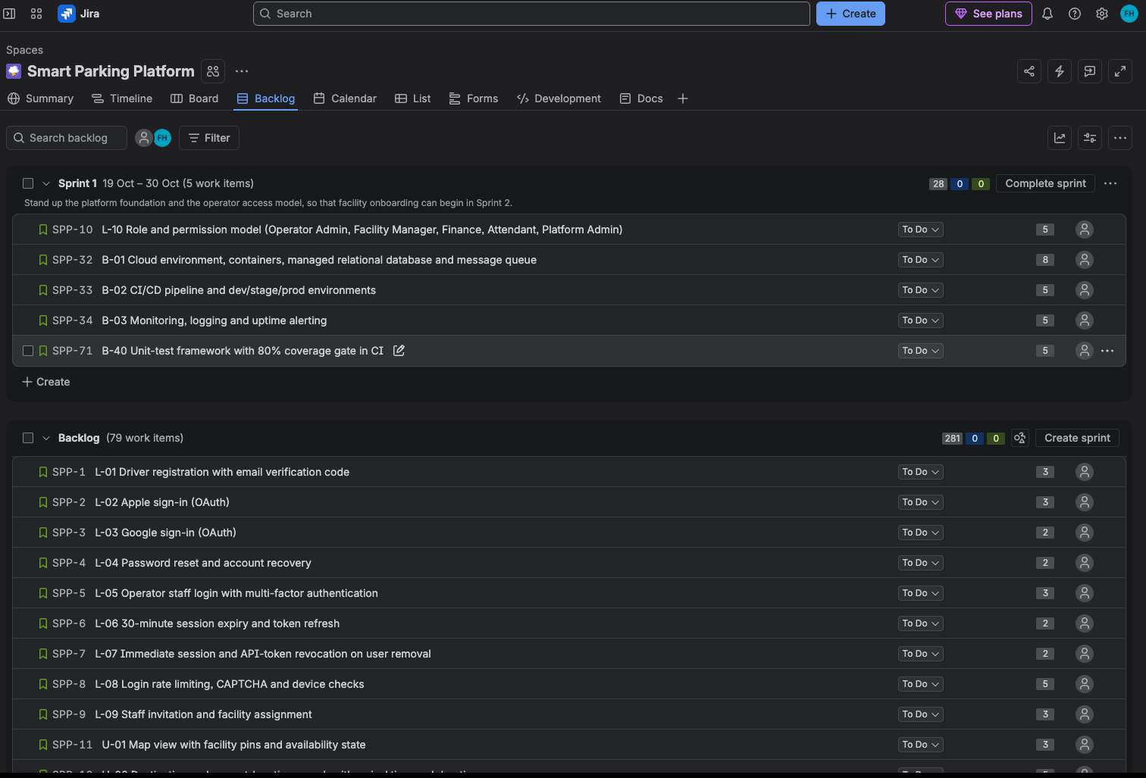
Figure 6. Product backlog. The sprint container holds the 28 committed points; the 79 remaining cards below it carry 281 points, which together reconcile to the 309 points the board holds against the 356-point project total.

11. References
- Project brief: “Semester Project: Smart Parking Platform,” CIS 4374, University of Houston, Fall 2026.
- Lecture 2 slides: “Kickoff, Requirements Gathering, and Documentation,” Dr. Otto Dobretsberger, September 4, 2026.
- Parksy, “SpotHero vs ParkWhiz vs ParkMobile: Which Wins in 2026?” https://www.parksy.com/blog/parking-apps-compared-spothero-vs-parkmobile-vs-parkwhiz
- Unstar, “ParkMobile vs SpotHero: 5 Parking Apps Ranked (2026),” https://unstar.app/blog/parkmobile-spothero-paybyphone-parkwhiz-passport-parking-apps-ranked-2026
- The Traveler, “The Hidden Cost of Using SpotHero for Parking Reservations,” https://www.thetraveler.org/the-hidden-cost-of-using-spothero-for-parking-reservations/
- FlashParking, “Parking Technology,” https://www.flashparking.com/parking-technology/
- FitGap, “Best parking management software,” https://us.fitgap.com/search/parking-management-software
- Wiegers, K. & Beatty, J., Software Requirements, 3rd ed. (Vision and Scope template structure).
- Lecture 3 slides: “Estimation, Scheduling, and Work Breakdown,” Dr. Otto Dobretsberger, CIS 4374, September 11, 2026.
- Boehm, B. W., Software Engineering Economics, Prentice Hall, 1981 (COCOMO).
- Brooks, F. P., The Mythical Man-Month, Addison-Wesley, 1975 (2nd ed. 1995).
- Project Management Institute, A Guide to the Project Management Body of Knowledge (PMBOK Guide), 7th ed., 2021 (WBS and schedule dependency definitions).

