$oftware ¢orp
Smart Parking Platform
Project Management Document: Software Requirements Specification, Vision & Scope, Work Breakdown Structure, Project Schedule, Sprint Backlog, Risk, Quality, Communication, Resource and Cost Plans, Stakeholder Analysis and Charters, Project Closure Report

Version 8.0 • November 5, 2026
Prepared by: Faiz Hajiani, Project Manager
Prepared for: Bayou City Parking Group (client) and project stakeholders

CIS 4374: Information Systems Project Management
University of Houston • Fall 2026 • Instructor: Dr. Otto Dobretsberger
Repository: https://github.com/FaizaliHajiani964/smart-parking-platform

Document Revision History
Version | Date | Author | Summary of changes
1.0 | Sep 8, 2026 | Faiz Hajiani | HW1: Project kickoff: vision and scope, market research and competitive analysis, overall description, functional and non-functional requirements, 18 use cases.
2.0 | Sep 17, 2026 | Faiz Hajiani | HW2: Added Section 8 (three-level Work Breakdown Structure with story-point estimates) and Section 9 (estimation approach, milestones, dependencies, draft schedule and Gantt chart); references updated. Existing sections unchanged.
3.0 | Sep 24, 2026 | Faiz Hajiani | HW3: Added Section 10 (sprint backlog traced to the WBS, Jira board conventions, Sprint 1 commitment of 28 story points); References renumbered to Section 11.
4.0 | Oct 1, 2026 | Faiz Hajiani | HW4: Added Section 11 (risk management: 18 risks in four categories, 5×5 assessment matrix, risk register with owners, responses and triggers, detailed response plans), Section 12 (quality management: QA and QC activities, metrics tied to the NFRs, trend monitoring) and Section 13 (communication plan: meeting cadence, reporting by audience, tools). Added the missing v3.0 row to this table; References renumbered to Section 14.
5.0 | Oct 8, 2026 | Faiz Hajiani | HW5: Added Section 14 (resource and cost management: 20 named roles with skill levels and FTE allocations, bottom-up cost plan, contingency and management reserve, monthly budgeted cashflow, operating costs after handover, RACI matrix, cost control). References renumbered to Section 15.
6.0 | Oct 15, 2026 | Faiz Hajiani | HW6: Full review of every section after Lecture 7; no new chapters. Added FR-27 to FR-30 and use cases UC-19 to UC-23 for WBS work that had no use case; three WBS work items (8.3.3, 8.5.1, 8.5.2; total now 369 SP) with schedule rows; Section 10.6 on source control and the CI/CD pipeline; Sprint 1 capacity reconciled team by team; three new risks (T-6, F-5, P-5) and S-3 re-rated; new stakeholders in 4.2 and the communication plan; DevOps engineer full-time from build start and a production-parity staging line (cost baseline now $2,146,328); new RACI row; Gantt chart and WBS diagram redrawn.
7.0 | Oct 29, 2026 | Faiz Hajiani | HW7: Added Section 15 (stakeholder management after Lecture 8: power–interest assessment of 16 stakeholders, power–interest grid, engagement strategy by quadrant and an engagement plan; one-page project charter and team charter as figures with text versions; leadership approach and conflict-resolution plan, including the API-failure scenario). Cross-references added in Sections 4.2 and 13; Project Manager named consistently in Table 14.1; Lecture 8 added to the references, which are renumbered to Section 16. No other section changed.
8.0 | Nov 5, 2026 | Faiz Hajiani | HW8: Added Section 16 (project closure report, marked internal, drafted after Lecture 9: executive summary and project snapshot, objectives and deliverables with acceptance evidence, achievements and shortfalls, schedule and budget comparison with actuals to date, a KPI dashboard and the Sprint 1 burndown chart (Figure 10), a lessons-learned register, recommendations for future projects, the seven-step closure checklist, ethical-accountability statement and sign-off). Cross-reference added in Section 13.4; Lecture 9 added to the references, which are renumbered to Section 17. The post-mortem of a failed product required by HW8 is a separate document in the repository. No other section changed.

Table of Contents
1. Introduction 6
1.1 Purpose 6
1.2 Intended Audience 6
1.3 Definitions and Acronyms 6
2. Vision and Scope 7
2.1 Business Need and Background 7
2.2 How the Project Was Acquired 7
2.3 About $oftware ¢orp 7
2.4 Vision Statement 8
2.5 Scope 8
2.5.1 In Scope 8
2.5.2 Out of Scope 8
2.6 Assumptions and Dependencies 9
3. Market Research and Competitive Analysis 9
3.1 Existing Software Landscape 9
3.2 Competitor Profiles 10
3.3 How the Smart Parking Platform Is Different 11
4. Overall Description 12
4.1 Product Perspective 12
4.2 User Classes and Stakeholders 13
4.3 Operating Environment 13
4.4 Execution Constraints 14
5. Functional Requirements 14
5.1 Accounts & Authentication 14
5.2 Availability & Map 14
5.3 Reservations 15
5.4 Payments & Receipts 15
5.5 Operator Dashboard 16
5.6 Notifications 16
5.7 Integrations & Administration 16
6. Non-Functional Requirements 16
7. Use Cases 18
7.1 End-User (Driver) Use Cases 18
7.2 Operator, Finance, Administrator, and External Use Cases 23
7.3 Use-Case Coverage Summary 26
8. Work Breakdown Structure 27
8.1 Conventions 27
8.2 WBS Overview (Levels 1 to 2) 28
8.3 Full Work Breakdown Structure (Levels 1 to 3) 29
8.4 Story-Point Summary by Module 34
9. Estimation and Project Timeline 34
9.1 Estimation Approach 35
9.2 Milestones 35
9.3 Schedule and Dependencies 36
9.4 Gantt Chart 39
9.5 Schedule Risks and Planned Refinements 41
10. Sprint Backlog and Board Management 41
10.1 Purpose and Tool Selection 41
10.2 Relationship Between the WBS and the Backlog 42
10.3 Board Conventions 43
10.4 Sprint 1 Backlog 43
10.5 Board Maintenance 45
10.6 Source Control, CI/CD Pipeline and Board Integration 46
11. Risk Management 48
11.1 Approach 48
11.2 Assessment Scales and Risk Matrix 48
11.3 Response Strategies 49
11.4 Identified Risks by Category 49
11.5 Risk Register 51
11.6 Detailed Response Plans 55
11.7 Monitoring and Review 55
12. Quality Management 56
12.1 Quality Assurance and Quality Control 56
12.2 Quality Standards and Metrics 56
12.3 Trend Monitoring 57
12.4 Testing by Non-Technical Users 57
13. Communication Plan 57
13.1 Structure and Communication Channels 58
13.2 Tools 58
13.3 Meeting Cadence 58
13.4 Reporting by Audience 59
13.5 Escalation and Records 60
14. Resource and Cost Management 60
14.1 Planning Assumptions 60
14.2 Roles and Resources 61
14.3 Cost Plan (Bottom-Up) 62
14.4 Contingency and Management Reserve 63
14.5 Monthly Budgeted Cashflow 63
14.6 Operating Costs After Handover 64
14.7 RACI Matrix 64
14.8 Cost Control 65
15. Stakeholder Management, Charters and Team Leadership 67
15.1 Stakeholder Register and Power–Interest Assessment 68
15.2 Power–Interest Grid and Engagement Strategy 69
15.3 Stakeholder Engagement Plan 71
15.4 Project Charter 72
15.5 Team Charter 74
15.6 Leadership Approach and Conflict Resolution 78
15.7 Keeping the Stakeholder Plan Current 79
16. Project Closure Report (Internal Draft) 80
16.1 Executive Summary 80
16.2 Objectives and Deliverables 81
16.3 Achievements and Shortfalls 82
16.4 Schedule and Budget Comparison (Actuals to Date) 84
16.5 Lessons Learned 86
16.6 Recommendations for Future Projects 88
16.7 Closure Checklist, Acknowledgments and Sign-off 89
17. References 79

1. Introduction

1.1 Purpose
This document defines the vision, scope, and software requirements for the Smart Parking Platform, a real-time parking discovery, reservation, payment, and facility-management system to be delivered by $oftware ¢orp. It is the single source of truth for what the system must do (functional requirements), how well it must do it (non-functional requirements), and the limits of the engagement (scope). It will be updated weekly throughout the project and acts as the foundation for the work breakdown structure, schedule, budget, risk register, and later project artifacts.

1.2 Intended Audience
- Client executives and operations leads at Bayou City Parking Group , to confirm scope, priorities, and acceptance criteria.
- $oftware ¢orp development teams (mobile, web, backend/API, mapping, payments, QA) , to derive work items, designs, and test cases.
- Project sponsors and course stakeholders , to monitor progress against the agreed baseline.

1.3 Definitions and Acronyms
Term | Definition
PARCS | Parking Access and Revenue Control System: gates, ticket dispensers, pay stations, and the software that runs them.
LPR / ALPR | (Automated) License Plate Recognition: cameras that read plates to open gates and match vehicles to reservations.
Operator | A company or agency that runs one or more parking facilities (garages, surface lots).
Driver / End user | A member of the public who uses the mobile or web app to find, reserve, and pay for parking.
Occupancy | The number of spaces currently in use in a facility, expressed as a count and a percentage of capacity.
Dynamic pricing | Adjusting parking rates based on time of day, demand, or events, within operator-defined limits.
SRS | Software Requirements Specification (this document).
RFP | Request for Proposal: the client’s formal solicitation to which $oftware ¢orp responded.
MVP | Minimum Viable Product: the smallest release that delivers end-to-end value to drivers and operators.
CI/CD | Continuous Integration / Continuous Delivery: an automated pipeline that builds and tests every code change and promotes it through Dev, Staging and Production (Section 10.6).
Pull request (PR) | A request to merge a feature branch into the main branch; it is reviewed by a second engineer and linked to one Jira work item.
Staging | A pre-production environment that mirrors Production (same container images, operating system and resource limits) and is used for final testing.
Regression test | An existing automated test re-run on every change to prove that new code has not broken features that already worked.

2. Vision and Scope

2.1 Business Need and Background
Drivers in dense urban areas spend a significant amount of time circling for parking, which creates congestion, frustration, wasted fuel, and lost productivity. On the other side of the transaction, parking facility operators typically have limited real-time visibility into occupancy, depend on static pricing, and lack integrated tools to manage reservations, payments, and reporting across multiple facilities. The result is under-utilized parking assets and a poor experience for both groups.
The Smart Parking Platform tackles both problems with one system: drivers locate, reserve, and pay for garage parking in real time from a web or mobile app, while operators manage inventory, pricing, and occupancy analytics from an administrative dashboard.

2.2 How the Project Was Acquired
In mid-2026, Bayou City Parking Group, a fictional Houston-area operator managing 14 garages and surface lots in the Downtown, Midtown, Medical Center, and Galleria districts issued a Request for Proposal for a “Smart Parking Platform” to replace its patchwork of third-party reservation listings, legacy pay stations, and spreadsheet-based reporting. The RFP was published on the client’s procurement platform and distributed to pre-qualified vendors.
$oftware ¢orp responded with a proposal built around three commitments the client identified as decisive: (1) real-time availability rather than estimated inventory, (2) a single platform serving drivers and operators instead of two disconnected vendors, and (3) reservations that are honored at the gate because the platform itself controls the facility’s inventory. Following a technical presentation and reference checks, $oftware ¢orp was awarded the contract. Payment is milestone-based (30% at kickoff, 40% at MVP acceptance, 30% at final delivery), and any features requested beyond the scope defined in this document will be handled through a formal change request and a separate contract, protecting both parties from scope creep.

2.3 About $oftware ¢orp
$oftware ¢orp is a fictitious software development studio with unlimited resources and budget for the purposes of this project. The studio specializes in mobility and smart-city platforms and organizes work into six cross-functional development teams: Mobile Application, Web Application, Backend/API, Mapping & Location Services, Payment Integration, and Quality Assurance & Testing. The project is led by a dedicated Project Manager (the author of this document) who owns the schedule, budget, risk register, and stakeholder interaction. Although budget is not a constraint, the semester timeline is fixed, so the plan prioritizes disciplined scope control and early delivery of an end-to-end MVP.

2.4 Vision Statement
For drivers who waste time and fuel looking for parking, and parking operators who lack real-time control over their facilities, the Smart Parking Platform is a web and mobile parking system that lets drivers find, reserve, navigate to, and pay for a guaranteed space in real time, while giving operators live occupancy, pricing, and revenue tools across all of their facilities. Unlike driver-only marketplaces such as SpotHero or operator-only access-control systems such as FLASH, our platform owns the inventory end to end, so a reservation made in the app is the same record that opens the gate.

2.5 Scope

2.5.1 In Scope
- Driver-facing mobile applications (iOS and Android) and a responsive web application for account management, search, reservation, payment, receipts, and notifications.
- Real-time availability at the facility and space-count level, fed by gate/LPR events and, where installed, occupancy sensors.
- Interactive map with turn-by-turn hand-off to external navigation apps (Google Maps, Apple Maps, Waze).
- Reservation engine supporting hourly, daily, event, and monthly-permit bookings with modification and cancellation rules.
- Digital payment processing through a PCI-compliant third-party provider, including saved payment methods, receipts, and refunds.
- Operator administrative dashboard: facility and rate configuration, occupancy monitoring, reservation management, and reporting/analytics.
- System administration: role-based access control, audit logging, and configuration management.
- Integrations with gate controllers and LPR cameras at client facilities through documented APIs.
- Notifications (push, SMS, email) for reservation confirmations, reminders, expirations, and operator alerts.

2.5.2 Out of Scope
- On-street (metered) parking and municipal enforcement or citation management.
- Manufacture, installation, or maintenance of physical hardware (gates, cameras, sensors, pay stations); the platform integrates with hardware the client procures separately.
- Valet operations and vehicle key management.
- Electric-vehicle charging management and billing (a candidate for a future phase).
- A public marketplace listing facilities owned by operators who are not platform customers.
- Loyalty or rewards programs and third-party advertising within the apps.
- Custom integrations with individual city permit systems beyond publishing open occupancy data.
Explicitly listing exclusions protects the project from scope creep: any of these items may be added later through the change-request process and a separate agreement.

2.6 Assumptions and Dependencies
ID | Assumption / Dependency | If it fails…
A-1 | Client facilities have reliable wired or 4G/5G internet connectivity for gate controllers and LPR cameras. | Gate events are queued locally and synchronized when connectivity returns; availability shown to drivers is flagged as “last updated N minutes ago.”
A-2 | Gate and LPR hardware exposes a documented API or webhook interface. | A hardware adapter must be built or an integration middleware licensed; schedule impact assessed via change request.
A-3 | A third-party payment provider (e.g., Stripe) handles card storage and PCI-DSS scope. | Alternative provider selected; payment module abstracted behind an interface so the switch is isolated.
A-4 | Mapping and geocoding are provided by an external service (Google Maps Platform or Mapbox) under a commercial license. | Secondary provider configured; map features degrade to list view if both are unavailable.
A-5 | The client will provide facility data (capacity, hours, rates, addresses) before integration testing. | Onboarding milestone slips; the schedule includes a two-week buffer for data collection.
A-6 | Drivers have smartphones running iOS 16+ or Android 12+ with location services enabled. | Web application provides equivalent functionality; manual address entry replaces GPS.
A-7 | The platform must comply with Texas and City of Houston ordinances on parking, consumer payments, and data privacy. | Legal review triggers requirement changes handled through change control.

3. Market Research and Competitive Analysis

3.1 Existing Software Landscape
The parking-technology market is fragmented into three largely separate segments. Driver-facing marketplaces (SpotHero, ParkWhiz, ParkMobile, PayByPhone) let the public pay for or pre-book parking but do not control the facility. Operator-facing access-and-revenue-control systems (FLASH, T2 Systems, ParkHub) run gates, lanes, and reporting yet reach drivers only through partners. A third segment of sensing and analytics vendors (Nwave, ParkiFi, Smarking) supplies occupancy data and forecasting to operators. Few products span more than one segment, which is the gap the Smart Parking Platform is designed to fill.
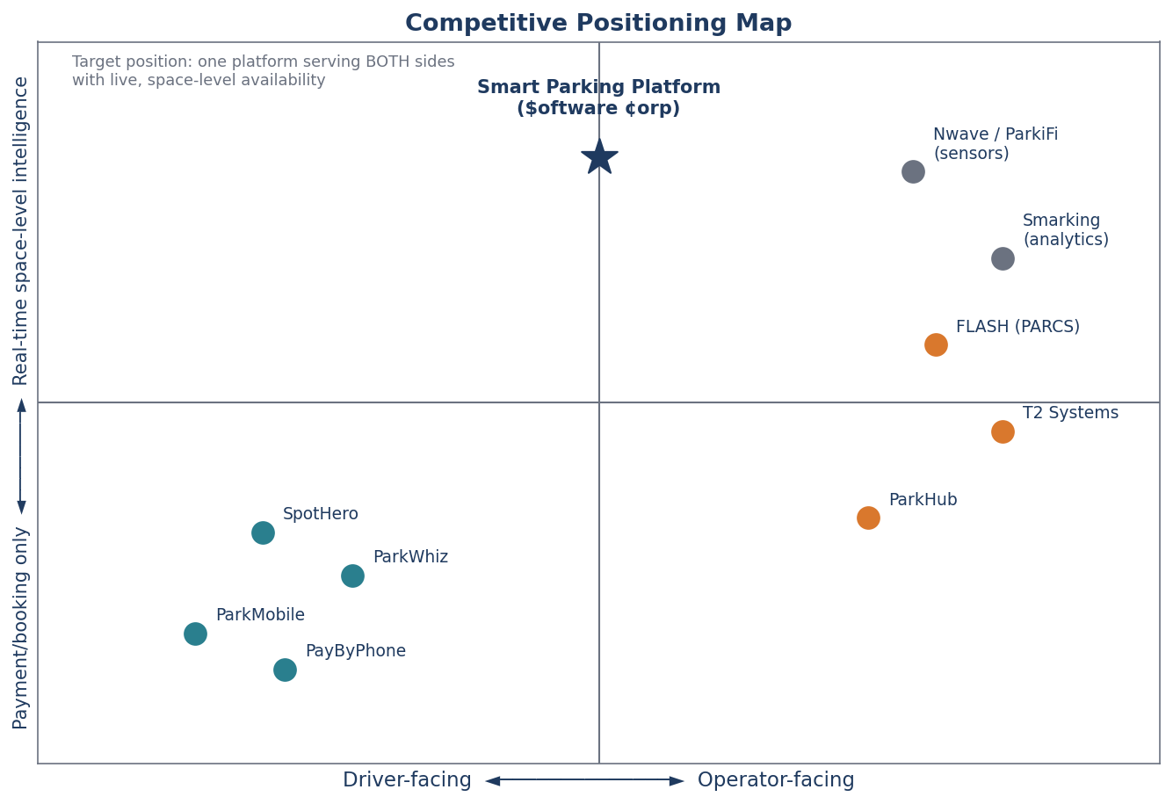
Figure 1. Competitive placement map: existing products cluster as either driver-facing booking tools or operator-facing control systems; the Smart Parking Platform targets the unoccupied center with real-time, space-level intelligence for both sides.

3.2 Competitor Profiles
Competitor | Segment / Focus | Strengths | Weaknesses and Limitations
SpotHero | Driver-facing garage and lot reservation marketplace across North America (7,000+ locations). | Largest garage marketplace; book-ahead pricing with average savings of about 30% versus drive-up rates; guaranteed-spot messaging. | Does not control facility inventory, so drivers report arriving to “Lot Full” signs or attendants refusing third-party reservations; access codes failing at gates; prices rising between search and checkout; support limited to chat.
ParkWhiz (Arrive) | Driver-facing reservations near venues and airports; event parking. | Simple, fast booking flow; strong event-day coverage; discounts up to 50%. | Garages fail to recognize reservations; surge pricing can double rates on event days; refunds take 10 to 15 business days; narrow check-in windows.
ParkMobile | Driver-facing mobile payment for on-street meters and municipal lots (1.5M+ spaces). | Largest zone footprint in U.S. cities; the default option for many municipalities; hourly session extension. | Street-focused with limited garage pre-booking; a $0.35 convenience fee on small meter payments; phantom sessions from GPS drift; failed stop commands that keep charging.
PayByPhone | Driver-facing meter payment; official partner in many U.S. and European cities. | Deep municipal integration; auto-extend sessions. | Expiration alerts fire only minutes before expiry; city-wide outages at peak hours; stale rate displays; account lockouts after card declines.
FLASH (FlashParking) | Operator-facing PARCS: kiosks, gates, LPR cameras, cloud management, business-intelligence dashboards. | Full-stack access and revenue control; camera-based “Flex Mode” entry; reports operators gain about 22% more daily revenue per spot; multi-facility portfolios. | Hardware-centric and capital-intensive; reaches drivers only by pushing inventory to partner apps; opaque pricing and long implementation timelines.
T2 Systems | Enterprise PARCS plus permits and enforcement for operators, municipalities, and universities. | Enterprise-grade multi-facility management; lane hardware integration; permit and citation workflows. | Primarily institutional; no consumer-grade driver experience; enforcement focus is outside garage-reservation use cases.
ParkHub | Operator-facing event and high-volume venue parking management. | Optimized for stadiums, arenas, and event surges; point-of-sale and pre-sold passes. | Narrow event focus; limited everyday commuter and monthly-permit functionality.
Nwave / ParkiFi / Smarking | Sensor and analytics vendors supplying occupancy data and demand forecasting. | Space-level occupancy sensing; utilization analytics and forecasting. | Data-only products that must be paired with separate booking and payment systems; no driver-facing app.

3.3 How the Smart Parking Platform Is Different
Differentiator | What it means for drivers | What it means for operators
One inventory, end to end | A reservation is the same record the gate reads; arrival is confirmed by LPR or QR code with no attendant intervention. | No double-booking between a marketplace and a pay station; one reconciliation report.
Live space-level availability | Search results show the number of free spaces and a “last updated” timestamp, not just open/closed. | Occupancy dashboards update within seconds of every entry and exit; alerts when a facility nears capacity.
All-in pricing up front | The price shown in search is the price charged, including taxes and fees. | Rates, surcharges, and dynamic-pricing rules are configured once and applied consistently across app, web, and on-site.
Built for both sides | One app for hourly, daily, event, and monthly parking across every facility on the platform. | Facility configuration, reservations, pricing, reporting, and staff roles in a single dashboard, with a role for finance/billing.
Open, adapter-based integrations | Navigation hand-off to the driver’s preferred maps app. | Works with existing gate and LPR hardware from multiple vendors; publishes open occupancy data to city transportation departments.

4. Overall Description

4.1 Product Perspective
The Smart Parking Platform is a new, cloud-hosted system composed of native mobile apps, a responsive web application, a backend/API layer, and an operator dashboard. It exchanges data with four classes of external systems: third-party payment providers, mapping and navigation services, garage hardware (gates, LPR cameras, occupancy sensors), and city transportation departments that consume open occupancy data.
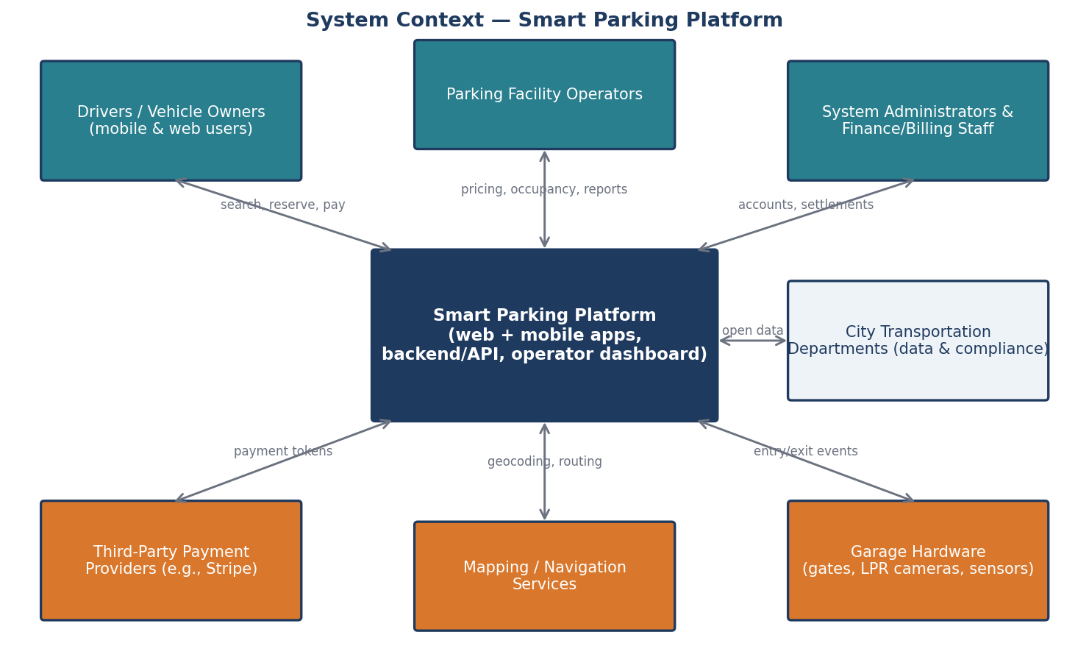
Figure 2. System context diagram showing the Smart Parking Platform, its user groups (teal), and the external systems it integrates with (orange).

4.2 User Classes and Stakeholders
Stakeholder / User Class | Role in the System | Primary Needs
Drivers and vehicle owners | End users of the mobile and web apps. | Find a guaranteed space quickly, know the total price up front, navigate to the entrance, enter without friction, get a receipt.
Mobile application users | Subset of drivers who rely on the iOS/Android app, often while in transit. | Fast, low-tap flows; reliable push notifications; offline access to an active reservation and QR code.
Parking facility operators | Primary paying customer; manage one or more facilities. | Configure rates and capacity, watch live occupancy, manage reservations and incidents, maximize utilization and revenue.
Client executive sponsor and product owner | Bayou City Parking Group leadership who fund the project, approve scope changes and accept milestones. | Milestone status, cost and cushion consumption, top risks; read-only access to the board and pipeline through a delivery dashboard; decisions confirmed in writing.
Finance and billing personnel | Operator staff who reconcile revenue and handle refunds. | Accurate daily settlement reports, refund tools, tax breakdowns, exports to accounting software.
Facility attendants | Operator staff at the lane and on site; first contact when entry fails. | Lane-assist view, quick manual override, training and a short guide before the pilot, a clear escalation path when hardware fails.
System administrators | $oftware ¢orp and client IT staff who run the platform. | Role-based access control, audit logs, integration health monitoring, configuration management.
City transportation departments | External consumers of aggregated occupancy data; regulators. | Open data feeds for congestion planning; assurance of compliance with local ordinances.
Third-party payment providers | External system handling card processing and PCI scope. | Well-formed API calls, tokenized card data, webhook acknowledgements.
Gate and LPR hardware vendors | External suppliers of the gate controllers, cameras and sensors installed at client facilities. | Clear integration specifications, sandbox and firmware access, timely defect reports, and notice of release dates that affect their devices.
Section 15 rates the power and interest of each of these stakeholders, places them on a power–interest grid and sets the engagement strategy for each group; the project charter and team charter in Sections 15.4 and 15.5 formalise the authority and working agreements behind this table.

4.3 Operating Environment
- Mobile: native applications for iOS 16+ and Android 12+, distributed through the Apple App Store and Google Play.
- Web: responsive single-page application supporting the two most recent versions of Chrome, Safari, Edge, and Firefox.
- Backend: cloud-hosted (AWS or Azure) containerized services with a managed relational database and a message queue for hardware events.
- Facility edge: gate controllers and LPR cameras communicate with the backend over HTTPS/webhooks; a local edge service buffers events during connectivity loss.
- Delivery environments: every change moves through Dev, Staging and Production using the same container image built once by the CI/CD pipeline. Staging runs the production operating system (Linux) and resource limits, and no service depends on OS-specific system calls or on hardware such as a GPU that Production does not have (risk T-6).

4.4 Execution Constraints
- Budget: theoretically unlimited for this engagement, so technical decisions are optimized for quality and time rather than cost.
- Timeline: fixed to the academic semester; the final project document is due December 4, 2026, and interim milestones are delivered weekly.
- Third-party dependence: payment, mapping, and hardware integrations rely on external APIs whose availability and terms are outside the project’s control.
- Compliance: PCI-DSS (via the payment provider), Texas and City of Houston ordinances governing parking and consumer payments, ADA accessibility for the apps and web (WCAG 2.1 AA), and applicable data-privacy requirements for personal and vehicle data.

5. Functional Requirements
Functional requirements describe what the system shall do. They are grouped by the high-level requirement areas identified in the project brief; each will be traced to one or more use cases in Section 7 and to work items in the project tracker.

5.1 Accounts & Authentication
ID | Requirement
FR-1 | The system shall allow a driver to create an account using an email address and password, or through Apple or Google sign-in, in no more than 3 steps.
FR-2 | The system shall allow a driver to register up to 5 vehicles (license plate, state, make, model, color) and designate one as default.
FR-3 | The system shall provide role-based accounts for operator staff (Operator Admin, Facility Manager, Finance, Attendant) and platform administrators.
FR-4 | The system shall support multi-factor authentication for all operator and administrator roles.
FR-27 | The system shall allow a driver to reset a forgotten password through a time-limited code sent to the verified email address or phone number, and shall sign out all other sessions after the reset.

5.2 Availability & Map
ID | Requirement
FR-5 | The system shall display facilities on an interactive map and in a list, filtered by distance, price, availability, vehicle-size restrictions, and amenities (covered, EV charging, 24/7).
FR-6 | The system shall show, for every facility, the number of available spaces and the time the count was last updated.
FR-7 | The system shall update facility availability from gate entry/exit events and, where installed, occupancy sensors.
FR-8 | The system shall hand off turn-by-turn navigation to the facility entrance to the driver’s preferred external maps application.
FR-28 | The system shall let a driver join a waitlist for a full facility and time window and shall notify the driver when a space becomes available, holding it for 10 minutes.
FR-29 | When a facility's occupancy data is flagged as unreliable, the system shall replace the space count with a warning, stop selling new pre-paid reservations for that facility, and continue to honor existing reservations at the gate.

5.3 Reservations
ID | Requirement
FR-9 | The system shall allow a driver to reserve a space for an hourly, daily, event, or monthly-permit period and shall display the all-in price (rate, taxes, and fees) before confirmation.
FR-10 | The system shall hold inventory for a confirmed reservation so that the same space count cannot be sold twice.
FR-11 | The system shall allow a driver to modify or cancel a reservation subject to the facility’s cancellation policy and shall calculate any refund automatically.
FR-12 | The system shall allow a driver to extend an active session from the app when capacity permits.
FR-13 | The system shall generate a QR code and register the vehicle’s license plate for each reservation so entry can be validated by scanner or LPR camera.

5.4 Payments & Receipts
ID | Requirement
FR-14 | The system shall process payments through a PCI-compliant third-party provider supporting major credit/debit cards, Apple Pay, and Google Pay, and shall never store raw card numbers.
FR-15 | The system shall issue an itemized digital receipt by email and in-app for every completed transaction and shall keep reservation history for at least 24 months.
FR-16 | The system shall allow finance staff to issue full or partial refunds and shall record the reason and the staff member for each refund.

5.5 Operator Dashboard
ID | Requirement
FR-17 | The system shall allow an Operator Admin to create and configure facilities: address, capacity, hours, vehicle restrictions, amenities, and entrance coordinates.
FR-18 | The system shall allow operators to define rate schedules (hourly, daily, event, monthly) and optional dynamic-pricing rules with operator-set floor and ceiling prices.
FR-19 | The system shall display a live occupancy dashboard for each facility and for the operator’s portfolio, with configurable alerts when occupancy exceeds a threshold.
FR-20 | The system shall allow operators to view, search, and manually override reservations (e.g., honor a reservation when a scanner fails) with an audit trail.
FR-21 | The system shall generate occupancy, revenue, and utilization reports by facility, date range, and rate type, exportable to CSV and PDF, and shall automatically email a weekly summary to designated staff.

5.6 Notifications
ID | Requirement
FR-22 | The system shall send reservation confirmations, arrival reminders, expiration warnings (at 30 and 10 minutes), and receipts via push notification, SMS, or email according to the driver’s preferences.
FR-23 | The system shall alert operators when a gate or camera integration stops reporting events for more than 5 minutes.

5.7 Integrations & Administration
ID | Requirement
FR-24 | The system shall provide a documented API and webhook interface for gate controllers and LPR cameras to report entry/exit events and to request entry authorization.
FR-25 | The system shall publish an anonymized, aggregated occupancy data feed that city transportation departments can consume.
FR-26 | The system shall log all administrative and financial actions with user, timestamp, and before/after values, retained for at least 12 months.
FR-30 | The system shall let a driver request a copy or deletion of their personal data from the app and shall complete the request within 30 days (NFR-15), keeping transaction records required by NFR-16 in anonymized form.

6. Non-Functional Requirements
Non-functional requirements describe how the system shall be. Each is stated with a measurable target so that it can be verified by the QA team; none uses an absolute (0% or 100%) commitment.
ID | Category | Requirement
NFR-1 | Performance | Search results for a map viewport containing up to 200 facilities shall load within 2 seconds on a 4G connection at the 95th percentile.
NFR-2 | Performance | Facility availability shown to drivers shall reflect gate and sensor events within 5 seconds of the event reaching the backend.
NFR-3 | Performance | Gate entry authorization requests shall receive a response within 1 second at the 99th percentile so that vehicles are not delayed at the lane.
NFR-4 | Availability | The platform shall provide 99.9% monthly uptime for driver-facing services and 99.95% for the gate-authorization API, excluding announced maintenance windows.
NFR-5 | Reliability | Facility edge services shall buffer at least 24 hours of gate events locally and synchronize automatically when connectivity is restored.
NFR-6 | Scalability | The system shall support at least 10,000 concurrent app users and 500 facilities without degradation of NFR-1 through NFR-3, with horizontal scaling to 10× those figures.
NFR-7 | Security | All data in transit shall be encrypted with TLS 1.2 or higher and all personal and vehicle data at rest with AES-256; card data shall be tokenized by the payment provider so the platform remains out of PCI-DSS card-data scope.
NFR-8 | Security | Operator and administrator sessions shall expire after 30 minutes of inactivity and shall require multi-factor authentication.
NFR-9 | Usability | A returning driver shall be able to complete a reservation for a previously used facility in no more than 4 taps from the app home screen.
NFR-10 | Usability | A new driver shall be able to complete registration and a first reservation in under 3 minutes in usability testing with at least 8 of 10 participants succeeding without assistance.
NFR-11 | Accessibility | The mobile and web applications shall conform to WCAG 2.1 Level AA, including screen-reader labels and minimum 4.5:1 text contrast.
NFR-12 | Compatibility | The apps shall support iOS 16+ and Android 12+ and the web application the two most recent major versions of Chrome, Safari, Edge, and Firefox.
NFR-13 | Bandwidth | The mobile app shall function on connections as slow as 1 Mbps, and an active reservation with its QR code shall remain viewable with no connectivity.
NFR-14 | Maintainability | Facility hardware integrations shall be implemented as pluggable adapters so that a new gate or camera vendor can be supported without changes to core services; automated test coverage of core services shall be at least 80%.
NFR-15 | Compliance | The platform shall comply with applicable Texas and City of Houston ordinances for parking and consumer payments and shall provide data-export and deletion tools for driver personal data on request within 30 days.
NFR-16 | Data retention | Transaction records shall be retained for at least 7 years for financial audit; personal data no longer needed shall be anonymized after 24 months of account inactivity.

7. Use Cases
The following use cases were synthesized from stakeholder user stories gathered across the hierarchy (drivers, attendants, facility managers, finance staff, and administrators) rather than from management alone. Each use case states its actor, precondition, ordered steps, and postcondition. Twenty-three use cases are defined in this version: thirteen for end users (drivers), nine for operators, finance and administrators, and one for an external consumer of open data. UC-19 to UC-23 were added in v6.0 because the review found WBS work items and requirements (password recovery, the waitlist, personal-data requests, hardware-fault handling and the open data feed) that had been estimated but never described from the user's point of view.

7.1 End-User (Driver) Use Cases
UC-1 | Register account and add a vehicle
Actor | Driver
Precondition | Driver has installed the mobile app or opened the web app and has a valid email address.
Steps | 1. Driver selects “Create account” and enters email and password, or chooses Apple/Google sign-in.  2. System sends a verification code; driver enters it.  3. Driver enters license plate, state, and vehicle details and saves the vehicle as default.  4. System confirms the account is active and shows the map home screen.
Postcondition | A verified driver account exists with one default vehicle.
Alternate / Exceptions | If the plate is already registered to another account, the system asks the driver to confirm ownership via email before proceeding.

UC-2 | Search for available parking near a destination
Actor | Driver
Precondition | Driver is logged in and has granted location permission or entered a destination address.
Steps | 1. Driver enters a destination or uses current location and selects arrival date/time and duration.  2. System displays facilities on the map and in a list with available-space counts, all-in prices, distance, and “last updated” time.  3. Driver applies filters (price, covered, EV charging, vehicle height).  4. Driver taps a facility to view details, photos, hours, and entrance instructions.
Postcondition | Driver has identified a facility with confirmed availability for the requested time.
Alternate / Exceptions | If no facilities have availability, the system shows the nearest alternatives and offers a waitlist notification.

UC-3 | Reserve a parking space
Actor | Driver
Precondition | Driver has selected a facility with available spaces for the chosen time window and has a saved payment method (or will add one).
Steps | 1. Driver taps “Reserve” and confirms vehicle, arrival time, and duration.  2. System shows the itemized total (rate, taxes, fees) and the cancellation policy.  3. Driver confirms; system holds the inventory and charges the payment method.  4. System issues a confirmation with a QR code and registers the plate for LPR entry; confirmation is sent by push and email.
Postcondition | A confirmed reservation exists, inventory is decremented, payment is captured, and the driver holds a QR code.
Alternate / Exceptions | If payment fails, the hold is released after 5 minutes and the driver is prompted to try another method.

UC-4 | Navigate to the facility entrance
Actor | Driver
Precondition | Driver has an upcoming or active reservation.
Steps | 1. Driver opens the reservation and taps “Navigate.”  2. System opens the driver’s preferred maps app with the facility’s entrance coordinates (not the postal address).  3. Driver follows directions; system sends an arrival reminder 15 minutes before the reservation start.
Postcondition | Driver arrives at the correct entrance.
Alternate / Exceptions | If no maps app is installed, the system shows in-app directions and the entrance description.

UC-5 | Enter the facility with a reservation
Actor | Driver
Precondition | Driver has a confirmed reservation starting within the facility’s early-arrival window and is at the entry lane.
Steps | 1. LPR camera reads the plate and requests authorization from the platform.  2. System validates the reservation and instructs the gate to open within 1 second.  3. If LPR fails, driver scans the QR code at the reader.  4. System records the entry event, starts the session, and updates facility availability.
Postcondition | Vehicle is inside; the session is active; occupancy is updated.
Alternate / Exceptions | If neither LPR nor QR succeeds, the driver presses the intercom and the attendant validates the reservation from the dashboard (see UC-15).

UC-6 | Extend an active parking session
Actor | Driver
Precondition | Driver has an active session and the facility has capacity for the extension period.
Steps | 1. System notifies the driver 30 and 10 minutes before expiry.  2. Driver taps “Extend” and selects the additional time.  3. System checks capacity, shows the additional charge, and charges the saved payment method.  4. System updates the reservation end time and the LPR/QR authorization.
Postcondition | The session end time is extended and the additional payment is captured.
Alternate / Exceptions | If capacity is unavailable, the system explains the overstay rate that will apply and offers nearby alternatives.

UC-7 | Modify or cancel a reservation
Actor | Driver
Precondition | Driver has an upcoming reservation that has not started.
Steps | 1. Driver opens the reservation and chooses “Change time” or “Cancel.”  2. System displays the facility’s policy and the refund or price difference that applies.  3. Driver confirms.  4. System releases or re-holds inventory, processes the refund or charge, and sends an updated confirmation.
Postcondition | The reservation is updated or cancelled and inventory and payment are reconciled.
Alternate / Exceptions | Cancellations inside the non-refundable window are confirmed with a clear $0 refund message before completion.

UC-8 | View reservation history and download a receipt
Actor | Driver
Precondition | Driver is logged in and has at least one completed transaction.
Steps | 1. Driver opens “History.”  2. System lists past reservations with facility, date, duration, and amount.  3. Driver selects a transaction and taps “Receipt.”  4. System displays the itemized receipt and offers PDF download or email.
Postcondition | Driver has an itemized receipt suitable for expense reporting.

UC-9 | Purchase a monthly permit
Actor | Driver (commuter)
Precondition | Driver is logged in and the facility offers monthly permits with capacity available.
Steps | 1. Driver selects a facility and chooses “Monthly permit.”  2. System shows price, access hours, and auto-renewal terms.  3. Driver confirms and payment is captured; plate is registered for the permit period.  4. System issues the permit and schedules renewal reminders 7 days before each term.
Postcondition | An active monthly permit is associated with the driver’s vehicle and renews per the chosen terms.
Alternate / Exceptions | If permit capacity is full, the driver can join a waitlist and is notified when a permit becomes available.

UC-10 | Manage notification preferences
Actor | Driver
Precondition | Driver is logged in.
Steps | 1. Driver opens “Settings → Notifications.”  2. Driver toggles push, SMS, and email for each event type (confirmations, reminders, expirations, receipts, promotions).  3. System saves the preferences and confirms.
Postcondition | Notifications are delivered only through the channels the driver selected.

UC-19 | Recover a forgotten password
Actor | Driver
Precondition | Driver has an account with a verified email address or phone number.
Steps | 1. Driver selects "Forgot password" and enters the email address or phone number on the account.  2. System sends a time-limited code (valid 15 minutes) without revealing whether the account exists.  3. Driver enters the code and a new password that meets the password rules.  4. System saves the password, signs out all other sessions and confirms by email.
Postcondition | Driver is signed in with the new password; other devices must sign in again (FR-27).
Alternate / Exceptions | If the code expires or is entered wrongly five times, the request is locked for 30 minutes and a new code must be requested.

UC-20 | Join the waitlist for a full facility
Actor | Driver
Precondition | Driver has searched for parking (UC-2) and the chosen facility has no space for the requested time.
Steps | 1. Driver selects "Notify me" on the full facility and confirms the time window.  2. System adds the driver to the waitlist in the order requests were made.  3. When a space is released, the system notifies the first driver and holds the space for 10 minutes.  4. Driver completes the reservation (UC-3) within the hold period.
Postcondition | Driver has a reservation, or is told the window has passed (FR-28).
Alternate / Exceptions | If the driver does not respond within 10 minutes, the hold passes to the next driver on the list.

UC-21 | Request a copy or deletion of personal data
Actor | Driver
Precondition | Driver is signed in and has no active reservation (for deletion).
Steps | 1. Driver opens Privacy settings and selects "Download my data" or "Delete my account".  2. System confirms the request by a code sent to the verified email address.  3. For a download, the system prepares a file of profile, vehicles and reservation history.  4. For deletion, the system removes personal data and anonymizes transaction records kept for audit.
Postcondition | The request is completed within 30 days and the driver is notified (FR-30, NFR-15).
Alternate / Exceptions | If an active reservation or unpaid balance exists, deletion waits until it is closed and the driver is told why.

7.2 Operator, Finance, Administrator, and External Use Cases
UC-11 | Configure a new facility
Actor | Operator Admin
Precondition | Operator Admin is logged in with MFA and has facility data (address, capacity, hours, restrictions).
Steps | 1. Admin selects “Add facility” in the dashboard.  2. Admin enters name, address, entrance coordinates, total capacity, hours, vehicle restrictions, and amenities.  3. Admin uploads photos and entrance instructions.  4. Admin links the facility’s gate/LPR integration credentials and runs the connection test.  5. Admin publishes the facility.
Postcondition | The facility is live in the driver apps with the configured capacity and is receiving hardware events.
Alternate / Exceptions | If the connection test fails, the facility can be saved as a draft while the integration is resolved.

UC-12 | Set rates and dynamic-pricing rules
Actor | Facility Manager
Precondition | Facility exists and the manager has the Facility Manager role.
Steps | 1. Manager opens the facility’s “Pricing” tab.  2. Manager defines hourly, daily, event, and monthly rate schedules, including taxes and fees.  3. Manager optionally enables dynamic pricing with a floor, a ceiling, and occupancy or event triggers.  4. Manager previews the price a driver would see for sample times and saves.  5. System applies the new rates to new reservations from the effective date.
Postcondition | Rates are active and every driver-facing price reflects them, all-in.
Alternate / Exceptions | Changes do not affect already-confirmed reservations; the system flags the number of future reservations at old rates.

UC-13 | Monitor live occupancy and receive capacity alerts
Actor | Facility Manager
Precondition | Facility is publishing gate/sensor events.
Steps | 1. Manager opens the occupancy dashboard for one facility or the whole portfolio.  2. System displays current occupancy, available spaces, reservations arriving in the next hour, and a 24-hour trend.  3. Manager sets an alert threshold (e.g., 90%).  4. When the threshold is crossed, the system sends a push/email alert and, if enabled, pauses new same-day reservations.
Postcondition | Manager has real-time visibility and is alerted before the facility fills.
Alternate / Exceptions | If events stop arriving for 5 minutes, the dashboard flags the facility as “stale” and an integration alert is sent (FR-23).

UC-14 | Generate occupancy and revenue reports
Actor | Facility Manager / Finance
Precondition | At least one day of transaction and event data exists.
Steps | 1. User opens “Reports” and selects report type, facilities, date range, and grouping (day, rate type).  2. System renders charts and tables of occupancy, revenue, average duration, and reservation counts.  3. User exports to CSV or PDF, or schedules the report to be emailed weekly.
Postcondition | The report is available on screen, exported, or scheduled.

UC-15 | Resolve an entry problem at the gate
Actor | Attendant
Precondition | A driver at the entry lane has pressed the intercom because LPR and QR validation failed.
Steps | 1. Attendant opens the “Lane assist” view and searches by plate, name, or confirmation number.  2. System shows the reservation status and the reason validation failed (e.g., plate mismatch, early arrival).  3. Attendant corrects the plate or overrides and opens the gate; the override reason is recorded.  4. System starts the session normally.
Postcondition | The driver is admitted, the session is active, and an audit entry records the override.
Alternate / Exceptions | If no reservation exists, the attendant can sell a drive-up session at the posted rate from the same screen.

UC-16 | Issue a refund
Actor | Finance
Precondition | A completed or cancelled transaction exists and a refund request has been received.
Steps | 1. Finance user searches for the transaction.  2. System displays the amount paid, the applicable policy, and any partial refunds already issued.  3. Finance user enters the refund amount and reason and confirms.  4. System instructs the payment provider to refund, updates the receipt, and notifies the driver.
Postcondition | The refund is processed within the provider’s settlement window and is visible in the daily settlement report.
Alternate / Exceptions | Refunds above a configurable limit require a second approval from an Operator Admin.

UC-17 | Reconcile daily settlement
Actor | Finance
Precondition | The day’s transactions have been captured by the payment provider.
Steps | 1. Finance user opens the daily settlement report.  2. System lists gross revenue, taxes, fees, refunds, and net payout per facility, matched against the payment provider’s settlement file.  3. Finance user reviews discrepancies flagged by the system and marks the day as reconciled or opens a dispute.  4. User exports the report to the accounting system.
Postcondition | The day is reconciled and exported; discrepancies are tracked to resolution.

UC-18 | Manage staff roles and review the audit log
Actor | System Administrator / Operator Admin
Precondition | Administrator is logged in with MFA.
Steps | 1. Admin opens “Users & roles,” invites a staff member by email, and assigns a role (Operator Admin, Facility Manager, Finance, Attendant) and facilities.  2. Invitee accepts and sets up MFA.  3. Admin later opens the audit log, filters by user, action, or date, and reviews before/after values for configuration or financial changes.
Postcondition | Staff access is limited to their role and facilities, and all sensitive actions are traceable.
Alternate / Exceptions | Removing a user immediately revokes sessions and API tokens.

UC-22 | Respond to a hardware fault at a facility
Actor | Facility Manager
Precondition | A gate, camera or sensor at the facility has stopped reporting or its counts no longer agree.
Steps | 1. System detects the fault (no events for 5 minutes, or exits stop while entries continue) and alerts the facility manager (FR-23).  2. System marks the facility's availability as unreliable, stops new pre-paid sales and switches the facility to "park first, pay later" (FR-29).  3. Facility manager confirms the fault on site and raises a ticket with the hardware vendor.  4. After repair, the manager enters a manual count and returns the facility to normal mode.
Postcondition | Availability is correct again and the incident is recorded in the audit log.
Alternate / Exceptions | If the fault lasts more than 4 hours, the manager can close the facility in the app so no driver is sent there.

UC-23 | Consume the open occupancy data feed
Actor | City transportation analyst
Precondition | The city department has registered for an API key.
Steps | 1. Analyst requests the occupancy feed for an area and time range.  2. System returns aggregated counts per facility without any personal or vehicle data.  3. Analyst loads the data into the city's congestion-planning tools.
Postcondition | The city receives current, anonymized occupancy data (FR-25).
Alternate / Exceptions | If the key exceeds its request limit, the system returns a rate-limit message and the time to retry.

7.3 Use-Case Coverage Summary
Actor group | Use cases | Count
Drivers / end users (including mobile users and commuters) | UC-1 to UC-10, UC-19 to UC-21 | 13
Operators (Operator Admin, Facility Manager, Attendant) | UC-11, UC-12, UC-13, UC-14, UC-15, UC-18, UC-22 | 7
Finance and billing personnel | UC-14, UC-16, UC-17 | 3
System administrators | UC-18 | 1
City transportation departments (external) | UC-23 | 1
Total distinct use cases |  | 23

8. Work Breakdown Structure
This section decomposes the Smart Parking Platform into a three-level Work Breakdown Structure (WBS). The WBS was derived top-down from the use cases and requirements in Sections 5 and 7: Level 1 groups the system into nine major modules, Level 2 breaks each module into deliverables (functional entities that can be built and tested as a unit), and Level 3 lists the work items required to complete each deliverable. Following the guidance from Lecture 3, Levels 1 and 2 are organized around deliverables rather than activities, and the structure stops at three levels because a fourth level would describe individual tasks that belong in the sprint backlog, where the management overhead of tracking them in the WBS would outweigh the benefit.

8.1 Conventions
Convention | Rule applied in this document
Numbering | Hierarchical decimal numbering (1, 1.1, 1.1.1). New scope discovered later is inserted under the relevant Level-2 deliverable (for example a new item 5.2.4) so that change requests keep a logical home.
Depth | Exactly three levels for every branch. Level 3 is the lowest level and is the level at which effort is estimated.
Deliverable orientation | Level-1 and Level-2 entries are nouns (modules and deliverables). Only Level-3 work items are phrased as work to be performed.
Estimation unit | Story points on the Fibonacci scale (1, 2, 3, 5, 8, 13), assigned only at Level 3 and rolled up to Levels 2 and 1. Points express relative complexity, risk and effort, not hours.
Baseline item | Item 7.2.1, the notification preference screen, is the simplest item in the project and defines 1 story point. Every other item was sized by comparison to it and to its neighbours.
Traceability | Each Level-1 module lists the functional requirements (FR), non-functional requirements (NFR), assumptions (A) and use cases (UC) it implements; each Level-3 item names its source requirement or lecture rationale.
Status | Revised in v6.0. Three work items were added after the Lecture 7 review (8.3.3, 8.5.1, 8.5.2) under a new Level-2 deliverable 8.5 and an existing one; earlier numbering is unchanged. Points will be re-based once velocity is measured.

8.2 WBS Overview (Levels 1 to 2)
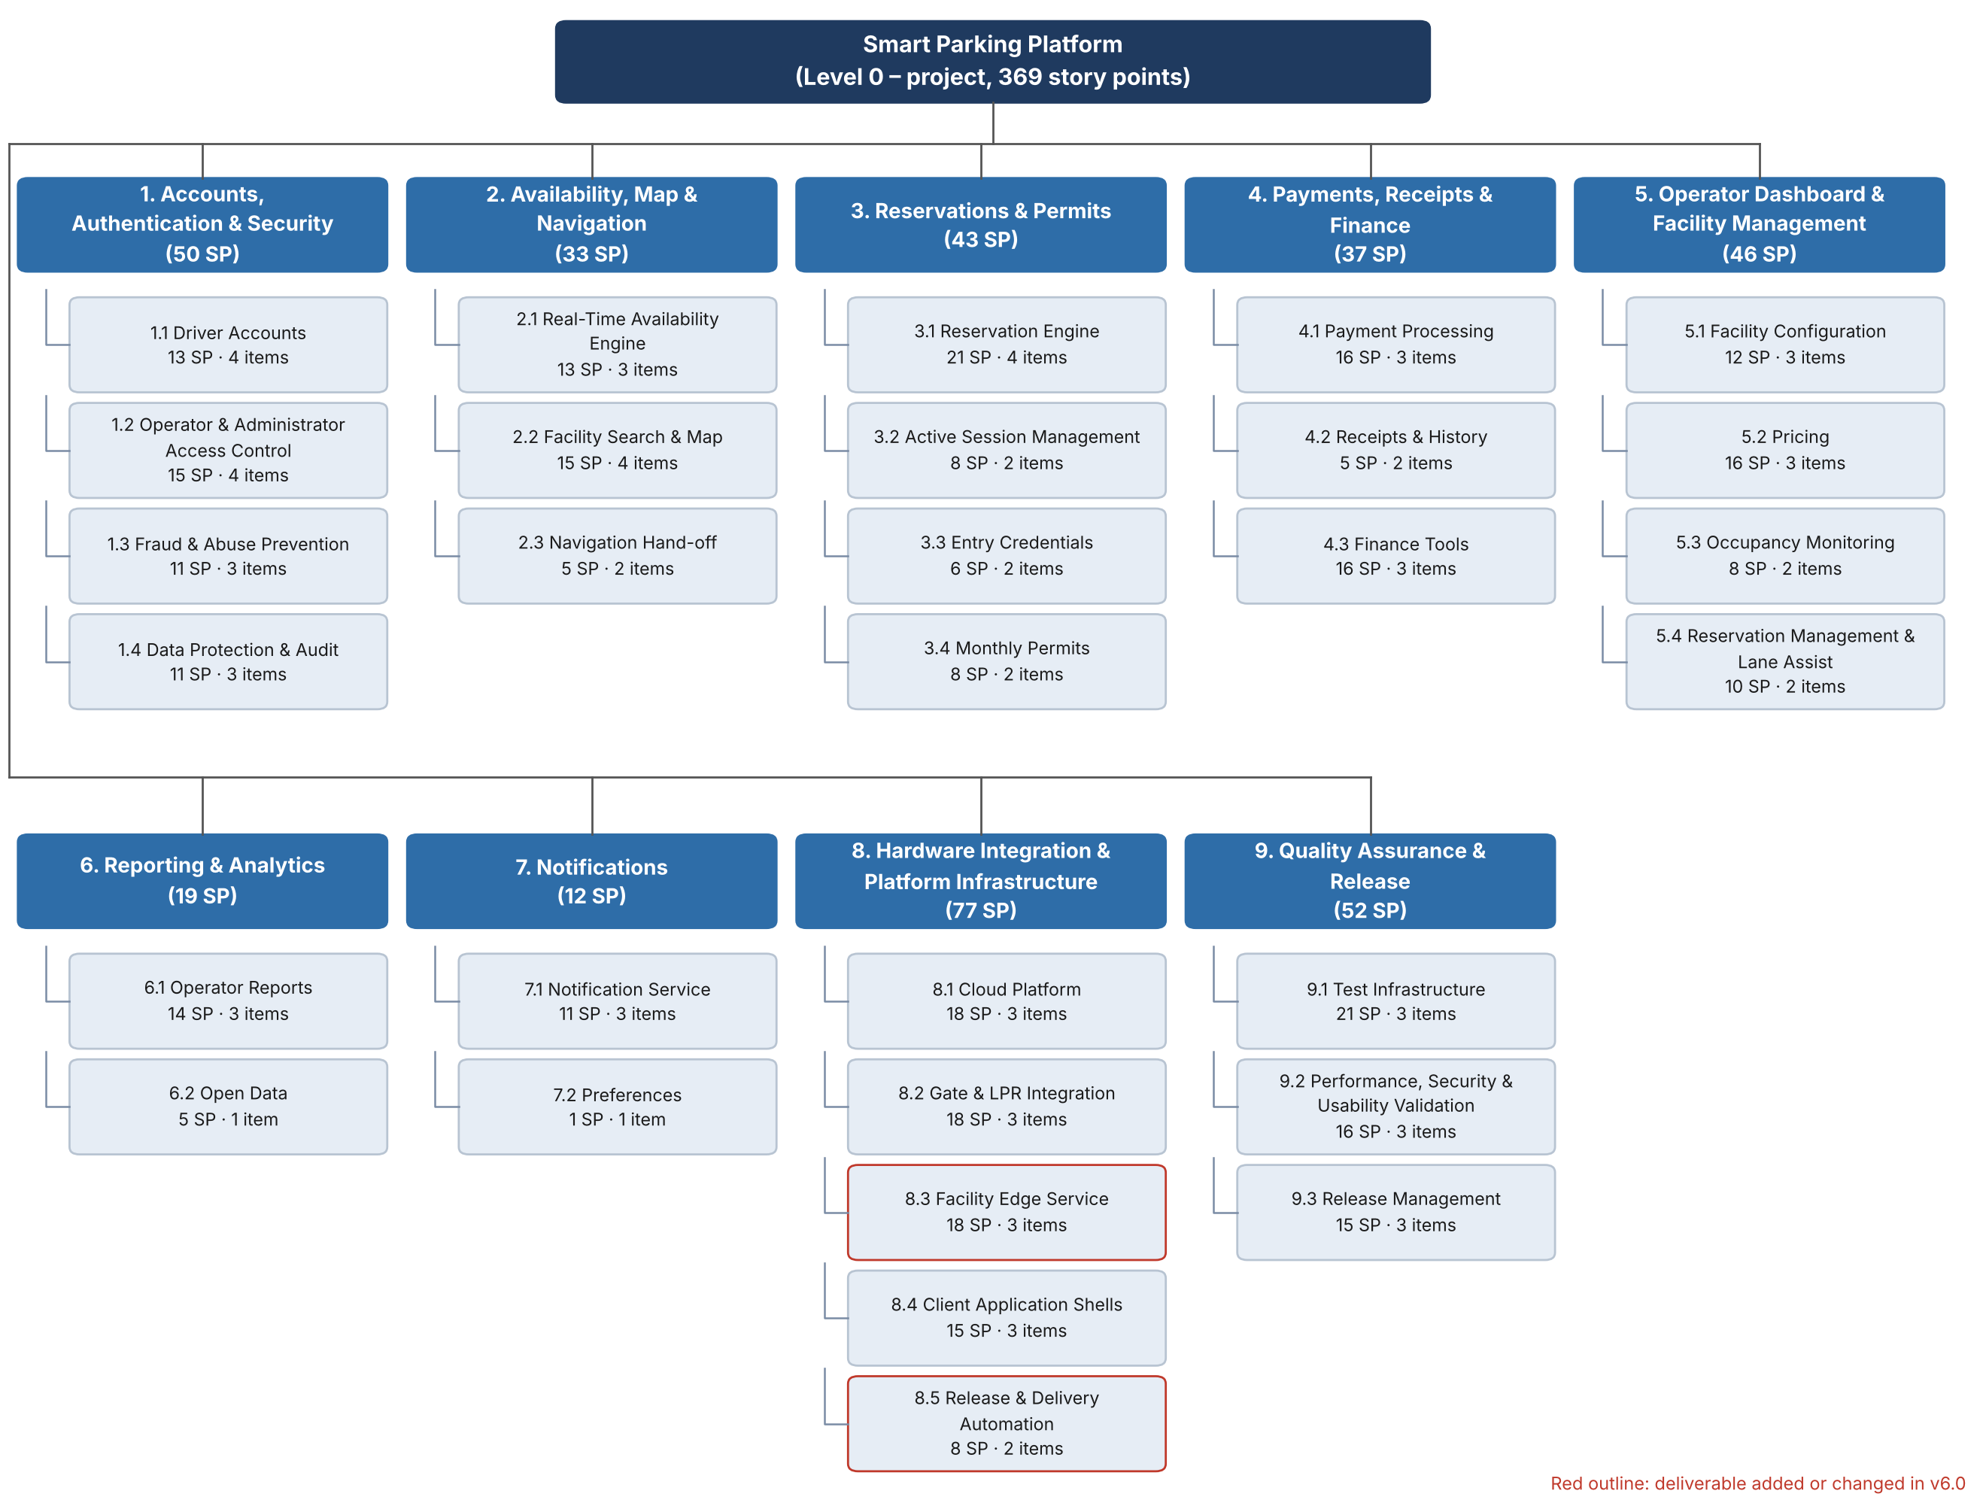
Figure 3. Work Breakdown Structure, Levels 0 to 2. Each Level-2 box shows its rolled-up story points and the number of Level-3 work items listed in Table 8-1. Red outlines mark the deliverables added or changed in v6.0.

8.3 Full Work Breakdown Structure (Levels 1 to 3)
Table 8-1 is the complete WBS. Shaded rows are Level-1 modules (dark) and Level-2 deliverables (light); unshaded rows are Level-3 work items with their story-point estimate and the requirement, use case or lecture rationale that justifies them.
Table 8-1. Work Breakdown Structure with story-point estimates.
ID | Module / Deliverable / Work item | SP | Trace / rationale
1 | Accounts, Authentication & Security | 50 | FR-1 to FR-4, FR-26, NFR-7/8/15; UC-1, UC-18
1.1 | Driver Accounts | 13 | 4 work items
1.1.1 | Email/password registration with verification code | 3 | UC-1 steps 1 to 2; standard but touches email service
1.1.2 | Apple and Google sign-in (OAuth) | 5 | Two third-party identity providers, app-store review rules
1.1.3 | Vehicle profiles (up to 5, default vehicle, plate-ownership check) | 3 | FR-2; CRUD plus duplicate-plate exception
1.1.4 | Password reset and account recovery | 2 | FR-27, UC-19; well-understood pattern
1.2 | Operator & Administrator Access Control | 15 | 4 work items
1.2.1 | Role and permission model (Operator Admin, Facility Manager, Finance, Attendant, Platform Admin) | 5 | FR-3; permissions scoped per facility
1.2.2 | Staff invitation and facility assignment | 3 | UC-18 steps 1 to 2
1.2.3 | Multi-factor authentication and 30-minute session expiry | 5 | FR-4, NFR-8; MFA provider integration
1.2.4 | Immediate session and API-token revocation on user removal | 2 | UC-18 exception
1.3 | Fraud & Abuse Prevention | 11 | 3 work items
1.3.1 | Bot and duplicate-account defenses (rate limiting, CAPTCHA, device checks) | 5 | Lecture 3 'bot army' risk; unknowns in tuning
1.3.2 | Verified payment method with name match required before first reservation | 3 | Depends on 4.1; policy logic
1.3.3 | Per-account reservation limits and no-show rules | 3 | Business rules plus enforcement
1.4 | Data Protection & Audit | 11 | 3 work items
1.4.1 | Encryption in transit (TLS 1.2+) and at rest (AES-256), key management | 3 | NFR-7; mostly configuration
1.4.2 | Personal-data export and deletion tools | 3 | NFR-15, FR-30, UC-21; touches every data store
1.4.3 | Audit log service with before/after values (12-month retention) | 5 | FR-26; cross-cutting hook into all admin actions
2 | Availability, Map & Navigation | 33 | FR-5 to FR-8, NFR-1/2; UC-2, UC-4
2.1 | Real-Time Availability Engine | 13 | 3 work items
2.1.1 | Occupancy counter service consuming gate and sensor events | 8 | NFR-2 5-second freshness; concurrency and event ordering risk
2.1.2 | 'Last updated' staleness tracking and degraded-mode flag | 2 | A-1 fallback
2.1.3 | Waitlist notification when no availability | 3 | FR-28, UC-20 (UC-2 exception)
2.2 | Facility Search & Map | 15 | 4 work items
2.2.1 | Map provider integration (Google Maps Platform / Mapbox) and geocoding | 5 | A-4; secondary provider fallback
2.2.2 | Search by destination or current location with arrival time and duration | 5 | UC-2 steps 1 to 2; NFR-1 2-second target
2.2.3 | Filters (price, distance, covered, EV, height, 24/7) and list view | 3 | FR-5
2.2.4 | Facility detail page (photos, hours, entrance instructions) | 2 | UC-2 step 4
2.3 | Navigation Hand-off | 5 | 2 work items
2.3.1 | Deep link to Google Maps, Apple Maps and Waze with entrance coordinates | 3 | FR-8; three platforms
2.3.2 | In-app fallback directions and entrance description | 2 | UC-4 exception
3 | Reservations & Permits | 43 | FR-9 to FR-13, NFR-9/13; UC-3, UC-6, UC-7, UC-9
3.1 | Reservation Engine | 21 | 4 work items
3.1.1 | Inventory hold and double-sell prevention | 8 | FR-10; core transactional logic, highest business risk
3.1.2 | Hourly, daily and event booking flow with all-in price display | 5 | UC-3; NFR-9 4-tap flow
3.1.3 | Cancellation-policy engine and automatic refund calculation | 5 | FR-11; per-facility policies
3.1.4 | Modify or cancel reservation flow | 3 | UC-7
3.2 | Active Session Management | 8 | 2 work items
3.2.1 | Session extension with capacity check and additional charge | 5 | UC-6, FR-12
3.2.2 | Overstay rate handling and nearby alternatives | 3 | UC-6 exception
3.3 | Entry Credentials | 6 | 2 work items
3.3.1 | QR code generation with offline caching | 3 | FR-13, NFR-13
3.3.2 | License-plate registration for LPR authorization | 3 | FR-13; links to 8.2
3.4 | Monthly Permits | 8 | 2 work items
3.4.1 | Permit purchase with auto-renewal terms | 5 | UC-9; recurring billing
3.4.2 | Permit waitlist and 7-day renewal reminders | 3 | UC-9 exception
4 | Payments, Receipts & Finance | 37 | FR-14 to FR-16, NFR-16; UC-8, UC-16, UC-17
4.1 | Payment Processing | 16 | 3 work items
4.1.1 | Payment-provider integration (card tokenization, PCI scope kept at provider) | 8 | A-3, FR-14; third-party API, webhooks, failure modes
4.1.2 | Apple Pay and Google Pay | 5 | Two wallet integrations with platform certification
4.1.3 | Saved payment methods and failed-payment retry (5-minute hold release) | 3 | UC-3 exception
4.2 | Receipts & History | 5 | 2 work items
4.2.1 | Itemized receipt generation (in-app, email, PDF) | 3 | FR-15, UC-8
4.2.2 | Reservation history with 24-month retention | 2 | FR-15
4.3 | Finance Tools | 16 | 3 work items
4.3.1 | Refund workflow with reason, actor and second approval above limit | 5 | UC-16, FR-16
4.3.2 | Daily settlement reconciliation against provider settlement file | 8 | UC-17; file matching, discrepancy handling
4.3.3 | Export to accounting system | 3 | UC-17 step 4
5 | Operator Dashboard & Facility Management | 46 | FR-17 to FR-20; UC-11, UC-12, UC-13, UC-15
5.1 | Facility Configuration | 12 | 3 work items
5.1.1 | Add, edit and remove facility (address, capacity, hours, restrictions, amenities, entrance coordinates) | 5 | FR-17, UC-11
5.1.2 | Photo and entrance-instruction upload | 2 | UC-11 step 3
5.1.3 | Hardware credential linking, connection test and draft state | 5 | UC-11 steps 4 to 5 and exception
5.2 | Pricing | 16 | 3 work items
5.2.1 | Rate schedules (hourly, daily, event, monthly) including taxes and fees | 5 | FR-18, UC-12
5.2.2 | Dynamic-pricing rules with floor, ceiling and occupancy/event triggers | 8 | FR-18; rules engine, high risk of edge cases
5.2.3 | Price preview and effective-date handling for existing reservations | 3 | UC-12 steps 4 to 5 and exception
5.3 | Occupancy Monitoring | 8 | 2 work items
5.3.1 | Live facility and portfolio occupancy dashboard with 24-hour trend | 5 | FR-19, UC-13
5.3.2 | Threshold alerts and optional pause of same-day reservations | 3 | UC-13 steps 3 to 4
5.4 | Reservation Management & Lane Assist | 10 | 2 work items
5.4.1 | Reservation search and manual override with audit trail | 5 | FR-20
5.4.2 | Lane-assist view for attendants including drive-up sale | 5 | UC-15
6 | Reporting & Analytics | 19 | FR-21, FR-25; UC-14
6.1 | Operator Reports | 14 | 3 work items
6.1.1 | Occupancy, revenue and utilization reports by facility, date range and rate type | 8 | FR-21, UC-14; aggregation queries over large data
6.1.2 | CSV and PDF export | 3 | FR-21
6.1.3 | Scheduled weekly email summary | 3 | FR-21
6.2 | Open Data | 5 | 1 work items
6.2.1 | Anonymized, aggregated occupancy feed for city transportation departments | 5 | FR-25, UC-23; anonymization rules
7 | Notifications | 12 | FR-22, FR-23; UC-10
7.1 | Notification Service | 11 | 3 work items
7.1.1 | Multi-channel delivery service (push, SMS, email) | 5 | Three providers, retry logic
7.1.2 | Driver event templates (confirmation, arrival reminder, 30/10-minute expiry, receipt) | 3 | FR-22
7.1.3 | Operator integration-health alerts after 5 minutes of silence | 3 | FR-23, UC-22
7.2 | Preferences | 1 | 1 work items
7.2.1 | Notification preference screen (per-channel, per-event toggles) | 1 | UC-10 — BASELINE: simplest item in the WBS
8 | Hardware Integration & Platform Infrastructure | 77 | FR-24, NFR-3/4/5/6/12/14; A-1, A-2; UC-5
8.1 | Cloud Platform | 18 | 3 work items
8.1.1 | Cloud environment, containers, managed relational database and message queue | 8 | Foundation for everything; NFR-6 scaling design
8.1.2 | CI/CD pipeline and dev/stage/prod environments | 5 | Enables interleaved testing
8.1.3 | Monitoring, logging and uptime alerting | 5 | NFR-4 99.9%/99.95% targets
8.2 | Gate & LPR Integration | 18 | 3 work items
8.2.1 | Public API and webhook specification for entry/exit events and entry authorization | 5 | FR-24; documentation deliverable
8.2.2 | Pluggable vendor adapters for gate controllers and LPR cameras | 8 | NFR-14, A-2; unknown vendor behaviour
8.2.3 | Sub-1-second entry authorization path | 5 | NFR-3, UC-5 gate entry; performance-critical
8.3 | Facility Edge Service | 18 | 3 work items
8.3.1 | Local event buffering (24 hours) and synchronization on reconnect | 8 | NFR-5, A-1; distributed-systems risk
8.3.2 | Occupancy sensor ingestion | 5 | FR-7
8.3.3 | Gate and sensor fault detection with degraded "park first, pay later" mode | 5 | FR-29, UC-22; response to risk T-2
8.4 | Client Application Shells | 15 | 3 work items
8.4.1 | iOS application shell and App Store setup | 5 | NFR-12
8.4.2 | Android application shell and Google Play setup | 5 | NFR-12
8.4.3 | Responsive web SPA shell with accessibility baseline (WCAG 2.1 AA) | 5 | NFR-11/12
8.5 | Release & Delivery Automation | 8 | 2 work items
8.5.1 | Release automation: staging-to-production promotion, node version check, kill switch and rehearsed rollback | 5 | Risk T-4 response; Lecture 7 CI/CD flow; Section 10.6
8.5.2 | Delivery dashboard, read-only client access to board and pipeline, pipeline-to-Jira status updates | 3 | Lecture 7 client visibility; Section 13.4; risk P-5
9 | Quality Assurance & Release | 52 | NFR-6/10/11/14; A-5
9.1 | Test Infrastructure | 21 | 3 work items
9.1.1 | Unit-test framework with 80% coverage gate in CI | 5 | NFR-14; runs from sprint 1 (lecture: unit tests as safety net)
9.1.2 | Integration test suite (payments, hardware adapters, notifications) | 8 | Third-party sandboxes, hardware simulators
9.1.3 | End-to-end device test suite (iOS, Android, web) | 8 | Device farm, three platforms
9.2 | Performance, Security & Usability Validation | 16 | 3 work items
9.2.1 | Stress-test harness (10,000 concurrent users, 500 facilities) | 8 | NFR-6; lecture: 'stress test harness' before launch
9.2.2 | Security review, PCI-scope confirmation and penetration test | 5 | NFR-7; external firm
9.2.3 | Accessibility and usability testing (8 of 10 first-time users) | 3 | NFR-10/11
9.3 | Release Management | 15 | 3 work items
9.3.1 | Pilot at two client facilities with beta feedback loop | 5 | Lecture: iterate on real feedback before big-bang launch
9.3.2 | Client facility data onboarding (14 facilities) and staff training | 5 | A-5 two-week data buffer
9.3.3 | Production launch, app-store publication and handover documentation | 5 | Final delivery milestone
 | Total project | 369 | 9 modules · 30 deliverables · 82 work items

8.4 Story-Point Summary by Module
Level-1 module | L2 | L3 | Story points | Share | Largest single work item (SP)
1. Accounts, Authentication & Security | 4 | 14 | 50 | 14% | Role and permission model (Operator Admin, Facility Manager, Finance, Attendant, Platform Admin) (5)
2. Availability, Map & Navigation | 3 | 9 | 33 | 9% | Occupancy counter service consuming gate and sensor events (8)
3. Reservations & Permits | 4 | 10 | 43 | 12% | Inventory hold and double-sell prevention (8)
4. Payments, Receipts & Finance | 3 | 8 | 37 | 10% | Payment-provider integration (card tokenization, PCI scope kept at provider) (8)
5. Operator Dashboard & Facility Management | 4 | 10 | 46 | 12% | Dynamic-pricing rules with floor, ceiling and occupancy/event triggers (8)
6. Reporting & Analytics | 2 | 4 | 19 | 5% | Occupancy, revenue and utilization reports by facility, date range and rate type (8)
7. Notifications | 2 | 4 | 12 | 3% | Multi-channel delivery service (push, SMS, email) (5)
8. Hardware Integration & Platform Infrastructure | 5 | 14 | 77 | 21% | Pluggable vendor adapters for gate controllers and LPR cameras (8)
9. Quality Assurance & Release | 3 | 9 | 52 | 14% | Stress-test harness (10,000 concurrent users, 500 facilities) (8)
Total | 30 | 82 | 369 | 100%

Two observations shape the schedule in Section 9. First, Module 8 (platform infrastructure and hardware integration) carries the most points and has no predecessors, so it starts first and everything else depends on it. Second, the items rated 8 points (inventory hold, occupancy engine, payment-provider integration, dynamic pricing, edge buffering, vendor adapters, settlement reconciliation, reporting queries, and the stress-test harness) are the project’s principal technical risks; each involves third-party systems, concurrency or unknown vendor behaviour, and each is deliberately scheduled with slack after it.
The v6.0 review added 13 points to Module 8, now 21% of the project. The new items come straight from the risk register and Lecture 7: fault detection with a degraded mode (risk T-2), release automation with a kill switch and rollback (risk T-4), and a delivery dashboard that gives the client read-only visibility. None of them sits on the critical path.

9. Estimation and Project Timeline
This section converts the WBS into a draft schedule. It states the estimation method and assumptions, defines the project milestones, derives task durations and dependencies from the Level-2 deliverables, and presents the resulting Gantt chart. The schedule is a first draft: it will be refined weekly as estimates are validated, resources are levelled and risks are analysed in later assignments.

9.1 Estimation Approach
Story points were chosen over function points and COCOMO for three reasons. The Smart Parking Platform is greenfield development on a modern three-tier architecture, so lines of code do not track complexity and COCOMO is not appropriate. Function-point analysis requires trained certified counters and is normally supplied by a client for fixed-price Waterfall bids, whereas $oftware ¢orp works in two-week sprints with milestone-based payments. Story points let the team size a new domain (smart parking) relative to itself, which is the method recommended in Lecture 3 when no comparable past project exists. Points were converted to calendar time using the assumptions in Table 9-1; the assumptions are inputs to the accompanying spreadsheet, so changing any of them re-times the entire plan.
Table 9-1. Scheduling assumptions.
Assumption | Value | Basis
Effort per story point | 2 blended developer-days | Includes design, coding, code review, unit tests and sprint ceremonies for a mixed-seniority team; Lecture 3’s example of 1 point = 2 hours applies to a senior developer on a trivial item and was scaled up accordingly.
Team size | 19 engineers + 1 project manager | Backend/API 6 (including the DevOps / Cloud engineer, full-time from build start in v6.0), Mobile 3, Web 3, Mapping & Location 2, Payment Integration 2, QA & Testing 3 (the six teams named in Section 2.3). In COCOMO terms a semi-detached project: mixed experience, 20 to 30 people.
Duration of a deliverable | ⌈ story points × 2 ÷ people assigned ⌉ working days | People assigned per deliverable are listed in Table 9-3; a deliverable never has more people than can work on it without coordination overhead (Mythical Man-Month).
Working calendar | Monday to Friday; U.S. holidays Nov 26 and 27, Dec 24 and 25, Dec 31 and Jan 1, Jan 18, Feb 15 excluded
Cushion | 18 working days (18% of the 100-day build), split 5 days before MVP and 13 days before final delivery | Lecture 3 recommends 15 to 20% for a team new to the domain; shown as explicit grey bars so stakeholders can see the buffer being consumed.
Testing | Unit-test framework built in the first sprint (9.1); a 10-day integration and end-to-end window before each of the MVP and Beta milestones | Testing is interleaved with development rather than deferred to a final phase, the main red flag in the Lecture 3 ‘Facebook in six weeks’ case. Unit-test effort is inside the 2-days-per-point rate; Lecture 7 puts it at 15 to 50% of pure development hours.
Build start | October 19, 2026 | First working day after milestone M1 (requirements and design approved).

9.2 Milestones
The project has five milestones, consistent with the Lecture 3 guidance that milestones are few, large and meaningful and are distinct from sprints. The two payment milestones from the contract (Section 2.2) map directly onto MVP acceptance and final delivery.
Table 9-2. Project milestones.
ID | Milestone | Target date | Definition of done
M0 | Project kickoff / contract award | Sep 8, 2026 | SRS v1.0 issued; 30% kickoff payment.
M1 | Requirements and design approved | Oct 16, 2026 | SRS v6.0 baselined; architecture, data model and UX designs accepted by Bayou City Parking Group; client read-only access to the board and pipeline agreed. Gate for the build phase.
M2 | MVP acceptance | Feb 17, 2027 | Accounts, search, reservation, payment, gate entry and operator facility setup working end to end at two pilot facilities; 40% payment.
M3 | Beta release | Mar 3, 2027 | All 14 facilities configured; finance tools, reporting, notifications, fraud controls live for invited drivers; stress test and security review signed off.
M4 | Final delivery and handover | Apr 5, 2027 | Public launch on App Store, Google Play and web; documentation and training delivered; 30% final payment.

9.3 Schedule and Dependencies
Table 9-3 lists every Level-2 deliverable with its team, effort, duration, start and end dates and predecessors. Dependencies use the two types recommended for most work: finish-to-start (FS), where a deliverable cannot begin until its predecessor is complete (for example the reservation engine needs rates from the pricing deliverable), and start-to-start (SS), where work can run in parallel from the same start (for example the mobile and web shells begin alongside the cloud platform). No finish-to-finish dependencies are used. Requirements and design (Phase 0) precede the build and are shown on the Gantt chart but are project-management work rather than WBS product deliverables.
Table 9-3. Draft schedule by Level-2 deliverable (working days; dates from the dependency network).
ID | Deliverable | Team | SP | Days | Start | End | Predecessors | Scope
1 | Accounts, Authentication & Security |  |  |  | Nov 4, 2026 | Dec 14, 2026
1.1 | Driver Accounts | Backend + Web | 13 | 9 | Nov 4, 2026 | Nov 16, 2026 | 8.1 FS | MVP
1.2 | Operator & Administrator Access Control | Backend + Web | 15 | 10 | Nov 17, 2026 | Dec 2, 2026 | 1.1 FS | MVP
1.3 | Fraud & Abuse Prevention | Backend | 11 | 11 | Nov 30, 2026 | Dec 14, 2026 | 4.1 FS, 1.1 FS | Beta
1.4 | Data Protection & Audit | Backend | 11 | 11 | Nov 17, 2026 | Dec 3, 2026 | 1.2 SS | Beta
2 | Availability, Map & Navigation |  |  |  | Nov 20, 2026 | Dec 10, 2026
2.1 | Real-Time Availability Engine | Backend + Mapping | 13 | 9 | Nov 20, 2026 | Dec 4, 2026 | 8.2 FS | MVP
2.2 | Facility Search & Map | Mapping + Mobile | 15 | 8 | Nov 20, 2026 | Dec 3, 2026 | 8.4 FS, 2.1 SS | MVP
2.3 | Navigation Hand-off | Mobile | 5 | 5 | Dec 4, 2026 | Dec 10, 2026 | 2.2 FS | MVP
3 | Reservations & Permits |  |  |  | Jan 5, 2027 | Feb 3, 2027
3.1 | Reservation Engine | Backend + Mobile | 21 | 11 | Jan 5, 2027 | Jan 20, 2027 | 5.2 FS, 2.2 FS, 4.1 FS | MVP
3.2 | Active Session Management | Backend + Mobile | 8 | 6 | Jan 27, 2027 | Feb 3, 2027 | 3.3 FS | Beta
3.3 | Entry Credentials | Backend + Mobile | 6 | 4 | Jan 21, 2027 | Jan 26, 2027 | 3.1 FS, 8.2 FS | MVP
3.4 | Monthly Permits | Backend + Mobile | 8 | 6 | Jan 21, 2027 | Jan 28, 2027 | 3.1 FS | Beta
4 | Payments, Receipts & Finance |  |  |  | Nov 4, 2026 | Feb 10, 2027
4.1 | Payment Processing | Payments | 16 | 16 | Nov 4, 2026 | Nov 25, 2026 | 8.1 FS | MVP
4.2 | Receipts & History | Payments + Mobile | 5 | 4 | Jan 21, 2027 | Jan 26, 2027 | 3.1 FS | Beta
4.3 | Finance Tools | Payments + Web | 16 | 11 | Jan 27, 2027 | Feb 10, 2027 | 4.2 FS | Beta
5 | Operator Dashboard & Facility Management |  |  |  | Dec 3, 2026 | Feb 4, 2027
5.1 | Facility Configuration | Web + Backend | 12 | 8 | Dec 3, 2026 | Dec 14, 2026 | 1.2 FS | MVP
5.2 | Pricing | Web + Backend | 16 | 11 | Dec 15, 2026 | Jan 4, 2027 | 5.1 FS | MVP
5.3 | Occupancy Monitoring | Web + Backend | 8 | 6 | Dec 15, 2026 | Dec 22, 2026 | 2.1 FS, 5.1 FS | Beta
5.4 | Reservation Management & Lane Assist | Web + Backend | 10 | 7 | Jan 27, 2027 | Feb 4, 2027 | 3.3 FS | Beta
6 | Reporting & Analytics |  |  |  | Dec 7, 2026 | Feb 9, 2027
6.1 | Operator Reports | Backend + Web | 14 | 10 | Jan 27, 2027 | Feb 9, 2027 | 4.2 FS, 5.3 FS | Beta
6.2 | Open Data | Backend | 5 | 5 | Dec 7, 2026 | Dec 11, 2026 | 2.1 FS | Beta
7 | Notifications |  |  |  | Nov 4, 2026 | Nov 20, 2026
7.1 | Notification Service | Backend | 11 | 11 | Nov 4, 2026 | Nov 18, 2026 | 8.1 FS | MVP
7.2 | Preferences | Mobile | 1 | 2 | Nov 19, 2026 | Nov 20, 2026 | 7.1 FS | MVP
8 | Hardware Integration & Platform Infrastructure |  |  |  | Oct 19, 2026 | Dec 17, 2026
8.1 | Cloud Platform | Backend/API | 18 | 12 | Oct 19, 2026 | Nov 3, 2026 | M1 FS | MVP
8.2 | Gate & LPR Integration | Backend/API | 18 | 12 | Nov 4, 2026 | Nov 19, 2026 | 8.1 FS | MVP
8.3 | Facility Edge Service | Backend/API | 18 | 18 | Nov 20, 2026 | Dec 17, 2026 | 8.2 FS | MVP
8.4 | Client Application Shells | Mobile + Web | 15 | 8 | Oct 19, 2026 | Oct 28, 2026 | 8.1 SS | MVP
8.5 | Release & Delivery Automation | DevOps (Backend/API) | 8 | 16 | Nov 4, 2026 | Nov 25, 2026 | 8.1 FS | MVP
9 | Quality Assurance & Release |  |  |  | Oct 19, 2026 | Mar 17, 2027
9.1 | Test Infrastructure | QA | 21 | 21 | Oct 19, 2026 | Nov 16, 2026 | 8.1 SS | MVP
9.2 | Performance, Security & Usability Validation | QA | 16 | 11 | Jan 27, 2027 | Feb 10, 2027 | 3.3 FS, 8.3 FS | Beta
9.3 | Release Management | QA + PM | 15 | 10 | Mar 4, 2027 | Mar 17, 2027 | M3 FS | Release
T1 | MVP integration & end-to-end testing (2 pilot facilities, gate/LPR, payments) | QA + all teams |  | 10 | Jan 27, 2027 | Feb 9, 2027 | 3.3 FS, 2.3 FS, 8.3 FS | MVP
C1 | Schedule cushion: MVP (5 working days) | — |  | 5 | Feb 10, 2027 | Feb 17, 2027 | T1 FS | MVP
T2 | Beta regression, stress-test run and security sign-off | QA + Backend |  | 10 | Feb 18, 2027 | Mar 3, 2027 | 9.2 FS, 6.1 FS, 4.3 FS | Beta
C2 | Schedule cushion: Final (13 working days) | — |  | 13 | Mar 18, 2027 | Apr 5, 2027 | 9.3 FS | Release

The critical path runs through the platform foundation and the reservation chain: 8.1 Cloud Platform → 1.1 Driver Accounts → 1.2 Operator Access Control → 5.1 Facility Configuration → 5.2 Pricing → 3.1 Reservation Engine → 3.3 Entry Credentials → MVP integration testing → M2. Any slip on these deliverables moves the MVP date one-for-one, which is why the first cushion sits immediately after them. Beta-scope deliverables (green in the Gantt chart) are scheduled as soon as their own predecessors finish, so several of them complete before the MVP milestone; they are excluded from MVP acceptance to keep that milestone small and testable.
The v6.0 changes do not move the critical path. Facility Edge Service (8.3) grows from 13 to 18 points and now ends on December 17, but its successors (T1 and 9.2) do not start until January 27. The new Release & Delivery Automation deliverable (8.5) is built by the DevOps engineer alone in parallel with 8.2, so it is ready before the first deployment to the pilot facilities.

9.4 Gantt Chart
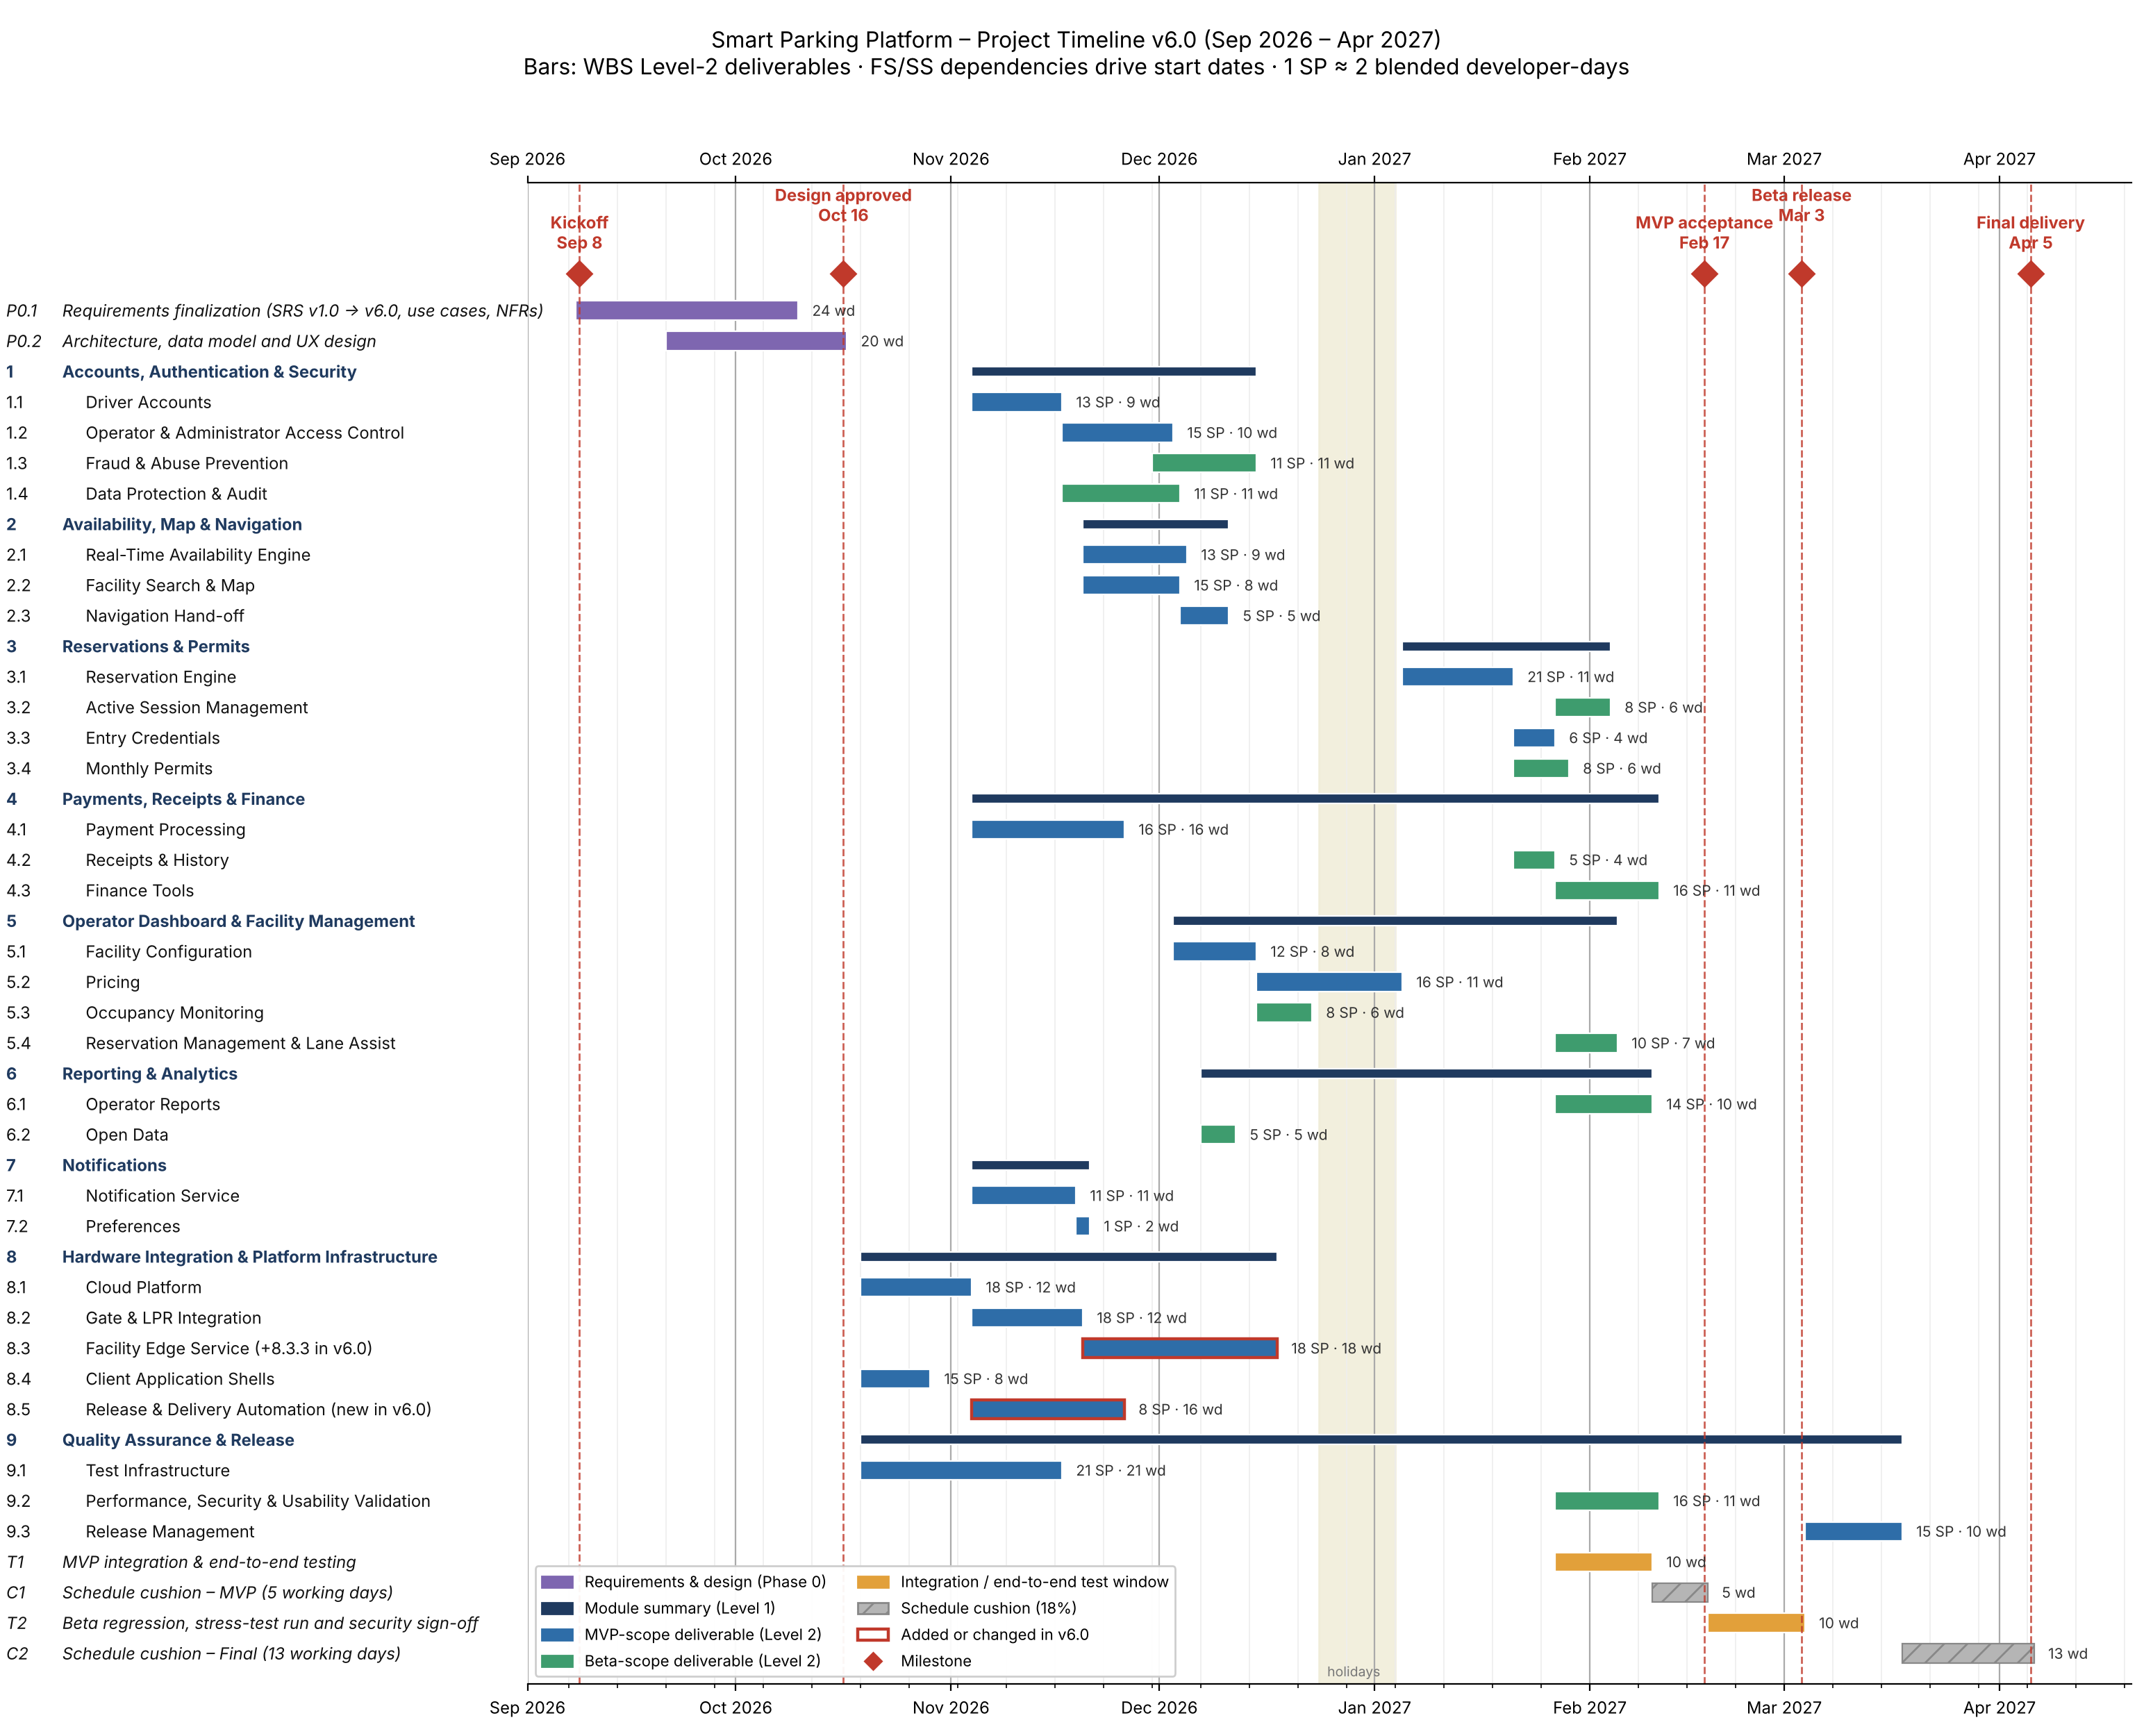
Figure 4. Gantt chart v6.0, September 2026 to April 2027. Blue bars are MVP-scope deliverables, green bars Beta-scope, amber bars integration and end-to-end test windows, grey hatched bars schedule cushion, and red diamonds milestones; red outlines mark the deliverables added or changed in v6.0 (8.3 and 8.5). The chart is generated from the dates in Table 9-3 by a script kept in the repository (figures/gantt_v6.py), so it can be re-timed by changing a date.

9.5 Schedule Risks and Planned Refinements
Risk or open item | Effect on the schedule | Planned handling
Vendor gate/LPR APIs (A-2) behave differently from their documentation | 8.2 and 8.3 are 8-point items on the MVP path; a slip delays M2 directly | Request vendor sandboxes during Phase 0; hardware simulators built under 9.1.2 so integration testing does not wait for physical gates
Client facility data (A-5) arrives late | 9.3.2 onboarding compresses into the final cushion | Two-week data-collection buffer already in the plan; onboarding of the two pilot facilities happens at MVP, not at final delivery
Resource contention: Backend/API is assigned to 17 of 29 deliverables | Parallel bars in November assume six backend engineers are fully available | Levelled in Section 14.2 (v5.0): five full-time backend engineers plus the DevOps engineer, now full-time from build start (v6.0), so pipeline and environment work no longer competes with feature cards. Remaining contention is watched through risk S-3.
Story-point calibration | Durations scale linearly with the 2-day-per-point assumption | Re-estimate after the first two sprints using measured velocity; update Assumptions!B4 in the spreadsheet and re-issue the chart
Holiday period Dec 24 to Jan 3 | 5.2 Pricing spans the break | Already excluded from working days; no MVP-critical item is scheduled to finish inside the break

Planned refinements for the next versions of this document: resource levelling and a staffing plan per sprint, cost estimates derived from the duration table, a risk register with mitigation owners, and conversion of the Level-3 items into a sprint backlog. As instructed, all sections remain in this single document and the version number is incremented with every change.
Update for v4.0: the risk register planned above is now Section 11. The schedule risks in this table are carried into it as T-1, S-3, S-4 and S-5, each with an owner and a response.
Update for v6.0: the resource-levelling and cost items planned above are complete (Section 14). Two refinements remain open: re-estimating story points once Sprints 1 to 3 give a measured velocity, and adding the defect Kanban board at the pilot.

10. Sprint Backlog and Board Management

10.1 Purpose and Tool Selection
Section 8 defined what the Smart Parking Platform must deliver and Section 9 defined when. This section converts that plan into the working artefact the development team uses day to day: a prioritised product backlog held on a Scrum board, and a committed backlog for the first sprint.
The board is maintained in Jira. Jira was selected over Trello because this project sits at the scale Jira is built for, with nine modules, thirty deliverables and 369 story points across a seven-month schedule, and because it carries the three fields this backlog depends on natively: story-point estimates, a multi-label taxonomy for category, actor and module, and a sprint container that separates committed work from the product backlog. Trello would hold the same cards, but the metadata would live in the card titles rather than in queryable fields, which makes filtering and reporting manual. Both are Atlassian products and either is defensible at a smaller scale; the deciding criterion was the one applied to schedule tooling in Section 9, ease of change, since this backlog will be revised at every sprint boundary for the remainder of the project.
The Lecture 7 decision matrix confirms the choice. With 20 people the project is a mid-size team (8 to 25 people), for which Jira is the recommended tool; Trello suits small or junior teams and Azure DevOps suits large enterprise programmes. Azure DevOps was considered again because the client is assumed to run on Microsoft 365 (Section 13.2), but the team is already productive in Jira and the client’s visibility needs are met by read-only access and a delivery dashboard (Section 10.6), so switching tools would add a learning curve without improving delivery. The decision will be revisited only if the client asks to host the board in its own Azure tenant at the M1 review.

10.2 Relationship Between the WBS and the Backlog
The Work Breakdown Structure in Section 8 stops at Level 3, which is the industry-standard depth: below Level 3, deliverables decompose into individual work items that are managed as discrete entities inside a project-management tool rather than inside the WBS document itself. Carrying that decomposition further inside the WBS would increase management overhead without improving the estimate.
The board is therefore the Level-4 view of the same structure. Every card on the board names its Level-3 parent, so each item of work can be traced upward to a deliverable, a module, and ultimately to the functional requirements and use cases in Sections 5 and 7. No card exists on the board that does not originate in the WBS, and the WBS remains the authoritative statement of scope.
Table 10.1 — Backlog composition
Category | Cards | Driver-facing | Operator-facing | Requirement
Login and access control | 10 | 5 | 5 | 5 minimum
User interface (operator and driver) | 21 | 14 | 7 | 15 minimum
Backend processes (operator and driver) | 40 | 14 | 13 | 15 minimum
Reporting (operator and driver) | 13 | 2 | 10 | 10 minimum
Total | 84 |  |  | 45 minimum
Counts of driver- and operator-facing cards overlap where a card serves both actors or is platform-internal, so the category columns do not sum to the card total.
The backlog covers 71 of the 82 Level-3 work items and carries 309 of the 369 story points. Two quality items move onto the board in v6.0 because Table 9-3 schedules them from October 19: the integration test suite with hardware simulators (9.1.2) and the end-to-end device suite (9.1.3), 16 points. The three work items added in v6.0 (8.3.3, 8.5.1 and 8.5.2, 13 points) are created as cards at Sprint 1 planning. That brings the board to 76 items and 338 points. The six items still to come are performance, security and usability validation (9.2.1 to 9.2.3) and release management (9.3.1 to 9.3.3), 31 points, which enter the board as the project approaches the Beta Release milestone on 3 March 2027. The unit-test framework (9.1.1) was committed to Sprint 1 from the start, because a coverage gate that arrives late provides no protection for the code written before it.

10.3 Board Conventions
Columns. The board uses four columns: To Do, In Progress, In Review and Done. The In Review column is retained deliberately, because review is itself a unit of work that must complete before a card can move to Done, and collapsing it into In Progress hides the review queue.
Card identifiers. Cards carry a prefix indicating their category, L for login, U for user interface, B for backend and R for reporting, followed by a sequence number. This identifier is stable and is used in stand-ups and in this document.
Labels. Each card carries four labels: its category, its actor (actor-driver, actor-operator, actor-both or actor-system), its WBS module (wbs-1 through wbs-9), and its sprint assignment. The actor label makes it possible to filter the board to the operator-side work that the first delivery phase depends on.
Estimates. Every card carries the story-point value assigned to its parent work item in Section 8, distributed across the cards that decompose it. Story points follow the Fibonacci scale and measure complexity, risk and effort rather than duration, as described in Section 9.1. Where a single Level-3 work item decomposes into both an interface card and a backend card, its points are divided between them rather than duplicated, so the board reconciles exactly to the WBS: after the v6.0 changes, 338 points on the board plus 31 points deferred equals the 369-point project total in Section 8.4.
Definition of Done. A card reaches Done when its functionality is implemented, its unit tests pass the coverage gate, it has been reviewed by a second engineer, and it has been demonstrated against its originating use case. A deliverable in Section 8 is complete only when every card decomposing it is Done.

10.4 Sprint 1 Backlog
Sprint 1 runs for two weeks immediately following the Design Approved milestone of 16 October 2026, from Monday 19 October to Friday 30 October, consistent with the schedule in Section 9.3.
Capacity. Sprint capacity is calculated team by team, because the 19 engineers in Table 9-1 do not all start the same work on 19 October. The Backend/API team, six engineers including the DevOps engineer who is full-time from build start (Section 14.2), gives 60 developer-days over ten working days. At the conversion rate in Section 9.1, one story point to two blended developer-days, that is 30 story points, and the team commits 28, a deliberate 93% load (Table 10.2). This is the commitment shown in Figure 5. Table 10.3 shows the other teams. Earlier versions quoted only the backend figure as if it were the whole project; v6.0 corrects that. The headroom in each team absorbs the first-sprint estimation error a team new to this domain should expect.
Table 10.2 — Sprint 1 committed backlog, Backend/API team
Card | WBS | Deliverable | Story points
B-01 | 8.1.1 | Cloud environment, containers, managed relational database and message queue | 8
B-02 | 8.1.2 | CI/CD pipeline and dev/stage/prod environments | 5
B-03 | 8.1.3 | Monitoring, logging and uptime alerting | 5
B-40 | 9.1.1 | Unit-test framework with 80% coverage gate in CI | 5
L-10 | 1.2.1 | Role and permission model (Operator Admin, Facility Manager, Finance, Attendant, Platform Admin) | 5
 |  | Total committed | 28
Table 10.3 — Sprint 1 capacity by team (19 October to 30 October)
Team | Engineers (FTE) | Capacity (SP) | Sprint 1 work | Committed SP
Backend/API (incl. DevOps) | 6 (6.0) | 30 | B-01, B-02, B-03, B-40, L-10 (Table 10.2) | 28
Mobile and Web (incl. UX) | 6 (5.75) | 28 | Client application shells, WBS 8.4.1 to 8.4.3; headroom covers app-store accounts and design-system components from Phase 0 | 15
QA & Testing | 3 (2.75) | 13 | Integration test suite with gate and LPR simulators, WBS 9.1.2 | 8
Mapping and Payments | 4 (2.2) | — | Join feature work on 4 November (Table 9-3); Sprint 1 time goes to the vendor sandbox spike (risks T-1, P-3) and provider accounts, not pointed | 0
Total | 19 (16.7) | 71 |  | 51

The Mobile/Web and QA cards are moved into the sprint at Sprint 1 planning on 19 October, so the whole-project commitment is 51 points against a capacity of 71 (72%). The lower load outside the backend team is deliberate: the shells finish on 28 October and those engineers then start their Sprint 2 cards early rather than sit idle.
Sprint Goal. Stand up the platform foundation and the operator access model, so that facility onboarding can begin in Sprint 2.
Rationale for this selection. Three constraints point to the same starting scope:
• Dependency order. Every subsequent card in the backlog runs on the cloud environment, the deployment pipeline and the permission model. These are finish-to-start predecessors for the rest of the project, and the Gantt chart in Section 9.4 places Module 8.1 at the head of the schedule for exactly this reason.
• Operator-before-driver sequencing. The platform has no service to sell until a garage has been onboarded, so the operator side of the product must precede the driver side. Sprint 1 delivers the access-control model that operator onboarding depends on; Sprint 2 delivers facility configuration itself.
• Testing is not a final phase. The unit-test framework and its coverage gate are commissioned in Sprint 1 rather than before release, so that every line of code written from Sprint 2 onward is covered as it is produced.
Sprint 1 does not include any driver-facing functionality. That is expected at this stage and is worth stating explicitly to stakeholders: the Sprint 1 review will demonstrate a deployed environment, a passing test pipeline and a working permission model rather than a user-visible screen. Visible driver functionality begins in Sprint 3 and is fully demonstrable by the MVP Acceptance milestone of 17 February 2027.
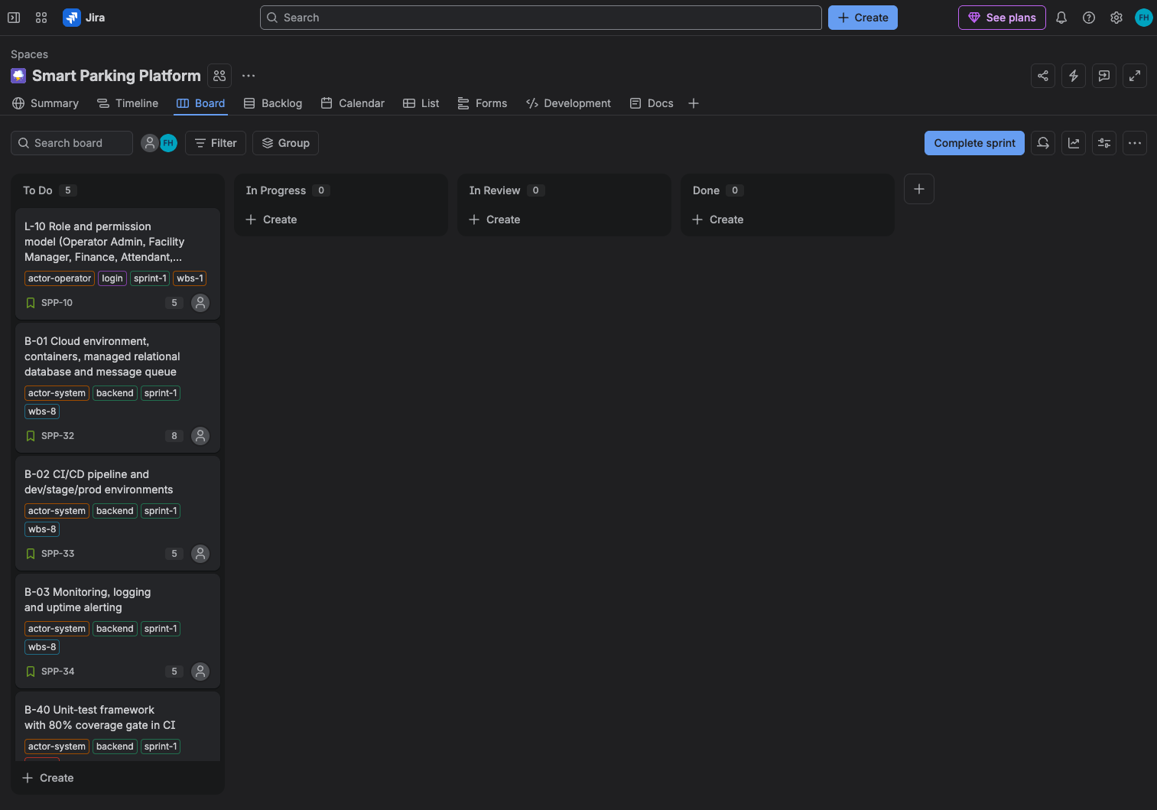
Figure 5. Sprint 1 board at the start of the sprint. All five committed cards sit in To Do; the In Review column is kept separate from In Progress so that the review queue stays visible. Each card shows its category, actor and WBS module labels and its story-point estimate. The screenshot shows the Backend/API commitment; the cards in Table 10.3 are added at Sprint 1 planning.

10.5 Board Maintenance
The backlog is a living artefact and will be revised at every sprint boundary. Three revisions are already anticipated:
• Story-point recalibration. The values in this backlog are relative estimates made without measured velocity. After two or three sprints the team's actual velocity replaces the assumed rate of two developer-days per point, and both this backlog and the schedule in Section 9 will be re-based against it.
• Resource levelling. Done in Section 14.2. Backend work is now covered by five full-time backend engineers and a full-time DevOps engineer, and sprint-by-sprint card assignment will show whether any concentration remains (risk S-3).
• A separate Kanban board for defects. Planned development work belongs on this Scrum board, which resets at each sprint boundary. Bugs and defects are unpredictable in both arrival and complexity and cannot be planned into a fixed timebox, so they will be tracked on a continuous Kanban board with work-in-progress limits. That board is introduced when the platform first reaches external users, at the pilot described in WBS 9.3.1, ahead of the Beta Release milestone.
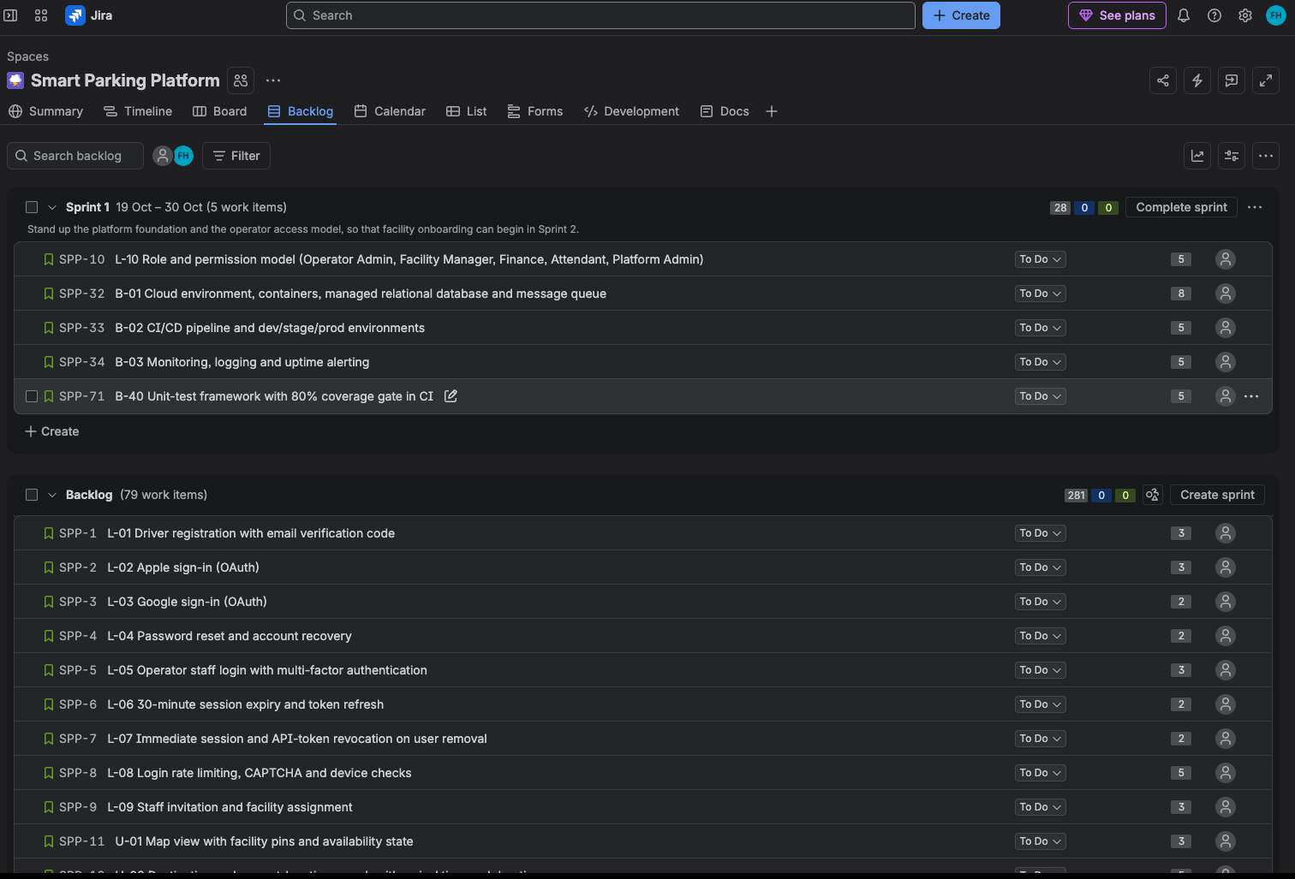
Figure 6. Product backlog. The sprint container holds the 28 committed points; the 79 remaining cards below it carry 281 points, which together reconcile to the 309 points the board holds against the 356-point project total at the time of the screenshot (v3.0). After the v6.0 changes the board holds 338 of 369 points (Section 10.2).

10.6 Source Control, CI/CD Pipeline and Board Integration
The board says what work is planned; source control and the CI/CD pipeline prove that the work is actually done. Lecture 7 groups project tools into three connected categories, and this project uses one tool in each, chosen to fit the team rather than for reputation.
Table 10.4 — Tool stack
Category | Tool | Why it fits this project
Task and project management | Jira (Scrum board, project key SPP) | Mid-size team; story points, labels and sprints as native fields (Section 10.1)
Source control | GitHub (protected main branch) | Largest community and native pull requests; links each pull request to its Jira card
CI/CD automation | GitHub Actions | Pipeline defined in a YAML file kept in the repository, so pipeline changes are reviewed like code
Communication and documents | Microsoft Teams and SharePoint | Match the client’s assumed Microsoft 365 ecosystem (Section 13.2)

Source control rules. These follow the Lecture 7 best practices and are enforced by branch protection rather than by goodwill:
• Feature branches. Every Jira card gets its own branch named after it (for example SPP-44-payment-processing). Main stays stable and deployable; nobody pushes to main directly.
• One work item per branch. A branch and its pull request cover exactly one card, even when two changes look convenient to combine. This keeps every change traceable to the work item that asked for it, so a defect can be traced back to its source.
• Small, meaningful commits. Commit often and push daily, with messages that say what changed and why (“Fix login validation bug”, not “Changed stuff”).
• Pull requests close cards. A pull request titled with its card key (for example “SPP-44 Payment processing”) moves the card automatically: to In Review when it opens and to Done when it merges. The branch is deleted after the merge.
Table 10.5 — Pipeline stages for every change
Stage | What happens | If it fails
1. Build | On every push to a feature branch, the pipeline compiles the new code together with the latest main branch. | Broken build: the developer is notified at once and fixes it before anything else.
2. Unit and regression tests | All existing tests run (regression) plus the new tests for the card, including edge cases such as an invalid or stolen card; the 80% coverage gate (NFR-14) applies. | The branch cannot be merged; the failing test names the problem before the code leaves the developer.
3. Pull request | If everything passes, the pipeline opens the pull request and assigns a reviewer from the same team. | —
4. Human review and merge | The reviewer checks that the code is correct and stays within its card’s scope, then approves; the merge updates the Jira card to Done. | Changes requested; the card stays In Review.
5. Promotion | Main deploys automatically to Dev. At the end of each sprint the release candidate is promoted to Staging; Production releases follow the milestones (pilot, Beta, launch) after QA Lead and PM sign-off. | Promotion stops; the rehearsed rollback and kill switch apply in Production (risk T-4, WBS 8.5.1).

Environments and cadence. The same container image moves unchanged from Dev to Staging to Production, and Staging runs the production operating system and resource limits, so a change that passes Staging behaves the same way in Production (risk T-6). Staging is refreshed every sprint; Production releases are feature-based, tied to what the client has accepted, not to a fixed weekly date.
Client visibility. Bayou City Parking Group owns the code and the environments being built for it, so its staff can see the board and the pipeline at any time. They get read-only access, which lets them follow progress without the risk of changing or deleting anything (risk P-5), and a delivery dashboard that turns pipeline and board data into a few colours and numbers: build health, cards done this sprint, points remaining and open defects (WBS 8.5.2). The Project Manager runs the pipeline as the team’s delivery process: work is assigned through it, and its status is what the PM reports to stakeholders (Section 13.4).

11. Risk Management
This section identifies what could prevent the project from meeting its scope, schedule and quality commitments, rates each risk, assigns an owner and records the agreed response. Following Lecture 5, a risk is an uncertain future event; an issue is a risk that has already happened. When a risk becomes an issue, the team looks up the response here and starts it instead of holding an emergency meeting.

11.1 Approach
Risk management follows four steps, repeated for the life of the project:
- Identify. Risks were brainstormed by category (technical, schedule, financial and people) and drawn from the assumptions in Section 2.6, the schedule risks in Section 9.5 and the Houston operating environment. Table 11.3 summarises them by category.
- Assess. Each risk is rated for probability and impact on the matrix in Section 11.2.
- Respond. Each risk receives one of the four response strategies in Section 11.3, an owner and a trigger that tells the owner when to act.
- Track. The register is reviewed every two weeks at sprint planning (Section 13.3). When a risk occurs, its status changes to Issue and the notes record how the response performed.
Assessment is done now, before the build starts on October 19, because insurance, cloud hosting and vendor sandboxes must be in place before a risk occurs. Financial risks are recorded even though the budget is unlimited for $oftware ¢orp (Section 4.4), because they affect the client and the milestone payments. Researching the Houston location surfaced hurricanes and heat-driven power outages, which a manager from another region might miss.

11.2 Assessment Scales and Risk Matrix
Probability and impact are each rated on a five-point scale, defined in the row and column headings of Table 11.1. The matrix is not a simple multiplication: impact carries more weight than probability. A catastrophic risk is never rated below Medium however unlikely it is, and a negligible risk is always Low however likely it is.
Table 11.1 — Risk matrix and scales, with the project’s risks placed
Probability / Impact | Catastrophic (5)  Project failure, major loss, legal issues | Major (4)  Overrun above 20%, key feature lost | Moderate (3)  Overrun 10% to 20%, scope cut, morale hit | Minor (2)  Slip under 10%, small rework | Negligible (1)  Easily absorbed
Very High (5)  over 80% | Extreme | High | High | Medium | Low
High (4)  61% to 80% | Extreme | High | High  T-2, S-4 | Medium  S-2 | Low
Moderate (3)  41% to 60% | High | High  T-1, T-3, P-3 | Medium  F-3, P-4, S-3, T-6 | Medium  S-5, F-2, P-1, F-5 | Low
Low (2)  21% to 40% | High  T-4, F-1 | Medium  F-4, P-2 | Medium  P-5 | Low  T-5 | Low
Very Low (1)  0% to 20% | Medium  S-1 | Medium | Low | Low | Low
No risk is currently Extreme. T-4 would become Extreme if releases were deployed manually, which is why automated deployment is part of its response.
The rating sets the level of detail: Low risks get a one-line response, Medium risks a response and a trigger, and High risks, or any risk with Major or Catastrophic impact, a step-by-step plan (Section 11.6).

11.3 Response Strategies
Table 11.2 — Response strategies used in this register
Strategy | Meaning | Example in this project
Avoid | Change the plan so the risk cannot occur. Preferred where possible. | Support only iOS 16+ and Android 12+ (T-5); no hard-dated release in hurricane season (S-1).
Mitigate | Reduce probability, or impact where probability cannot be controlled (weather). | Park first, pay later mode when a gate fails (T-2); deployment checks and a kill switch (T-4).
Transfer | Shift the risk or its cost to a third party: insurance, outsourcing, contract. | Business interruption insurance (S-1); specialist contractor (P-3); client-bought hardware (F-3).
Accept | Acknowledge and monitor; acting would cost more than the risk. | Third-party usage fees (F-2).
A response can create a secondary risk: relying on a contractor for P-3 creates a dependency on that contractor, which is why two in-house engineers are paired with them.

11.4 Identified Risks by Category
Twenty-one risks are now identified and all are carried into the register. Three were added in v6.0 from Lecture 7 (T-6, F-5 and P-5), and S-3 was re-rated after the resource levelling in Section 14.2.
Table 11.3 — Identified risks by category
Category | Risks
Technical (6) | T-1 Gate and LPR vendor APIs differ from their documentation  T-2 Gate or sensor failure at a live facility makes occupancy data wrong  T-3 Automated accounts reserve a facility’s entire inventory  T-4 A faulty production release damages live transactions  T-5 Older phones multiply testing and defects  T-6 Code behaves differently in Dev, Staging and Production
Schedule (5) | S-1 Hurricane or tropical storm closes the Houston office  S-2 Regional power outage stops work for several days  S-3 Backend/API team is over-allocated  S-4 Story-point conversion is too optimistic  S-5 Client data or app-store approval arrives late
Financial (5) | F-1 Client funding is cut or the client becomes insolvent  F-2 Third-party service costs exceed plan  F-3 Hardware integration needs paid middleware or extra devices  F-4 Regulatory change forces rework  F-5 The client pushes back on the cost of automated testing
People (5) | P-1 A key engineer is ill during a critical sprint  P-2 A key engineer leaves the project  P-3 The team lacks gate, LPR and IoT integration skills  P-4 Friction between teams or team leads  P-5 A client stakeholder changes pipeline or board settings by accident

11.5 Risk Register
Table 11.4 is the risk register. Probability (P) and impact (I) use the scales in Table 11.1, from which the rating is read. Owners are roles rather than named people; the owner monitors the trigger and starts the response. Financial risks that only the company can act on are owned by $oftware ¢orp leadership rather than the Project Manager.
Table 11.4 — Risk register (status as of October 15, 2026)
ID | Risk and description | P | I | Rating | Owner | Response strategy and trigger | Status / notes
T-1 | Gate and LPR vendor APIs differ from their documentation (Technical)  Gate and camera interfaces at the 14 facilities are non-standard or undocumented, so the WBS 8.2 adapters overrun or miss the 1-second entry target.  Source: A-2; NFR-3, NFR-14; WBS 8.2; Section 9.5 | 3 | 4 | High | Backend/API Lead | Mitigate. Request vendor sandboxes during Phase 0; build each vendor as a pluggable adapter (NFR-14) so one bad interface is isolated; build hardware simulators under WBS 9.1.2 so integration testing does not wait for physical gates; run a one-sprint technical spike on the first vendor before committing the rest.  Trigger: Sandbox not available by M1, or the spike exceeds its estimate by more than 50%. | Open. Sandbox access requested from the client during Phase 0.
T-2 | Gate or sensor failure at a live facility makes occupancy data wrong (Technical)  A gate, camera or sensor fails; the gate is opened manually, exits stop being counted and the app shows wrong availability.  Source: A-1; FR availability; NFR-2, NFR-5; WBS 8.3; Lecture 5 example | 4 | 3 | High | Backend/API Lead (with client facility operations) | Mitigate. Detect the fault automatically (no exit events while entries continue, or a count that drifts from the sensor total). The app then replaces the space count with "Occupancy data for this facility is currently unreliable", stops selling pre-paid reservations for that facility and switches it to park first, pay later. Existing reservations are still honoured at the gate. The operator dashboard raises an alert, and the count is re-baselined from a manual walk-through once the hardware is repaired.  Trigger: Facility count anomaly alert, or an operator reports a hardware fault. | Open. Fault detection and degraded mode are now WBS 8.3.3 (5 SP), FR-29 and UC-22.
T-3 | Automated accounts reserve a facility’s entire inventory (Technical)  Scripted fake accounts book every space at a garage, so real drivers see it as full (the Lecture 3 "evil garage owner").  Source: FR reservations; WBS 3 and 1; M3 fraud controls; Lecture 3 example | 3 | 4 | High | Backend/API Lead (with Payment Integration Lead) | Mitigate. Require a verified payment method before any space is held; cap active reservations per account, per card and per device; rate-limit booking requests; flag bursts of bookings from new accounts for operator review; hold unpaid reservations for no more than a few minutes.  Trigger: More than 20% of a facility’s spaces reserved by accounts less than 24 hours old. | Open. Controls scheduled with the fraud work due live at M3.
T-4 | A faulty production release damages live transactions (Technical)  A release reaches only part of production or reactivates old code, double-charging drivers or cancelling reservations (the Knight Capital pattern).  Source: WBS 8.1.2, 9.3; Lecture 5 case study | 2 | 5 | High | QA & Testing Lead | Mitigate. Automated deployment only, with a post-deploy check that every node runs the same version; a staging environment that mirrors production; automated regression tests on every release; no reuse of retired feature flags and removal of dead code; a kill switch that suspends payments and bookings while gates fall back to local rules; a written, rehearsed rollback plan; sign-off by the QA Lead and PM before each release. Detailed plan in Section 11.6.  Trigger: Version mismatch between nodes, payment error rate above normal, or a spike in refunds or cancellations after a release. | Open. Pipeline (B-02) and coverage gate (B-40) in Sprint 1; release automation, kill switch and rollback added as WBS 8.5.1 in v6.0.
T-5 | Older phones multiply testing and defects (Technical)  Supporting phones older than iOS 16 or Android 12 would multiply test combinations and defects.  Source: A-6; NFR-12; WBS 8.4, 9.1.3 | 2 | 2 | Low | Mobile Lead | Avoid. Support only iOS 16+ and Android 12+ (NFR-12); drivers on older phones use the responsive web application.  Trigger: Client asks for older-device support. | Closed by design; would return as a change request.
T-6 | Code behaves differently in Dev, Staging and Production (Technical)  Code that passes on a developer’s machine fails in Staging or Production because of an OS-specific system call (for example a clock-tick call that behaves differently on Windows and Linux and breaks session timers), lower memory limits, or hardware such as a GPU that Production does not have.  Source: Section 4.3; WBS 8.1.2, 8.5.1; Lecture 7 | 3 | 3 | Medium | DevOps / Cloud Engineer | Mitigate. Build one container image and promote it unchanged from Dev to Staging to Production; run build agents and Staging on the production operating system (Linux) with production memory limits; the code review checklist rejects OS-specific system calls; Staging is funded to match Production (Table 14.3).  Trigger: A change passes in Dev but fails in Staging, or a configuration difference between Staging and Production is detected. | Open. Production-parity staging funded in v6.0.
S-1 | Hurricane or tropical storm closes the Houston office (Schedule)  A storm closes the Houston office and leaves staff without power for one to several weeks (season June 1 to November 30).  Source: Houston location; Section 2.3; Lecture 5 case study | 1 | 5 | Medium | $oftware ¢orp leadership (insurance); Project Manager (continuity) | Transfer and mitigate. Leadership confirms before October 19 that business interruption insurance is in force and its waiting period has elapsed, since cover cannot be bought once a storm is forecast. All development and test environments are cloud-hosted (Section 4.3), so the codebase and pipelines stay available. No hard-dated release falls inside the remaining season. Staff with power continue remotely; if the client faces a non-negotiable date, work moves to another $oftware ¢orp office.  Trigger: National Hurricane Center watch or warning for the Houston area. | Open. Exposure ends November 30; the project finishes before the 2027 season begins. Re-rate if the schedule moves past June 2027.
S-2 | Regional power outage stops work for several days (Schedule)  Heat, a winter storm or equipment failure cuts power across the area, including staff homes, for several days.  Source: Houston location; Lecture 5 example | 4 | 2 | Medium | Project Manager | Mitigate. Cloud-hosted environments; company laptops so affected staff can work from any location with power; a short list of critical personnel per sprint; the sprint goal is re-planned at the next stand-up rather than the whole schedule.  Trigger: Outage expected to exceed one working day for a team. | Open. Lecture 5 rates power outages High impact; impact is Minor here because nothing in production is hosted at the office. Re-rate if that changes.
S-3 | Backend/API team is over-allocated (Schedule)  Backend/API is assigned to 17 of 29 deliverables and becomes the bottleneck for MVP.  Source: Section 9.5; Table 9-3 | 3 | 3 | Medium | Project Manager | Mitigate. Resource levelling completed in Section 14.2; move suitable work to the Web and Mapping teams; cross-train two engineers from other teams on the backend codebase; watch backend cards in progress at every stand-up.  Trigger: Backend cards carried over in two consecutive sprints. | Open. Re-rated High to Medium in v6.0 after levelling: five full-time backend engineers plus a full-time DevOps engineer (Section 14.2).
S-4 | Story-point conversion is too optimistic (Schedule)  The 2-developer-days-per-point conversion is unmeasured; if real velocity is lower, every duration in Section 9 is short.  Source: Sections 9.1, 9.5, 10.5 | 4 | 3 | High | Project Manager | Mitigate. Measure velocity in Sprints 1 to 3 and re-base the schedule and backlog; protect the 18-day cushion; report cushion consumption at each steering review.  Trigger: Measured velocity more than 15% below plan after Sprint 2. | Open. First velocity reading at the end of Sprint 1 (October 30).
S-5 | Client data or app-store approval arrives late (Schedule)  Client facility data arrives after integration testing starts, or app-store review delays launch.  Source: A-5; WBS 9.3.2, 9.3.3; M4 | 3 | 2 | Medium | Project Manager (client data); Mobile Lead (app stores) | Mitigate. Two-week data-collection buffer is already in the plan; onboard the two pilot facilities at MVP; submit to both app stores for TestFlight and internal testing well before M4.  Trigger: Client data not received two weeks before the onboarding window. | Open.
F-1 | Client funding is cut or the client becomes insolvent (Financial)  The client loses funding or is sold between milestones, delaying or losing the 40% or 30% payment.  Source: Section 2.2 payment terms; Lecture 5 | 2 | 5 | High | $oftware ¢orp leadership (company owner) | Mitigate. Milestone billing (30/40/30) limits exposure; leadership reviews the client’s financial standing before each milestone; every sprint ends in a deployable state so delivered value is usable if work stops; the contract terminates cleanly with payment for accepted work. Detailed plan in Section 11.6.  Trigger: Late payment, a change of ownership, or a request to pause work. | Open. Client is an established 14-facility operator, so probability is Low.
F-2 | Third-party service costs exceed plan (Financial)  Mapping, SMS, payment and cloud charges grow faster than forecast at Beta and launch.  Source: A-3, A-4; Section 4.4 | 3 | 2 | Medium | Project Manager | Accept. Accept and monitor monthly against forecast; usage-based fees are passed through to the operator under the service terms.  Trigger: Monthly third-party spend more than 20% above forecast. | Open.
F-3 | Hardware integration needs paid middleware or extra devices (Financial)  A vendor cannot be integrated directly, so paid middleware or extra devices are needed.  Source: A-2; Section 2.5.2 | 3 | 3 | Medium | Project Manager | Transfer. Hardware is procured by the client under separate agreements (Section 2.5.2); any middleware licence is raised as a change request with its cost before work starts.  Trigger: T-1 spike shows a vendor cannot be integrated directly. | Open. Linked to T-1.
F-4 | Regulatory change forces rework (Financial)  A change in Texas or Houston rules on parking, payments or plate data, or in PCI-DSS, forces rework.  Source: A-7; NFR-15, NFR-16 | 2 | 4 | Medium | Project Manager | Mitigate. Legal review at each milestone; retention periods and data-deletion rules built as configuration rather than code; card data stays with the payment provider so PCI scope stays small.  Trigger: New ordinance or rule announced that touches parking, payments or vehicle data. | Open.
F-5 | The client pushes back on the cost of automated testing (Financial)  Unit and regression tests add 15 to 50% to development hours and lengthen the pipeline; a non-technical client may ask to cut them to save money or time.  Source: Lecture 7; NFR-14; Section 9.1 | 3 | 2 | Medium | Project Manager | Mitigate. Test effort is already inside the 2-days-per-point rate and the 80% coverage target is a contracted NFR (NFR-14); the PM explains tests as insurance for live payments and gates; any reduction goes through a change request that records the accepted risk in writing.  Trigger: The client asks to reduce test coverage or skip pipeline stages to ship faster. | Open.
P-1 | A key engineer is ill during a critical sprint (People)  The engineer on a sprint-critical card is out for several days.  Source: Lecture 3 and Lecture 5 examples | 3 | 2 | Medium | Team lead of the affected team | Mitigate. A senior engineer on the same team takes over the card; if needed, an engineer from another team with the right skills (for example a QA engineer who can code) is lent for the sprint.  Trigger: Absence of more than two working days on a committed card. | Open.
P-2 | A key engineer leaves the project (People)  An engineer resigns; the Payment and Mapping teams have only two engineers each.  Source: Table 9-1 team sizes | 2 | 4 | Medium | Project Manager | Mitigate. Pair programming and code review spread knowledge; every deliverable has a named backup owner; design decisions are documented in the repository; replacement hiring begins on notice.  Trigger: Resignation notice from any engineer. | Open.
P-3 | The team lacks gate, LPR and IoT integration skills (People)  Few engineers have built gate, LPR or IoT integrations, so WBS 8.2 and 8.3 overrun.  Source: WBS 8.2, 8.3; Section 9.5 | 3 | 4 | High | Backend/API Lead | Transfer and mitigate. Engage a specialist integration contractor for the first vendor adapter; pair them with two in-house engineers so the skill stays after the contract ends; run the early spike from T-1.  Trigger: Spike shows the team cannot reach the 1-second entry target unaided. | Open. Linked to T-1.
P-4 | Friction between teams or team leads (People)  Disagreement over API contracts between Backend/API and the Mobile and Web teams slows decisions.  Source: Section 13; Lecture 5 | 3 | 3 | Medium | Project Manager | Mitigate. Weekly API contract review with only the affected leads; retrospectives each sprint; the PM mediates disputes between leads; milestone celebrations to keep morale up.  Trigger: The same disagreement raised in two consecutive lead syncs. | Open.
P-5 | A client stakeholder changes pipeline or board settings by accident (People)  Client staff given full access to the pipeline or the Jira board delete a component or change a setting they do not understand.  Source: Lecture 7; Sections 10.6, 13.4 | 2 | 3 | Medium | DevOps / Cloud Engineer | Avoid. Client stakeholders get read-only access and the delivery dashboard (WBS 8.5.2); write access is given only to named client IT staff on a written request approved by the PM.  Trigger: Any request for write access from a client user. | Open. Read-only roles set up with WBS 8.5.2.

11.6 Detailed Response Plans
The following plans cover the risks with Major or Catastrophic impact whose response involves several people acting in sequence. They are written so that a team lead can carry them out if the owner is unavailable.
T-4: Faulty production release
- Before every release: the release runs in staging against a copy of production configuration; automated regression and payment tests pass; the deployment check confirms every node will receive the same version; QA Lead and PM sign the release checklist.
- Trigger: any node reports a different version, the payment error rate or refund rate rises above its normal band, or an operator reports gates admitting unpaid vehicles.
- First 5 minutes: the on-call engineer activates the kill switch, which pauses new bookings and payments; gates fall back to their local rules so no driver is trapped and reservations already paid are honoured.
- Next 30 minutes: roll back every node to the last signed-off version using the rehearsed procedure, never a partial rollback; confirm all nodes match.
- Same day: the Payment Integration Lead reconciles affected transactions and issues refunds; the PM informs the client operations lead and records the incident in the register.
S-1: Hurricane or tropical storm
- Before October 19: leadership confirms the business interruption policy is active and the PM records the policy number, insurer contact and claim procedure in this entry (held in the internal copy of the register).
- Watch issued: staff take laptops home; the PM confirms who will have power and connectivity; no release is deployed until the storm has passed.
- During and after: work continues at reduced capacity remotely; the PM tells the client which sprint commitments are affected; salaries continue and the insurance claim is filed so payroll for lost days is not charged to the client.
- If a client date cannot move: affected work transfers to another $oftware ¢orp office until the Houston team recovers.
F-1: Client funding loss
- Trigger: a milestone payment more than 15 days late, a change of client ownership, or a request to pause.
- Within 2 working days: leadership and the client sponsor meet; the PM prepares the list of accepted, in-progress and not-started work.
- Decision: finish the current sprint so delivered work is usable, then pause or close the project under the contract; no new sprint starts until payment is current.

11.7 Monitoring and Review
- Review cadence. The PM and risk owners review the register every two weeks during sprint planning; the top five risks are reported at each monthly steering review (Section 13.4).
- Status values. Open (being monitored), Issue (the risk has occurred and the response is running), Closed (the risk can no longer occur or has been avoided by design).
- After a risk occurs. The notes record what happened and how well the response worked, and the response is revised for next time, even where the risk was accepted.
- New risks. Anyone on the project can raise a risk at stand-up or in the lead sync; the PM adds it to the register with an owner within one sprint.

12. Quality Management
Quality means meeting the requirements in Sections 5 and 6, the standards the platform must follow (WCAG 2.1 AA, PCI-DSS through the payment provider, TLS), and the client’s expectations of how the apps look, work and perform.

12.1 Quality Assurance and Quality Control
Quality assurance (QA) is process-oriented: it prevents defects during development and is done mostly by the engineers doing the work. Quality control (QC) is product-oriented: it detects defects in completed work and is done by people or systems separate from the authors.
Table 12.1 — QA and QC activities in this project
 | Quality assurance (prevent) | Quality control (detect)
Focus | The process used to build the product | The product itself
When | Continuously, during development | After a card, build or release is complete
Who | Engineers reviewing each other’s work; team leads | QA & Testing team, automated test suites, business analysts, non-technical testers
Activities | Pull request review by a second engineer for correctness and scope before merge (Definition of Done, Section 10.3)  80% coverage gate enforced in CI (card B-40)  API contract review between teams  Release checklist and sign-off (T-4)  Change requests for any scope change | Unit and regression tests on every push (pipeline stage 2, Section 10.6)  Integration tests with payment, mapping and gate sandboxes (WBS 9.1.2)  End-to-end device tests (WBS 9.1.3)  Stress, security and accessibility testing (WBS 9.2)  Pilot at two facilities (WBS 9.3.1)
WBS module 9 keeps its name, Quality Assurance & Release, for traceability with earlier versions, but by the definition above most of its work items are quality control. The QA activities sit inside every module through the Definition of Done.

12.2 Quality Standards and Metrics
The standards were set early as the measurable NFRs in Section 6, so most metrics below already have an agreed threshold. Defect density and app start-up time are baselined in Sprint 3 and their thresholds agreed at the next steering review.
Table 12.2 — Quality metrics
Metric | Standard or threshold | How it is measured | When
Search response time | NFR-1: 2 s at the 95th percentile | Automated performance test | Every release candidate
Availability update latency | NFR-2: 5 s from event to app | Synthetic gate events in staging | Every release candidate
Gate authorisation time | NFR-3: 1 s at the 99th percentile | Load test against the gate API | Every release candidate
Uptime | NFR-4: 99.9% driver services, 99.95% gate API | Production monitoring (WBS 8.1.3) | Continuous; reported monthly
Unit-test coverage | NFR-14: at least 80% of core services | CI coverage gate (card B-40) | Every merge
Build health | Main branch green on at least 95% of pipeline runs; a broken build is fixed the same day | CI pipeline history (GitHub Actions) | Every push; reported per sprint
Pipeline duration | Push to pull request in under 20 minutes, so testing does not slow delivery | Pipeline timing | Every run; trend per sprint (12.3)
Defect density | Defects found in QC per 10 story points completed; target set after Sprint 3 | Jira defect count against points done | Every sprint
App start-up time | Baseline measured in Sprint 3; threshold agreed with the client | Device test suite (WBS 9.1.3) | Every release candidate
Reservation in four taps | NFR-9 | Scripted usability check | Each driver-facing release
First reservation under 3 minutes | NFR-10: 8 of 10 participants unaided | Usability test (WBS 9.2.3) | Before MVP and Beta
Accessibility | NFR-11: WCAG 2.1 AA | Automated scan plus manual screen-reader test | Before MVP and Beta

12.3 Trend Monitoring
Applications slow down as features and data accumulate. Performance metrics are measured on every release candidate and charted per sprint in the sprint report.
- Within threshold and steady: keep monitoring.
- Rising toward the threshold: past 70% of the threshold, or rising in three consecutive releases, the lead investigates backend, front end and data growth, and a fix enters the next sprint.
- Falling sharply: confirmed against test data volume first, so missing data is not mistaken for speed.

12.4 Testing by Non-Technical Users
Before the pilot (WBS 9.3.1), staff with no involvement in the project use the driver app and operator dashboard without instructions. Unlike engineers, they leave the intended path, for example pasting an image into a plate or rate field or closing a screen mid-payment. Findings go to the defect Kanban board.

13. Communication Plan
Communication takes most of a project manager’s time, and miscommunication causes delays, conflict and failure. This plan sets who meets, how often and with what record, and how each audience is kept informed. It will be revised as the project runs; v6.0 adds facility attendants and hardware vendors as audiences, a vendor check-in and a release readiness review. Section 15 adds the power–interest analysis that decides how much engagement each audience receives.

13.1 Structure and Communication Channels
The number of possible one-to-one communication channels in a group of n people is n(n − 1) / 2. The project has 20 people (19 engineers in six teams and the Project Manager), which gives 190 possible channels; more than one person can follow.
Table 13.1 — Communication channels at each level
Group | People (n) | Channels, n(n − 1) / 2
Whole project, if everyone talked to everyone | 20 | 190
Lead sync (six team leads and the PM) | 7 | 21
Largest team (Backend/API) | 6 | 15
At 20 people the project is mid-sized, the hardest size to manage: too large for the PM to follow every conversation, too small for full-time middle managers. The six team leads therefore link the teams; the PM works with the leads, the client and company leadership. Three rules keep channels from multiplying:
- Invite only contributors. A person is added to a meeting or channel only if they contribute to its outcome; inviting people as a courtesy wastes their time.
- Spin off side topics. A discussion outside the agenda moves to a separate, smaller meeting with only the people it concerns.
- People may leave a meeting once their part is finished and stay reachable in case they are needed again. Stand-ups are the exception: they last 15 minutes and everyone stays.

13.2 Tools
The client’s existing tools decide the communication platform. Bayou City Parking Group is assumed to run on Microsoft 365, to be confirmed at the M1 review on October 16, so the project uses Microsoft Teams for chat and video meetings, with a shared channel for client communication, and SharePoint for documents; if the client uses a different platform, the plan switches to it without other changes. Jira is the single source of task status (Section 10); GitHub holds the code and pull-request reviews; and a delivery dashboard fed by the CI/CD pipeline gives the client read-only status (Section 10.6). Email is used for formal decisions, approvals and milestone acceptance. Personal messaging apps such as WhatsApp, Signal and Telegram are not approved for project business, because files sent there are outside the document library and records are lost.

13.3 Meeting Cadence
Sprint ceremonies follow the two-week sprint in Section 10.4; the monthly stakeholder meeting from Lecture 5 is held as a separate steering review.
Table 13.2 — Meeting cadence
Meeting | Participants | Cadence | Level | PM role | Record
Team stand-up | Each of the six teams with its lead | Daily, 15 min, staggered 9:00 to 10:15 | Team | Drops in on rotation; not required | Blockers logged on the Jira board; no minutes
Lead sync | Six team leads and the PM (7 people) | Tuesday and Thursday, 30 min | Lead to lead | Chairs | Action list posted in the Leads channel
API contract review | Backend/API, Mobile and Web leads plus the engineers on the affected endpoints | Weekly, 30 min | Cross-team | Optional | Approved contract changes recorded in the repository
Vendor integration check-in | Backend/API Lead, DevOps engineer, gate and LPR vendor engineers | Weekly, 30 min, Nov 4 to Dec 17 (WBS 8.2, 8.3) | External | Optional | Agreed actions emailed to the vendor the same day
Sprint planning | Team leads, then each team for its own cards | Every two weeks, first Monday of the sprint, 2 h | Full team by team | Facilitates | Sprint backlog and goal in Jira
Sprint review and demo | Client product owner and operations lead, team leads, PM | Every two weeks, last Friday of the sprint, 1 h | Client-facing | Presents | Written sprint report within 24 h
Retrospective | Each team, internal only | Every two weeks, after the review, 45 min | Team | Attends one team per sprint | Start / Stop / Continue actions
Risk review | PM and the owners of open risks | Every two weeks, during sprint planning, 20 min | Risk owners | Owns | Updated risk register (Section 11.5)
Steering review | Client executives, $oftware ¢orp leadership, PM | Monthly, 45 min | Executive | Presents | Dashboard and one-page summary
Release readiness review | QA Lead, DevOps engineer, team leads, PM; client product owner for Production | Before each promotion to Production (pilot, Beta, launch), 30 min | Cross-team | Co-signs | Signed release checklist (risk T-4)
Milestone acceptance | Client executives and product owner, PM, leads | At M1 to M4 | Executive | Leads | Signed acceptance; triggers milestone payment
Defect triage | QA & Testing Lead and the engineers assigned to defects | Daily from the pilot (WBS 9.3.1), 15 min | Team | As needed | Defect Kanban board
All-hands | Everyone on the project | Monthly and after each milestone, 30 min | Full project | Hosts | Recognition of the milestone; no minutes
Stand-ups are staggered 15 minutes apart from 9:00 so the PM can join any of them, and each person takes about a minute: yesterday, today, blockers.

13.4 Reporting by Audience
Information is tailored to the audience, not the meeting: non-technical client executives get high-level metrics and visuals; engineers and client IT get the technical detail.
Table 13.3 — Reporting methods
Audience | What they receive | Format | Frequency | Channel
Client executives | Milestone status, schedule and cushion used, payments, top five risks, quality trends | Dashboard, one-page report, live demo at milestones | Monthly and at milestones | Email and Teams meeting
Client product owner and operations | Stories completed and accepted, next sprint plan, items needing their decision | Sprint report, demo, read-only Jira and pipeline access, delivery dashboard | Every two weeks | Teams shared channel
Client IT staff | Integration specifications, API documentation, security and test results | Technical documents | As produced | SharePoint document library
$oftware ¢orp leadership | Staffing, cost, insurance, risks owned at company level | Steering dashboard and summary | Monthly | Teams meeting and email
Team leads | Cross-team dependencies, risks, blockers | Lead sync action list, risk register | Twice weekly | Teams Leads channel
Engineers | Detailed tasks, acceptance criteria, blockers | Jira board and stand-up | Daily | Jira and team Teams channel
Facility attendants | What changes at the lane, how to override an entry, who to call | Quick guide and a short training session | Before the pilot and before each release that changes the lane | On site, through the facility manager
Gate and LPR hardware vendors | Integration specification, defects found in their interface, release dates that affect their devices | Technical documents and defect tickets | As produced; weekly during integration | Email and the vendor check-in
Closure reporting: the project closure report in Section 16 (internal) carries the KPI dashboard, the schedule and budget comparison and the lessons-learned register that the sprint report and the steering pack feed from Sprint 1 onward; the client-facing versions in Table 13.3 summarise it.

13.5 Escalation and Records
- Escalation. Blockers go to the team lead the same day, to the PM after one working day, and to the steering review if a milestone is affected.
- Records. Client-facing meetings have minutes in SharePoint within 24 hours; internal meetings record only actions and decisions; scope changes go through a change request.
- In writing. Any decision made in a call or meeting with the client or a vendor is confirmed by email within 24 hours, so there is a record if it is disputed later.

14. Resource and Cost Management
This section assigns named people to the roles the project needs, prices the work bottom-up, spreads the budget across the months of the schedule, and fixes who is Responsible, Accountable, Consulted and Informed for each major deliverable. It builds on the WBS (Section 8), the schedule (Section 9) and the risk register (Section 11).

14.1 Planning Assumptions
- Project calendar: September 8, 2026 to April 5, 2027, which is 142 working days (1,136 full-time hours) after the holidays in Table 9-1. The build phase from October 19, 2026 is 113 working days (904 hours).
- Team: 20 people, the same 19 engineers and one project manager as Table 9-1. All names other than the Project Manager’s are fictional.
- FTE % is the share of a full-time week a person gives this project while assigned. Hours = FTE % x working days assigned x 8.
- Six people are assigned for the full project because requirements, architecture, UX design and the test strategy start in Phase 0. The other 14 join at build start.
- Hourly rates are loaded internal rates by skill level: junior $40 to $50, mid $60 to $70, senior $75 to $110.
- Estimating method: bottom-up. The studio has no fixed budget to divide, so a top-down split has nothing to start from, and the WBS already gives the detail a bottom-up estimate needs.

14.2 Roles and Resources
Specialist teams are deliberately part-time. Mapping and payment work is concentrated in modules 2 and 4, so those engineers are shared with other studio projects instead of being held at 100%. This is the resource-levelling pass promised in Section 9.5: backend contention is covered by five full-time backend engineers, and no specialist is billed for idle time.
In v6.0 the DevOps / Cloud engineer moves from 75% to 100% from build start. Lecture 7 recommends a dedicated DevOps role for CI/CD rather than borrowing a developer, and this role now also owns release automation and the delivery dashboard (WBS 8.5), production-parity staging (risk T-6) and the vendor integration check-ins. The change adds 226 hours and $21,470 of labor.
Table 14.1 — Resource plan: roles, skill level, allocation and labor cost
Role | Name | Skill level | Assigned | FTE % | Est. hours | Rate / hr | Cost
Project Manager | Faiz Hajiani | Senior | Sep 8 to Apr 5 | 100% | 1,136 | $95 | $107,920
Solutions Architect / Backend Lead | Daniel Okafor | Senior | Sep 8 to Apr 5 | 100% | 1,136 | $110 | $124,960
Senior Backend Engineer | Priya Raman | Senior | Oct 19 to Apr 5 | 100% | 904 | $90 | $81,360
Backend Engineer | Marcus Lee | Mid | Oct 19 to Apr 5 | 100% | 904 | $70 | $63,280
Backend Engineer | Elena Petrova | Mid | Oct 19 to Apr 5 | 100% | 904 | $70 | $63,280
Backend Engineer | Tyler Brooks | Junior | Oct 19 to Apr 5 | 100% | 904 | $50 | $45,200
DevOps / Cloud Engineer | Samir Haddad | Senior | Sep 8 to Apr 5 | 75% / 100% | 1,078 | $95 | $102,410
Mobile Lead | Grace Kim | Senior | Sep 8 to Apr 5 | 100% | 1,136 | $90 | $102,240
Mobile Engineer (iOS) | Jordan Alvarez | Mid | Oct 19 to Apr 5 | 100% | 904 | $70 | $63,280
Mobile Engineer (Android) | Aisha Rahman | Mid | Oct 19 to Apr 5 | 100% | 904 | $70 | $63,280
Web Lead | Nathan Wright | Senior | Oct 19 to Apr 5 | 100% | 904 | $90 | $81,360
UX/UI Designer | Sofia Marino | Mid | Sep 8 to Apr 5 | 75% | 852 | $65 | $55,380
Frontend Engineer | Ben Carter | Mid | Oct 19 to Apr 5 | 100% | 904 | $70 | $63,280
Senior Mapping Engineer | Hiro Tanaka | Senior | Oct 19 to Apr 5 | 60% | 542.4 | $95 | $51,528
Mapping Engineer | Lucy Nguyen | Mid | Oct 19 to Apr 5 | 50% | 452 | $70 | $31,640
Senior Payments Engineer | Robert Stein | Senior | Oct 19 to Apr 5 | 60% | 542.4 | $100 | $54,240
Payments Engineer | Chloe Dubois | Mid | Oct 19 to Apr 5 | 50% | 452 | $70 | $31,640
QA Lead | Angela Morris | Senior | Sep 8 to Apr 5 | 100% | 1,136 | $75 | $85,200
QA Automation Engineer | Kevin Osei | Mid | Oct 19 to Apr 5 | 100% | 904 | $60 | $54,240
QA Tester | Mia Hernandez | Junior | Oct 19 to Apr 5 | 75% | 678 | $40 | $27,120
Total labor (20 people) |  |  |  |  | 17,276.8 |  | $1,352,838
Table 14.2 — Labor by team
Team | People | Hours | Total FTE | Labor cost
Project management | 1 | 1,136 | 1.00 | $107,920
Backend/API | 6 | 5,830 | 6.00 | $480,490
Mobile | 3 | 2,944 | 3.00 | $228,800
Web | 3 | 2,660 | 2.75 | $200,020
Mapping & Location | 2 | 994.4 | 1.10 | $83,168
Payment Integration | 2 | 994.4 | 1.10 | $85,880
QA & Testing | 3 | 2,718 | 2.75 | $166,560
Total | 20 | 17,276.8 | 17.70 | $1,352,838
Capacity check. The WBS estimates 369 story points, or 738 developer-days (5,904 hours) of feature work at the Section 9.1 conversion. The plan funds 17,276.8 hours. The difference is deliberate: it pays for Phase 0 requirements and design, the two 10-day integration windows (T1 and T2), the pilot, defect fixing, release and training, and the 18-day schedule cushion, none of which carry story points. Writing unit and regression tests is not extra on top of this: it is inside the 2-days-per-point rate, in line with Lecture 7’s estimate that a thorough test suite adds 15 to 50% to pure development hours. The ratio will be re-based once real velocity exists.

14.3 Cost Plan (Bottom-Up)
Every line is priced as quantity x unit cost and then summed. Overhead and benefits are taken at 25% of labor, following the Lecture 6 enterprise example. Hidden costs named in the lecture (cloud, licenses, third-party APIs, security and compliance, training) each have their own line so none is absorbed silently into labor.
Table 14.3 — Bottom-up cost plan
Item | Category | Type | Qty / duration | Unit cost | Total | Notes
Labor: 20 people (Table 14.1) | Labor | OPEX | 17,276.8 hours | blended $78.30 | $1,352,838 | Hours x rate per person
Overhead and benefits | Labor | OPEX | 25% of labor |  | $338,210 | Lecture 6 enterprise rate
Cloud: dev, test and staging environments | Infrastructure | OPEX | 7 months | $5,000 | $35,000 | Vendor pays hosting during development
Cloud: production environment (pre-launch) | Infrastructure | OPEX | 2 months | $8,000 | $16,000 | Beta and launch; client pays after handover
Production-parity staging and CI/CD build capacity | Infrastructure | OPEX | 5 months | $2,400 | $12,000 | Nov to Mar; risk T-6 (added v6.0)
Mapping and geocoding API usage | Third-party API | OPEX | 6 months | $1,500 | $9,000 | Assumption A-4; usage-based
SMS, push and email notification services | Third-party API | OPEX | 6 months | $400 | $2,400 | Usage-based
Team tooling (Jira, GitHub, Figma, IDEs, monitoring) | Licenses | OPEX | 20 seats x 8 months | $95 | $15,200 | $95 per seat per month
Mobile test devices (iOS and Android) | Hardware | CAPEX | 12 devices | $800 | $9,600 | One-time purchase
Gate controller and LPR camera test kits | Hardware | CAPEX | 2 kits | $6,500 | $13,000 | Lab rig for module 8.2 and 8.3
External penetration test | Security | OPEX | 1 engagement | $30,000 | $30,000 | Before Beta security sign-off (T2)
PCI-DSS self-assessment consulting | Compliance | OPEX | 1 engagement | $12,000 | $12,000 | Assumption A-3; provider holds card data
Operator training and handover materials | Training | OPEX | 14 facilities | $1,500 | $21,000 | All 14 client facilities
App Store and Google Play developer accounts | Licenses | OPEX | 2 accounts | $62 | $124 | $99 Apple + $25 Google
Base estimate |  |  |  |  | $1,866,372 | Sum of all lines above
Contingency (15%) | Reserve |  | 15% of base |  | $279,956 | Known unknowns; see 14.4
Cost baseline (BAC) |  |  |  |  | $2,146,328 | Budget the project is measured against
Management reserve (5%) | Reserve |  | 5% of BAC |  | $107,316 | Unknown unknowns; held by studio leadership
Total project funding |  |  |  |  | $2,253,644 | BAC + management reserve
CAPEX is $22,600 (test devices and the gate and LPR lab kits, bought once). Everything else is OPEX. Labor with overhead is 90.6% of the base estimate, which is typical for a software project.

14.4 Contingency and Management Reserve
Contingency is set at 15%, the high-risk band from Lecture 6 (2 to 5% very low, 10% standard, 15% high, 20% or more extreme). Three entries in the risk register justify it: dependence on third-party map and payment services, integration with gate and LPR hardware that the team does not control, and a team that is new to the parking domain. Contingency is added on top of the bottom-up base and is charged to the client only if it is used. The 5% management reserve sits outside the cost baseline, is not in the monthly cashflow, and can be released only by studio leadership through a change request.

14.5 Monthly Budgeted Cashflow
Labor follows the working days in each month and the dates people join. Non-labor costs fall in the month they are incurred. Contingency is spread in proportion to each month's base cost. The cashflow total equals the cost baseline in Table 14.3.
Table 14.4 — Monthly budgeted cashflow
Month | Labor | Overhead | Infra and APIs | Licenses and hardware | Security and training | Contingency | Total
Sep 2026 | $66,640 | $16,660 | $0 | $1,900 | $0 | $12,780 | $97,980
Oct 2026 | $156,700 | $39,175 | $5,000 | $11,500 | $0 | $31,856 | $244,231
Nov 2026 | $208,354 | $52,089 | $9,300 | $14,900 | $0 | $42,696 | $327,339
Dec 2026 | $219,320 | $54,830 | $9,300 | $1,900 | $0 | $42,802 | $328,152
Jan 2027 | $208,354 | $52,088 | $9,300 | $1,900 | $0 | $40,746 | $312,388
Feb 2027 | $208,354 | $52,089 | $9,300 | $1,900 | $42,000 | $47,046 | $360,689
Mar 2027 | $252,218 | $63,054 | $17,300 | $2,024 | $10,500 | $51,767 | $396,863
Apr 2027 | $32,898 | $8,225 | $14,900 | $1,900 | $10,500 | $10,263 | $78,686
Total | $1,352,838 | $338,210 | $74,400 | $37,924 | $63,000 | $279,956 | $2,146,328
September is a partial month (17 working days from kickoff) with six people. October rises as 14 engineers join and the DevOps engineer moves to full time on October 19. November through February is steady-state burn, with February carrying the penetration test and PCI-DSS review before Beta sign-off. March is the peak month: it has the most working days (23) and adds the production environment and operator training. The production-parity staging line added in v6.0 runs from November to March. April covers only the 3 working days to final delivery.

14.6 Operating Costs After Handover
Lecture 6 requires operating costs to be disclosed before the client signs, because the vendor pays for hosting during development and the customer pays after release. These are outside the project budget and are estimates for Bayou City Parking Group's own planning.
Table 14.5 — Estimated monthly operating cost after launch (paid by the client)
Item | Est. monthly cost | Driver
Production cloud hosting | $9,000 | Scales with active users and facilities
Mapping and geocoding API | $3,500 | Per map load and route request
SMS, push and email notifications | $1,200 | Per message
Monitoring, logging and licenses | $800 | Fixed
Support and maintenance contract (updates, on-call) | $18,000 | Optional; limits technical debt such as end-of-support frameworks
Total | $32,500 | Payment processing fees are passed through per transaction

14.7 RACI Matrix
R = Responsible (does the work), A = Accountable (owns and approves the result), C = Consulted (two-way input), I = Informed (one-way updates). Each row has exactly one A and at least one R. Teams are used as columns because the project is larger than the 8 to 10 person threshold from Lecture 6; names for each team are in Table 14.1. The Client PO and Client Sponsor are Bayou City Parking Group staff and are not costed.
Columns: PM = Project Manager, PO = Client Product Owner, Arch = Solutions Architect, BE = Backend/API team, Mob = Mobile team, Web = Web and UX team, Map = Mapping and Location team, Pay = Payment Integration team, QA = QA and Testing team, Ops = DevOps / Cloud Engineer, Spon = Client Sponsor.
Table 14.6 — RACI matrix by deliverable
Deliverable | PM | PO | Arch | BE | Mob | Web | Map | Pay | QA | Ops | Spon
Requirements baseline (SRS) | R | A | C | C | C | C | C | C | C | I | I
Architecture and data model | C | I | A | R | C | C | C | C | C | R | I
UX and UI design (web and mobile) | C | A | C | I | R | R | I | I | C | I | I
Cloud platform and CI/CD pipeline | I | I | A | C | I | I | I | I | C | R | I
Release automation, environments and delivery dashboard | C | I | A | C | I | I | I | I | C | R | I
Accounts, authentication and security | I | I | A | R | R | R | I | I | C | C | I
Availability, map and navigation | I | C | A | R | C | C | R | I | C | I | I
Reservations and permits | I | C | A | R | R | R | I | I | C | I | I
Payments, receipts and finance tools | I | C | A | R | I | I | I | R | C | C | C
Operator dashboard and reporting | I | C | A | R | I | R | I | I | C | I | I
Gate and LPR hardware integration | I | C | A | R | I | I | C | I | C | R | I
Test plan, automation and QA sign-off | A | I | C | C | C | C | C | C | R | C | I
Pilot at two facilities and MVP acceptance | R | A | C | C | C | C | C | C | R | C | I
Release, training and handover | R | A | C | C | C | C | I | I | R | R | I
Budget, cost control and status reporting | R | C | C | I | I | I | I | I | I | I | A
The Solutions Architect is accountable for the technical build deliverables so that one person owns cross-team design decisions. The Client PO is accountable wherever the result is an acceptance decision. The Client Sponsor is accountable for the budget because every use of contingency above the threshold in 14.8 needs sponsor approval.

14.8 Cost Control
The cost baseline of $2,146,328 is the Budget at Completion. Each month the project manager reports Planned Value from Table 14.4, Actual Cost, and Earned Value, with SPI = EV / PV and CPI = EV / AC, and forecasts EAC = BAC / CPI. A CPI or SPI below 0.90 triggers a recovery plan at the monthly stakeholder review (Section 13). Any single draw on contingency above $25,000, and any change in scope, goes through a change request approved by the Client Sponsor.

15. Stakeholder Management, Charters and Team Leadership
Sections 4.2 and 13 say who the stakeholders are and how each audience is informed. Lecture 8 adds the question of how much attention each stakeholder should get. This section rates every stakeholder’s power and interest, places them on a power–interest grid, and turns the result into an engagement plan. It then adds the two documents that formalise the project’s governance: a project charter, which authorises the project and the Project Manager’s authority, and a team charter, which records how the delivery team agrees to work. It closes with the leadership approach and the conflict-resolution plan the team will follow, applied to the lecture’s scenario of an API failing just before a release.

15.1 Stakeholder Register and Power–Interest Assessment
Each stakeholder from Section 4.2, plus the course-project stakeholders named in Lecture 8 (investors, instructor, development team, end users), is scored from 1 to 5 on two dimensions, using the same five-point scale as the risk matrix in Section 11.2. Power is the ability to change scope, schedule, budget or acceptance. Interest is how closely the stakeholder follows the project and how much its outcome matters to them. Scores of 4 and 5 are high, 1 and 2 low; a score of 3 is medium and the quadrant is then decided by judgment, stated in the last column.
Table 15.1 — Stakeholder power–interest assessment
ID | Stakeholder | Power  (1–5) | Interest  (1–5) | Quadrant | Why this rating
S1 | Client product owner (Bayou City Parking Group operations lead) | 5 | 5 | Manage closely | Accepts every sprint and milestone and sets priorities; Accountable for requirements and acceptance in the RACI (Table 14.6). Follows the project every week.
S2 | Client executive sponsor (BCPG leadership) | 5 | 3 | Keep satisfied | Funds the milestone payments and approves scope changes and management reserve, but wants status, cost and top risks once a month rather than daily detail.
S3 | $oftware ¢orp leadership and investors | 4 | 3 | Keep satisfied | Control staffing and margin and can reassign people; interest is in the studio’s portfolio, not in this project’s features. Lecture 8: investors are high power, medium interest.
S4 | Course instructor (Dr. Dobretsberger) | 5 | 3 | Keep satisfied | Grades the document and the weekly updates and can require rework; interest is in the quality of the management process, not in the product. Lecture 8: high power, medium interest.
S5 | Team leads and Solutions Architect (7 people) | 4 | 5 | Manage closely | Make the cross-team design decisions; the Architect is Accountable for every technical deliverable. They see the project daily.
S6 | Development teams (19 engineers) | 3 | 5 | Keep informed | Do the work and influence it through their leads and the sprint planning vote; individually they cannot change scope or dates. Lecture 8: medium power, high interest.
S7 | Drivers and end users | 2 | 4 | Keep informed | Individually powerless over the project, but adoption and app-store ratings decide its success after launch. High interest in a working app.
S8 | Facility managers and operations staff | 3 | 5 | Keep informed | Daily users of the operator dashboard; shape requirements through the product owner and test the pilot. Power rises at MVP acceptance.
S9 | Finance and billing personnel | 2 | 4 | Keep informed | Depend on settlement and refund tools; raise defects but do not decide scope.
S10 | Facility attendants | 1 | 4 | Keep informed | First contact when gate entry fails; need training and an override path. No influence on the plan.
S11 | Client IT and system administrators | 3 | 4 | Keep informed | Review security, integration and audit features; their sign-off is required at Beta (M3), when their power is high.
S12 | City transportation departments and regulators | 4 | 2 | Keep satisfied | Ordinances, consumer-payment rules and the open-data feed can block a release, but they rarely engage with the project.
S13 | App-store review (Apple App Store, Google Play) | 4 | 1 | Keep satisfied | Can reject or delay a mobile release (risk S-5); no interest in the project itself. Satisfied by following the guidelines early.
S14 | Gate and LPR hardware vendors | 3 | 3 | Keep satisfied | Firmware, sandbox and specification access gate the T1 and T2 integration windows (risks T-1, P-3); moderate interest as suppliers to the client.
S15 | Payment and mapping providers | 3 | 1 | Monitor | Standard commercial APIs; power only if pricing or terms change (risk F-2). No interest in this project.
S16 | Competitors (SpotHero, ParkWhiz, ParkMobile, Flash) | 1 | 2 | Monitor | Observers. Their feature moves inform Section 3 and the backlog but they cannot act on the project.
Three ratings will move and are watched at the monthly steering review: Client IT (S11) becomes high power at the security sign-off before Beta; the hardware vendors (S14) gain interest during the integration windows in November and February; and drivers (S7) gain power once the apps are public and reviews start.

15.2 Power–Interest Grid and Engagement Strategy
Figure 7 plots Table 15.1. Colour is the engagement strategy; a score of 3 is drawn just on the side of the midline that matches the assigned quadrant, so the development teams sit just below the power midline, as in the Lecture 8 example.
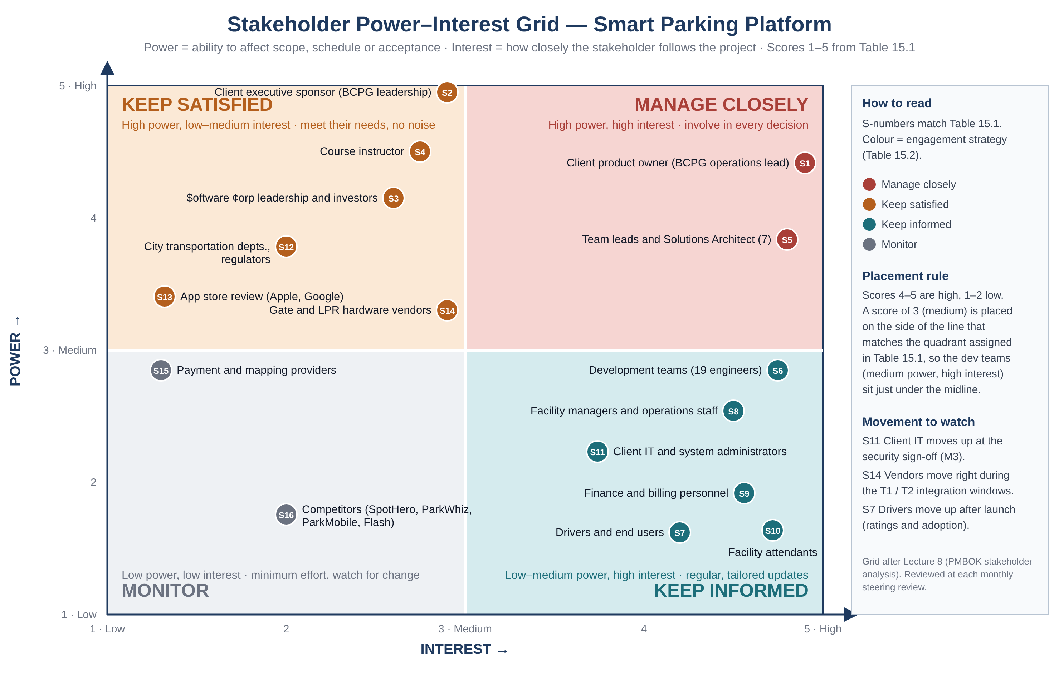
Figure 7. Stakeholder power–interest grid for the Smart Parking Platform. S-numbers refer to Table 15.1; colour is the engagement strategy in Table 15.2.
Table 15.2 — Engagement strategy by quadrant
Quadrant | Stakeholders | What they need | How the project engages them (Section 13 channels) | Owner
Manage closely  (high power, high interest) | S1 client product owner; S5 team leads and Solutions Architect | Involve in every decision that touches scope, priorities or design; no surprises. Decisions confirmed in writing. | Sprint planning, sprint review and demo, lead sync, milestone acceptance, release readiness review (Table 13.2); Teams shared channel daily. | Project Manager
Keep satisfied  (high power, lower interest) | S2 client sponsor; S3 studio leadership; S4 instructor; S12 regulators; S13 app-store review; S14 hardware vendors | Meet their requirements with the least demand on their time; escalate early when something they control is needed. | Monthly steering review and one-page summary; weekly update video for the instructor; compliance checklist reviewed before each release; store guidelines applied from Sprint 1; weekly vendor check-in during integration. | Project Manager (S2–S4, S12); Web and Mobile Leads (S13); Backend Lead and DevOps (S14)
Keep informed  (lower power, high interest) | S6 development teams; S7 drivers; S8 facility managers; S9 finance; S10 attendants; S11 client IT | Regular, tailored information so they can prepare and give feedback; a clear channel to raise defects and concerns. | Daily stand-ups and Jira (S6); sprint report and pilot feedback sessions (S8, S9); training and quick guide before the pilot (S10); technical documents in SharePoint (S11); release notes and in-app messages after launch (S7). | Team leads (S6); Product owner with PM (S7–S10); DevOps and Architect (S11)
Monitor  (low power, low interest) | S15 payment and mapping providers; S16 competitors | Minimum effort: watch for changes in terms, pricing or features that would move them to another quadrant. | Provider status pages and contract renewals checked at the monthly cost review (Section 14.8); competitor features reviewed at each milestone and fed into the backlog. | Payments and Mapping leads (S15); Project Manager (S16)

15.3 Stakeholder Engagement Plan
The grid says how much attention each stakeholder gets; the plan below says what the project does about the stakeholders whose attitude matters most. Attitude is recorded as Resistant, Neutral, Supportive or Leading, following the PMBOK engagement assessment matrix. The plan is reviewed at the monthly steering review together with the risk register.
Table 15.3 — Engagement plan for key stakeholders
Stakeholder | Attitude (current → desired) | Main concern | Engagement action | Owner and frequency
S1 Client product owner | Supportive → Leading | That the MVP does not slip and that accepted stories really work at the gate. | Owns the sprint review agenda; accepts stories in Jira within two working days; joins the release readiness review for every Production promotion. | PM, every sprint
S2 Client executive sponsor | Supportive → Supportive | Payments against milestones, cost cushion used, reputational risk of a bad launch. | One-page dashboard and 45-minute steering review monthly; same-day call if a milestone date moves; contingency draws above $25,000 pre-approved in writing. | PM, monthly
S3 $oftware ¢orp leadership | Neutral → Supportive | Margin and whether the five full-time backend engineers can be released early. | Staffing and cost shown against the baseline at the steering review; early notice before any role extension beyond April 5. | PM, monthly
S4 Course instructor | Neutral → Supportive | Does the document show the lecture concepts applied, not copied? | Weekly version bump, update video naming what changed and why, and a document that stays one continuous record. | PM, weekly
S5 Team leads and Architect | Supportive → Leading | Design authority respected; cross-team dependencies visible early. | Lead sync twice a week; Architect decides API contracts after hearing affected teams; leads set sprint scope with their teams. | PM and Architect, twice weekly
S6 Development teams | Supportive → Supportive | Realistic sprint commitments; blockers removed; psychological safety when something breaks. | Team sets its own commitment (Table 10.3); PM drops into stand-ups; retrospectives produce Start / Stop / Continue actions that are closed by the next retro. | Team leads, daily
S8 Facility managers | Neutral → Supportive | Extra work during the pilot and losing manual control of pricing. | Pilot at two facilities with named managers; dashboard training; manual override and incident view kept in scope (FR-5.5 area). | Product owner with PM, before and during pilot
S10 Facility attendants | Resistant → Neutral | Being blamed when a gate does not open for a paid reservation. | Lane-assist view and manual override; quick guide and training before every release that changes the lane; clear escalation number. | Product owner, before each lane release
S11 Client IT | Neutral → Supportive | Security, audit and who runs the platform after handover. | Technical documents in SharePoint as produced; security review scheduled before Beta; handover pack and operating-cost table (14.6) reviewed with them. | DevOps and Architect, as produced; sign-off at M3
S12 Regulators | Neutral → Neutral | Ordinance and consumer-payment compliance; open-data format. | Compliance checklist in the release readiness review; open-data feed specification shared before Beta. | PM, before each release
S13 App-store review | Neutral → Neutral | Guideline compliance, privacy labels, payment rules. | Developer accounts and privacy labels prepared in Sprint 1; TestFlight and internal-track Beta before the public release (risk S-5). | Mobile Lead, from Sprint 1
S14 Hardware vendors | Neutral → Supportive | Their devices working at launch; specification changes late in the window. | Weekly vendor check-in from November 4; integration specification frozen before T1; defects reported with logs the same day; release dates shared in writing. | Backend Lead and DevOps, weekly

15.4 Project Charter
A project charter is the formal, high-level document that authorises the project and gives the Project Manager the authority to apply the organisation’s resources to it. It is normally written at initiation; here it is issued with v7.0 and back-dated to the M1 approval on October 16, 2026, because the SRS has served as the project’s authorising document since kickoff and the charter consolidates what the SRS already says. The charter is kept as a one-page figure (Figure 8) so it can be signed and shared on its own; it is also stored as figures/project_charter_v7.pdf in the repository. Table 15.4 gives the same content in text.
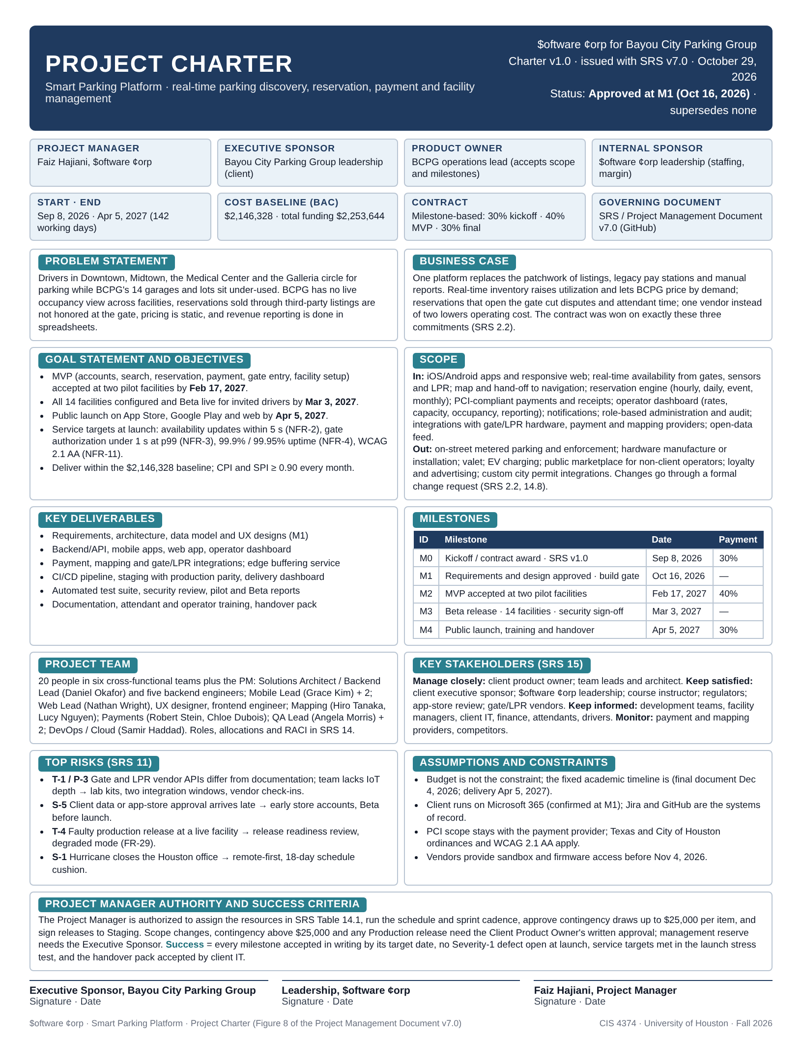
Figure 8. Project charter for the Smart Parking Platform (one page, signed by the client sponsor, $oftware ¢orp leadership and the Project Manager). Also in the repository as figures/project_charter_v7.pdf.
Table 15.4 — Project charter (text version)
Element | Content
Project and parties | Smart Parking Platform, delivered by $oftware ¢orp for Bayou City Parking Group (BCPG). Project Manager: Faiz Hajiani. Executive sponsor: BCPG leadership. Product owner: BCPG operations lead. Internal sponsor: $oftware ¢orp leadership. September 8, 2026 to April 5, 2027.
Problem statement | Drivers in Downtown, Midtown, the Medical Center and the Galleria circle for parking while BCPG’s 14 garages and lots sit under-used. BCPG has no live occupancy view, reservations sold through third-party listings are not honoured at the gate, pricing is static and reporting is done in spreadsheets (Section 2.1).
Business case | One platform replaces the patchwork of listings, legacy pay stations and manual reports; real-time inventory raises utilisation and allows demand-based pricing; reservations that open the gate cut disputes and attendant time. The contract was awarded on these commitments (Section 2.2).
Objectives | MVP accepted at two pilot facilities by February 17, 2027; Beta on all 14 facilities by March 3, 2027; public launch by April 5, 2027; NFR-2, NFR-3, NFR-4 and NFR-11 met at launch; delivered within the $2,146,328 baseline with CPI and SPI at or above 0.90 each month.
Scope | In: mobile and web apps, real-time availability, reservations, PCI-compliant payments, operator dashboard, notifications, administration, hardware, payment and mapping integrations, open-data feed. Out: on-street parking and enforcement, hardware supply, valet, EV charging, marketplace, loyalty and advertising, custom city permit integrations (Section 2.5). Changes go through a formal change request.
Deliverables and milestones | Requirements, architecture and designs (M1, Oct 16, 2026); backend, mobile, web and dashboard; integrations and edge service; CI/CD pipeline and delivery dashboard; test suite and security review; training and handover pack. M0 kickoff Sep 8, 2026 (30% payment); M2 MVP Feb 17, 2027 (40%); M3 Beta Mar 3, 2027; M4 launch Apr 5, 2027 (30%) (Table 9-2).
Budget | Cost baseline (BAC) $2,146,328, including 15% contingency of $279,956; management reserve $107,316; total funding $2,253,644 (Section 14).
Team | 20 people in six cross-functional teams plus the Project Manager; names, allocations and the RACI matrix in Section 14.
Key stakeholders | Table 15.1 and Figure 7.
Top risks | T-1 and P-3 vendor API differences and IoT depth; S-5 late client data or app-store approval; T-4 faulty production release; S-1 hurricane closure (Section 11).
Assumptions and constraints | Fixed academic timeline; client on Microsoft 365; PCI scope with the payment provider; Texas and City of Houston ordinances and WCAG 2.1 AA apply; vendor sandbox and firmware available before November 4, 2026.
Project Manager authority | Assign the resources in Table 14.1; run the schedule and sprint cadence; approve contingency draws up to $25,000 per item; sign releases to Staging. Scope changes, larger contingency draws and Production releases require the product owner’s written approval; management reserve requires the executive sponsor.
Success criteria and approval | Every milestone accepted in writing by its date; no Severity-1 defect open at launch; launch stress test passes the service targets; handover pack accepted by client IT. Signed by the BCPG executive sponsor, $oftware ¢orp leadership and the Project Manager.

15.5 Team Charter
While the project charter authorises the project, the team charter governs how the team operates to complete it. It was agreed by the six team leads, the DevOps engineer and the Project Manager at Sprint 1 planning on October 19, 2026 and is reviewed at every retrospective. Figure 9 is the signed one-page version (also figures/team_charter_v7.pdf in the repository); Table 15.5 gives the content in text. The charter follows the template shown in Lecture 8: mission, scope, goals, strengths and skills, roles and responsibilities, metrics, values, norms, fun, and the communication plan and coordination tools.
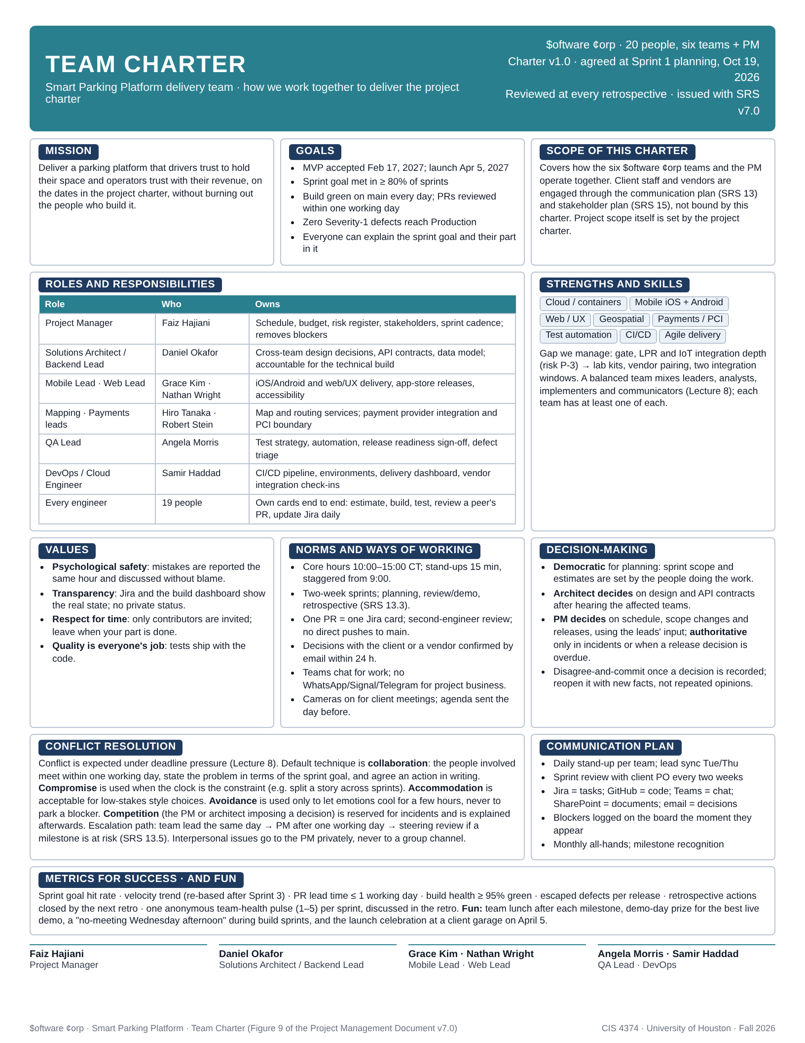
Figure 9. Team charter for the Smart Parking Platform delivery team, agreed at Sprint 1 planning and reviewed at every retrospective. Also in the repository as figures/team_charter_v7.pdf.
Table 15.5 — Team charter (text version)
Element | Agreement
Mission | Deliver a parking platform that drivers trust to hold their space and operators trust with their revenue, on the dates in the project charter, without burning out the people who build it.
Scope of the charter | The six $oftware ¢orp teams and the Project Manager. Client staff and vendors are engaged through Sections 13 and 15, not bound by this charter.
Goals | MVP accepted February 17, 2027 and launch April 5, 2027; sprint goal met in at least 80% of sprints; build green on main every day and pull requests reviewed within one working day; no Severity-1 defect reaches Production; everyone can state the sprint goal and their part in it.
Roles and responsibilities | Project Manager (schedule, budget, risks, stakeholders, blockers); Solutions Architect / Backend Lead (design decisions, API contracts, data model; accountable for the technical build); Mobile and Web Leads (app delivery, store releases, accessibility); Mapping and Payments leads (map services; payment integration and PCI boundary); QA Lead (test strategy, release readiness sign-off, defect triage); DevOps / Cloud Engineer (pipeline, environments, delivery dashboard, vendor check-ins); every engineer owns cards end to end, reviews a peer’s pull request and updates Jira daily.
Strengths and skills | Cloud and containers, iOS and Android, web and UX, geospatial, payments and PCI, test automation, CI/CD, agile delivery. Managed gap: gate, LPR and IoT integration depth (risk P-3), covered by lab kits, vendor pairing and the two integration windows. Each team mixes leaders, analysts, implementers and communicators.
Values | Psychological safety: mistakes are reported the same hour and discussed without blame. Transparency: Jira and the build dashboard show the real state. Respect for time: only contributors are invited and people leave when their part is done. Quality is everyone’s job: tests ship with the code.
Norms | Core hours 10:00 to 15:00 Central; 15-minute stand-ups staggered from 9:00; two-week sprints with planning, review and retrospective; one pull request per Jira card with second-engineer review and no direct pushes to main; decisions with the client or a vendor confirmed by email within 24 hours; Teams for work chat and no personal messaging apps; cameras on and agenda sent the day before for client meetings.
Decision-making | Democratic for planning: sprint scope and estimates are set by the people doing the work. The Architect decides design and API contracts after hearing the affected teams. The PM decides schedule, scope changes and releases with the leads’ input, and is authoritative only in incidents or when a release decision is overdue. Disagree and commit once a decision is recorded; reopen it with new facts, not repeated opinions.
Conflict resolution | Collaboration by default: the people involved meet within one working day, state the problem in terms of the sprint goal and record an action. Compromise when the clock is the constraint; accommodation for low-stakes style choices; avoidance only to let emotions cool for a few hours, never to park a blocker; competition (an imposed decision) reserved for incidents and explained afterwards. Escalation: team lead the same day, PM after one working day, steering review if a milestone is at risk. Interpersonal issues go to the PM privately.
Communication plan and tools | Daily stand-up per team; lead sync Tuesday and Thursday; sprint review with the client product owner every two weeks; Jira for tasks, GitHub for code, Teams for chat, SharePoint for documents, email for decisions; blockers logged on the board as they appear; monthly all-hands with milestone recognition (Section 13).
Metrics and fun | Sprint goal hit rate; velocity trend, re-based after Sprint 3; pull-request lead time of one working day or less; build health at least 95% green; escaped defects per release; retrospective actions closed by the next retro; an anonymous team-health pulse (1 to 5) each sprint. Team lunch after each milestone, a demo-day prize, a no-meeting Wednesday afternoon during build sprints, and the launch celebration at a client garage on April 5.
Signed by | Faiz Hajiani (PM), Daniel Okafor (Architect / Backend Lead), Grace Kim (Mobile Lead), Nathan Wright (Web Lead), Hiro Tanaka (Mapping), Robert Stein (Payments), Angela Morris (QA Lead), Samir Haddad (DevOps).

15.6 Leadership Approach and Conflict Resolution
Lecture 8 describes three leadership styles and says that different styles work best in different contexts. The project does not pick one. The Project Manager’s default is servant leadership: the PM’s job is to remove blockers, protect the team’s time and manage stakeholder expectations so that the six teams can deliver, which is why the communication plan limits meetings to contributors and why Table 10.3 let each team set its own Sprint 1 commitment. Planning decisions are democratic: estimates, sprint scope and retrospective actions are decided by the people who do the work, because they know the work best and because participation builds the commitment that a 20-person team needs. Authoritative leadership is reserved for two situations where speed matters more than consensus: production incidents, where the release readiness checklist and the degraded mode in FR-29 give the PM and QA Lead pre-agreed authority to roll back or hold a release, and a release decision that is overdue, where the PM decides after hearing the leads and records the decision and its reasons.
Conflict is natural, especially under deadline pressure, and the team charter treats it as something to resolve rather than avoid. Table 15.6 maps the five techniques from the lecture to the conflicts this project is most likely to see.
Table 15.6 — Conflict-resolution techniques and where the project uses them
Technique | When the project uses it | How it looks in practice
Collaboration | Default for technical and scope disagreements between teams, such as an API contract dispute between Backend and Mobile. | The leads meet within one working day in the API contract review, define the problem in terms of the sprint goal, and record the agreed contract change in the repository.
Compromise | When the clock is the constraint: a story is too large for the sprint, or two teams need the same backend engineer. | Split the story across sprints or defer the lower-value half; the backend lead re-sequences work (risk S-3) and the change is visible on the board.
Accommodation | Low-stakes style and tooling choices where harmony is worth more than the point. | Naming conventions, linting rules and meeting times are settled by letting the team that lives with the choice have it.
Avoidance | Only to let emotions cool after a heated exchange, for hours, not days. | The lead calls a pause and re-schedules the conversation the same or next day; a blocker is never parked by avoidance.
Competition | Incidents and overdue release decisions, where someone must decide. | The PM or Architect decides, records the decision and the reasons the same day, and explains it at the next lead sync so it does not become a pattern (risk P-4).
Scenario from Lecture 8 applied to this project. Suppose the gate-authorization API fails during the release readiness review on the day before the MVP acceptance at the two pilot facilities (M2, February 17, 2027). Management and the client sponsor want to release on time because the 40% milestone payment and the client’s announcement depend on it; the development team wants to delay. The project’s response combines the three styles in a fixed order. First, the PM takes an authoritative decision within the hour: no release to Production with a failing gate API, because a vehicle stuck at a lane damages the client’s reputation more than a one-week slip (risk T-4), and the degraded mode in FR-29 is switched on at the pilot facilities so attendants can open gates manually. Second, the PM runs a democratic 30-minute session with the Backend Lead, DevOps engineer and QA Lead to agree the fix, the test that proves it, and a new date, using the 18-day schedule cushion so the April 5 launch does not move. Third, the PM acts as a servant leader towards the team, taking the conversation with the sponsor and product owner personally, in writing within 24 hours, so engineers fix the problem instead of defending themselves, and the agreed date is confirmed at a special steering call rather than left to rumour. The conflict between management and the team is handled by collaboration on the facts, with compromise on the date, and the whole sequence is recorded in the risk register as the T-4 response that was actually used.

15.7 Keeping the Stakeholder Plan Current
The stakeholder register, the grid and the engagement plan are reviewed at the monthly steering review alongside the risk register, and whenever a stakeholder is added, a milestone is accepted or a stakeholder’s attitude changes. Three triggers re-open the analysis before the next monthly review: a new client contact with approval authority, a regulator or city department asking for data or a change, and any stakeholder moving from Supportive to Resistant. The two charters are living documents: the team charter is revisited at each retrospective and re-issued when a norm changes, and the project charter is re-approved only through a change request that alters scope, budget or dates.

16. Project Closure Report (Internal Draft)
INTERNAL. Not for distribution to the client. This section is the project closure report for the Smart Parking Platform, drafted after Lecture 9 (Monitoring, Reporting and Project Closure) at the end of Sprint 1 and the start of Sprint 2. The project does not close until the final delivery and handover milestone M4 on April 5, 2027, so this is a working draft: the structure, the measures and the evidence list are fixed now, the actuals are filled in to November 5, 2026, and every item that depends on the final outcome is marked to be completed at M4. It follows the closure-report contents from the lecture (executive summary, objectives and deliverables, final schedule and budget comparison, lessons learned, recommendations, acknowledgments and signatures) and the four items the homework asks for.
Drafting the closure report five months early is deliberate. The lecture's point is that closure is educational rather than administrative; a report that is only assembled in April depends on whatever data happens to survive. Writing the format now means the KPIs it needs (schedule and budget variance, defects per release, velocity, customer satisfaction) are collected from the first sprint onward, through the sprint report in Section 13.4 and the trend monitoring in Section 12.3, and the final version in April becomes a compilation rather than a reconstruction. The section is marked internal because it records shortfalls and their causes candidly; the client-facing status reports summarise them, as the communication plan already provides.

16.1 Executive Summary
$oftware ¢orp is delivering the Smart Parking Platform for Bayou City Parking Group: a web and mobile product that lets drivers find, reserve, navigate to and pay for garage parking across the client's 14 facilities, with live occupancy, pricing and revenue tools for operators. The engagement is fixed-price with milestone payments of 30/40/30 per cent at kickoff, MVP acceptance and final delivery (Section 2.2). The cost baseline is $2,146,328 including 15% contingency (Table 14.3), the schedule runs from September 8, 2026 to April 5, 2027 through five milestones (Table 9-2), and the team is 20 people at 16.7 FTE (Table 14.1).
Status at this draft (November 5, 2026). The planning phase is complete and both planning milestones were met on their dates: M0 (kickoff, SRS v1.0, 30% payment) on September 8 and M1 (requirements and design approved, SRS v6.0 baselined) on October 16. Sprint 1 (October 19 to 30) delivered 44 of the 51 committed story points: the cloud environment, the CI/CD pipeline with dev, staging and production environments, the unit-test framework with its 80% coverage gate, the role and permission model and the client application shells. Seven points carried into Sprint 2 (November 2 to 13), which is in progress on facility onboarding. Spend to date is $289,745 against a planned base of $297,575, 2.6% under, with no contingency drawn. No milestone date has moved and the 18-day schedule cushion before MVP acceptance is intact.
Overall assessment. Cost is green, quality is green, stakeholder engagement is green and schedule is amber: measured velocity is 14% below the planning assumption, inside the 15% trigger of risk S-4 but close to it, and the two causes were both third-party lead times rather than team performance. The structural choices in the plan (capacity planned per team, a cushion before every paid milestone, testing commissioned in the first sprint) are working as intended; the plan's assumptions about how quickly vendors and tooling providers respond were optimistic and are corrected in Sections 16.5 and 16.6.
Table 16.1 — Project snapshot
Item | Baseline | At this draft (Nov 5, 2026) | At closure (M4)
Start / planned finish | Sep 8, 2026 / Apr 5, 2027 | Started on plan; finish forecast Apr 5, 2027 | To be completed at M4
Cost baseline (incl. 15% contingency) | $2,146,328 | Spend to date $289,745 (planned base $297,575) | To be completed at M4
Contingency and management reserve used | $279,956 / 5% MR available | $0 / $0 | To be completed at M4
Milestones achieved | M0 to M4 | M0 (Sep 8) and M1 (Oct 16), both on their dates | To be completed at M4
Story points complete | 369 total | 44 of 369 (12%) after Sprint 1 | To be completed at M4
Open critical defects | 0 at every release | 0 (3 minor found and closed in Sprint 1) | To be completed at M4
Overall status | — | Cost green · Quality green · Stakeholders green · Schedule amber | To be completed at M4

16.2 Objectives and Deliverables
The objectives are the vision in Section 2.4 and the success criteria in the project charter (Figure 8 and Table 15.4): launch across the 14 facilities by April 5, 2027 within the cost baseline, with the measurable quality in the non-functional requirements of Section 6. Table 16.2 lists the deliverables against which closure will be judged, the evidence each one needs, and its status. The evidence column is the point of this table: a milestone date says when something is due, the evidence says what must exist for the Client Product Owner to accept it.
Table 16.2 — Objectives and deliverables, acceptance evidence and status
Objective or deliverable | Acceptance evidence | Status (Nov 5, 2026) | Closure (M4)
M0 Project kickoff and contract award | SRS v1.0 issued; 30% kickoff payment received | Achieved Sep 8, 2026, on plan | Closed
M1 Requirements and design approved | SRS v6.0 baselined; architecture, data model and UX designs accepted by the client; read-only board and pipeline access agreed | Achieved Oct 16, 2026, on plan | Closed
Platform foundation (Sprint 1 goal) | Cloud environment, pipeline with three environments, 80% coverage gate and permission model deployed and demonstrated at the sprint review | Achieved Oct 30; uptime alerting (B-03) carried to Sprint 2 | Closed when B-03 passes review
M2 MVP acceptance at two pilot facilities | Accounts, search, reservation, payment, gate entry and operator facility setup working end to end; usability test NFR-10 passed; 40% payment | Due Feb 17, 2027; forecast on plan | To be completed
M3 Beta release | All 14 facilities configured; finance tools, reporting, notifications and fraud controls live; stress test, penetration test and PCI-DSS review signed off | Due Mar 3, 2027 | To be completed
M4 Final delivery and handover | Public launch on App Store, Google Play and web; documentation and operator training delivered; acceptance certificate signed; 30% final payment | Due Apr 5, 2027 | To be completed
Project documentation | This document at its final version, charters, risk register, AI usage logs, pipeline and environment documentation, operator runbooks | v8.0; runbooks start in Sprint 6 | To be completed
Handover to operations | Operating-cost disclosure (Table 14.5) accepted; support model and dependency owners named; knowledge transfer to client IT (S11) complete | Cost disclosure done; owners and transfer plan open | To be completed

16.3 Achievements and Shortfalls
Achievements to date.
- Both planning milestones were met on their dates. The single-document discipline meant M1 was accepted on a baselined requirements document rather than a slide deck, and the client's design acceptance referenced specific sections and figures.
- Sprint 1 delivered the dependency head of the whole project. The cloud environment (B-01), the pipeline with dev, staging and production (B-02), the coverage gate (B-40) and the role model (L-10) are the finish-to-start predecessors of every later card; from Sprint 2 onward every line of code is built, tested and deployed through the same path it will use in production.
- Quality indicators started green. The main branch was green on 50 of 52 pipeline runs (96%, target 95%), the median pipeline time was 14 minutes (target under 20), coverage on the core services sits at 83% behind the 80% gate, and the three defects QC found were all minor and were closed inside the sprint.
- Cost is 2.6% under the base plan through October with no contingency drawn. Section 16.4 explains why part of that variance is not good news.
- Stakeholder expectations were managed deliberately. Section 10.4 stated in advance that the Sprint 1 review would show a deployed environment, a passing pipeline and a permission model rather than a user-visible screen. The Client Product Owner and Executive Sponsor attended, and the sponsor asked for the pipeline demonstration to be repeated for the client's IT lead, which is exactly the engagement action planned for S11 in Table 15.3.
- The team charter is in use. The first retrospective on October 30 followed the five-step format from Lecture 9 and produced actions with owners, recorded in Section 16.5.
Shortfalls to date, with causes.
- Seven of 51 story points carried over (86% completion). B-03 (monitoring, logging and uptime alerting, 5 SP) waited 11 working days for the on-call tooling account to be provisioned, and 2 SP of the QA integration suite waited for the LPR vendor sandbox, requested on October 5 and received on October 27. Root cause: third-party lead times were assumptions in Section 2.6 rather than dated dependencies in Table 9-3.
- Measured velocity is below the planning assumption. The Backend/API team completed 23 of 28 committed points against a capacity of 30, which makes the first measured conversion rate 2.6 developer-days per story point rather than the 2.0 assumed in Section 9.1. Across all teams the figure is 44 of 51 (14% below). Risk S-4 triggers at 15% below plan after Sprint 2; if Sprint 2 repeats this result, the durations in Section 9 are re-based three weeks earlier than the Sprint 3 point planned in Section 10.5.
- Two Mobile engineers started on October 12 instead of October 5 because onboarding paperwork had no task or duration in the plan. The $7,830 cost underrun in Table 16.4 is this week of absent labor, not efficiency, which is why the cost variance is read together with the schedule variance in 16.4.
- The defect Kanban board is not yet in place although defects already exist; Section 10.5 planned it for the pilot, and the three Sprint 1 defects were tracked as sub-tasks instead. It is set up in Sprint 2 (owner: QA Lead).
- The document's own currency slipped. Figures 5 and 6 still show the v3.0 board while the plan sections were being added. They are refreshed in v9.0.

16.4 Schedule and Budget Comparison (Actuals to Date)
The comparison uses the KPIs from Lecture 9: schedule variance, budget variance, defects per release, team velocity and a customer-satisfaction index, with the project's own quality metrics from Table 12.2. Progress is measured in story points because the WBS, the backlog and the schedule all use them (369 points, Section 8.4); cost is measured against the base plan in Table 14.4 with contingency shown separately, because contingency is charged only when used (Section 14.4). Milestone variance is in working days. The final columns are completed at M4.
Table 16.3 — Schedule comparison by milestone
Milestone or checkpoint | Baseline | Actual or forecast | Variance | Notes
M0 Kickoff / contract award | Sep 8, 2026 | Sep 8, 2026 | 0 days | SRS v1.0 issued; payment received
M1 Requirements and design approved | Oct 16, 2026 | Oct 16, 2026 | 0 days | SRS v6.0 baselined Oct 15
Sprint 1 (51 SP committed) | Oct 30, 2026 | 44 SP done Oct 30; 7 SP forecast Nov 6 | +5 days on 7 SP; 0 on milestones | Carry-over absorbed inside Sprint 2
M2 MVP acceptance | Feb 17, 2027 | Forecast Feb 17, 2027 | 0 days | 18-day cushion intact; re-forecast after Sprint 3
M3 Beta release | Mar 3, 2027 | Forecast Mar 3, 2027 | 0 days | Depends on M2 and security sign-offs
M4 Final delivery and handover | Apr 5, 2027 | Forecast Apr 5, 2027 | 0 days | To be completed at M4

Table 16.4 — Budget comparison (base cost; contingency shown separately)
Period | Planned base (Table 14.4 less contingency) | Actual | Variance | CPI | Notes
Sep 2026 | $85,200 | $85,200 | $0 | 1.00 | Six people, 17 working days, as planned
Oct 2026 | $212,375 | $204,545 | +$7,830 | 1.04 | Two Mobile engineers joined one week late (80 h × $78.30 blended + 25% overhead)
To date (Sep to Oct) | $297,575 | $289,745 | +$7,830 (2.6%) | 1.03 | Favourable, but see the schedule reading below
Contingency (15%) | $279,956 available | $0 drawn | — | — | No draw requested; next review at the November steering meeting
Management reserve (5%) | Outside baseline | $0 released | — | — | Studio leadership only, by change request
Project total at closure | $2,146,328 (BAC) | To be completed at M4 | To be completed at M4 | — | Final reconciliation is closure step 2

Reading the two tables together. A cost underrun with a story-point shortfall is not a saving: the labor that was not spent in October is the labor that did not complete the seven carried-over points, and the plan expects that money to be spent in November instead. The schedule performance index in story points is 44 ÷ 51 = 0.86 for Sprint 1 while the cost performance index is 1.03. The management rule adopted from this reading is that both indices are reported side by side in every steering pack (lesson L-9) and that a favourable CPI is never reported without the SPI next to it.
Table 16.5 — KPI dashboard at the end of Sprint 1 (reported every sprint from now on)
KPI (Lecture 9 and Table 12.2) | Target | Sprint 1 actual | RAG | Source
Schedule variance (story points) | 0 | −7 SP (−14%) | Amber | Jira sprint report
Schedule performance index (SP earned ÷ planned) | ≥ 0.95 | 0.86 | Amber | Jira sprint report
Budget variance (base cost) | 0 | +$7,830 (+2.6%) | Green | Timesheets vs Table 14.4
Cost performance index | ≥ 1.00 | 1.03 | Green | Timesheets vs Table 14.4
Velocity, whole team | 51 SP assumed (Table 10.3) | 44 SP | Amber | Jira velocity chart
Velocity, Backend/API team | 28 committed / 30 capacity | 23 SP (2.6 dev-days per SP) | Amber | Jira velocity chart
Defects per 10 SP completed | Threshold set after Sprint 3 (Table 12.2) | 0.7 (3 minor defects / 44 SP) | Green | Jira defect count
Open critical or high defects | 0 | 0 | Green | Jira
Build health (main branch green) | ≥ 95% of runs | 96% (50 of 52 runs) | Green | GitHub Actions history
Pipeline duration, push to pull request | < 20 minutes | 14 minutes median | Green | Pipeline timing
Unit-test coverage, core services | ≥ 80% (NFR-14) | 83%; gate enforced since Oct 28 | Green | CI coverage gate (B-40)
Customer satisfaction index | ≥ 4.0 of 5 at each milestone review | 4.5 at the M1 review (sponsor and product owner) | Green | Two-question survey after each review
Sprint goal hit rate | 100% | 1 of 1 (goal met; alerting outstanding) | Green | Sprint review minutes

Figure 10 is the Sprint 1 burndown chart that the sprint report now carries every two weeks. The flat line from October 23 to 26 is the wait for the LPR sandbox and the tooling account; the steep drop on the last two days is the review queue clearing, which the team charter's norm of reviewing within one working day is meant to spread more evenly from Sprint 2. The seven points above zero at the end are the carry-over listed in Section 16.3.
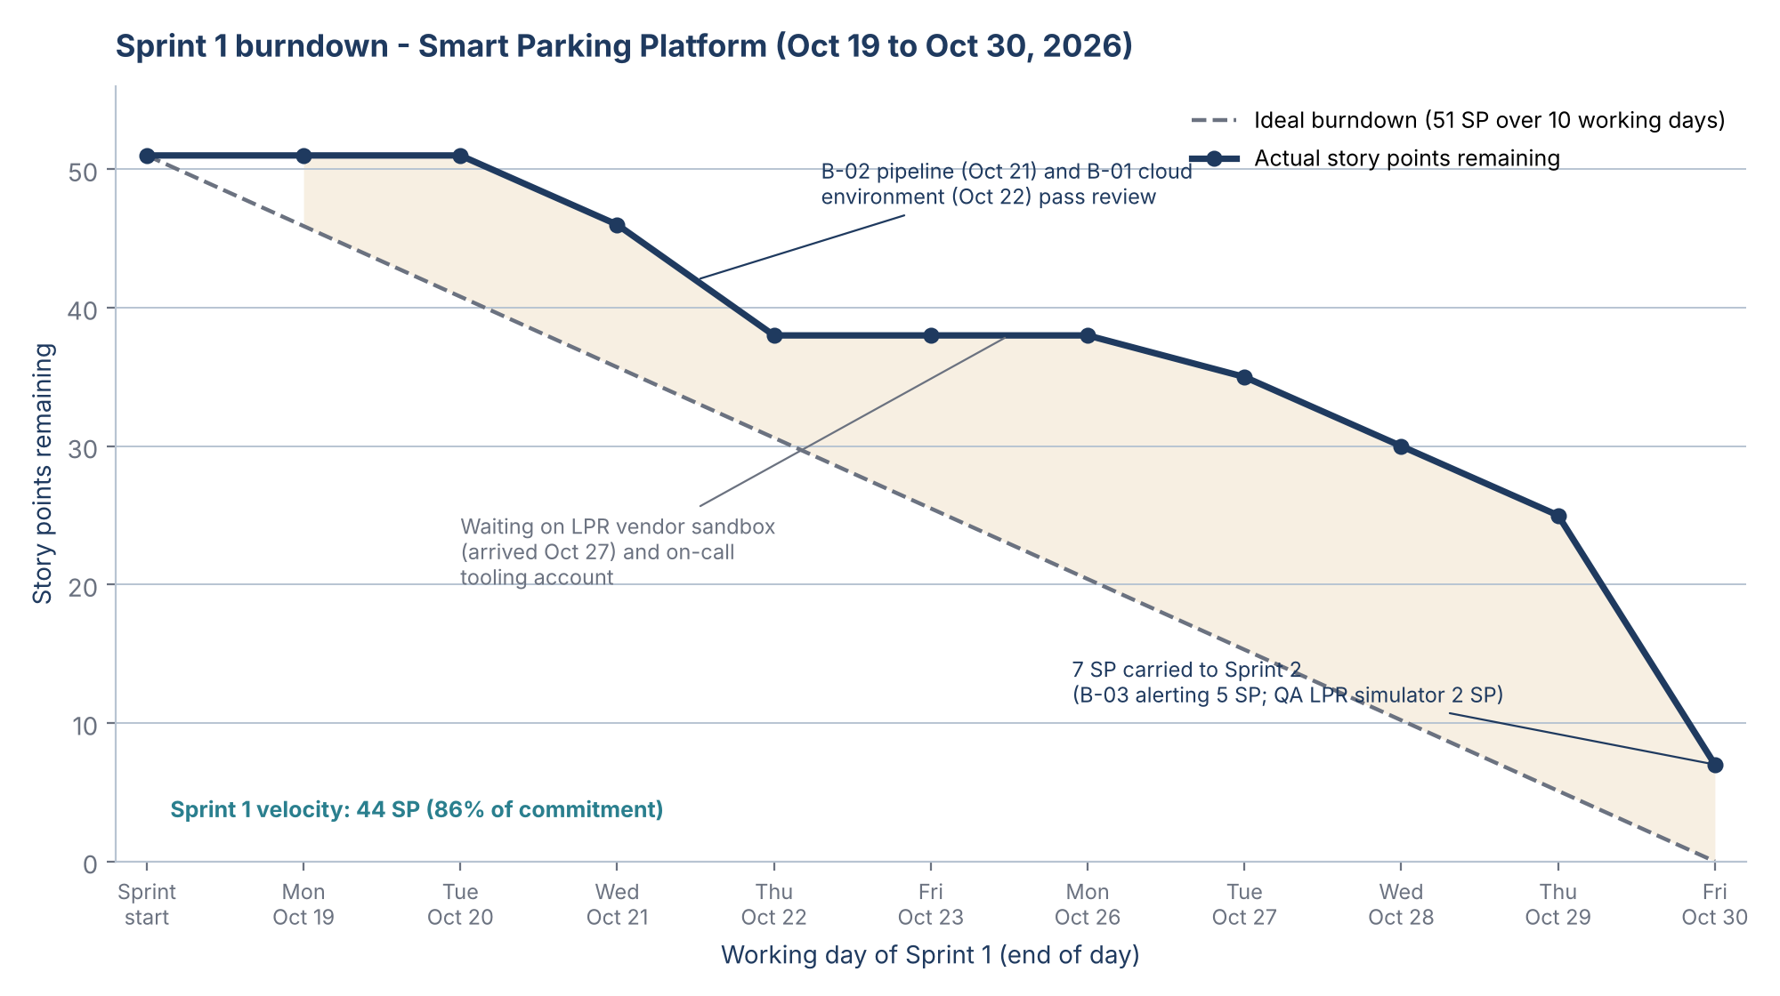
Figure 10. Sprint 1 burndown: story points remaining at the end of each working day against the ideal line for the 51-point commitment. Velocity for the sprint was 44 points. Also in the repository as figures/sprint1_burndown_v8.png.

16.5 Lessons Learned
The lessons were gathered in the first retrospective on October 30, run in the five-step format from Lecture 9 (set the stage, gather data, generate insights, decide actions, close the session), and from the Project Manager's review of what changed between versions 1.0 and 7.0 of this document, since each correction in the revision history is a lesson the plan taught itself. They are grouped in the lecture's four areas: communication, testing and QA, team performance, and management. Every lesson has an action and an owner. The register is kept in the studio's central lessons-learned repository, the lecture's tip, so the next $oftware ¢orp project starts from it rather than from a blank page, and it is reviewed at every retrospective and closed out in the final retrospective at M4.
Table 16.6 — Lessons-learned register (draft; closed out at M4)
# | Area | What happened | Lesson | Action and owner
L-1 | Communication | The Sprint 1 review had nothing user-visible to show. Section 10.4 and the M1 review said so in advance. | Telling stakeholders what they will not see is as important as what they will; an expectation set early is not a disappointment later. | A "not in this sprint" line in every sprint review and status report (PM).
L-2 | Communication | Sandbox and tooling requests went out after M1; lead times were 11 to 16 working days. | Third-party lead times are schedule dependencies, not assumptions. They belong in Table 9-3 with dates and owners. | Vendor onboarding rows added to the schedule in v9.0; future requests go out at contract award (PM, Mapping and Payments leads).
L-3 | Testing and QA | The coverage gate (B-40) was built in Sprint 1 and three defects were caught and closed in-sprint. | Testing from the first sprint costs little and removes the late-surprise risk the Google+ and 737 MAX cases illustrate. | Keep the gate; add the integration suite to it once the simulators land (QA Lead, Angela Morris).
L-4 | Testing and QA | The LPR simulator was blocked by the vendor sandbox and 2 SP of QA work could not finish. | Simulators should be specified from the vendor documentation first and refined against the sandbox later, so testing never waits on a third party. | Simulators built documentation-first for the remaining vendors (QA Lead).
L-5 | Team performance | Backend completed 23 of 28 points in a new domain in its first sprint. | The 2-days-per-point conversion was a planning placeholder; the first measured number is 2.6. Commitments should rest on measured, not assumed, capacity. | Commit at 85% of measured velocity until the Sprint 3 re-base (Backend Lead, Daniel Okafor).
L-6 | Team performance | Two engineers joined a week late for onboarding reasons. | Onboarding is a task with a duration and a dependency; it had neither in the plan. | Onboarding tasks per joiner added to the WBS and Table 9-3 (PM).
L-7 | Management | Versions 3.0 to 5.0 quoted the backend commitment as if it were the project's; v6.0 corrected it. | Capacity must be planned and reported per team. A single number hides idle teams and overloaded ones. | Table 10.3 format kept for every sprint (PM).
L-8 | Management | The Project Manager was named inconsistently between the title page and Table 14.1 until v7.0. | One source of truth for roles avoids charter and RACI confusion. | Roles referenced from Table 14.1 only (PM).
L-9 | Management | October's favourable cost variance was mostly late starts, not efficiency. | Read CPI together with SPI; a cost underrun with a schedule slip is not good news. | Both indices in every steering pack (PM).
L-10 | Management | Weekly update videos and the revision history worked as small retrospectives. | Short, regular reporting improves a plan faster than large reviews, and it is the transparency that builds stakeholder trust. | Weekly cadence kept through closure (PM).
L-11 | Closure | The M4 definition of done was written in September; the acceptance evidence list was only written now. | Define the closure evidence, not just the closure date, at the start. | Table 16.2 and 16.7 reviewed at every milestone (PM, Client Product Owner).

16.6 Recommendations for Future Projects
These recommendations are addressed to $oftware ¢orp studio leadership for the next project of this kind. They are drawn from the lessons above and from the three post-mortems in Lecture 9: Google+ (KPIs must reflect real usage and security testing must be continuous), the Boeing 737 MAX (never trade safety for schedule, and closure reports must include ethical accountability) and Microsoft Silverlight (assess long-term viability and watch the market). A separate post-mortem of a failed product, prepared with this version as a stand-alone document, applies the same method to a case not covered in class.
- Draft the closure report at kickoff. Create this section at version 1.0 with blank actuals and wire its KPIs (Table 16.5) into the sprint report from Sprint 1, so closure is a compilation rather than an archaeology exercise.
- Treat every third party as a schedule dependency with a lead time. Sandbox accounts, tooling accounts, app-store accounts and compliance assessors are requested at contract award, with a dated row in the schedule and an owner.
- Plan capacity per team and per sprint, commit at 85% of measured velocity after the first sprint, re-base durations after three sprints, and protect a cushion of at least 10% of the build duration before every fixed-date milestone that carries a payment.
- Make testing a Sprint 1 deliverable with a coverage gate in the pipeline, and open the defect board at the first defect rather than at the first pilot.
- Report CPI and SPI together and in the unit the plan uses, show the burndown at every sprint review, and state what is not in the sprint.
- Keep one living project document with a revision history and a short recorded update every week. The discipline produced a more coherent plan than separate deliverables would have, and the revision history is itself a lessons-learned record.
- Add an ethical-accountability statement to every closure report. The Project Manager confirms in writing that no safety, security or compliance control was descoped or deferred to protect a date, or lists the ones that were and who approved it. For this project the controls are the degraded gate mode (FR-29), the penetration test and the PCI-DSS review before Beta.
- Assess long-term viability at closure. A product that depends on third-party map, payment and gate APIs needs a named owner for each dependency after handover; Section 14.6 covers the operating cost but not the ownership, so the handover pack must add it.
- Hold a post-implementation review 90 days after launch and feed its findings into the central lessons-learned repository; the format is planned after Lecture 10.

16.7 Closure Checklist, Acknowledgments and Sign-off
The closure follows the seven-step process from Lecture 9. Table 16.7 lists the evidence each step needs and its status; the table is reviewed at each milestone and completed at M4, after the final retrospective and the final budget reconciliation.
Table 16.7 — Closure checklist (seven steps from Lecture 9)
Step | Evidence required | Owner | Status (Nov 5, 2026)
1. Verify all deliverables | M4 definition of done (Table 9-2) met; UAT sign-off at all 14 facilities; store listings live; documentation and training delivered | Client Product Owner, QA Lead | Pending (M4)
2. Obtain formal acceptance | Signed acceptance certificate; final budget reconciliation against Table 14.4; final 30% invoice issued | Client Executive Sponsor, PM | Pending (M4)
3. Release project resources | Release dates per Table 14.1; knowledge transfer to client IT (S11) complete; vendor accounts transferred to the client | PM, studio leadership | Pending (M4)
4. Archive documents | Final document version tagged in the repository; Jira export; pipeline and environment configuration; AI usage logs; signed charters | PM, DevOps (Samir Haddad) | In progress: repository versioned since v1.0
5. Conduct final retrospective | Table 16.6 closed out; open lessons transferred to the central repository with owners | PM with the team | Pending; first retrospective held Oct 30
6. Prepare closure report | This section, completed with M4 actuals and signed | PM | Draft (this version)
7. Celebrate achievements | Team event funded from the team budget in the team charter (Table 15.5) | PM | Pending (M4)

Ethical accountability statement (to be re-confirmed at M4). At this draft, no safety, security or compliance control in the plan has been descoped, deferred or weakened to protect a date or a budget line. The degraded gate mode (FR-29), the penetration test and the PCI-DSS review before Beta, and the WCAG 2.1 AA accessibility checks before MVP and Beta remain in scope on their planned dates. Any future change to this statement goes through a change request approved by the Client Sponsor and is recorded here with the approver's name.
Acknowledgments. The Project Manager thanks the delivery team named in Table 14.1 for a first sprint that put the foundations in place, the Client Product Owner and Executive Sponsor at Bayou City Parking Group for attending every review and for the candour that made the engagement plan in Section 15 work, and Dr. Otto Dobretsberger, whose course structure is the reason this project has had a plan, a risk register and now a closure report from the start.
Table 16.8 — Closure sign-off (signatures collected at M4)
Role | Name | Signature | Date
Project Manager, $oftware ¢orp | Faiz Hajiani
Client Product Owner (BCPG operations lead)
Client Executive Sponsor (BCPG leadership)
Studio leadership (internal sponsor), $oftware ¢orp

17. References
- Project brief: “Semester Project: Smart Parking Platform,” CIS 4374, University of Houston, Fall 2026.
- Lecture 2 slides: “Kickoff, Requirements Gathering, and Documentation,” Dr. Otto Dobretsberger, September 4, 2026.
- Parksy, “SpotHero vs ParkWhiz vs ParkMobile: Which Wins in 2026?” https://www.parksy.com/blog/parking-apps-compared-spothero-vs-parkmobile-vs-parkwhiz
- Unstar, “ParkMobile vs SpotHero: 5 Parking Apps Ranked (2026),” https://unstar.app/blog/parkmobile-spothero-paybyphone-parkwhiz-passport-parking-apps-ranked-2026
- The Traveler, “The Hidden Cost of Using SpotHero for Parking Reservations,” https://www.thetraveler.org/the-hidden-cost-of-using-spothero-for-parking-reservations/
- FlashParking, “Parking Technology,” https://www.flashparking.com/parking-technology/
- FitGap, “Best parking management software,” https://us.fitgap.com/search/parking-management-software
- Wiegers, K. & Beatty, J., Software Requirements, 3rd ed. (Vision and Scope template structure).
- Lecture 3 slides: “Estimation, Scheduling, and Work Breakdown,” Dr. Otto Dobretsberger, CIS 4374, September 11, 2026.
- Boehm, B. W., Software Engineering Economics, Prentice Hall, 1981 (COCOMO).
- Brooks, F. P., The Mythical Man-Month, Addison-Wesley, 1975 (2nd ed. 1995).
- Project Management Institute, A Guide to the Project Management Body of Knowledge (PMBOK Guide), 7th ed., 2021 (WBS and schedule dependency definitions).
- Lecture 4 slides: “Agile, Scrum, and Kanban,” Dr. Otto Dobretsberger, September 18, 2026.
- Lecture 5 slides and notes: “Risk, Quality, and Communication Management,” Sep 25, 2026.
- Lecture 6 slides and notes: “Resource and Cost Management,” Dr. Otto Dobretsberger, CIS 4374, October 2, 2026.
- Lecture 7 slides and notes: “Tools and Technology in Project Management” and “Cross-Platform Development and CI/CD Best Practices,” Dr. Otto Dobretsberger, CIS 4374, October 9, 2026.
- SEC, In the Matter of Knight Capital Americas LLC, Release No. 34-70694, October 16, 2013.
- NOAA National Hurricane Center, Atlantic hurricane season dates, https://www.nhc.noaa.gov
- Lecture 8 slides: “Managing Teams and Stakeholders: Leadership, Conflict Resolution, and Stakeholder Management,” Dr. Otto Dobretsberger, CIS 4374, University of Houston, October 23, 2026.
- Project Management Institute, “Stakeholder Engagement Assessment Matrix” and “Power/Interest Grid,” in A Guide to the Project Management Body of Knowledge (PMBOK Guide), 6th ed., 2017, Section 13.
- Lecture 9 slides: “Monitoring, Reporting, and Project Closure,” Dr. Otto Dobretsberger, CIS 4374, University of Houston, October 30, 2026.

