TASK–02: Nmap Scanning & Vulnerability
Detection Report

Objective
The objective of this task is to perform network reconnaissance and basic vulnerability assessment using Nmap.
The task focuses on identifying open ports, running services, operating system details, and potential vulnerabilities on a lab machine only using different Nmap scan techniques.

Tool Used
- Tool Name: Nmap (Network Mapper)
- Operating System: Kali Linux
- Version: Nmap 7.98
- Target Machine: Localhost (127.0.0.1) – Lab Environment

Methodology
Multiple Nmap scans were executed on the target system to gather network and service information.
Each scan served a different purpose, as explained below.

Scans Performed & Analysis

Full Scan (-A)
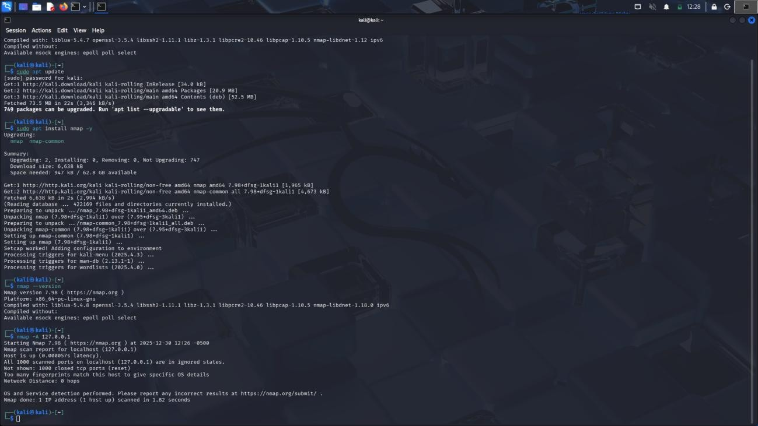
Command Used:
nmap -A 127.0.0.1
Purpose:
- Detect open ports
- Identify running services
- Perform OS detection
- Enable script scanning and traceroute
Observation:
- The host was found to be up
- All scanned ports were in a closed or filtered state
- OS detection was attempted but could not determine specific OS details
- No active services were detected on the target

Top Ports Scan
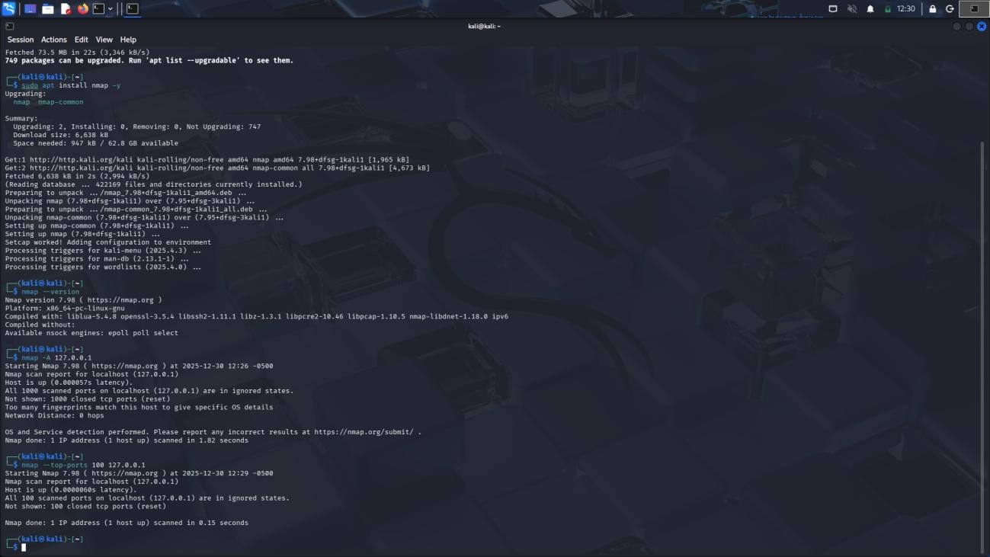
Command Used:
nmap --top-ports 100 127.0.0.1
Purpose:
- Quickly scan the most commonly used 100 ports
Observation:
- The system responded successfully
- No open ports were detected among the top 100 ports
- All scanned ports were reported as closed

OS Detection Scan
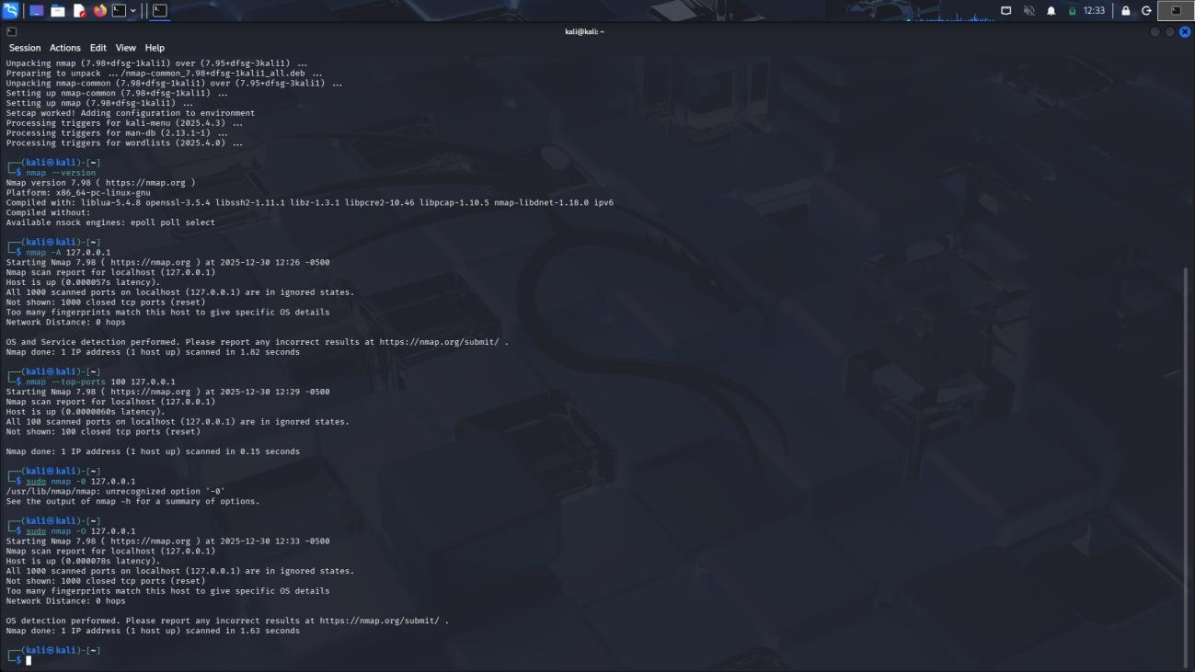
Command Used:
sudo nmap -O 127.0.0.1
Purpose:
- Identify the operating system running on the target machine
Observation:
- Nmap attempted OS fingerprinting
- Due to lack of sufficient open ports, OS detection was inconclusive
- Network distance was reported as 0 hops (local system)

Vulnerability Script Scan
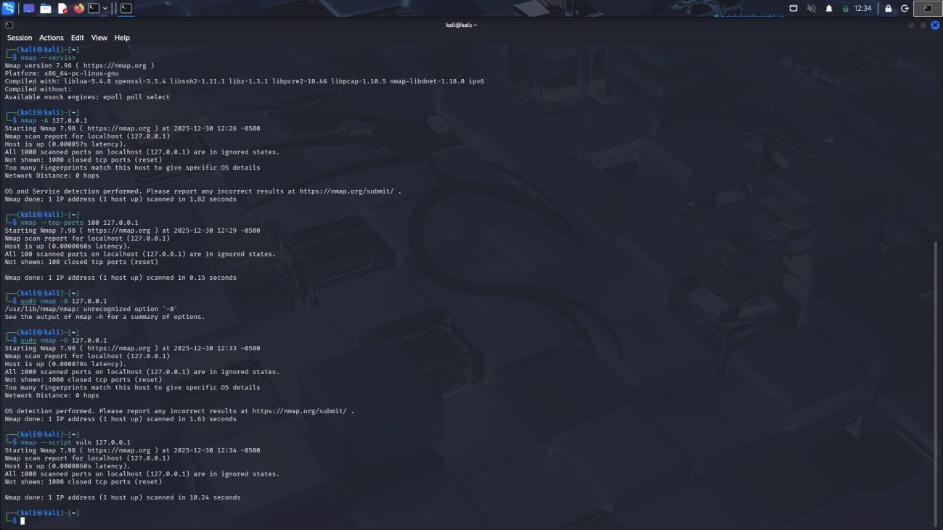
Command Used:
nmap --script vuln 127.0.0.1
Purpose:
- Run vulnerability detection scripts
- Identify known security vulnerabilities Observation:
- Vulnerability scripts executed successfully
- No vulnerabilities were detected
- The system appeared secure under basic vulnerability scanning
(Insert Screenshot: Vulnerability Scan Output)

Results Summary
- The target system was reachable and responsive
- No open ports were detected
- No running network services were exposed
- OS detection could not be confirmed due to limited response
- No known vulnerabilities were identified during script scanning

Conclusion
This task demonstrated the use of Nmap for network scanning and vulnerability detection. The scans confirmed that the lab system had no exposed services or open ports, indicating a secure baseline configuration.
Nmap proved to be an effective tool for reconnaissance, service discovery, and preliminary security assessment.

Ethical Consideration
All scans were performed strictly on a lab machine (localhost) for educational purposes only. No unauthorized systems were scanned.

