

Critical Path Analysis (Lab Task)

**Prepared for**

Syed Shahab Zarin

**Prepared by**

Faizan (FA21-BSE-011)

Department of Computer Science

COMSATS University Islamabad, Lahore Campus

06 June 2024

Table of Contents

1. Introduction 3

2. Problem 3

3. Critical Path Analysis 4

3.1 Paths Identified 4

3.2 Activity on Node Diagram 4

3.3 Critical Path 5

3.4 EST, LST, EFT, LFT 5

# 1. Introduction

This report focuses on the critical path analysis of a single task assigned by our instructor. Critical path analysis, though typically applied to entire projects, can also be used to identify the most time-consuming sequence within a complex task.

By analyzing the critical path of this task, we aim to:

* **Identify the bottleneck:** Pinpoint the sequence of sub-steps within the task that takes the longest time.
* **Optimize the workflow:** Understand dependencies between sub-steps and streamline the overall process.
* **Improve efficiency:** Focus efforts on the most time-consuming parts of the task.

# 2. Problem

|  |  |  |
| --- | --- | --- |
| Activity | Predecessor | Duration |
| A | -- | 7 |
| B | A | 15 |
| C | A | 10 |
| D | C | 12 |
| F | B | 17 |
| G | D | 6 |
| H | D, F | 11 |
| I | G, H | 13 |

# 3. Critical Path Analysis

## 3.1 Paths Identified

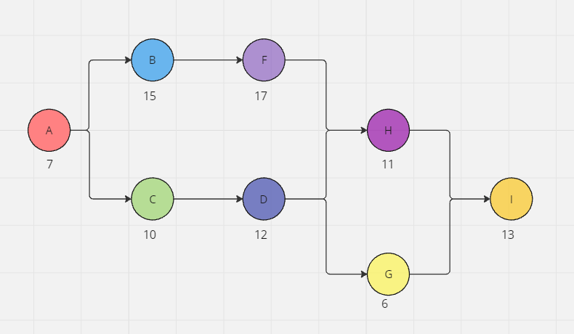

## 3.2 Activity on Node Diagram

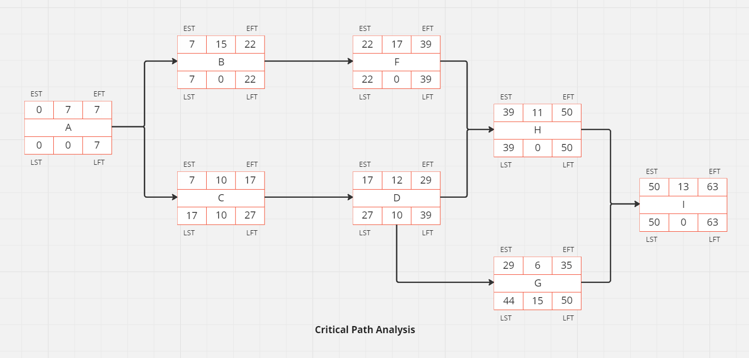

## 3.3 Critical Path

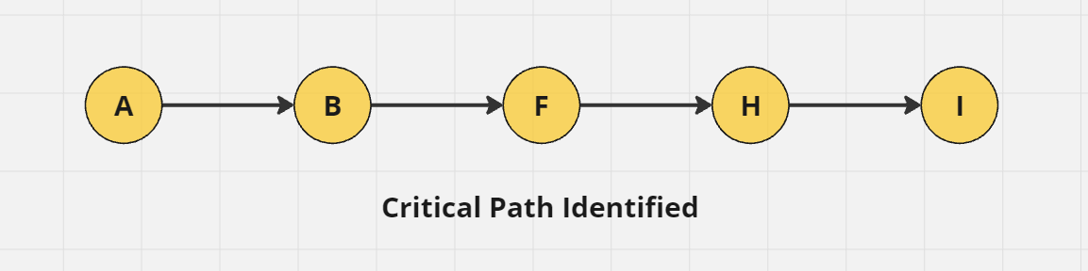

## 3.4 EST, LST, EFT, LFT

|  |  |  |  |  |  |
| --- | --- | --- | --- | --- | --- |
| Activity | EST | LST | EFT | LFT | Slack |
| A | 0 | 0 | 7 | 7 | 0 |
| B | 7 | 7 | 22 | 22 | 0 |
| C | 7 | 17 | 17 | 27 | 10 |
| D | 17 | 27 | 29 | 39 | 10 |
| F | 22 | 22 | 39 | 39 | 0 |
| G | 29 | 44 | 35 | 50 | 15 |
| H | 39 | 39 | 50 | 50 | 0 |
| I | 50 | 50 | 63 | 63 | 0 |