**Name:**  **Faizan**

**Reg No: FA21-BSE-011**

**Section: BSE-6B**

# White Box Testing

**Write a function that takes an array of integers as an argument and returns a value based on the sums of the even and odd numbers in the array. Let X = the sum of the odd numbers in the array and let Y = the sum of the even numbers. The function should return X – Y**

### 1. Program Unit:

public static int find(int[] arr){

if(arr==null||arr.length==0){

return 0;

}

int x=0,y=0;

for(int i=0;i<arr.length;i++){

if(arr[i]%2!=0){

x+=arr[i];

}else{

y+=arr[i];

}

}

return x-y;

}

### 2. Control Flow Graph:

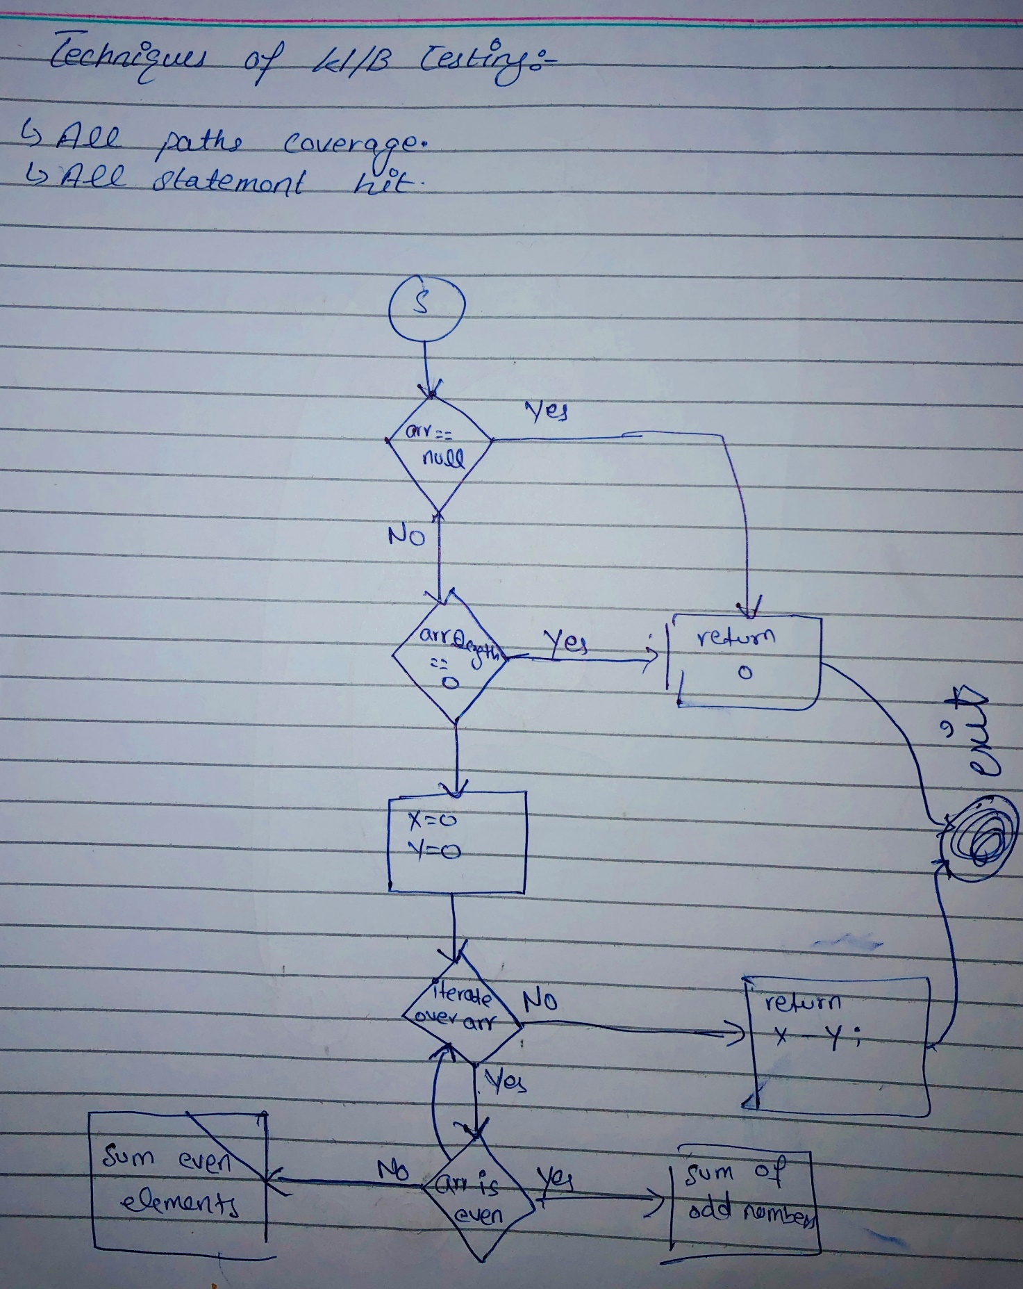

### 3. Identifying Execution instances (paths):

### 4. All Paths:

### 5. Input Data:

### 6. Test Cases:

|  |  |  |  |  |  |
| --- | --- | --- | --- | --- | --- |
| Test Case No. | Description | Input | Expected Output | Actual Output | Status |
| 1 | Single odd number | {1} | 1 | 1 | Pass |
| 2 | One odd and one even number | {1, 2} | -1 | -1 | Pass |
| 3 | Three odd numbers | {1, 3, 5} | -9 | -9 | Pass |
| 4 | Three even numbers | {2, 4, 6} | -12 | -12 | Pass |
| 5 | One odd, one even, and one odd number | {1, 2, 3} | -4 | -4 | Pass |
| 6 | Two odd and one even number | {1, 3, 2} | 2 | 2 | Pass |
| 7 | Two even and one odd number | {2, 4, 1} | -5 | -5 | Pass |
| 8 | Two even, one odd, and one even number | {3, 2, 1, 4} | 4 | 4 | Pass |
| 9 | Two even, one odd, and one even number (reversed) | {6, 2, 1, 4} | -11 | -11 | Pass |
| 10 | Three odd numbers | {5, 7, 9} | -21 | -21 | Pass |