|  |  |
| --- | --- |
|  |  |
| Mid-Lab |  |
|  |  |
|  | 5th May 2024Software Testing |
|  | Faizan (FA21-BSE-011)Prof. Mukhtiar Zamin |

## Question No: 04

### Control Flow Graph

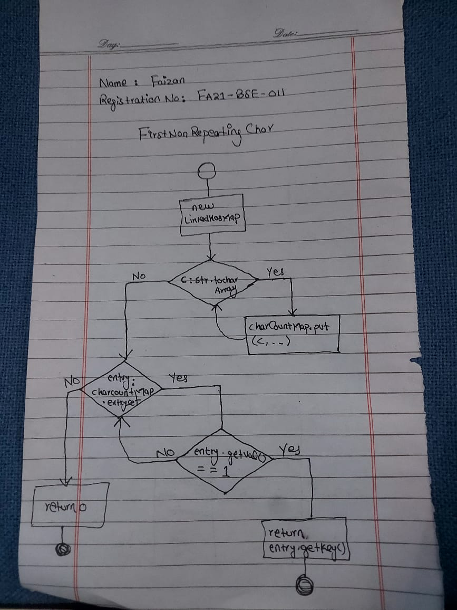

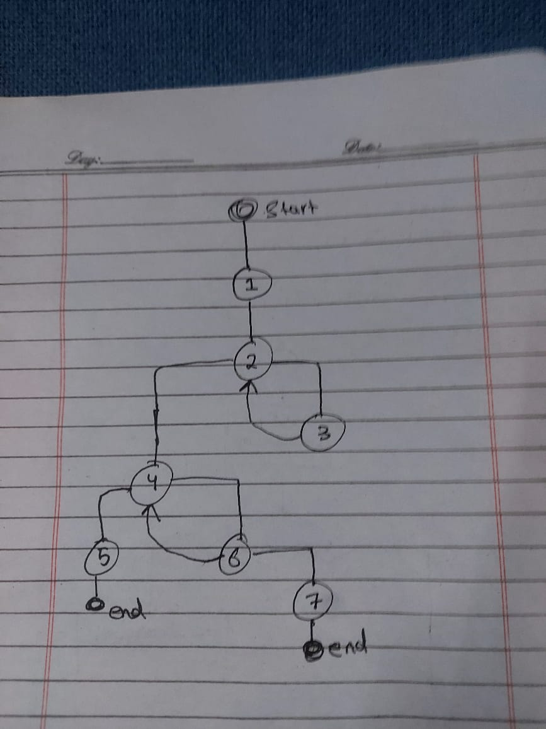

## Test Cases

|  |  |  |  |
| --- | --- | --- | --- |
| **TC_No** | **Test Case Name** | **Input String** | **Expected Output** |
| 001 | testFirstNonRepeatingChar_swiss | "swiss" | 's' |
| 002 | testFirstNonRepeatingChar_emptyString | "" | '\0' |
| 003 | testFirstNonRepeatingChar_allRepeating | "aabbcc" | '\0' |

