VAC Forming — Scrap Analysis
Consolidated Report

IAC Business Team + Algo8 AI Team

Data period: 11 March 2026 – 6 May 2026 (14 production days)
Process rows: 7,372 Scrap rows: 386 Overall rate: 5.24 %
Source: data/VF_export.csv, data/VF_Scrap_export.csv

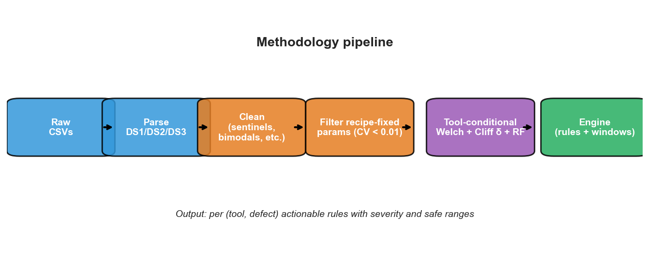
Figure 0 — Analysis pipeline

1. Executive Summary
- Defects are tool-locked: Wrinkle 99% on Tool 1, Low Glue 98% on Tool 2, Bumps 67% on Tool 8. Recommendations must therefore be (tool, defect)-specific.
- Tool 1 has the highest scrap rate (7.28%), Tool 2 the lowest (3.97%), Tool 8 in between (5.40%).
- Many parameters cannot be a cause: within each tool the recipe-fixed parameters (Stretch Cross *, Stetch Length *, Roller Gap *, Top Tool Pos Close, Glue Temp) have within-tool CV < 0.01 and are excluded from causal ranking.
- A warm-up effect is real: first 10 parts of a production day scrap at ~12% vs steady-state ~5% (χ² p = 2.3×10⁻⁶).
- Machine Cycle Time = 9999 is a stoppage marker in 9.5% of rows; both the row itself and the next part have elevated scrap (7.6% and 8.0%).
- Pyro Clean is a monotonic cycle counter with a non-monotonic relation to scrap — each tool has its own sweet-spot band.
- Multivariate diagnostic models reach AUC 0.72–0.89 per (tool, defect). Burnt Carpet (0.63) is the weakest, suggesting it is multi-causal.
- A simple operating-window threshold rule alone is weak (AUC ≈ 0.55). Use it for triage; use the defect-specific engine for diagnosis.

2. Approach
We separate the work into three layers, each with its own deliverable:
Layer | Question | Deliverable
Audit | What is in the data? What is suspicious or surprising? | EDA.ipynb
Diagnose | For each (tool, defect): which parameters deviate, by how much, with what confidence? | VAC_Forming_Scrap_Analysis_Final.ipynb
Act | What should an operator do when defect D is detected on tool T? | Scrap_Recommendations_Report_v2.xlsx + live recommend() engine

We describe; we do not prescribe causation. Scrap is already detected on-line. The value here is in explaining why a part went bad and converting that into a corrective action, not in predicting scrap.

3. Data inventory & cleaning decisions

3.1 Schema
File | Rows | Columns | Description
VF_export.csv | 7,372 | 7 | ID, PartDesc, BuiltTime, DS1/DS2/DS3 (40 parameters)
VF_Scrap_export.csv | 386 | 4 | ID, Desc (defect type), ScrapTime
Join | 386 / 386 | — | all scrap IDs found in process table; IDs unique on both sides

3.2 Production timeline
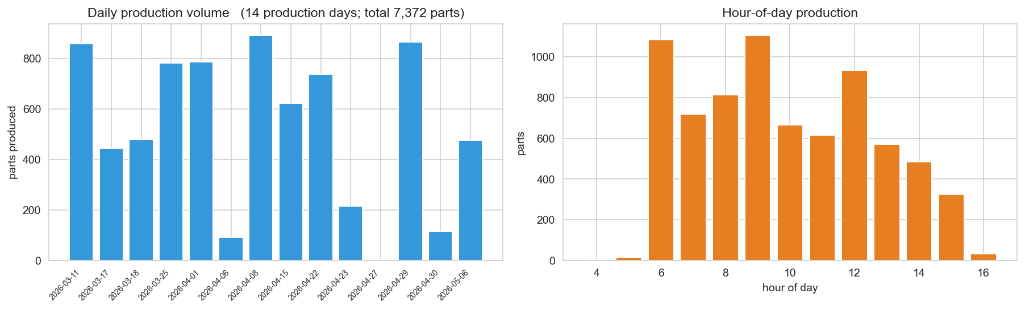
Figure 1 — Production volume by day (left) and by hour (right). Production is bursty: 14 production days inside the 56-day span; Mondays–Thursdays only.

3.3 Cleaning decisions applied
Issue | Parameter(s) | Action
Constants | Pick Material Pos (=220), TTF Circuit 2 Temp (=0) | Drop — cannot diagnose anything
Sentinel cap (9.5% of rows) | Machine Cycle Time = 9999 | Treat as missing; add mct_capped flag
Bimodal (off vs active) | Pos Vinyl N/S Length/Width, Temp Z4 | Encode (value, active_flag)
Heavy tail (two regimes) | BT Circuit 2 Temp (p50=23, max=833) | Keep raw; model handles
Recipe-fixed (CV < 0.01) | Stretch Cross *, Stetch Length *, Roller Gap *, Top Tool Pos Close, Glue Temp | Exclude from causal ranking per tool

3.4 Engineered context features
- is_warmup — first 20 parts of a production day on a tool
- prev_mct_capped — whether the previous part on the same tool had MCT = 9999
- color, family — parsed from PartDesc

3.5 Defect taxonomy
Scope | Defect codes
Process (in scope) | Wrinkle, Dent, Bumps / lumps, Burnt Carpet / Vynil, Low Glue / Read Thru / Impression, Out of dimension, Bad edge wrap, Glue bleed thru, Delamination
Non-process (excluded) | Hole, Broken / Fracture, Fabric Flaw, Fabric Torn

4. Methodology

4.1 Statistical primitives
Primitive | Use
Welch's t-test | Significance of mean shift, unequal variance
Cliff's δ | Non-parametric effect size in [-1, +1]. Severity: CRITICAL > 0.474, STRONG > 0.33, MODERATE > 0.20
Kolmogorov–Smirnov | Distribution-shape sanity check
Wilson 95 % CI | Confidence interval for every rate comparison

4.2 Multivariate models (per tool × defect, n_bad ≥ 15)
- L1-regularised logistic regression — sparse coefficients (picks 3-5 features)
- Random Forest — 400 trees, depth 8, class-balanced
- Gradient Boosting — 200 stages, depth 3, learning rate 0.06
- 5-fold stratified CV; report mean AUC + Brier score
- Permutation importance on the best model for a model-agnostic feature ranking

4.3 Anomaly detection (cross-defect)
Isolation Forest (300 trees, contamination 0.05) over the union of drifting parameters. Provides a tool-agnostic "this row looks unusual" score for triage; complements but does not replace the defect-specific engine.

4.4 Validation
We hold out 30 % stratified on is_scrap, build per-tool windows from train-good only, then score test rows by the count of drifting parameters that fall outside [P5, P95]. We report AUC and precision/coverage at thresholds 0–7. This is deliberately a deflationary test: its AUC is ~0.55, which is precisely the point — the simple rule is a triage signal, not a classifier.

5. Iterative hypothesis testing
Every hypothesis was stated before running the test. Verdicts: A = accept, R = reject, C = conditional with caveats.
# | Hypothesis | Verdict | Numeric anchor
H1 | Scrap rate differs by tool | A | T1 7.28% [6.27, 8.43]; T2 3.97% [3.39, 4.64]; T8 5.40% [4.32, 6.74]. χ² p = 1.7e-7
H2 | Scrap rate differs by part within each tool | A | All tools p < 1e-4
H3 | Color matters after controlling for part family | C | Significant on PS LOWER LHD (BEIGE 15% vs BLACK 5%) and DS LOWER LHD; not universal
H4 | MAP POCKET parts scrap more | C | True marginally; confounded — map pockets are almost exclusively Tool 1
H5 | Day-of-week effect (Monday spike) | A | Mon 14.9% vs Thu 1.5%; all Monday parts are Tool 2 — tool-confounded
H6 | Hour-of-day shift effect | A | T1 hour 6 = 14.7% (warm-up); T8 hour 13 = 19% (afternoon spike)
H7 | First parts of a production day scrap more | A | First 10 ≈ 12%, 10-19 ≈ 10%, 20-49 ≈ 5.5%, 50+ ≈ 4.9%. p = 2.3e-6
H8 | First part after a long gap scraps more | R | p = 0.80 — intra-day gaps dominated by overnight rolls
H9 | MCT = 9999 marks a stoppage | A | Scrap rate inside 7.56% vs 4.99% outside; next part 8.0%
H10 | Pyro Clean → scrap is monotonic | A (non-monotone) | Per-tool sweet spots; outside band scrap doubles
H11 | Defect–tool exclusivity | A | Wrinkle 99% T1, Low Glue 98% T2, Bumps 67% T8, Out of dim 78% T1
H12 | Parameter drift across the data window | A (selective) | Glue Temp / Cycle Time drift on some tools; no single global drift
H13 | Bad days pile multiple defect types | C | Day-level Pearson(rate, n_defects) = 0.39
H14 | TTF Circuit 1 Temp = 0 marks a different recipe | R | Within-tool scrap rates do not differ
H15 | Pos Vinyl * are bimodal (active vs off) | A | 50-60 % zero; non-zero p50 ≈ 200+
H16 | Defects co-cluster on the same day | A | Wrinkle days also see Bad edge wrap + Dent

6. Findings — tool level
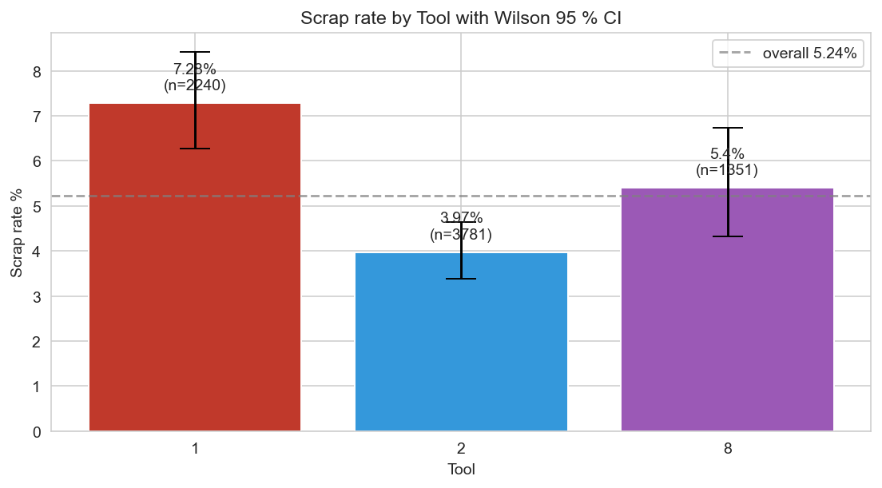
Figure 2 — Scrap rate by tool with Wilson 95 % CI. Differences are statistically significant (χ² p = 1.7e-7).
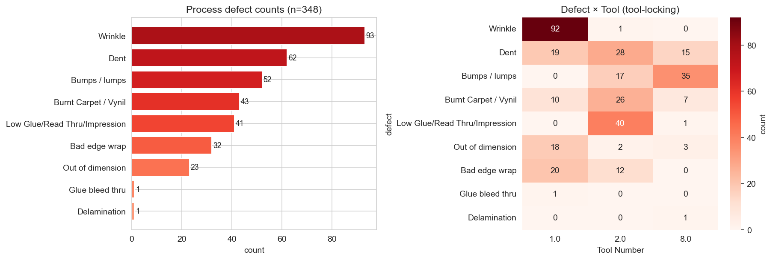
Figure 3 — (left) Process-defect counts; (right) Defect × Tool heatmap showing strong tool-locking.
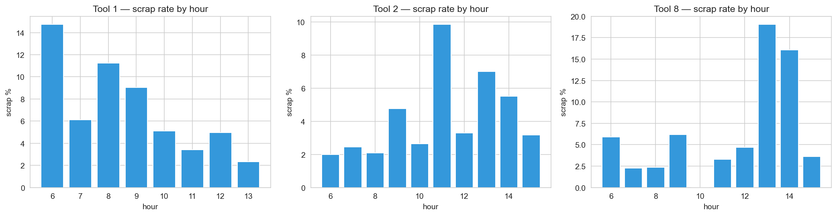
Figure 4 — Scrap rate by hour, per tool. Tool 1 shows a morning warm-up; Tool 8 an afternoon spike.
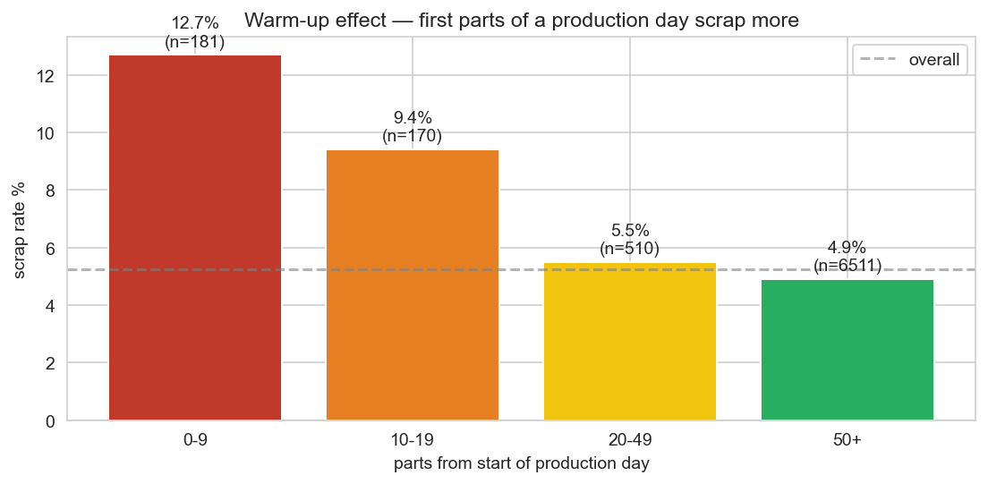
Figure 5 — Warm-up effect: scrap rate vs position in production day.
Tool | Parts | Scrap | Rate % | 95 % CI | Dominant defects
Tool 1 | 2,240 | 163 | 7.28 % | [6.27, 8.43] | Wrinkle, Out of dim, Bad edge wrap, Dent
Tool 2 | 3,781 | 150 | 3.97 % | [3.39, 4.64] | Low Glue, Dent, Burnt Carpet, Bumps
Tool 8 | 1,351 | 73 | 5.40 % | [4.32, 6.74] | Bumps (35/52 of all Bumps), Dent

7. Findings — defect-by-defect (tool-conditional)

7.1 Wrinkle (n = 93; 99 % Tool 1) — largest single defect
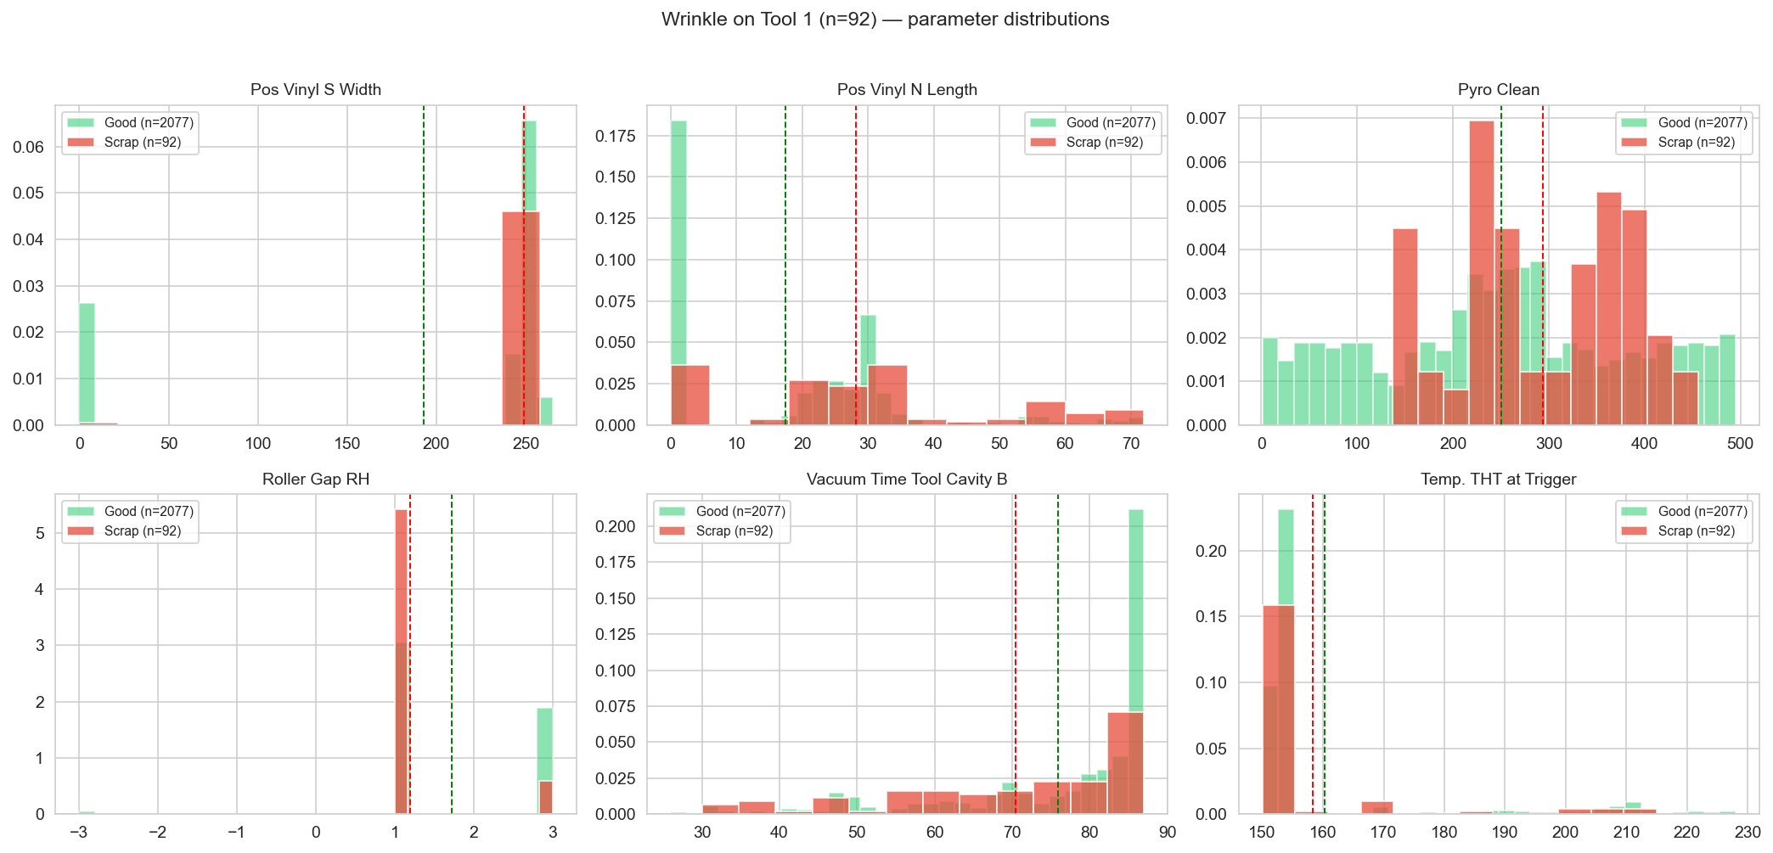
Figure 6 — Wrinkle on Tool 1: green = good parts, red = scrap parts. Pos Vinyl S Width is the dominant signal.
Parameter | Good P50 | Scrap P50 | % diff | Cliff's δ | Welch p
Pos Vinyl S Width | 249.0 | 253.0 | +29.2 % | +0.36 | 4.9e-39
Pos Vinyl N Length | 21.0 | 28.0 | +61.1 % | +0.29 | 3.7e-06
Roller Gap RH | 1.0 | 1.0 | -30.3 % | -0.27 | 2.4e-12
Roller Gap LH | 10.0 | 10.0 | -3.7 % | -0.26 | 1.4e-06
Vacuum Time Tool Cavity B | 83.0 | 76.0 | -7.2 % | -0.23 | 1.8e-03
Vacuum Time Tool Cavity A | 84.0 | 76.0 | -4.1 % | -0.20 | 5.7e-03
Pos Vinyl N Width | 23.0 | 26.0 | +38.5 % | +0.20 | 1.2e-05
Pos Vinyl S Length | 120.0 | 123.0 | +26.2 % | +0.19 | 1.5e-22

7.2 Low Glue / Read Thru / Impression (n = 41; 98 % Tool 2)
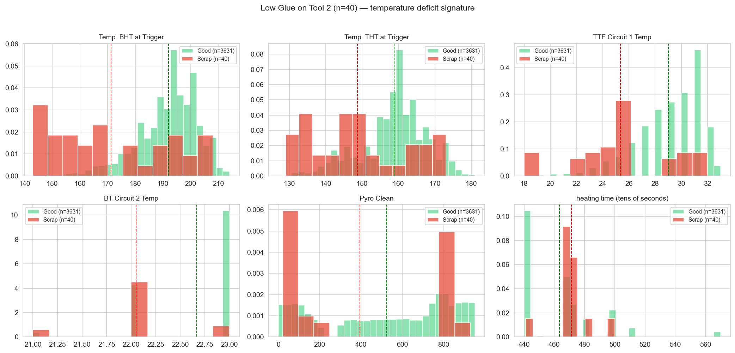
Figure 7 — Low Glue on Tool 2: temperature-deficit signature. BHT/THT trigger temps and BT/TTF circuits all run below the good norm.
Parameter | Good P50 | Scrap P50 | % diff | Cliff's δ | Welch p
TTF Circuit 1 Temp | 29.0 | 25.0 | -12.6 % | -0.57 | 2.4e-07
BT Circuit 2 Temp | 23.0 | 22.0 | -2.7 % | -0.55 | 2.2e-09
Temp. BHT at Trigger | 194.0 | 168.0 | -10.8 % | -0.55 | 2.8e-07
BT Circuit 1 Temp | 25.0 | 24.0 | -3.5 % | -0.48 | 1.1e-05
Temp. THT at Trigger | 160.0 | 147.5 | -6.3 % | -0.44 | 2.8e-05
Capacity BHT | 60.0 | 52.0 | -6.3 % | -0.36 | 1.5e-04
Temp Z3 | 136.0 | 122.0 | -8.5 % | -0.35 | 6.6e-04
Temp Z2 | 138.0 | 122.0 | -8.2 % | -0.35 | 1.3e-03

7.3 Bumps / lumps (n = 52; 67 % Tool 8, 33 % Tool 2)
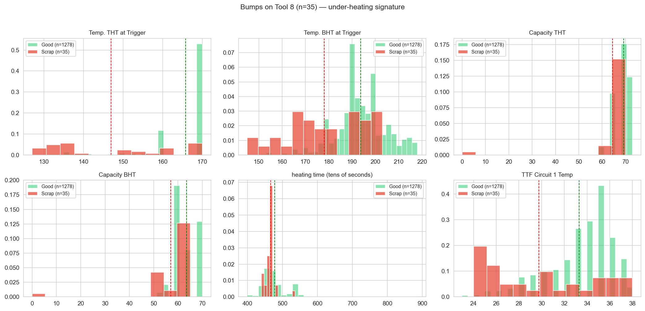
Figure 8 — Bumps on Tool 8: under-heating signature. THT/BHT trigger temps, Capacities, and TTF Circuit 1 all run below the good norm.
Parameter | Good P50 | Scrap P50 | % diff | Cliff's δ | Welch p
Temp. THT at Trigger | 170.0 | 140.0 | -11.3 % | -0.67 | 2.8e-08
Capacity BHT | 60.0 | 60.0 | -10.3 % | -0.52 | 9.1e-04
Temp. BHT at Trigger | 193.0 | 174.0 | -8.1 % | -0.51 | 3.9e-06
Capacity THT | 70.0 | 65.0 | -6.9 % | -0.48 | 2.1e-02
TTF Circuit 1 Temp | 34.0 | 29.0 | -10.6 % | -0.43 | 7.6e-05
Pos Vinyl N Width | 0.0 | 292.0 | +125.3 % | +0.40 | 3.5e-05
Temp Z2 | 150.0 | 137.0 | -9.9 % | -0.40 | 2.8e-04
Temp Z1 | 155.0 | 138.0 | -9.4 % | -0.40 | 4.4e-04

7.4 Other defects — short summaries
Dent (n = 62; spread across tools)
Different signatures per tool: T2 ↑ heating time + ↑ Pyro Clean + ↓ Capacity BHT (AUC 0.835); T1 ↑ Pos Vinyl N Width + ↑ Pyro Clean (AUC 0.721); T8 ↓ BT Circuit 1 Temp (AUC 0.719). Illustrates why pooling is wrong.
Burnt Carpet / Vynil (n = 43; 60 % Tool 2)
T2: ↓ Pyro Clean very low (fresh-clean residue effect). Vacuum times slightly reduced. AUC 0.632 — weakest signal; multi-causal.
Bad edge wrap (n = 32; 63 % Tool 1, 37 % Tool 2)
T1: ↓ Temp BHT at Trigger + ↓ Pyro Clean + ↓ BT Circuit 2 Temp. AUC 0.803.
T2: ↑ Pos Vinyl N Length/Width activated where good parts have them off.
Out of dimension (n = 23; 78 % Tool 1)
T1: ↑ Pyro Clean (+35 %), ↓ Roller Gap LH (-8 %), ↓ Vacuum Time Cavity B. AUC 0.733.

8. Cross-defect spotlight — Pyro Clean
Pyro Clean is monotonic across rows (≤ 0.5 % decreases), consistent with a counter that increments per part. But its relation to scrap is non-monotonic: each tool has a sweet-spot band of cycles where scrap is lowest, with rates rising on either side.
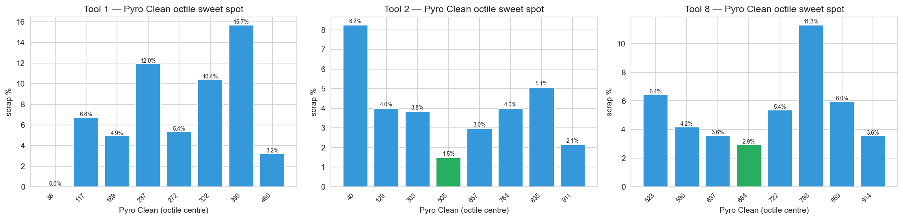
Figure 9 — Per-tool scrap rate by Pyro Clean octile. Green bar = lowest-scrap band (recommended target). Tool 8 never resets in the window (min observed = 496).
Tool | Recommended Pyro Clean band | Rate in band | Rate outside
Tool 1 | 0 – 76 | 0.0 % | 8.32 %
Tool 2 | 426 – 584 | 1.48 % | 4.33 %
Tool 8 | 665 – 703 | 2.92 % | 5.78 %

9. Multivariate model results
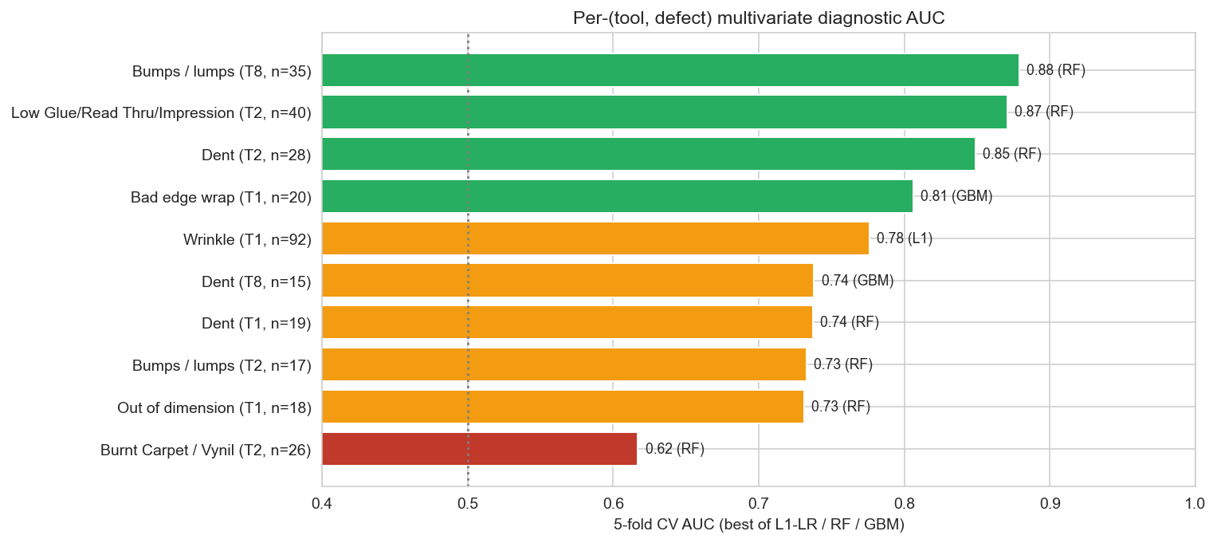
Figure 10 — 5-fold CV AUC per (tool, defect), best of L1-LR / RF / GBM. Green > 0.80, amber 0.70-0.80, red < 0.70.
Tool | Defect | n_bad | L1 | RF | GBM | Best AUC | Best model
T1 | Bad edge wrap | 20 | 0.746 | 0.797 | 0.806 | 0.806 | GBM
T1 | Dent | 19 | 0.682 | 0.737 | 0.645 | 0.737 | RF
T1 | Out of dimension | 18 | 0.676 | 0.731 | 0.644 | 0.731 | RF
T1 | Wrinkle | 92 | 0.776 | 0.768 | 0.732 | 0.776 | L1
T2 | Bumps / lumps | 17 | 0.724 | 0.733 | 0.68 | 0.733 | RF
T2 | Burnt Carpet / Vynil | 26 | 0.571 | 0.617 | 0.608 | 0.617 | RF
T2 | Dent | 28 | 0.826 | 0.849 | 0.801 | 0.849 | RF
T2 | Low Glue/Read Thru/Impression | 40 | 0.835 | 0.871 | 0.869 | 0.871 | RF
T8 | Bumps / lumps | 35 | 0.842 | 0.879 | 0.755 | 0.879 | RF
T8 | Dent | 15 | 0.525 | 0.584 | 0.738 | 0.738 | GBM

9.1 Anomaly score (Isolation Forest)
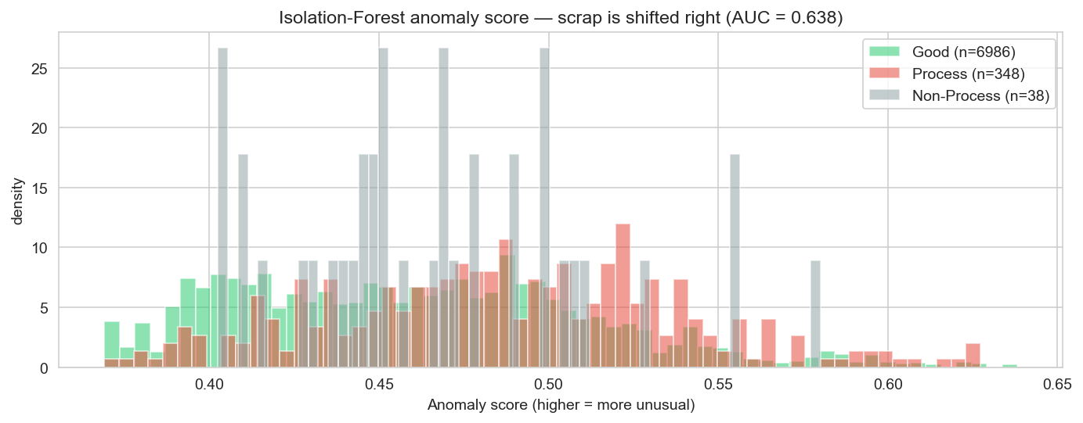
Figure 11 — Anomaly-score distribution. Scrap parts are shifted right; overall AUC ≈ 0.64. Use as triage filter, not a classifier.

10. Recommendation engine — how it works
recommend(defect, tool, current_params, pyro_band) → list[action]
- For each rule (filtered to Welch p < 0.05 and |Cliff δ| > 0.20 on the relevant tool):
- — look up the parameter's good [P5, P50, P95] band on this tool;
- — compare current reading to the band: inside → OK; above P95 → REDUCE to P50; below P5 → INCREASE to P50;
- — severity label inherited from historical effect size;
- — Pyro Clean has a sweet-spot overlay: outside band → WAIT_BEFORE_CLEAN or PYRO_CLEAN_DUE.

10.1 Live demo (worst-violating scrap example per defect)
On the most out-of-band scrap row per defect, the engine fires 2–6 actions per case. Example below from Tool 8 Bumps (worst-violator scrap row):
Severity | Parameter | Current | Safe band | Action
CRITICAL | Temp. THT at Trigger | 137 | 141 – 170 | INCREASE → 170
CRITICAL | Capacity BHT | 53 | 55 – 70 | INCREASE → 60
CRITICAL | Temp. BHT at Trigger | 164 | 177 – 213 | INCREASE → 193
STRONG | TTF Circuit 1 Temp | 27 | 28 – 37 | INCREASE → 34
STRONG | Pos Vinyl N Width | 304 | 0 – 295 | REDUCE → 0
MODERATE | Pyro Clean | 810 | 665 – 703 | PYRO_CLEAN_DUE

11. Assumptions (explicit)
These are the assumptions we made because we cannot verify them from data alone. If any prove wrong, the affected finding should be re-examined.
# | Assumption | Risk if wrong
A1 | The 9 listed defect codes are operator-actionable; the other 4 (Hole, Broken/Fracture, Fabric Flaw, Fabric Torn) are upstream / material defects. | We could be under-counting recoverable scrap if some excluded defects are process-related.
A2 | ID uniquely identifies a single produced part; the process↔scrap join is correct. | Empirically supported: 386/386 matches, unique IDs on both sides.
A3 | BuiltTime is the actual production timestamp (not record-creation time). | Warm-up finding depends on this; if violated, the warm-up signal is spurious.
A4 | ScrapTime is the QC / detection time, not the production time. | Consistent with the 6-h median / 43-day max lag we observe.
A5 | Each tool's recipe (Roller Gap, Stretch *) is stable within the 56-day window. | Supported empirically by very low within-tool CV on these parameters.
A6 | Good parts are a valid baseline. | If many marginal parts slipped through QC, the "good" targets are biased.
A7 | P5–P95 of good parts is a reasonable operating window. | Wider would dilute the signal; narrower would over-fire. Not cost-optimised.
A8 | Scrap Desc labels are accurate. | Some defect categories (Dent vs Bumps) are visually similar and may be subjectively labelled.
A9 | Pyro Clean is a counter (cycles since last clean). | Supported by ≤0.5 % decreases. If actually a setpoint, sweet-spot recommendation must be re-interpreted.
A10 | MCT = 9999 is a stoppage sentinel. | Supported by elevated surrounding scrap. A different cause (data-logger error) would change the engineered flag's meaning.
A11 | Pos Vinyl * zero values mean the feature is inactive. | Treating as (active_flag, value) is safer either way than treating zero as a numerical level.

12. Process-related ambiguities & open questions
These cannot be answered from the data alone — they need the operator / maintenance / engineering teams.

A. Sensor / data semantics
- Pyro Clean — exact meaning? Cycles since last pyro clean? Why does Tool 8 never reach a reset in 56 days (min = 496)?
- Machine Cycle Time = 9999 — what event does this code represent? Stop, sensor not-ready, reset, manual override?
- Pos Vinyl N/S Length/Width zero values — feature disabled by recipe, or default-when-unset?
- TTF Circuit 2 Temp = 0 everywhere — sensor removed, retired, or always-off configuration?
- Capacity BHT capped at 70 (5.4 % of rows); Capacity THT capped at 85 — hardware ceiling, or controller setpoint cap?
- Top Tool Pos Close has only 4 unique values (12330/12480/12490/12500) — discrete clamp positions?
- BT Circuit 2 Temp has two regimes (22-28 most rows, 300-833 others). Different heater modes?

B. Operations & people
- Operator / shift identifiers — are they logged anywhere? Tool 1 morning warm-up and Tool 8 afternoon spike both have a personnel-signal signature.
- Warm-up procedure — is there a standardised one? First 10–20 parts of a day at ≈12 % scrap vs ≈5 % steady-state.
- Recipe configurability — recipes hard-locked per tool, or editable per part?
- Tool 8 absence of Wrinkle / Bad edge wrap — real (geometry/mechanics) or label-coding difference?
- MAP POCKET BEIGE on Tool 1 at 23.1 % scrap — colorant interaction, geometric difficulty, supply-lot variance, inspection bias?
- Pyro Clean cleaning policy — scheduled, defect-triggered, or operator judgement? Tool 8 not resetting in 56 days is unusual.
- Scrap detection workflow — median lag 6 h, max 43 d. Recent days' scrap counts may still grow.
- Color × family confound — PS LOWER LHD BEIGE 15.3 % vs BLACK 4.79 %. Different vinyl, supplier, or inspection visibility?

13. What we did not do, and why
No annual-savings projection. 14 production days inside 56 calendar days is too bursty to annualise without an expected production-volume baseline.
No causal claims about prior interventions. We have no metadata about what was or wasn't changed on the line between datasets.
No supervised classifier exposed as a "scrap predictor". The CV AUCs (0.72-0.89) show that signal exists, but the line already detects scrap in-line. The value is explanation, not prediction.
No leaderboard tuning. Model hyperparameters are out-of-the-box defaults — methodology is interpretable and reproducible.
No part-level recommendation table. Per-part rates (e.g. FL MAP POCKET BEIGE 23.1 %) are an engineering question, not an operator runtime knob.

14. Repo deliverables
File | Purpose
EDA.ipynb | Pure exploratory audit (34 cells)
VAC_Forming_Scrap_Analysis_Final.ipynb | Diagnosis, modeling, recommendation engine, live demo, validation (38 cells)
Scrap_Recommendations_Report_v2.xlsx | 7-sheet operator report (tool summary, defect × tool, operating windows, Pyro Clean bands, defect rules, model CV AUC, all deviations)
operating_windows_final.csv | Per-tool P5/P50/P95 reference table
FINDINGS.md | Plain-text consolidated report (same content as this document)
VAC_Forming_Scrap_Report.docx | This document — illustrated consolidated report
_exp/10_deep_eda.py / 11_hypotheses.py / 12_models.py | Reproducible scripts: EDA, hypothesis tests, modeling
_exp/build_eda_notebook.py / build_final_notebook.py / build_docx_report.py | Notebook & report generators
_exp/results/*.csv | Intermediate artefacts (parameter profile, deviations, drift, CV AUCs)
_exp/df_clean.parquet | Cleaned & joined data frame

Jupyter kernel: py311-vacforming (Python 3.11, sklearn, scipy, pandas, seaborn, openpyxl, python-docx).

