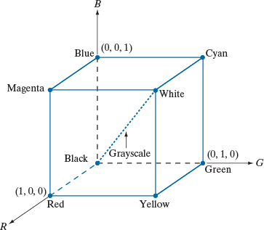

The figure is a 3D cube that represents the RGB color space.
- Each axis corresponds to one color component
- Every point inside the cube represents one color
- Colors are formed by combining Red (R), Green (G), and Blue (B)
This is also called the RGB color model in Cartesian space.

2. Axes Explanation (Very Important)
(a) Red Axis (R)
- Direction shown toward Red
- Value increases from 0 → 1
- Pure red = (1, 0, 0)
(b) Green Axis (G)
- Horizontal axis labeled G
- Value increases from 0 → 1
- Pure green = (0, 1, 0)
(c) Blue Axis (B)
- Vertical axis labeled B
- Value increases from 0 → 1
- Pure blue = (0, 0, 1)
✅ Each axis range is normalized (0 to 1 instead of 0 to 255).

3. Cube Corners and Their Colors
Each vertex (corner) of the cube represents a primary or secondary color.
Corner Color | RGB Value
Black | (0, 0, 0)
Red | (1, 0, 0)
Green | (0, 1, 0)
Blue | (0, 0, 1)
Yellow | (1, 1, 0)
Magenta | (1, 0, 1)
Cyan | (0, 1, 1)
White | (1, 1, 1)
📌 These are exactly the points labeled in the image.

4. Understanding Each Named Color in the Figure
Blue
- Coordinate: (0, 0, 1)
- Only blue is maximum
Red
- Coordinate: (1, 0, 0)
- Only red is maximum
Green
- Coordinate: (0, 1, 0)
Yellow
- Coordinate: (1, 1, 0)
- Red + Green
Cyan
- Coordinate: (0, 1, 1)
- Green + Blue
Magenta
- Coordinate: (1, 0, 1)
- Red + Blue
White
- Coordinate: (1, 1, 1)
- All colors at maximum intensity
Black
- Coordinate: (0, 0, 0)
- Absence of all colors

5. The Grayscale Line (Very Important Concept)
The dotted diagonal line running from Black → White is labeled Grayscale.
What does this mean?
- Along this line:
R=G=BR = G = BR=G=B
- Examples:
  - Black → (0, 0, 0)
  - Gray → (0.5, 0.5, 0.5)
  - White → (1, 1, 1)
📌 Any point on this diagonal produces a shade of gray, not a color.

6. Why Grayscale Lies Inside the Cube
- When R = G = B, no color dominates
- The result is:
  - Light → bright gray
  - Low values → dark gray
- This is why grayscale is inside the cube, not on faces

7. Significance in Image Processing
(a) Color Images
- Every pixel is represented as:
(R,G,B)(R, G, B)(R,G,B)
- Example pixel:
(0.2,0.6,0.9)(0.2, 0.6, 0.9)(0.2,0.6,0.9)
This point lies inside the cube.

(b) Grayscale Conversion
A color image is often converted to grayscale using:
Gray=0.299R+0.587G+0.114BGray = 0.299R + 0.587G + 0.114BGray=0.299R+0.587G+0.114B
This computation projects color values toward the grayscale axis.

