Context:

A borough is just a fancy word for district. There are 32 London boroughs within Greater London, and each borough has its own governing council. As you can guess, some of them are more desirable to live in and will reflect that desirability in a greater rise in housing prices.

Problem Statement:

**Here is the question we are trying to solve while working on this case study: Which borough of London has seen the greatest average increase in housing prices over the (approximately) two decades covered by the dataset?**

Findings / Solutions:

After Cleaning the data dropping the rows with Nan Values filtering nonborough from the given dataset, then we calculated the ratio of prices of borough in 2018 to price in 1998 and sorted the values by grouping years and borough name we found out the top 15 boroughs whose prices have increased

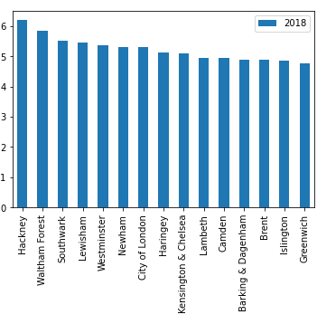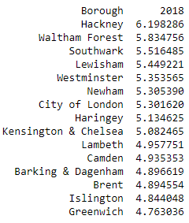

As seen Hackney borough has the highest ratio with the value of 6.19 followed by others in general for the entire borough we observed an increase in borough prices:

