A Hybrid Cloud Approach for Secure Authorized Deduplication

**Use-Case-Daigram**

**Admin**

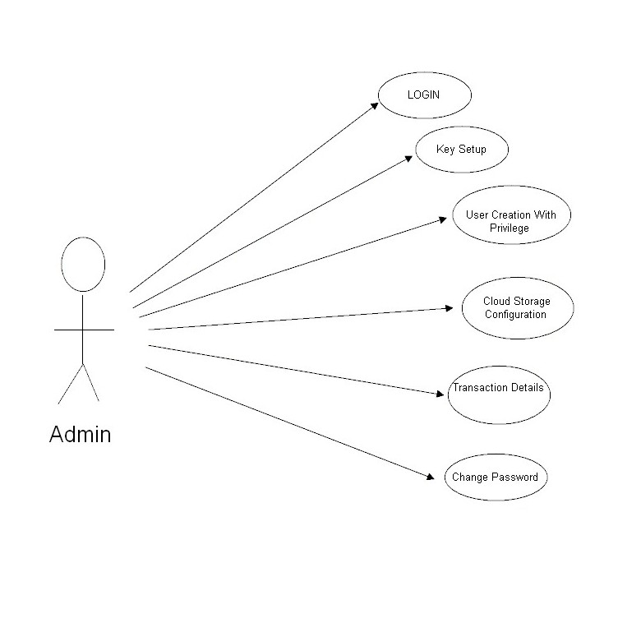

**User**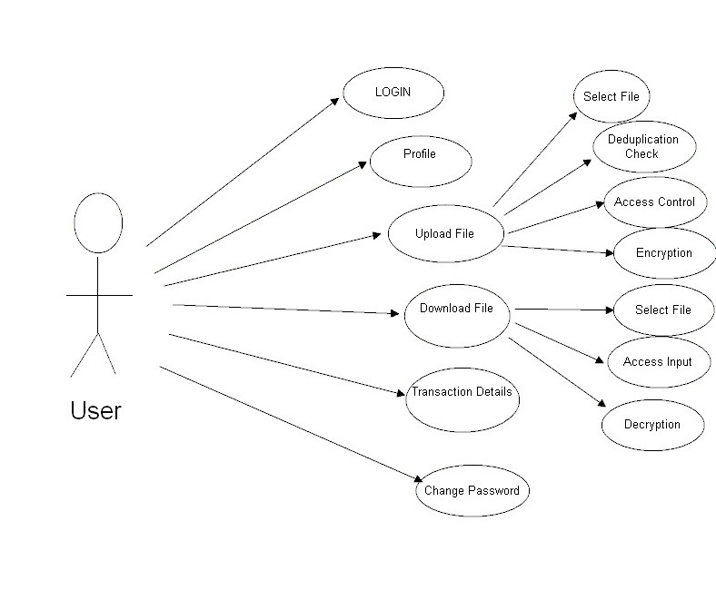

**Sequence Daigram**

**1.Successful file upload**

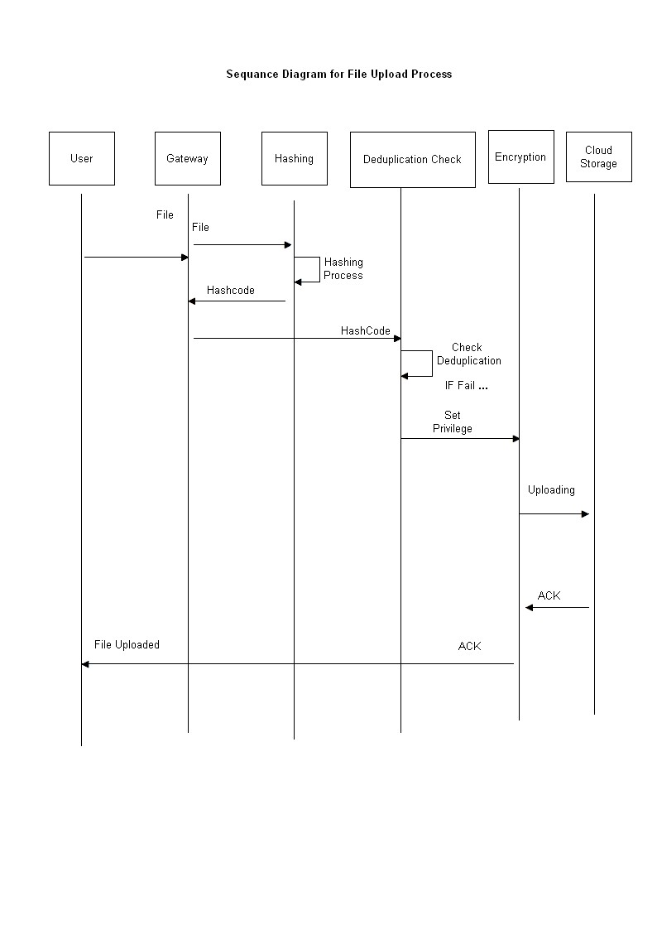

**2.Successful Deduplicate file upload**

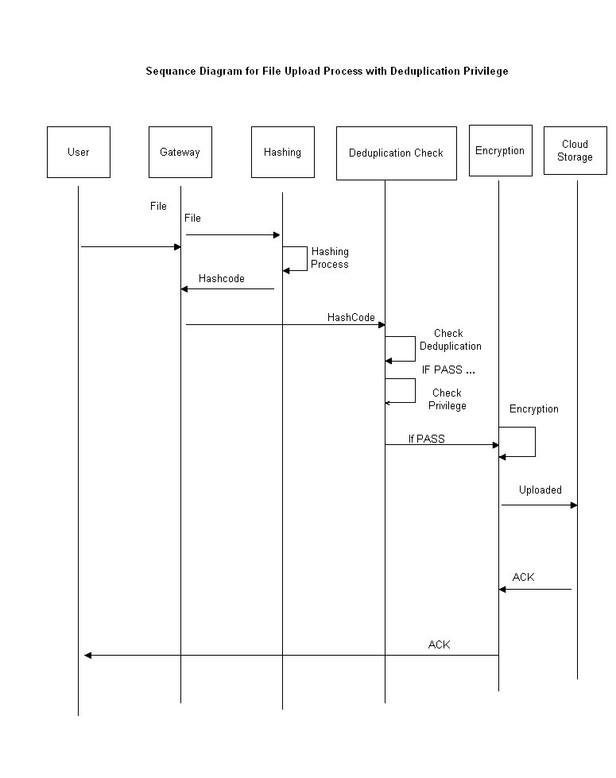

**3.Privilege Fail**

