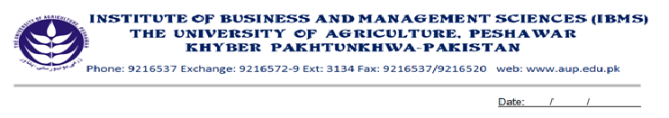
Program: BS (CS) - I
Course Name: English Composition & Comprehension
Course Code: EG- 301
Session: 2012-2015
Credit Hours: 03
Total weeks: 16-18
Total Hours: 48-54

Course Objectives:

This course has been designed to introduce and enhance the basic grammatical concepts of the English Language. Students in this course will learn to improve their basic and fundamental writing, reading and speaking skills. The main emphasis will be to help them to use the English language correctly in their Business Administration field for which English language competency is a prerequisite.

- Week-1 Sentence & Sentence Structure
Subject, Predicate
Phrase, clause
Kinds of sentences
- Week-2
Noun and Kinds of noun
Noun case,
Noun clause, noun phrase
Pronoun
Articles

- Week-3 Verb
Kinds of verb: lexical/auxiliary
Transitive/ Intransitive, Regular/ Irregular, Gerund/ Infinitive

- Week-4
Forms of verb
Subject-verb agreement
- Week-5
Adverb & kinds of adverb
Formation of adverb
Use of adverb
Degree of adverb
Adverb clause & phrase

- Week-6
Adjective, Kinds of adjective
Composition of adjective
Adjective clause and phrase
Degree of adjective
- Week-7
Preposition, kinds, usage
Conjunction
Interjection

- Week-8 Punctuation
Spellings Rules
Vocabulary

- Week-9 Introduction to Tense Structure
Present Simple Tense
Past Simple Tense
Future Simple Tense

Week-10
Present Continuous Tense
Past Continuous Tense
Future Continuous Tense
- Week-11
Present Perfect Tense
Past perfect Tense
Future Perfect Tense
- Week-12 Present Perfect Continuous Tense
Past Perfect Continuous Tense
Future Perfect Continuous Tense
- Week-13
Active & Passive Voice
Use & Rules regulation
- Week-14
Active & Passive Voice
Use & Rules regulation

- Week-15 Direct & Indirect Narration
Use & Rules regulation

- Week-16 Direct & Indirect Narration
Use & Rules regulation

Recommended Books:
- High School English Grammar and Composition. Wren and Mortin
- A functional Approach to Modern English Grammar. Green Baul

