INSTRUCTIONS:
- Solve each problem on a separate sheet of paper (using pen/ball pen). Write your Name, Registration Number and signature on every sheet used.
- Take a picture of your sheet(s) and paste it under the question statement in the word document.
- Submit the word document on portal and also submit in hard form in class. Both sumbissions are compulsory.
CLO | CLO STATEMENT | Bloom’s Taxonomy Level | PLO
2 | Apply different strategies (brute-force, greedy, divide and conquer, and dynamic programming) to solve computing problem | C3 | 2
Q1:
- Please recall LCS in your mind and write its complete recurrence with all the base cases and details. [In variable terms]  - Compute the LCS between two strings X= A G C G T A G and Y=G T C A G A. Fill out the table for finding longest common subsequence.  - You have to calculate value for C[4, 5] for above two strings, through recursive function calls. First try to understand what is asked and then show step by step all the calls what are to be used in the form of recursion tree. [At every step it should be clearly mentioned that what was the decision at the step, with reason]. | 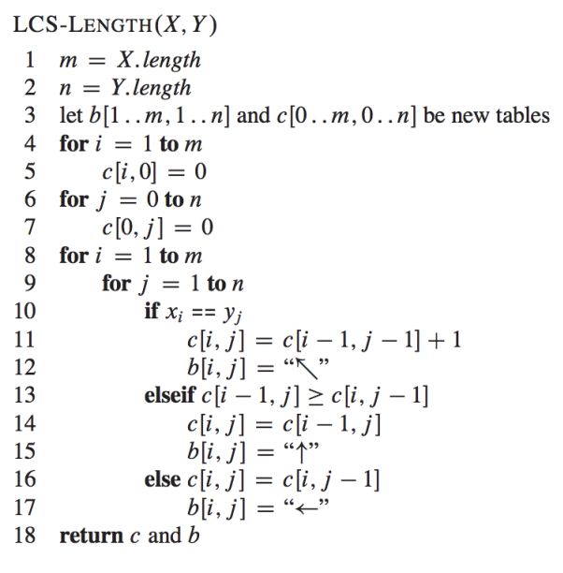

Q2:
- Compute the LCS between two strings X= 0 0 1 0 1 0 1 0 and Y=1 0 0 1 0 0 1 1. Fill out the table for finding longest common subsequence.

- You have to calculate value for C[4, 5] for above two strings, through recursive function calls. First try to understand what is asked and then show step by step all the calls what are to be used in the form of recursion tree. [At every step it should be clearly mentioned that what was the decision at the step, with reason].

Q3:
- Please recall Knapsack (0/1) in your mind and write its complete recurrence with all the base cases and details. [In variable terms]  - You have been given data to solve the question, capacity for the Knapsack is 10. Total 7 items are there for the selection  You have to calculate value for V[5, 8], through recursive function calls. First try to understand what is asked and then show step by step all the calls what are to be used in the form of recursion tree. [At every step it should be clearly mentioned that what was the decision at the step, with reason]. Also Fill out the table. | 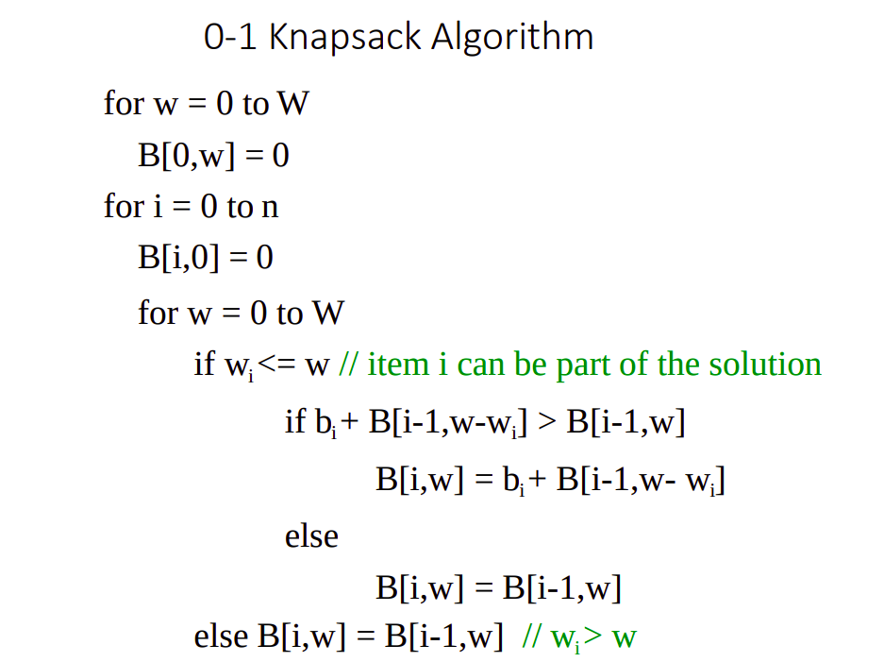
  W | 1 | 2 | 3 | 4 | 5 | 6
  V | 2 | 4 | 5 | 7 | 8 | 10

Q4:
You have been given data to solve the question, capacity for the Knapsack is 14. Total 7 items are there for the selection

W | 1 | 3 | 5 | 7 | 9 | 11
V | 3 | 5 | 8 | 10 | 12 | 15

You have to calculate value for V[5, 8], through recursive function calls. First try to understand what is asked and then show step by step all the calls what are to be used in the form of recursion tree. [At every step it should be clearly mentioned that what was the decision at the step, with reason]. Also Fill out the table.

Q5:
A data center has a fixed power budget of 15 units. There are 5 different computational tasks available, each with a specific power consumption (weight) and a priority value (value).
- Tasks (Weight, Value): T1(4, 5), T2(2, 3), T3(5, 8), T4(3, 4), T5(7, 10).
- Task: Determine the maximum priority value the data center can achieve without exceeding the power budget. Show your work using the Dynamic Programming table.
Q6:
In bioinformatics, the similarity between two DNA sequences is often found using LCS. Given two DNA strands:
- Strand 1: TACGTAC
- Strand 2: GCTACGA
- Task: Identify the Longest Common Subsequence. If there are multiple sequences of the same maximum length, list at least two of them and explain the "Backtracking" process used to find them from your DP table.

