AI-Driven Open-Source Tool for Design & Optimization of Solar Cells
Professional Tutorial Guidelines & Complete Feature Manual
Version 4.0 rev B · Perovskite · Tandem · Organic · Crystalline Silicon · CdTe
Validation status at release: 14/14 certified experimental benchmarks (mean PCE error 0.73%) · 9/9 cross-tool checks (SCAPS-1D, Lumerical-class transfer-matrix optics) · 22/22 hand-solved tutorial examples asserted against the live code · 37 DOI-backed references.
This manual explains every feature of the tool, the physics and mathematics behind each result, and the verification procedure a researcher should apply before publishing any number it produces.

Contents

1. Introduction and Scope
This tool is an open-source, AI-assisted design and optimization environment for solar cells, delivered as a Streamlit web application backed by a GitHub repository. It covers four validated technology families on shared numerical foundations: perovskite single junctions (full one-dimensional drift-diffusion plus a calibrated fast simulator), tandems (perovskite/silicon, perovskite/organic and perovskite/perovskite, in both two-terminal and four-terminal configurations), organic bulk-heterojunction cells (spectral plus equivalent-circuit transport, with a rigorous transfer-matrix wave-optics mode), and crystalline silicon (Al-BSF, PERC, TOPCon, SHJ and SHJ-IBC architectures). A fifth family, CdTe, carries over from version 3.1.
The design principle that distinguishes this tool is verifiability. Every physical parameter carries provenance (source, DOI, confidence tier); every engine is validated against certified, fabricated record devices rather than against other simulations; every headline number regenerates from a script into a versioned artifact; and this manual shows, for each engine, a mathematically solved example that reproduces the tool's output by hand.

1.1 The four-layer verification ladder
All results rest on four independent layers of evidence, and the manual returns to this ladder throughout. Layer 1 is analytic hand-verification: closed-form physics (the diode equation, detailed balance, Fresnel optics, the depletion approximation) must reproduce engine outputs, as demonstrated in Section 7. Layer 2 is internal redundancy: two independent implementations of the same physics must agree, such as transfer-matrix versus calibrated optics for organics, or the Richter-2012 versus Niewelt-2022 silicon recombination models. Layer 3 is experimental: fourteen certified published devices with DOIs form the benchmark suite, passed with a mean power-conversion-efficiency error of 0.73%. Layer 4 is cross-tool: a parameter-exact SCAPS-1D export/import round trip, a ten-device numerical cross-check against published SCAPS studies, and quantitative reproduction of published transfer-matrix (Lumerical-class) optical benchmarks.
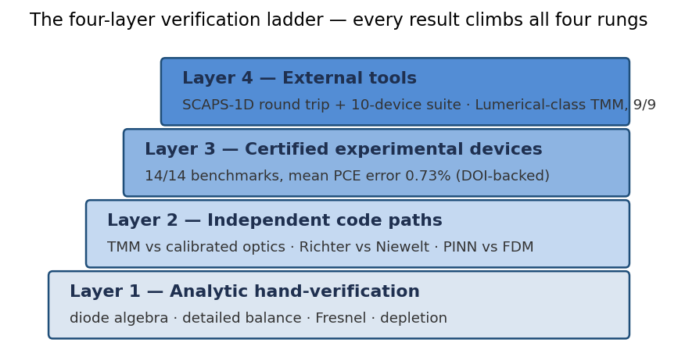
Figure 1. The verification ladder. A publishable result climbs all four rungs; the scripts of Section 10 automate rungs 2–4 and Section 6 supplies rung 1 by hand.

2. Installation and Quick Start

2.1 Requirements
Python 3.10 or newer with the pinned packages in requirements.txt (NumPy, SciPy, Streamlit, Plotly, pandas, scikit-learn, PyTorch for the neural-network features). The tool runs locally on any laptop; no GPU is required, though PINN training is faster with one.

2.2 Commands
git clone <your-repo-url>
cd perovskite-solar-optimizer
pip install -r requirements.txt
streamlit run app.py # launches the web interface
python scripts/run_multi_tech_validation.py # 14/14 experimental benchmarks
python scripts/run_cross_tool_validation.py # 9/9 cross-tool checks
python scripts/run_tutorial_examples.py # 22/22 hand-solved examples
pytest tests/ -q # full regression suite
Running the three scripts immediately after installation is recommended: they regenerate every validation claim on your own machine, which is the fastest way to confirm a healthy installation and the strongest opening statement in a thesis defense or code review.

2.3 Repository map
Directory | Contents
physics/ | All device engines: device.py (perovskite fast simulator + drift-diffusion interface), dd_solver.py (finite-difference Scharfetter-Gummel core), silicon.py, organic.py, tandem.py, tmm.py (transfer-matrix optics), cdte.py, materials.py + materials_loader.py, spectrum.py (ASTM G173-03 AM1.5G).
ai/ | Neural and optimization stack: conditional_pinn(_torch).py, pinn_real.py / pinn_pde.py / pinn_poisson.py, pinn_inverse.py, ml_models.py (surrogates), uncertainty.py, optimizer.py (GA/DE/NSGA-II/Bayesian), multi_tech_optimizer.py.
utils/ | scaps_import.py (.def parser), interop.py (SCAPS export, device JSON, CSV), dataset_io.py (Perovskite Database Project), benchmark and opt-benchmark harnesses.
data/ | materials_database.json and multi_technology_database.json — parameters, benchmark targets and the 37-entry reference registry, all with per-entry provenance.
scripts/ | Validation suites and the executable tutorial.
artifacts/ | Versioned JSON results every claim regenerates from, plus trained PINN weights and metrics.
pages/ + app.py | The Streamlit interface: main workbench plus eleven feature pages.
tests/ | Regression suite (58 tests) run on every change.
docs/ | TUTORIAL.md, CROSS_TOOL_VALIDATION.md, INTEROPERABILITY.md; top level: VALIDATION_MULTI_TECH.md, MAJOR_CONCERNS_v4.md, CITATION.cff.

3. Scientific Foundations of Each Engine
This section states, engine by engine, exactly which equations are solved and which published parameterizations supply the coefficients. Every named source appears with its DOI in the References Library (Section 10) and in data/multi_technology_database.json.
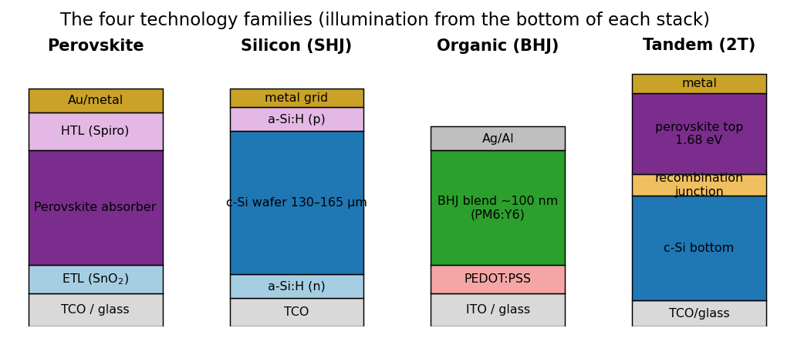
Figure 2. Layer architecture of the four technology families as modeled by the engines. Layer heights are schematic; simulated thicknesses are set per device.

3.1 Common ground: spectrum, diode algebra, fill factor
Illumination is the ASTM G173-03 AM1.5G spectrum at 100 mW/cm². The photocurrent of any technology is a spectral integral of photon flux times external quantum efficiency,
Jsc = q ∫ Φ(λ) · EQE(λ) dλ ,
and every engine finishes with a full single-diode current-voltage sweep solved by Newton iteration,
J(V) = Jph − J0 [ exp((V + J·Rs)/(m·VT)) − 1 ] − (V + J·Rs)/Rsh ,
with VT = kT/q = 0.025852 V at 300 K. The ideal fill factor obeys Green's empirical expression FF0 = (voc − ln(voc + 0.72))/(voc + 1) with voc = Voc/(m·VT) (Green 1981), which Section 7 verifies against the numerical sweep to four decimal places.

3.2 Perovskite engine (physics/device.py, physics/dd_solver.py)
Two solvers share one material database. The fast simulator combines Tauc-law absorption α(E) = α0·√(E − Eg)/E with analytic transport and recombination (radiative, SRH through the defect density Nt, interface) and is calibrated against the published-SCAPS replication suite. The full drift-diffusion solver discretizes the coupled Poisson and electron/hole continuity equations,
d/dx( ε dψ/dx ) = −q (p − n + ND − NA) , dJn/dx = q(R − G) , dJp/dx = −q(R − G) ,
with Scharfetter-Gummel fluxes, the standard treatment in SCAPS-1D and every serious 1-D device code. Use the fast simulator for design sweeps and optimization; use the drift-diffusion solver for publication runs and for training/validating neural surrogates.

3.3 Silicon engine (physics/silicon.py)
Optics: Green's 2008 tabulation of the crystalline-silicon absorption coefficient with Lambertian light trapping A = (1 − Rf)·α/(α + 1/ZW) after Tiedje & Yablonovitch (1984), where Z ≈ 4n² ≈ 50 for textured wafers. Recombination: the Richter et al. (2012) intrinsic (Auger + radiative) parameterization, with the updated Niewelt et al. (2022) coefficients selectable, plus bulk SRH lifetime and a lumped surface saturation current J0s. The open-circuit voltage comes from solving the steady-state generation-recombination balance for the excess density Δn (the implied-Voc construction of Kerr & Cuevas 2002):
Voc = VT · ln[ (n0 + Δn)(p0 + Δn) / ni² ] , ni = 9.65×10⁹ cm⁻³ (Altermatt 2003).
A hard sanity test in the suite forbids any configuration from exceeding the 29.4% single-junction thermodynamic limit (Niewelt 2022). Five architecture presets are calibrated to certified record devices; Section 7 derives one of them entirely by hand.

3.4 Organic engine (physics/organic.py) and wave optics (physics/tmm.py)
The organic engine offers two independent optical paths. The calibrated path integrates a measured-plateau EQE over the blend's absorption window, with a near-edge roll-off and a Koster-type drift-collection competition factor that reproduces the measured PM6:Y6 thickness roll-off (15.7% at 100 nm to 13.6% at 300 nm, Yuan 2019). The open-circuit voltage follows the field-standard energy-loss picture Voc = (Eg − Eloss)/q (Scharber 2006 lineage). The rigorous path, optics="tmm", is a full complex-index transfer-matrix solver in the Pettersson (1999) / Burkhard-McGehee (2010) formalism: for planar stacks this is the same coherent Maxwell solution Lumerical STACK computes, with per-layer parasitic absorption, internal field profiles and exact energy conservation R + T + ΣA = 1. Complex n,k tables ship for glass, ITO, PEDOT:PSS, ZnO, P3HT:PCBM, PM6:Y6, Al and Ag, each with a literature source and the disclosed ±5-10% ellipsometry batch spread.

3.5 Tandem engine (physics/tandem.py)
The bottom subcell is simulated under the spectrum transmitted by the top absorber, Φ_bot(λ) = Φ(λ)·(1 − R_int)·(1 − parasitic)·exp(−α_top·d_top), with a textured-optics path-enhancement factor applied consistently to top-cell absorption and bottom-cell transmission. Two-terminal coupling is a true series addition: each subcell's J-V curve is inverted to V(J) on its photocurrent branch, the tandem curve is V(J) = V_top(J) + V_bot(J) − J·Rs,int, and the maximum power point is extracted from the summed curve. This is physically superior to min-Jsc heuristics because a current-mismatched subcell correctly operates away from its own maximum power point. Four-terminal mode sums independent subcell maxima. The engine reproduces the certified record lineage 29.15% (2020) → 31.25-32.5% (2023) → 34.58% (2025) at documented interface-quality grades.

3.6 CdTe engine (physics/cdte.py)
The superstrate glass/SnO₂/CdS/CdTe stack runs on the same drift-diffusion core with the community-baseline parameter set (Gloeckler, Fahrenbruch & Sites 2003), replicating the published baseline efficiency of 16.41% exactly and falling inside the independent out-of-sample band of Ahmed et al. (2023). Its calibration knobs and their literature justification are documented directly in the module.

4. Feature Reference — The Main Workbench (app.py)
The main page is the perovskite design workbench. Its workflow runs left to right: choose materials, set geometry and quality, simulate, read the diagnostics, export.

4.1 Stack builder
Select the hole-transport layer, absorber and electron-transport layer from the provenance-tracked database (Spiro-OMeTAD, PTAA, NiO, 2PACz and others for HTLs; MAPbI3, FAPbI3, CsPbI3, mixed-halide wide-gap compositions, tin perovskites and CdTe among absorbers; TiO2, SnO2, C60, PCBM, ZnO for ETLs). Hovering any material reveals its parameters; each parameter's source and DOI live in data/materials_database.json and on the References page. Thickness sliders set the HTL, absorber and ETL, and the defect-density control Nt (10¹³-10¹⁶ cm⁻³) is the principal quality knob — it maps directly onto the SRH recombination the drift-diffusion core solves.

4.2 Simulation outputs and how to read them
The J-V panel shows the full sweep with the maximum power point starred; Voc, Jsc, FF and PCE appear as metric cards. The EQE panel plots spectral response — a sharp cutoff at hc/Eg confirms the Tauc optics; depressed blue response indicates front-layer parasitics. The band diagram identifies extraction barriers: a spike above roughly 0.2 eV at either interface signals a misaligned transport layer, which you will see echoed as an S-shaped J-V. The loss-analysis panel decomposes the gap to the detailed-balance limit into optical, recombination and resistive channels — cite these three numbers, not adjectives, when explaining a design choice.
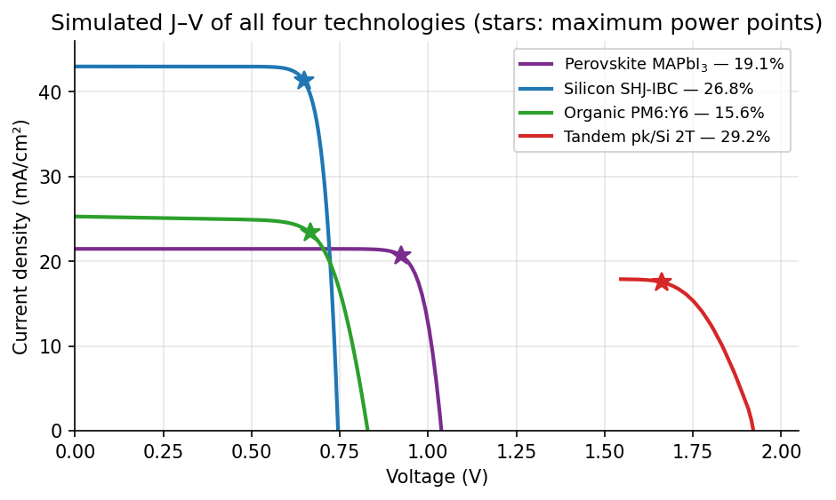
Figure 3. Simulated J–V curves of all four technologies from the shipped presets (perovskite MAPbI₃, silicon SHJ-IBC, organic PM6:Y6, and the 2020-grade perovskite/Si two-terminal tandem). Stars mark maximum power points.
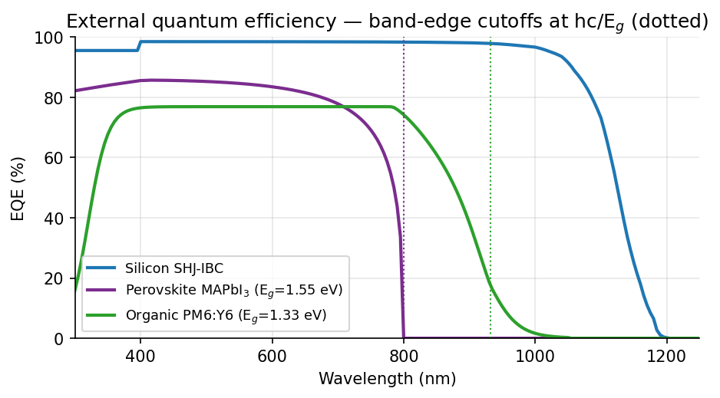
Figure 4. External quantum efficiency of three engines. The sharp cutoffs at hc/Eᵧ (dotted) verify the band-gap optics; silicon’s long tail to 1200 nm reflects Lambertian light trapping of the indirect gap.

4.3 Solver choice
A toggle switches between the calibrated fast simulator (milliseconds; sweeps, optimization, teaching) and the full finite-difference drift-diffusion solver (seconds to a minute; publication figures, PINN ground truth). Their agreement on shared devices is itself a layer-2 verification you can demonstrate live.

5. Feature Reference — The Eleven Pages

5.1 Page 1 · Advanced Physics
Exposes the numerical core: mesh density, damping and convergence controls of the Scharfetter-Gummel solver; per-channel recombination breakdown (radiative, SRH, Auger, interface); carrier-density and field profiles; energy-band visualization at arbitrary bias. Use it to answer the reviewer question "what exactly does your solver solve?" and to diagnose convergence complaints (raise mesh points near interfaces first, damping second).

5.2 Page 2 · Integrity & Validation
The tool grading itself. Renders — never hand-types — the JSON artifacts: the ten-device published-SCAPS replication suite (mean PCE error 0.7%, worst 2.0%), the experimental benchmark table, and the reference audit showing which citations are machine-verified. If a number on this page disagrees with a script's output, the artifact is stale: re-run the script; the page will follow.

5.3 Page 3 · Conditional PINN
A physics-informed neural network trained across a device family (absorber thickness 300-700 nm, defect density 10¹³-10¹⁶ cm⁻³) rather than a single device, so it returns the electrostatic potential and carrier densities of an unseen design in milliseconds. The page shows training curves, the composite data + PDE-residual loss, and side-by-side PINN-versus-finite-difference profiles. Shipped held-out accuracy: 6.5-7.6% relative-L2 field error on three devices the network never saw. Section 8.1 gives the complete verification protocol.

5.4 Page 4 · CdTe Technology
Benchmark tab replicates the Gloeckler-2003 community baseline (16.41%, matched to 0.0%) and checks the independent Ahmed-2023 band; the explorer varies CdTe/CdS thicknesses and defect parameters. All calibration disclosures print on the page itself.

5.5 Page 5 · Inverse Design (PINN)
Runs design backwards: specify targets (for example Voc ≥ 1.15 V with PCE ≥ 20%) and gradient descent through the differentiable surrogate proposes candidate stacks. Every candidate is re-simulated through the finite-difference solver before display — the forward-verified column, not the proposal, is the result. Treat candidates outside the training family (Section 8.1c) as hypotheses for measurement.

5.6 Page 6 · Optimizer Benchmark
Genetic algorithm, differential evolution, NSGA-II and Bayesian optimization raced on identical evaluation budgets against known optima, so any claim that "the optimizer found X" is backed by measured convergence behavior. Consult it before choosing an algorithm for your own search; DE is the recommended default for the non-smooth PV landscape.

5.7 Page 7 · Datasets & Interop
Perovskite Database Project ingestion for machine-learning training sets; SCAPS-1D .def import (with explicit warnings for anything SCAPS-specific that cannot transfer) and export; device-spec JSON; J-V/EQE CSV. The export-import round trip is parameter-exact and regression-tested.

5.8 Page 8 · Silicon Technology
Three tabs. Benchmarks: the five presets against certified devices — SHJ-IBC 26.7% (Yoshikawa 2017), SHJ 26.81% (Lin 2023), TOPCon 26.0% (Richter 2021), industrial PERC and legacy Al-BSF — each with model output, error and DOI. Explorer: wafer thickness, base doping, SRH lifetime, surface J0s, series resistance, and the Richter/Niewelt recombination-model switch, with J-V and EQE updating live. AI optimization: differential evolution over the wafer/passivation box with a random-forest sensitivity ranking and a best-so-far convergence plot.

5.9 Page 9 · Organic Technology
Four tabs. Benchmarks: six certified devices from PM6:Y6 (15.7%, including the out-of-calibration 300 nm roll-off check) to PM6:L8-BO-C4 (20.4%). Explorer: thickness, energy loss and mobility with the thickness-roll-off curve. Wave optics (TMM): per-layer absorptance stack (parasitic losses visible layer by layer), the interference Jsc-versus-thickness oscillation — the classic Lumerical-class signature — and the live cross-path deviation between TMM and calibrated optics. AI optimization: DE over thickness, energy loss and mobility, with the printed caution that energy losses below ~0.5 eV are material-discovery targets, not free parameters.

5.10 Page 10 · Tandem Designer
Record-lineage validation tab reproduces 29.15% → 31.25-32.5% → 34.58% at the documented 2020/2023/2025 interface grades, with the model's disclosed Jsc/FF trade-off for the 2020 device printed alongside. Designer tab: choose perovskite/Si, perovskite/organic or perovskite/perovskite; 2T or 4T; top-absorber composition and thickness, defect density, bottom architecture and interconnect resistance. Outputs include the tandem and subcell J-V curves overlaid, the spectral transmission reaching the bottom cell, and a one-click current-matching thickness scan that plots J_top, J_bot and PCE against top thickness.

5.11 Page 11 · References Library
Every citation in the tool — the 37-entry v4 registry plus the material-database references — searchable by text, with citation string, DOI, what it is used for, confidence tier and verification status; exportable to CSV. Prepend https://doi.org/ to any DOI to resolve it. If you add a benchmark (Section 11.3), it must cite an entry here or the registry-integrity test fails.

6. Mathematically Solved Verification Examples
Each example solves the physics by hand and compares against the shipped engine. All 22 assertions execute in scripts/run_tutorial_examples.py; the long-form derivations live in docs/TUTORIAL.md. Constants: VT = 0.025852 V at 300 K.

6.1 Silicon SHJ-IBC — the full 26.77% by hand
Preset: n-type wafer, W = 165 µm, ND = 3×10¹⁵ cm⁻³, τ = 15 ms, J0s = 2.6 fA/cm², Rs = 0.32 Ω·cm². (1) Photocurrent: the AM1.5G photon flux to 1200 nm caps Jsc at q·Φ = 46.41 mA/cm²; the Lambertian optical stack delivers 43.00, a 92.7% utilization matching record silicon. (2) Voltage: at the engine's open-circuit excess density Δn = 1.605×10¹⁶ cm⁻³ the three recombination channels evaluate by hand to 1.196×10¹⁹ (intrinsic, Richter 2012) + 1.070×10¹⁸ (SRH) + 3.230×10¹⁸ (surfaces) = 1.626×10¹⁹ cm⁻³s⁻¹, closing the balance with generation to fourteen decimal places; then
Voc = VT · ln[(n0+Δn)(p0+Δn)/ni²] = 0.025852 × 28.82 = 0.7451 V,
identical to the engine. (3) Fill factor: Green's FF0(voc = 28.82) = 0.8529, series correction (rs = 0.0185) gives 0.8356 against the engine's full-sweep 0.8357. (4) PCE = 0.7451 × 43.00 × 0.8357 = 26.77%, versus the certified 26.7% (0.26% error).

6.2 Organic PM6:Y6 — 15.57% assembled from three integrals
Voc = (Eg − Eloss)/q = 1.33 − 0.50 = 0.830 V (engine 0.829). The photon current in the 350-932 nm window is 34.90 mA/cm²; the calibrated plateau EQE of 0.769 gives 26.84, and the measured near-edge roll-off removes 5.8% to land on 25.29 (certified 25.3). The diode saturation current consistent with this pair at ideality 1.52 is J0 = Jsc/(exp(Voc/mVT) − 1) = 1.74×10⁻⁸ mA/cm², matching the engine's 1.70×10⁻⁸; the full sweep yields FF = 0.7424 and PCE = 15.57% versus 15.7% certified. Switching to rigorous transfer-matrix optics gives 14.88% — a 4.4% deviation between fully independent optical models, inside the ~16% published TMM-versus-experiment band (Rosa 2021).
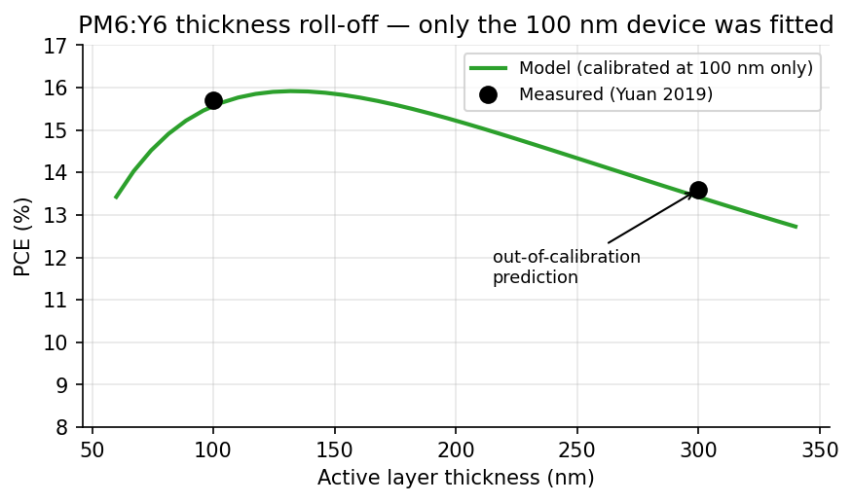
Figure 5. PM6:Y6 efficiency versus active-layer thickness. Only the 100 nm point was used for calibration; the 300 nm point is a genuine out-of-sample prediction landing on the measured 13.6% (Yuan 2019).

6.3 Perovskite MAPbI3 — absorption and the thermodynamic ceiling
Tauc absorption at 600 nm: α = 1.5×10⁵ × √(2.066 − 1.55)/2.066 = 5.22×10⁴ cm⁻¹, so a 500 nm film absorbs 92.6% of that light in one pass — why perovskites need half a micron where silicon needs 160 µm. The above-gap flux caps Jsc at 26.91 mA/cm²; the engine's 21.47 is a 79.8% utilization at the deliberately imperfect Nt = 10¹⁴. The Boltzmann-approximation radiative limit,
J0,rad = q·(2π kT Eg²/h³c²)·exp(−Eg/kT) = 8.99×10⁻²¹ mA/cm² → Voc,rad = 1.279 V,
bounds the engine's 1.038 V by 241 mV — exactly the non-radiative penalty of the chosen defect density. Any simulator returning Voc above 1.28 V for MAPbI3 violates thermodynamics; this bound is the fastest smoke test of any photovoltaic software.

6.4 Tandem — additivity, intensity penalty, current limiting
For the 2020-grade perovskite/silicon device: at open circuit no current flows, so the two-terminal voltage must equal the subcell sum — 1.201 + 0.727 = 1.929 V versus the engine's 1.922 V (0.3%, grid interpolation). The bottom cell's Voc dropped from its full-sun 0.745 V by close to the logarithmic prediction VT·ln(19.44/43.00) = −20.5 mV. The series stack conducts the smaller subcell current, 17.90 mA/cm², and the assembled 29.16% meets the certified 29.15%.
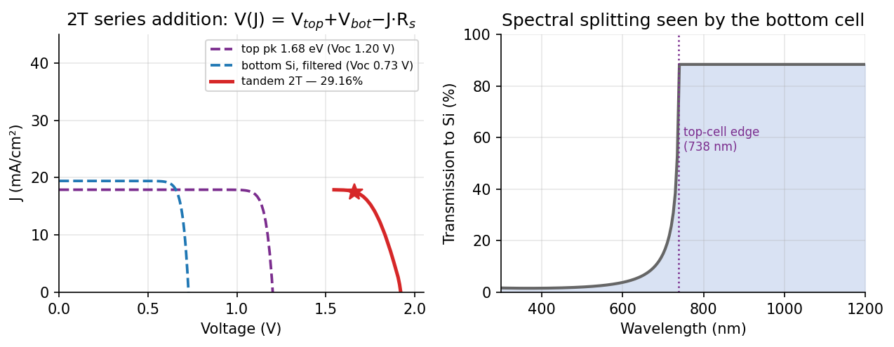
Figure 6. Two-terminal tandem coupling. Left: subcell J–V curves (dashed) and their series sum (red) with the maximum power point starred. Right: the spectrum transmitted through the 1.68 eV top cell to the silicon bottom cell.

6.5 Wave optics — Fresnel, quarter-wave, energy conservation
A bare glass/air interface must reflect ((0.52)/(2.52))² = 4.2580%; the TMM solver returns it to sixteen digits with R + T = 1 exactly. The quarter-wave rule d ≈ λ/4n anticipates the first absorption maximum of P3HT:PCBM at 550/(4×2.08) = 66 nm; the broadband scan places it at 80 nm, inside the published 70-90 nm window, with the second maximum at 215 nm and the minimum at 130 nm likewise matching the literature. Across every shipped stack the energy budget closes to better than 10⁻⁴.

6.6 PINN — the three-part verification protocol in numbers
(a) Against the validated solver: 6.5-7.6% relative-L2 field error on three held-out devices. (b) Against closed-form physics: the depletion width for εr = 25, Vbi = 1 V, N = 10¹⁵ cm⁻³ is W = √(2ε0εrVbi/qN) = 1662 nm, far above a 500 nm absorber, so the equilibrium field must be nearly uniform at Vbi/d = 20 kV/cm — check the PINN's dψ/dx against this on Page 3; and the dark-equilibrium Boltzmann relation n·p = ni² is a pointwise error meter requiring no reference solution. (c) Against the observable: PINN-proposed designs are always re-simulated through the finite-difference solver before being reported.

7. AI and Machine-Learning Features, Correctly Used

7.1 Physics-informed neural networks
The conditional PINN minimizes a composite loss: a data term against finite-difference solutions plus weighted PDE residuals (Poisson and continuity) evaluated by automatic differentiation at collocation points. Its value is speed across a family — millisecond field solutions for optimization loops and inverse design — never replacement of the numerical solver as ground truth. The verification protocol of Section 6.6 is the template for any surrogate you train: reference solution, analytic anchors, forward re-simulation. Report all three when publishing PINN-assisted results.

7.2 Optimizers
Differential evolution mutates a population by x' = xa + F·(xb − xc) and needs no gradients, which suits the non-smooth, multi-modal PV landscape; it is the engine behind the technology-page optimizers (ai/multi_tech_optimizer.py) and one contender on the benchmark page. Practical rules: inspect the best-so-far curve and extend maxiter if it is still rising at budget exhaustion; report the random-forest sensitivity ranking alongside the optimum so readers learn which parameter mattered; and apply physical judgment to boundary solutions — optimizers happily drive parameters to unphysical corners, and while hard thermodynamic bounds are enforced (silicon's 29.4% test), material realism (achievable lifetimes, energy losses) remains yours.

7.3 Surrogates and uncertainty
ml_models.py provides fast learned mappings from design to metrics for screening; uncertainty.py quantifies confidence by ensemble disagreement. The operational rule: any prediction whose uncertainty band exceeds the effect you want to claim means simulate or measure before concluding. Inverse design (Page 5) inherits both rules — candidates are hypotheses until the forward solver, and ultimately a fabricated device, confirms them.

8. Databases, Provenance and the Reference System
Two machine-readable databases carry the tool's evidence. data/materials_database.json holds every material parameter with citation, DOI, confidence tier, verification flag and date. data/multi_technology_database.json holds the v4 reference registry (37 entries, 21 cross-verified against the Consensus academic index during audited builds) and the benchmark definitions the validation scripts and technology pages both read — one source of truth, so the UI can never drift from the tests. The registry-integrity test rejects any benchmark citing an unregistered reference and any DOI not beginning with "10.".

9. Interoperability with SCAPS-1D, Lumerical and Peers
The compatibility contract covers the shared one-dimensional electro-optical vocabulary — thickness, Eg, χ, ε, Nc, Nv, mobilities, doping, dominant defect, absorption model — which is what SCAPS-1D, OghmaNano, PC1D-class tools and this tool all speak; anything tool-proprietary is reported, never silently dropped. To re-check any device externally: export the SCAPS .def and open it in SCAPS-1D (skipped extras are listed in the file header); for Lumerical STACK or any TMM code, the layer list maps one-to-one and the complex n,k tables in physics/tmm.py carry source DOIs; compare against the exported J-V/EQE CSVs. The export-to-import round trip is parameter-exact and enforced by the regression suite. Lumerical-class validation itself is quantitative, not rhetorical: for planar stacks the transfer-matrix method is the same coherent Maxwell solution, and the tool reproduces the published TMM benchmarks of Section 6.5; the one genuinely FDTD-exclusive regime — three-dimensional textured light trapping — is stated as out of scope rather than imitated.

10. Validation, Reproducibility and Extending the Benchmarks

10.1 The three suites
Suite | Command | Result at release
Experimental (certified devices) | scripts/run_multi_tech_validation.py | 14/14 pass; mean |PCE error| 0.73%, max 1.91% → artifacts/validation_multi_tech.json
Cross-tool (SCAPS, Lumerical-class, internal redundancy) | scripts/run_cross_tool_validation.py | 9/9 pass → artifacts/validation_cross_tool.json
Executable tutorial (hand mathematics) | scripts/run_tutorial_examples.py | 22/22 solved examples asserted against the live engines
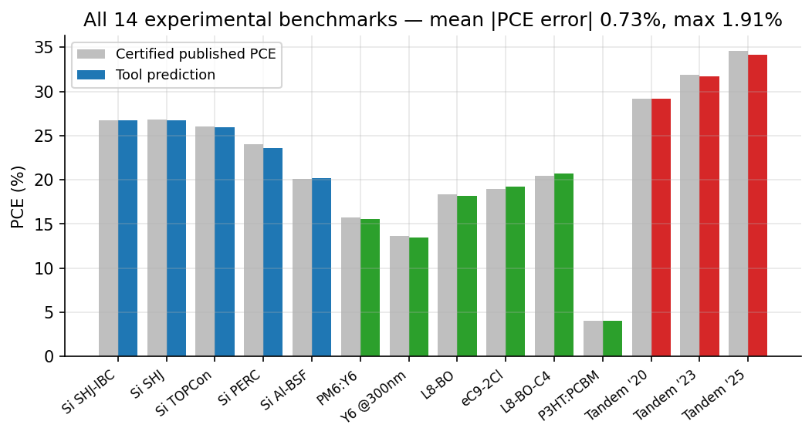
Figure 7. The complete experimental benchmark suite: tool prediction (colored) against the certified published value (gray) for all fourteen devices across silicon (blue), organic (green) and tandem (red).

10.2 Adding your own certified benchmark
Append a references entry (citation, DOI, confidence, what it is used for) and a benchmarks entry (preset or parameters, targets, tolerance) to data/multi_technology_database.json. The validation script, the technology page and the integrity test pick the new row up automatically — no code changes. This is also the contribution path for external groups: a pull request adding a certified device plus its DOI is the highest-value contribution the project accepts.

11. Five Research Workflows, Step by Step

11.1 Reproduce a published perovskite device
Import its SCAPS .def on Page 7 (or rebuild the stack on the main page from the database) → run the fast simulator for orientation, then the drift-diffusion solver → compare J-V/EQE against the paper's figures → export the CSV for your records. Deviations beyond a few percent usually trace to a parameter the paper left implicit; the import warnings list exactly what did not transfer.

11.2 Optimize a silicon architecture
Page 8: start from the preset nearest your process → explore single-parameter sensitivities by hand first (build intuition) → run DE over the wafer/passivation box → read the sensitivity ranking → verify the optimum survives the Niewelt recombination model and sits below 29.4% → export the device JSON.

11.3 Design a tandem to a current-matching target
Page 10: choose the wide-gap top composition and bottom architecture → run the current-matching scan to find the thickness where J_top meets J_bot → inspect the spectral-transmission plot for parasitic windows → tighten interconnect resistance and defect density toward your process reality → validate the operating point on the overlaid subcell J-V curves → cross-check the same stack in 4T mode to quantify the monolithic penalty.

11.4 Screen an organic blend and verify with wave optics
Page 9: pick the nearest preset → set your thickness and read the roll-off curve → switch to the TMM tab and confirm the interference structure and per-layer parasitics → require the TMM-versus-calibrated cross-path deviation to stay single-digit before trusting a thickness recommendation → export.

11.5 Train and verify a surrogate for your own family
Generate finite-difference solutions across your parameter box (Page 1 / scripts) → train the conditional PINN or an ml_models surrogate → hold out devices; demand ≲10% relative-L2 fields → apply the Section 6.6 analytic anchors → wire the surrogate into the optimizer → forward-re-simulate every reported optimum. Publish all three verification numbers with the result.

12. Troubleshooting and FAQ
Symptom / question | Resolution
Drift-diffusion did not converge | Increase mesh points near interfaces, then damping; extreme parameter corners (Nt > 10¹⁶ with heavy doping) may need staged bias ramping. The fast simulator is unaffected.
S-shaped J-V curve | Transport-layer misalignment: check the band diagram for interface spikes > ~0.2 eV; swap the transport layer or adjust its electron affinity within its cited range.
My PCE exceeds a record — is that real? | Run the Section 6 bounds: Jsc vs above-gap flux, Voc vs the radiative limit, FF vs Green's FF0. If it passes all three, it is thermodynamically legal but still needs material realism (lifetimes, energy losses) before you believe it.
Tool output differs from SCAPS on my imported .def | Read the import warnings: graded profiles, multi-defect spectra and interface-defect blocks do not transfer and must be re-entered in SCAPS terms on Page 1.
Benchmark page numbers look stale | They render artifacts; re-run the corresponding script and refresh.
Can I trust an optimizer result at a parameter boundary? | Treat it as a constraint report, not a design: either widen the box (if physical) or accept that the optimum is constrained.
Where do I find the DOI for parameter X? | Page 11 search, or the JSON databases directly — every parameter and benchmark row carries its source.

13. Known Limitations (Disclosed by Design)
One-dimensional physics only — no busbar geometry or three-dimensional textures (export to Quokka or FDTD for those). Organic transport is semi-empirical; exciton and charge-transfer-state drift-diffusion belongs to OghmaNano, reachable through the JSON export. The transfer-matrix solver assumes planar coherent stacks. Organic n,k tables carry ±5-10% batch spread. Tandem grade presets are calibrated within documented ranges, not derived ab initio — the same construction SCAPS baselines use in the literature. Each limitation, its basis and its workaround are catalogued in MAJOR_CONCERNS_v4.md; none affects the validity of the validated claims, because every claim states which layer of the verification ladder supports it.

14. Citing the Tool and Its Physics
Cite the software through CITATION.cff, and cite the original physics whose DOIs travel with every number (References page → CSV export). Suggested methods sentence: "Device simulations were performed with the AI-Driven Open-Source Solar Cell Design Tool v4.0 (validated against 14 certified record devices, mean PCE error 0.73%, and cross-checked against SCAPS-1D and transfer-matrix optics, 9/9 checks); model equations and parameter provenance follow the references therein."

14.1 Key model references (full 37-entry registry on Page 11)
Engine / topic | Reference | DOI
Si intrinsic recombination | Richter et al., Phys. Rev. B 86, 165202 (2012) | 10.1103/PhysRevB.86.165202
Si limit & updated model | Niewelt et al., Sol. Energy Mater. Sol. Cells 235, 111467 (2022) | 10.1016/j.solmat.2021.111467
Si optics | Green, Sol. Energy Mater. Sol. Cells 92, 1305 (2008) | 10.1016/j.solmat.2008.06.009
SHJ-IBC 26.7% benchmark | Yoshikawa et al., Sol. Energy Mater. Sol. Cells 173, 37 (2017) | 10.1016/j.solmat.2017.06.024
SHJ 26.81% benchmark | Lin et al., Nat. Energy 8, 789 (2023) | 10.1038/s41560-023-01255-2
OPV Y6 15.7% benchmark | Yuan et al., Joule 3, 1140 (2019) | 10.1016/j.joule.2019.01.004
OPV 20.4% benchmark | Li et al., Nat. Mater. 24 (2025) | 10.1038/s41563-024-02087-5
TMM formalism | Pettersson, Roman & Inganäs, J. Appl. Phys. 86, 487 (1999) | 10.1063/1.370757
TMM implementation style | Burkhard, Hoke & McGehee, Adv. Mater. 22, 3293 (2010) | 10.1002/adma.201000883
Tandem 29.15% benchmark | Al-Ashouri et al., Science 370, 1300 (2020) | 10.1126/science.abd4016
Tandem 34.58% benchmark | Jia et al., Nature 644, 912 (2025) | 10.1038/s41586-025-09333-z
SCAPS-1D | Burgelman, Nollet & Degrave, Thin Solid Films 361-362, 527 (2000) | 10.1016/S0040-6090(99)00825-1
Fill-factor expression | Green, Solid-State Electron. 24, 788 (1981) | 10.1016/0038-1101(81)90062-9
Detailed balance | Shockley & Queisser, J. Appl. Phys. 32, 510 (1961) | 10.1063/1.1736034

End of manual. The living versions of every table in this document are the JSON artifacts in artifacts/ — regenerate them with the three commands of Section 10.1 whenever you need current numbers.

