Task A
一、Data preparation and model implementation
  - Dataset description and import
The experiments are based on the public Heart Disease UCI dataset from Kaggle, which contains structured clinical and demographic information for each patient. The original CSV file heart_disease_uci.csv is loaded directly from Kaggle into a pandas DataFrame using the kagglehub interface:
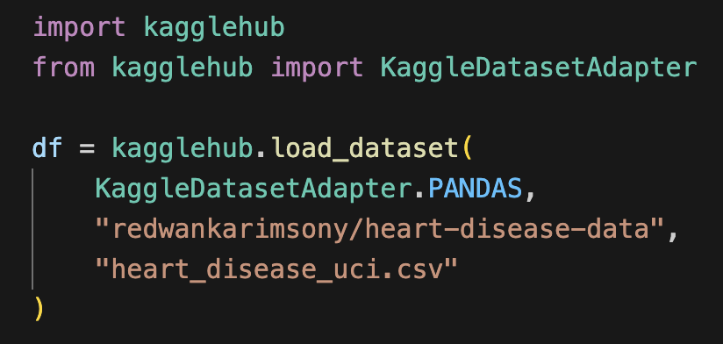
  - Pre-processing pipeline
The original label column num is first converted into a binary target: samples with num > 0 are encoded as 1 (heart disease present), and num == 0 as 0 (no heart disease). A new column target is created to store this label. To avoid redundancy and potential information leakage, the technical identifier id and the original num column are removed, and only useful predictors and the binary target are retained.
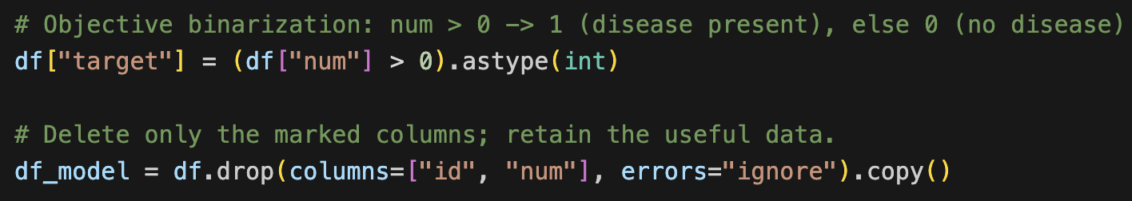
According to the dataset description, several variables are inherently categorical, such as chest pain type (cp) and resting ECG result (restecg). These features are explicitly cast to the category type, while all remaining integer or float columns are treated as numerical features. The select_dtypes function is then used to automatically collect numerical columns, and all other non-target columns are assigned to the categorical feature group, preparing for the subsequent ColumnTransformer.
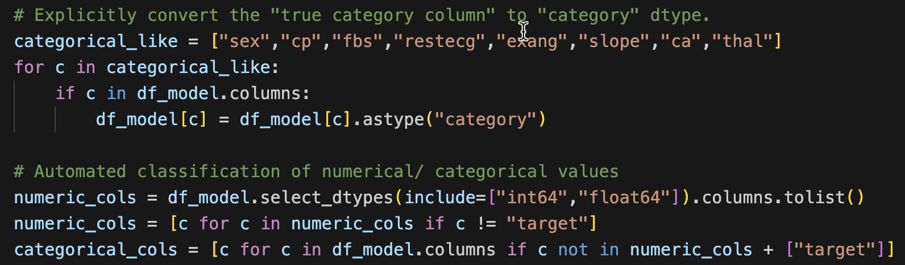
The preprocessing adopts a unified pipeline based on ColumnTransformer: for numerical features, missing values are filled with the median and a missing indicator column is added; for categorical features, missing values are filled with the mode and One-Hot encoding is performed; during encoding, "ignore" is set to avoid errors when new categories appear in the test set.
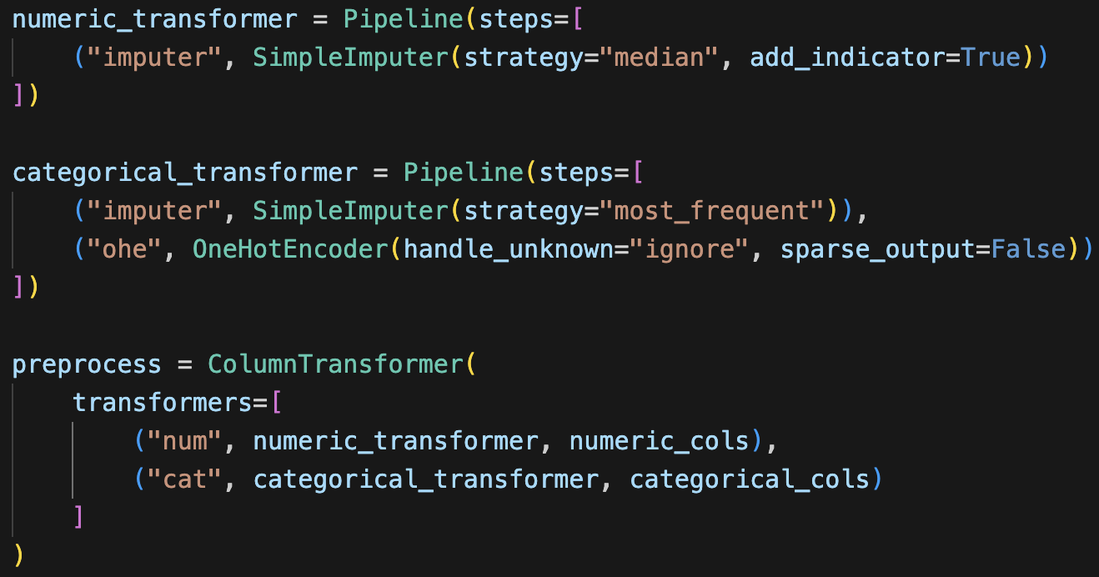
  - Data split
The data is divided into the training set and the test set in a ratio of 0.8 : 0.2. In the train_test_split function, stratify=y is used to ensure that the proportion of positive and negative samples in both parts is consistent with the overall data. Subsequently, the training set is further divided into a training subset and a validation set in a 8 : 2 ratio within the training set, which is used to monitor the convergence during the model training process and combined with early stopping to select the appropriate number of iterations.
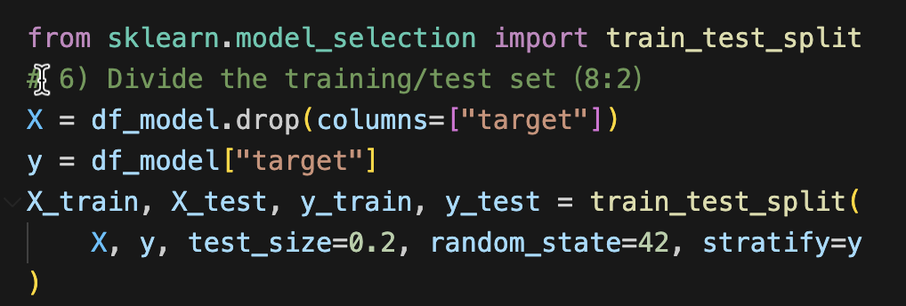
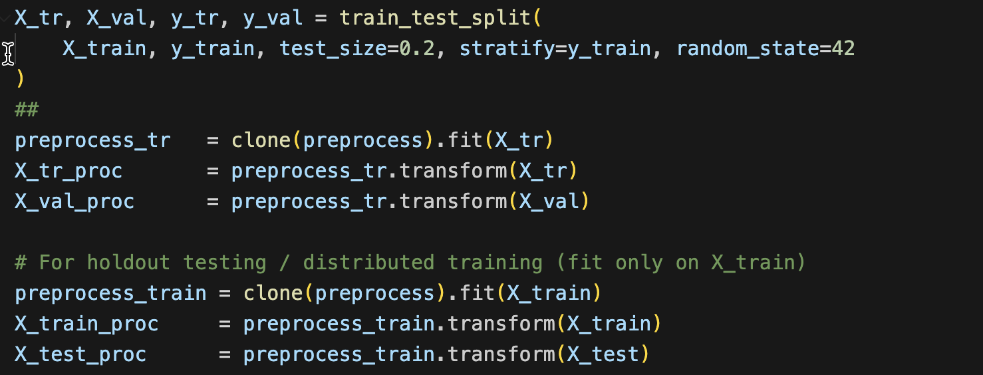

- Model implementation and selection
XGBoost is implemented using the XGBClassifier with key hyperparameters such as n_estimators, max_depth and learning_rate. In addition, subsample, colsample_bytree and the L2 regularisation term reg_lambda are used to control model complexity and reduce overfitting. Because the data exhibit a certain degree of class imbalance, I set scale_pos_weight based on the ratio of negative to positive samples in the training subset, and applied early stopping on the training and validation sets to automatically select an appropriate number of boosting rounds.
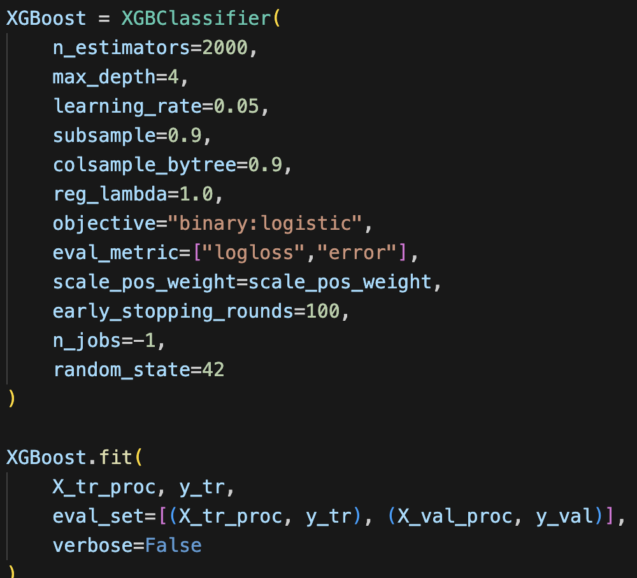
The standalone version of LightGBM uses LGBMClassifier, with configurations similar to those of XGBoost, including num_leaves, feature_fraction, bagging_fraction, etc., and handles class imbalance through class_weight="balanced". Both XGBoost and standalone LightGBM are combined with the preprocessing module through a Pipeline, and the model performance is evaluated on the training set using a 10-fold stratified cross-validation system.
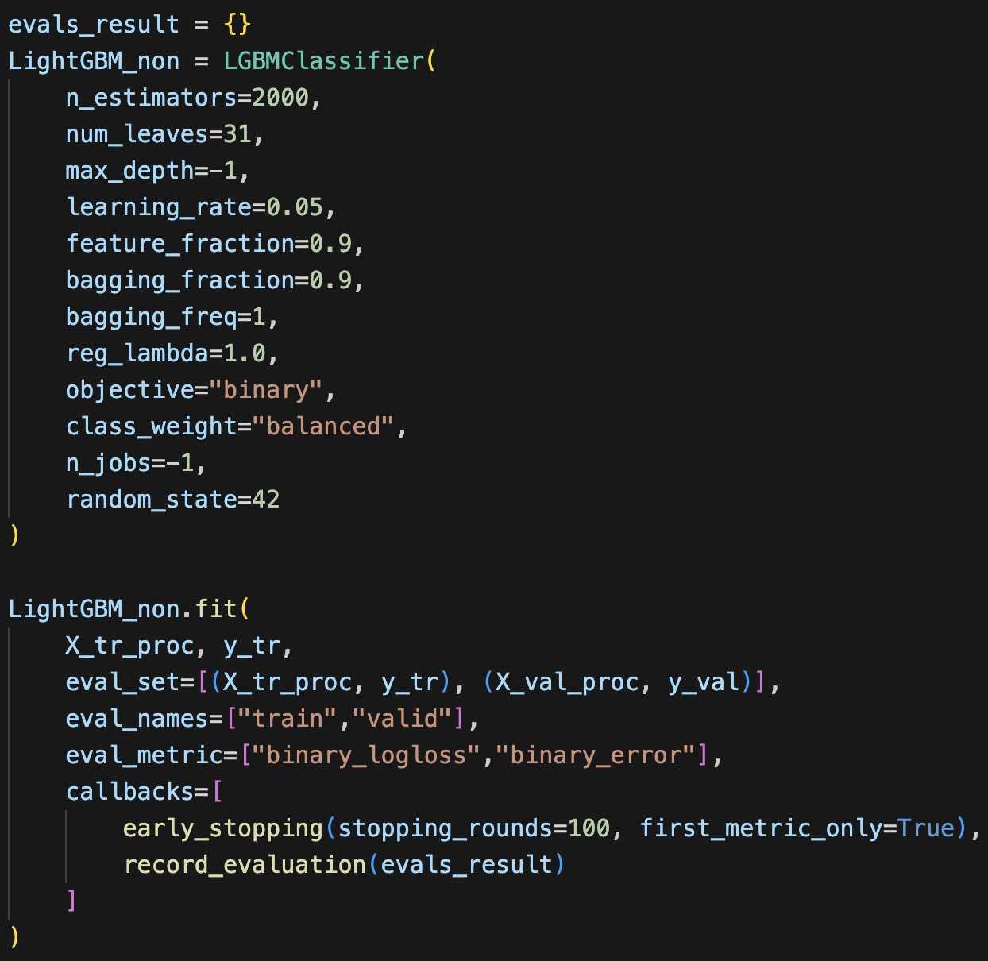
The distributed LightGBM is implemented using DaskLGBMClassifier. In terms of the model structure and hyperparameter settings, it is basically the same as the single-machine version of LightGBM. However, the training and inference processes are deployed on a local Dask cluster, enabling the parallel construction of tree models in a distributed manner. This approach is used to evaluate the training efficiency and inference speed performance of LightGBM in a distributed environment.
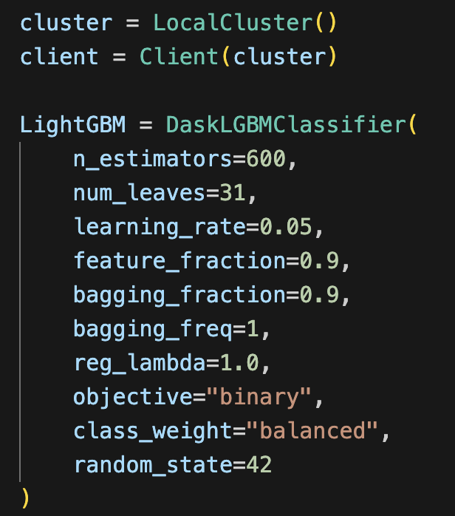
- Evaluation and Analysis
From the perspective of the training process, both XGBoost and the standalone LightGBM's train logloss decreased rapidly within the first few dozen iterations. The valid logloss reached a plateau after approximately 40-60 iterations and then slightly increased. Correspondingly, the train accuracy continued to rise, while the valid accuracy remained stable at around 0.78-0.80, indicating that both models experienced slight overfitting in the middle and later stages. In contrast, LightGBM achieved similar validation performance to XGBoost with fewer iterations, and its convergence speed was faster.
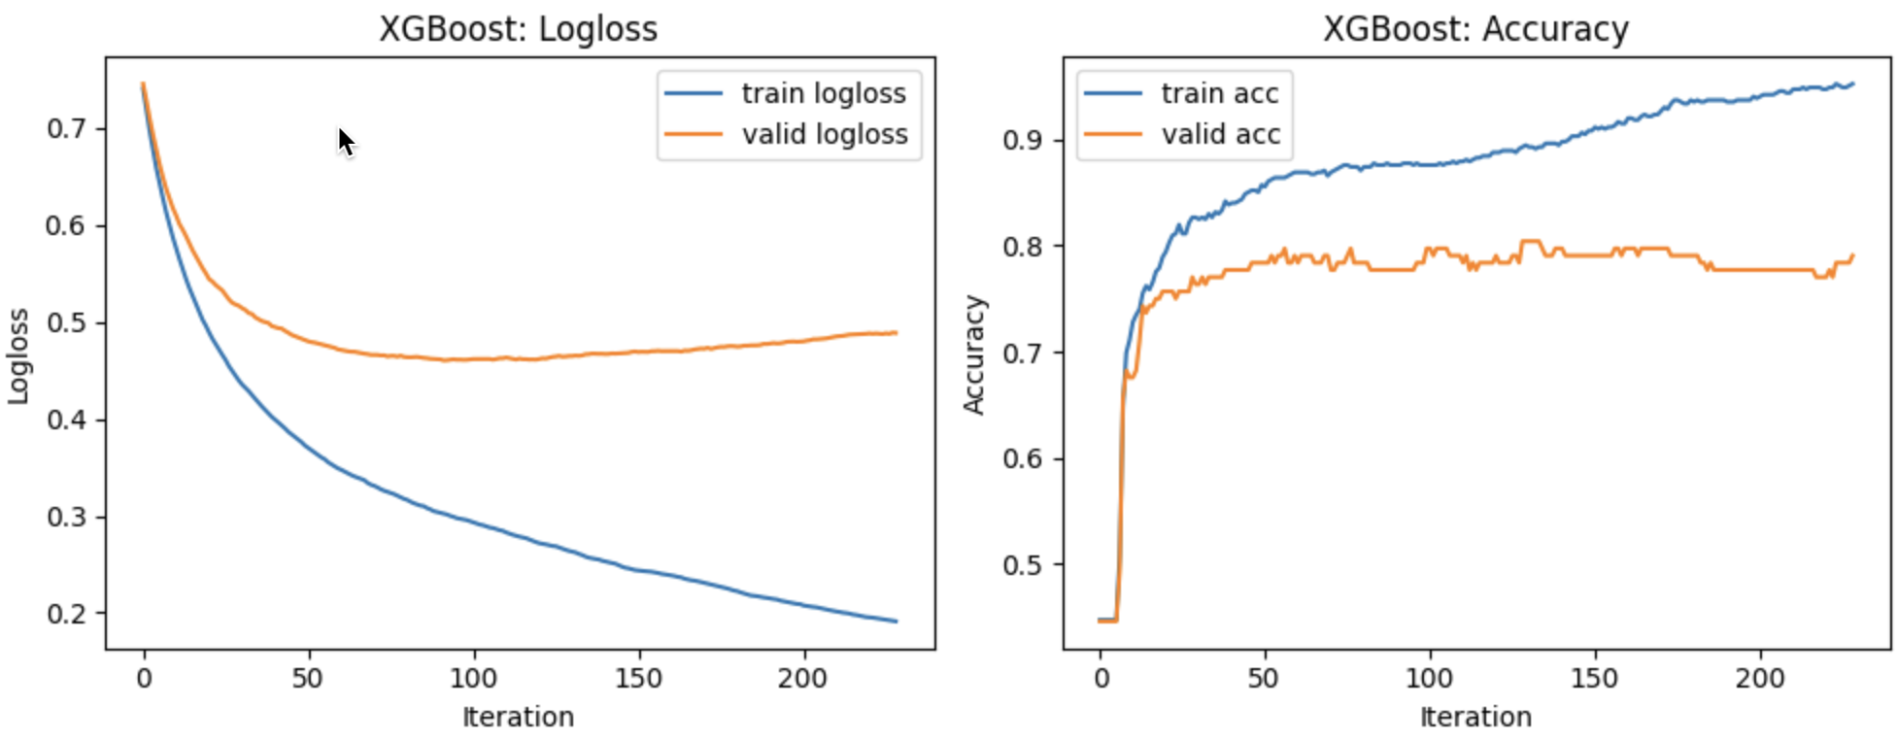
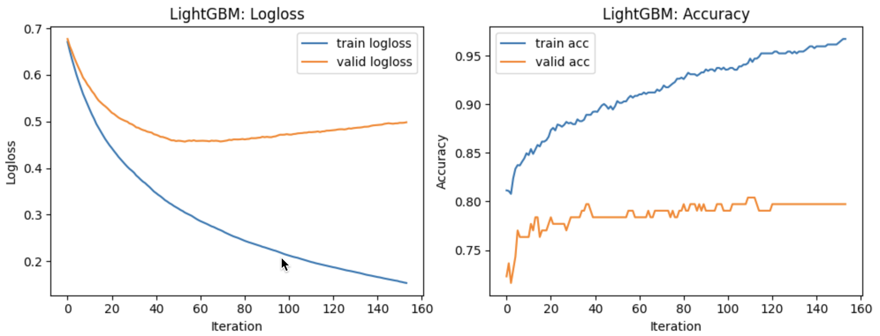
From the table, it can be seen that the classification performance of the three models is generally quite similar. The Accuracy and F1 score of XGBoost are both approximately 0.788, and the Precision is also around 0.81. The single-machine version of LightGBM has a slight improvement in Recall and F1, and the Precision is also slightly higher (about 0.81 - 0.82). The distributed LightGBM performs the best, with an Accuracy increase to 0.842, a Precision of 0.841, a Recall of 0.882, an F1 of 0.861, and an AUROC of 0.893. It is also more robust in identifying positive samples. In terms of time, XGBoost takes the shortest training time, the single-machine LightGBM is the slowest, while the distributed LightGBM takes about 3.33 seconds for training and approximately 0.13 seconds for prediction. It achieves a better balance between accuracy and efficiency.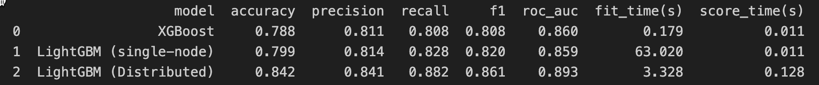

Task B——SHAP
一、Problem, environment and dataset
Task B aims to build an interpretable heart-disease risk predictor and analyse its decisions with SHAP. The experiments reuse the processed Heart Disease UCI dataset from Task A. After binarising the original label num into target (1 = disease, 0 = no disease) and dropping id and num, the final table df_model contains 920 records and 15 columns.
Its characteristics include data such as resting blood pressure and serum cholesterol. The CSV file is loaded into a pandas DataFrame in Python using NumPy, pandas, scikit-learn, LightGBM and the shap package, and then split into training and test sets as in Task A.
二、Exploratory data analysis
Basic summaries show a mildly imbalanced target (about 55% positive and 45% negative). Missing-value analysis indicates that most numerical variables are almost complete, whereas ca, thal and slope have more than 30% missing values and require careful imputation.
Histograms of numerical features show that age mainly lies between 45–65 years; blood pressure and cholesterol are roughly unimodal but skewed; oldpeak is strongly right-skewed with many zeros. Bar plots for categorical variables reveal that most patients are male, asymptomatic chest pain is the most common type, and records are mainly from the Cleveland and Hungarian centres.
A Pearson-correlation heatmap over numerical features plus target shows that higher oldpeak and age are positively associated with disease, while higher maximum heart rate is negatively correlated. These clinically plausible patterns later reappear in the SHAP explanations. 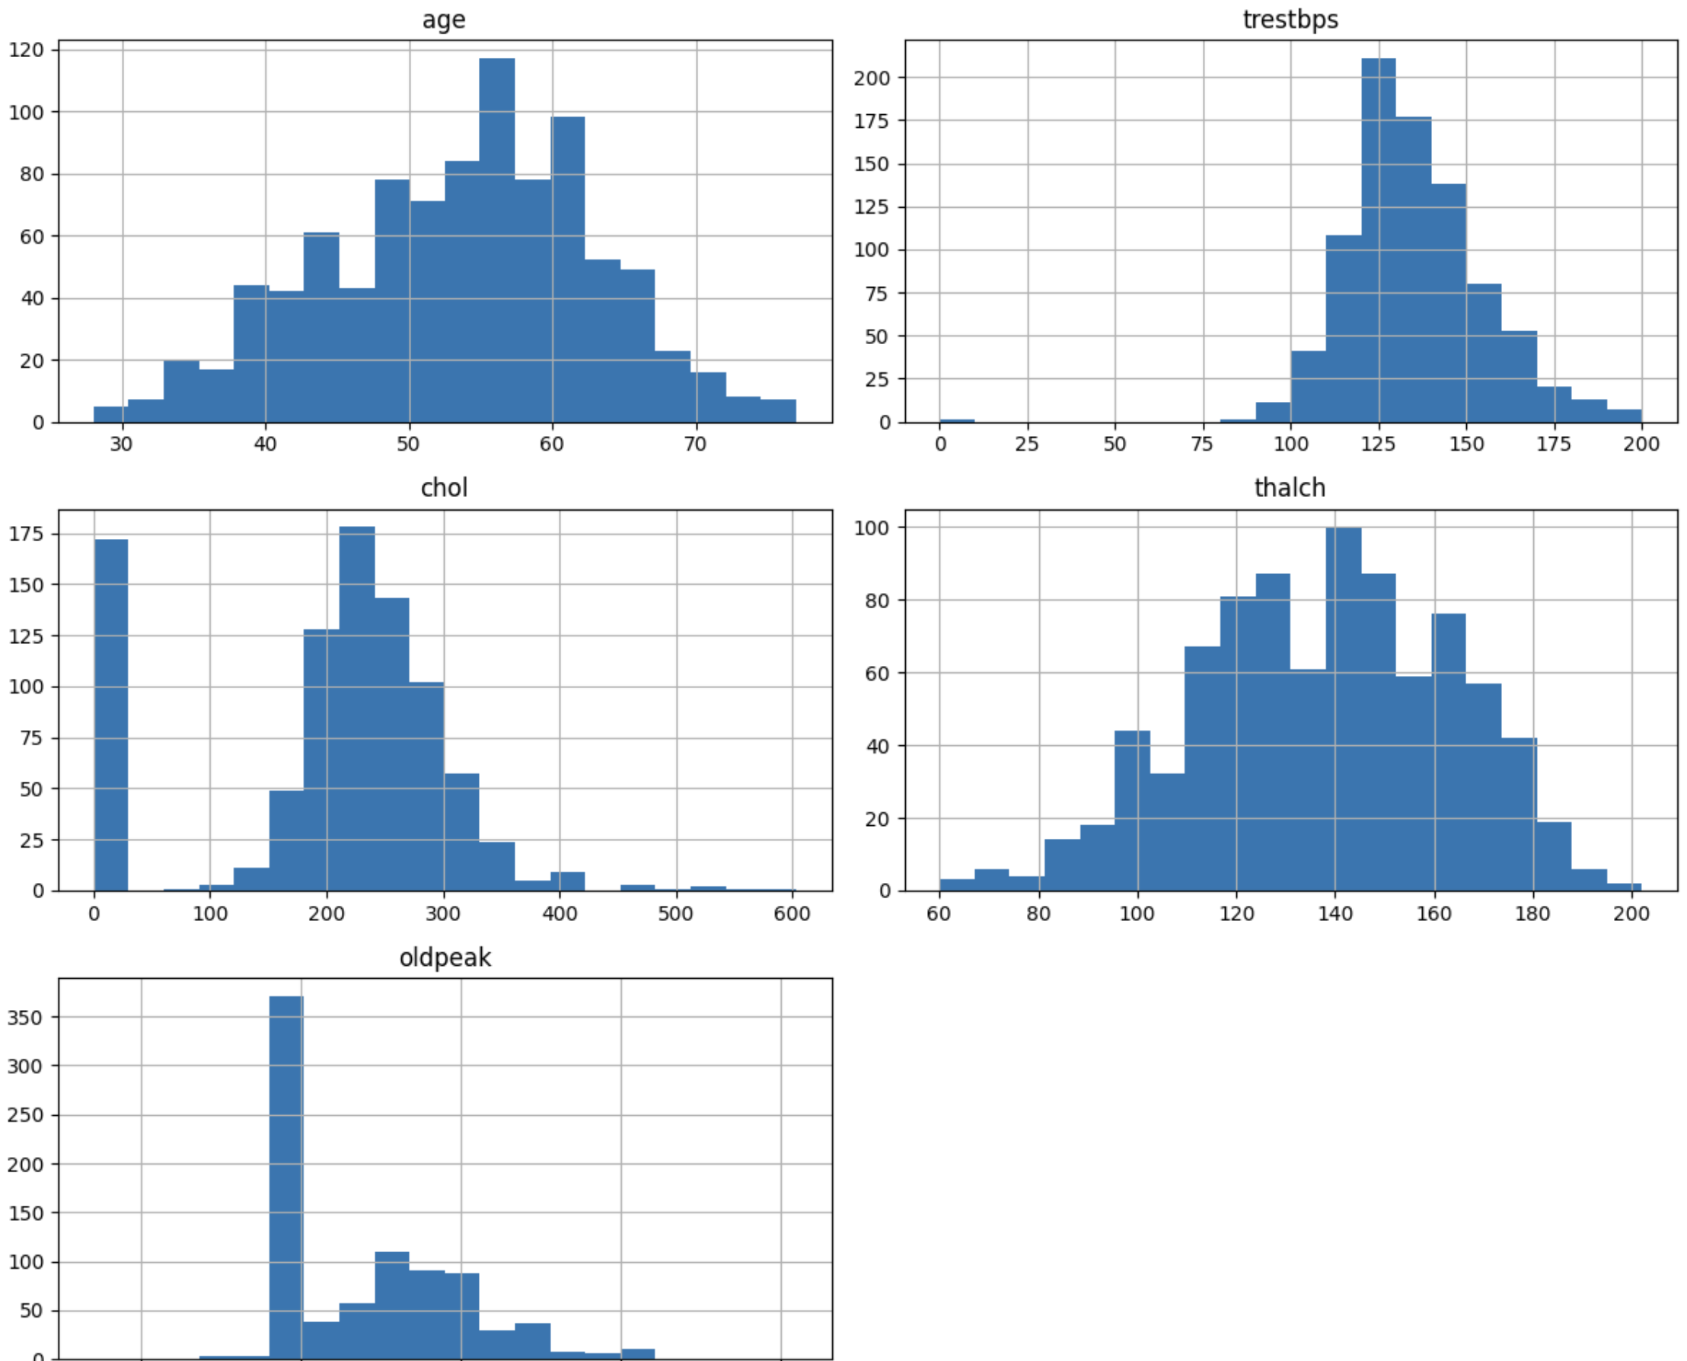
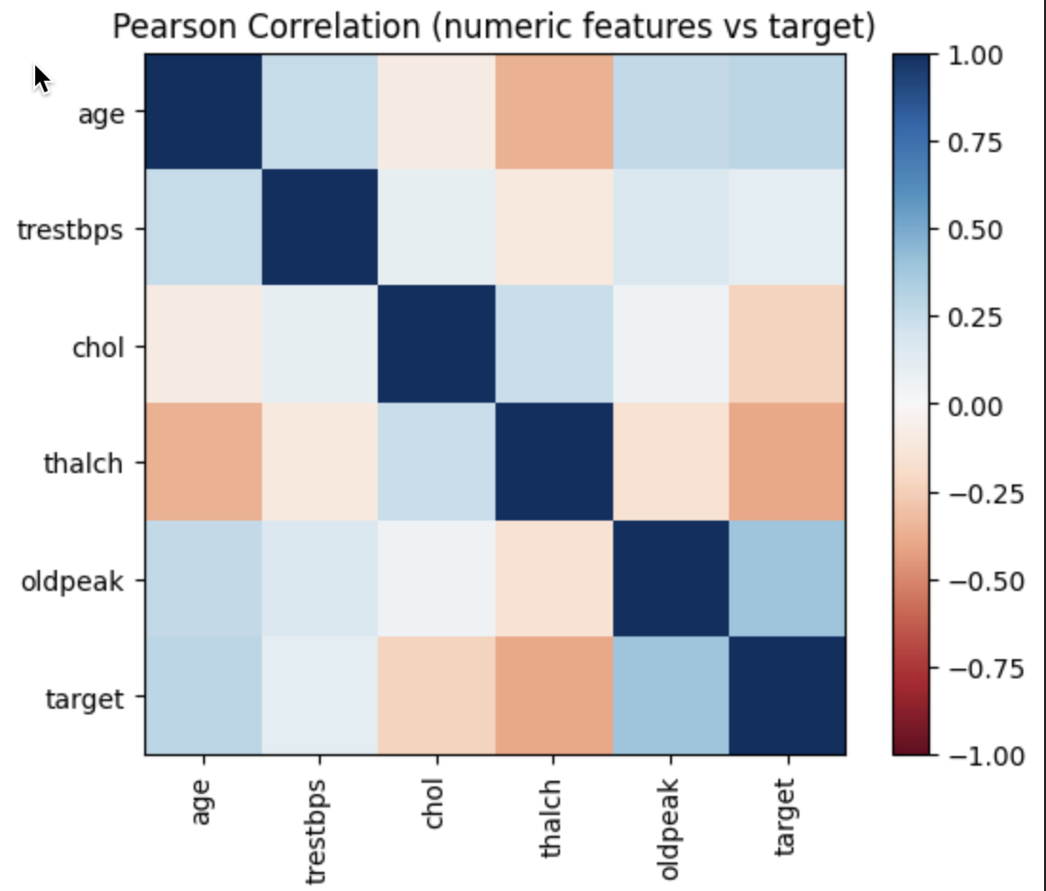
三、Explanation approaches and model choice
Several explanation methods could be used. Global feature- or permutation-importance gives an overall ranking but little local detail, while LIME builds local surrogate models for individual samples, yet its explanations can be unstable and not globally consistent.
SHAP instead treats prediction as a cooperative game and assigns each feature a Shapley value. It is additive and consistent, provides both global and instance-level explanations, and has efficient implementations for tree-based and linear models. These properties make SHAP particularly suitable for medical decision support, where transparency and patient-level reasoning are required.
I therefore use LightGBM as the main non-linear tree-based model and Logistic Regression as a non-tree baseline: LightGBM captures complex interactions in tabular data, whereas Logistic Regression is simple, fast and widely accepted in clinical risk scoring.
四、Pre-processing
Task B reuses the pre-processing pipeline from Task A. Numerical features are imputed with the median and augmented with a missing-indicator column; categorical features are imputed with the most frequent category and then one-hot encoded with handle_unknown="ignore" to avoid errors when unseen categories appear in the test set.
The transformer preprocess_tr is fitted on the training data only and applied to both training and test sets to obtain X_train_proc_lgb and X_test_proc_lgb, ensuring no information leakage.
五、Model implementation and evaluation
The LightGBM_non classifier is implemented using LGBMClassifier with standard boosting hyperparameters. Early stopping on a validation split is used to monitor convergence, and the training/validation logloss and accuracy curves show rapid initial improvement, with validation loss flattening after about 50–70 iterations and then slightly increasing, indicating mild overfitting.
The non-tree model is a LogisticRegression with the liblinear solver, max_iter=2000 and class_weight="balanced". On the test set, LightGBM_non achieves Accuracy 0.848, Precision 0.856, Recall 0.873, F1 0.864 and AUROC 0.889. Logistic Regression attains very similar metrics but a higher AUROC, while training and prediction are almost instantaneous, suggesting that the linear model already captures most of the predictive signal in this dataset.
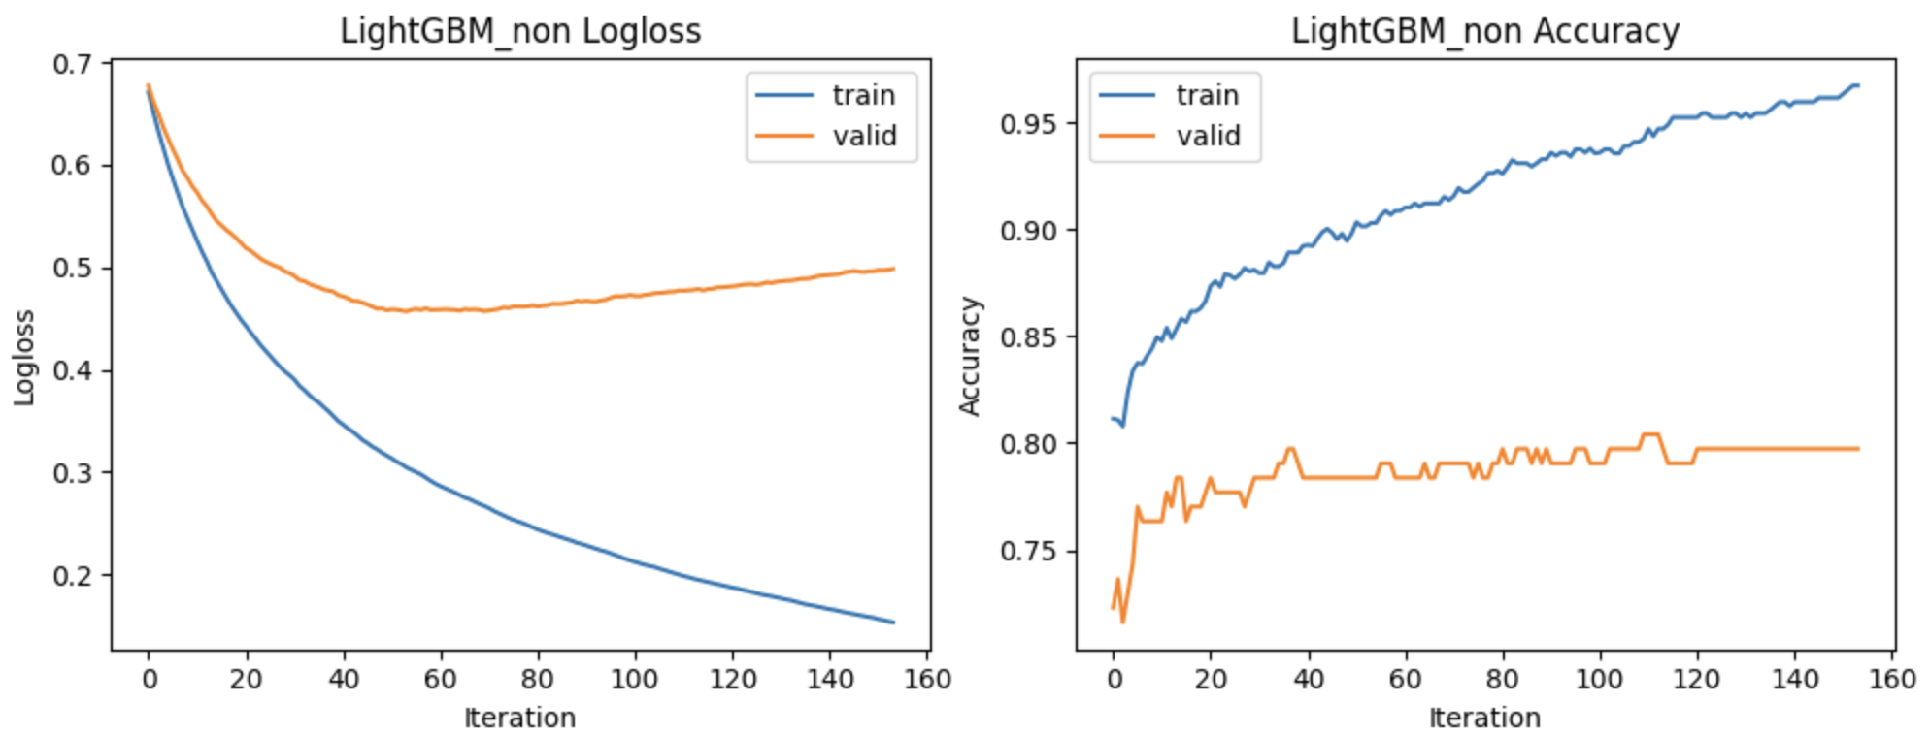
六、SHAP deployment with the prediction models
For LightGBM_non, SHAP values are computed using shap.TreeExplainer. A random subset of 200 test samples is taken for visualisation. SHAP values on this subset are summarised using beeswarm and bar plots to obtain global feature importance, and dependence plots are generated for the top three features to inspect non-linear effects and interactions.
For Logistic Regression, shap.LinearExplainer is used with the processed training data as the background distribution. SHAP values are again computed on the same 200-sample subset and visualised with summary and bar plots, giving a comparable explanation pipeline for both models.
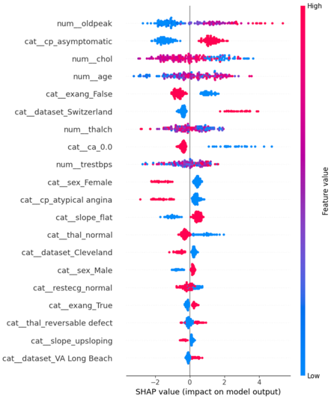
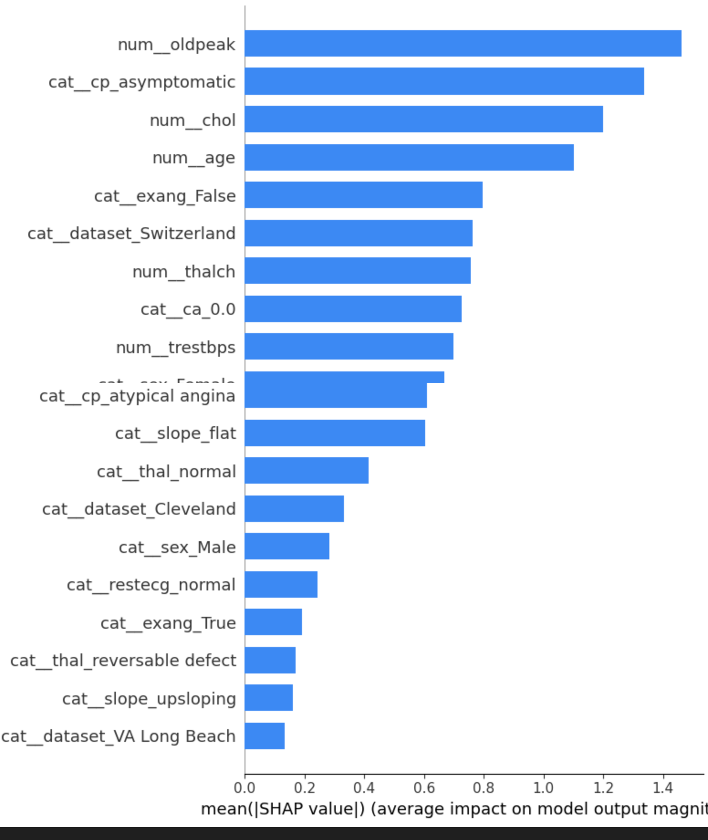
七、Important features and comparison of explanations
LightGBM’s SHAP summaries show that a small set of predictors drives predictions: ST depression (oldpeak), asymptomatic chest pain, serum cholesterol, age, absence of exercise-induced angina, maximum heart rate, resting blood pressure, sex and some dataset indicators. Dependence plots reveal that larger oldpeak, higher cholesterol and older age strongly increase predicted risk, whereas higher maximum heart rate reduces it—patterns consistent with known cardiovascular risk factors.
Logistic Regression’s SHAP analysis yields a very similar ranking, which increases confidence in the explanations. However, its SHAP values change almost linearly with feature values, while LightGBM exhibits threshold-like effects and interactions. Overall, both models agree on the key drivers of heart-disease risk, but LightGBM plus SHAP provides richer non-linear insights, which is more informative for personalised clinical decision support.
