WEEK 3 TASK

Advanced Data Analysis and Visualization
in Logistics
Logistics Delivery Performance Analysis

Dataset: 25,000 logistics delivery records | 18 analytical columns
Tools: Python, Pandas, Matplotlib, Seaborn

1. Executive Summary
This Week 3 analysis builds on the cleaned logistics dataset prepared in Week 2. The objective was to move beyond data preparation and use exploratory data analysis, grouped comparisons, correlation analysis, and visualizations to identify operational risks and business opportunities. The dataset contains 25,000 records and 18 columns, with no missing values after preprocessing.
The analysis shows that delivery distance and delivery mode are the most important operational signals in the available data. Overall delay rate is 26.68%. Express deliveries have a 73.78% delay rate, while standard deliveries show 0% delay in this dataset. Delay rates also rise steadily with distance, from 17.02% for 0–50 km to 38.82% for 250–300 km. Weather compounds the risk: stormy conditions have a 41.45% overall delay rate, and the Express + Stormy combination reaches 99.81%.
Customer satisfaction is strongly associated with delivery reliability. On-time deliveries have an average rating of 4.21/5, compared with 2.18/5 for delayed deliveries. Delivery cost is almost perfectly correlated with distance (0.99), while package weight has only a weak correlation with cost (0.10). These results support targeted recommendations around express-service controls, weather contingency planning, long-distance routing, and realistic delivery commitments.

2. Dataset and Analytical Scope
Item | Result
Rows | 25,000
Columns | 18
Missing values | 0
Numerical variables | 7
Categorical variables | 8
Key outcome fields | delayed, delivery_status, delivery_rating
Key operational fields | delivery_mode, delivery_partner, distance_km, weather_condition
The analysis uses the cleaned dataset produced during Week 2. Numerical fields include distance, package weight, delivery time, expected time, rating, and cost, along with normalized versions of selected numeric variables. Categorical fields include delivery partner, package type, vehicle type, delivery mode, region, weather condition, delayed, and delivery status.

3. Methodology
The workflow followed a practical analytics sequence: validate the dataset, summarize central tendencies and distributions, calculate logistics KPIs, compare delay rates across operational categories, examine customer ratings, create visualizations, and use correlation analysis to identify strong and weak relationships.
# Basic dataset validation
print("Rows:", df.shape[0])
print("Columns:", df.shape[1])
print("Missing values:", df.isnull().sum().sum())
# Descriptive statistics
print(df.describe())

4. Key Logistics KPIs
KPI | Value | Interpretation
Overall delay rate | 26.68% | About one in four deliveries is marked delayed.
Average delivery time | 6.25 hours | Observed average actual delivery time.
Average expected time | 13.11 hours | Average planned/expected delivery time.
Average delivery cost | 864.94 | Average cost per delivery in the dataset.
Average delivery rating | 3.67 / 5 | Moderate overall customer rating.
delay_rate = (df["delayed"] == "yes").mean() * 100
print("Overall Delay Rate:", round(delay_rate, 2), "%")
print("Average Delivery Time:", round(df["delivery_time_hours"].mean(), 2))
print("Average Expected Time:", round(df["expected_time_hours"].mean(), 2))
print("Average Delivery Cost:", round(df["delivery_cost"].mean(), 2))
print("Average Delivery Rating:", round(df["delivery_rating"].mean(), 2))

5. Delivery Status Distribution
The dataset contains 18,331 delivered shipments, 5,341 delayed shipments, and 1,328 failed shipments. This means delayed and failed outcomes together represent a meaningful operational burden and justify deeper segmentation rather than relying only on the overall KPI.
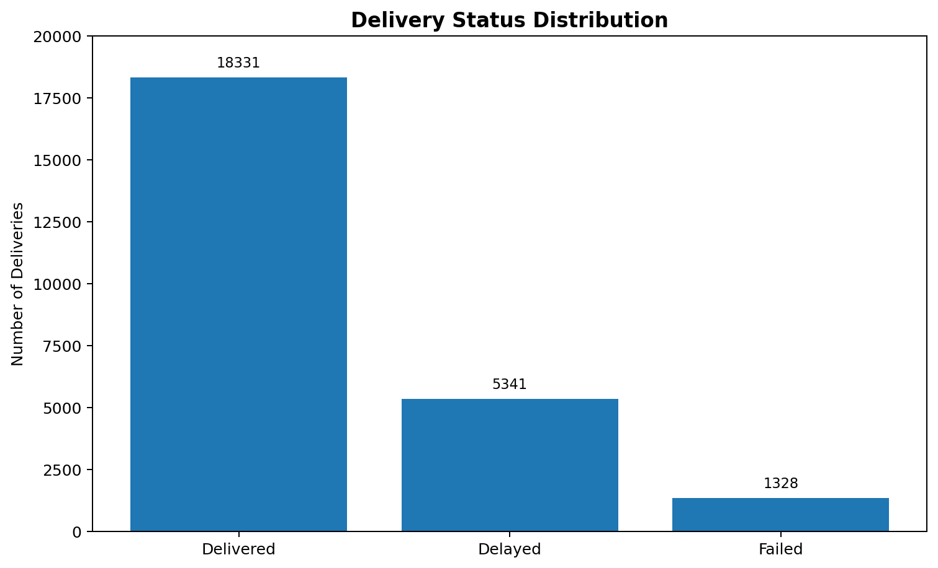
Figure 1. Distribution of delivery outcomes.

6. Delay Rate by Delivery Mode
Delivery mode is one of the strongest differentiators in the analysis. Express deliveries have a 73.78% delay rate, more than twice the 32.54% rate for same-day delivery. Two-day delivery is 0.43%, while standard delivery is 0% in this dataset. The gap suggests that the fastest service promises are associated with substantially higher execution risk.
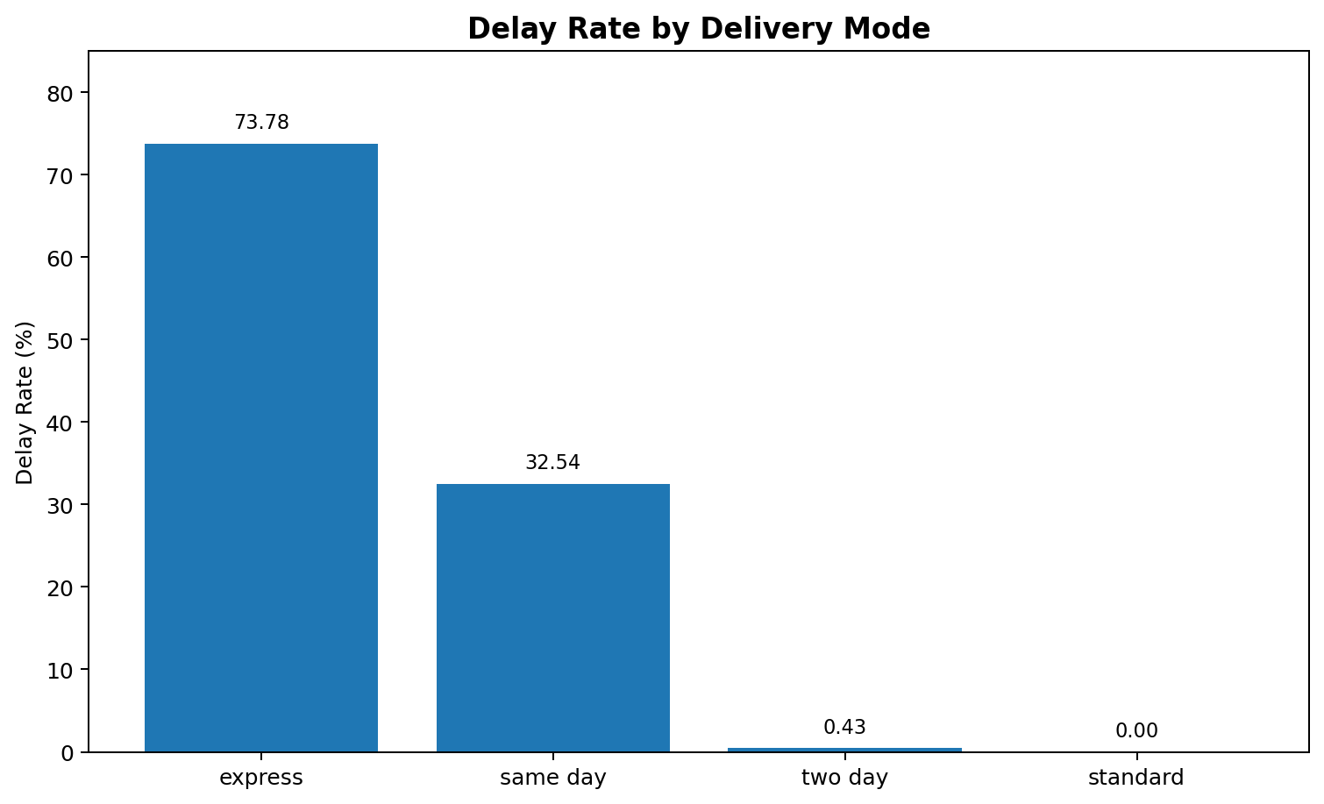
Figure 2. Delay rate by delivery mode.
delay_by_mode = (
df.groupby("delivery_mode")["delayed"]
.apply(lambda x: (x == "yes").mean() * 100)
.sort_values(ascending=False)
)
print(delay_by_mode)
Business implication: management should review the capacity, route planning, cutoff times, and promised service levels behind Express and Same-day products. The goal should not simply be to eliminate fast services, but to ensure that the promise is feasible under real operating conditions.

7. Delivery Partner Performance
Partner delay rates are much closer to one another than the differences observed across delivery modes. Xpressbees has the highest delay rate at 28.27%, while Delhivery has the lowest at 24.80%. The approximately 3.47 percentage-point gap indicates that partner performance matters, but it is not as dramatic as the delivery-mode effect.
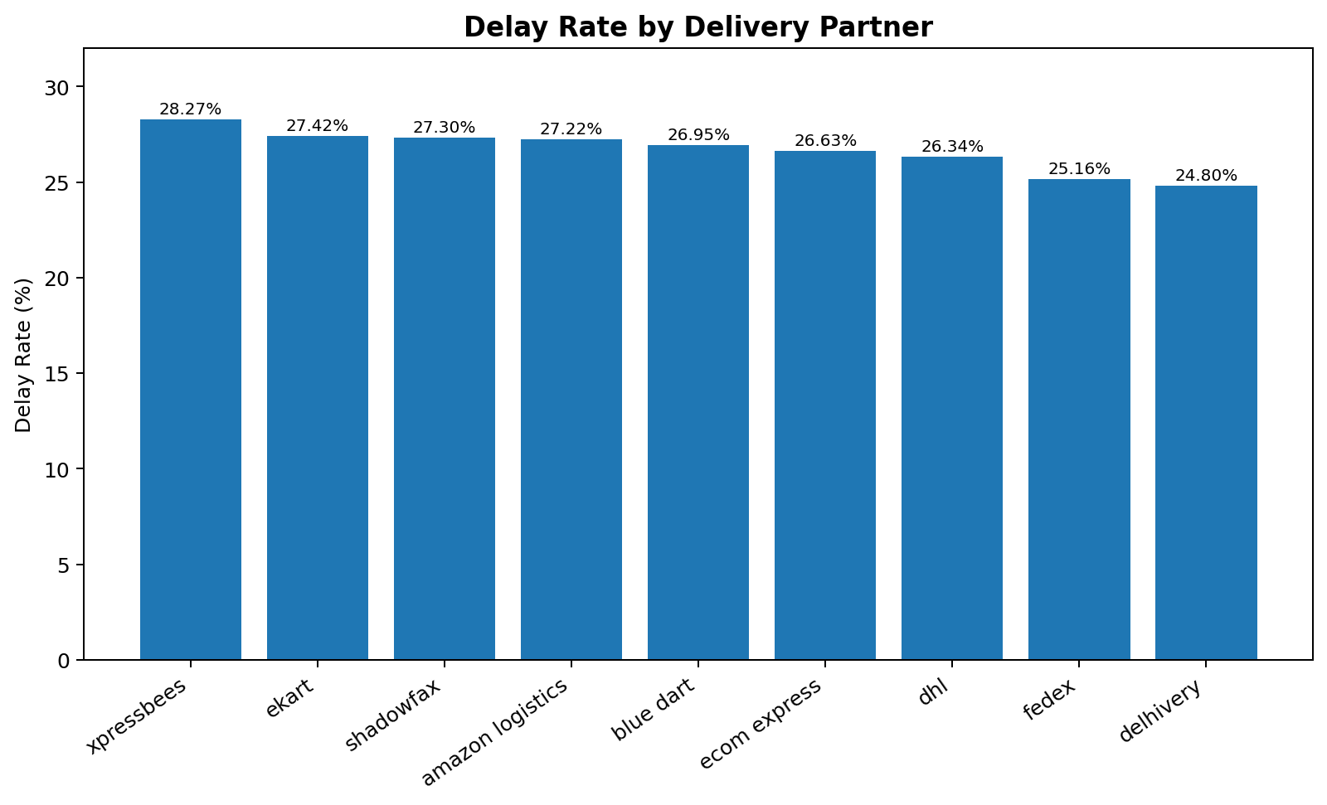
Figure 3. Delay rate by delivery partner, ordered from highest to lowest.

8. Impact of Weather Conditions
Weather is strongly associated with delays. Stormy conditions have the highest overall delay rate at 41.45%, followed by rainy at 37.35% and foggy at 30.32%. Clear, hot, and cold conditions are substantially lower, between about 16% and 17.4%.
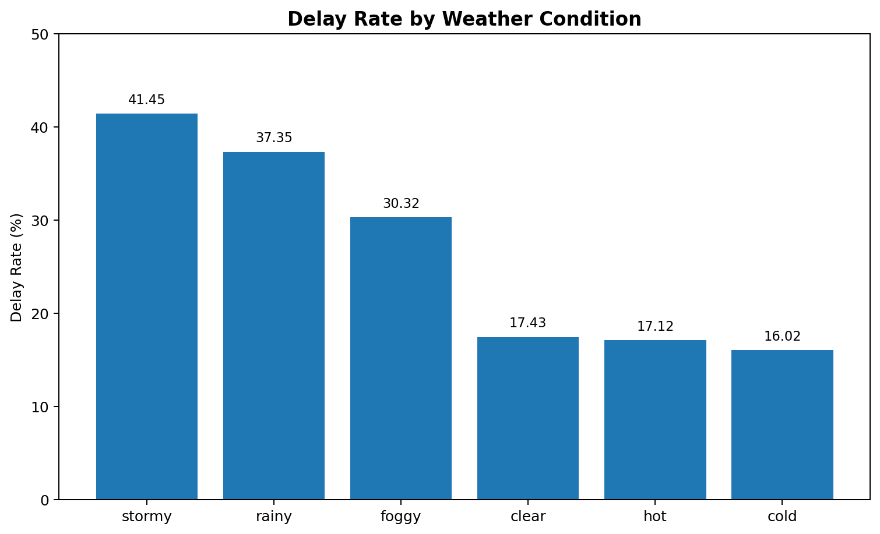
Figure 4. Delay rate by weather condition.
Business implication: weather should be incorporated into operational planning. High-risk weather conditions can trigger route reassignment, additional delivery capacity, proactive customer communication, and revised delivery-time commitments.

9. Distance and Delivery Delays
Delay rate rises consistently as shipment distance increases. It starts at 17.02% for 0–50 km and reaches 38.82% for 250–300 km. This monotonic pattern is operationally important because it suggests that long-distance shipments need additional planning and realistic time buffers.
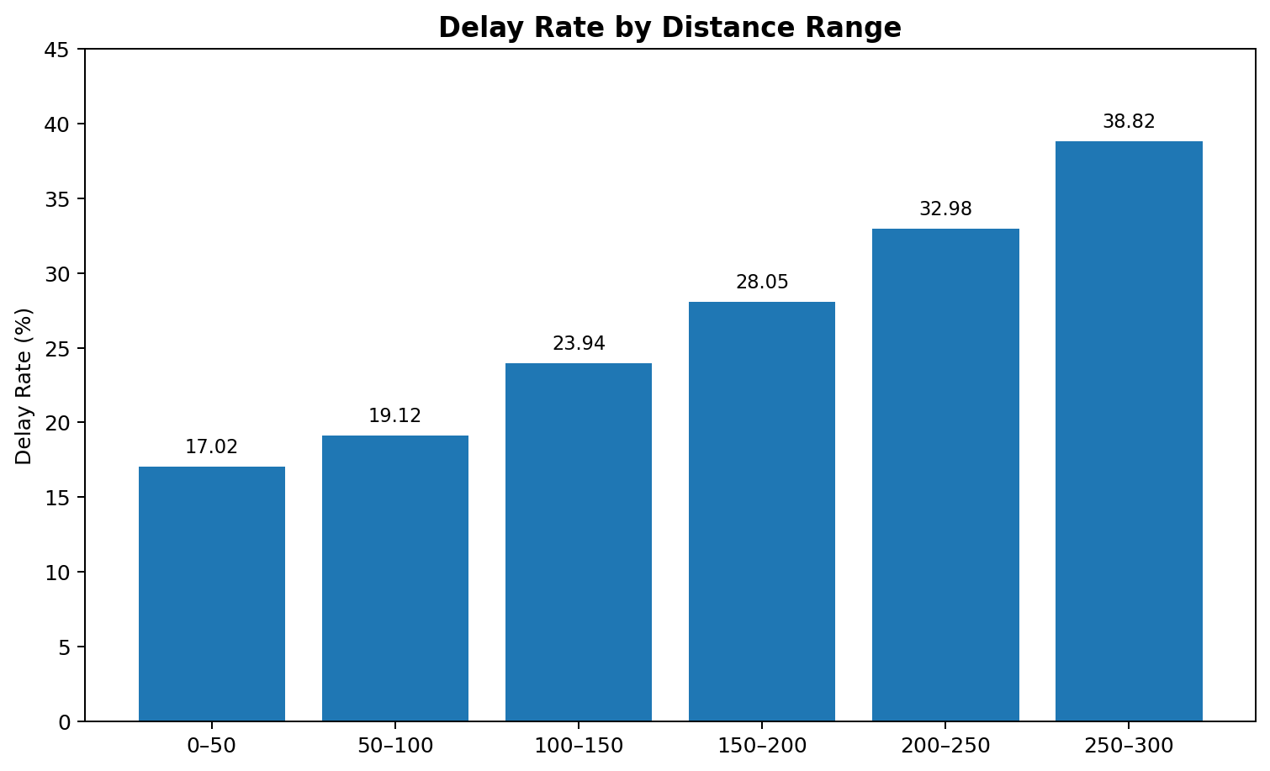
Figure 5. Delay rate increases across distance bands.

10. Delivery Cost vs Distance
The notebook scatter plot shows a clear upward relationship between distance and delivery cost. The correlation matrix quantifies this relationship at 0.99, which is extremely strong. Delivery distance is therefore the dominant cost driver among the variables tested.
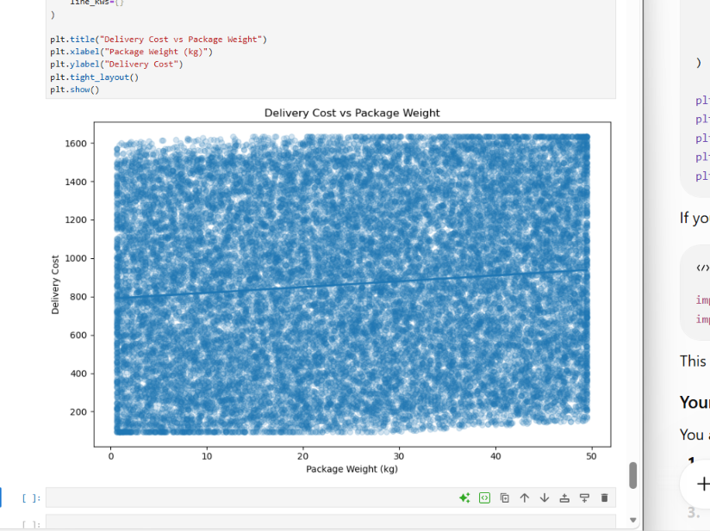
Figure 6. Notebook output: delivery cost vs distance.

11. Correlation Analysis
Correlation analysis was used to quantify linear relationships among key numeric variables. Distance and delivery cost have a correlation of 0.99; distance and actual delivery time are 0.69; and delivery time and delivery cost are 0.68. Package weight has only a 0.10 correlation with cost. Delivery rating is negatively related to actual delivery time (-0.27), indicating that longer actual delivery times are associated with lower ratings.
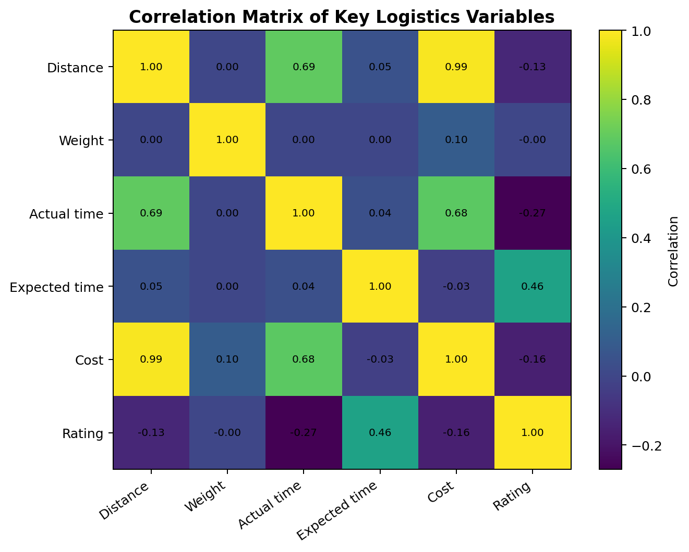
Figure 7. Correlation matrix of key logistics variables.
correlation = df[
["distance_km", "package_weight_kg", "delivery_time_hours",
"expected_time_hours", "delivery_cost", "delivery_rating"]
].corr()
print(correlation.round(2))

12. Delivery Cost vs Package Weight
The package-weight scatter plot has a slight upward trend, but the correlation with delivery cost is only 0.10. This is a weak positive relationship. Therefore, package weight alone should not be treated as the primary explanation for delivery cost in this dataset; distance is far more influential.
Figure 8. Notebook output: delivery cost vs package weight with trend line.

13. Customer Satisfaction by Delivery Mode
Average delivery ratings vary considerably by service mode. Standard has the highest average rating at 4.22/5 and Express the lowest at 2.72/5. This aligns with the earlier finding that Express has the highest delay rate, making service reliability a likely operational concern for customer experience.
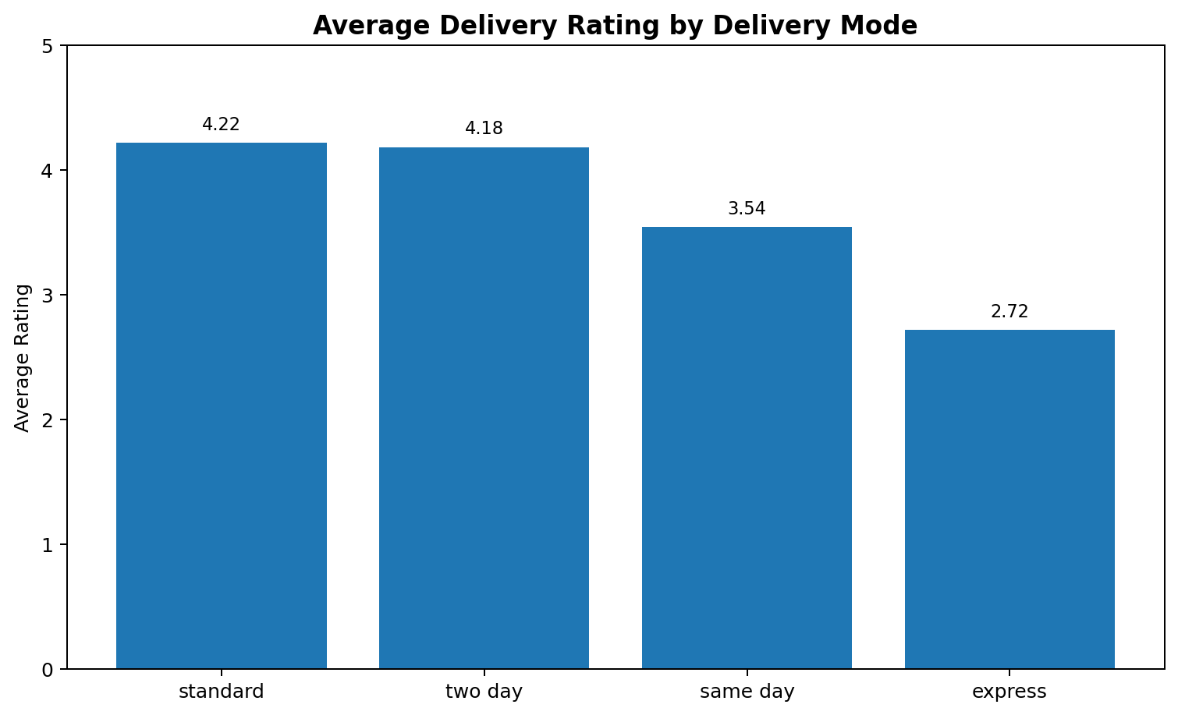
Figure 9. Average customer rating by delivery mode.

14. Delays and Customer Ratings
The relationship becomes even clearer when ratings are grouped directly by delay status. On-time deliveries average 4.21/5, while delayed deliveries average only 2.18/5. The 2.03-point difference is substantial. This demonstrates a strong association between delivery reliability and customer satisfaction.
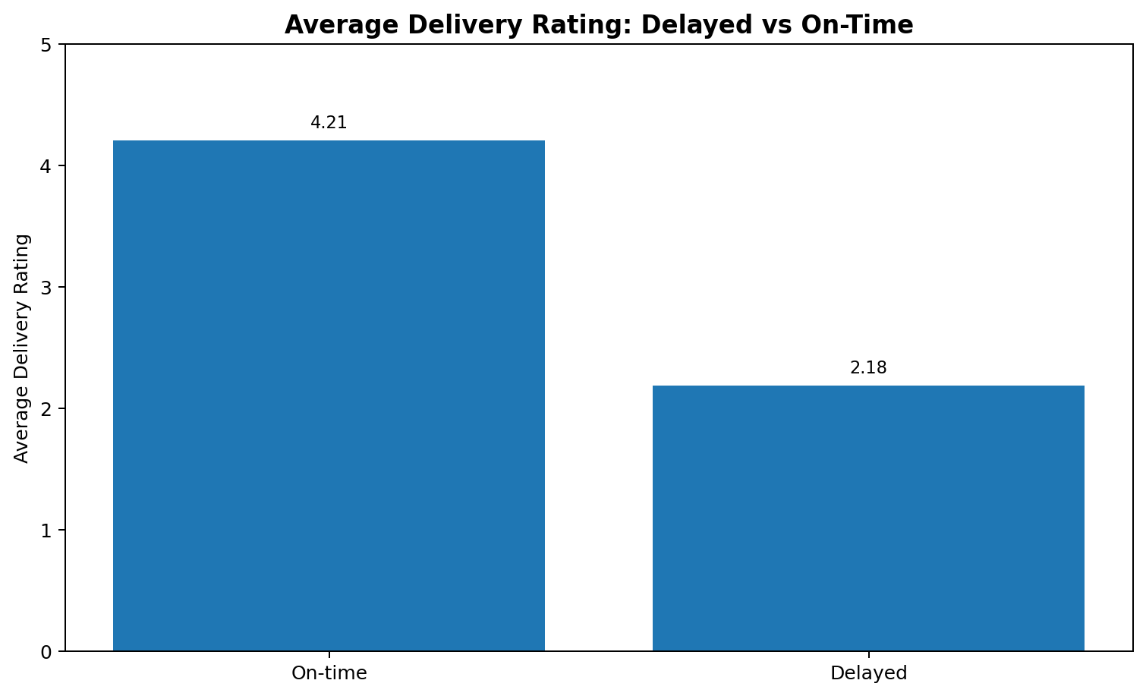
Figure 10. Average customer rating for on-time versus delayed deliveries.
rating_by_delay = df.groupby("delayed")["delivery_rating"].agg(["count", "mean"])
print(rating_by_delay)
Important analytical limitation: this comparison establishes association, not causation. Other factors could contribute to lower ratings. A future analysis could use regression or controlled comparisons to test the relationship more rigorously.

15. Combined Risk: Delivery Mode × Weather
The cross-tabulation identifies the highest-risk combinations. Express delivery under stormy conditions has a 99.81% delay rate, while Express under rainy conditions has 97.71% and Express under foggy conditions has 89.35%. Same-day delivery is also vulnerable under stormy (65.59%) and rainy (52.37%) conditions.
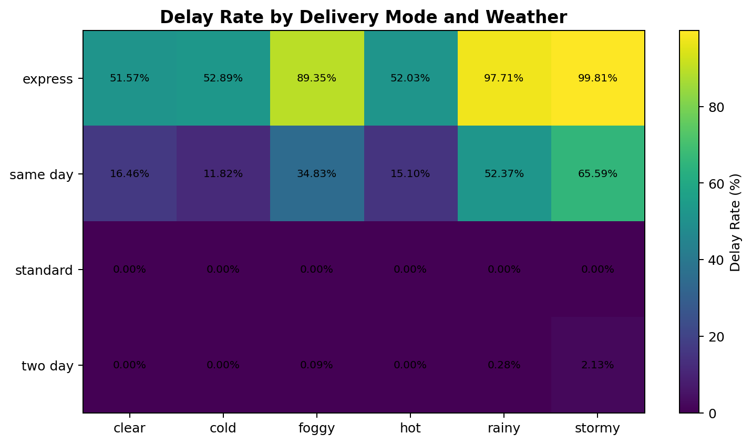
Figure 11. Delay rate by delivery mode and weather condition.
mode_weather = pd.crosstab(
df["delivery_mode"],
df["weather_condition"],
values=df["delayed"].eq("yes"),
aggfunc="mean"
) * 100
print(mode_weather.round(2))
Business implication: this interaction is more actionable than looking at weather or delivery mode separately. Operational rules could flag high-risk combinations before dispatch, allowing planners to reroute shipments, adjust promises, or add capacity.

16. Data Quality and Analytical Reliability
The dataset contains 25,000 records with zero missing values, which provides a strong base for grouped analysis and visualization. However, zero missing values do not automatically mean the data is perfect. The Week 2 cleaning process identified inconsistent records, including cases where delivery time and expected time did not align cleanly with the delayed flag. For example, the time-difference analysis showed 5,466 deliveries with actual time greater than expected time, compared with 6,669 records marked delayed. This indicates that the delayed field should be treated as an operational label and validated against business rules before using it as a ground-truth target.
This matters because incorrect or inconsistent labels can distort delay rates, customer-satisfaction analysis, and performance comparisons. A production logistics system should define a single authoritative rule for delay classification and routinely audit records that violate that rule.

17. Actionable Recommendations
1. Review Express service design
Express has a 73.78% overall delay rate and a 2.72/5 average rating. Review capacity, cutoff times, routing, and promised delivery windows before accepting additional Express volume.
2. Introduce weather-risk triggers
Stormy, rainy, and foggy conditions materially increase delay risk. Use weather forecasts to trigger contingency planning, route changes, extra capacity, and proactive customer notifications.
3. Add distance-based planning buffers
Delay rate rises from 17.02% at 0–50 km to 38.82% at 250–300 km. Long-distance shipments should receive more realistic time estimates and closer monitoring.
4. Prioritize reliability to protect ratings
Delayed deliveries average 2.18/5 compared with 4.21/5 for on-time deliveries. Reducing delays is likely to be one of the highest-value levers for customer experience.
5. Use distance as a primary cost-planning variable
Distance has a 0.99 correlation with delivery cost. Pricing, route optimization, and cost forecasting should therefore give distance substantial weight.
6. Monitor partner performance without over-attributing blame
Partner delay rates range from 24.80% to 28.27%. Track partner-level performance, but recognize that delivery mode, weather, and distance show larger differences in this analysis.

18. Conclusion
The Week 3 analysis demonstrates how cleaned logistics data can be converted into operational insight. The strongest findings are the high delay rate associated with Express service, the increasing delay risk with distance, the strong weather effect, and the close relationship between delivery reliability and customer rating. The correlation analysis further shows that distance is a dominant driver of delivery cost and a meaningful driver of actual delivery time.
The most important management priority is not simply reducing the overall delay percentage. It is identifying where delay risk concentrates. The Express + Stormy combination reaches 99.81%, making it a clear candidate for targeted intervention. Similarly, the 250–300 km range and adverse-weather conditions should receive additional planning attention.
Overall, the analysis supports a more proactive logistics strategy: predict risk before dispatch, set realistic service promises, allocate capacity according to risk, and continuously connect operational KPIs to customer outcomes.

19. Appendix: Core Python Workflow
# Grouped delay analysis
delay_by_mode = (
df.groupby("delivery_mode")["delayed"]
.apply(lambda x: (x == "yes").mean() * 100)
.sort_values(ascending=False)
)
# Distance bands
distance_bins = pd.cut(
df["distance_km"],
bins=[0, 50, 100, 150, 200, 250, 300],
labels=["0-50", "50-100", "100-150", "150-200", "200-250", "250-300"]
)
distance_summary = df.groupby(distance_bins, observed=True).agg(
total_deliveries=("distance_km", "count"),
avg_delivery_time=("delivery_time_hours", "mean"),
avg_delivery_cost=("delivery_cost", "mean"),
delay_rate=("delayed", lambda x: (x == "yes").mean() * 100)
)
# Customer rating by delay
rating_by_delay = df.groupby("delayed")["delivery_rating"].mean()
# Delivery mode x weather
mode_weather = pd.crosstab(
df["delivery_mode"],
df["weather_condition"],
values=df["delayed"].eq("yes"),
aggfunc="mean"
) * 100

20. Key Evidence at a Glance
Finding | Evidence | Priority
Overall delay problem | 26.68% delayed | High
Express risk | 73.78% delay rate | Critical
Worst weather | Stormy: 41.45% delay rate | High
Longest-distance risk | 250–300 km: 38.82% delay rate | High
Cost driver | Distance–cost correlation: 0.99 | Critical
Customer impact | Delayed rating 2.18 vs 4.21 on-time | Critical
Combined risk | Express + Stormy: 99.81% delay rate | Critical
Package weight effect | Weight–cost correlation: 0.10 | Low

