Higher Colleges of Technology
CIS Division

CIS2213 – Full-Stack Web Applications Development

Final Project – Back-End Development Report

Project Title: GymForge – Gym Equipment & Services

Student Name(s) | Saif Obaid
Student HCT ID(s) | H00________ H00________ H00________
Semester | 202520
Submission Date | Week 14

Academic Integrity Statement
This assignment is entirely my own work. I have not used any AI tools to complete this submission.

1. PROJECT PROPOSAL 4
1.1 Project Title and Description 4
1.2 Project Scope and Features 4
1.3 Proposed Web Application Structure 4
2. FRONT-END DEVELOPMENT 6
2.1 Home Page (index.html) 6
2.2 Login Page (pages/login.html) 6
2.3 Registration Page (pages/register.html) 6
2.4 Dashboard Page (pages/dashboard.html) 7
2.5 Machines Catalogue Page (pages/machines.html) 7
2.6 Machine Detail Page (pages/machine-detail.html) 7
2.7 Services / Checkout Page (pages/services.html) 7
2.8 Search Page (pages/search.html) 8
2.9 Repair & Maintenance Page (pages/repair.html) 8
2.10 Profile Page (pages/profile.html) 8
3. BACK-END DEVELOPMENT 9
3.1 Setting Up the Express Server 9
Overview 9
Implementation 9
Code Snippet 9
3.2 Serving Static Assets 10
Overview 10
Implementation 10
Code Snippet 10
3.3 Defining Routes and Handling Requests 10
Overview 10
Implementation 10
Code Snippet 11
3.4 Implementing Authentication with Cookies and Sessions 11
Overview 11
Implementation 11
Code Snippet 12
3.5 Additional Cookie Usage 12
Overview 12
Implementation 13
Code Snippet 13
4. DATABASE DESIGN AND IMPLEMENTATION 14
4.1 Database Design 14
Overview 14
4.2 Database Implementation 15
Overview 15
4.3 Database Integration 16
Overview 17
CONCLUSION 19
REFERENCES 19

1. PROJECT PROPOSAL

1.1 Project Title and Description
Project Title: GymForge – Gym Equipment & Services
GymForge is a full-stack client–server web application designed for gym owners and managers to streamline the management of gym equipment, professional services, and maintenance operations. The system allows registered users to browse an equipment catalogue, book professional services such as installation, maintenance, and repair, as well as submit and track repair requests for faulty machines. The platform is built with a modern responsive interface supported by a robust server-side back end and a relational MySQL database.

1.2 Project Scope and Features
The GymForge application targets gym owners and facility managers who require a centralised digital platform to manage their equipment inventory and related services. The key features of the system are as follows:
- User Registration and Authentication – new users can create an account; existing users can log in and log out securely using session-based authentication.
- Equipment Catalogue – a browsable and searchable catalogue of gym machines, filterable by category and availability status.
- Machine Detail View – a dedicated page showing full technical specifications, pricing, rating, and availability for each machine.
- Service Catalogue – a list of professional services (installation, maintenance, repair, upgrade, relocation, annual package) with pricing and duration details.
- Service Booking – authenticated users can book a service for a specific machine, choosing a preferred date and time.
- Repair Request Submission – users can submit detailed repair or maintenance requests for their equipment.
- Search Page – live search with keyword highlighting and advanced filters by category, status, and price.
- User Dashboard – a personal dashboard showing active bookings, repair requests, and account summary.
- Profile Management – users can view and update their personal profile information.

1.3 Proposed Web Application Structure
The application consists of the following pages and their relationships:
Home Page (index.html) | Landing page; entry point for login and registration links.
Login Page | Allows existing users to authenticate with email and password.
Register Page | New user registration form with full validation.
Dashboard Page | Post-login welcome page; shows booking and request summaries.
Machines Catalogue | Displays all gym equipment with search and filter options.
Machine Detail Page | Full details of a selected machine including specifications.
Services / Checkout Page | Lists all available professional services; users can book a service.
Search Page | Live debounced search across equipment with advanced filters.
Repair / Booking Page | Allows authenticated users to submit repair or maintenance requests.
Profile Page | View and update personal account information.

2. FRONT-END DEVELOPMENT

The front end of GymForge was developed using HTML5, CSS3, Bootstrap 5.3.2, JavaScript (ES6+), and jQuery 3.7.1. All pages follow a consistent dark industrial design with a shared navigation bar and sidebar. Each page is stored in the pages/ subfolder and linked to a shared external stylesheet (css/style.css) and modular JavaScript files in the js/ folder (main.js, data.js, sidebar.js).

2.1 Home Page (index.html)
The home page is the main entry point of the application. It features a full-screen hero section with animated statistics counters (machines, brands, services), dynamically rendered featured machine cards loaded from data.js using jQuery, a services preview section, and call-to-action buttons for registration and login. Semantic HTML5 elements including <section>, <nav>, <main>, and <footer> are used throughout.

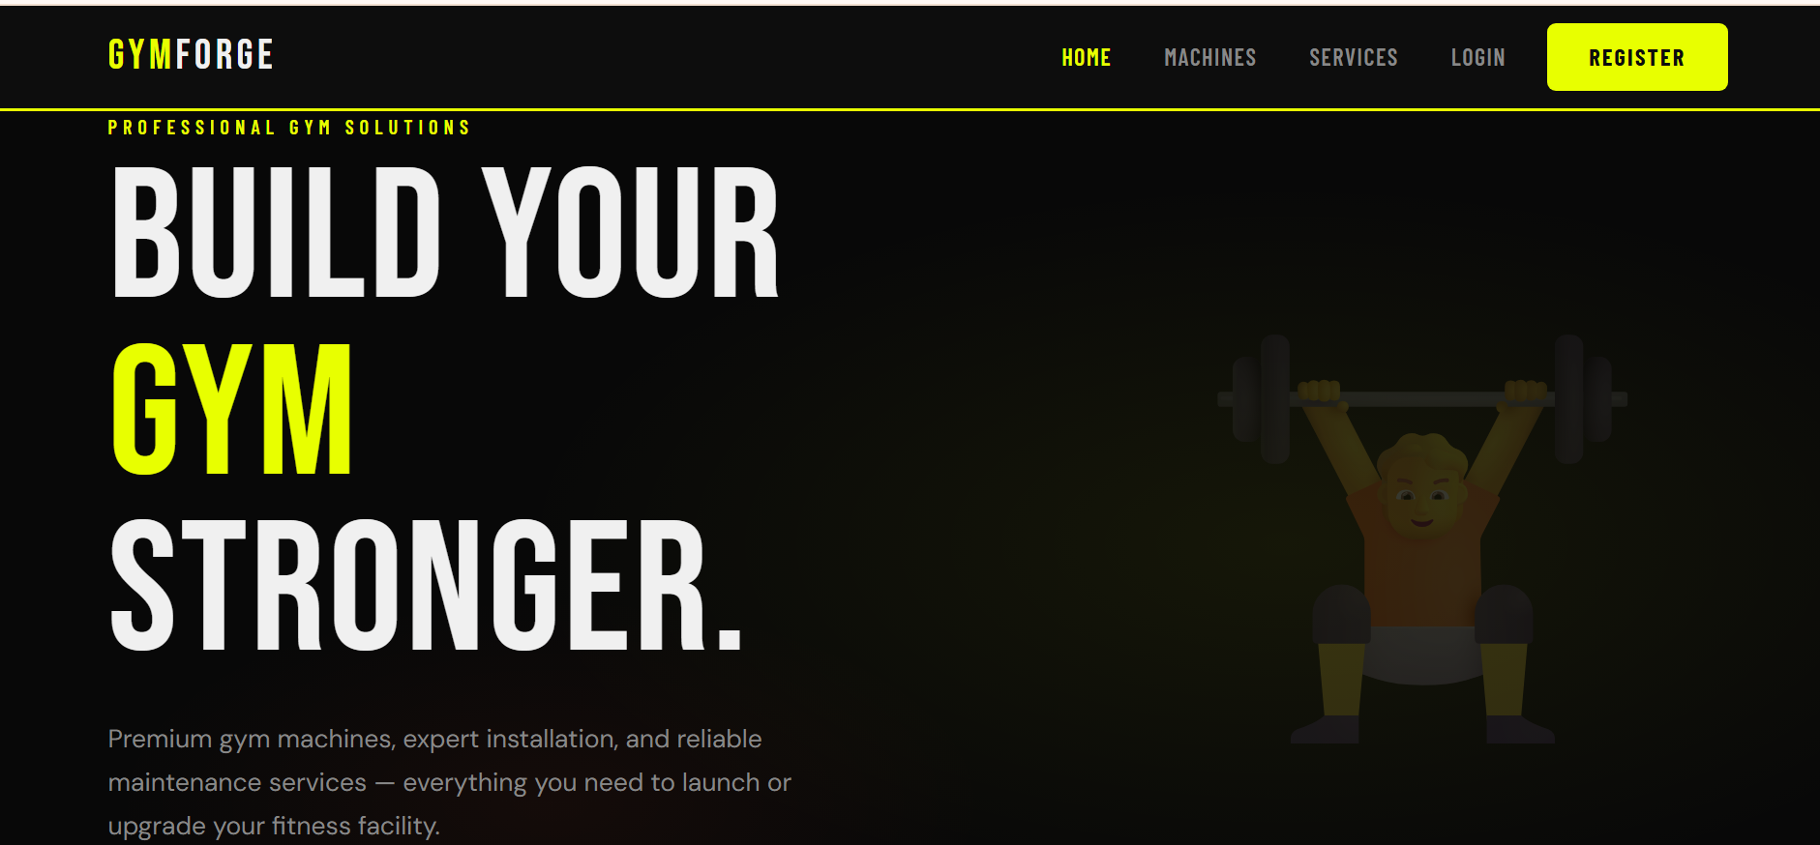

2.2 Login Page (pages/login.html)
The login page provides a centred authentication form on a dark background. It includes email and password input fields, a show/hide password toggle button, and a Remember Me checkbox. Validation is applied on both blur and form submission. A demo account is available for testing. On successful login the user is redirected to the dashboard.

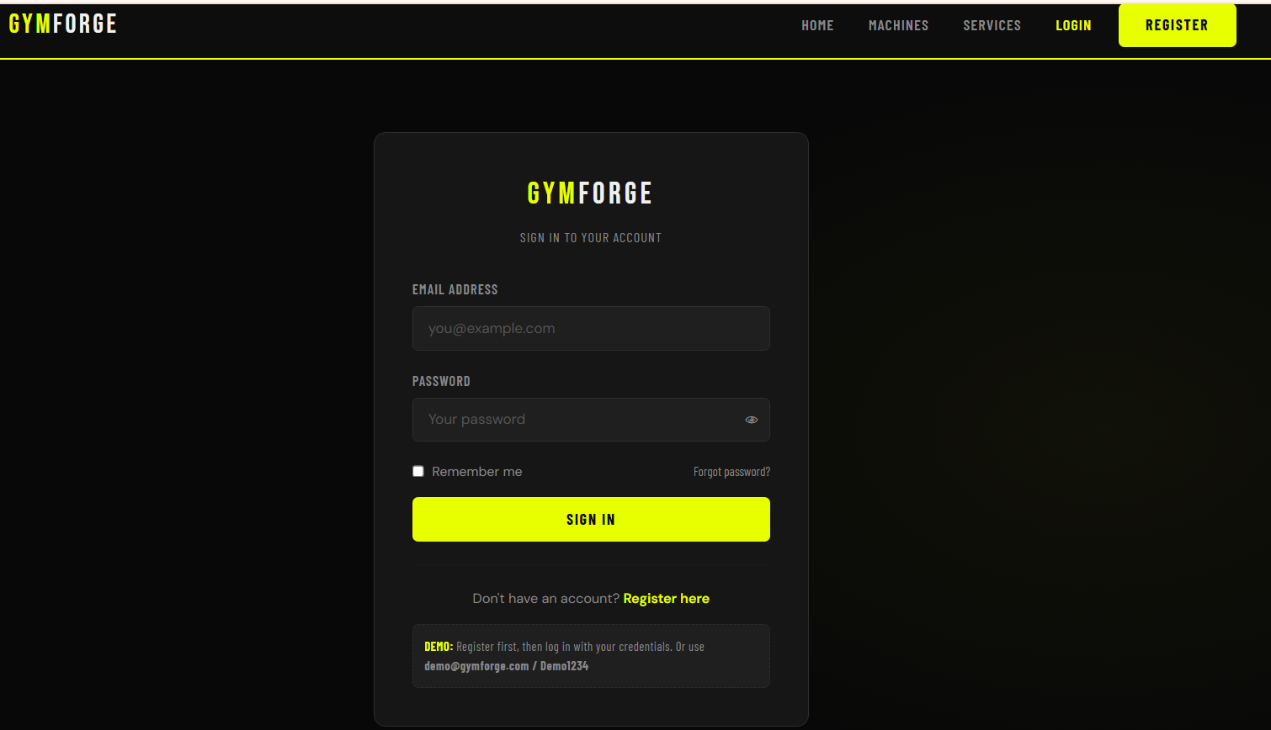

2.3 Registration Page (pages/register.html)
The registration page collects full name, email, phone, gym name, city, password, and confirm password. All fields have real-time blur validation with specific error messages. A dynamic password strength meter (Weak / Fair / Good / Strong) updates as the user types. A Terms of Service checkbox must be accepted before submission. On success the user is redirected to the login page.

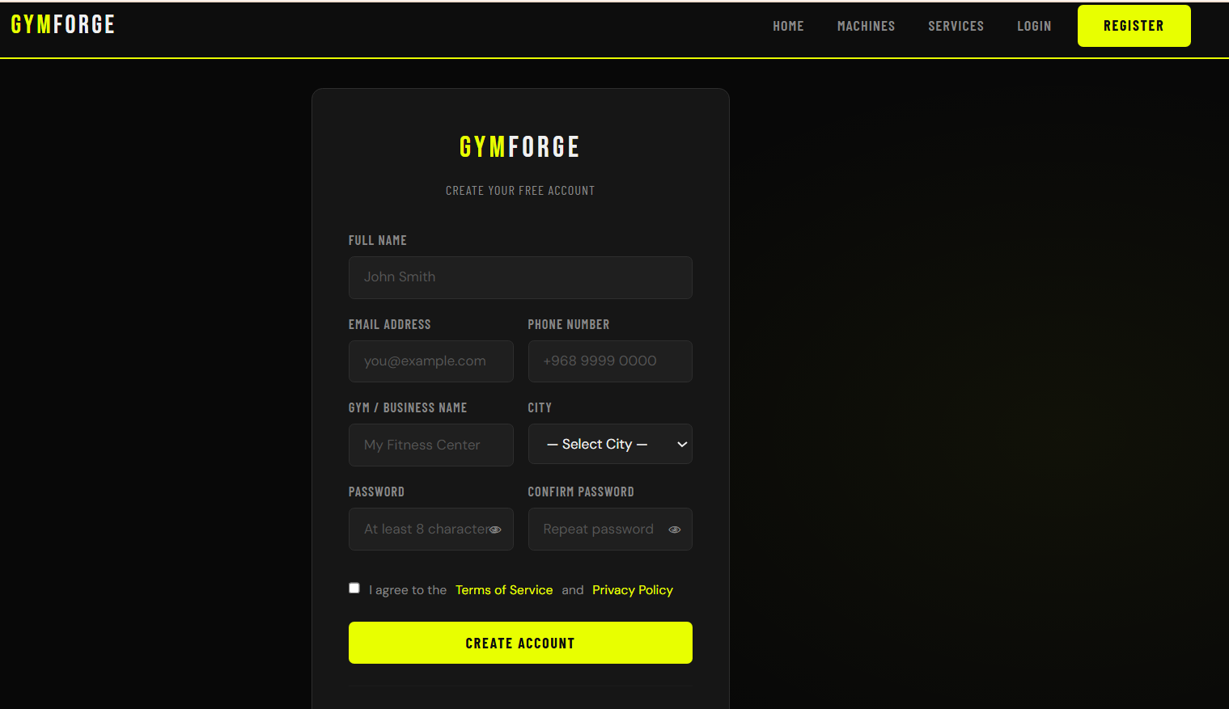

2.4 Dashboard Page (pages/dashboard.html)
The dashboard is the main authenticated hub of the application. It displays a personalised welcome heading with the user's first name, a stats grid (Total Bookings, Active Bookings, Repair Requests, Cancelled), a recent bookings table, and a repair requests panel. The sidebar navigation is rendered by sidebar.js and highlights the active page. Non-logged-in users are redirected to login.

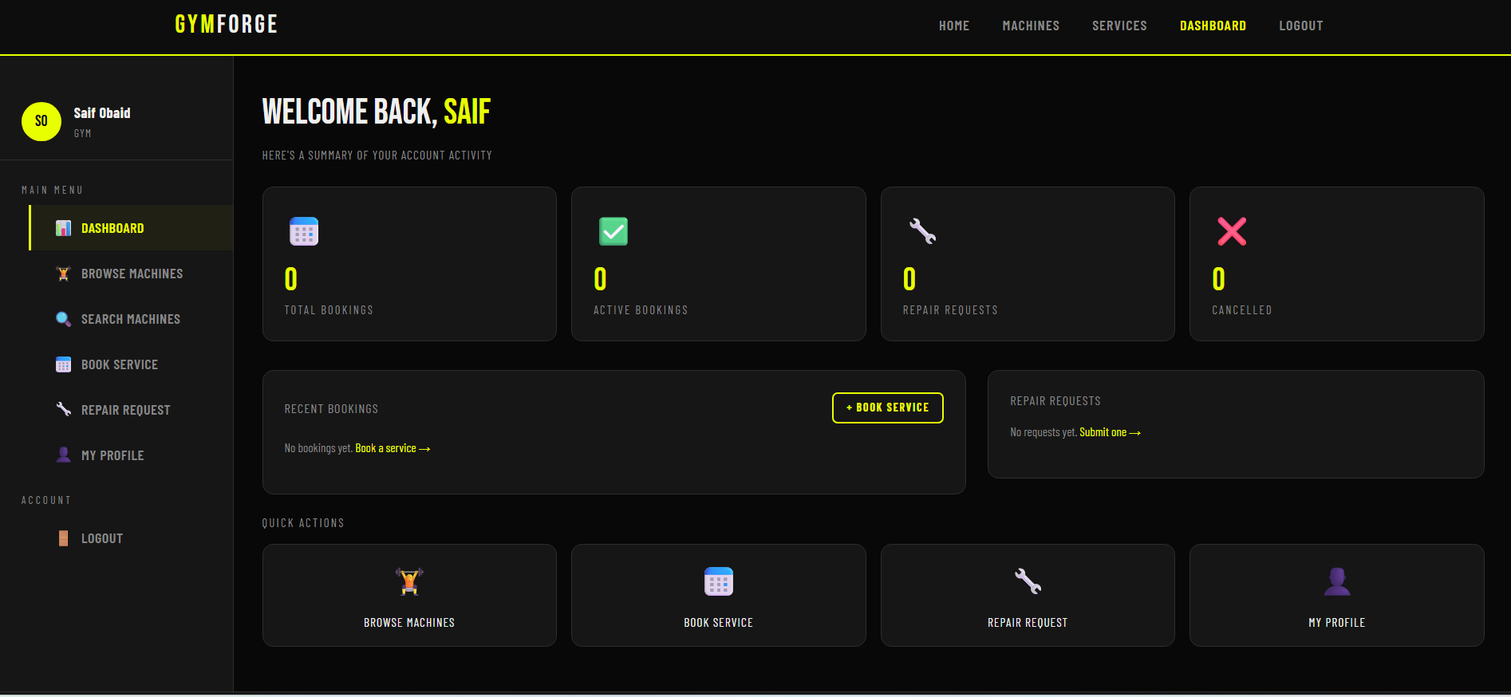

2.5 Machines Catalogue Page (pages/machines.html)
This page displays all gym machines as interactive Bootstrap cards in a responsive grid. Users can filter by category using clickable chip buttons (All, Cardio, Strength, Functional, Free Weights, Recovery) and sort by price or alphabetical order. Each card shows the machine image, category badge, availability badge, name, star rating, description excerpt, price, and a View Details button. A result counter shows how many machines are currently displayed.

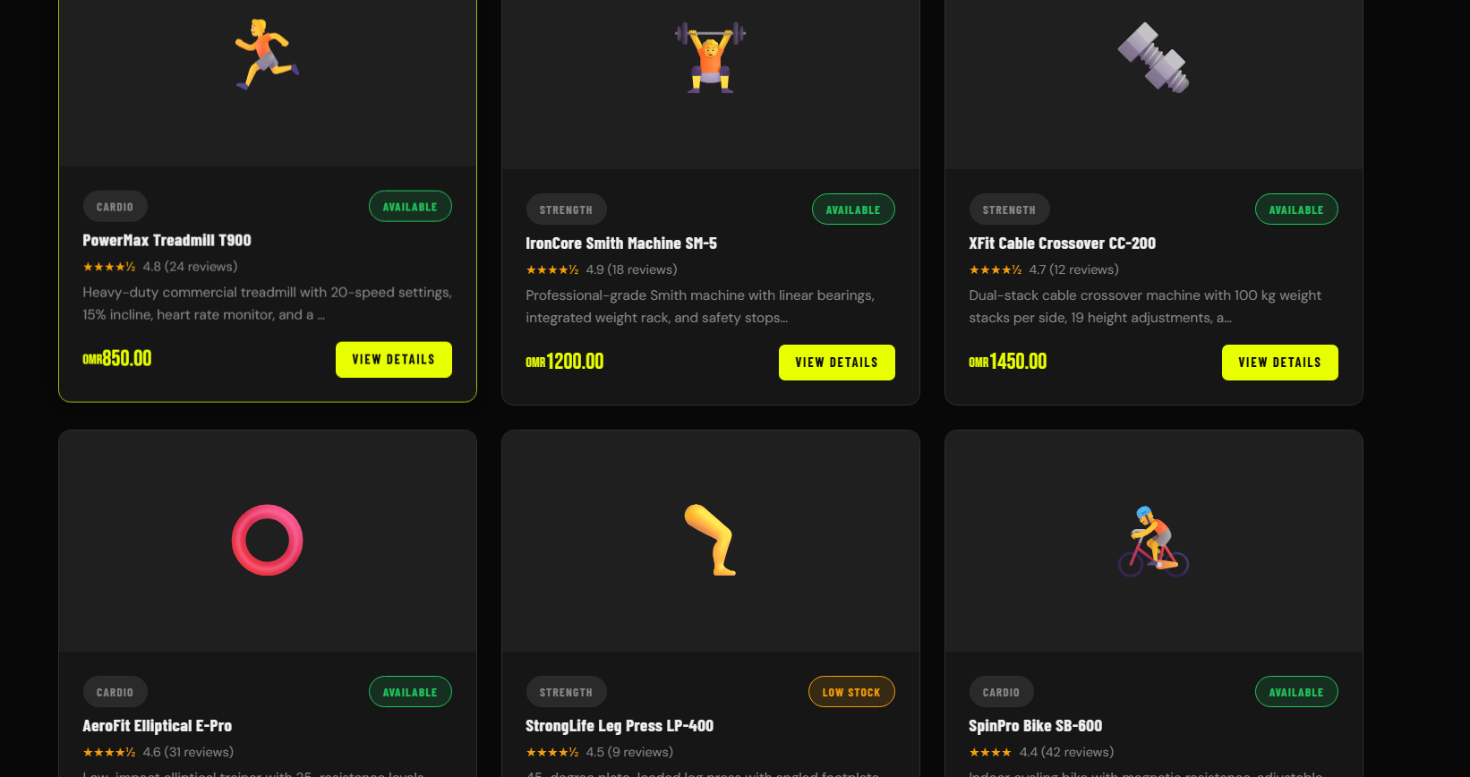

2.6 Machine Detail Page (pages/machine-detail.html)
This page reads the machine ID from the URL query string and renders the full detail view for that machine, including image, name, category badge, rating with review count, availability, full description, price, brand, and a specifications table. Action buttons (Book Installation and Request Repair) link to the relevant pages with pre-filled query parameters. A related machines section shows up to three machines from the same category.

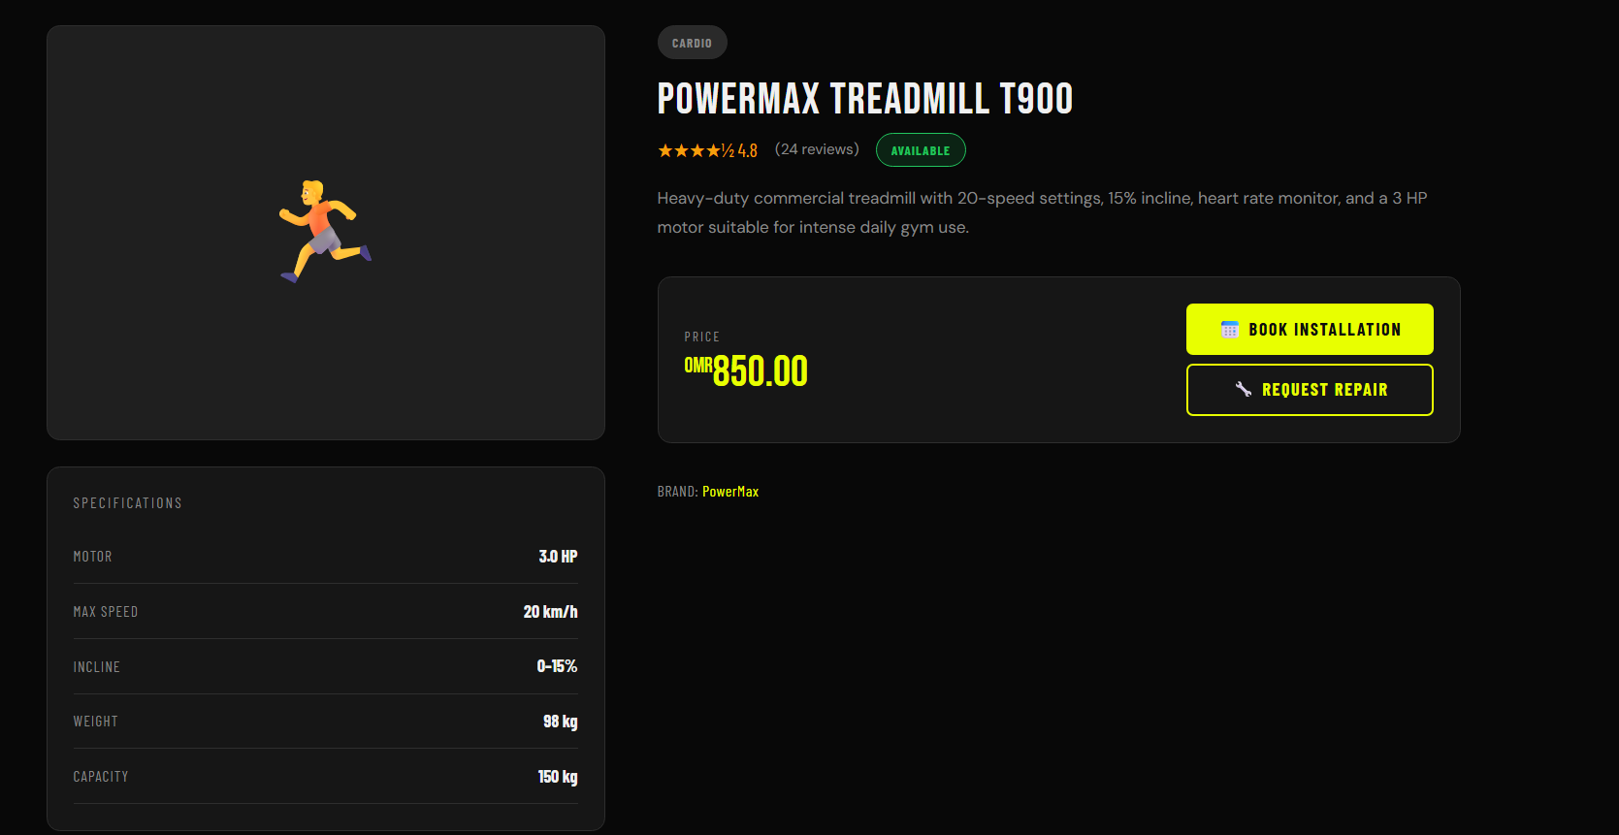

2.7 Services / Checkout Page (pages/services.html)
This page serves as both the service catalogue and booking confirmation page. Six service cards are listed on the left (icon, name, category, description, price, duration). Clicking a card selects it and populates the booking form on the right. The form collects machine name, preferred dates (future dates only), time slot, and optional notes. After submission a confirmation is shown and the booking is saved. Existing bookings are displayed in a sortable table with cancel functionality.

[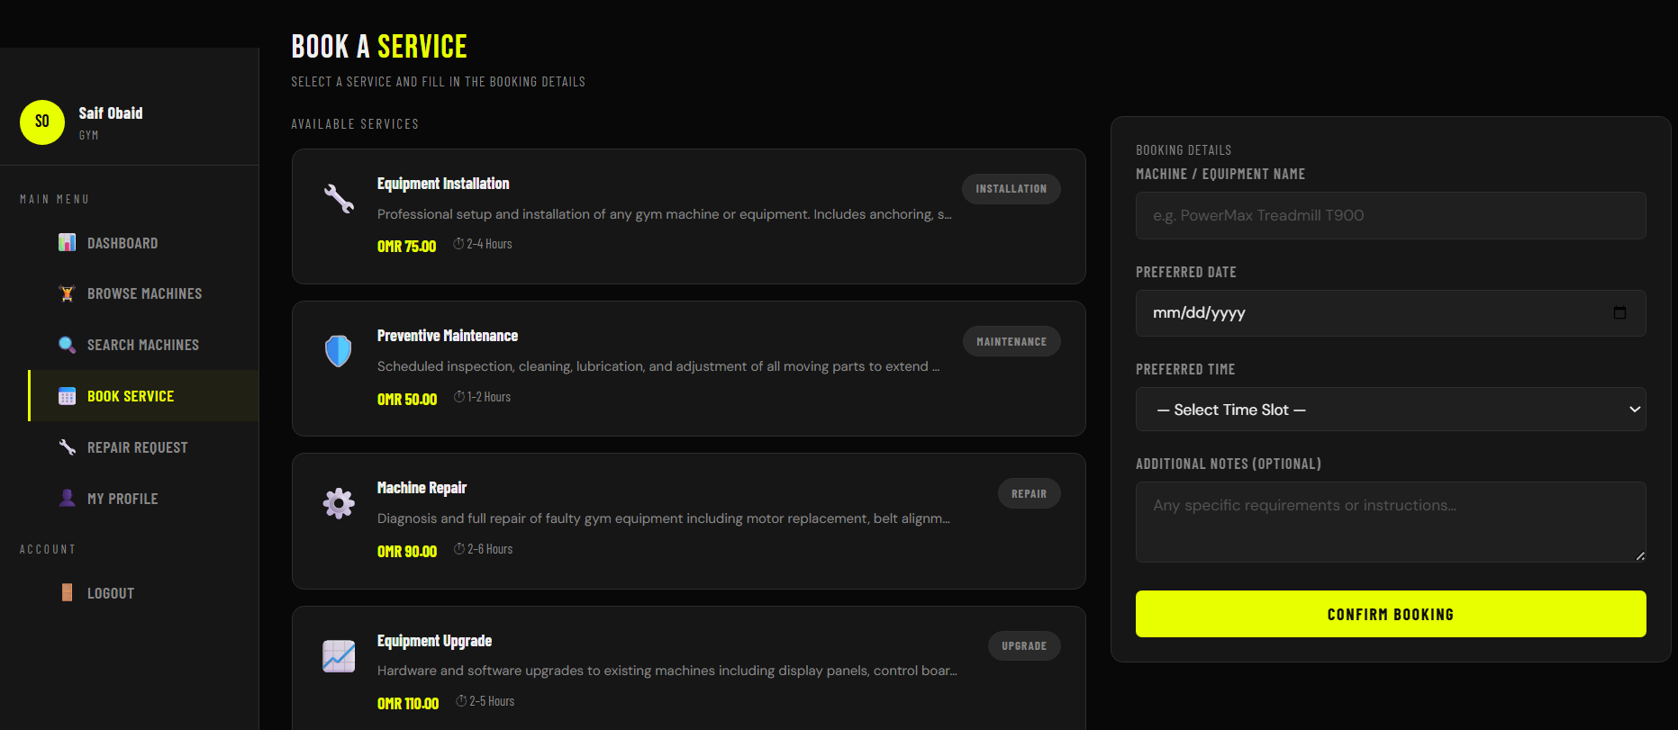

2.8 Search Page (pages/search.html)
This page provides a live debounced search experience with a 280ms delay to avoid excessive re-rendering on every keypress. Search matches against machine name, brand, category, and description. Matched keywords are highlighted in yellow within result cards using a RegExp replacement. Advanced filter controls allow filtering simultaneously by category, availability status, and maximum price. A clear button resets all filters and returns to the default state.

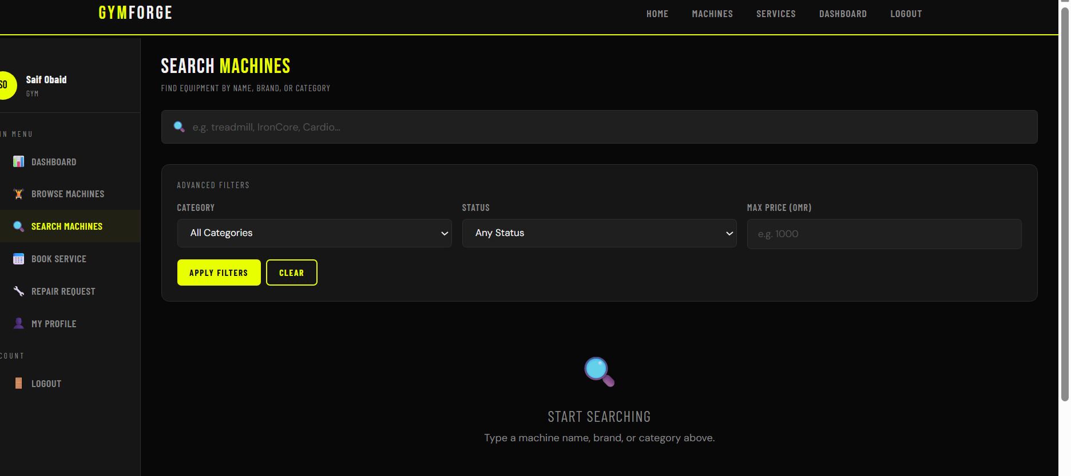

2.9 Repair & Maintenance Page (pages/repair.html)
This page allows logged-in users to submit a repair or maintenance request. The form collects machine name, optional brand, request type, urgency level (Low, Medium, High, Critical), issue description with a character counter (minimum 20 characters), preferred service date, contact phone, and facility address. The machine name and phone fields can be pre-filled from URL parameters. Existing requests are displayed below with urgent colour coding.

[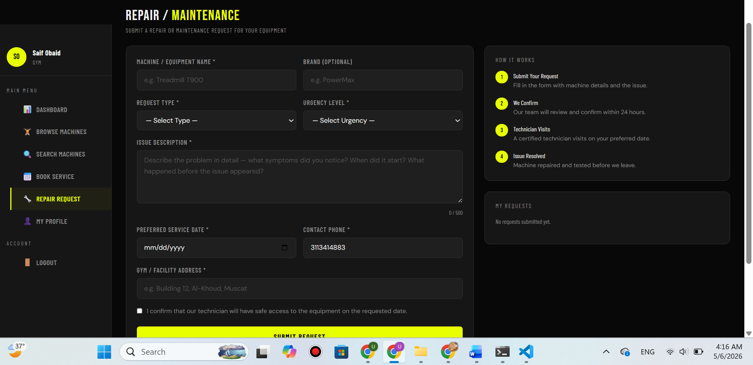

2.10 Profile Page (pages/profile.html)
The profile page displays the user's current information alongside a live booking and request count summary. An editable form on the right allows updating all personal fields. An optional password change section is included, validated only if any password field is filled. The profile avatar shows the user's initials dynamically generated from their full name. All changes are saved and the session is updated immediately.

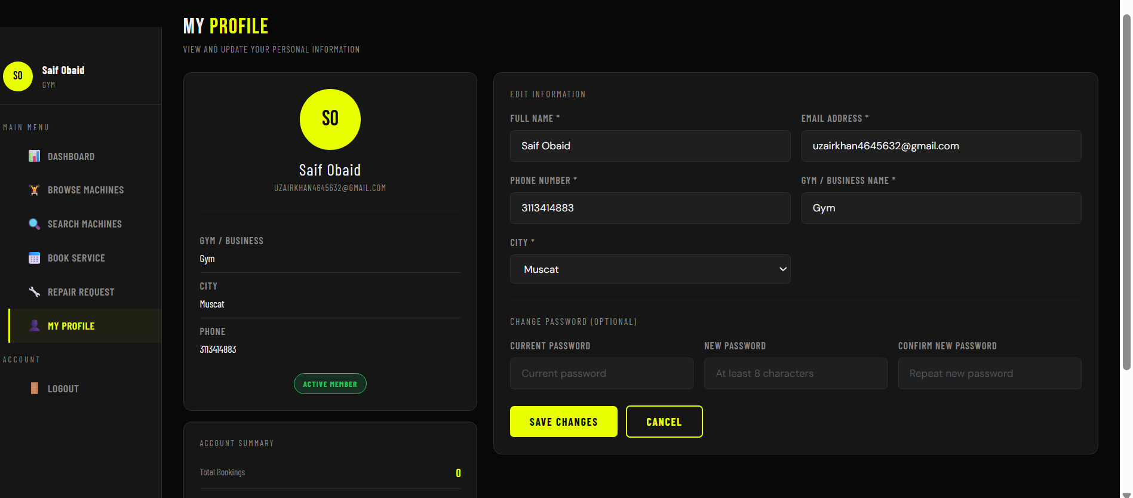

3. BACK-END DEVELOPMENT

3.1 Setting Up the Express Server

Overview
The Gym Forge back end is built using Node.js and the Express framework. The entry point of the server is server.js, located in the gymforge-backend/ folder. The project was initialized using npm init and all required dependencies were installed via npm install. The server listens on port 3000 by default, configurable through the .env environment file.

Implementation
The server initialization process involves loading environment variables using dotenv, creating an Express application instance, applying middleware for JSON and URL-encoded body parsing, configuring CORS for cross-origin requests from the front end on port 5500, setting up session middleware, and registering all route handlers. The following dependencies are used:
express | Core web framework for routing and middleware.
express-session | Manages server-side session storage and session cookies.
cookie-parser | Parses Cookie headers from incoming requests.
cors | Enables Cross-Origin Resource Sharing for the front-end client.
bcryptjs | Hashes and verifies user passwords securely.
mysql2 | MySQL client for Node.js promise support.
dotenv | Loads environment variables from the .env file.

Code Snippet
require('dotenv').config();
const express = require('express');
const session = require('express-session');
const cookieParser = require('cookie-parser');
const cors = require('cors');
const path = require('path');

const app = express();
const PORT = process.env.PORT || 3000;

app.use(express.json());
app.use(express.urlencoded({ extended: true }));
app.use(cookieParser());
app.use(cors({ origin: 'http://localhost:5500', credentials: true }));

app.listen(PORT, () => {
console.log(`GymForge server running at http://localhost:${PORT}`);
});

3.2 Serving Static Assets

Overview
All front-end files including HTML pages, the external CSS stylesheet, JavaScript files, and product images are stored in the gym-project/ folder, located one level above the backend directory. Express is configured to serve all these files as static assets so that any client browser can load them directly.

Implementation
The express.static() middleware points Express to the gym-project/ folder. The path.join() method with dirname and a relative parent path ('..') ensures the correct absolute path is resolved on any operating system. A catch-all GET route returns index.html for any unmatched GET request, supporting client-side navigation.

Code Snippet
// Serve static front-end files from gym-project/ folder
app.use(express.static(path.join(__dirname, '..', 'gym-project')));

// Fallback: return index.html for any unmatched GET request
app.get('*', (req, res) => {
res.sendFile(path.join(__dirname, '..', 'gym-project', 'index.html'));
});

3.3 Defining Routes and Handling Requests

Overview
All server-side routes are organized into separate files within the routes/ folder. Each route file handles a specific area of functionality. The main server.js file imports and mounts these route files under their respective API prefixes.

Implementation
POST /api/register | Creates a new user account in the database.
POST /api/login | Authenticates a user and creates a session.
POST /api/logout | Destroy the user session and clears cookies.
GET /api/me | Returns the currently logged-in user's data.
GET /api/machines | Returns all machines with optional filters (category, status, search).
GET /api/machines/:id | Returns a single machine by ID.
GET /api/services | Returns all available services.
GET /api/services/:id | Returns a single service by ID.
GET /api/bookings | Returns all bookings for the logged-in user.
POST /api/bookings | Creates a new service booking.
DELETE /api/bookings/:id | Cancels a booking by setting status to Cancelled.
GET /api/repairs | Returns all repair requests for the logged-in user.
POST /api/repairs | Submits a new repair or maintenance request.
PUT /api/profile | Updates the logged-in user's profile information.

Code Snippet
const authRoutes = require('./routes/auth');
const machineRoutes = require('./routes/machines');
const serviceRoutes = require('./routes/services');
const bookingRoutes = require('./routes/bookings');
const repairRoutes = require('./routes/repairs');
const profileRoutes = require('./routes/profile');

app.use('/api', authRoutes);
app.use('/api/machines', machineRoutes);
app.use('/api/services', serviceRoutes);
app.use('/api/bookings', bookingRoutes);
app.use('/api/repairs', repairRoutes);
app.use('/api/profile', profileRoutes);

The machines route handles optional query parameters for dynamic filtering:
router.get('/', async (req, res) => {
const { category, status, search } = req.query;
let query = 'SELECT * FROM machines WHERE 1=1';
const params = [];
if (category) { query += ' AND category = ?'; params.push(category); }
if (status) { query += ' AND status = ?'; params.push(status); }
if (search) {
query += ' AND (name LIKE ? OR brand LIKE ? OR description LIKE ?)';
const like = `%${search}%`;
params.push(like, like, like);
}
const [rows] = await db.query(query, params);
return res.json({ success: true, machines: rows });
});

3.4 Implementing Authentication with Cookies and Sessions

Overview
GymForge uses session-based authentication implemented with the express-session middleware. When a user logs in successfully, a session is created on the server and a session cookie is sent to the browser. This cookie is used to identify the user on subsequent requests. Passwords are never stored in plain text — they are hashed using bcryptjs before being saved to the database.

Implementation
The session middleware is configured with a secret key from .env, httpOnly cookies, a maxAge of 24 hours, sameSite: lax, and saveUninitialized: false. Protected routes use a requireAuth middleware function that checks for a valid session before proceeding. The Remember Me feature extends the cookie maxAge to 30 days when selected.

Code Snippet
Session middleware configuration:
app.use(session({
secret: process.env.SESSION_SECRET || 'gymforge_secret',
resave: false,
saveUninitialized: false,
cookie: {
httpOnly: true,
secure: false,
maxAge: 24 * 60 * 60 * 1000,
sameSite: 'lax',
},
}));

Login route – authenticates the user and creates a session:
router.post('/login', async (req, res) => {
const { email, password, remember } = req.body;
const [rows] = await db.query('SELECT * FROM users WHERE email = ?', [email]);
const isMatch = await bcrypt.compare(password, rows[0].password);
if (!isMatch) return res.status(401).json({ success: false });
req.session.userId = rows[0].id;
req.session.userName = rows[0].full_name;
req.session.userEmail = rows[0].email;
if (remember) req.session.cookie.maxAge = 30 * 24 * 60 * 60 * 1000;
return res.json({ success: true });
});

requireAuth middleware used on all protected routes:
function requireAuth(req, res, next) {
if (!req.session || !req.session.userId) {
return res.status(401).json({ success: false,
message: 'You must be logged in to perform this action.' });
}
next();
}

Logout route – destroys the session and clears cookies:
router.post('/logout', (req, res) => {
req.session.destroy(() => {
res.clearCookie('connect.sid');
res.clearCookie('gf_remember');
return res.json({ success: true, message: 'Logged out successfully.' });
});
});

3.5 Additional Cookie Usage

Overview
In addition to the session cookie used for authentication, GymForge implements two additional persistent cookies to enhance the user experience:
- gf_welcome – set after successful registration, stores the user's name for a personalised welcome message. Expires after 7 days.
- gf_remember – set when the user selects Remember Me on login, stores the user's email to pre-fill the login form on next visit. Expires after 30 days.

Implementation
Both cookies are set with httpOnly: false so they can be read by client-side JavaScript to display personalised UI messages. They are set using res.cookie() in the relevant auth routes and readable by the front end via document.cookie.

Code Snippet
// Set after registration – welcome message cookie (7 days)
res.cookie('gf_welcome', fullName, {
maxAge: 7 * 24 * 60 * 60 * 1000,
httpOnly: false,
sameSite: 'lax',
});

// Set on login with Remember Me selected (30 days)
res.cookie('gf_remember', email, {
maxAge: 30 * 24 * 60 * 60 * 1000,
httpOnly: false,
sameSite: 'lax',
});

4. DATABASE DESIGN AND IMPLEMENTATION

4.1 Database Design

Overview
The GymForge database is implemented using MySQL and follows a relational model. It is responsible for storing all persistent application data including user accounts, equipment inventory, service catalogue, service bookings, and repair requests. The database is named gymforge_db and is accessed from the Express server using the mysql2 library with a connection pool.
Entities
users | Stores registered user accounts including authentication credentials.
machines | Stores the gym equipment catalogue with pricing and specifications.
services | Stores provide professional services with pricing and duration.
bookings | Records service bookings made by users for specific machines.
repair_requests | Records repair or maintenance requests submitted by users.

Relationships
- users → bookings: One-to-Many (1:M) – one user can have many bookings.
- users → repair_requests: One-to-Many (1:M) – one user can submit many repair requests.
- services → bookings: One-to-Many (1:M) – one service can be associated with many bookings.
- machines is an independent entity referenced by name in bookings and repair_requests, allowing flexibility for equipment not yet registered in the catalogue.

Primary Keys
users | id – INT, AUTO_INCREMENT
machines | id – INT, AUTO_INCREMENT
services | id – INT, AUTO_INCREMENT
bookings | id – VARCHAR(30), timestamp-based e.g. BK-1712345678
repair_requests | id – VARCHAR(30), timestamp-based e.g. RQ-1712345678

Entity Relationship Diagram (ERD)
The following ERD was generated from MySQL Workbench and illustrates the complete database structure and the relationships between all entities:

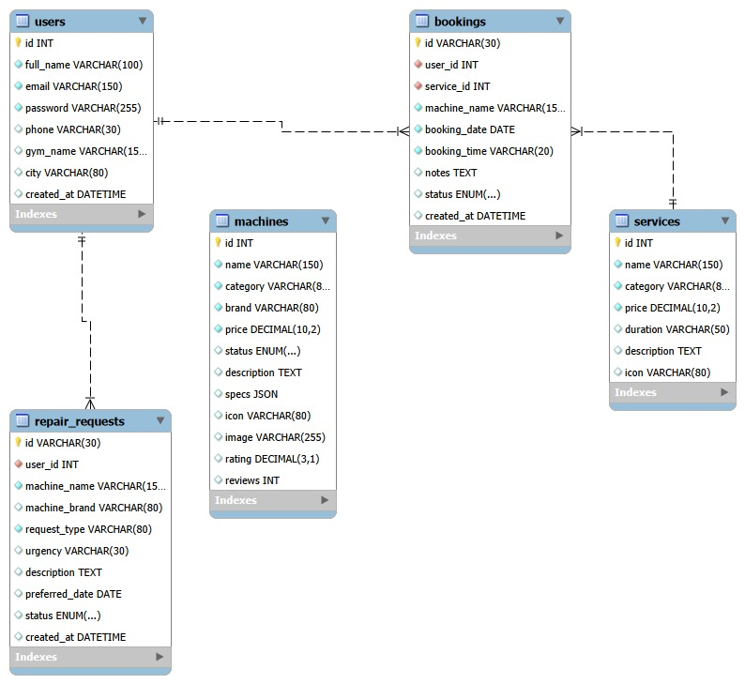

4.2 Database Implementation

Overview
The database schema is implemented in database/schema.sql. This file contains the CREATE TABLE statements for all five entities as well as seed data for the machines and services tables. The schema includes appropriate data types, constraints (NOT NULL, UNIQUE, DEFAULT), ENUM types for status fields, a JSON column for machine specifications, and foreign key definitions with ON DELETE CASCADE behaviour.
Tables and Columns
Table: users
Column | Data Type | Constraint | Description
id | INT | PK, AUTO_INCREMENT | Unique user identifier
full_name | VARCHAR(100) | NOT NULL | User's full name
email | VARCHAR(150) | NOT NULL, UNIQUE | Login email address
password | VARCHAR(255) | NOT NULL | bcrypt hashed password
phone | VARCHAR(30) | DEFAULT NULL | Optional phone number
gym_name | VARCHAR(150) | DEFAULT NULL | Name of user's gym
city | VARCHAR(80) | DEFAULT NULL | City of the gym
created_at | DATETIME | DEFAULT NOW() | Account creation timestamp

Table: bookings
Column | Data Type | Constraint | Description
id | VARCHAR(30) | PRIMARY KEY | e.g. BK-1712345678
user_id | INT | FK → users(id) | Owner of the booking
service_id | INT | FK → services(id) | Booked service
machine_name | VARCHAR(150) | NOT NULL | Machine being serviced
booking_date | DATE | NOT NULL | Scheduled date
booking_time | VARCHAR(20) | NOT NULL | Scheduled time slot
notes | TEXT | DEFAULT NULL | Optional additional notes
status | ENUM | Confirmed/Cancelled/Completed | Current booking status
created_at | DATETIME | DEFAULT NOW() | Booking creation timestamp

Table: repair_requests
Column | Data Type | Constraint | Description
id | VARCHAR(30) | PRIMARY KEY | e.g. RQ-1712345678
user_id | INT | FK → users(id) | User who submitted request
machine_name | VARCHAR(150) | NOT NULL | Machine requiring repair
machine_brand | VARCHAR(80) | DEFAULT NULL | Optional brand name
request_type | VARCHAR(80) | NOT NULL | Type of request
urgency | VARCHAR(30) | DEFAULT NULL | Low / Medium / High / Critical
description | TEXT | DEFAULT NULL | Issue description
preferred_date | DATE | DEFAULT NULL | Preferred service date
status | ENUM | Pending/In Progress/Resolved | Current request status
created_at | DATETIME | DEFAULT NOW() | Submission timestamp

4.3 Database Integration

Overview
The database is connected to the Express server using the mysql2 library configured as a promise-based connection pool. The pool configuration is defined in database/db.js and reads all connection credentials from the .env file. The pool supports up to 10 simultaneous connections for efficient handling of concurrent requests.
CRUD Operations
CREATE (INSERT) | User registration (POST /api/register), new booking (POST /api/bookings), new repair request (POST /api/repairs).
READ (SELECT) | Fetch machines with filters (GET /api/machines), fetch user bookings (GET /api/bookings), fetch repair requests (GET /api/repairs), get current user (GET /api/me).
UPDATE (UPDATE) | Update user profile (PUT /api/profile), set booking status to Cancelled (DELETE /api/bookings/:id).
DELETE (logical) | Bookings are soft-deleted by setting status = 'Cancelled' rather than removing the row, preserving the transaction history.

Code Snippet
Database connection pool (database/db.js):
const mysql = require('mysql2');
require('dotenv').config();

const pool = mysql.createPool({
host: process.env.DB_HOST || 'localhost',
user: process.env.DB_USER || 'root',
password: process.env.DB_PASSWORD || '',
database: process.env.DB_NAME || 'gymforge_db',
waitForConnections: true,
connectionLimit: 10,
queueLimit: 0,
});

module.exports = pool.promise();

CREATE – Insert a new booking (routes/bookings.js):
router.post('/', requireAuth, async (req, res) => {
const { serviceId, machineName, bookingDate, bookingTime, notes } = req.body;
const bookingId = 'BK-' + Date.now();
await db.query(
`INSERT INTO bookings
(id, user_id, service_id, machine_name, booking_date, booking_time, notes)
VALUES (?, ?, ?, ?, ?, ?, ?)`,
[bookingId, req.session.userId, serviceId,
machineName, bookingDate, bookingTime, notes || null]
);
return res.status(201).json({ success: true, bookingId });
});

UPDATE – Update user profile (routes/profile.js):
router.put('/', requireAuth, async (req, res) => {
const { fullName, phone, gymName, city } = req.body;
await db.query(
'UPDATE users SET full_name=?, phone=?, gym_name=?, city=? WHERE id=?',
[fullName, phone||null, gymName||null, city||null, req.session.userId]
);
req.session.userName = fullName;
return res.json({ success: true, message: 'Profile updated.' });
});

CONCLUSION

The back-end development phase of the GymForge project has been successfully completed. An Express server was set up with all required dependencies correctly installed and configured, including session middleware, CORS, cookie-parser, and bcryptjs for secure password handling. Static front-end assets are served efficiently using express.static(), and all API routes are well-organised into separate route files for authentication, machines, services, bookings, repairs, and profile management.
Session-based authentication is fully implemented, with login, logout, and protected routes enforcing server-side session checks via the requireAuth middleware. Additional cookies (gf_welcome and gf_remember) enhance the user experience beyond basic authentication. The MySQL database has been designed with five clearly related entities, and all four CRUD operations (Create, Read, Update, Delete) are implemented across the relevant routes and integrated with the Express server.
The main challenge encountered during this phase was ensuring correct cross-origin cookie behaviour between the front end running on port 5500 via VS Code Live Server and the back end running on port 3000. This was resolved by configuring the CORS middleware with credentials: true and aligning the session cookie's sameSite setting to lax.
The next steps for the project are to complete final integration testing, ensure all front-end pages communicate correctly with the live API, record the demonstration video, and submit the final complete report incorporating all deliverable feedback.

REFERENCES

The following official documentation sources were consulted during the back-end development of the GymForge application:

- OpenJS Foundation. (2024). Node.js Documentation. Retrieved from https://nodejs.org/en/docs
- OpenJS Foundation. (2024). Express.js – Fast, unopinionated, minimalist web framework for Node.js. Retrieved from https://expressjs.com
- npm, Inc. (2024). express-session. Retrieved from https://www.npmjs.com/package/express-session
- npm, Inc. (2024). bcryptjs. Retrieved from https://www.npmjs.com/package/bcryptjs
- npm, Inc. (2024). cookie-parser. Retrieved from https://www.npmjs.com/package/cookie-parser
- npm, Inc. (2024). cors. Retrieved from https://www.npmjs.com/package/cors
- npm, Inc. (2024). mysql2. Retrieved from https://www.npmjs.com/package/mysql2
- npm, Inc. (2024). dotenv. Retrieved from https://www.npmjs.com/package/dotenv
- Oracle Corporation. (2024). MySQL 8.0 Reference Manual. Retrieved from https://dev.mysql.com/doc/refman/8.0/en/
- The Bootstrap Authors. (2024). Bootstrap 5 Documentation. Retrieved from https://getbootstrap.com/docs/5.0/
- OpenJS Foundation. (2024). jQuery API Documentation. Retrieved from https://api.jquery.com

