AI-Based Queue Monitoring and Checkout Time Estimation System for Supermarkets
Group Members
Faizan Ali (24L-0501)
Ahmed Aziz (24L-0829)

I. Problem Definition & Domain Research
Supermarket checkout queues are a common source of customer frustration. A customer usually chooses a queue based only on what they can see directly, but visual judgement is often inaccurate because a short queue with multiple full trolleys may take longer than a longer queue with customers carrying only small baskets. Our project addresses this problem by estimating checkout waiting time using computer vision.

We chose this system because applying queue monitoring separately to each checkout line can help customers make better decisions. If waiting times are displayed on monitors near the checkout area, customers can compare different queues and decide whether to stay in their current line or move to another one. This can reduce congestion, improve customer experience, and help store staff identify when an additional checkout counter should be opened.

The data used in this project was sourced from public datasets available on Kaggle and Roboflow. The person class was trained using a face-based dataset, while the shopping trolley and shopping basket classes were trained using images containing supermarket trolleys, baskets, and plastic carts. The final model detects three classes: person, shopping_basket, and shopping_trolley.

The dataset had some limitations. The person dataset was based mainly on faces/heads rather than full human bodies, so it does not always detect people from behind or when their faces are hidden. Another bias came from the trolley images: many training examples contained metal trolleys, while some real-world supermarket trolleys are plastic and can visually resemble baskets. This caused some plastic trolleys to be confused with the shopping_basket class. To reduce the effect of missed person detections, the final system does not rely only on the person class. If a basket or trolley is detected inside the queue area, the system still treats it as an estimated customer, even if the person detection fails.

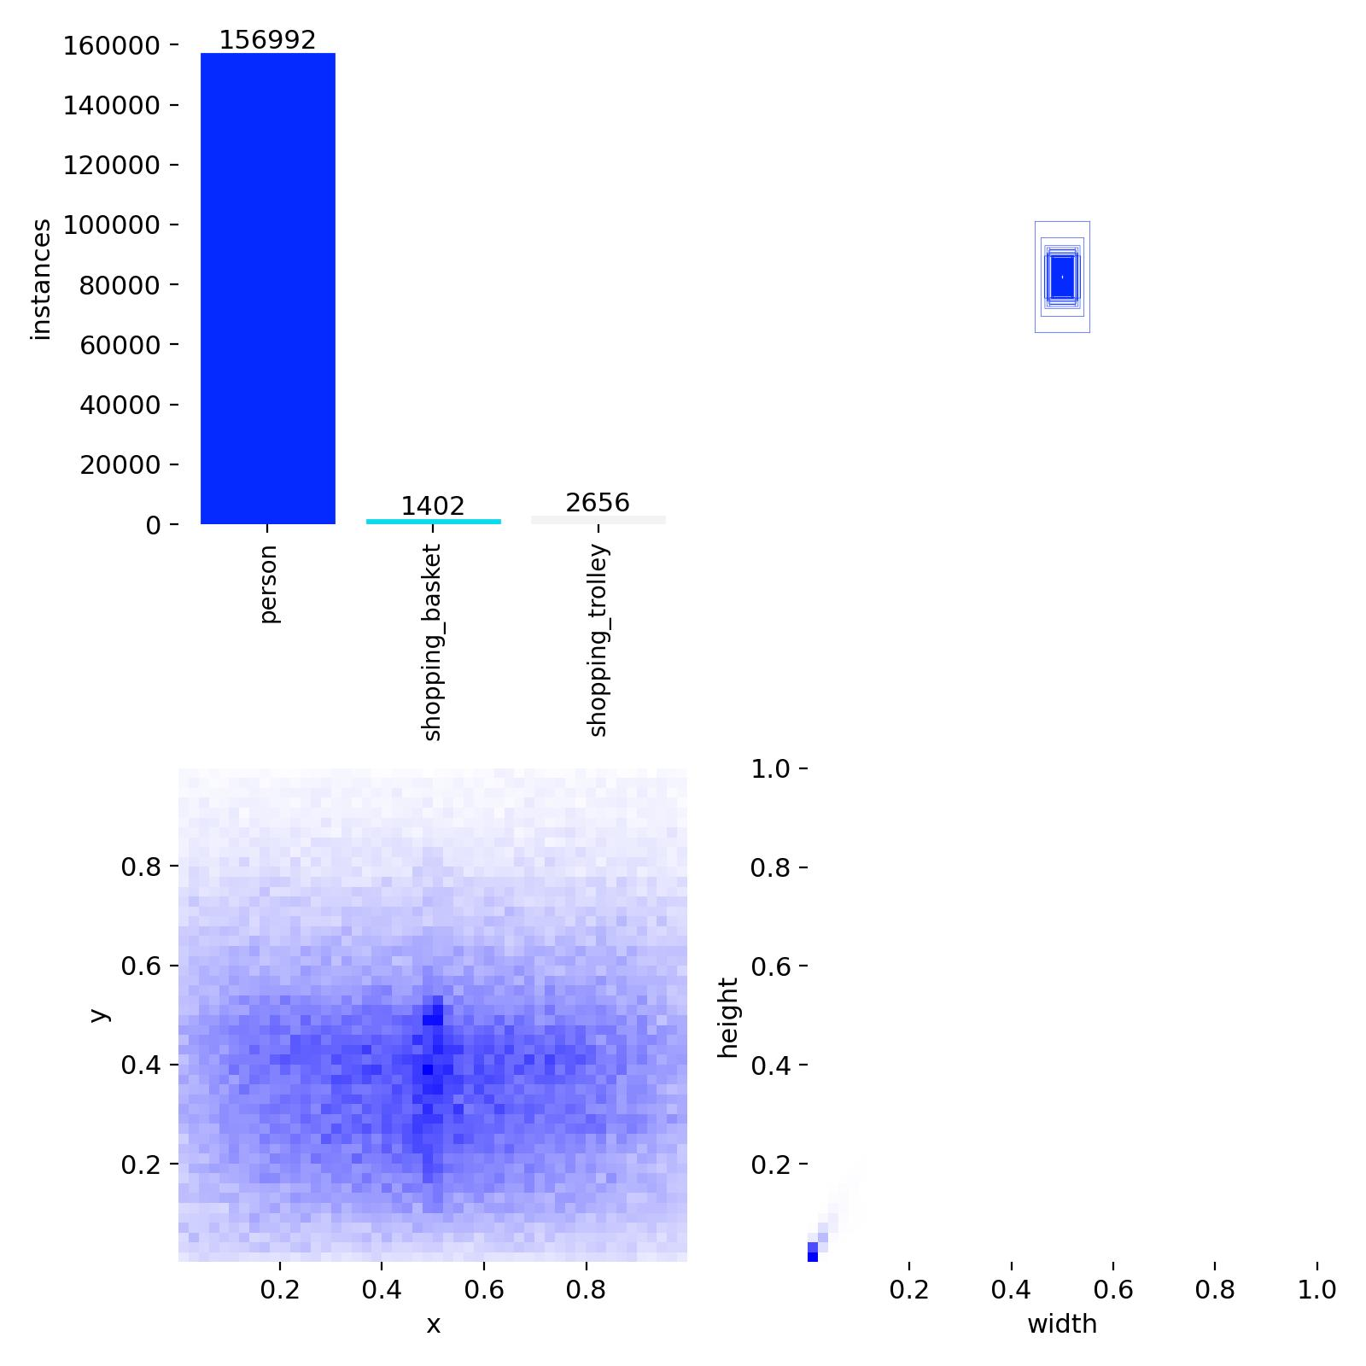
Figure 1. Dataset label distribution showing the class imbalance between person, shopping_basket, and shopping_trolley examples.

II. Methodology & Design Choices
The system uses an object detection pipeline based on YOLO. A camera is assumed to be installed near the checkout counter and pointed toward a predefined queue region. Each video frame is passed through the trained YOLO model, which detects persons, shopping baskets, and shopping trolleys.

The main logic is:

- A detected person inside the queue region is counted as a customer.
- A detected shopping_basket or cart is assigned a lower checkout service time.
- A detected shopping_trolley is assigned a higher checkout service time.
- If a person is missed but a basket or trolley is detected, the system still adds an estimated customer.
- Waiting time is calculated cumulatively based on the service time of the customers ahead.
- The waiting time for the last five customers is displayed.
- A long queue warning is shown when the queue length crosses a threshold.

Originally, the proposal planned to estimate trolley fullness using edge detection. However, during implementation, we replaced this with a more practical class-based service time approach. Instead of trying to estimate exact cart fullness, the system uses the object type as a proxy for checkout time. A customer with a basket or small cart is expected to take less time, while a customer with a trolley is expected to take more time.

The estimated service times used are:

Detected Case | Estimated Service Time
Shopping basket/cart | 45 seconds
Person only / unknown item | 75 seconds
Shopping trolley | 120 seconds

This design was selected because the model could reliably distinguish trolleys and baskets after training, while edge detection would be sensitive to lighting, camera angle, shadows, and background clutter.

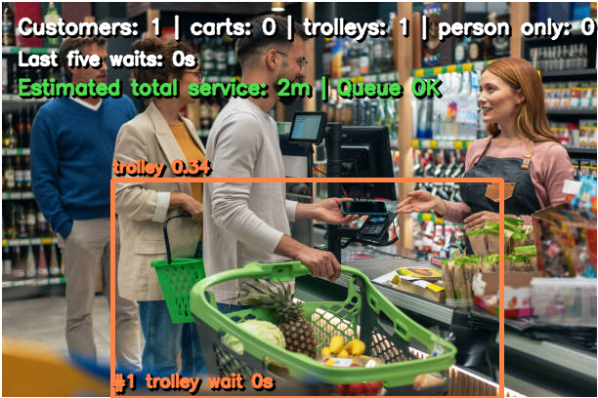
Figure 2. Example queue output where a trolley is detected and converted into an estimated service time.

For preprocessing, labels from different sources were cleaned, remapped, and converted into a unified YOLO format. The final class mapping was kept consistent as: 0 = person, 1 = shopping_basket, and 2 = shopping_trolley. Images without useful matching labels were either removed or treated carefully so that incorrect labels would not damage training. The final dataset was split into training and validation sets and used for YOLO fine-tuning.

YOLO was selected because the input data is image/video-based and the task requires real-time object detection. Traditional models such as Random Forests are not suitable for detecting objects in frames because they do not naturally handle spatial bounding boxes. YOLO is designed for fast object localization and classification, making it appropriate for a checkout monitoring system.

III. Failure Analysis
Not everything worked perfectly during development. One major issue was person detection. Since the person class was trained using a face-based dataset, the model often failed when people were facing away from the camera, standing sideways, or partially hidden. This meant that the system is better at detecting visible faces than full human bodies. In real supermarket queues, people may turn around, bend down, or be blocked by carts, so this remains a limitation.

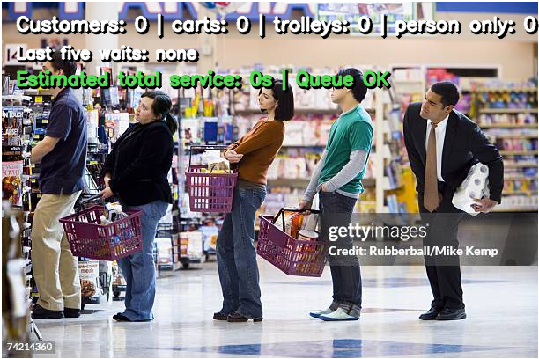
Figure 3. Failure example: visible customers are present, but the system reports zero customers because the person detector misses them.

A second issue was plastic trolleys. Many trolley training examples were metal trolleys, while some real-world supermarket carts are plastic and visually similar to baskets. Because of this, the model sometimes classified plastic trolleys as shopping_basket. This affects waiting time estimation because baskets are assigned lower service time while trolleys are assigned higher service time.

Another approach that was reconsidered was edge detection for cart fullness. Edge detection was part of the original proposal, but it was not reliable enough for real supermarket scenes. The number of edges inside a cart can change due to lighting, reflections, shadows, background texture, and trolley structure itself. Therefore, object class-based service estimation was chosen instead.

The system was adjusted to handle some of these failures by adding fallback logic. If a person is missed but a basket or trolley is detected, the system still increases the queue estimate. This prevents the queue length from becoming too low just because the person detector misses a customer.

IV. Results & Hyperparameter Tuning
The final model was trained using YOLO26s for three classes: person, shopping_basket, and shopping_trolley. Training was performed using GPU-based environments including Colab and Kaggle. The final trolley-focused fine-tuning was run on Kaggle using dual Tesla T4 GPUs.

The final fine-tuning run used:

- Image size: 960
- Batch size: 8
- Device: dual GPU
- Epochs planned: 50, Total: 136
- Early stopping patience: 15
- Mosaic augmentation: 0.8
- Mixup: 0.0
- Lower geometric distortion to preserve trolley shape

The run stopped early after 37 epochs because no further improvement was observed for 15 epochs. The best model was saved from epoch 22.

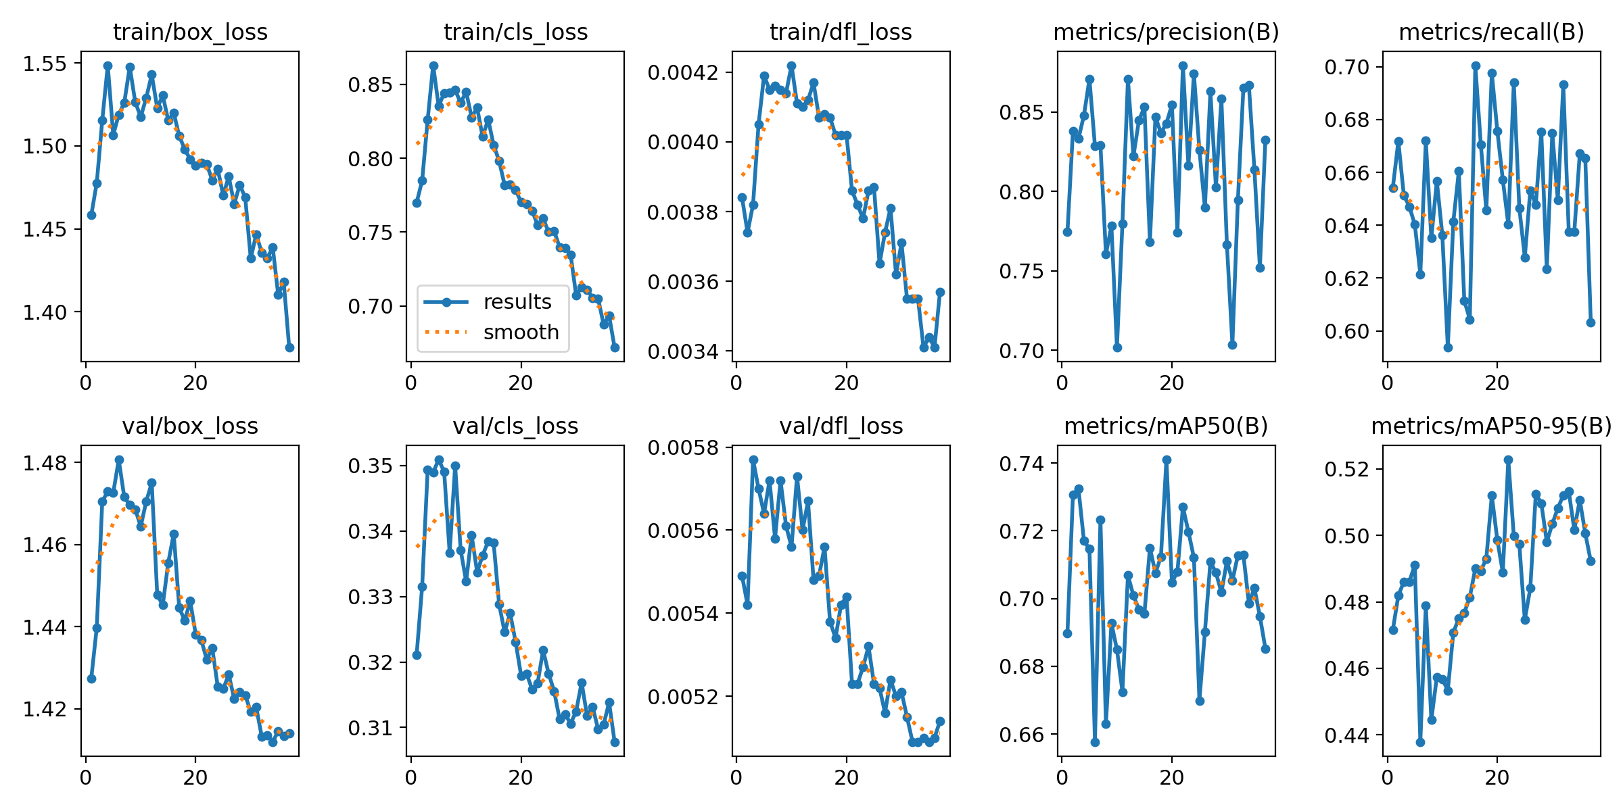
Figure 4. Training and validation curves from the final YOLO fine-tuning run.

Final validation results:

Class | Precision | Recall | mAP50 | mAP50-95
All classes | 0.879 | 0.640 | 0.726 | 0.523
Person | 0.900 | 0.664 | 0.760 | 0.425
Shopping basket | 0.819 | 0.333 | 0.463 | 0.355
Shopping trolley | 0.917 | 0.923 | 0.957 | 0.788

The trolley class performed very well after fine-tuning, reaching a high recall of 0.923 and mAP50 of 0.957. This shows that the model became strong at detecting shopping trolleys. The person class also had good precision, but recall was lower because the detector still misses some people when faces are not visible. The basket class had good precision but low recall, mainly because the validation set had very few basket examples compared to the other classes.

Instead of reporting only accuracy, we used precision, recall, mAP50, and mAP50-95. These metrics are more suitable for object detection because they measure both classification and bounding box quality.

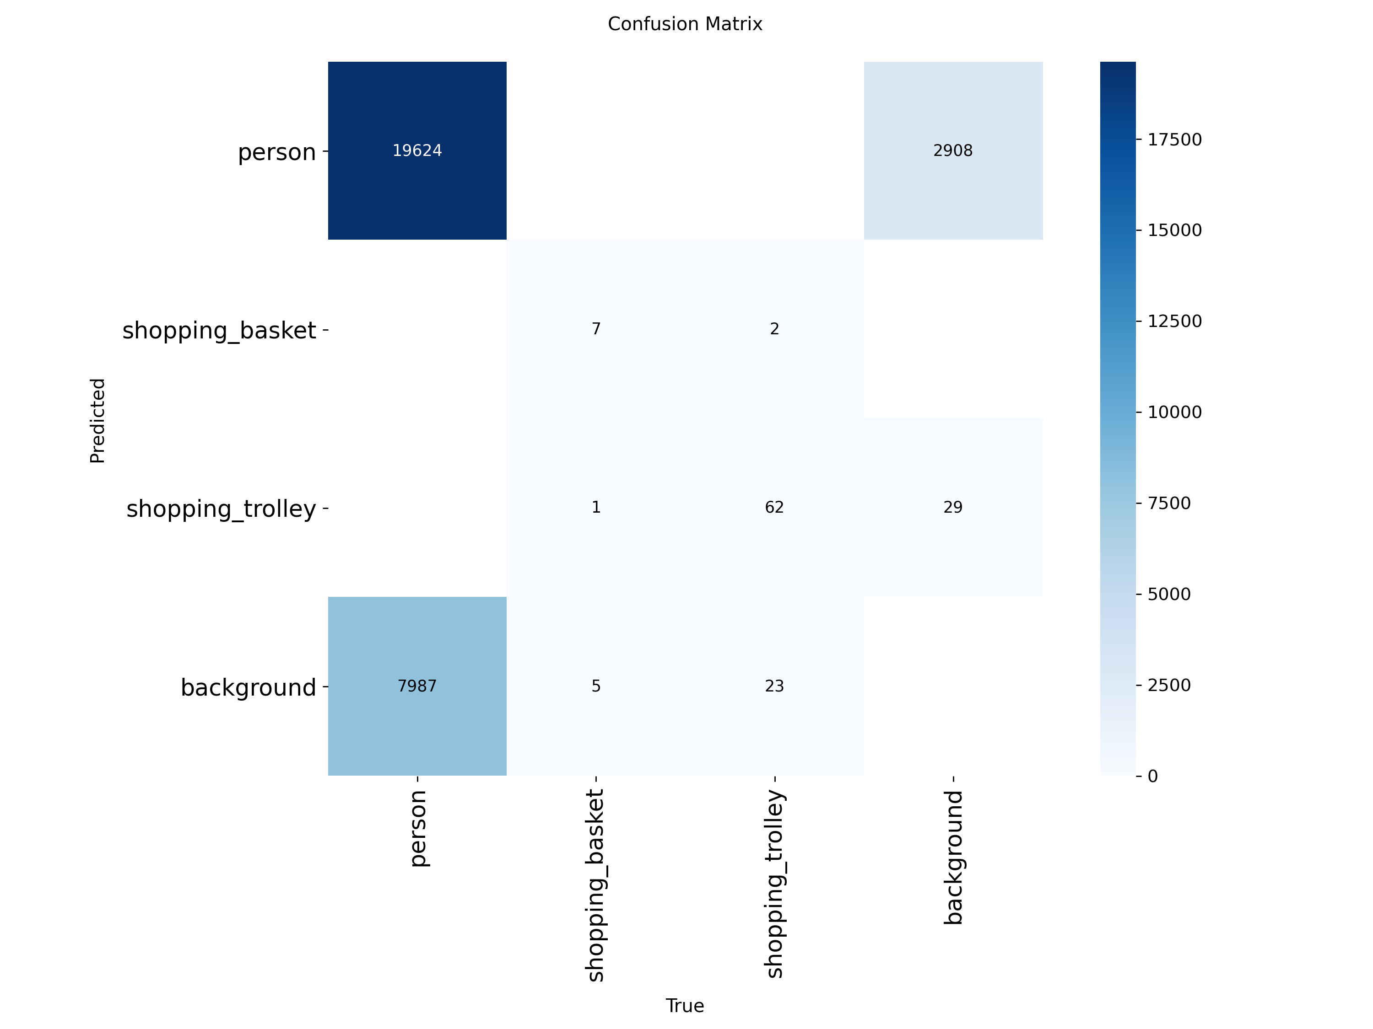
Figure 5. Confusion matrix showing correct detections, missed detections, and class-level errors.

V. Ethical Reflection & Limitations
The system has practical limitations in real-world use. It can fail when trolleys are hidden behind people, when customers are heavily occluded, or when the camera angle does not clearly show both people and carts. It may also perform poorly in low light, crowded scenes, unusual supermarket layouts, or stores using trolley designs that were not well represented in the training data.

The person detection limitation is especially important. Since the model uses face-based detection for the person class, it may miss customers whose faces are turned away, covered, or outside the camera view. This means queue estimates may be inaccurate unless the fallback basket/trolley logic catches those customers.

There are also ethical concerns. The system uses cameras in a public shopping environment, so customers may be recorded or detected without explicit consent. Some people may be uncomfortable being monitored, especially if they are camera shy or concerned about privacy. To reduce this concern, the system should avoid storing identifiable video whenever possible and should only use detections for aggregate queue estimation. Clear signs should inform customers that automated queue monitoring is being used. The system should not perform identity recognition, face matching, or customer profiling.

Overall, the project demonstrates that computer vision can be used to estimate supermarket queue length and waiting time, but deployment should be done carefully. The model works best when the camera has a clear view of the queue, the trolley and basket types match the training data, and privacy safeguards are respected.

