10PEARLS
10Shine Internship Program

Assignment No. 6

Cypress Automation
Project: SauceDemo
Domain: Quality Assurance (Manual + Automation)

Submitted by: Muhammad Faizan Anwar
QA Intern – 10Shine Cohort

1. Executive Summary
This report documents the end-to-end (E2E) UI automation of the SauceDemo application using the Cypress testing framework. Based on the technical requirements and sync-up guidelines, this project goes beyond basic scripting by implementing an enterprise-grade automation architecture. The core focus was on code maintainability, readability, and reusability, culminating in a CI/CD-ready test suite with professional HTML reporting.
- Key Technical Milestones Achieved:
- Initialized a Node.js project with custom NPM scripts for headed and headless execution.
- Implemented the Page Object Model (POM) design pattern to separate UI locators from test logic.
- Created reusable Custom Commands to reduce code duplication.
- Automated both negative and positive user flows, including product validation.
- Integrated Mochawesome Reporter for high-quality, interactive test execution dashboards.

2. Project Initialization & Architecture [Task 1]
The project was initialized as a standard Node.js environment (npm init -y). Cypress was installed as a development dependency (--save-dev) to align with industry best practices.
Advanced Configuration (Custom NPM Scripts):
To simulate a Continuous Integration (CI) environment, custom scripts were added to the package.json file. This allows testers to trigger the suite without typing verbose Cypress CLI commands:
- npm run cy:open: Launches the interactive Cypress Test Runner.
- npm run cy:run: Executes the entire test suite invisibly in headless mode.

3. Framework Design: Scalability & Reusability
As highlighted during the technical sync-up, writing readable and maintainable code is the primary goal of modern QA automation. This was achieved through two critical architectural decisions:

3.1 Custom Commands [Task 5]
A custom command (cy.login) was engineered inside the cypress/support/commands.js file. Since logging into an application is a prerequisite for almost every test case, encapsulating the visit(), type(), and click() events into a single, reusable function drastically reduced code bloat in the main spec files.
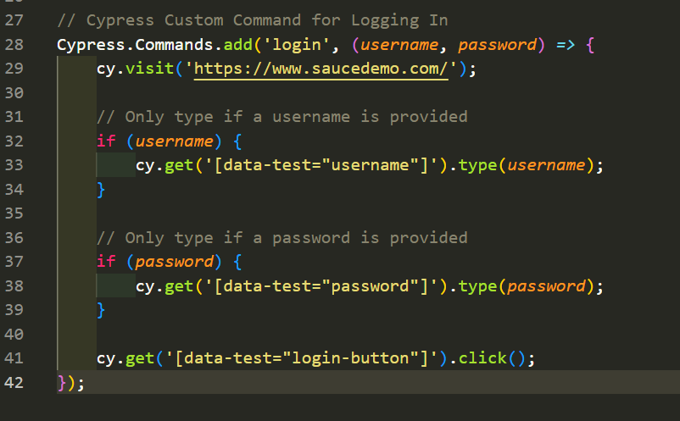

3.2 Page Object Model (POM) [Task 6]
The Page Object Model was strictly enforced to separate web locators from testing logic. A dedicated 'pageObjects' directory was created containing class files for different views:
- - LoginPage.js: Encapsulates error message locators and validation actions.
- - InventoryPage.js: Encapsulates complex locators, including dynamic product selection and DOM traversal to verify specific product prices based on dynamic text.
By importing these classes into the main test file, the actual test blocks read like plain English, making the suite highly scalable and easy for non-technical stakeholders to understand.

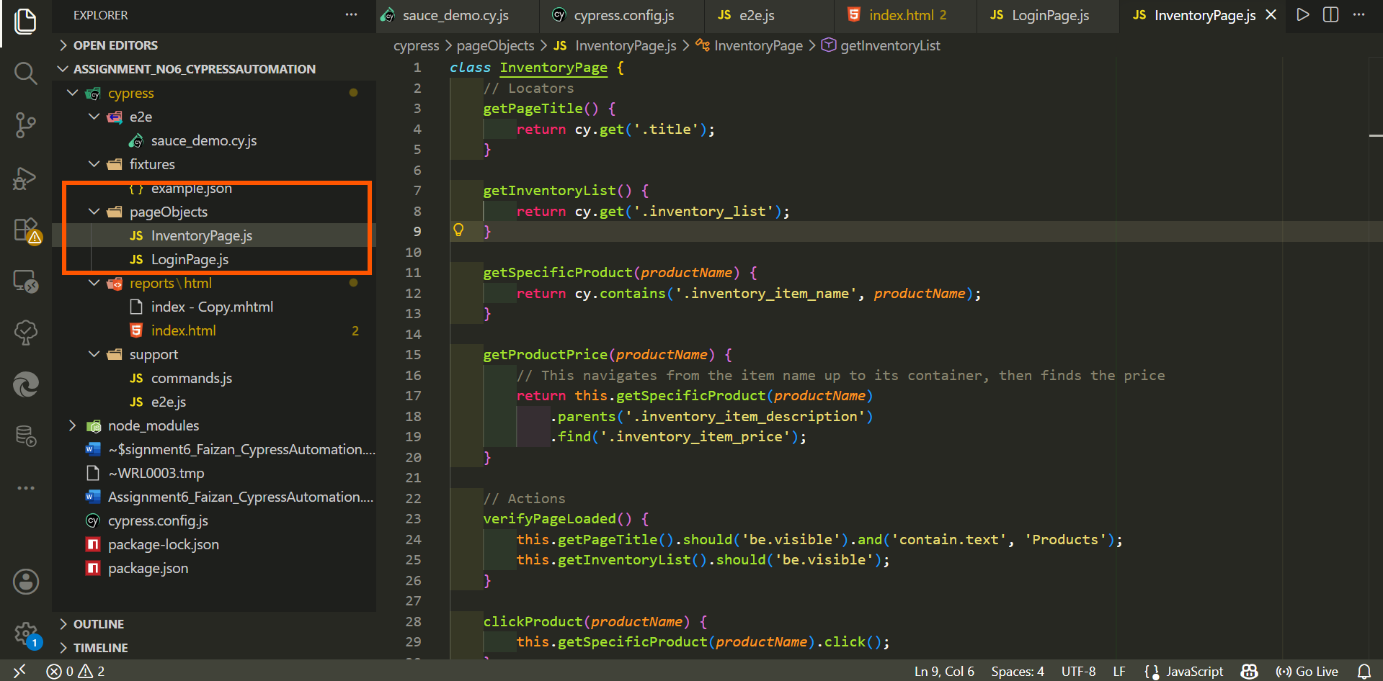

4. E2E Test Suite Implementation
With the POM and Custom Commands in place, the core automation logic was executed within a single, highly readable spec file (sauce_demo.cy.js).

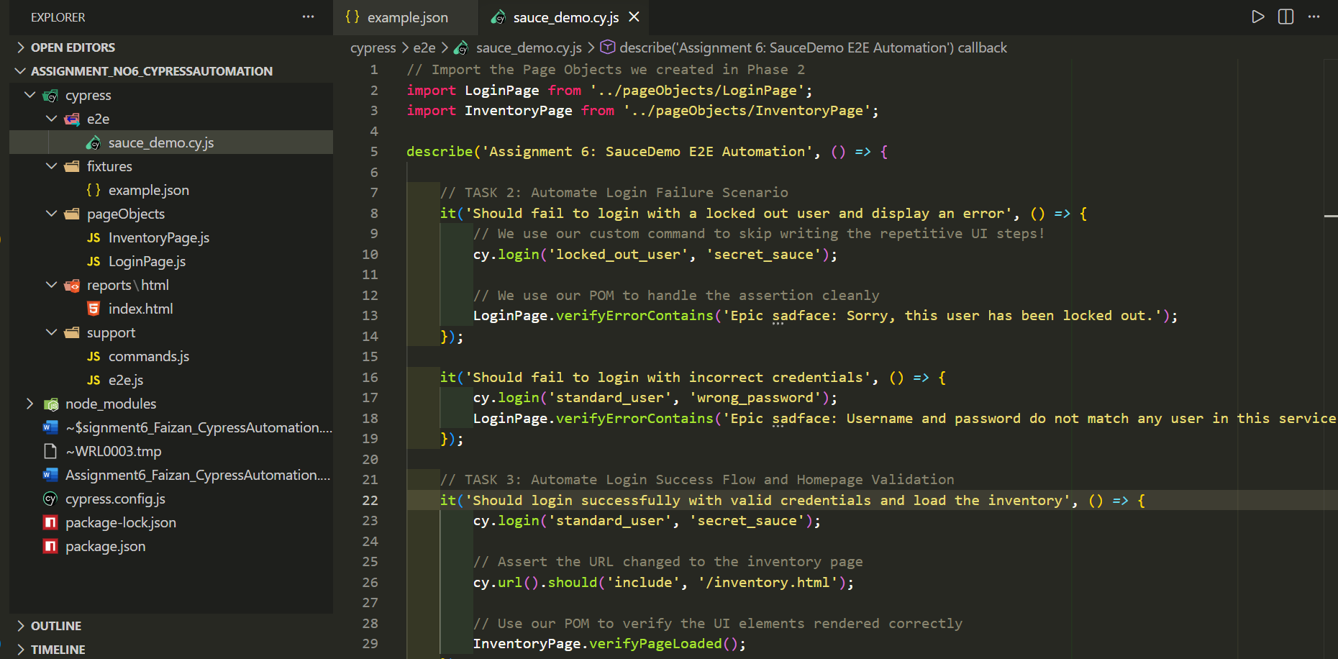

4.1 Automating Negative Flows: Login Failures [Task 2]
Objective: Validate that the system properly restricts access and displays accurate error messaging for invalid authentication attempts.
Test Case A: Attempted login with 'locked_out_user'. Asserted the specific 'Epic sadface' lockout warning using the LoginPage POM.
Test Case B: Attempted login with incorrect credentials. Asserted the 'Username and password do not match' error message.

4.2 Positive Flows: Successful Login & Validation [Task 3]
Objective: Validate that a standard user can successfully authenticate and is routed to the correct dashboard.
Execution: Utilized the cy.login() custom command with valid credentials. Asserted that the application URL updated to '/inventory.html' and utilized the InventoryPage POM to ensure the 'Products' header and inventory list were visible in the DOM.

4.3 Product Navigation & Data Validation [Task 4]
Objective: Ensure the e-commerce inventory functions correctly, rendering accurate prices and navigating successfully to product detail pages.
Execution: The test located the 'Sauce Labs Backpack', dynamically retrieved its price tag from the parent container, and asserted it equaled '$29.99'. It then commanded a click on the product, asserted the URL transition to '/inventory-item.html', and validated the product name and price on the details page.

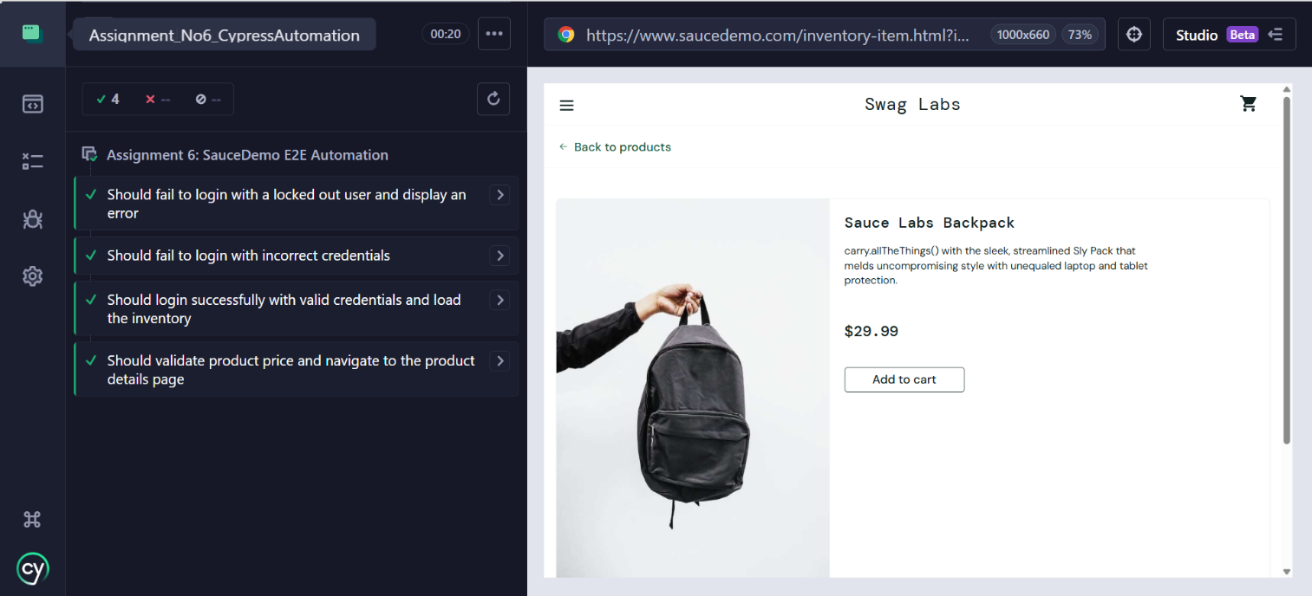

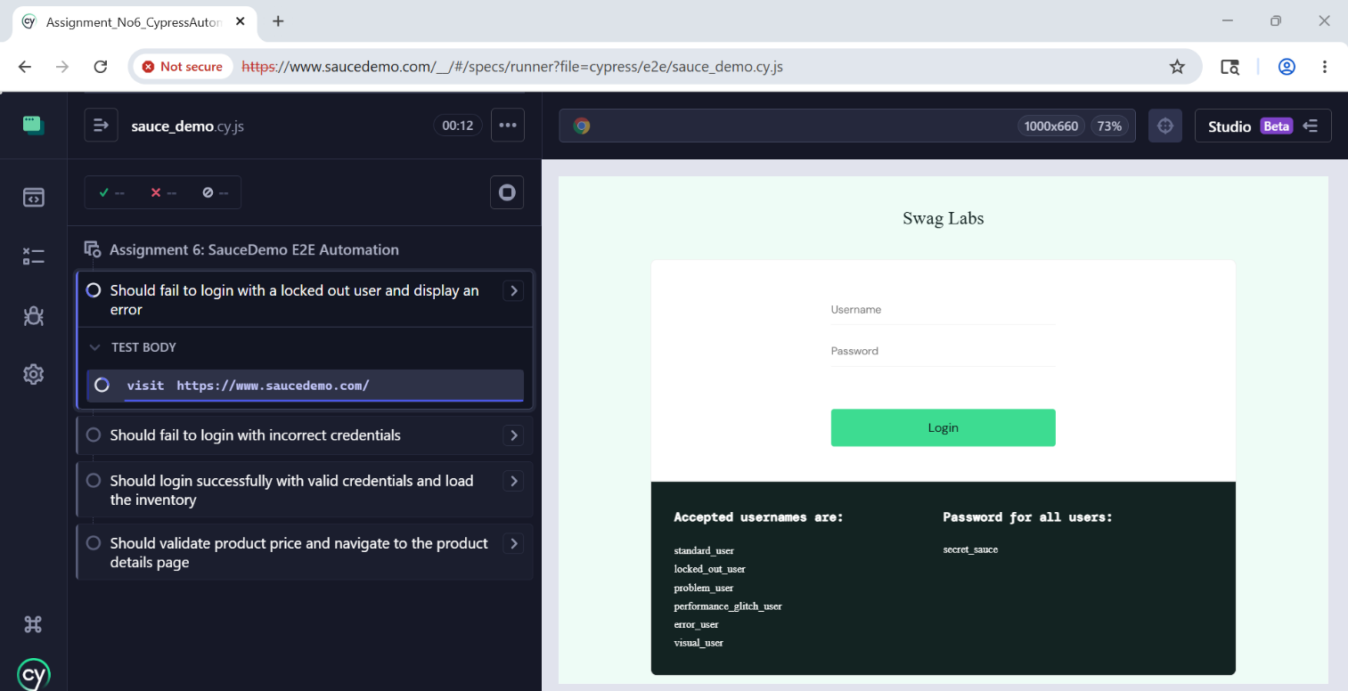

5. Advanced Execution & Professional Reporting
To elevate the project to an enterprise standard, the suite was configured for headless execution and integrated with cypress-mochawesome-reporter.

Headless Execution: By running 'npm run cy:run', the entire E2E suite was executed in the background without launching a browser UI. This proves the framework is ready to be plugged into a CI/CD pipeline (e.g., Jenkins, GitHub Actions).

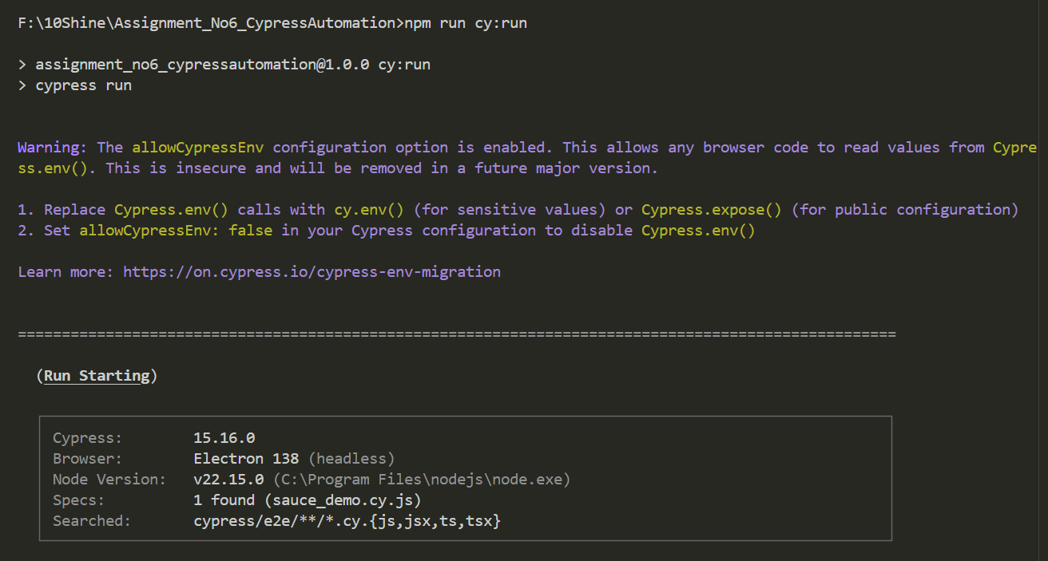
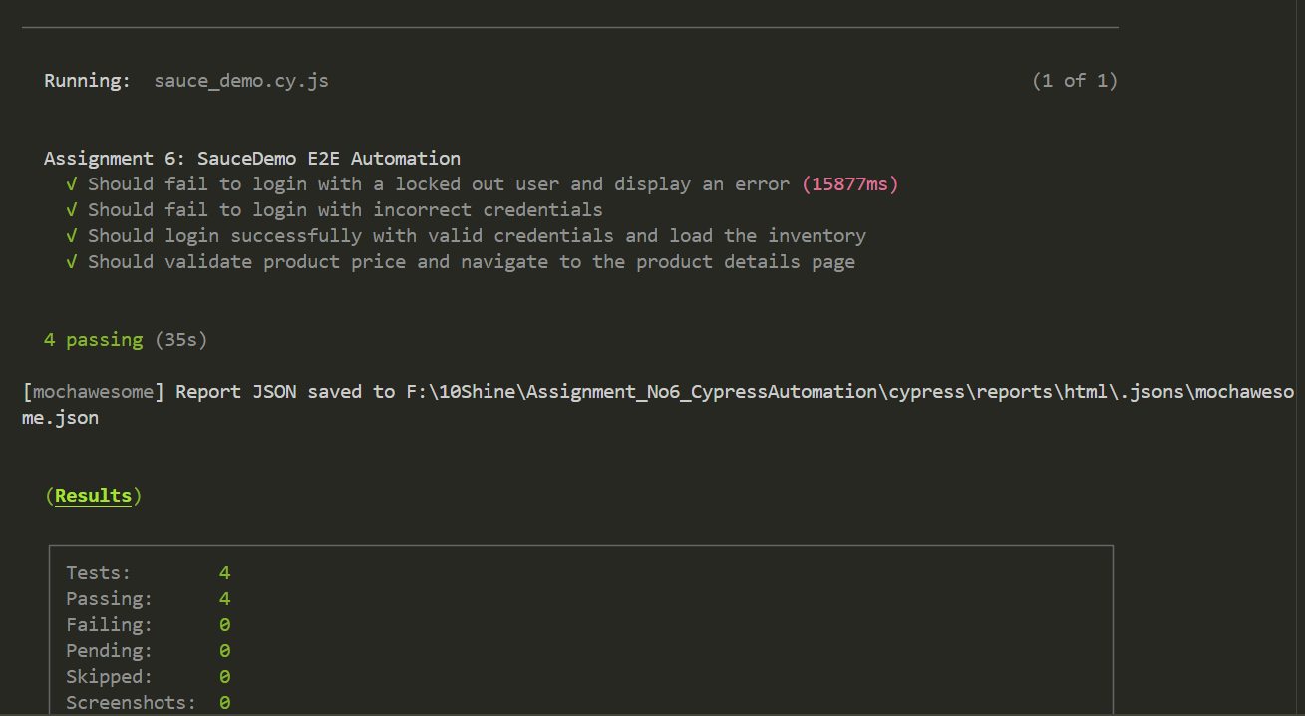

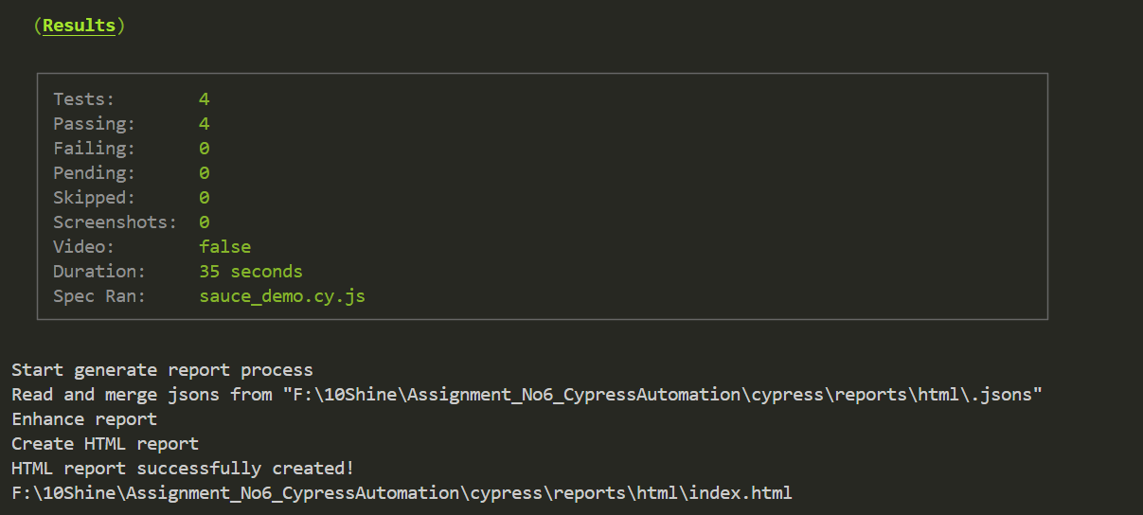
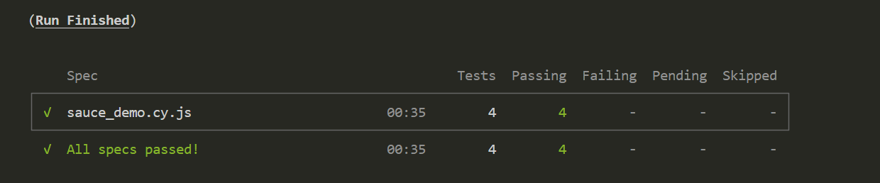

Mochawesome HTML Dashboard: The test configuration was modified to automatically generate a rich, interactive HTML dashboard upon completion of the headless run. This report provides a high-level overview of the suite's pass/fail ratio, execution time, and detailed logs, which is an industry requirement for QA reporting to management.

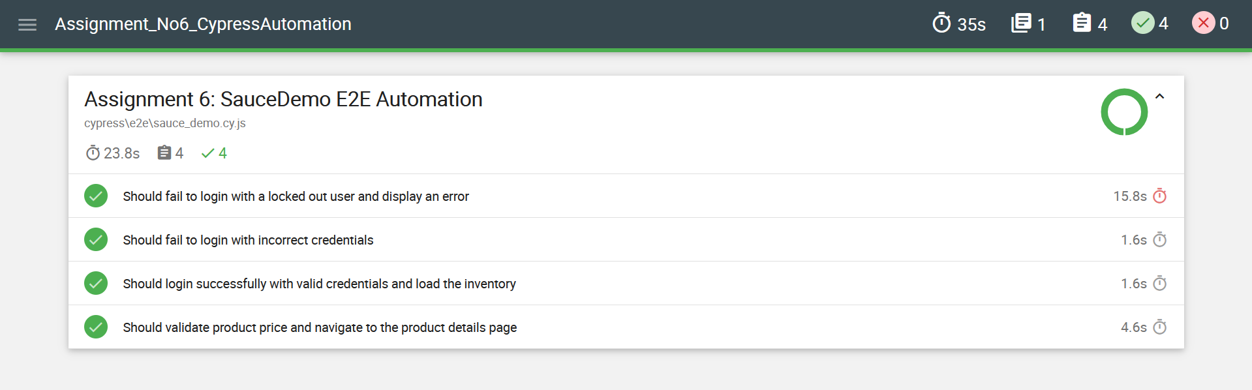

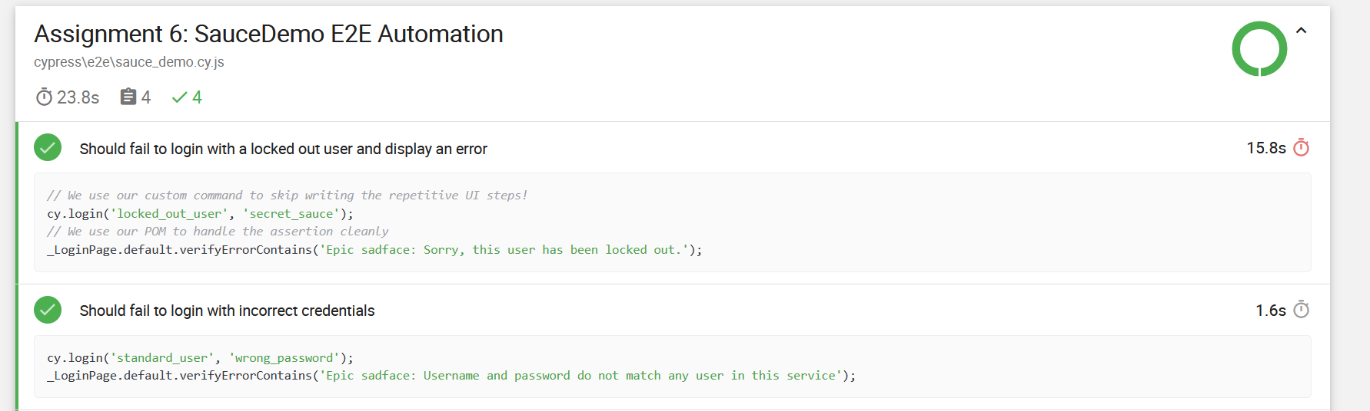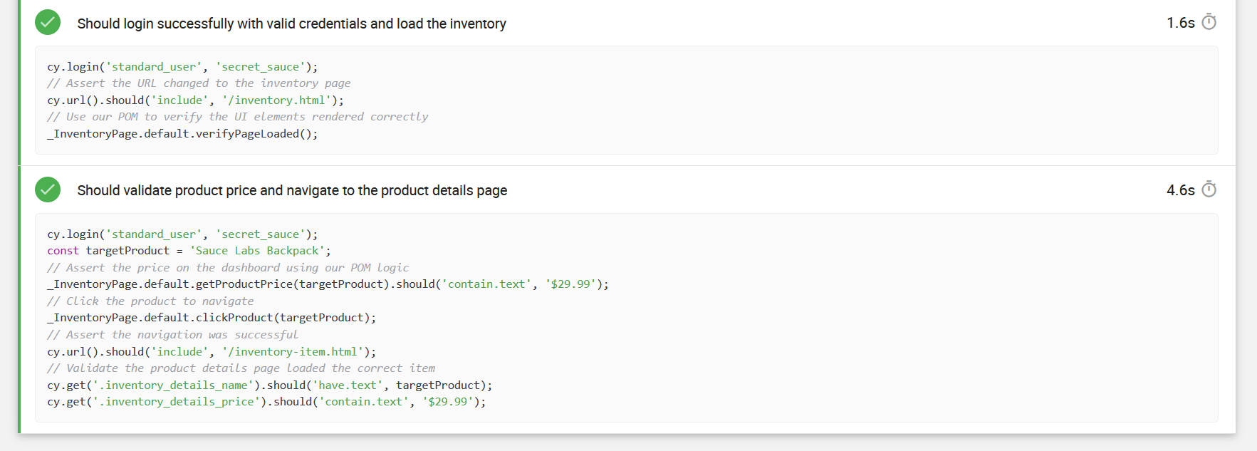

6. Conclusion
This assignment successfully demonstrates a comprehensive understanding of modern UI automation. By abstracting the locators into a Page Object Model and writing custom commands, the resulting Cypress codebase is highly robust, easily readable, and built for future scalability.

End of Submission — 10Shine Internship Program | Quality Assurance Domain

