10PEARLS
10Shine Internship Program

Assignment No. 4

Assignment No. 4 – API Testing with Postman

Domain: Quality Assurance (Manual + Automation)

Submitted by: Muhammad Faizan Anwar
QA Intern – 10Shine Cohort

1. Project Overview & Objectives
This report documents the completion of Assignment 4, focusing on comprehensive API testing using Postman. The objective was to create a fully functional Postman Collection that demonstrates the utilization of all standard HTTP methods (GET, POST, PUT, PATCH, DELETE), API chaining, dynamic data generation, and Chai assertions (including an intentional failure).
Target API: https://api.restful-api.dev/objects

2. Environment & Variable Setup
To ensure scalability and prevent hardcoding, a Collection Variable was established for the base URL.
Variable: baseUrl
Current Value: https://api.restful-api.dev/objects

3. API Execution Chain & Test Documentation

Request 1: Create Object (POST)
Objective: Generate random data using Postman's dynamic variables, send a POST request, and extract the generated ID for API chaining.
Endpoint: POST {{baseUrl}}
Key Concepts Demonstrated: Pre-request scripting for random data ({{$randomProductName}}), JSON parsing, Collection Variable setting (objectId).

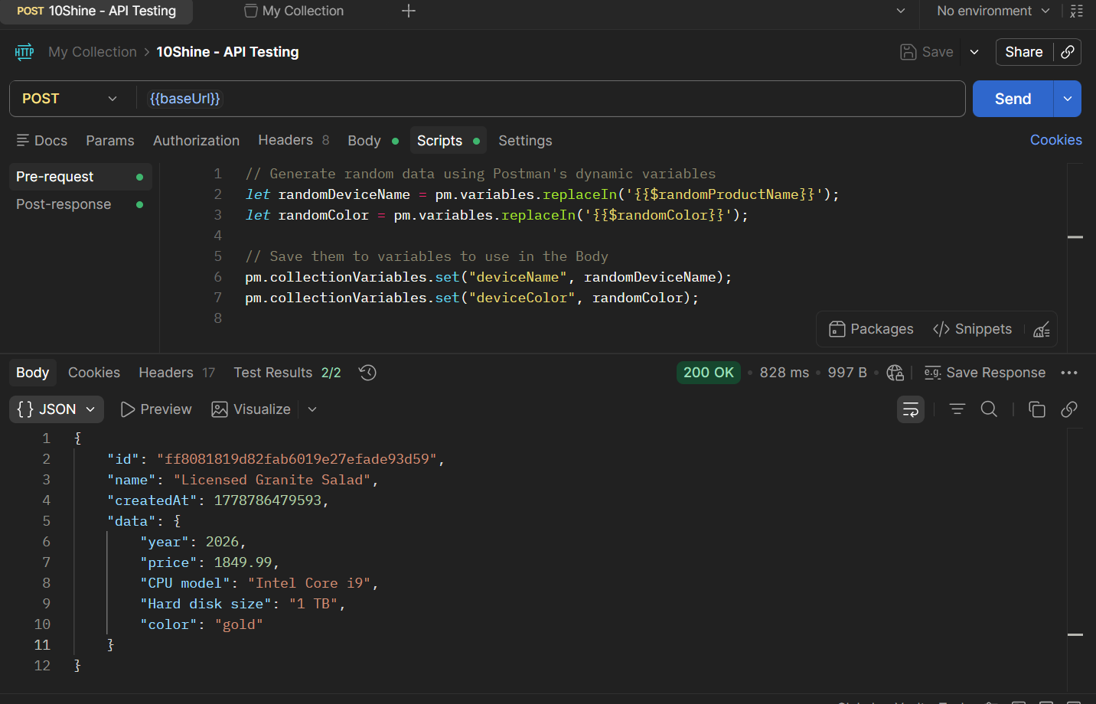

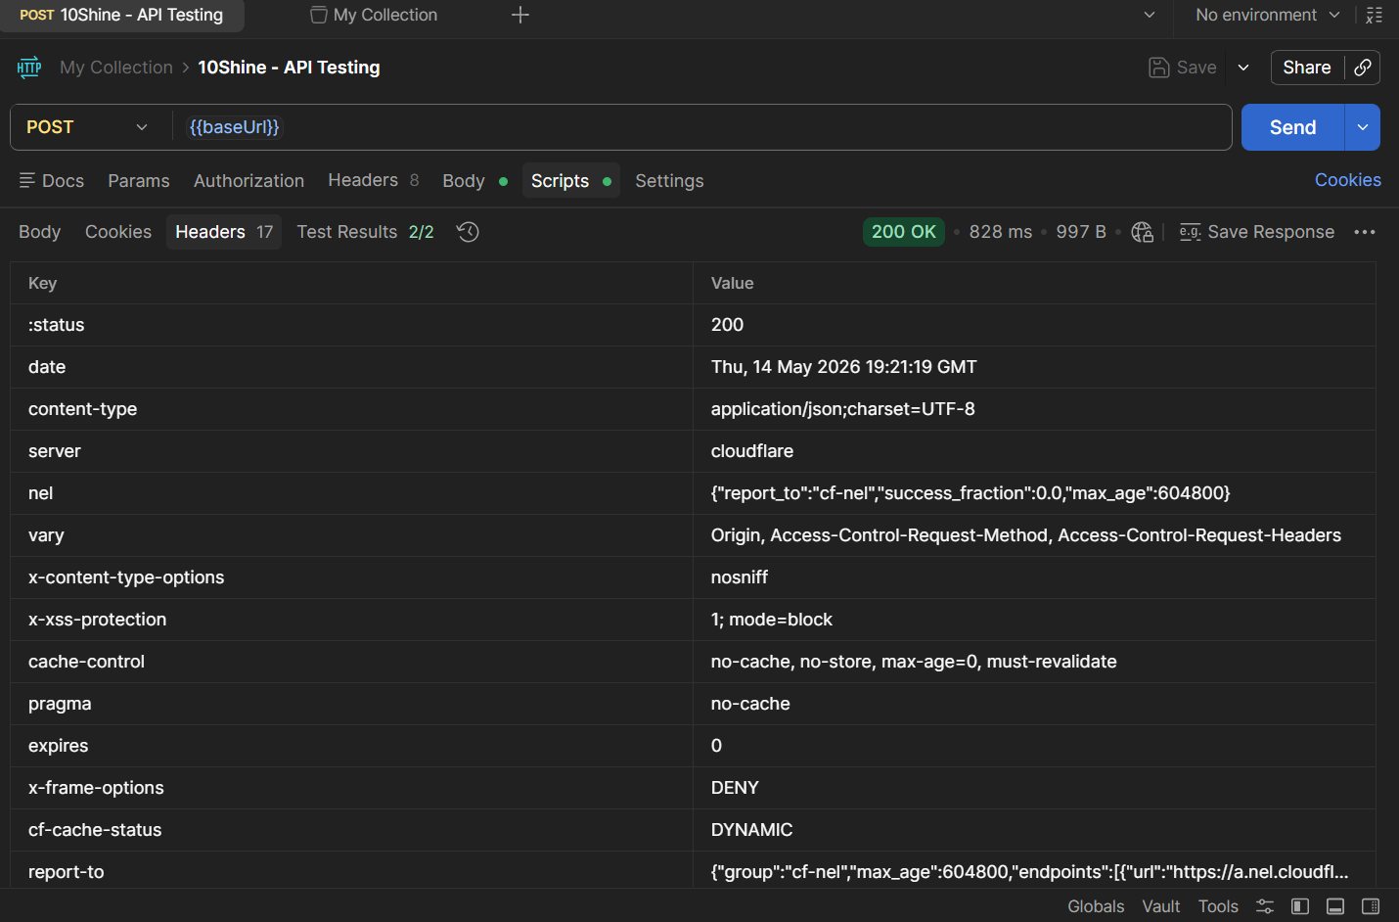

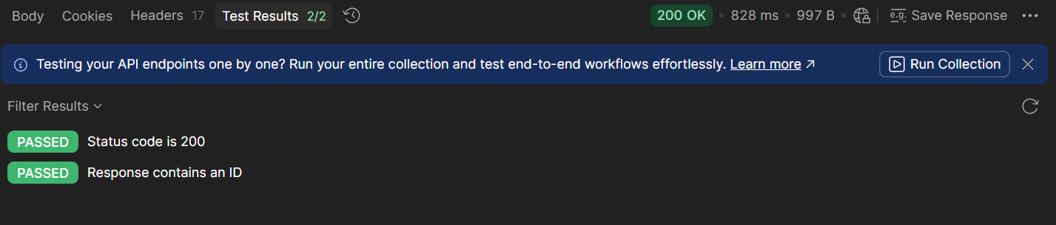

Request 2: Retrieve Object (GET)
Objective: Retrieve the newly created object using the chained variable and verify the data matches.
Endpoint: GET {{baseUrl}}/{{objectId}}
Key Concepts Demonstrated: API Chaining, GET method execution, verifying JSON response against saved collection variables.

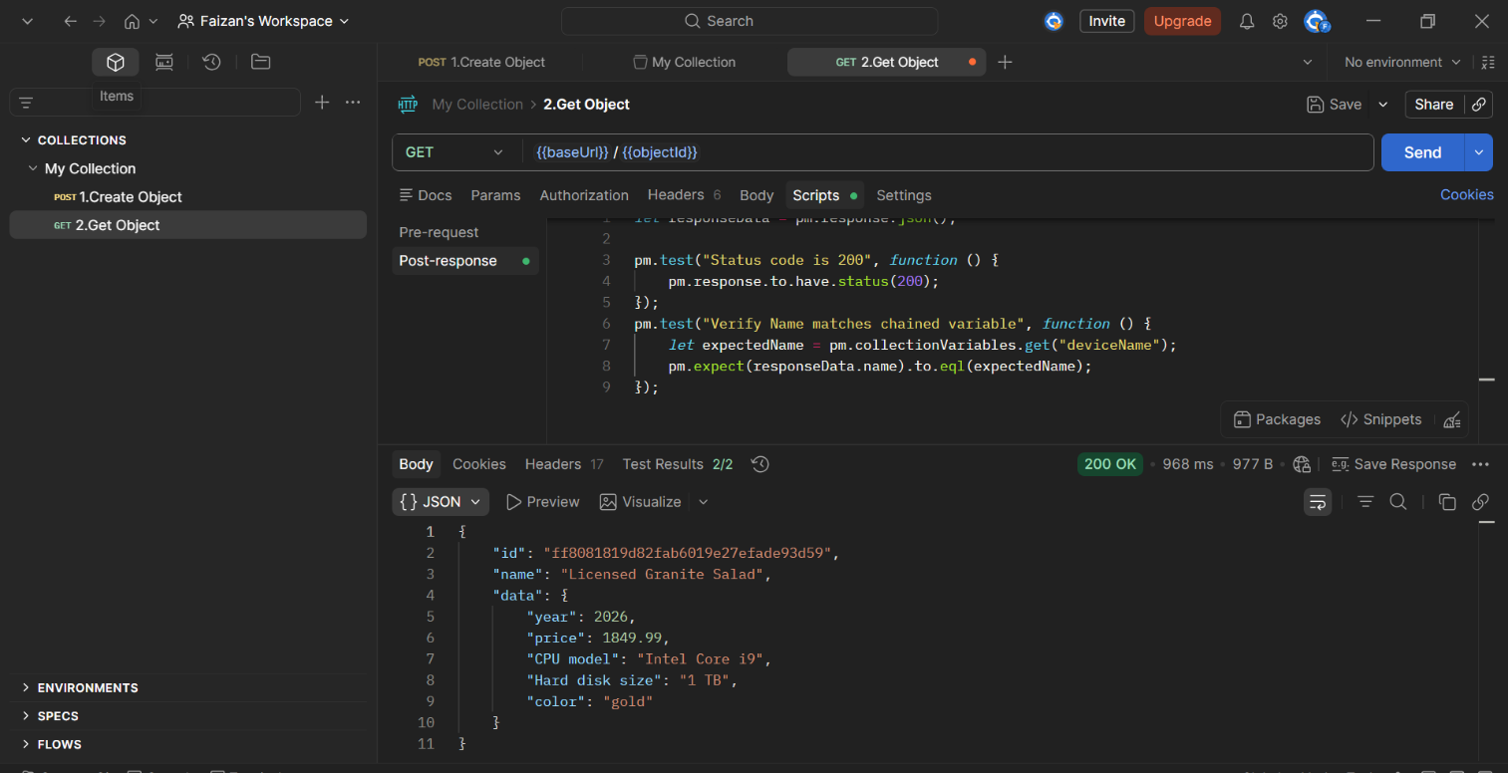

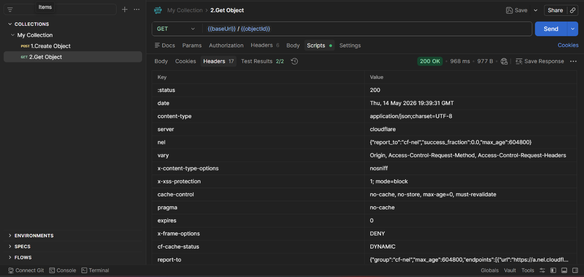

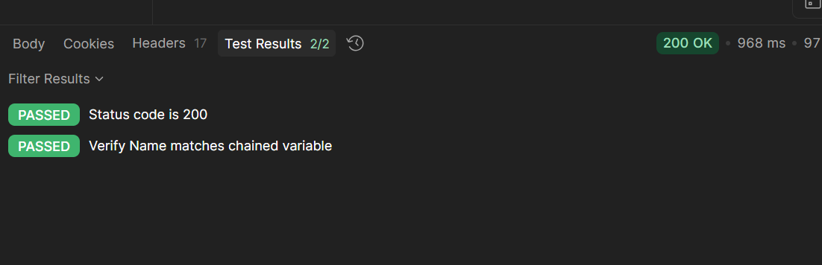

Request 3: Update Object (PUT)
Objective: Completely overwrite the target object's payload and verify the updated fields.
Endpoint: PUT {{baseUrl}}/{{objectId}}
Key Concepts Demonstrated: PUT method execution, payload modification, numerical value assertions (e.g., verifying updated price).

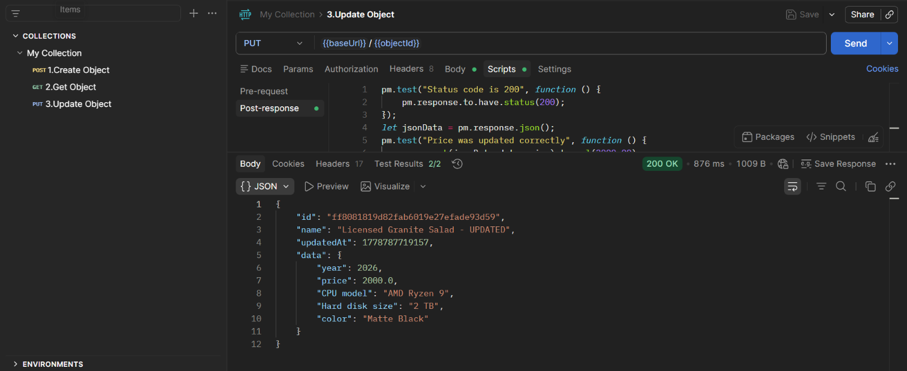

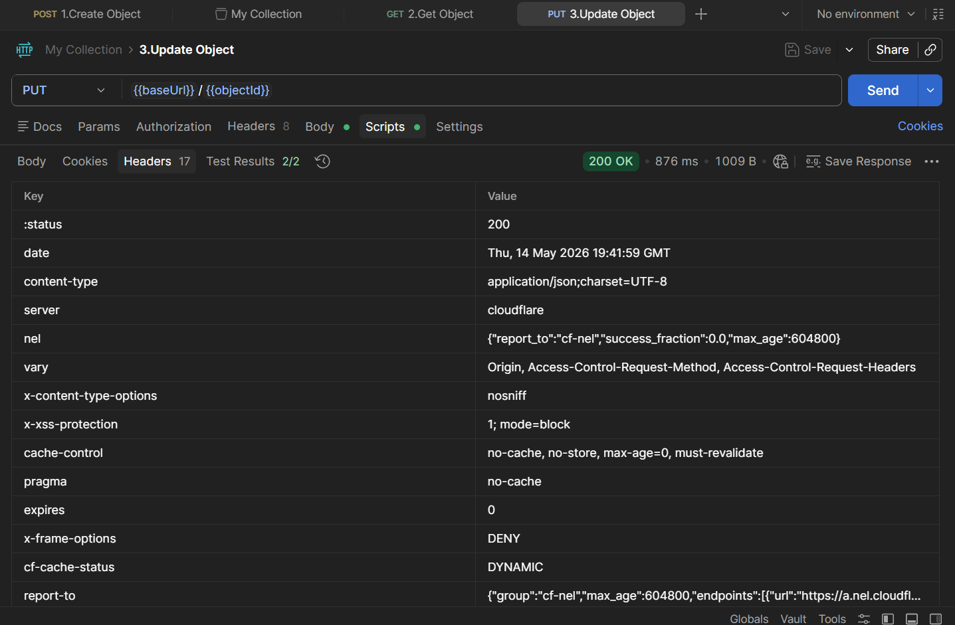

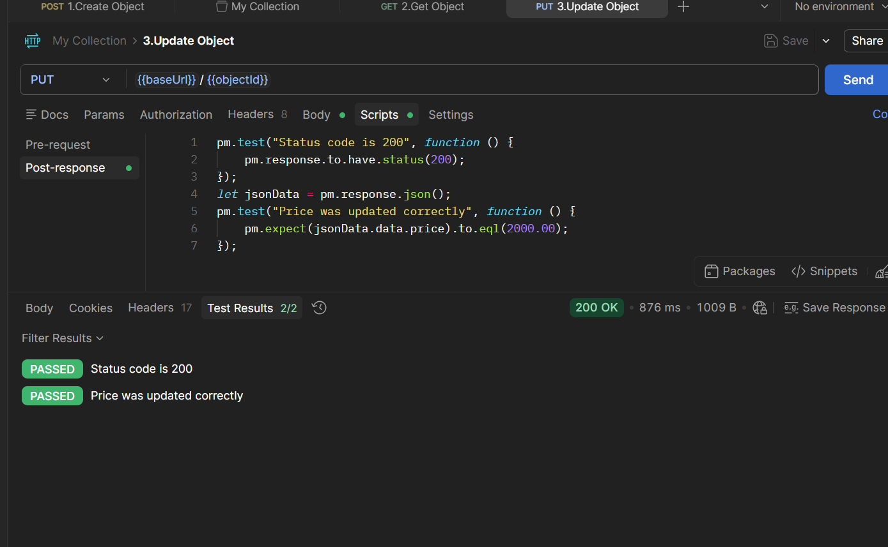

Request 4: Partially Update Object (PATCH)
Objective: Partially update the object's name and execute an intentionally failing Chai assertion to demonstrate test failure handling.
Endpoint: PATCH {{baseUrl}}/{{objectId}}
Key Concepts Demonstrated: PATCH method execution, string inclusion assertions (.to.include), intentional failing test (expecting 201 when server returns 200).

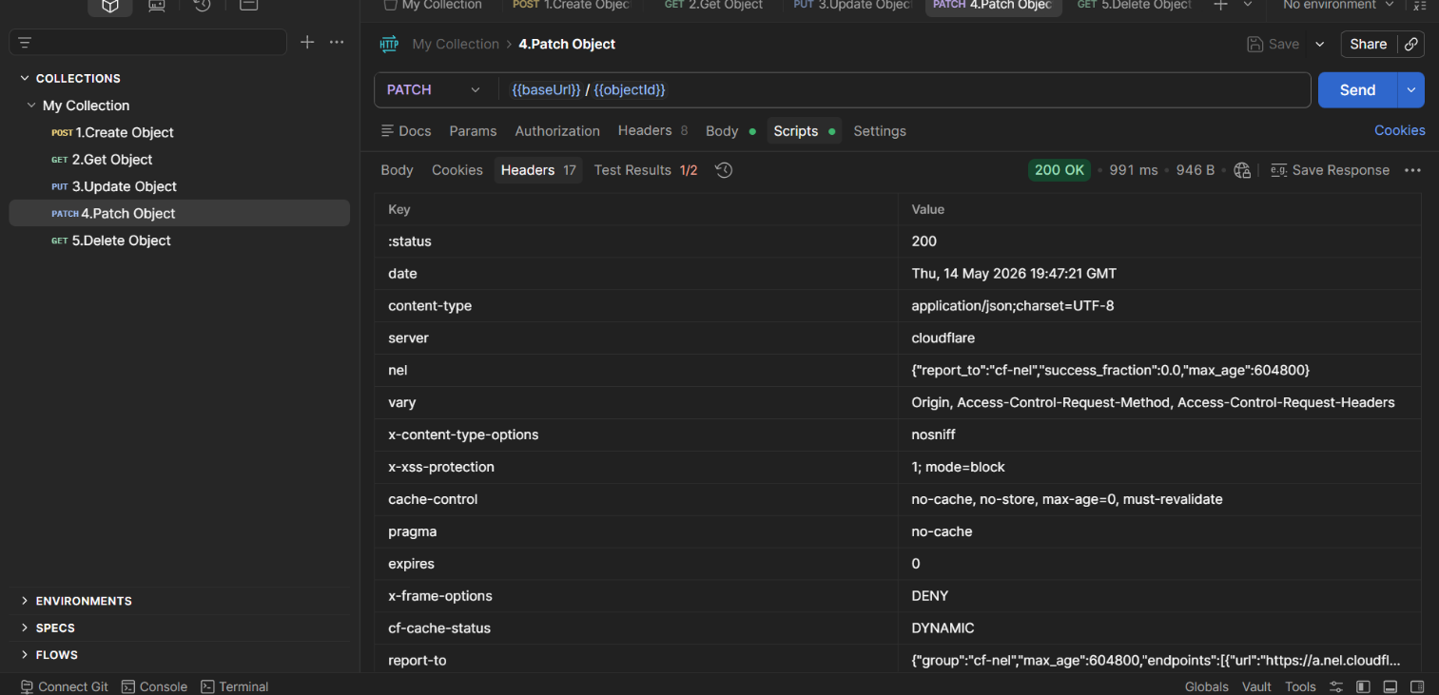

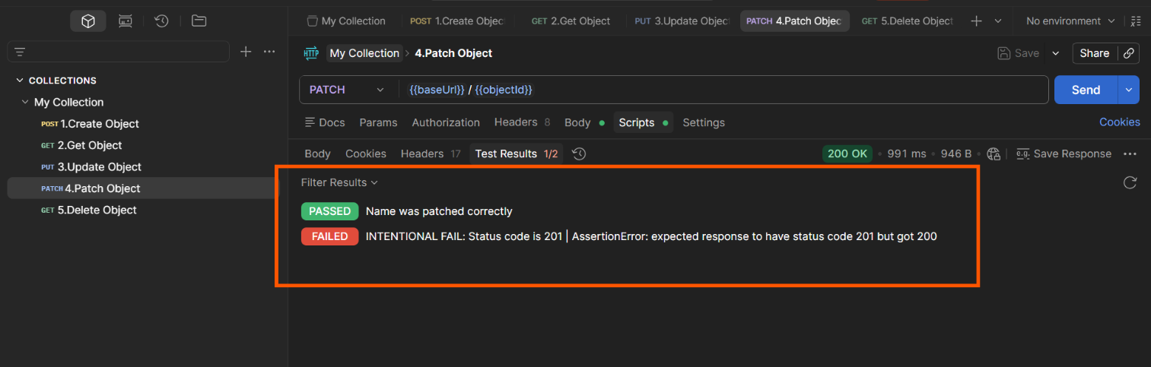

Request 5: Delete Object (DELETE)
Objective: Delete the target object and clean up the Postman environment.
Endpoint: DELETE {{baseUrl}}/{{objectId}}
Key Concepts Demonstrated: DELETE method execution, message string assertions, variable unsetting (pm.collectionVariables.unset).

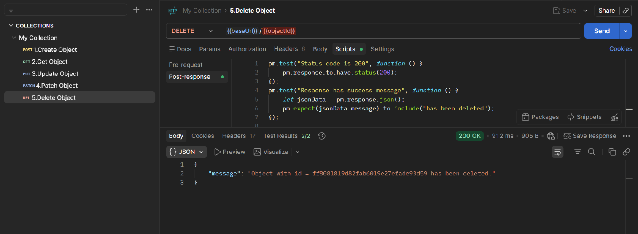

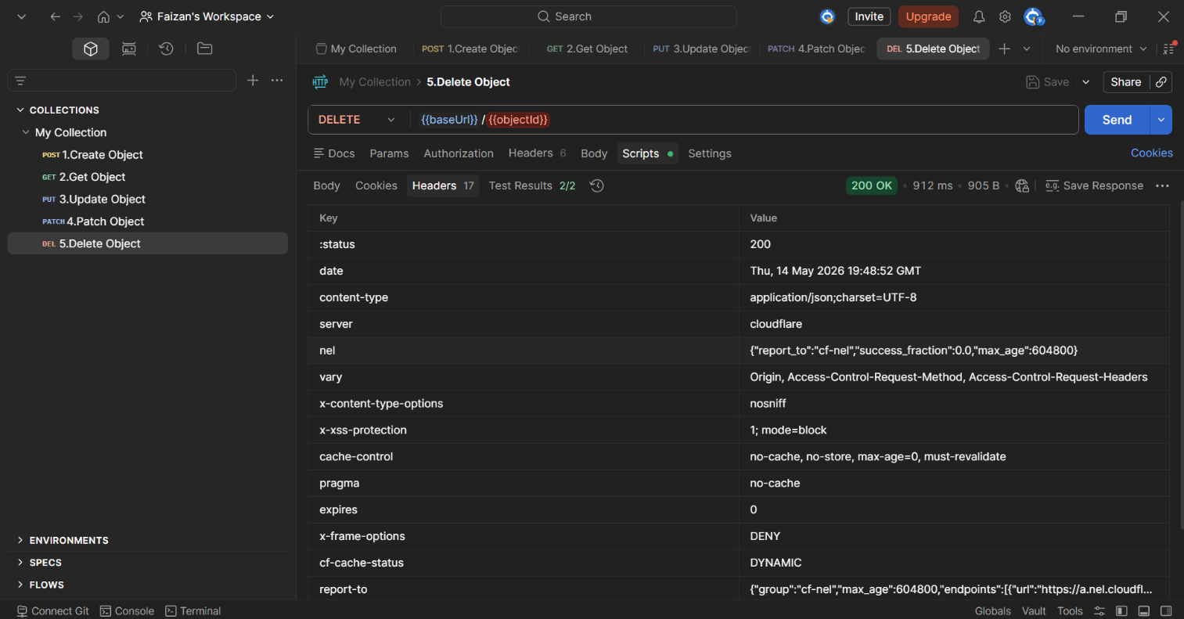

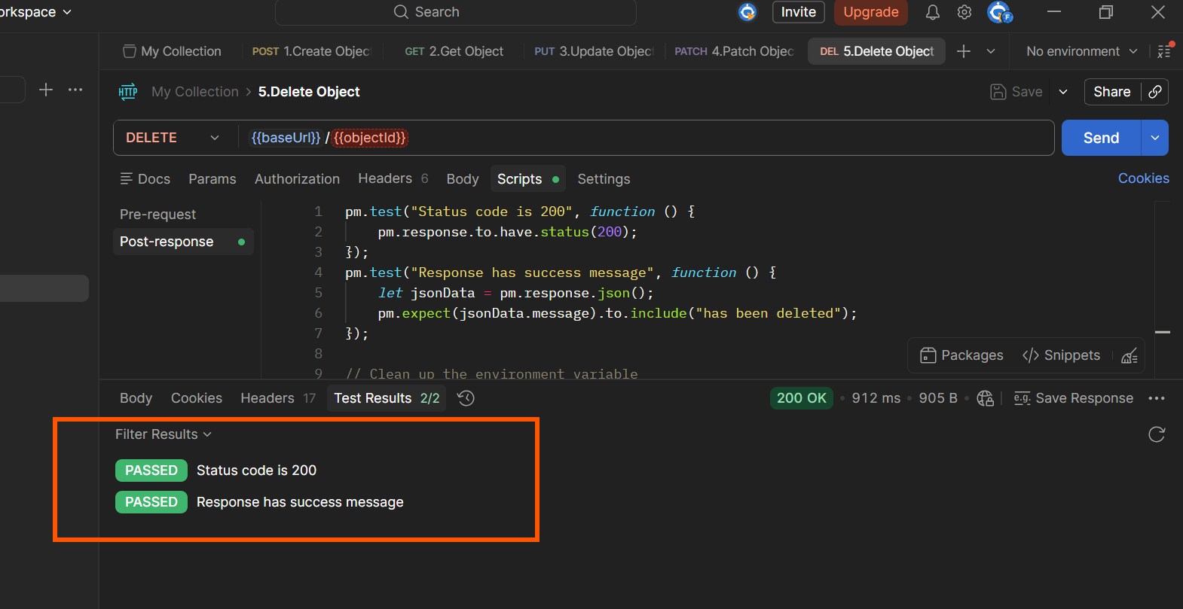

4. Final Deliverables
The complete, executable Postman JSON Collection has been exported and is available in the associated GitHub repository.

